Supplementary Materials
Exploring liposome-based rifabutin delivery against methicillin-resistant Staphylococcus aureus infections
Jacinta O. Pinho¹, Magda Ferreira^{1,2,3}, Mariana Coelho¹ Sandra N. Pinto⁴, Sandra I. Aguiar^{2,3}, Maria Manuela Gaspar^{1,5}*
¹ Research Institute for Medicines (iMed.ULisboa), Faculty of Pharmacy, Universidade de Lisboa, Av. Prof. Gama Pinto, 1649-003 Lisboa, Portugal. pinho.jacinta@campus.ul.pt (J.O.P.); magda.ferreira@campus.ul.pt (M.F.); mariana.coelho@ff.ulisboa.pt (M.C.); mgaspar@ff.ulisboa.pt (M.M.G.)
² Center for Interdisciplinary Research in Animal Health (CIISA), Faculty of Veterinary Medicine, Universidade de Lisboa, 1300-477 Lisboa, Portugal siraguiar@gmail.com (S.I.A.)
³ Associate Laboratory for Animal and Veterinary Sciences (AL4AnimalS), Portugal
⁴iBB-Institute for Bioengineering and Biosciences and i4HB-Institute for Health and Bioeconomy, Instituto Superior Técnico, Universidade de Lisboa, 1049-001 Lisboa, Portugal; sandrapinto@ist.utl.pt (S.N.P.)
⁵ IBEB, Institute of Biophysics and Biomedical Engineering, Faculty of Sciences, Universidade de Lisboa, Lisboa, Portugal;

*Corresponding author *: mgaspar@ff.ulisboa.pt

Supplementary Figures
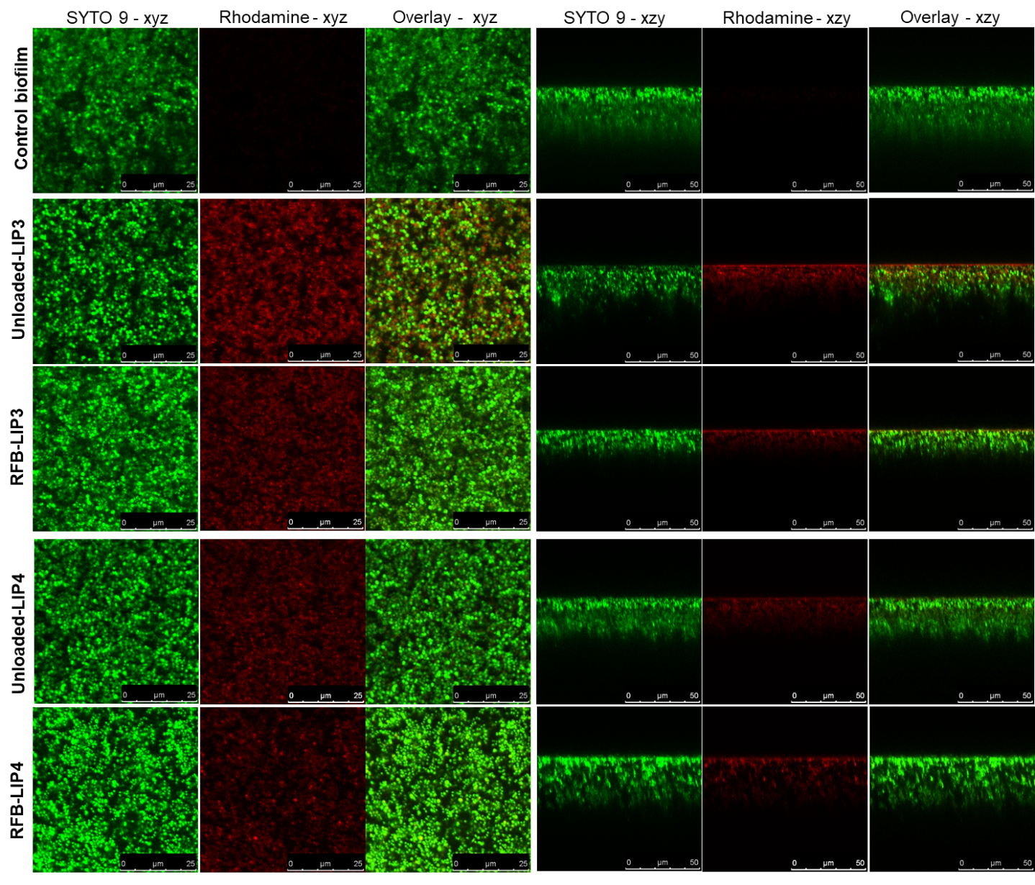
Figure S1. Representative CSLM images of 24 h-old MRSA-C1 biofilms after incubation with rhodamine-labelled LIP3 and LIP4 liposomes, unloaded and RFB-loaded, at a lipid concentration of 1.5 µmol/mL, for 24 h. Biofilms were stained with the green dye SYTO 9 at 3 µM. Untreated biofilm was used as a control (Control biofilm). Images in the left panels correspond to xyz view, and images in the right panels correspond to xzy orthogonal view. The overlay of the green and red channels from each plane image is presented as Overlay - xyz and Overlay - xzy. Lipid compositions: DMPC:DMPG (RFB-LIP3 and Unloaded-LIP3); DPPC:DPPG (RFB-LIP4 and Unloaded-LIP4).

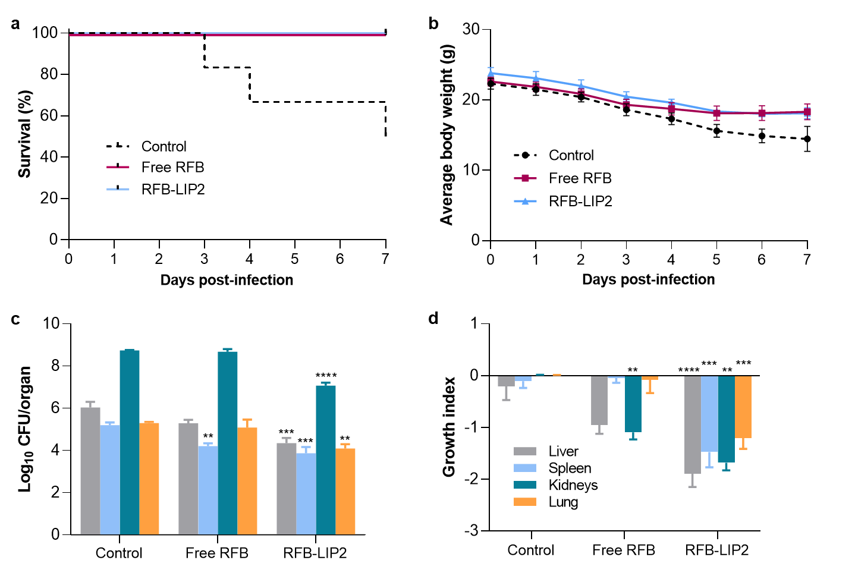
Figure S2. In Vivo Assay 1 – Preliminary evaluation of RFB formulations in a murine model of systemic MRSA-C1 infection. infection was induced intravenously in male Balb/c mice with a MRSA-C1 inoculum at 1.4×10⁹ CFU/mouse. Three days after infection induction mice received i.v. administrations of RFB formulations (Free RFB and RFB-LIP2) at dose of 20 mg/kg. Control group received buffer by intravenous route. (a) percentage of survival (Kaplan-Meier analysis), (b) average body weight, (c) bacterial burden in major organs at the end of treatment protocol, and (d) growth index. RFB-LIP2: DPPC:DPPG:DSPE-PEG. Results are expressed as mean ± SEM (n=4-5). *p<0.05, **p<0.01, ***p<0.001, ****p<0.0001 vs Control group.

Table S1. Tissue indexes of liver, spleen, kidneys, and lung of healthy mice (naïve) and mice infected with systemic MRSA-C1 and treated with tested formulations. In Vivo Assay 1 corresponds to mice induced with 1.4×10⁹ CFU/mouse and In Vivo Assay 2 to animals induced with 3.4×10⁸ CFU/mouse. Results are expressed as AVG ± SEM (n=4-5).
In vivo assay | Group | Tissue Index (AVG ± SEM)
 |  | Liver | Spleen | Kidneys | Lung
In Vivo Assay 1  (1.4×10⁹ CFU/mouse) | Control  (beginning of treatment) | 25.6 ± 0.1 | 7.9 ± 0.3 | 15.1 ± 1.0 | 8.8 ± 0.2
 | Control | 25.6 ± 0.6 | 8.4 ± 1.0 | 15.5 ± 0.2 | 9.9 ± 0.5
 | Free RFB | 23.2 ± 0.3 | 6.9 ± 0.5 | 13.6 ± 0.5 | 9.8 ± 0.3
 | RFB-LIP2 | 23.9 ± 0.7 | 8.8 ± 0.5 | 14.0 ± 0.5 | 9.2 ± 0.2
In Vivo Assay 2  (3.4×10⁸ CFU/mouse) | Control  (beginning of treatment) | 25.3 ± 0.4 | 8.0 ± 0.1 | 12.5 ± 0.3 | 9.8 ± 0.3
 | Control | 25.4 ± 0.4 | 10.2 ± 0.2 | 14.4 ± 0.1 | 10.4 ± 0.4
 | VCM | 25.1 ± 0.6 | 8.4 ± 0.4 | 14.0 ± 0.3 | 9.6 ± 0.3
 | Free RFB | 24.9 ± 0.4 | 7.2 ± 0.2 | 13.1 ± 0.2 | 9.1 ± 0.2
 | RFB-LIP1 | 26.1 ± 0.4 | 7.8 ± 0.3 | 13.4 ± 0.1 | 9.0 ± 0.3
 | RFB-LIP2 | 25.0 ± 0.5 | 8.0 ± 0.2 | 13.3 ± 0.2 | 8.8 ± 0.4
N.A. | Naïve | 24.0 ± 0.4 | 5.9 ± 0.3 | 13.0 ± 0.2 | 7.2 ± 0.3
RFB: rifabutin; VCM: vancomycin; CFU: colony forming units; Lipid compositions: DMPC:DMPG:DSPE-PEG (RFB-LIP1) and DPPC:DPPG:DSPE-PEG (RFB-LIP2); N.A.: not applicable.

Table S2. In Vivo Assay 2 – Score of analysed organs in terms of inflammation/necrosis (liver, kidney, and lung) and reaction to infection (spleen). Systemic infection was induced with 3.4×10⁸ CFU/mouse.
 | Inflammation/Necrosis |  |  | Reaction to infection
 | Liver | Kidney | Lung | Spleen
Control | 1 | 4 | 0 | 1
VCM | 0 | 3 | 0 | 1
Free RFB | 0 | 0 | 0 | 2
RFB-LIP1 | 0 | 0 | 0 | 1
RFB-LIP2 | 0 | 1 | 0 | 1
Inflammation/necrosis score: 0 = within normal limits; 1 = single cell necrosis; 2 = small foci of necrosis/abscesses; 3 = multifocal large foci of necrosis/abscesses; 4 = extended coalescing foci of necrosis/abscesses. Spleen reaction to infection: 0 = within normal limits; 1 = minimal; 2 = mild; 3 = moderate; 4 = severe.

