Development of n-type, passivating nanocrystalline silicon oxide (nc-SiOx:H) films via PECVD

Gurleen Kaur 1,2,*, Antonio J. Olivares 2 and Pere Roca i Cabarrocas 1,2, *

1Institut Photovoltaïque d'Ile-de-France (IPVF), 18 Bvd Thomas Gobert, 91120 Palaiseau, France

2LPICM, CNRS, Ecole Polytechnique, Institut Polytechnique de Paris, route de Saclay, 91128 Palaiseau, France

**\***Correspondence: gur.khera@gmail.com; [pere.roca@polytechnique.edu](mailto:pere.roca@polytechnique.edu)

**Supplementary section**

|  |
| --- |
|  |



Fig. S1. Variation in minority carrier lifetime (τeff) w.r.t. minority carrier density of nc-SiOx:H films deposited with changing CO2 gas flow ratio.



Fig. S2. Variation in minority carrier lifetime (τeff) w.r.t. minority carrier density of nc-SiOx:H films deposited with changing PH3 gas flow ratio.

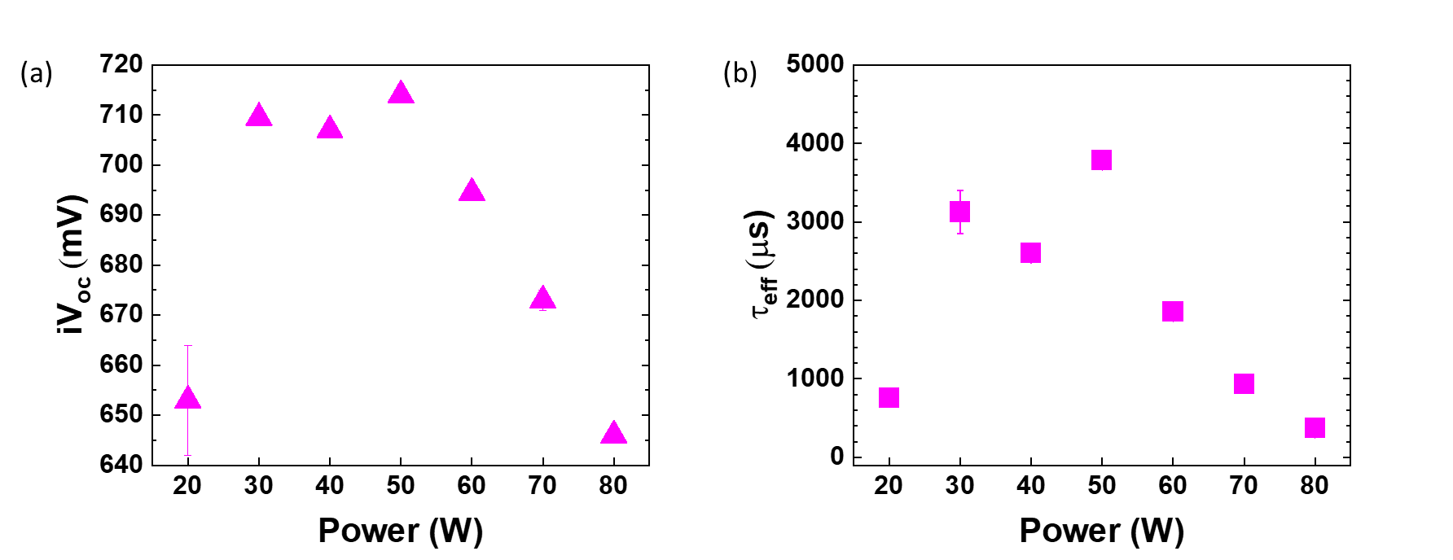

Fig. S3. (a) Effective minority carrier lifetime (τeff) and (b) implied Voc (iVoc) of nanocrystalline silicon oxide (nc-SiOx:H) films deposited at various powers (20-80 W).