Supplementary table and figures
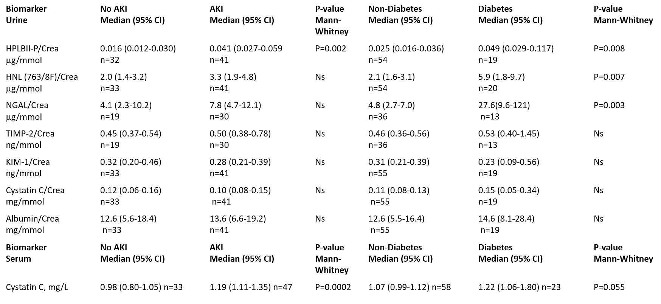
COVID-19 study
Biomarkers in urine corrected for urine Creatinine

Figure 1 supplement

Figure 2 supplement

