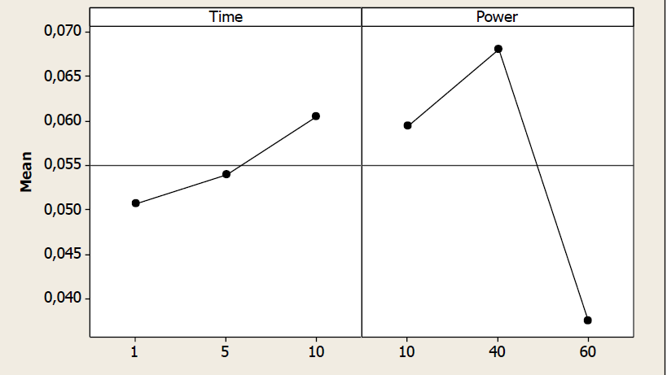
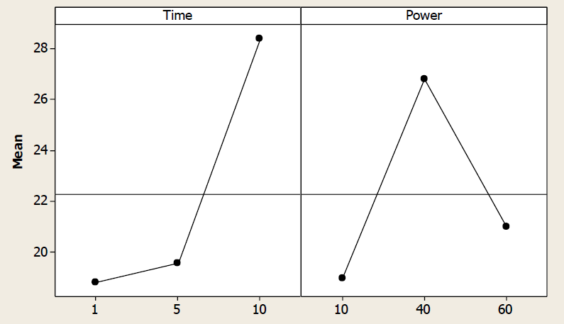
(b)
(a)

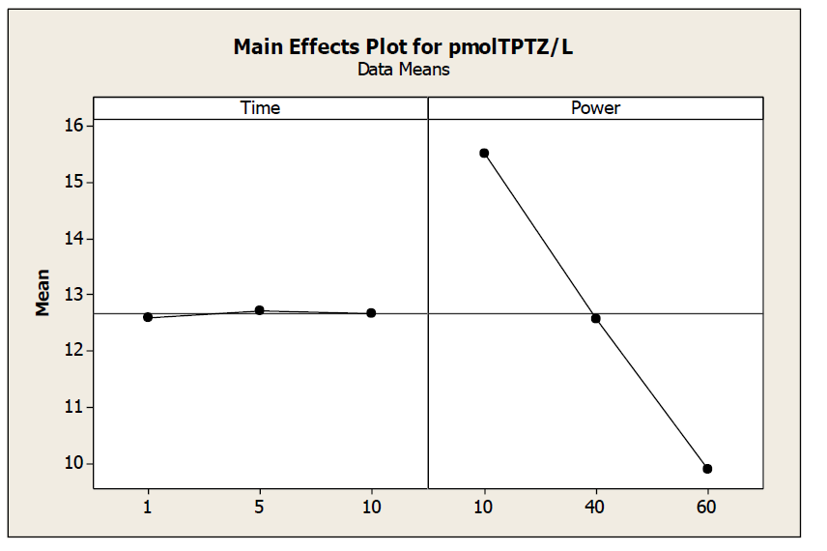
(c)

Figure S1. Main effects plots for the effect of extraction time and ultrasound amplitude on (a) total phenolic content of extract (GAE mg/g of waste), (b) antioxidant capacity of extract (DPPH, %,) (c) antioxidant capacity (FRAP, μmoles TPTZ/L).

Table S1. Experimental design for the UAE of lavender solid waste for two different solvents.

