Repurposing drugs for senotherapeutic effect: potential senomorphic effects of female synthetic hormones.

Laura R Bramwell¹, Ryan Frankum¹ & Lorna W Harries¹*

¹RNA-Mediated Mechanisms of Disease Group, Department of Clinical and Biomedical Sciences (Medical School), Faculty of Health and Life Sciences, University of Exeter, Exeter, UK

*corresponding author
Correspondence address:
Professor Lorna W Harries
Institute of Biomedical and Clinical Sciences
University of Exeter College of Medicine and Health
RILD Building
Royal Devon and Exeter Hospital
Barrack Road
Exeter
Devon
EX2 5DW
United Kingdom

Correspondence email: L.W.Harries@exeter.ac.uk
ORCID numbers: LRB - 0000-0003-4069-3959, RF - 0000-0002-2665-5625, LWH - 0000-0001-7791-8061

X (formerly known as Twitter): @miRNAgirl, @LauraBramwell1, @TeamRNA

Supplementary information

Supplementary Figure Legends

Supplementary Fig. 1: Descriptive data for the drug panel for the senescence screen. A. Type of clinical approval, i.e. compounds approved by the European Medical Association (EMA), the US Food and Drug Administration (FDA) or other countries. B. Research areas linked with each compound. C. Frequency of biological pathways that are targeted by the compounds in the screen. D. Compounds in the panel categorised by target/function.

Supplementary Fig. 2: The chemical structures of compounds that decreased senescent cell load. The chemical structures of compounds that decreased senescent cell load as measured by CDKN2A (p16) expression are given above.

Supplementary Fig. 3: Chemical structures of compounds that decreased senescent cell load. The chemical structures of compounds that decreased senescent cell load as measured by SAB staining are given above.

Supplementary Fig. 4: The chemical structures of compounds that increased senescent cell load. The chemical structures of compounds that increased senescent cell load as measured by CDKN2A (p16) expression are given above.

Supplementary Fig. 5: Dendrogram indicating structure-function similarity for compounds influencing senescence. Dendrogram constructed using the Tanimoto coefficient to show structural similarity of compounds tested that decreased SAB activity.

Supplementary Fig. 6: Dendrogram indicating structure-function similarity for compounds influencing senescence. Dendrogram constructed using the Tanimoto coefficient to show structural similarity of compounds tested that increased CDKN2A gene expression.

Supplementary Tables
Supplementary Table 1: Information on compound synonyms, targets and pathways used in a screen for CDKN2A gene expression. Information provided from the MedChemExpress FDA Approved Drug Library Plus (MedChemTronica, Stockholm).
Product Name | Synonyms | Target | Pathway
5-Aminosalicylic Acid | Mesalamine; 5-ASA;Mesalazine | NF-κB; PAK; PPAR | Cell Cycle/DNA Damage; Cytoskeleton; NF-κB
5-Azacytidine | Ladakamycin; 5-AzaC;Azacitidine | Autophagy; DNA Methyltransferase; Nucleoside Antimetabolite/Analog | Autophagy; Cell Cycle/DNA Damage; Epigenetics
5-Fluorouracil | 5-FU | Nucleoside Antimetabolite/Analog | Cell Cycle/DNA Damage
6-Thioguanine | Thioguanine; 2-Amino-6-purinethiol | Autophagy; Deubiquitinase; SARS-CoV | Anti-infection; Autophagy; Cell Cycle/DNA Damage
Abemaciclib (methanesulfonate) | LY2835219 (methanesulfonate) | CDK | Cell Cycle/DNA Damage
Acalabrutinib | ACP-196 | Btk | Protein Tyrosine Kinase/RTK
Acamprosate (calcium) | Calcium N-acetylhomotaurinate | GABA Receptor | Membrane Transporter/Ion Channel; Neuronal Signalling
Aceglutamide | α-N-Acetyl-L-glutamine; N2-Acetylglutamine | Autophagy; Endogenous Metabolite | Autophagy; Metabolic Enzyme/Protease
Aclacinomycin A hydrochloride | Aclarubicin hydrochloride | Proteasome; Topoisomerase | Cell Cycle/DNA Damage; Metabolic Enzyme/Protease
Allantoin | 5-Ureidohydantoin | Endogenous Metabolite; Imidazoline Receptor | GPCR/G Protein; Metabolic Enzyme/Protease; Neuronal Signalling
Alpelisib | BYL-719 | PI3K | PI3K/Akt/mTOR
Altretamine | ENT-50852; RB-1515;WR-95704 | DNA Alkylator/Crosslinker | Cell Cycle/DNA Damage
Amlexanox | AA673; Amoxanox; CHX3673 | IKK | NF-κB
Amoxapine | CL-67772 | Others | Others
Amsacrine | m-AMSA; acridinyl anisidide | Autophagy; Topoisomerase | Autophagy; Cell Cycle/DNA Damage
Anethole (trithione) |  | Others | Others
Apatinib | YN968D1 | Autophagy; c-Kit; RET; Src; VEGFR | Autophagy; Protein Tyrosine Kinase/RTK
Artemisinin | Qinghaosu; NSC 369397 | HCV; Parasite | Anti-infection
Artesunate |  | STAT | JAK/STAT Signalling; Stem Cell/Wnt
Aspirin | ASA; Acetylsalicylic Acid | Autophagy; COX; Mitophagy | Autophagy; Immunology/Inflammation
Atorvastatin (hemicalcium salt) | CI-981; Atorvastatin hemicalcium | Autophagy; HMG-CoA Reductase (HMGCR) | Autophagy; Metabolic Enzyme/Protease
Balsalazide |  | Interleukin Related; STAT | Immunology/Inflammation; JAK/STAT Signalling; Stem Cell/Wnt
Baricitinib (phosphate) | INCB028050 (phosphate); LY3009104 (phosphate) | JAK | Epigenetics; JAK/STAT Signalling; Stem Cell/Wnt
Belinostat | PXD101; PX105684 | Autophagy; HDAC | Autophagy; Cell Cycle/DNA Damage; Epigenetics
Belotecan (hydrochloride) | CKD-602 | Topoisomerase | Cell Cycle/DNA Damage
Bendamustine (hydrochloride) | SDX-105; EP-3101 | DNA Alkylator/Crosslinker | Cell Cycle/DNA Damage
Bendazol |  | NO Synthase | Immunology/Inflammation
Berberine (chloride hydrate) | Natural Yellow 18 (chloride hydrate) | Autophagy; Bacterial; ROS; Topoisomerase | Anti-infection; Autophagy; Cell Cycle/DNA Damage; Protein Tyrosine Kinase/RTK
Bexarotene | LGD1069 | Autophagy; RAR/RXR | Autophagy; Metabolic Enzyme/Protease
Bezafibrate | BM15075 | PPAR | Cell Cycle/DNA Damage
Binimetinib | MEK162; ARRY-162; ARRY-438162 | Autophagy; MEK | Autophagy; MAPK/ERK Pathway
Bleomycin (sulfate) |  | Bacterial; DNA/RNA Synthesis | Anti-infection; Cell Cycle/DNA Damage
Bortezomib | PS-341; Brotezamide; DPBA; LDP 341; MG 341; Radiciol; NSC 681239 | Apoptosis; Autophagy; Proteasome | Apoptosis; Autophagy; Metabolic Enzyme/Protease
Bosutinib | SKI-606 | Autophagy; Bcr-Abl; Src | Autophagy; Protein Tyrosine Kinase/RTK
Bremelanotide (Acetate) | PT-141 Acetate | Melanocortin Receptor | GPCR/G Protein; Neuronal Signalling
Bromhexine (hydrochloride) |  | Autophagy; Reactive Oxygen Species | Autophagy; Immunology/Inflammation; Metabolic Enzyme/Protease; NF-κB
Bucladesine (sodium salt) | Dibutyryl-cAMP sodium salt; DC2797; Sodium dibutyryl cAMP | PKA | Protein Tyrosine Kinase/RTK; Stem Cell/Wnt
Bufexamac | Bufexamic acid | HDAC | Cell Cycle/DNA Damage; Epigenetics
Busulfan |  | DNA Alkylator/Crosslinker | Cell Cycle/DNA Damage
Cabazitaxel | XRP6258; RPR-116258A; taxoid XRP6258 | Autophagy; Microtubule/Tubulin | Autophagy; Cell Cycle/DNA Damage; Cytoskeleton
Cabozantinib | XL184; BMS-907351 | c-Kit; c-Met/HGFR; FLT3; TAM Receptor; VEGFR | Protein Tyrosine Kinase/RTK
Caffeic acid |  | 5-Lipoxygenase; Endogenous Metabolite; TRP Channel | Membrane Transporter/Ion Channel; Metabolic Enzyme/Protease; Neuronal Signalling
Capecitabine |  | DNA/RNA Synthesis; Nucleoside Antimetabolite/Analog | Cell Cycle/DNA Damage
Carbamazepine | CBZ; NSC 169864 | Autophagy; Mitophagy; Sodium Channel | Autophagy; Membrane Transporter/Ion Channel
Carmofur | HCFU | Nucleoside Antimetabolite/Analog | Cell Cycle/DNA Damage
Carmustine |  | DNA Alkylator/Crosslinker | Cell Cycle/DNA Damage
Carprofen |  | Autophagy; COX; FAAH | Autophagy; Immunology/Inflammation; Metabolic Enzyme/Protease; Neuronal Signalling
Ceritinib | LDK378 | ALK; IGF-1R; Insulin Receptor | Protein Tyrosine Kinase/RTK
Chlorambucil | CB-1348; WR-139013 | DNA Alkylator/Crosslinker | Cell Cycle/DNA Damage
Chloroquine (diphosphate) |  | Autophagy; Toll-like Receptor (TLR) | Autophagy; Immunology/Inflammation
Chlorpheniramine (maleate) | Chlorphenamine maleate | Histamine Receptor | GPCR/G Protein; Immunology/Inflammation; Neuronal Signalling
Chlorzoxazone |  | Cytochrome P450 | Metabolic Enzyme/Protease
Choline Fenofibrate | ABT-335 | Cytochrome P450; PPAR | Cell Cycle/DNA Damage; Metabolic Enzyme/Protease
Chromocarb | Chromone-2-carboxylic acid | Others | Others
Ciprofibrate | Win35833 | PPAR | Cell Cycle/DNA Damage
Citalopram (hydrobromide) | (±)-Citalopram hydrobromide; Lu 10-171 | Autophagy; Serotonin Transporter | Autophagy; Neuronal Signalling
Citric acid |  | Apoptosis; Endogenous Metabolite | Apoptosis; Metabolic Enzyme/Protease
Clioquinol | Iodochlorhydroxyquin | Autophagy; Fungal; Mitophagy | Anti-infection; Autophagy
Clofarabine |  | Autophagy; Nucleoside Antimetabolite/Analog | Autophagy; Cell Cycle/DNA Damage
Clofibrate |  | PPAR | Cell Cycle/DNA Damage
Cobimetinib | GDC-0973; XL518 | MEK | MAPK/ERK Pathway
Colchicine |  | Autophagy; Microtubule/Tubulin | Autophagy; Cell Cycle/DNA Damage; Cytoskeleton
Conivaptan (hydrochloride) | YM 087 | Vasopressin Receptor | GPCR/G Protein
Crizotinib (hydrochloride) | PF-02341066 hydrochloride | ALK; Autophagy; c-Met/HGFR | Autophagy; Protein Tyrosine Kinase/RTK
Cytarabine | Cytosine β-D-arabinofuranoside; Cytosine Arabinoside; Ara-C | Autophagy; DNA/RNA Synthesis; Nucleoside Antimetabolite/Analog | Autophagy; Cell Cycle/DNA Damage
Dabrafenib | GSK2118436A; GSK2118436 | Raf | MAPK/ERK Pathway
Dacarbazine | Imidazole Carboxamide | Nucleoside Antimetabolite/Analog | Cell Cycle/DNA Damage
Dacomitinib | PF-00299804; PF-299804 | EGFR | JAK/STAT Signalling; Protein Tyrosine Kinase/RTK
Dasatinib (hydrochloride) | BMS 354825 hydrochloride | Autophagy; Bcr-Abl; Src | Autophagy; Protein Tyrosine Kinase/RTK
Daunorubicin (Hydrochloride) | RP 13057 (Hydrochloride); Daunomycin (Hydrochloride); Rubidomycin (Hydrochloride) | ADC Cytotoxin; Autophagy; DNA/RNA Synthesis; Topoisomerase | Antibody-drug Conjugate/ADC Related; Autophagy; Cell Cycle/DNA Damage
Decitabine | NSC 127716; 5-Aza-2'-deoxycytidine | DNA Methyltransferase | Epigenetics
Deferoxamine (mesylate) | Desferrioxamine B mesylate; DFOM | Amyloid-β; Autophagy; Mitophagy | Autophagy; Neuronal Signalling
Dexamethasone | Hexadecadrol; Prednisolone F | Autophagy; Glucocorticoid Receptor; Mitophagy | Autophagy; GPCR/G Protein
Diacerein | Diacerhein; Diacetylrhein | Interleukin Related | Immunology/Inflammation
Diethylstilboestrol | DES; Diethylstilbestrol; Stilbestrol | Estrogen Receptor/ERR | Others
Dimethyl fumarate | DMF | Keap1-Nrf2 | NF-κB
Disulfiram | Tetraethylthiuram disulfide; TETD | Aldehyde Dehydrogenase (ALDH); Apoptosis; Interleukin Related | Apoptosis; Immunology/Inflammation; Metabolic Enzyme/Protease
Docetaxel | RP-56976 | Microtubule/Tubulin | Cell Cycle/DNA Damage; Cytoskeleton
Doxifluridine | Ro 21-9738; 5-Fluoro-5'-deoxyuridine; 5'-DFUR | Nucleoside Antimetabolite/Analog | Cell Cycle/DNA Damage
Doxorubicin (hydrochloride) | Hydroxydaunorubicin (hydrochloride) | ADC Cytotoxin; AMPK; Autophagy; Mitophagy; Topoisomerase | Antibody-drug Conjugate/ADC Related; Autophagy; Cell Cycle/DNA Damage; Epigenetics; PI3K/Akt/mTOR
Dronedarone | SR 33589 | Autophagy; mAChR | Autophagy; GPCR/G Protein; Neuronal Signalling
Duvelisib | IPI-145; INK1197 | PI3K | PI3K/Akt/mTOR
Emtricitabine | BW1592 | HIV; Reverse Transcriptase | Anti-infection
Enasidenib | AG-221 | Isocitrate Dehydrogenase (IDH) | Metabolic Enzyme/Protease
Entacapone |  | COMT | Metabolic Enzyme/Protease; Neuronal Signalling
Entrectinib | NMS-E628; RXDX-101 | ALK; Autophagy; ROS; Trk Receptor | Autophagy; Neuronal Signalling; Protein Tyrosine Kinase/RTK
Epirubicin (hydrochloride) | 4'-Epidoxorubicin hydrochloride | Topoisomerase | Cell Cycle/DNA Damage
Erdosteine | RV 144 | NF-κB | NF-κB
Erlotinib | CP-358774; NSC 718781; OSI-774 | Autophagy; EGFR | Autophagy; JAK/STAT Signalling; Protein Tyrosine Kinase/RTK
Erlotinib (Hydrochloride) | CP-358774 (Hydrochloride); NSC 718781 (Hydrochloride); OSI-774 (Hydrochloride) | Autophagy; EGFR | Autophagy; JAK/STAT Signalling; Protein Tyrosine Kinase/RTK
Estramustine (phosphate sodium) |  | Microtubule/Tubulin | Cell Cycle/DNA Damage; Cytoskeleton
Ethamsylate |  | Prostaglandin Receptor | GPCR/G Protein
Ethynyl Estradiol | 17α-Ethynylestradiol; Ethynylestradiol | Endogenous Metabolite; Estrogen Receptor/ERR | Metabolic Enzyme/Protease; Others
Etoposide | VP-16; VP-16-213 | Apoptosis; Autophagy; Mitophagy; Topoisomerase | Apoptosis; Autophagy; Cell Cycle/DNA Damage
Ezetimibe | SCH 58235 | Autophagy; Keap1-Nrf2 | Autophagy; NF-κB
Fasudil (Hydrochloride) | HA-1077 (Hydrochloride); AT-877 (Hydrochloride) | Autophagy; Calcium Channel; ROCK | Autophagy; Cell Cycle/DNA Damage; Membrane Transporter/Ion Channel; Neuronal Signalling; Stem Cell/Wnt; TGF-beta/Smad
Favipiravir | T-705 | DNA/RNA Synthesis | Cell Cycle/DNA Damage
Fenofibrate |  | Autophagy; Cytochrome P450; PPAR | Autophagy; Cell Cycle/DNA Damage; Metabolic Enzyme/Protease
Fenofibric acid | FNF acid | COX; PPAR | Cell Cycle/DNA Damage; Immunology/Inflammation
Fingolimod | FTY720 free base | LPL Receptor; PAK | Cell Cycle/DNA Damage; Cytoskeleton; GPCR/G Protein
Floxuridine | 5-Fluorouracil 2'-deoxyriboside | Nucleoside Antimetabolite/Analog | Cell Cycle/DNA Damage
Flubendazole |  | Apoptosis; Microtubule/Tubulin; Parasite | Anti-infection; Apoptosis; Cell Cycle/DNA Damage; Cytoskeleton
Fludarabine | F-ara-A; NSC 118218 | DNA/RNA Synthesis; Nucleoside Antimetabolite/Analog; STAT | Cell Cycle/DNA Damage; JAK/STAT Signalling; Stem Cell/Wnt
Fluvastatin (sodium) | XU 62320 sodium | Autophagy; HMG-CoA Reductase (HMGCR) | Autophagy; Metabolic Enzyme/Protease
Folic acid | Vitamin B9; Vitamin M | DNA/RNA Synthesis; Endogenous Metabolite | Cell Cycle/DNA Damage; Metabolic Enzyme/Protease
Forodesine (hydrochloride) | BCX-1777; Immucillin-H hydrochloride | Nucleoside Antimetabolite/Analog | Cell Cycle/DNA Damage
Fostamatinib Disodium | R788(Disodium) | Syk | Protein Tyrosine Kinase/RTK
Gefitinib (hydrochloride) | ZD-1839 hydrochloride | EGFR | JAK/STAT Signalling; Protein Tyrosine Kinase/RTK
Gemcitabine | NSC 613327; LY188011 | Autophagy; DNA/RNA Synthesis; Nucleoside Antimetabolite/Analog | Autophagy; Cell Cycle/DNA Damage
Gemfibrozil | CI-719 | Cytochrome P450; PPAR | Cell Cycle/DNA Damage; Metabolic Enzyme/Protease
Glasdegib | PF-04449913 | Smo | Stem Cell/Wnt
Glycerol phenylbutyrate | HPN-100 | Others | Others
Homoharringtonine | Omacetaxine mepesuccinate; HHT | STAT | JAK/STAT Signalling; Stem Cell/Wnt
Hydrocortisone | Cortisol | Endogenous Metabolite; Glucocorticoid Receptor | GPCR/G Protein; Metabolic Enzyme/Protease
Hydroxychloroquine sulfate | HCQ sulfate | Autophagy; Parasite; Toll-like Receptor (TLR) | Anti-infection; Autophagy; Immunology/Inflammation
Hydroxyfasudil | HA-1100 | ROCK | Cell Cycle/DNA Damage; Stem Cell/Wnt; TGF-beta/Smad
Hydroxyurea | Hydroxycarbamide | Apoptosis; Autophagy; DNA/RNA Synthesis | Apoptosis; Autophagy; Cell Cycle/DNA Damage
Ibuprofen | (±)-Ibuprofen | COX | Immunology/Inflammation
Idarubicin (hydrochloride) | 4-Demethoxydaunorubicin hydrochloride | Autophagy; Topoisomerase | Autophagy; Cell Cycle/DNA Damage
Idelalisib | CAL-101; GS-1101 | Autophagy; PI3K | Autophagy; PI3K/Akt/mTOR
Imatinib | STI571; CGP-57148B | Autophagy; Bcr-Abl; c-Kit; PDGFR | Autophagy; Protein Tyrosine Kinase/RTK
Indomethacin | Indometacin | Autophagy; COX | Autophagy; Immunology/Inflammation
Irinotecan (hydrochloride) | CPT-11 hydrochloride; Camptothecin 11 hydrochloride | Autophagy; Topoisomerase | Autophagy; Cell Cycle/DNA Damage
Isotretinoin | 13-cis-Retinoic acid | Autophagy; Endogenous Metabolite; RAR/RXR | Autophagy; Metabolic Enzyme/Protease
Ixabepilone | Azaepothilone B; BMS 247550;BMS 247550-1 | Apoptosis; Microtubule/Tubulin | Apoptosis; Cell Cycle/DNA Damage; Cytoskeleton
Lamivudine | BCH-189 | HIV; Reverse Transcriptase | Anti-infection
Lanatoside C |  | Autophagy | Autophagy
Lapatinib | GW572016 | Autophagy; EGFR | Autophagy; JAK/STAT Signalling; Protein Tyrosine Kinase/RTK
LCZ696 | Sacubitril mixture with Valsartan | Angiotensin Receptor; JNK; Neprilysin; NF-κB; p38 MAPK | GPCR/G Protein; MAPK/ERK Pathway; Metabolic Enzyme/Protease; NF-κB
L-Epinephrine (Bitartrate) | (-)-Epinephrine (+)-bitartrate salt; L-Adrenaline (+)-bitartrate salt | Adrenergic Receptor | GPCR/G Protein; Neuronal Signalling
Levoleucovorin (Calcium) | Calcium levofolinate; CL307782 | Antifolate | Cell Cycle/DNA Damage
Lidocaine (hydrochloride) | Lignocaine hydrochloride | ERK; MEK; NF-κB; Sodium Channel | MAPK/ERK Pathway; Membrane Transporter/Ion Channel; NF-κB; Stem Cell/Wnt
Loperamide (hydrochloride) | R-18553 (hydrochloride) | Autophagy; Opioid Receptor | Autophagy; GPCR/G Protein; Neuronal Signalling
Lovastatin | Mevinolin | Autophagy; HMG-CoA Reductase (HMGCR) | Autophagy; Metabolic Enzyme/Protease
Melphalan | L-PAM | DNA Alkylator/Crosslinker | Cell Cycle/DNA Damage
Memantine (hydrochloride) | D-145 (hydrochloride) | Autophagy; Cytochrome P450; iGluR | Autophagy; Membrane Transporter/Ion Channel; Metabolic Enzyme/Protease; Neuronal Signalling
Metformin (hydrochloride) | 1,1-Dimethylbiguanide hydrochloride | AMPK; Autophagy; Mitophagy | Autophagy; Epigenetics; PI3K/Akt/mTOR
Methotrexate | Amethopterin; CL14377;WR19039 | ADC Cytotoxin; Antifolate | Antibody-drug Conjugate/ADC Related; Cell Cycle/DNA Damage
Methylthiouracil | MTU | ERK; Interleukin Related; NF-κB; TNF Receptor | Apoptosis; Immunology/Inflammation; MAPK/ERK Pathway; NF-κB; Stem Cell/Wnt
Metyrapone | Su-4885 | Autophagy; Cytochrome P450 | Autophagy; Metabolic Enzyme/Protease
Mifepristone | RU486; RU 38486 | Autophagy; Glucocorticoid Receptor; Progesterone Receptor | Autophagy; GPCR/G Protein; Others
Miltefosine | HePC; Hexadecyl phosphocholine | Akt; HIV | Anti-infection; PI3K/Akt/mTOR
Mitomycin C | Ametycine | ADC Cytotoxin; Autophagy; DNA Alkylator/Crosslinker; DNA/RNA Synthesis | Antibody-drug Conjugate/ADC Related; Autophagy; Cell Cycle/DNA Damage
Mitoxantrone | Mitozantrone | PKC; Topoisomerase | Cell Cycle/DNA Damage; Epigenetics; TGF-beta/Smad
Mizoribine | NSC 289637; HE 69 | HSP | Cell Cycle/DNA Damage; Metabolic Enzyme/Protease
Montelukast (sodium) | MK0476 | Autophagy; Leukotriene Receptor | Autophagy; GPCR/G Protein
Mycophenolic acid | Mycophenolate | Others | Others
Nedaplatin | NSC 375101D | DNA/RNA Synthesis | Cell Cycle/DNA Damage
Nefopam (hydrochloride) | Fenazoxine hydrochloride | β-catenin | Stem Cell/Wnt
Nelarabine | 506U78; GW 506U78; Nelzarabine | Nucleoside Antimetabolite/Analog | Cell Cycle/DNA Damage
Neratinib | HKI-272 | EGFR | JAK/STAT Signalling; Protein Tyrosine Kinase/RTK
Niclosamide | BAY2353 | STAT | JAK/STAT Signalling; Stem Cell/Wnt
Nicotinamide | Niacinamide; Nicotinic acid amide; Vitamin B3 | Endogenous Metabolite; Sirtuin | Cell Cycle/DNA Damage; Epigenetics; Metabolic Enzyme/Protease
Nifuroxazide |  | STAT | JAK/STAT Signalling; Stem Cell/Wnt
Niraparib | MK-4827 | PARP | Cell Cycle/DNA Damage; Epigenetics
Nitisinone | NTBC; Nitisone;SC0735 | Reactive Oxygen Species | Immunology/Inflammation; Metabolic Enzyme/Protease; NF-κB
Olaparib | AZD2281; KU0059436 | Autophagy; Mitophagy; PARP | Autophagy; Cell Cycle/DNA Damage; Epigenetics
Opicapone | BIA 9-1067 | COMT | Metabolic Enzyme/Protease; Neuronal Signalling
Orotic acid | 6-Carboxyuracil; Vitamin B13 | Endogenous Metabolite; Nucleoside Antimetabolite/Analog | Cell Cycle/DNA Damage; Metabolic Enzyme/Protease
Osalmid | Oxaphenamide; 4'-Hydroxysalicylanilide | HBV | Anti-infection
Paclitaxel | Taxol | ADC Cytotoxin; Autophagy; Microtubule/Tubulin | Antibody-drug Conjugate/ADC Related; Autophagy; Cell Cycle/DNA Damage; Cytoskeleton
Palbociclib (hydrochloride) | PD 0332991 hydrochloride | CDK | Cell Cycle/DNA Damage
Pamidronic acid |  | Wnt; β-catenin | Stem Cell/Wnt
Panobinostat | LBH589; NVP-LBH589 | Autophagy; HDAC | Autophagy; Cell Cycle/DNA Damage; Epigenetics
Pazopanib | GW786034 | Autophagy; c-Kit; FGFR; PDGFR; VEGFR | Autophagy; Protein Tyrosine Kinase/RTK
Pazopanib (Hydrochloride) | GW786034 (Hydrochloride) | Autophagy; c-Fms; c-Kit; FGFR; PDGFR; VEGFR | Autophagy; Protein Tyrosine Kinase/RTK
Peficitinib | ASP015K; JNJ-54781532 | JAK | Epigenetics; JAK/STAT Signalling; Stem Cell/Wnt
Pemetrexed (disodium hemipenta hydrate) | LY231514 (disodium hemipenta hydrate) | Antifolate; Autophagy | Autophagy; Cell Cycle/DNA Damage
Penfluridol | R-16341 | Autophagy; Calcium Channel | Autophagy; Membrane Transporter/Ion Channel; Neuronal Signalling
Pexidartinib | PLX-3397 | c-Fms; c-Kit | Protein Tyrosine Kinase/RTK
Phenindione | Rectadione | Others | Others
Pioglitazone | U 72107 | PPAR | Cell Cycle/DNA Damage
Pipobroman |  | Others | Others
Pirfenidone | AMR69 | TGF-beta/Smad | Stem Cell/Wnt; TGF-beta/Smad
Pixantrone (dimaleate) | BBR 2778 dimaleate | Topoisomerase | Cell Cycle/DNA Damage
Podofilox | Podophyllotoxin | Microtubule/Tubulin | Cell Cycle/DNA Damage; Cytoskeleton
Ponatinib | AP24534 | Autophagy; Bcr-Abl; FGFR; PDGFR; Src; VEGFR | Autophagy; Protein Tyrosine Kinase/RTK
Pralatrexate |  | Antifolate | Cell Cycle/DNA Damage
Pranlukast | ONO-1078 | Leukotriene Receptor | GPCR/G Protein
Procarbazine (Hydrochloride) |  | DNA Alkylator/Crosslinker | Cell Cycle/DNA Damage
Propranolol (hydrochloride) |  | Adrenergic Receptor; Autophagy | Autophagy; GPCR/G Protein; Neuronal Signalling
Pyrimethamine | Pirimecidan; Pirimetamin; RP 4753 | Antifolate; Parasite | Anti-infection; Cell Cycle/DNA Damage
Pyrvinium pamoate | Pyrvinium embonate | Wnt | Stem Cell/Wnt
Quinapril (hydrochloride) | CI-906 | Angiotensin-converting Enzyme (ACE) | Metabolic Enzyme/Protease
Raloxifene (hydrochloride) | LY156758 hydrochloride; LY139481 hydrochloride | Autophagy; Estrogen Receptor/ERR | Autophagy; Others
Raltitrexed | ZD1694; D1694; ICI-D1694 | Nucleoside Antimetabolite/Analog; Thymidylate Synthase | Apoptosis; Cell Cycle/DNA Damage
Rasagiline (mesylate) | AGN1135 (mesylate); TVP1012 (mesylate) | Autophagy; Monoamine Oxidase | Autophagy; Neuronal Signalling
Regorafenib (monohydrate) | BAY 73-4506 monohydrate | Autophagy; PDGFR; Raf; RET; VEGFR | Autophagy; MAPK/ERK Pathway; Protein Tyrosine Kinase/RTK
Resveratrol | SRT 501; trans-Resveratrol | Autophagy; IKK; Mitophagy; Sirtuin | Autophagy; Cell Cycle/DNA Damage; Epigenetics; NF-κB
Retinoic acid | ATRA; Tretinoin; Vitamin A acid; all-trans-Retinoic acid | Autophagy; Endogenous Metabolite; PPAR; RAR/RXR | Autophagy; Cell Cycle/DNA Damage; Metabolic Enzyme/Protease
Ribociclib | LEE011 | CDK | Cell Cycle/DNA Damage
Ripasudil | K-115 | ROCK | Cell Cycle/DNA Damage; Stem Cell/Wnt; TGF-beta/Smad
Rosiglitazone | BRL 49653 | Autophagy; PPAR; TRP Channel | Autophagy; Cell Cycle/DNA Damage; Membrane Transporter/Ion Channel; Neuronal Signalling
Rucaparib (phosphate) | AG-014699 phosphate; PF-01367338 phosphate | PARP | Cell Cycle/DNA Damage; Epigenetics
Ruxolitinib | INCB018424 | Autophagy; JAK; Mitophagy | Autophagy; Epigenetics; JAK/STAT Signalling; Stem Cell/Wnt
Salicylic acid | 2-Hydroxybenzoic acid | Autophagy; COX; Endogenous Metabolite; Mitophagy | Autophagy; Immunology/Inflammation; Metabolic Enzyme/Protease
Selumetinib | AZD6244; ARRY-142886 | MEK | MAPK/ERK Pathway
Sertraline (hydrochloride) |  | Serotonin Transporter | Neuronal Signalling
Sildenafil | UK-92480 | Autophagy; Phosphodiesterase (PDE) | Autophagy; Metabolic Enzyme/Protease
Silibinin | Silybin; Silibinin A; Silymarin I | Autophagy; Reactive Oxygen Species | Autophagy; Immunology/Inflammation; Metabolic Enzyme/Protease; NF-κB
Sitagliptin | MK0431 | Autophagy; Dipeptidyl Peptidase | Autophagy; Metabolic Enzyme/Protease
Sodium phenylbutyrate | Sodium 4-phenylbutyrate; TriButyrate | Autophagy; HDAC | Autophagy; Cell Cycle/DNA Damage; Epigenetics
Sorafenib | Bay 43-9006 | Autophagy; FLT3; Raf; VEGFR | Autophagy; MAPK/ERK Pathway; Protein Tyrosine Kinase/RTK
Sulfasalazine | NSC 667219 | Autophagy; NF-κB | Autophagy; NF-κB
Sunitinib | SU 11248 | Autophagy; Mitophagy; PDGFR; VEGFR | Autophagy; Protein Tyrosine Kinase/RTK
Tacrolimus (monohydrate) | FK506 (monohydrate); Fujimycin (monohydrate); FR900506 (monohydrate) | Autophagy; FKBP; Phosphatase | Apoptosis; Autophagy; Immunology/Inflammation; Metabolic Enzyme/Protease
Talazoparib | BMN-673; LT-673 | PARP | Cell Cycle/DNA Damage; Epigenetics
Tamoxifen | ICI47699; Z-Tamoxifen; trans-Tamoxifen | Autophagy; Oestrogen Receptor/ERR | Autophagy; Others
Taurodeoxychloic Acid (sodium hydrate) | Sodium taurodeoxycholate monohydrate | Apoptosis; Caspase | Apoptosis
Tegafur | FT 207; NSC 148958 | Nucleoside Antimetabolite/Analog | Cell Cycle/DNA Damage
Telmisartan | BIBR 277 | Angiotensin Receptor; Autophagy | Autophagy; GPCR/G Protein
Temozolomide | NSC 362856; CCRG 81045; TMZ | Autophagy; DNA Alkylator/Crosslinker | Autophagy; Cell Cycle/DNA Damage
Temsirolimus | CCI-779 | Autophagy; mTOR | Autophagy; PI3K/Akt/mTOR
Teniposide | VM26 | Topoisomerase | Cell Cycle/DNA Damage
Teprenone | Geranylgeranylacetone | HSP | Cell Cycle/DNA Damage; Metabolic Enzyme/Protease
Terazosin (hydrochloride dihydrate) |  | Adrenergic Receptor | GPCR/G Protein; Neuronal Signalling
Theophylline | 1,3-Dimethylxanthine; Theo-24 | Adenosine Receptor; Autophagy; Endogenous Metabolite; Phosphodiesterase (PDE) | Autophagy; GPCR/G Protein; Metabolic Enzyme/Protease
Thio-TEPA |  | DNA Alkylator/Crosslinker | Cell Cycle/DNA Damage
Tofacitinib (citrate) | Tasocitinib citrate; CP-690550 citrate | JAK | Epigenetics; JAK/STAT Signalling; Stem Cell/Wnt
Topotecan (Hydrochloride) | SKF 104864A (Hydrochloride); NSC 609669 (Hydrochloride) | Autophagy; Topoisomerase | Autophagy; Cell Cycle/DNA Damage
Trametinib (DMSO solvate) | GSK-1120212 (DMSO solvate); JTP-74057 (DMSO solvate) | MEK | MAPK/ERK Pathway
Tranylcypromine (hemisulfate) | dl-Tranylcypromine hemisulfate; trans-2-Phenylcyclopropylamine hemisulfate salt | Histone Demethylase; Monoamine Oxidase | Epigenetics; Neuronal Signalling
Triclabendazole | CGA89317 | Microtubule/Tubulin | Cell Cycle/DNA Damage; Cytoskeleton
Trifluridine | Trifluorothymidine; 5-Trifluorothymidine; TFT | HSV; Nucleoside Antimetabolite/Analog; Thymidylate Synthase | Anti-infection; Apoptosis; Cell Cycle/DNA Damage
Trimethoprim |  | Antifolate | Cell Cycle/DNA Damage
Troglitazone | CS-045 | Autophagy; PPAR | Autophagy; Cell Cycle/DNA Damage
Troxipide |  | Others | Others
Tucidinostat | Chidamide; HBI-8000;CS 055 | HDAC | Cell Cycle/DNA Damage; Epigenetics
Upadacitinib | ABT-494 | JAK | Epigenetics; JAK/STAT Signalling; Stem Cell/Wnt
VAL-083 | Dianhydrodulcitol; Dianhydrogalactitol | DNA Alkylator/Crosslinker | Cell Cycle/DNA Damage
Valproic acid (sodium salt) | Sodium Valproate | Autophagy; HDAC; Mitophagy | Autophagy; Cell Cycle/DNA Damage; Epigenetics
Valpromide |  | Others | Others
Valrubicin | AD-32 | PKC | Epigenetics; TGF-beta/Smad
Vemurafenib | PLX4032; RG7204; RO5185426 | Autophagy; Raf | Autophagy; MAPK/ERK Pathway
Venetoclax | ABT-199; GDC-0199 | Autophagy; Bcl-2 Family | Apoptosis; Autophagy
Vidarabine | Ara-A; Adenine Arabinoside; 9-β-D-Arabinofuranosyladenine | HSV; Nucleoside Antimetabolite/Analog | Anti-infection; Cell Cycle/DNA Damage
Vinblastine (sulfate) | Vincaleukoblastine sulfate salt | Autophagy; Microtubule/Tubulin | Autophagy; Cell Cycle/DNA Damage; Cytoskeleton
Vinorelbine (ditartrate) | KW-2307; Nor-5'-anhydrovinblastine ditartrate | Autophagy; Microtubule/Tubulin | Autophagy; Cell Cycle/DNA Damage; Cytoskeleton
Vorinostat | SAHA | Autophagy; HDAC; Mitophagy | Autophagy; Cell Cycle/DNA Damage; Epigenetics
Zidovudine | Azidothymidine; AZT; ZDV | CRISPR/Cas9; HIV | Anti-infection; Cell Cycle/DNA Damage

Supplementary Figures

Supplementary Fig. 1
a)
b)
c)

d)

Supplementary Fig. 2
5-Azacytidine | Abemaciclib (methanesulfonate) | Acalabrutinib | Balsalazide | Bendazol
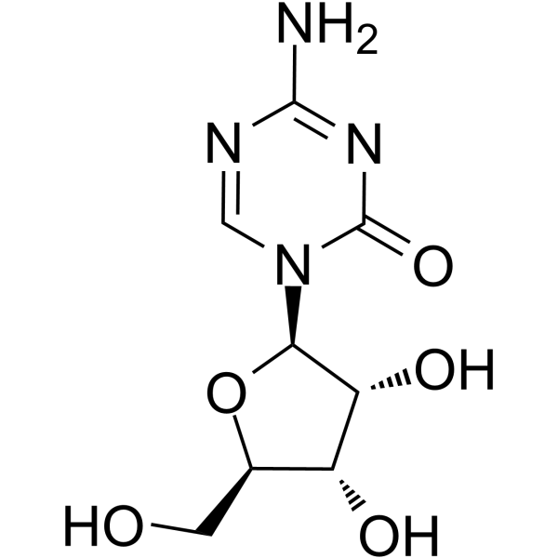 |  | 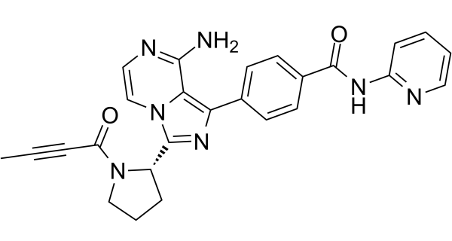 |  | 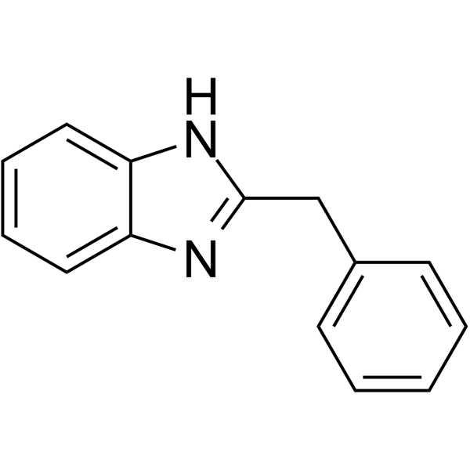
Bexarotene | Bortezomib | Bosutinib | Cabozantinib | Carmofur
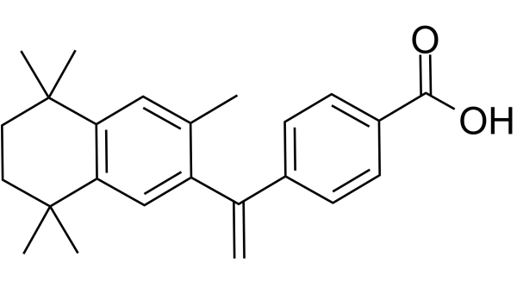 | 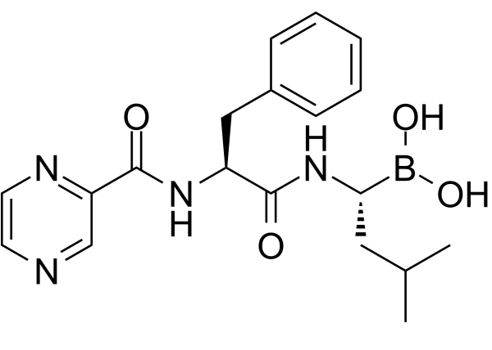 | 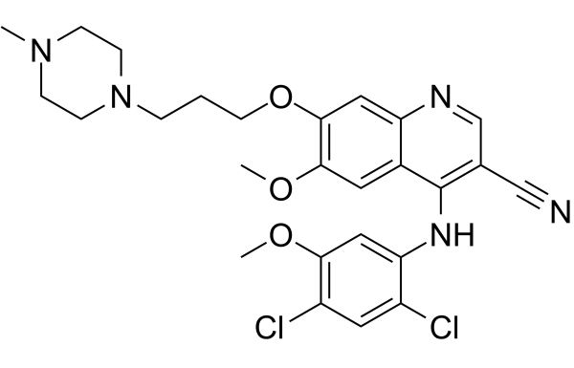 | 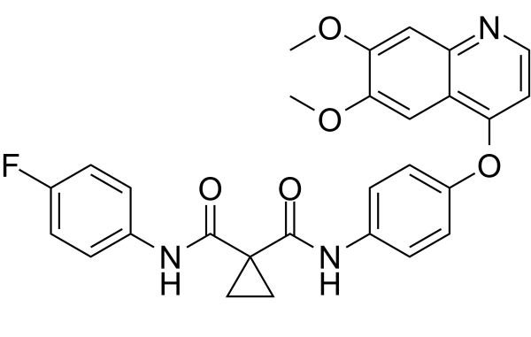 | 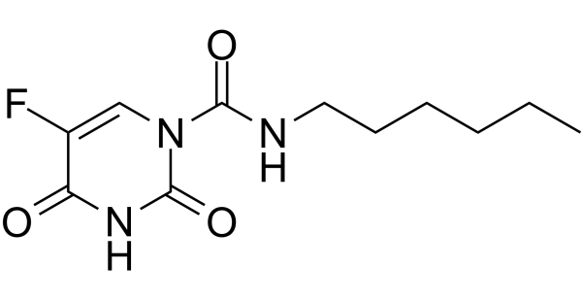
Chlorpheniramine (maleate) | Chlorzoxazone | Chromocarb | Clofarabine | Conivaptan (hydrochloride)
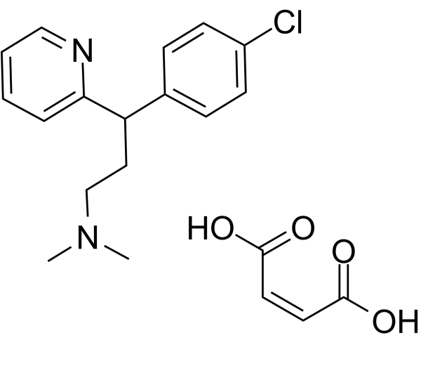 | 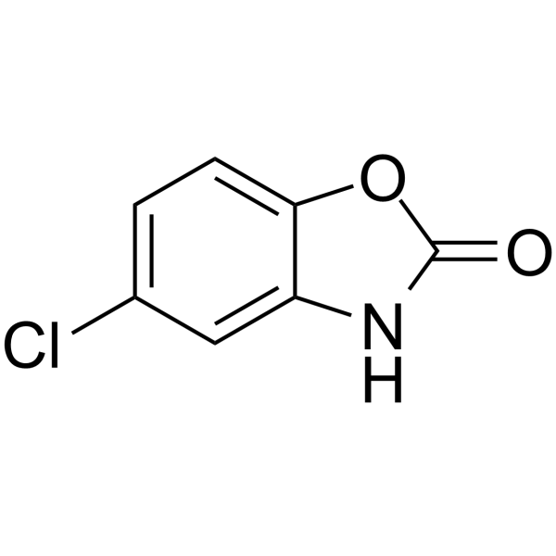 | 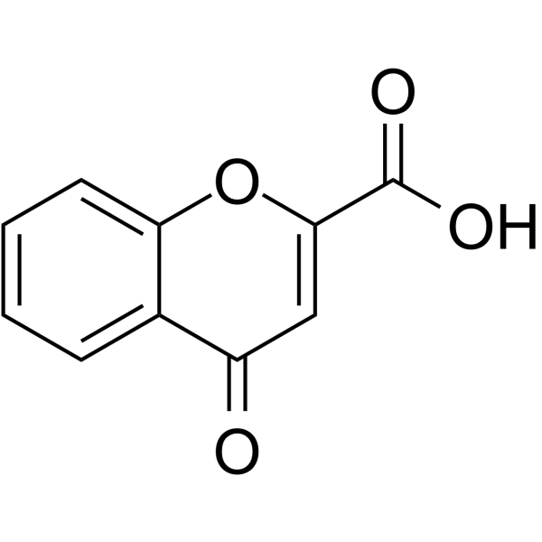 | 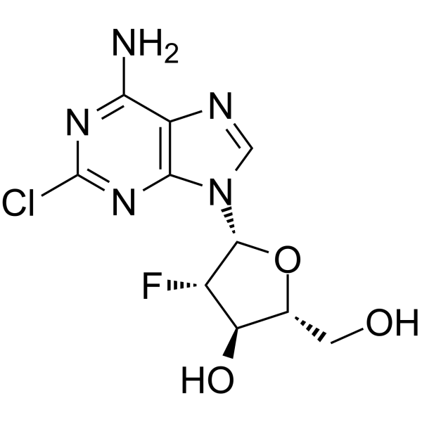 | 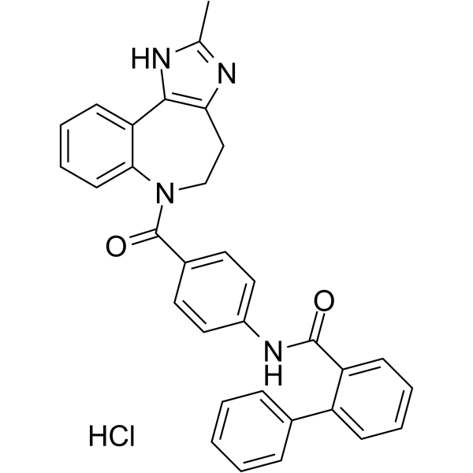

Note this figure continues onto the following page

Erlotinib | Dexamethasone | Diethylstilboestrol | Dimethyl fumarate | Dronedarone
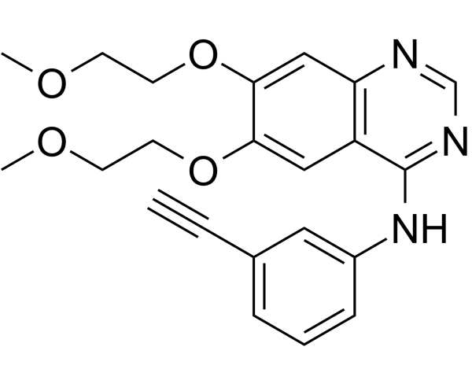 | 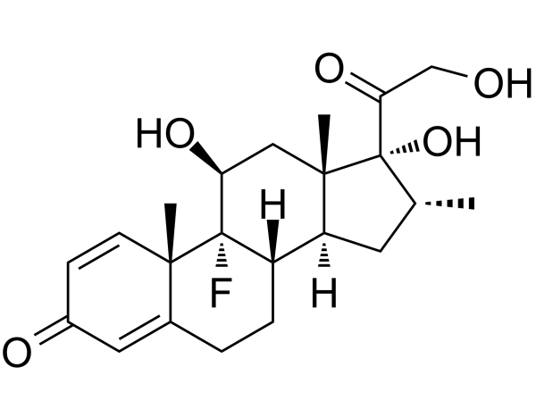 | 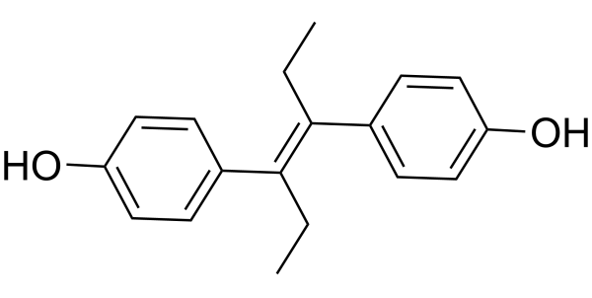 | 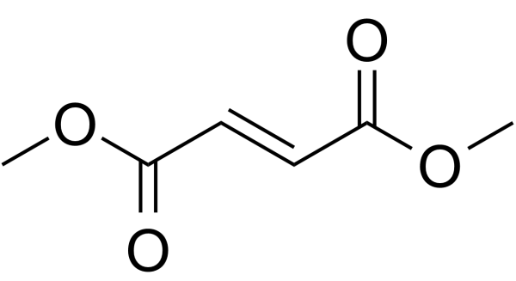 | 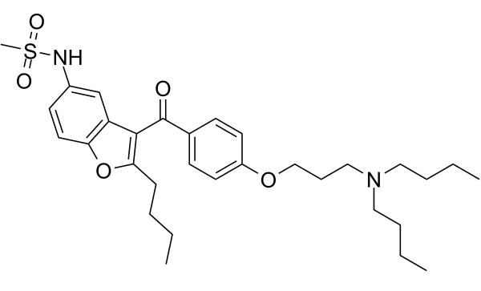
Ethynyl estradiol | Methylthiouracil | Metyrapone | Nefopam (hydrochloride) | Nelarabine
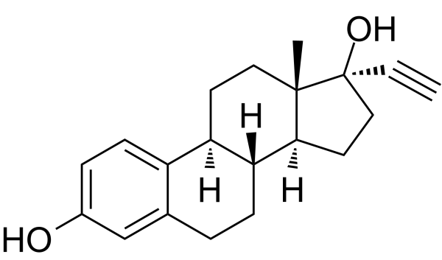 | 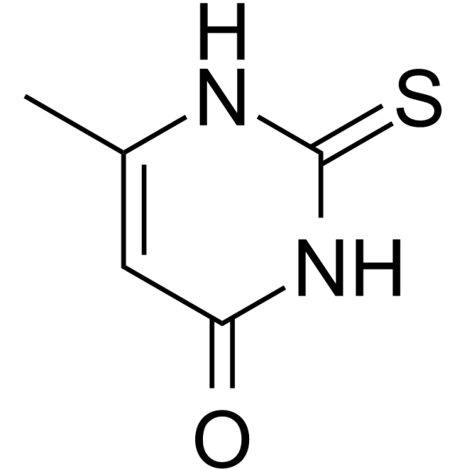 | 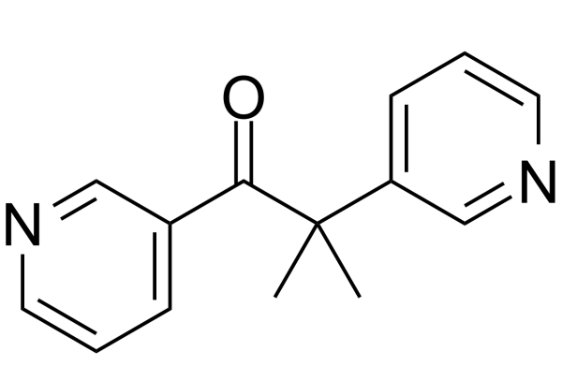 | 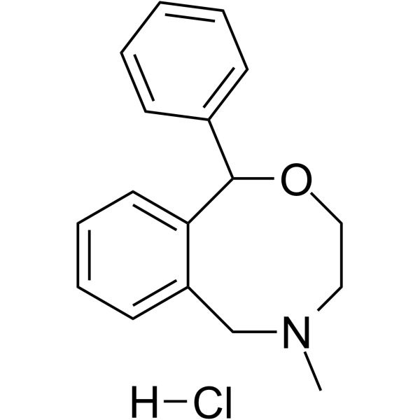 | 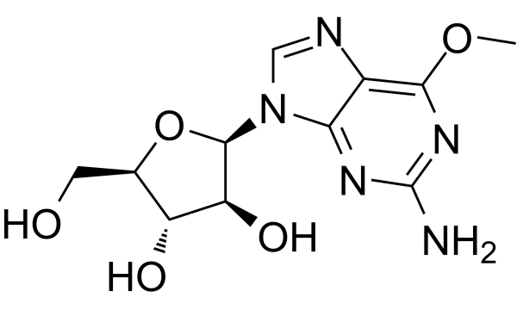
Niraparib | Osalmid | Penfluridol | Sodium 4-phenylbutyrate | Topotecan (Hydrochloride)
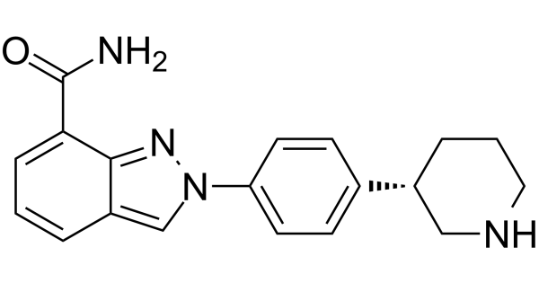 | 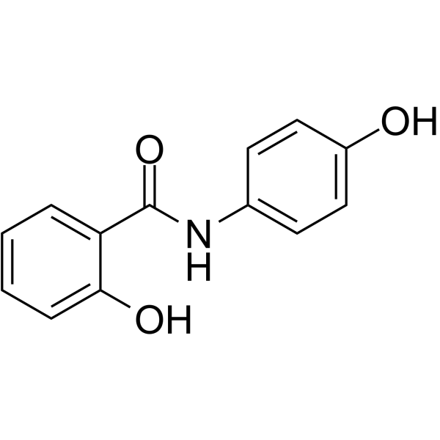 | 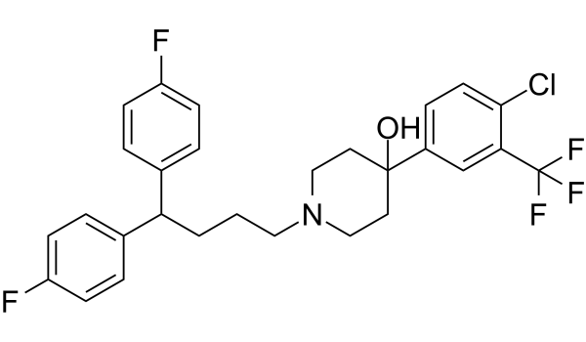 |  | 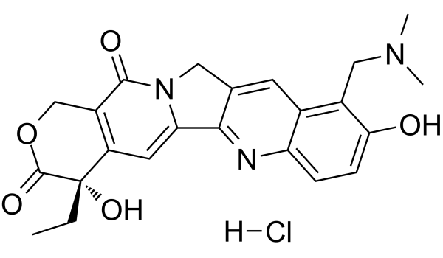

Supplementary Fig. 3
Aspirin | Cabozantinib | Carmofur | Chlorpheniramine (maleate) | Ethynyl estradiol
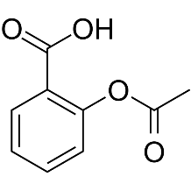 | 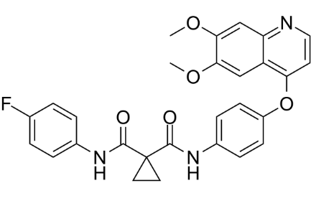 | 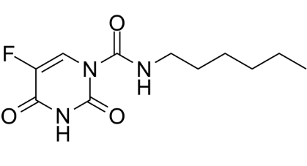 | 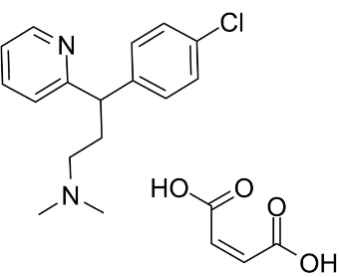 | 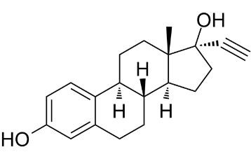
Levonorgestrel | Metyrapone | Penfluridol | Diethylstilboestrol | Sodium 4-phenylbutyrate
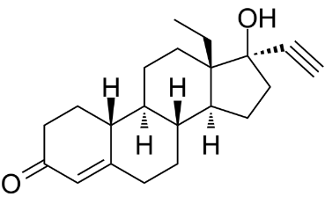 | 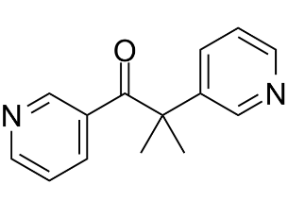 | 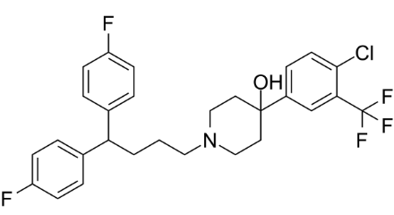 | 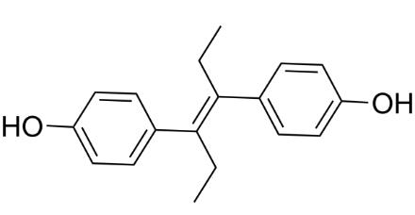

Supplementary Fig. 4
Atorvastatin  (hemicalcium salt) | Chlorambucil | Cobimetinib | Doxorubicin (hydrochloride) | Gemfibrozil
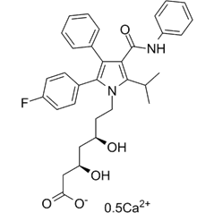 | 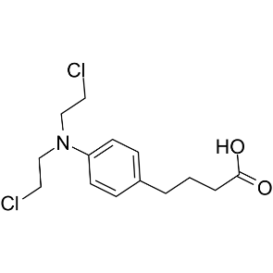 | 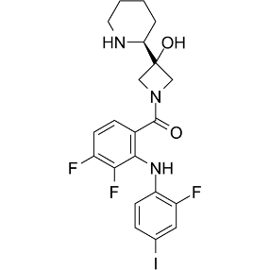 | 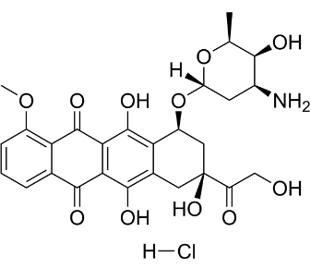
Homoharringtonine | Imatinib | Tucidinostat
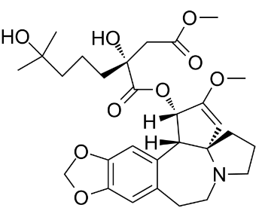 | 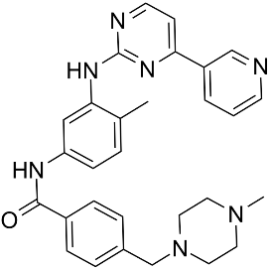 | 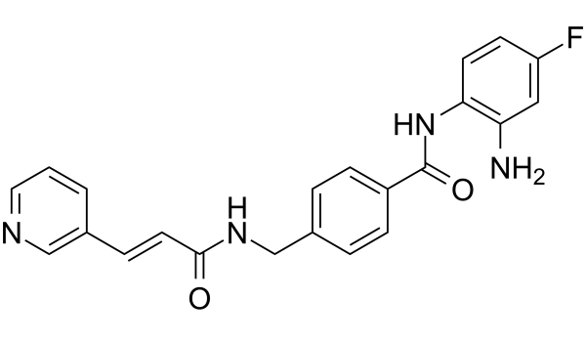

Supplementary Fig. 5
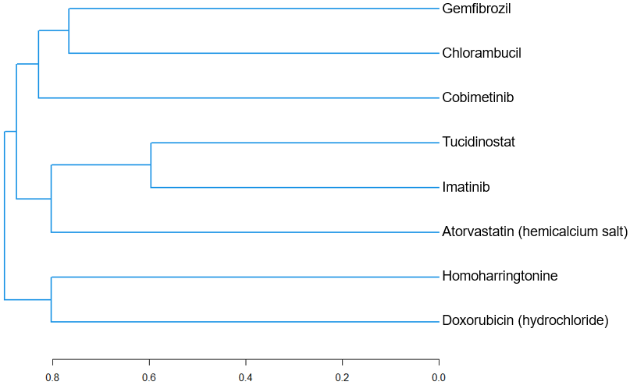

Supplementary Fig. 6
