SuppLEMENTARY Information
When an Unsuspected Crystallinity Can Ruin Your Biological Testing in Early Discovery: An Example Case

Claudi de Rocafiguera ¹, Blanca Belsa ¹, Mercè Font-Bardia ², Cristina Puigjaner ², Eduard Serra ¹, Ana M. Cuartero-Albesa ¹, Raimon Puig de la Bellacasa ¹ and José I. Borrell ^{1,}*

¹Grup de Química Farmacèutica, IQS School of Engineering, Universitat Ramon Llull, Via Augusta, 390, E-08017 Barcelona, Spain. E-mail: jose.borrell@iqs.url.edu
² Unitat de Difracció de Raigs X, Centres Científics i Tecnològics, Universitat de Barcelona, Lluís Solé i Sabarís 1-3, 08028 Barcelona, Spain

Table of Contents

Page

1.1 HPLC-MS study of the IQS016 and PB1 samples 2

1.2 X-ray powder diffraction analysis of IQS016 and PB1 6

1.3 Determination of the crystal structure of PB1 from X-ray powder diffraction data 8

1.4 Crystal structure determination of a single crystal of IQS016 grown in MeOH 10

1.5 Crystal structure determination of a single crystal of IQS016 grown in DMSO 20

1.6 Selectivity profiling of 3 compounds using 4 protein kinases 33

Experimental Procedures
  - HPLC-MS study of the IQS016 and PB1 samples
Chemicals and reagents
The reagents used are, Acetonitrile (ACN) of HPLC-MS grade (83640.320) from VWR. HPLC-MS grade formic acid optima (A117-60) from Fisher Chemical. Dimethyl sulfoxide (DMSO) LC-MS grade (85190) from Thermo Scientific and Ultra-purified water was prepared using a Milli-Q purification system (Milli-Q Integral 3, Millipore).

Samples
IQS016 was synthesized at IQS by the Grup de Química Farmacèutica. PB1 was obtained from APPlus. The working sample solutions were prepared by dissolving an accurately weighed 1.5 mg of each sample in 1.5 mL of DMSO. The sample solutions were obtained from the dilution of 70 µL of working sample solutions in 1.5 mL of ACN (0.05 mg/mL). The volume was filtered through 0.45 μm nylon syringe filter (FILTER-LAB JNY045025N).

Equipment, column, experimental conditions
The liquid chromatography analysis was performed using an HPLC-MS, Agilent technologies 1200 series LC/LC MSD iQ, column X-bridge C18 (100 × 4.6 x 3.5 µm, waters) and a combined isocratic and linear gradient mode of elution (Table S1) at a flow rate of 0.5 mL min⁻¹ consisting of a mobile phase of water (A) and acetonitrile (B), each containing 0.1% formic acid (v/v), over a 20 min run time. The oven temperature was 40°C and the sample injection volume was set at 10 μL.

Table S1: Chromatographic gradient
Time (min) | Mobile phase A (v/v) | Mobile phase B (v/v)
0.0 – 5.0 | 70 | 30
15.0 | 0 | 100
15.0-20.0 | 0 | 100

ESI-MS interface was operated in the positive ionization mode at gas temperature 350°C, gas flow 10 L/min., nebulizer 45 psi and capillary voltage 4000 V.
Detection was performed at 254 nm, ionization method with cone voltage 110 V and MS scan 100-1000, SIM (m/z) 412, positive mode, 410 negative mode.

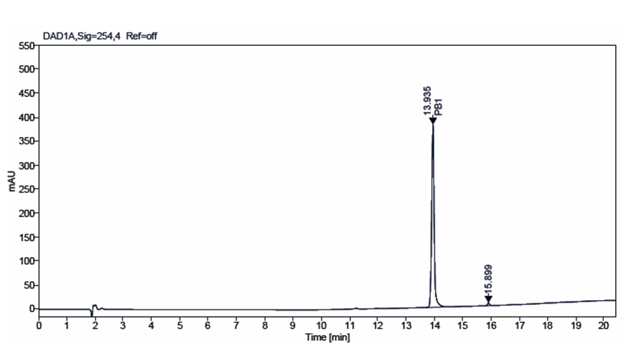
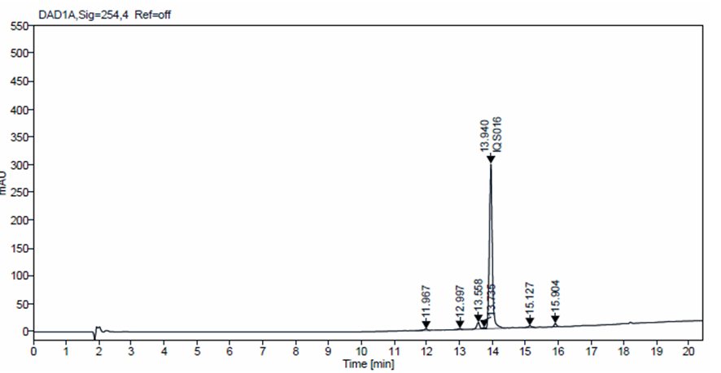
Figure S1: Chromatograms at 254 nm of PB1 and IQS016

Figure S2 shows the UV profile of both compounds, with both samples displaying the same profile.

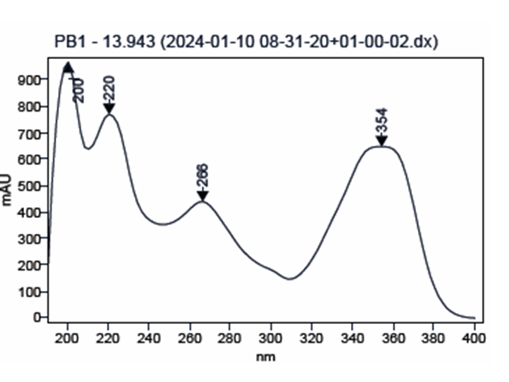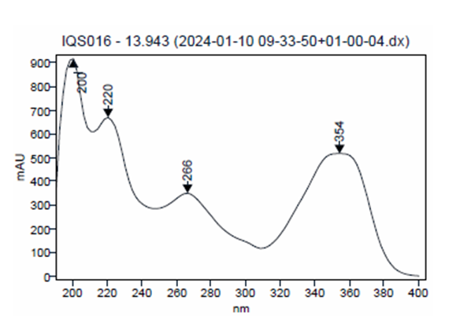
Figure S2: PB1 and IQS016 UV profile

Figures S3 and S4, display the mass spectrum positive of peak retention time 13,94 min [M+H]⁺ 412, for samples PB1 and IQS016 respectively. Both samples present the same profile an fulfill with sample mass 411.

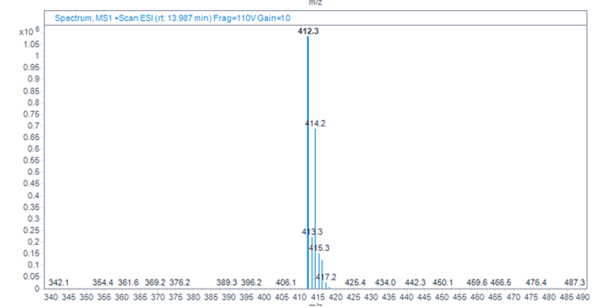
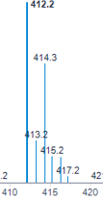

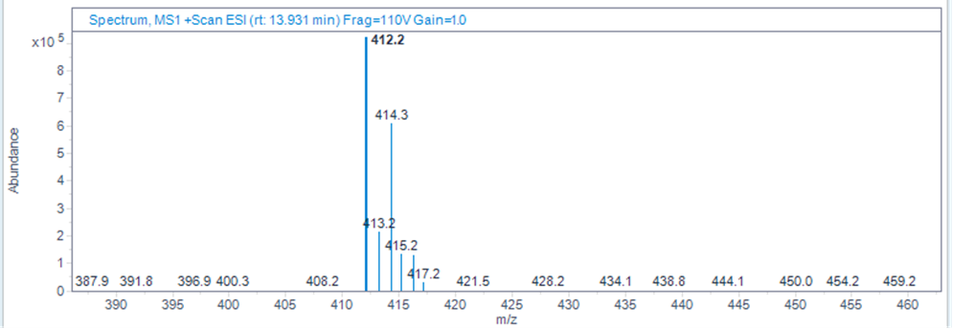
Figure S3: [M+H]⁺ 412 for sample PB1

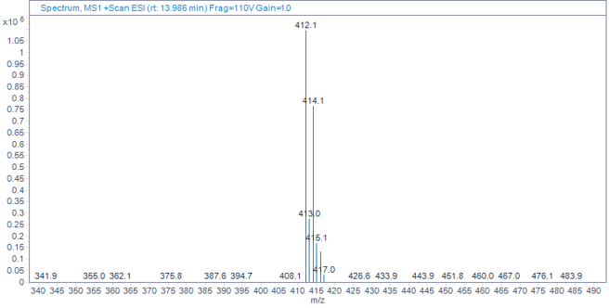
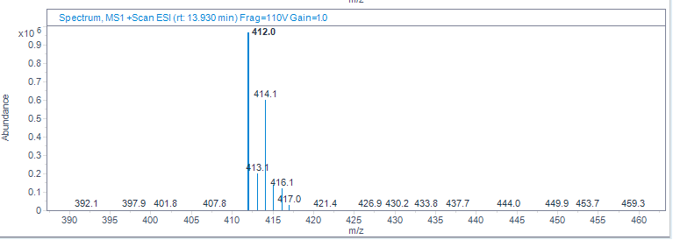

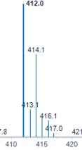

Figure S4: [M+H]⁺ 412 for samples PB1 for sample IQS016

  - X-ray powder diffraction analysis of IQS016 and PB1
Sample preparation:
Parts of the submitted powder materials were sandwiched between films of polyester of 3.6 microns of thickness.

Instrument and experimental conditions:
PANalytical X’Pert PRO MPD θ/θ powder diffractometer of 240 millimeters of radius, in a configuration of convergent beam with a focalizing mirror and a transmission geometry with flat samples sandwiched between low absorbing films.
Cu Kα radiation (λ = 1.5418 Å).
Work power: 45 kV – 40 mA.
Incident beam slits defining a beam height of 0.4 millimeters.
Incident and diffracted beam 0.02 radians Soller slits
PIXcel detector: Active length = 3.347 º.
2θ scans from 2 to 60 º2θ with a step size of 0.026 º2θ and a measuring time of 300 seconds per step.

Table S2: Peak list for sample PB1 from 2 to 40 º2θ

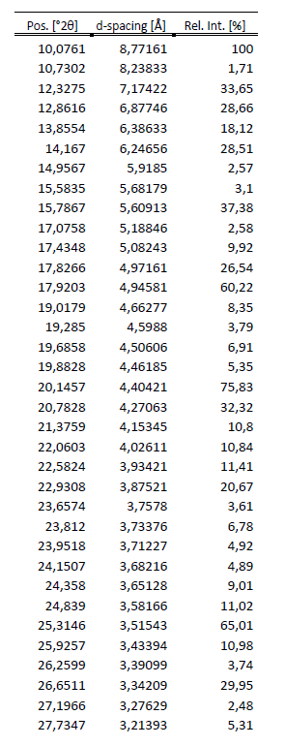
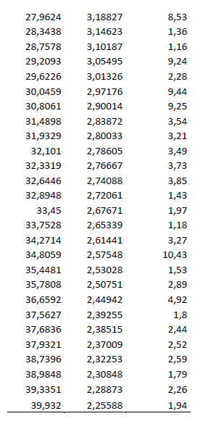

Figure S5 compares both diagrams in the main angular range from 2 to 40 º2θ.

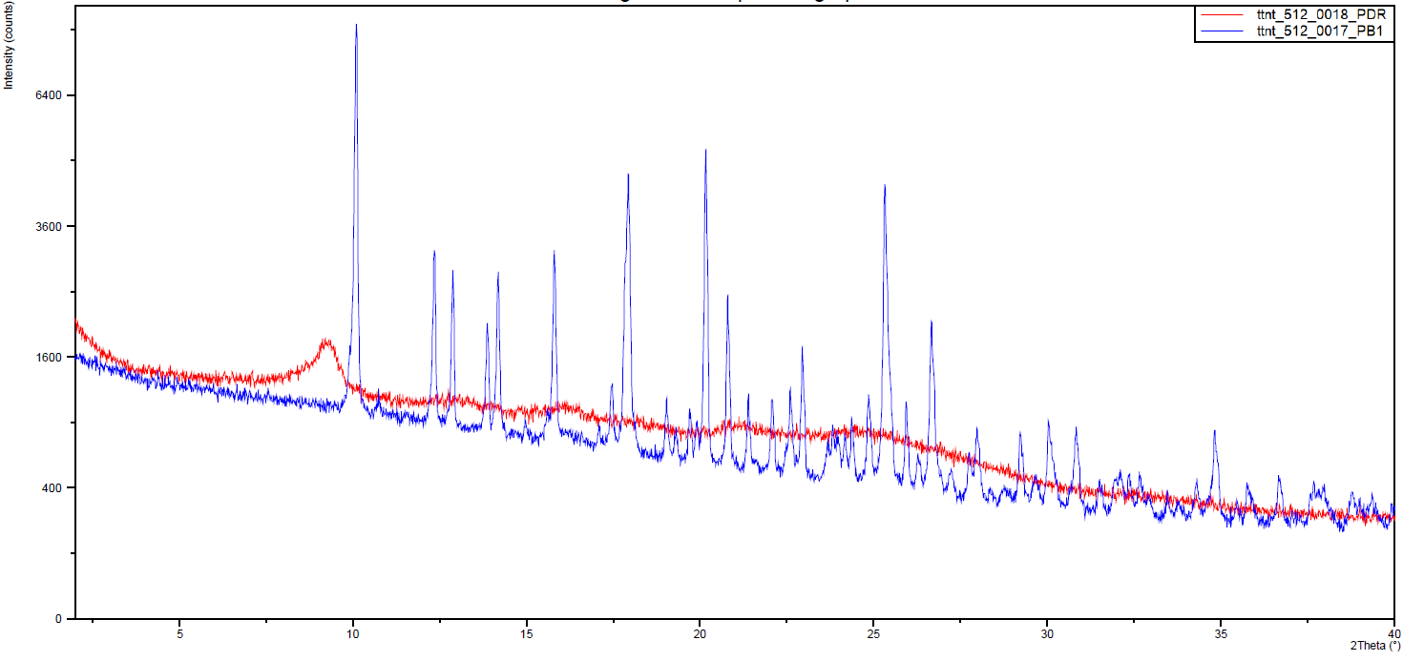
Figure S5: Powder X-ray diffractograms of PB1(blue) and IQS016 (red) from 2 to 40 2q

  - Determination of the crystal structure of PB1 from X-ray powder diffraction data
Powder X-ray diffraction pattern was obtained on a PANalytical X’Pert PRO MPD diffractometer of 240 millimeters of radius in transmission configuration with a spinner glass capillary sample holder, using Cu K_{α1+2} radiation (λ = 1.5418 Å) with a focalizing elliptic mirror and a PIXcel detector working at a maximum detector’s active length of 3.347º. Incident and diffracted beam 0.02 radians soller slits and incident beam slits defining a beam height of 0.4 millimeters have been used with the sample placed in glass capillary. Ten consecutive 2theta/theta scans were measured and added from 2 to 70º in 2θ, with a step size of 0.013º and a measuring time of 300 seconds per step (total measuring time 18 h).
The elucidation of its crystal structure was attempted from powder X-Ray diffraction data. The powder X-ray diffractogram of PB1 was perfectly indexed to an orthorhombic unit cell with unit cell parameters a = 18.63 Å, b = 17.49 Å and c = 12.46 Å and a volume of 4062.6 Å³. Taking into account the unit cell volume, the molecular weight of the compound and an estimated density value of 1.2 Mg/m³, the number of molecules in the unit cell was calculated to be Z = 8. The space group Pbca was assigned based on the systematic absences and the subsequent Pawley pattern matching fitted very well the experimental X-ray powder diffractogram, being the agreement factor 2.63%. Its crystal structure was solved by using the Global Optimization Simulated Annealing approach integrated in Topas and the crystal structure of the DMSO solvate of IQS016 (see 1.5) was used as a starting model. Some constraints were introduced, considering the molecule as a rigid body using the Z-matrix notation, which was allowed to rotate and translate in the three directions within the unit cell. Planar restrictions were applied to the aromatic rings and the phenyl and dichlorophenyl rings were allowed to rotate about two fixed points. A chemical sense solution with agreement factor of 13.4% was obtained. The crystal structure so obtained was subsequently refined by the Rietveld method also by means of TOPAS v6 software, giving a satisfying result with low Rwp value of 6.59 %.
Figure S6: Pattern matching Pawley fit plot of 1; agreement factor: Rwp = 2.63%. The plot shows the experimental PXRD profile (blue solid line), the calculated PXRD profile (red solid line) and the difference profile (grey, lower line). Blue tick marks indicate the peak positions.

Figure S7: Final Rietveld plot for the crystal structure refinement of 1; agreement factors: Rwp = 6.59% and Rp = 4.77%. The plot shows the experimental PXRD profile (blue solid line), the calculated PXRD profile (red solid line) and the difference profile (grey, lower line). Blue tick marks indicate the peak positions.
Table S3 summarizes the most relevant parameters of the crystal structure determination and refinement of PB1.

Table S3: Crystal data and structure refinement parameters of PB1 from powder X-ray diffraction
Empirical formula | C₂₀H₁₅Cl₂N₅O
Formula Weight | 412.27
Temperature (K) | 298
Wavelength (Å) | 1.54180
Crystal system | Orthorhombic
Space group | Pbca
a (Å) | 18.6367(6)
b (Å)  c (Å) | 17.4982(5)  12.4676(3)
α (°) | 90
β (°) | 90
γ (°) | 90
Volume (Å³) | 4065.80(19)
Z, Z’ | 8, 1
Density (calc.) (Mg/m³) | 1.347
Measured 2θ range | 2.018 to 69.9820
Stepsize (°) | 0.013
Measured data points | 5230
Rietveld Refinement Details:
Profile function | Double-Voigt
2θ range used (°) | 5.0 to 69.98
Num. of reflections | 889
Data points | 5000
Parameters | 94
R_{wp} | 6.59
R_{p} | 4.77
R_{Bragg} | 3.26
GoF | 7.15

  - Crystal structure determination of a single crystal of IQS016 grown in MeOH
A colorless prism-like specimen of C₂₀H₁₅Cl₂N₅O, approximate dimensions 0.104 mm x 0.129 mm x 0.413 mm, was used for the X-ray crystallographic analysis. The X-ray intensity data were measured on a D8 Venture system equipped with a multilayer monochromator and a Mo microfocus (λ = 0.71073 Å).

The frames were integrated with the Bruker SAINT software package using a narrow-frame algorithm. The integration of the data using an orthorhombic unit cell yielded a total of 79253 reflections to a maximum θ angle of 26.40° (0.80 Å resolution), of which 4037 were independent (average redundancy 19.632, completeness = 99.9%, Rint = 5.16%, Rsig = 1.49%) and 3596 (89.08%) were greater than 2σ(F2). The final cell constants of a = 16.9088(6) Å, b = 12.6026(4) Å, c = 18.5117(5) Å, volume = 3944.7(2) Å³, are based upon the refinement of the XYZ-centroids of reflections above 20 σ(I). Data were corrected for absorption effects using the multi-scan method (SADABS). The calculated minimum and maximum transmission coefficients (based on crystal size) are 0.7161 and 0.7454.

The structure was solved and refined using the Bruker SHELXTL Software Package (Sheldrick, G.M. A Short History of SHELX. Acta Crystallogr. 2008, A64, 112–122, doi.org/10.1107/S0108767307043930), using the space group Pbca, with Z = 8 for the formula unit, C₂₀H₁₅Cl₂N₅O. The final anisotropic full-matrix least-squares refinement (Hübschle, C.B.; Sheldrick, G.M.; Dittrich, B.J. ShelXle: A Qt graphical user interface for SHELXL. J. Appl. Crystallogr. 2011, 44, 1281–1284, doi.org/10.1107/S0021889811043202) on F2 with 253 variables converged at R1 = 4.63%, for the observed data and wR2 = 10.94% for all data. The goodness-of-fit was 1.149. The largest peak in the final difference electron density synthesis was 0.424 e-/Å3 and the largest hole was -0.448 e-/Å3 with an RMS deviation of 0.063 e-/Å3. On the basis of the final model, the calculated density was 1.388 g/cm3 and F(000), 1696 e-.

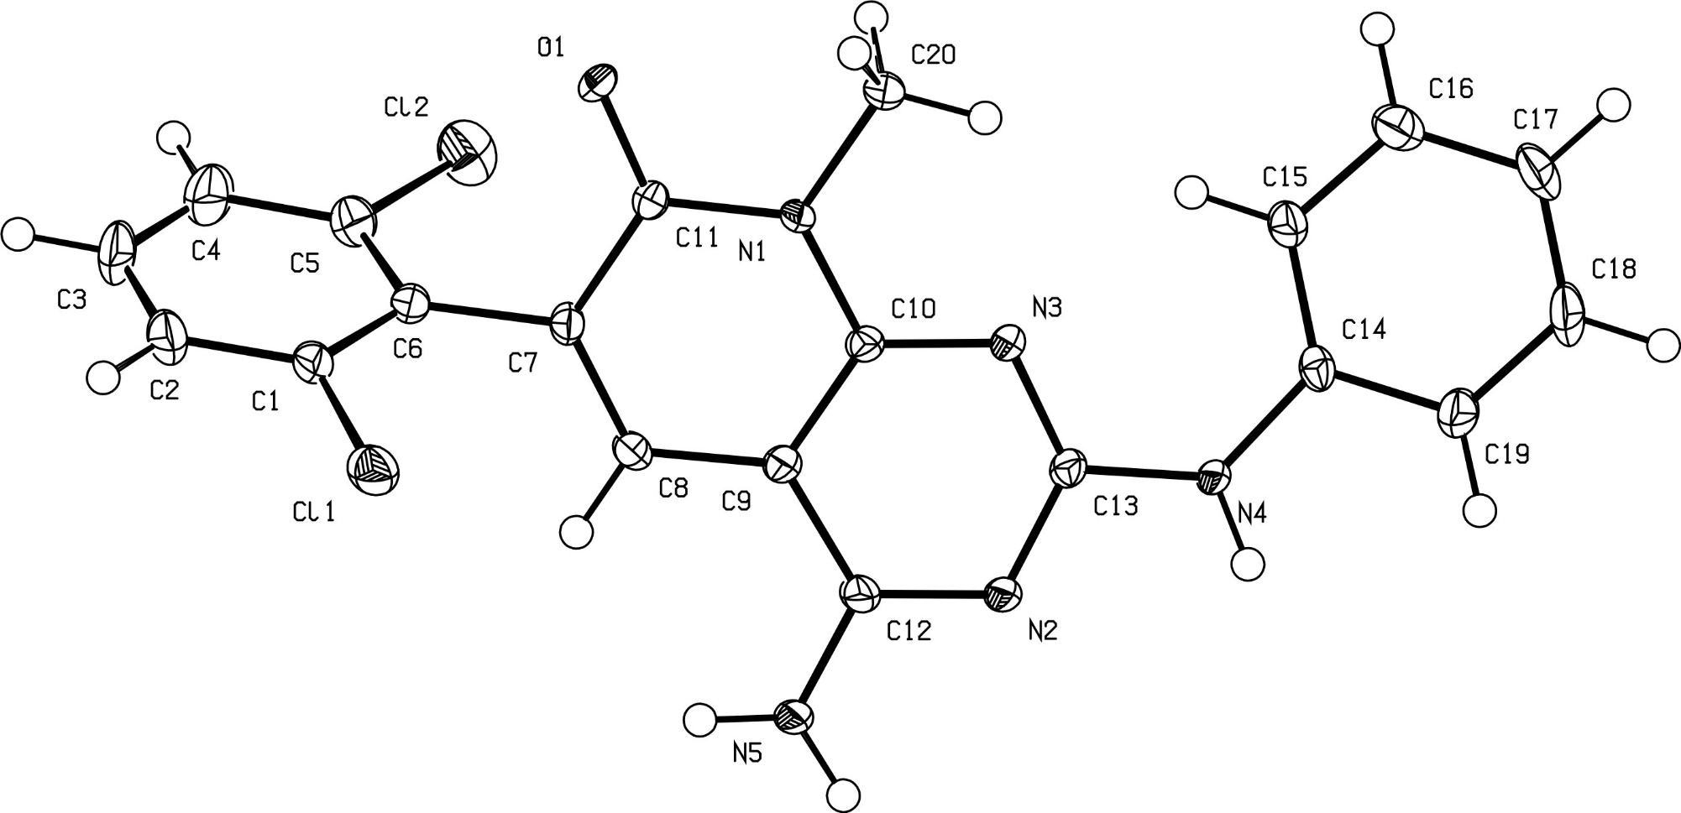
Figure S8: ORTEP diagram and atomic numbering of 1.

Table S4: Crystal data and structure refinement for 1 (mo_023VB113_0ma_a).
Identification code mo_023VB113_0ma_a
Empirical formula C20 H15 Cl2 N5 O
Formula weight 412.27
Temperature 100(2) K
Wavelength 0.71073 Å
Crystal system Orthorhombic
Space group P b c a
Unit cell dimensions a = 16.9088(6) Å α= 90°.
b = 12.6026(4) Å β= 90°.
c = 18.5117(5) Å γ = 90°.
Volume 3944.7(2) Å3
Z 8
Density (calculated) 1.388 Mg/m3
Absorption coefficient 0.350 mm-1
F(000) 1696
Crystal size 0.413 x 0.129 x 0.104 mm3
Theta range for data collection 2.296 to 26.398°.
Index ranges -21<=h<=21, -15<=k<=15, -23<=l<=22
Reflections collected 79253
Independent reflections 4037 [R(int) = 0.0516]
Completeness to theta = 25.242° 99.8 %
Absorption correction Semi-empirical from equivalents
Max. and min. transmission 0.7454 and 0.7161
Refinement method Full-matrix least-squares on F2
Data / restraints / parameters 4037 / 0 / 253
Goodness-of-fit on F2 1.149
Final R indices [I>2sigma(I)] R1 = 0.0463, wR2 = 0.1057
R indices (all data) R1 = 0.0530, wR2 = 0.1094
Extinction coefficient n/a
Largest diff. peak and hole 0.424 and -0.448 e.Å-3
CCDC 2325664

Table S5: Atomic coordinates ( x 104) and equivalent isotropic displacement parameters (Å2x 103)
for 1 (mo_023VB113_0ma_a). U(eq) is defined as one third of the trace of the orthogonalized Uij tensor.
________________________________________________________________________________
x y z U(eq)
________________________________________________________________________________
Cl(1) 5193(1) 417(1) 1351(1) 25(1)
Cl(2) 3897(1) 4240(1) 2002(1) 32(1)
O(1) 5829(1) 3749(1) 1872(1) 15(1)
N(1) 5984(1) 3256(1) 3043(1) 13(1)
N(2) 5499(1) 1332(2) 4772(1) 19(1)
N(3) 6185(1) 2811(1) 4244(1) 14(1)
N(4) 6330(1) 2334(1) 5451(1) 16(1)
N(5) 4628(2) 326(2) 4124(1) 32(1)
C(1) 4612(1) 1512(2) 1130(1) 21(1)
C(2) 4230(2) 1511(2) 464(1) 32(1)
C(3) 3764(2) 2367(3) 279(2) 38(1)
C(4) 3667(2) 3209(2) 746(2) 35(1)
C(5) 4054(1) 3193(2) 1405(1) 24(1)
C(6) 4550(1) 2356(2) 1613(1) 18(1)
C(7) 4986(1) 2391(2) 2312(1) 15(1)
C(8) 4827(1) 1732(2) 2872(1) 18(1)
C(9) 5232(1) 1822(2) 3537(1) 17(1)
C(10) 5798(1) 2616(2) 3625(1) 14(1)
C(11) 5610(1) 3172(2) 2377(1) 12(1)
C(12) 5118(2) 1148(2) 4150(1) 20(1)
C(13) 5992(1) 2172(2) 4789(1) 14(1)
C(14) 6806(1) 3179(2) 5699(1) 15(1)
C(15) 6929(1) 4124(2) 5326(1) 19(1)
C(16) 7363(2) 4930(2) 5643(1) 27(1)
C(17) 7667(2) 4821(3) 6331(2) 40(1)
C(18) 7555(2) 3879(3) 6695(2) 43(1)
C(19) 7134(2) 3054(2) 6383(1) 27(1)
C(20) 6608(1) 4060(2) 3123(1) 22(1)
________________________________________________________________________________
Table S6: Bond lengths [Å] and angles [°] for 1 (mo_023VB113_0ma_a).
_____________________________________________________
Cl(1)-C(1) 1.742(3)
Cl(2)-C(5) 1.741(3)
O(1)-C(11) 1.242(3)
N(1)-C(10) 1.383(3)
N(1)-C(11) 1.388(3)
N(1)-C(20) 1.471(3)
N(2)-C(12) 1.340(3)
N(2)-C(13) 1.347(3)
N(3)-C(13) 1.332(3)
N(3)-C(10) 1.341(3)
N(4)-C(13) 1.369(3)
N(4)-C(14) 1.412(3)
N(4)-H(4N) 0.8800
N(5)-C(12) 1.327(3)
N(5)-H(5A) 0.8800
N(5)-H(5B) 0.8800
C(1)-C(2) 1.392(3)
C(1)-C(6) 1.392(3)
C(2)-C(3) 1.379(4)
C(2)-H(2A) 0.9500
C(3)-C(4) 1.378(4)
C(3)-H(3) 0.9500
C(4)-C(5) 1.386(4)
C(4)-H(4) 0.9500
C(5)-C(6) 1.402(3)
C(6)-C(7) 1.490(3)
C(7)-C(8) 1.354(3)
C(7)-C(11) 1.447(3)
C(8)-C(9) 1.414(3)
C(8)-H(8) 0.9500
C(9)-C(10) 1.395(3)
C(9)-C(12) 1.430(3)
C(14)-C(19) 1.391(3)
C(14)-C(15) 1.392(3)
C(15)-C(16) 1.383(3)
C(15)-H(15) 0.9500
C(16)-C(17) 1.381(4)
C(16)-H(16) 0.9500
C(17)-C(18) 1.379(4)
C(17)-H(17) 0.9500
C(18)-C(19) 1.386(4)
C(18)-H(18) 0.9500
C(19)-H(19) 0.9500
C(20)-H(20A) 0.9800
C(20)-H(20B) 0.9800
C(20)-H(20C) 0.9800

C(10)-N(1)-C(11) 122.96(18)
C(10)-N(1)-C(20) 119.09(17)
C(11)-N(1)-C(20) 117.94(17)
C(12)-N(2)-C(13) 116.94(19)
C(13)-N(3)-C(10) 114.59(18)
C(13)-N(4)-C(14) 129.97(19)
C(13)-N(4)-H(4N) 115.0
C(14)-N(4)-H(4N) 115.0
C(12)-N(5)-H(5A) 120.0
C(12)-N(5)-H(5B) 120.0
H(5A)-N(5)-H(5B) 120.0
C(2)-C(1)-C(6) 122.3(2)
C(2)-C(1)-Cl(1) 117.9(2)
C(6)-C(1)-Cl(1) 119.78(18)
C(3)-C(2)-C(1) 119.0(3)
C(3)-C(2)-H(2A) 120.5
C(1)-C(2)-H(2A) 120.5
C(4)-C(3)-C(2) 121.0(2)
C(4)-C(3)-H(3) 119.5
C(2)-C(3)-H(3) 119.5
C(3)-C(4)-C(5) 119.0(3)
C(3)-C(4)-H(4) 120.5
C(5)-C(4)-H(4) 120.5
C(4)-C(5)-C(6) 122.4(2)
C(4)-C(5)-Cl(2) 118.4(2)
C(6)-C(5)-Cl(2) 119.23(18)
C(1)-C(6)-C(5) 116.3(2)
C(1)-C(6)-C(7) 122.9(2)
C(5)-C(6)-C(7) 120.7(2)
C(8)-C(7)-C(11) 119.83(19)
C(8)-C(7)-C(6) 123.19(19)
C(11)-C(7)-C(6) 116.98(18)
C(7)-C(8)-C(9) 121.4(2)
C(7)-C(8)-H(8) 119.3
C(9)-C(8)-H(8) 119.3
C(10)-C(9)-C(8) 119.39(19)
C(10)-C(9)-C(12) 115.2(2)
C(8)-C(9)-C(12) 125.4(2)
N(3)-C(10)-N(1) 116.62(18)
N(3)-C(10)-C(9) 124.47(19)
N(1)-C(10)-C(9) 118.92(19)
O(1)-C(11)-N(1) 119.21(19)
O(1)-C(11)-C(7) 123.55(19)
N(1)-C(11)-C(7) 117.24(18)
N(5)-C(12)-N(2) 117.8(2)
N(5)-C(12)-C(9) 121.2(2)
N(2)-C(12)-C(9) 120.9(2)
N(3)-C(13)-N(2) 127.6(2)
N(3)-C(13)-N(4) 119.10(19)
N(2)-C(13)-N(4) 113.32(19)
C(19)-C(14)-C(15) 119.3(2)
C(19)-C(14)-N(4) 115.9(2)
C(15)-C(14)-N(4) 124.70(19)
C(16)-C(15)-C(14) 119.8(2)
C(16)-C(15)-H(15) 120.1
C(14)-C(15)-H(15) 120.1
C(17)-C(16)-C(15) 121.0(2)
C(17)-C(16)-H(16) 119.5
C(15)-C(16)-H(16) 119.5
C(18)-C(17)-C(16) 119.0(2)
C(18)-C(17)-H(17) 120.5
C(16)-C(17)-H(17) 120.5
C(17)-C(18)-C(19) 120.9(2)
C(17)-C(18)-H(18) 119.6
C(19)-C(18)-H(18) 119.6
C(18)-C(19)-C(14) 119.9(2)
C(18)-C(19)-H(19) 120.1
C(14)-C(19)-H(19) 120.1
N(1)-C(20)-H(20A) 109.5
N(1)-C(20)-H(20B) 109.5
H(20A)-C(20)-H(20B) 109.5
N(1)-C(20)-H(20C) 109.5
H(20A)-C(20)-H(20C) 109.5
H(20B)-C(20)-H(20C) 109.5
_____________________________________________________________

Table S8: Anisotropic displacement parameters (Å2x 103) for 1 (mo_023VB113_0ma_a). The anisotropic displacement factor exponent takes the form: -2π2[ h2 a*2U11 + ... + 2 h k a* b* U12 ]
______________________________________________________________________________
U11 U22 U33 U23 U13 U12
______________________________________________________________________________
Cl(1) 31(1) 23(1) 22(1) -4(1) 3(1) -5(1)
Cl(2) 24(1) 31(1) 42(1) -4(1) -6(1) 6(1)
O(1) 18(1) 16(1) 11(1) 4(1) -1(1) 0(1)
N(1) 14(1) 14(1) 12(1) 1(1) -1(1) -6(1)
N(2) 32(1) 14(1) 10(1) 1(1) -1(1) -9(1)
N(3) 18(1) 14(1) 10(1) 1(1) -1(1) -3(1)
N(4) 26(1) 12(1) 9(1) 1(1) -2(1) -5(1)
N(5) 59(2) 27(1) 10(1) 4(1) -5(1) -28(1)
C(1) 22(1) 25(1) 16(1) 2(1) -1(1) -10(1)
C(2) 39(2) 38(2) 17(1) -2(1) -5(1) -17(1)
C(3) 38(2) 52(2) 23(1) 7(1) -18(1) -14(1)
C(4) 30(1) 42(2) 32(2) 10(1) -15(1) -4(1)
C(5) 21(1) 28(1) 24(1) 2(1) -5(1) -4(1)
C(6) 16(1) 23(1) 14(1) 3(1) -1(1) -8(1)
C(7) 15(1) 19(1) 11(1) -1(1) -1(1) -2(1)
C(8) 22(1) 18(1) 14(1) -1(1) 0(1) -9(1)
C(9) 23(1) 16(1) 11(1) 0(1) 1(1) -5(1)
C(10) 16(1) 13(1) 12(1) 0(1) 2(1) -1(1)
C(11) 12(1) 14(1) 11(1) 0(1) 1(1) 1(1)
C(12) 31(1) 17(1) 12(1) -2(1) 1(1) -10(1)
C(13) 21(1) 12(1) 10(1) -1(1) 0(1) 1(1)
C(14) 15(1) 19(1) 12(1) -4(1) 0(1) -1(1)
C(15) 22(1) 20(1) 15(1) -3(1) -1(1) -4(1)
C(16) 31(1) 25(1) 25(1) -1(1) 1(1) -11(1)
C(17) 47(2) 47(2) 27(1) -2(1) -10(1) -32(2)
C(18) 48(2) 60(2) 22(1) 6(1) -19(1) -28(2)
C(19) 26(1) 36(1) 20(1) 8(1) -8(1) -12(1)
C(20) 22(1) 26(1) 16(1) 5(1) -2(1) -14(1)
______________________________________________________________________________
Table S9: Hydrogen coordinates ( x 104) and isotropic displacement parameters (Å2x 10 3)
for 1 (mo_023VB113_0ma_a).
________________________________________________________________________________
x y z U(eq)
________________________________________________________________________________

H(4N) 6236 1835 5772 19
H(5A) 4562 -77 4508 38
H(5B) 4369 183 3723 38
H(2A) 4289 929 142 38
H(3) 3506 2376 -177 45
H(4) 3340 3792 617 42
H(8) 4435 1199 2815 22
H(15) 6716 4215 4855 23
H(16) 7452 5569 5383 32
H(17) 7951 5387 6550 48
H(18) 7769 3794 7166 52
H(19) 7069 2404 6637 32
H(20A) 7018 3941 2758 32
H(20B) 6841 4007 3606 32
H(20C) 6380 4769 3057 32
________________________________________________________________________________
Table S10: Analysis of Potential Hydrogen Bond for 1 (mo_023VB113_0ma_a).
________________________________________________________________

Donor --- H....Acceptor [ ARU ] D - H H...A D...A D - H...A

N(4) --H(4N) ..O(1) [x,1/2-y,-1/2+z] 0.88 2.27 3.0818 153
N(5) --H(5A) ..N(2) [-x,-y,-z] 0.88 2.07 2.9299 165
N(5) --H(5B) ..O(1) [-x,-1/2+y,1/2-z] 0.88 2.14 2.8181 133

  - Crystal structure determination of a single crystal of IQS016 grown in DMSO
A colorless prism-like specimen of C₂₂H₂₁Cl₂N₅O₂S, approximate dimensions 0.092 mm x 0.123 mm x 0.266 mm, was used for the X-ray crystallographic analysis. The X-ray intensity data were measured on a D8 Venture system equipped with a multilayer monochromator and a Mo microfocus (λ = 0.71073 Å).

The frames were integrated with the Bruker SAINT software package using a narrow-frame algorithm. The integration of the data using a monoclinic unit cell yielded a total of 34473 reflections to a maximum θ angle of 27.15° (0.78 Å resolution), of which 4959 were independent (average redundancy 6.952, completeness = 99.6%, Rint = 3.69%, Rsig = 2.15%) and 4190 (84.49%) were greater than 2σ(F2). The final cell constants of a = 20.0528(9) Å, b = 11.8577(5) Å, c = 18.8759(8) Å, β = 90.855(2)°, volume = 4487.8(3) Å³, are based upon the refinement of the XYZ-centroids of reflections above 20 σ(I). Data were corrected for absorption effects using the multi-scan method (SADABS). The calculated minimum and maximum transmission coefficients (based on crystal size) are 0.7026 and 0.7455.

The structure was solved and refined using the Bruker SHELXTL Software Package, using the space group C12/c1, with Z = 8 for the formula unit, C₂₂H₂₁Cl₂N₅O₂S. The final anisotropic full-matrix least-squares refinement on F2 with 330 variables converged at R1 = 3.25%, for the observed data and wR2 = 8.54% for all data. The goodness-of-fit was 1.067. The largest peak in the final difference electron density synthesis was 0.396 e-/Å3 and the largest hole was -0.322 e-/Å3 with an RMS deviation of 0.056 e-/Å3. On the basis of the final model, the calculated density was 1.452 g/cm3 and F(000), 2024 e-.

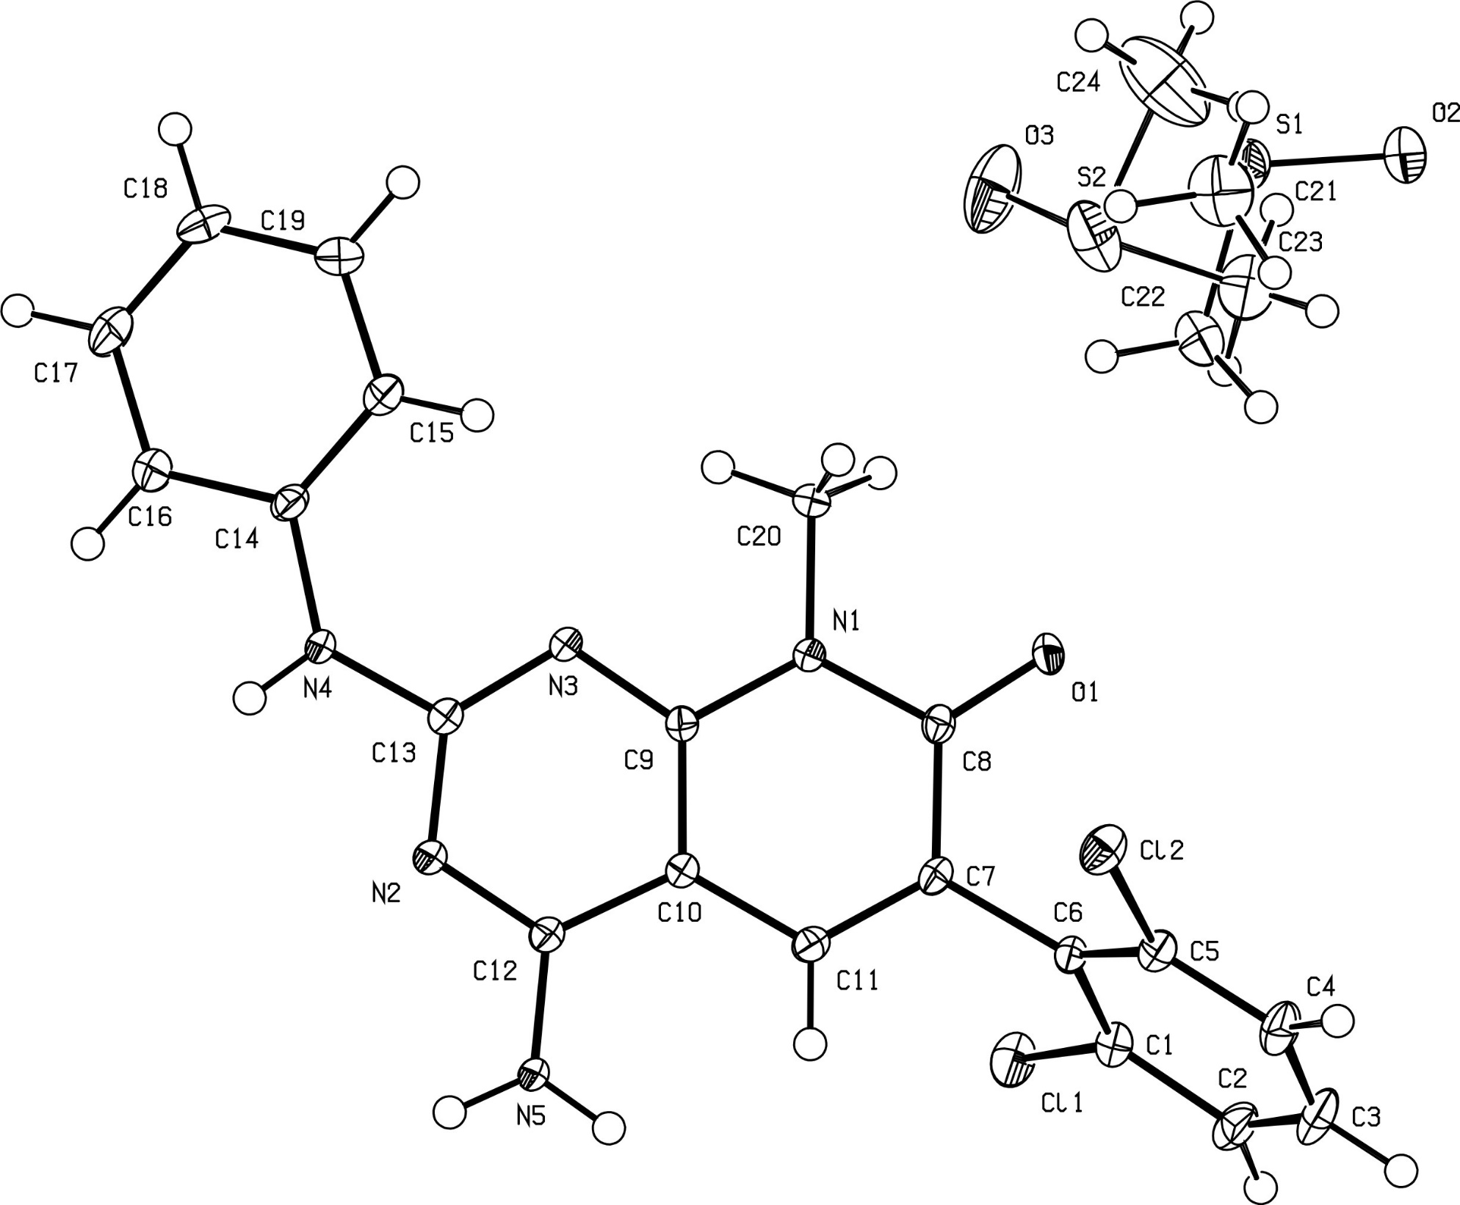
Figure S9: ORTEP diagram and atomic numbering of a DMSO solvate of 1.

Table S11: Crystal data and structure refinement for a DMSO solvate of 1 (mo_023VB102_0m_a).
Identification code mo_023VB102_0m_a
Empirical formula C22 H21 Cl2 N5 O2 S
Formula weight 490.40
Temperature 100(2) K
Wavelength 0.71073 Å
Crystal system Monoclinic
Space group C 2/c
Unit cell dimensions a = 20.0528(9) Å α= 90°.
b = 11.8577(5) Å β= 90.855(2)°.
c = 18.8759(8) Å γ = 90°.
Volume 4487.8(3) Å3
Z 8
Density (calculated) 1.452 Mg/m3
Absorption coefficient 0.413 mm-1
F(000) 2032
Crystal size 0.266 x 0.123 x 0.092 mm3
Theta range for data collection 1.995 to 27.147°.
Index ranges -25<=h<=25, -15<=k<=15, -24<=l<=21
Reflections collected 34473
Independent reflections 4959 [R(int) = 0.0369]
Completeness to theta = 25.242° 99.7 %
Absorption correction Semi-empirical from equivalents
Max. and min. transmission 0.7455 and 0.7026
Refinement method Full-matrix least-squares on F2
Data / restraints / parameters 4959 / 0 / 333
Goodness-of-fit on F2 1.067
Final R indices [I>2sigma(I)] R1 = 0.0325, wR2 = 0.0779
R indices (all data) R1 = 0.0425, wR2 = 0.0854
Extinction coefficient n/a
Largest diff. peak and hole 0.396 and -0.322 e.Å-3
CCDC 2325663

Table S12: Atomic coordinates ( x 104) and equivalent isotropic displacement parameters (Å2x 103)
for a DMSO solvate of 1 (mo_023VB102_0m_a). U(eq) is defined as one third of the trace of the orthogonalized Uij tensor.
________________________________________________________________________________
x y z U(eq)
________________________________________________________________________________
Cl(1) 7079(1) 7348(1) 6412(1) 22(1)
Cl(2) 8330(1) 3385(1) 6929(1) 20(1)
O(1) 6671(1) 3714(1) 6853(1) 14(1)
N(1) 6568(1) 4192(1) 8015(1) 12(1)
N(2) 7059(1) 6110(1) 9757(1) 14(1)
N(3) 6445(1) 4582(1) 9215(1) 13(1)
N(4) 6314(1) 5121(1) 10395(1) 16(1)
N(5) 7829(1) 7136(1) 9148(1) 18(1)
C(1) 7639(1) 6295(1) 6181(1) 16(1)
C(2) 8012(1) 6454(2) 5573(1) 22(1)
C(3) 8460(1) 5635(2) 5374(1) 25(1)
C(4) 8546(1) 4669(2) 5776(1) 22(1)
C(5) 8177(1) 4548(1) 6388(1) 16(1)
C(6) 7711(1) 5340(1) 6610(1) 13(1)
C(7) 7358(1) 5200(1) 7292(1) 12(1)
C(8) 6857(1) 4328(1) 7353(1) 12(1)
C(9) 6748(1) 4824(1) 8605(1) 12(1)
C(10) 7226(1) 5670(1) 8528(1) 12(1)
C(11) 7525(1) 5843(1) 7864(1) 13(1)
C(12) 7372(1) 6315(1) 9152(1) 13(1)
C(13) 6612(1) 5257(1) 9757(1) 13(1)
C(14) 5788(1) 4408(1) 10600(1) 14(1)
C(15) 5623(1) 3402(1) 10265(1) 22(1)
C(16) 5444(1) 4734(1) 11206(1) 20(1)
C(17) 4940(1) 4062(2) 11466(1) 28(1)
C(18) 4776(1) 3061(2) 11133(1) 33(1)
C(19) 5120(1) 2734(2) 10538(1) 29(1)
C(20) 6050(1) 3319(1) 8077(1) 19(1)
S(1) 9860(1) 4472(1) 3879(1) 22(1)
O(2) 9857(1) 4793(2) 4651(1) 23(1)
C(21) 9145(2) 5141(4) 3472(2) 36(1)
C(22) 9545(2) 3061(4) 3834(2) 29(1)
S(2) 9462(1) 4074(1) 3061(1) 35(1)
O(3) 10059(2) 3607(3) 2720(1) 45(1)
C(23) 9533(3) 3663(6) 3966(3) 55(2)
C(24) 9614(3) 5542(4) 3180(3) 65(2)
________________________________________________________________________________
Table S13: Bond lengths [Å] and angles [°] for a DMSO solvate of 1 (mo_023VB102_0m_a).
_____________________________________________________
Cl(1)-C(1) 1.7401(16)
Cl(2)-C(5) 1.7403(16)
O(1)-C(8) 1.2458(18)
N(1)-C(9) 1.3852(18)
N(1)-C(8) 1.3950(18)
N(1)-C(20) 1.4716(18)
N(2)-C(12) 1.3337(18)
N(2)-C(13) 1.3499(19)
N(3)-C(13) 1.3368(19)
N(3)-C(9) 1.3417(18)
N(4)-C(13) 1.3635(18)
N(4)-C(14) 1.4099(19)
N(4)-H(4N) 0.84(2)
N(5)-C(12) 1.3377(19)
N(5)-H(5A) 0.8800
N(5)-H(5B) 0.8800
C(1)-C(2) 1.392(2)
C(1)-C(6) 1.398(2)
C(2)-C(3) 1.378(2)
C(2)-H(2) 0.9500
C(3)-C(4) 1.383(2)
C(3)-H(3) 0.9500
C(4)-C(5) 1.387(2)
C(4)-H(4) 0.9500
C(5)-C(6) 1.395(2)
C(6)-C(7) 1.4885(19)
C(7)-C(11) 1.359(2)
C(7)-C(8) 1.447(2)
C(9)-C(10) 1.396(2)
C(10)-C(11) 1.4130(19)
C(10)-C(12) 1.431(2)
C(11)-H(11) 0.9500
C(14)-C(15) 1.387(2)
C(14)-C(16) 1.398(2)
C(15)-C(19) 1.388(2)
C(15)-H(15) 0.9500
C(16)-C(17) 1.383(2)
C(16)-H(16) 0.9500
C(17)-C(18) 1.380(3)
C(17)-H(17) 0.9500
C(18)-C(19) 1.384(3)
C(18)-H(18) 0.9500
C(19)-H(19) 0.9500
C(20)-H(20A) 0.9800
C(20)-H(20B) 0.9800
C(20)-H(20C) 0.9800
S(1)-O(2) 1.506(2)
S(1)-C(22) 1.790(5)
S(1)-C(21) 1.801(4)
C(21)-H(21A) 0.9800
C(21)-H(21B) 0.9800
C(21)-H(21C) 0.9800
C(22)-H(22A) 0.9800
C(22)-H(22B) 0.9800
C(22)-H(22C) 0.9800
S(2)-O(3) 1.475(3)
S(2)-C(23) 1.779(6)
S(2)-C(24) 1.781(5)
C(23)-H(23A) 0.9800
C(23)-H(23B) 0.9800
C(23)-H(23C) 0.9800
C(24)-H(24A) 0.9800
C(24)-H(24B) 0.9800
C(24)-H(24C) 0.9800

C(9)-N(1)-C(8) 123.36(12)
C(9)-N(1)-C(20) 119.53(12)
C(8)-N(1)-C(20) 117.11(12)
C(12)-N(2)-C(13) 117.22(13)
C(13)-N(3)-C(9) 114.66(12)
C(13)-N(4)-C(14) 130.80(13)
C(13)-N(4)-H(4N) 114.6(13)
C(14)-N(4)-H(4N) 114.3(13)
C(12)-N(5)-H(5A) 120.0
C(12)-N(5)-H(5B) 120.0
H(5A)-N(5)-H(5B) 120.0
C(2)-C(1)-C(6) 122.31(14)
C(2)-C(1)-Cl(1) 117.81(12)
C(6)-C(1)-Cl(1) 119.86(11)
C(3)-C(2)-C(1) 119.32(15)
C(3)-C(2)-H(2) 120.3
C(1)-C(2)-H(2) 120.3
C(2)-C(3)-C(4) 120.66(15)
C(2)-C(3)-H(3) 119.7
C(4)-C(3)-H(3) 119.7
C(3)-C(4)-C(5) 118.61(15)
C(3)-C(4)-H(4) 120.7
C(5)-C(4)-H(4) 120.7
C(4)-C(5)-C(6) 123.23(15)
C(4)-C(5)-Cl(2) 118.67(12)
C(6)-C(5)-Cl(2) 118.02(11)
C(5)-C(6)-C(1) 115.84(13)
C(5)-C(6)-C(7) 120.94(13)
C(1)-C(6)-C(7) 123.05(13)
C(11)-C(7)-C(8) 120.06(13)
C(11)-C(7)-C(6) 120.62(13)
C(8)-C(7)-C(6) 119.25(13)
O(1)-C(8)-N(1) 119.18(13)
O(1)-C(8)-C(7) 123.91(13)
N(1)-C(8)-C(7) 116.91(12)
N(3)-C(9)-N(1) 117.28(13)
N(3)-C(9)-C(10) 124.25(13)
N(1)-C(9)-C(10) 118.47(12)
C(9)-C(10)-C(11) 119.83(13)
C(9)-C(10)-C(12) 115.52(12)
C(11)-C(10)-C(12) 124.65(13)
C(7)-C(11)-C(10) 121.34(13)
C(7)-C(11)-H(11) 119.3
C(10)-C(11)-H(11) 119.3
N(2)-C(12)-N(5) 117.99(13)
N(2)-C(12)-C(10) 120.91(13)
N(5)-C(12)-C(10) 121.10(13)
N(3)-C(13)-N(2) 127.36(13)
N(3)-C(13)-N(4) 119.77(13)
N(2)-C(13)-N(4) 112.86(13)
C(15)-C(14)-C(16) 119.55(14)
C(15)-C(14)-N(4) 124.37(14)
C(16)-C(14)-N(4) 116.00(14)
C(14)-C(15)-C(19) 119.43(15)
C(14)-C(15)-H(15) 120.3
C(19)-C(15)-H(15) 120.3
C(17)-C(16)-C(14) 120.20(15)
C(17)-C(16)-H(16) 119.9
C(14)-C(16)-H(16) 119.9
C(18)-C(17)-C(16) 120.34(16)
C(18)-C(17)-H(17) 119.8
C(16)-C(17)-H(17) 119.8
C(17)-C(18)-C(19) 119.43(16)
C(17)-C(18)-H(18) 120.3
C(19)-C(18)-H(18) 120.3
C(18)-C(19)-C(15) 121.04(17)
C(18)-C(19)-H(19) 119.5
C(15)-C(19)-H(19) 119.5
N(1)-C(20)-H(20A) 109.5
N(1)-C(20)-H(20B) 109.5
H(20A)-C(20)-H(20B) 109.5
N(1)-C(20)-H(20C) 109.5
H(20A)-C(20)-H(20C) 109.5
H(20B)-C(20)-H(20C) 109.5
O(2)-S(1)-C(22) 106.00(18)
O(2)-S(1)-C(21) 106.70(17)
C(22)-S(1)-C(21) 96.6(2)
S(1)-C(21)-H(21A) 109.5
S(1)-C(21)-H(21B) 109.5
H(21A)-C(21)-H(21B) 109.5
S(1)-C(21)-H(21C) 109.5
H(21A)-C(21)-H(21C) 109.5
H(21B)-C(21)-H(21C) 109.5
S(1)-C(22)-H(22A) 109.5
S(1)-C(22)-H(22B) 109.5
H(22A)-C(22)-H(22B) 109.5
S(1)-C(22)-H(22C) 109.5
H(22A)-C(22)-H(22C) 109.5
H(22B)-C(22)-H(22C) 109.5
O(3)-S(2)-C(23) 105.2(2)
O(3)-S(2)-C(24) 106.5(3)
C(23)-S(2)-C(24) 97.8(3)
C(23)-S(2)-O(3)#1 130.2(3)
C(24)-S(2)-O(3)#1 107.6(3)
S(2)-O(3)-S(2)#1 131.88(19)
S(2)-C(23)-H(23A) 109.5
S(2)-C(23)-H(23B) 109.5
H(23A)-C(23)-H(23B) 109.5
S(2)-C(23)-H(23C) 109.5
H(23A)-C(23)-H(23C) 109.5
H(23B)-C(23)-H(23C) 109.5
S(2)-C(24)-H(24A) 109.5
S(2)-C(24)-H(24B) 109.5
H(24A)-C(24)-H(24B) 109.5
S(2)-C(24)-H(24C) 109.5
H(24A)-C(24)-H(24C) 109.5
H(24B)-C(24)-H(24C) 109.5
_____________________________________________________________
Symmetry transformations used to generate equivalent atoms:
#1 -x+2,y,-z+1/2
Table S14: Anisotropic displacement parameters (Å2x 103) for a DMSO solvate of 1 (mo_023VB102_0m_a). The anisotropic displacement factor exponent takes the form: -2π2[ h2 a*2U11 + ... + 2 h k a* b* U12 ]
______________________________________________________________________________
U11 U22 U33 U23 U13 U12
______________________________________________________________________________
Cl(1) 29(1) 19(1) 19(1) 3(1) 4(1) 6(1)
Cl(2) 19(1) 19(1) 21(1) 3(1) 6(1) 6(1)
O(1) 16(1) 15(1) 11(1) -4(1) 2(1) 0(1)
N(1) 13(1) 13(1) 11(1) -2(1) 3(1) -3(1)
N(2) 17(1) 15(1) 10(1) 0(1) 2(1) -5(1)
N(3) 15(1) 14(1) 11(1) -1(1) 4(1) -4(1)
N(4) 21(1) 18(1) 9(1) -2(1) 4(1) -8(1)
N(5) 24(1) 21(1) 9(1) -2(1) 4(1) -12(1)
C(1) 17(1) 19(1) 13(1) -1(1) 2(1) 1(1)
C(2) 24(1) 27(1) 15(1) 7(1) 4(1) -2(1)
C(3) 24(1) 38(1) 15(1) 3(1) 9(1) 1(1)
C(4) 19(1) 30(1) 18(1) -2(1) 8(1) 3(1)
C(5) 15(1) 18(1) 13(1) 1(1) 2(1) 0(1)
C(6) 13(1) 17(1) 10(1) -2(1) 2(1) -2(1)
C(7) 12(1) 14(1) 11(1) 1(1) 3(1) 1(1)
C(8) 12(1) 12(1) 11(1) -1(1) 2(1) 3(1)
C(9) 13(1) 12(1) 11(1) -1(1) 1(1) 0(1)
C(10) 13(1) 12(1) 11(1) 0(1) 2(1) -1(1)
C(11) 13(1) 13(1) 13(1) 1(1) 2(1) 0(1)
C(12) 14(1) 15(1) 11(1) 1(1) 1(1) -2(1)
C(13) 14(1) 14(1) 11(1) 1(1) 2(1) -1(1)
C(14) 15(1) 17(1) 12(1) 3(1) 2(1) -2(1)
C(15) 29(1) 20(1) 17(1) -1(1) 9(1) -7(1)
C(16) 20(1) 23(1) 18(1) -4(1) 6(1) -4(1)
C(17) 24(1) 39(1) 23(1) -5(1) 13(1) -8(1)
C(18) 32(1) 40(1) 28(1) -2(1) 13(1) -21(1)
C(19) 39(1) 25(1) 24(1) -3(1) 8(1) -17(1)
C(20) 21(1) 20(1) 15(1) -4(1) 4(1) -10(1)
S(1) 18(1) 29(1) 18(1) -2(1) 1(1) 1(1)
O(2) 26(1) 25(1) 18(1) -4(1) 1(1) 4(1)
C(21) 30(2) 45(2) 34(2) 4(2) -12(2) 8(2)
C(22) 32(2) 30(2) 24(2) -6(2) -1(2) -4(2)
S(2) 29(1) 42(1) 35(1) -18(1) -6(1) 7(1)
O(3) 52(2) 52(2) 32(2) 6(1) 17(2) 26(2)
C(23) 59(3) 70(4) 35(3) -13(3) 13(2) -26(3)
C(24) 72(4) 37(3) 84(4) -20(3) -31(3) 15(3)
______________________________________________________________________________
Table S15: Hydrogen coordinates ( x 104) and isotropic displacement parameters (Å2x 10 3)
for a DMSO solvate of 1 (mo_023VB102_0m_a).
________________________________________________________________________________
x y z U(eq)
________________________________________________________________________________

H(4N) 6442(9) 5572(16) 10709(10) 19
H(5A) 7915 7522 9537 22
H(5B) 8044 7290 8757 22
H(2) 7959 7120 5298 26
H(3) 8711 5734 4956 31
H(4) 8852 4102 5637 26
H(11) 7849 6421 7815 16
H(15) 5852 3174 9852 26
H(16) 5557 5419 11439 24
H(17) 4706 4291 11875 34
H(18) 4429 2600 11312 40
H(19) 5011 2041 10312 35
H(20A) 5760 3335 7655 28
H(20B) 5784 3464 8499 28
H(20C) 6262 2576 8119 28
H(21A) 9200 5962 3492 54
H(21B) 8742 4925 3726 54
H(21C) 9104 4900 2977 54
H(22A) 9464 2853 3338 43
H(22B) 9127 3014 4094 43
H(22C) 9872 2543 4047 43
H(23A) 9500 2840 4001 82
H(23B) 9174 4012 4235 82
H(23C) 9965 3910 4159 82
H(24A) 9610 5918 2717 97
H(24B) 10049 5650 3412 97
H(24C) 9265 5866 3475 97
________________________________________________________________________________
Table S16: Hydrogen Bonds for a DMSO solvate of 1 (mo_023VB102_0m_a).
________________________________________________________________

N(4) --H(4N) ..O(1) [x,-y,1/2+z] 0.84 2.36 3.1512 159
N(5) --H(5A) ..N(2) [1/2-x,-1/2-y,1-z] 0.88 2.10 2.9392 159
N(5) --H(5B) ..O(1) [1/2-x,-1/2+y,1/2-z] 0.88 2.13 2.8512 139

  - Selectivity profiling of 3 compounds using 4 protein kinases
A radiometric protein kinase assay (33PanQinase® Activity Assay) was used for measuring the kinase activity of the 17 protein kinases. All kinase assays were performed in 96-well ScintiPlatesTM from Perkin Elmer (Boston, MA, USA) in a 50 µl reaction volume. The reaction cocktail was pipetted in 4 steps in the following order:
- 10 µl of non-radioactive ATP solution (in H2O)
- 25 µl of assay buffer/ [γ-33P]-ATP mixture
- 5 µl of test sample in 10% DMSO
- 10 µl of enzyme/substrate mixture

The assay for all protein kinases contained 70 mM HEPES-NaOH pH 7.5, 3 mM MgCl2, 3 mM MnCl2, 3 µM Na-orthovanadate, 1.2 mM DTT, 50 μg/ml PEG20000, ATP (variable concentrations, corresponding to the apparent ATP-Km of the respective kinase), [γ-33P]-ATP (approx. 8 x 1005 cpm per well), protein kinase (variable amounts), and substrate (variable amounts).
All protein kinases provided by RBE were expressed in Sf9 insect cells or in E.coli as recombinant GST-fusion proteins or His-tagged proteins, either as full-length or enzymatically active fragments. All kinases were produced from human cDNAs. Kinases were purified by affinity chromatography using either GSH-agarose or immobilized metal. Affinity tags were removed from a number of kinases during purification. The purity of the protein kinases was examined by SDS-PAGE/Coomassie staining. The identity of the protein kinases was checked by mass spectroscopy.
Kinases from external vendors (CAR = Carna Biosciences Inc.; INV = Life Technologies (Invitrogen Corporation); MIL = Merck-Millipore (Millipore Corporation)) were expressed, purified and quality-controlled by virtue of the vendors readings.

The reaction cocktails were incubated at 30° C for 60 minutes. The reaction was stopped with 50 µl of 2 % (v/v) H3PO4, plates were aspirated and washed two times with 200 µl 0.9 % (w/v) NaCl. Incorporation of 33Pi (counting of “cpm”) was determined with a microplate scintillation counter (Microbeta, Wallac).

For each kinase, the median value of the cpm of three wells with complete reaction cocktails, but without kinase, was defined as "low control" (n=3). This value reflects unspecific binding of radioactivity to the plate in the absence of protein kinase but in the presence of the substrate. Additionally, for each kinase the median value of the cpm of three other wells with the complete reaction cocktail, but without any compound, was taken as the "high control", i.e. full activity in the absence of any inhibitor (n=3). The difference between high and low control was taken as 100 % activity for each kinase.
As part of the data evaluation the low control value of each kinase was subtracted from the high control value as well as from their corresponding "compound values". The residual activity (in %) for each compound well was calculated by using the following formula:

Res. Activity (%) = 100 X [(cpm of compound – low control) / (high control – low control)]

As a parameter for assay quality, the Z´-factor (Zhang et al., J. Biomol. Screen. 2: 67-73, 1999) for the low and high controls of each assay plate (n = 8) was used. RBE´s criterion for repetition of an assay is a Z´-factor below 0.4 (Iversen et al., J. Biomol. Screen. 3: 247-252, 2006).

