Supplementary materials
3.1 Synthesis of 1-(naphthalen-1-yl) benzene-1,4-diamine (27)
A mixture of 1-naphthylamine 25 (2.0 mmol) and 4-chloroaniline 26 (2.0 mmol) in dimethyl for- mamide (25 ml) was refluxed in the presence of anhydrous potassium hydroxide (2.0 mmol) for three hours using an oil bath. The mixture was filtered and residue was washed with 10.0 ml hot dimethylformamide. The filtrate obtained was poured into ice cold water, followed by acidification with 10.0 ml dilute HCl. The precipitate was washed twice with dichloromethane (30 ml) and finally with ethylacetate (3x 20 ml) in a separating funnel. The organic layers obtained were combined and air dried to give a colored solid product, 1-(naphthalen-1-yl) benzene-1,4-diamine 27. The compounds were characterized as thus;
Yield 75.7%, melting point 190-191C. FTIR (KBr, cm⁻¹): 3350.9 (N-H stretch), 3049 (C-H aromatic), 1617.7 (C=C aromatics), 1285.9 (C-N). ¹H NMR (δ): 8.85 (s, 1H, NH proton), 7.71 (d, J = 8.0 Hz, 2H, Ar-H), 7.34 (d, J = 0.4 Hz, 2H, Ar-H), 6.21 (s, 1H, Ar-H), 4.95 (d, J=3.0 Hz, 2H, NH₂). ¹³C NMR (δ): 142.7 (1C), 135.9 (1C), 130.3 (1C), 130.0 (1C), 127.8 (1C), 127.3 (1C), 126.8 (1C), 126.4 (1C), 125.8 (1C), 125.6 (1C), 123.4 (1C), 122.5 (1C), 120.5 (1C), 118.5 (1C) (14 aromatic carbons)
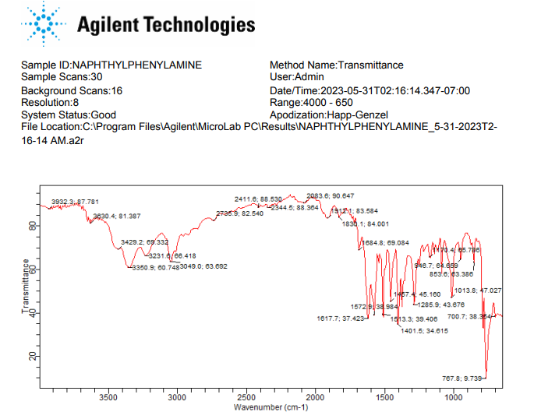
FTIR spectrum of N¹-(naphthalen-1-yl)benzene-1,4-diamine

¹H NMR spectrum of N¹-(naphthalen-1-yl)benzene-1,4-diamine
¹³C NMR spectrum of N¹-(naphthalen-1-yl)benzene-1,4-diamine

3.2. Synthesis of 12H-benzo[a]phenothiazin-9-amine (28)
A mixture of 1-(naphthalen-1-yl)benzene-1,4-diamine 27 ( 0.4 mmol), sulphur powder (0.8 mmol) and iodine crystals (0.8 mmol) in 1,2-dichlorobenzene (20 ml) was refluxed for five hours in oil bath. The reaction mixture was then distilled to remove excess solvent. The product obtained was then recrystallized from acetone, filtered and allowed to air dry to give a dark colored solid product. The compound was characterized as thus; Yield 83.4%, m.p. 250°C. FT-IR (KBr, cm⁻¹): 3388.2 (N-H stretch), 3049 cm⁻¹ (C-H aromatic), 1617.5 (C=C aromatics), 1248.7(C-N). ¹H NMR (δ) 8.21 (d, 1H, NH), 7.82 (s, 1H₂, Ar-H), 7.73-7.71 (t, 3H, J=0.8Hz, Ar-H), 7.65 (s, 1H, Ar-H), 7.52-7.54 (m, J=0.8Hz, Ar-H), 7.34-7.32 (d, J=0.8Hz, 2H, Ar-H), 4.89 (s, 1H, NH₂). ¹³C NMR (δ): 152.1-111.5 (16 aromatic carbons).

FTIR spectrum of 12H-benzo[a]phenothiazin-9-amine

¹H NMR spectrum of 9-amino-12H-benzo[a]phenothiazine
¹³C NMR spectrum for 9-amino-12H-benzo[a]phenothiazine.

3.3. General method for the synthesis of phenothiazine-3-sulphonamides derivatives (30a-c)
Sodium carbonate, Na₂CO₃ (0.5 mmol) was weighed and added to a solution of 12H-benzo[a]phenothiazin-9-amine 28 (0.1 mmol) in dichloromethane (20 ml) and acetone with continuous stirring using a magnetic stirrer until all the solutes were dissolved. The appropriate substituted arylsulphonyl chlorides 29 a-c (1.0 mmol) were added in three portions over a period of 45 minutes. The solution was refluxed for ten hours in water bath. After completion, the pH of the reaction mixture was adjusted from 7 to 2 using HCl (2 mol) and a cloudy solution was obtained. The organic portion was extracted with dichloromethane (50 ml) and ethylacetate (50 ml), and left to air-dry. The compounds were then characterized as follows:
N-(12H-benzo[a]phenothiazine-9-yl)-4-methylbenzenesulphonamide (30a)
Yield 82.5%, melting point 240-241°C. FT-IR (KBr, cm⁻¹) 3369.5 (N-H stretch), 3063.9 (C-H aromatic), 2914.8 (C-H stretch), 1625.1 (C=C aromatics), 1375.4 (S=O vibration of sulphonamide), 1319.5 (C-N). ¹H NMR (δ): 9.60 (s, 1H, NH), 8.15 (s, 1H, SO₂-NH of amide), 7.81 (s, 1H, Ar-H), 7.79 (s, 1H, Ar-H), 7.50-7.61 (m, 7H, J=4.4Hz, Ar-H), 7.59 (d, 2H, Ar-H, J=0.8Hz), 7.15 (s, 1H, Ar-H), 6.97 (s, 1H, Ar-H), 2.40 (s, 1H, Ar-CH₃). ¹³C NMR (δ): 144.6- 111.6 (18 aromatic carbons).
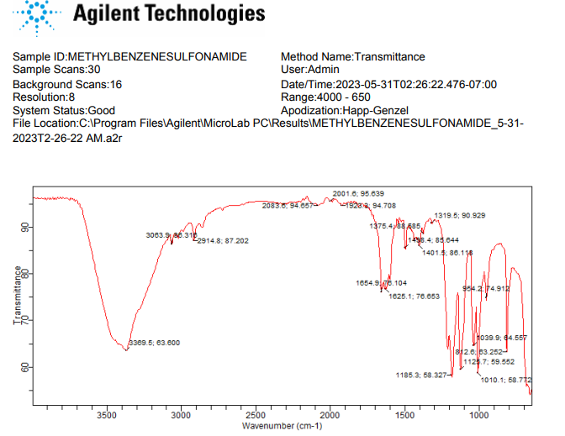
FTIR spectrum of N-(12H-benzo[a]phenothiazin-9-yl)-4-methylbenzenesulfonamide

¹H NMR spectrum of N-(12H-benzo[a]phenothiazin-9-yl)-4-methylbenzenesulphonamide

¹³C NMR spectrum of N-(12H-benzo[a]phenothiazin-9-yl)-4-methylbenzenesulphonamide

N-(12H-benzo[a]phenothiazine-9-yl)benzenesulphonamide (30b)
Yield 80.6%, melting point 195-196°C. FT-IR (KBr, cm⁻¹): 3350.9cm⁻¹ (N-H stretch), 3063.9 (C-H aromatic), 2922.2 (C-H stretch), 1621.4 (C=C aromatics), 1379.1 (S=O vibration of sulphonamide), 1330.7 (C-N). ¹H NMR (δ): 9.60 (s, 1H, NH), 8.15 (s, 1H, SO₂-NH of amide), 7.85 (s, 1H, Ar-H), 7.75 (t, 3H, J=0.4Hz, Ar-H), 7.55-7.57 (m, J=0.8Hz, 4H, Ar-H), 7.49 (d, 2H, J=0.2Hz, Ar-H), 7.15 (s, 1H, Ar-H), 6.87 (s, 1H, Ar-H), 6.61 (s, 1H, Ar-H), 6.23 (s, 1H, Ar-H). ¹³C NMR (δ): 144.6-18.0 (22 aromatic carbons).

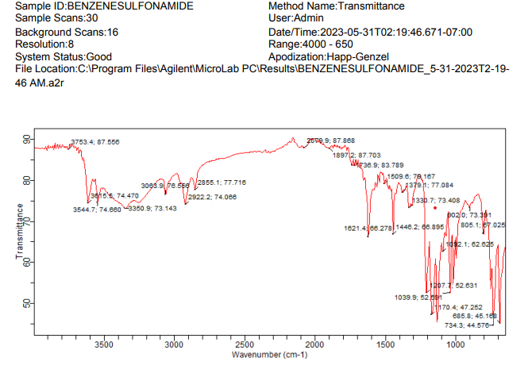
FTIR spectrum of N-(12H-benzo[a]phenothiazin-9-yl)benzenesulponamide
¹H NMR spectrum of N-(12H-benzo[a]phenothiazin-9-yl)benzenesulponamide

¹³C NMR spectrum of N-(12H-benzo[a]phenothiazin-9-yl)benzenesulponamide

N-(12H-benzo[a]phenothiazine-9-yl)-4-nitrobenzenesulphonamide (30c)
Yield 81.9%, melting point 237-238°C. FT-IR (KBr, cm⁻¹): 3388.2cm⁻¹ (N-H stretch), 2079.9 cm⁻¹ (C-H aromatic), 1625.1 cm⁻¹ (C=C aromatics), 1524.5 cm⁻¹(N-O stretch), 1360.5 cm⁻¹ (S=O vibration of sulphonamide), 1211.4 cm⁻¹ (C-N). ¹H NMR (δ): 9.80 (s, 1H, NH), 8.37-8.35 (d, 2H, J=0.8Hz, SO₂-NH of amide), 8.21 (s, 1H, Ar-NO₂), 8.01 (d, 1H, Ar-H), 7.85 (s, 1H, Ar-H), 7.78 (s, 1H, Ar-H), 7.64 (s, 1H, Ar-H), 7.45-7.44 (d, 2H, J=0.4Hz, Ar-H), 6.80 (s, 1H, Ar-H), 6.75 (s, 1H, Ar-H), 6.69 (s, 1H, Ar-H), 6.60 (s, 1H, Ar-H). ¹³C NMR (δ): 152.5-111.5 (22 aromatic carbons).
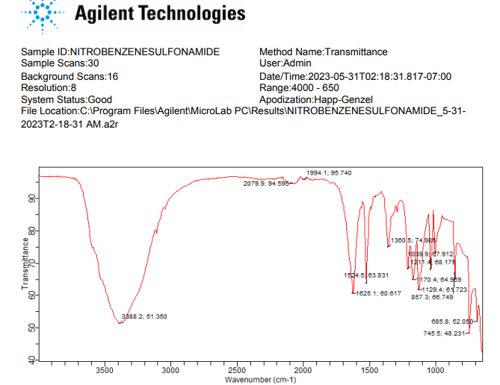
FTIR spectrum for N-(12H-benzo[a]phenothiazin-9-yl)-4-nitrobenzenesulphonamide.
¹H NMR spectrum for N-(12H-benzo[a]phenothiazin-9-yl)-4-nitrobenzenesulphonamide.

¹³C NMR spectrum for N-(12H-benzo[a]phenothiazin-9-yl)-4-nitrobenzenesulphonamide.

