Article - Supplementary Information
Waterproofing a thermally-actuated vibrational MEMS viscosity sensor
Luis Gan, Shreyas Choudhary, Kavana Reddy, Connor Levine, Lukas Jander, Amogh Uchil and Ivan Puchades*
Electrical and Microelectronic Engineering Department, Rochester Institute of Technology, Rochester, New York, 14568, USA
* Correspondence: ixpeme@rit.edu;

Once the protective film layer is applied, there is a change in the vibration properties of the resonator. As the main text shows, these changes expand from negative -30% to positive 25%. When the change in frequency and Q are plotted against the measured thickness, as seen in Figure S1, a loose correlation between the parameters indicates that the change in frequency and Q is negative for thinner films but turns positive for thicker films. As such, it may be possible to find a thickness for each particular material that could result in no change as the added mass and the effective spring constant are balanced.

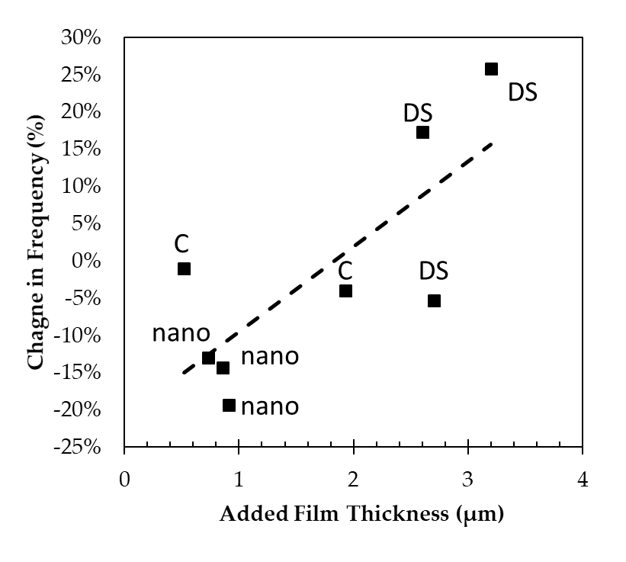 | 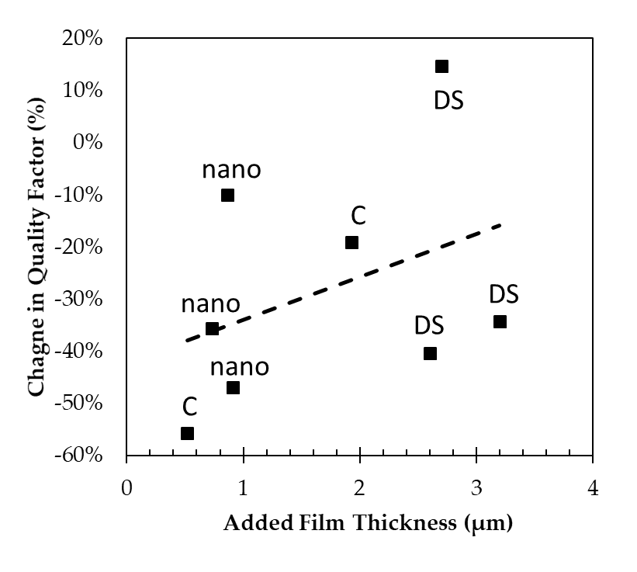
a) | (b)
Figure S1. (a) Change in frequency vs. added film thickness for the different coat materials (labels); (b) Change in Q vs. added film thickness for the different coat materials (labels);

The Q-value of each sensor was plotted individually to compare the before and after coating response of each sensor, as shown in Figure S2 for the Parylene-C sensors and S3 for nano coat and DS sensors. Table 2 in the main text summarizes the fitting terms where an increase in the value exponential term is seen between each sensor when compared individually before and after the application of the waterproofing material. The plots indicate that an acceptable fit is obtained for most sensors. The fits are closed from the theoretical fit of X^{-0.5}, as described in the main text. Most sensors show that after applying the waterproofing coat, the value of the fitting exponential increases slightly. The sensor's sensitivity has increased possibly due to the added mass and the increased inertia and how it couples to the fluid being tested.
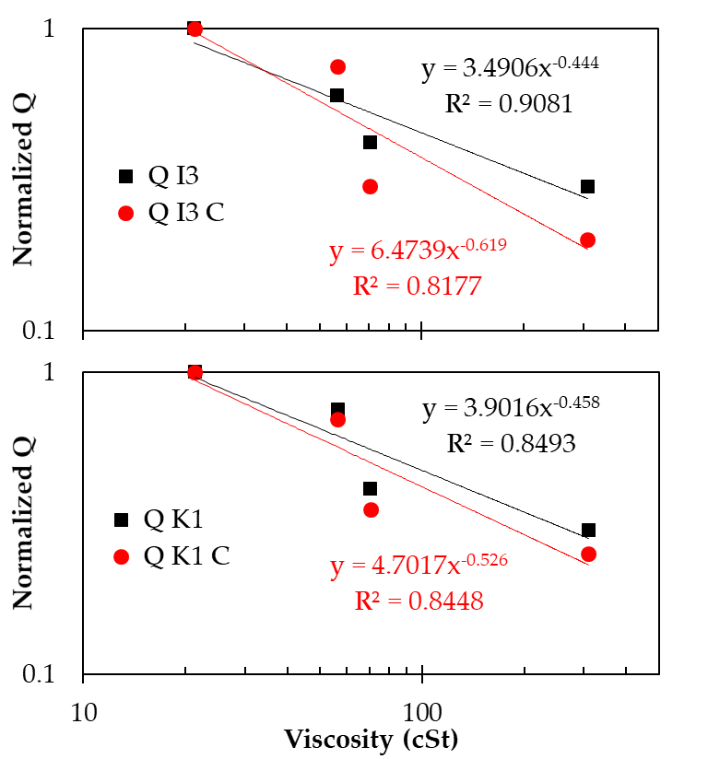
Figure S2. Fitted exponential to the normalized Q factor versus kinematic viscosity response, which was measured on sensors before and after applying a Parylene-C coating.
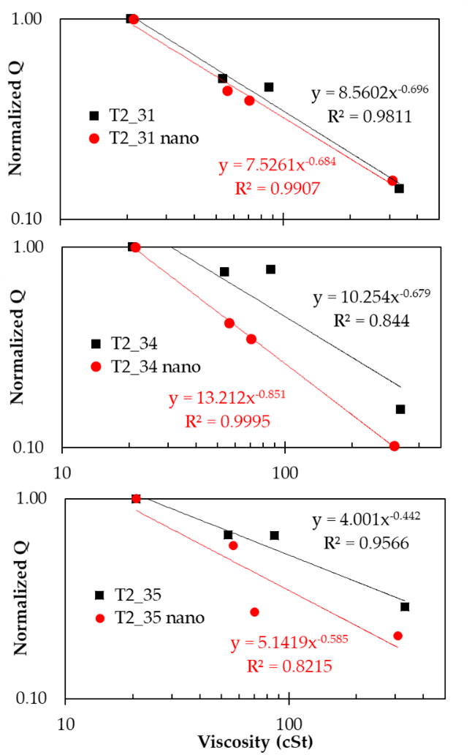 | 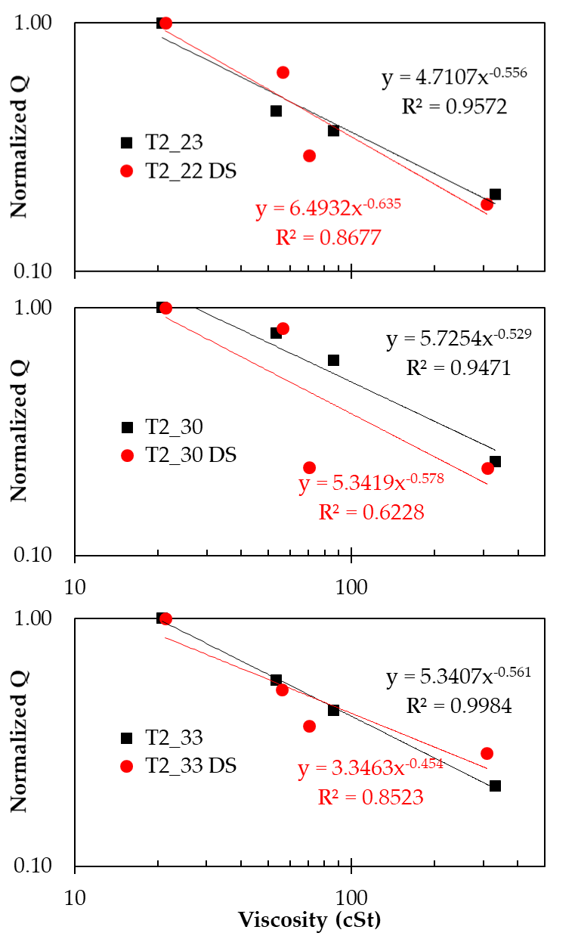
(a) | (b)
Figure S3. Fitted exponential to the normalized Q factor versus kinematic viscosity response, which was measured on sensors before and after applying (a) nano coat polymer (b) nail polish DS coat.

A summary of all the normalized averages of the quality factor for each is shown in Figure S4a for oil and Figure S4b for glycerol-water mixtures as a log-log plot. The value of the quality factor decays in a similar fashion before and after the application of the waterproofing material. On the other hand, the measurements taken in the mid-range of viscosities show a larger spread of values when compared to the in-oil measurements. Solid lines are superimposed to the data to aid in the visualization of the data, indicating exponential fits of x^{-0.4}, x^{-0.5}, and x^{-0.7}, respectively, where x is kinematic viscosity.
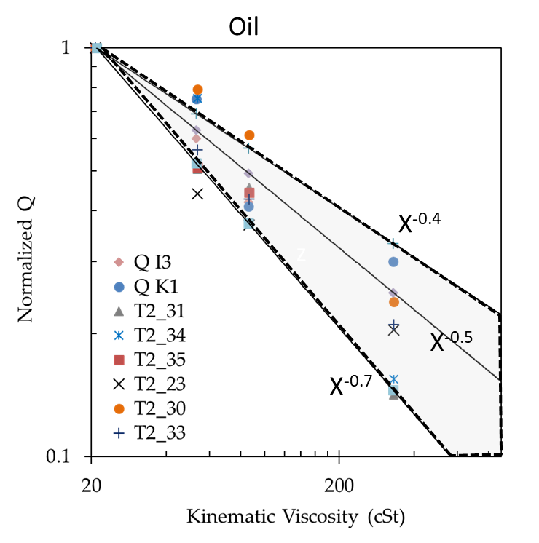 | 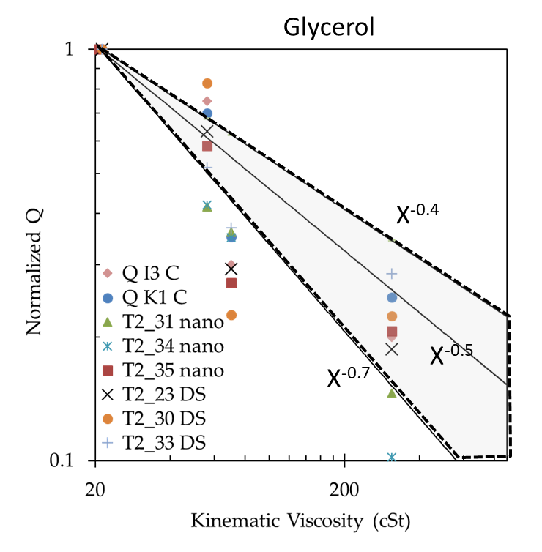
(a) | (b)
Figure S4. Log-log plots of the normalized q-factor value calculated for each sensor in (a) standard oils and (b) glycerol/water mixtures of different viscosities. Each data point is an average of about 180 data points. The standard deviation of the measurement is about 1% for the lower viscosities and 3% for the higher viscosities, but not shown for simplicity.

The data of these averages and standard deviations are presented in Table S1 and S2 in the supplementary information for both the tests in oil and glycerol.

Table S1. Average and standard deviation of the characteristic vibration properties of the tested viscosity sensors in different oils.
T2_23 | Average
 | Row Labels | N | Temp ºC | Viscosity | FFT Amp | Av Wv Freq | Av Wv Amp | Q Factor
 | N10 | 257 | 19.16 | 20.70 | 0.09 | 5297.98 | 0.45 | 24.47
 | N24 | 229 | 19.19 | 53.51 | 0.04 | 5219.76 | 0.14 | 10.40
 | N35 | 235 | 19.14 | 86.32 | 0.03 | 5094.91 | 0.12 | 10.88
 | N100 | 139 | 19.09 | 330.74 | 0.02 | 5092.73 | 0.08 | 8.52
 | Stdev
 | Row Labels | N | Temp ºC | Viscosity | FFT Amp | Av Wv Freq | Av Wv Amp | Q Factor
 | N10 | 257 | 2.1E-01 | 2.4E-06 | 9.4E-03 | 1.1E+01 | 5.3E-02 | 2.5E+00
 | N24 | 229 | 1.8E-01 | 0.0E+00 | 4.3E-03 | 7.0E+01 | 3.0E-02 | 9.3E-01
 | N35 | 235 | 1.8E-01 | 6.9E-06 | 2.9E-03 | 9.2E+00 | 8.0E-03 | 4.5E-01
 | N100 | 139 | 1.8E-01 | 0.0E+00 | 2.7E-04 | 5.3E-01 | 5.9E-04 | 5.4E-02
T2_30 | Average
 | Row Labels | N | Temp ºC | Viscosity | FFT Amp | Av Wv Freq | Av Wv Amp | Q Factor
 | N10 | 238 | 18.32 | 20.70 | 0.00 | 10142.65 | 0.03 | 13.41
 | N24 | 238 | 18.36 | 53.51 | 0.00 | 10095.81 | 0.03 | 11.33
 | N35 | 223 | 18.43 | 86.32 | 0.00 | 10082.39 | 0.02 | 9.58
 | N100 | 251 | 18.50 | 330.74 | 0.00 | 9783.52 | 0.01 | 4.74
 | Stdev
 | Row Labels | N | Temp ºC | Viscosity | FFT Amp | Av Wv Freq | Av Wv Amp | Q Factor
 | N10 | 238 | 2.0E-01 | 2.3E-06 | 1.4E-05 | 3.1E+00 | 5.7E-04 | 3.7E-01
 | N24 | 238 | 1.8E-01 | 0.0E+00 | 1.1E-04 | 1.2E+01 | 1.1E-03 | 3.8E-01
 | N35 | 223 | 1.9E-01 | 6.8E-06 | 4.4E-05 | 1.3E+01 | 5.5E-04 | 3.0E-01
 | N100 | 251 | 2.0E-01 | 0.0E+00 | 2.2E-05 | 1.6E+01 | 4.8E-04 | 4.1E-01
T2_31 | Average
 | Row Labels | N | Temp ºC | Viscosity | FFT Amp | Av Wv Freq | Av Wv Amp | Q Factor
 | N10 | 147 | 18.54 | 20.70 | 0.08 | 6870.40 | 0.30 | 22.96
 | N24 | 161 | 18.65 | 53.50 | 0.04 | 6857.11 | 0.15 | 16.44
 | N35 | 159 | 18.68 | 86.30 | 0.03 | 6856.83 | 0.14 | 16.15
 | N100 | 159 | 18.74 | 330.70 | 0.01 | 6703.29 | 0.04 | 9.46
 | Stdev
 | Row Labels | N | Temp ºC | Viscosity | FFT Amp | Av Wv Freq | Av Wv Amp | Q Factor
 | N10 | 147 | 1.7E-01 | 1.0E-06 | 1.2E-03 | 3.3E+00 | 3.0E-03 | 2.2E-01
 | N24 | 161 | 1.7E-01 | 0.0E+00 | 1.1E-03 | 3.9E+00 | 3.1E-03 | 2.4E-01
 | N35 | 159 | 1.7E-01 | 3.0E-06 | 2.5E-04 | 2.3E+00 | 8.0E-04 | 1.7E-01
 | N100 | 159 | 1.7E-01 | 2.5E-05 | 9.2E-04 | 1.3E+01 | 4.0E-03 | 2.9E-01
T2_32 | Average
 | Row Labels | N | Temp ºC | Viscosity | FFT Amp | Av Wv Freq | Av Wv Amp | Q Factor
 | N10 | 131 | 18.75 | 20.70 | 0.08 | 5313.36 | 0.24 | 14.80
 | N24 | 157 | 18.77 | 53.50 | 0.04 | 5388.73 | 0.13 | 10.09
 | N35 | 171 | 18.82 | 86.30 | 0.02 | 5217.45 | 0.08 | 8.27
 | Stdev
 | Row Labels | N | Temp ºC | Viscosity | FFT Amp | Av Wv Freq | Av Wv Amp | Q Factor
 | N10 | 131 | 1.6E-01 | 7.1E-07 | 9.7E-04 | 2.1E+00 | 1.7E-03 | 2.8E-01
 | N24 | 157 | 1.6E-01 | 0.0E+00 | 2.6E-03 | 1.6E+01 | 4.8E-03 | 2.2E-01
 | N35 | 171 | 1.7E-01 | 3.7E-06 | 2.5E-04 | 1.0E+01 | 1.8E-03 | 1.2E-01
T2_33 | Average
 | Row Labels | N | Temp ºC | Viscosity | FFT Amp | Av Wv Freq | Av Wv Amp | Q Factor
 | N10 | 161 | 18.87 | 20.70 | 0.09 | 5313.01 | 0.35 | 29.83
 | N24 | 161 | 18.90 | 53.50 | 0.03 | 5318.17 | 0.12 | 16.77
 | N35 | 161 | 18.94 | 86.30 | 0.02 | 5204.38 | 0.07 | 12.73
 | N100 | 155 | 18.99 | 330.70 | 0.00 | 5061.03 | 0.01 | 6.27
 | Stdev
 | Row Labels | N | Temp ºC | Viscosity | FFT Amp | Av Wv Freq | Av Wv Amp | Q Factor
 | N10 | 161 | 1.5E-01 | 1.3E-06 | 8.7E-05 | 2.2E-01 | 1.1E-03 | 1.3E-01
 | N24 | 161 | 1.6E-01 | 0.0E+00 | 3.5E-03 | 2.9E+00 | 1.5E-02 | 9.1E-01
 | N35 | 161 | 1.7E-01 | 3.2E-06 | 4.8E-04 | 9.2E+00 | 2.4E-03 | 3.2E-01
 | N100 | 155 | 1.7E-01 | 2.5E-05 | 2.6E-05 | 1.8E+01 | 2.1E-04 | 1.7E-01
T2_34 | Average
 | Row Labels | N | Temp ºC | Viscosity | FFT Amp | Av Wv Freq | Av Wv Amp | Q Factor
 | N10 | 154 | 19.01 | 20.70 | 0.00 | 5168.20 | 0.05 | 18.67
 | N24 | 142 | 19.03 | 53.50 | 0.00 | 5269.33 | 0.04 | 16.22
 | N35 | 169 | 19.08 | 86.30 | 0.00 | 5280.56 | 0.04 | 16.73
 | N100 | 162 | 19.10 | 330.70 | 0.00 | 5065.76 | 0.01 | 6.05
 | Stdev
 | Row Labels | N | Temp ºC | Viscosity | FFT Amp | Av Wv Freq | Av Wv Amp | Q Factor
 | N10 | 154 | 1.7E-01 | 1.1E-06 | 1.5E-04 | 1.5E+00 | 1.9E-03 | 8.2E-01
 | N24 | 142 | 1.9E-01 | 0.0E+00 | 6.5E-05 | 2.5E+01 | 1.5E-03 | 1.2E+00
 | N35 | 169 | 1.9E-01 | 3.5E-06 | 8.6E-05 | 2.0E+00 | 8.2E-04 | 4.9E-01
 | N100 | 162 | 1.7E-01 | 2.5E-05 | 1.6E-05 | 1.9E+01 | 3.0E-04 | 2.4E-01
T2_35 | Average
 | Row Labels | N | Temp ºC | Viscosity | FFT Amp | Av Wv Freq | Av Wv Amp | Q Factor
 | N10 | 178 | 19.14 | 20.70 | 0.06 | 5340.48 | 0.22 | 23.34
 | N24 | 177 | 19.13 | 53.50 | 0.03 | 5338.53 | 0.10 | 15.34
 | N35 | 163 | 19.14 | 86.30 | 0.03 | 5367.87 | 0.10 | 15.31
 | N100 | 175 | 19.16 | 330.70 | 0.01 | 5293.41 | 0.01 | 6.72
 | Stdev
 | Row Labels | N | Temp ºC | Viscosity | FFT Amp | Av Wv Freq | Av Wv Amp | Q Factor
 | N10 | 178 | 1.8E-01 | 1.7E-06 | 5.0E-04 | 7.9E-01 | 2.7E-03 | 2.3E-01
 | N24 | 177 | 1.7E-01 | 0.0E+00 | 2.0E-03 | 2.0E+00 | 7.8E-03 | 5.3E-01
 | N35 | 163 | 1.7E-01 | 3.4E-06 | 6.5E-04 | 2.8E+01 | 8.7E-04 | 3.2E-01
 | N100 | 175 | 1.7E-01 | 2.4E-05 | 1.3E-03 | 1.4E+01 | 4.9E-03 | 5.0E-01

Table S2. Average and standard deviation of the characteristic vibration properties of the tested viscosity sensors in different glycerol-water mixtures.

T2_33 DS | Average
DS | Row Labels | N | Temp ºC | Viscosity | FFT Amp | Av Wv Freq | Av Wv Amp | Q Factor
 | 66pct | 616 | 21.88 | 21.30 | 9.6E-02 | 4621.60 | 2.6E-01 | 19.20
 | 77pct | 136 | 21.99 | 56.30 | 9.1E-03 | 4214.20 | 4.2E-02 | 9.90
 | 80pct | 143 | 21.91 | 70.40 | 3.2E-03 | 4184.58 | 1.5E-02 | 7.06
 | 90pct | 143 | 21.81 | 309.00 | 1.8E-03 | 3905.97 | 9.7E-03 | 5.48
 | Stdev
 | Row Labels | N | Temp ºC | Viscosity | FFT Amp | Av Wv Freq | Av Wv Amp | Q Factor
 | 66pct | 616 | 2.5E-01 | 3.2E-06 | 1.2E-02 | 3.8E+01 | 3.8E-02 | 1.9E+00
 | 77pct | 136 | 1.8E-01 | 0.0E+00 | 5.3E-03 | 5.7E+01 | 1.9E-02 | 9.9E-01
 | 80pct | 143 | 1.9E-01 | 5.1E-06 | 2.8E-04 | 4.5E+00 | 1.5E-03 | 2.5E-01
 | 90pct | 143 | 1.8E-01 | 0.0E+00 | 1.9E-04 | 6.7E+01 | 2.7E-03 | 2.6E-01
T2_34 nano | Average
nano | Row Labels | N | Temp ºC | Viscosity | FFT Amp | Av Wv Freq | Av Wv Amp | Q Factor
 | 66pct | 174 | 21.00 | 21.30 | 1.5E-03 | 4168.71 | 2.2E-02 | 9.91
 | 77pct | 186 | 21.06 | 56.30 | 3.9E-04 | 3961.24 | 9.2E-03 | 6.94
 | 80pct | 188 | 21.08 | 70.40 | 5.3E-04 | 3968.70 | 7.7E-03 | 4.68
 | 90pct | 224 | 21.13 | 309.00 | 1.7E-04 | 4906.22 | 2.3E-03 | 5.96
 | Stdev
 | Row Labels | N | Temp ºC | Viscosity | FFT Amp | Av Wv Freq | Av Wv Amp | Q Factor
 | 66pct | 174 | 1.9E-01 | 0.0E+00 | 1.7E-05 | 2.3E+00 | 3.2E-04 | 4.3E-01
 | 77pct | 186 | 1.6E-01 | 1.6E-06 | 2.0E-05 | 1.6E+01 | 3.2E-04 | 2.5E-01
 | 80pct | 188 | 1.7E-01 | 6.4E-06 | 3.5E-05 | 5.5E+00 | 3.5E-04 | 3.5E-01
 | 90pct | 224 | 1.9E-01 | 0.0E+00 | 2.5E-05 | 1.1E+03 | 3.9E-04 | 2.6E+00
T2_35 nano | Average
nano | Row Labels | N | Temp ºC | Viscosity | FFT Amp | Av Wv Freq | Av Wv Amp | Q Factor
 | 66pct | 141 | 21.31 | 20.70 | 5.6E-02 | 4575.52 | 2.2E-01 | 21.01
 | 77pct | 166 | 21.28 | 56.30 | 3.3E-02 | 4554.01 | 1.5E-01 | 16.66
 | 80pct | 151 | 21.25 | 70.40 | 1.5E-02 | 4478.50 | 5.7E-02 | 8.86
 | 90pct | 161 | 21.13 | 309.00 | 1.2E-02 | 4449.42 | 3.6E-02 | 8.88
 | Stdev
 | Row Labels | N | Temp ºC | Viscosity | FFT Amp | Av Wv Freq | Av Wv Amp | Q Factor
 | 66pct | 141 | 2.1E-01 | 9.4E-07 | 1.5E-03 | 1.0E+00 | 4.4E-03 | 5.2E-01
 | 77pct | 166 | 2.0E-01 | 0.0E+00 | 1.3E-03 | 1.1E+00 | 6.6E-03 | 6.8E-01
 | 80pct | 151 | 1.9E-01 | 5.4E-06 | 9.6E-05 | 2.2E+01 | 5.6E-04 | 1.1E-01
 | 90pct | 161 | 1.9E-01 | 0.0E+00 | 1.6E-04 | 6.7E-01 | 9.0E-04 | 1.7E-01
T2_30 DS | Average
 | Row Labels | N | Temp ºC | Viscosity | FFT Amp | Av Wv Freq | Av Wv Amp | Q Factor
 | 66pct | 117 | 21.44 | 21.30 | 8.3E-04 | 9606.31 | 1.6E-02 | 15.37
 | 77pct | 158 | 21.44 | 56.30 | 9.0E-04 | 9423.42 | 1.3E-02 | 15.71
 | 80pct | 185 | 21.40 | 70.40 | 8.6E-04 | 5377.64 | 3.6E-03 | 22.51
 | 90pct | 131 | 21.35 | 309.00 | 8.4E-04 | 6951.34 | 3.6E-03 | 25.89
 | Stdev
 | Row Labels | N | Temp ºC | Viscosity | FFT Amp | Av Wv Freq | Av Wv Amp | Q Factor
 | 66pct | 117 | 1.7E-01 | 5.6E-07 | 4.2E-05 | 5.6E+01 | 9.3E-04 | 7.6E-01
 | 77pct | 158 | 1.8E-01 | 0.0E+00 | 3.6E-05 | 1.2E+02 | 8.2E-04 | 1.4E+00
 | 80pct | 185 | 1.6E-01 | 6.3E-06 | 2.2E-05 | 1.7E+03 | 4.6E-04 | 7.1E+00
 | 90pct | 131 | 1.9E-01 | 0.0E+00 | 2.3E-05 | 1.4E+03 | 6.2E-04 | 5.4E+00
T2_31 nano | Average
 | Row Labels | N | Temp ºC | Viscosity | FFT Amp | Av Wv Freq | Av Wv Amp | Q Factor
 | 66pct | 142 | 21.43 | 21.30 | 1.0E-02 | 8059.69 | 5.4E-02 | 13.69
 | 77pct | 137 | 21.46 | 56.30 | 4.2E-03 | 7734.60 | 2.4E-02 | 9.89
 | 80pct | 152 | 21.48 | 70.40 | 3.7E-03 | 7718.27 | 2.1E-02 | 9.57
 | 90pct | 135 | 21.36 | 309.00 | 1.5E-03 | 7468.30 | 8.5E-03 | 7.61
 | Stdev
 | Row Labels | N | Temp ºC | Viscosity | FFT Amp | Av Wv Freq | Av Wv Amp | Q Factor
 | 66pct | 142 | 1.9E-01 | 0.0E+00 | 3.6E-04 | 5.9E+00 | 1.2E-03 | 2.1E-01
 | 77pct | 137 | 1.7E-01 | 0.0E+00 | 1.1E-04 | 4.3E+00 | 7.0E-04 | 3.3E-01
 | 80pct | 152 | 1.8E-01 | 5.5E-06 | 8.8E-05 | 3.3E+00 | 6.1E-04 | 3.8E-01
 | 90pct | 135 | 2.0E-01 | 0.0E+00 | 6.7E-05 | 5.0E+01 | 3.9E-04 | 5.1E-01
T2_22 DS | Average
 | Row Labels | N | Temp ºC | Viscosity | FFT Amp | Av Wv Freq | Av Wv Amp | Q Factor
 | 66pct | 149 | 21.43 | 21.30 | 4.5E-02 | 6667.33 | 1.5E-01 | 16.06
 | 77pct | 146 | 21.46 | 56.30 | 2.8E-02 | 6674.66 | 1.0E-01 | 14.12
 | 80pct | 145 | 21.45 | 70.40 | 1.3E-02 | 5566.39 | 4.5E-02 | 8.93
 | 90pct | 156 | 21.47 | 309.00 | 8.3E-03 | 5274.93 | 4.3E-02 | 8.64
 | Stdev
 | Row Labels | N | Temp ºC | Viscosity | FFT Amp | Av Wv Freq | Av Wv Amp | Q Factor
 | 66pct | 149 | 1.9E-01 | 0.0E+00 | 3.2E-03 | 4.4E+00 | 5.8E-03 | 1.4E-01
 | 77pct | 146 | 1.8E-01 | 0.0E+00 | 1.0E-03 | 8.4E-01 | 1.7E-03 | 3.2E-01
 | 80pct | 145 | 1.8E-01 | 5.2E-06 | 6.7E-04 | 5.2E+02 | 1.8E-03 | 7.1E-01
 | 90pct | 156 | 1.7E-01 | 0.0E+00 | 1.9E-04 | 5.9E+00 | 7.6E-04 | 3.0E-01

