Supplementary material
Table S1. RT-qPCR target genes and primer sequences
 | Gene id. Bf | MSª | Ref. | Description/Name | Cellular | Primer
 | 638R | FC |  |  | pathway^{b} | designation | sequence F(1)^{d} | sequence R(2)^{d}
1 | BF638R_0963 | 8,30 | [24] | FprA family A-type flavoprotein (fprA) | 1 | fprA1/2 | TAACGACCGTAACANGCACC | GATCAGTGCCACCATTTCAT
2 | BF638R_1663 | 10,55 | [24] | galactokinase (galK) | 1 | galK1/2 | TGGCAGANGCAAAAGCTGAT | YTCGTAAAGTTTGCTCATGC
3 | BF638R_1728 | -2,95 | [24] | exo-alpha-sialidase (nanH) | 2 | nanH1/2 | TGTGTGCTATACCGGTAGTT | GTCTGGCTCTCTTTAGCATC
4 | BF638R_3176 | 8,40 | [24] | BmeB15 (acr15) | 2 | act15-1/2 | AGTATCGATCACCTTCGGAA | TACTTGCTGTCGTTCAGTTC
5 | BF638R_3999 | 9,10 | [24] | BmeB5 (acr5) | 2 | acr51/2 | CCTATCGACTTGTATCCGGA | ATTCAGCGTATTCTCCAACG
6 | BF638R_2281 | 4,00 | [24] | RelA/SpoT family protein (relA) | 5 | relA_1/2 | CGTGACCGTTATATTGCCAA | ACTGGCATTTCTGTTTCTTCA
7 | BF638R_1701 | 22,80 | [24] | 50S ribosomal protein L20 | 4 | L20_31/2 | CGTGACCGTAGAAACAAGAA | AAGTCAGCCAAAACCTTACG
8 | BF638R_4035 | 15,10 | [24] | 30S ribosomal protein S3 | 4 | S3-1/2 | GTGGCCAGGAAGTTGATAAG | ACAATCACAGCATCCAGTTC
9 | BF638R_3828 | - | This study | malate dehydrogenase (mdh) | 1 | mdh-1/2 | GACTCGTGAAGAACTGATCG | AGTCATTGTATCCATCGGGT
10 | BF638R_1473 | - | [17] | lactate dehydrogenase (ldh) | 1 | ldh-1/2 | TCGGACCGTATCATNGACGA | TATTCTCCAGAGTCGTTGCT
11 | BF638R_3133 | - | This study | phospho-glycerate kinase (pgk) | 1 | pgk-1/2 | TTCGAAAACTTCACTCACGG | TACCCGGAAGAACTTTTCCT
12 | BF638R_1421 | - | [16] | feoAB | 3 | feoAB-1/2 | GCTTCCGTAAACGNATTGTG | GTCGNCGCAGAGAGATTTCA
13 | BF638R_2696 | 4,1 | [24] | flavodoxin (fldA) | 1 | fldA-1/2 | ATTTTACGGTTCCACAACGG | TCACTAACTCGTCGTTCAGT
14 | BF638R_4500 | - | This study | fumarate reductase (frdA) | 1 | frdA-1/2 | ATCTGGGTTCCGAAGAAGAT | GCGTTCCAGATAGAAGTCAC
15 | BF638R_4499 | 11,50 | [24] | succinate dehydrogenase/fumarate reductase cytochrome b subunit (frdC) | 1 | frdC-1/2 | TGGGCTAAAATGCAGTTACC | CAGAAACCATGAGTCAGGTG
16 | BF638R_2263 | 2,40 | [24] | Crp/Fnr family transcriptional regulator (crpF) | 5 | crpF-1/2 | CGTGATTTTGACGGAATCG | TAATCGATCATTTCTCCCCG
17 | BF638R_1544 | -3,20 | [24]^{c} | GNAT family N-acetyltransferase (gat) | 5 | gatMZ-1/2^{c} | TTCCCTATCGTAGCATACCC | TCTGGTGTCCACTCTGTATC
18 | BF638R_3194 | 43,12 | This study^{c} | pyruvate-flavodoxin/ferredoxin oxidoreductase (por) | 1 | porMZ-1/2^{c} | ATGACATTCCGTATCCAGGT | GTTGTTTGCTCTTCACGTTG
Endogeneous controls
19 | BF638R_0945 |  | This study | glyceraldehyde-phosphate dehydrogenase (gap) | - | gap1/3BF | AGCCATTGTAGCAGCTTTTT | GAAGACGGGATGATGTTTC
20 | 6 16S rRNA |  | This study | 16S rRNA (rrn) | - | rrnBF-1/2 | TCCTGTTTGATACCCACACT | GCTCAACCGTAAAATTGCAG
21 | BF638R_2767 |  | This study | rpoD | - | rpoD_BF1/2 | CCAATCTTCGTTTCGTCGTA | TTCATCAAACTTCTCGGCAG

ª FC means fold change in the proteomic study. ^{b} The numbers designate the following pathways - 1: glycolysis, carbohydrate metabolism, redox processes, 2: cell-wall, efflux, virulence, 3: heme/Fe2+ metabolism, 4: protein synthesis, 5: nucleic acids, repair, stress, gene regulation. ^{c} These items were selected from the different paralog genes of these proteins in the B. fragilis genomes based on differential expressions, the pyruvate-ferredoxin oxidoreductase gene here was selected on its differential expression in RNASeq experiments (our unpublished results). ^{d} Forward (1) and reverse (2) orientations.

Table S3. Cross-correlation values of gene expressions metronidazole resistance for eight nim-positive B. fragilis strainsª
 | S3 | acr5 | acr15 | crpF | frdC | feoAB | fldA | fprA | frdA | galK | gatMZ | ldh | mdh | nanH | porMZ | pgk | relA | MIC^{b}
L20 | 0,476 | 0,429 | 0,762 | -0,167 | 0,31 | -0,333 | -0,214 | 0,286 | 0,881 | 0,762 | -0,247 | 0,143 | 0,119 | 0,429 | 0,381 | 0,5 | 0,357 | -0,334
 | 0,207 | 0,26 | 0,0212 | 0,662 | 0,423 | 0,387 | 0,578 | 0,46 | 2E-07 | 0,0212 | 0,537 | 0,705 | 0,749 | 0,26 | 0,321 | 0,182 | 0,353 | 0,387
S3 |  | 0,548 | 0,333 | -0,333 | 0,548 | 0,143 | 0,357 | 0,619 | 0,0952 | 0,738 | 0,577 | -0,119 | 0,429 | 0,0238 | 0,667 | 0,595 | 0,81 | -0,124
 |  | 0,139 | 0,387 | 0,387 | 0,139 | 0,705 | 0,353 | 0,086 | 0,794 | 0,0287 | 0,12 | 0,749 | 0,26 | 0,931 | 0,0588 | 0,102 | 0,0096 | 0,749
acr5 |  |  | 0,286 | -0,0476 | 0,119 | -0,333 | -0,262 | 0,476 | 0,143 | 0,452 | 0,412 | -0,429 | 0,857 | -0,19 | 0,714 | 0,81 | 0,262 | 0,272
 |  |  | 0,46 | 0,885 | 0,749 | 0,387 | 0,498 | 0,207 | 0,705 | 0,233 | 0,29 | 0,26 | 0,00178 | 0,619 | 0,0374 | 0,0096 | 0,498 | 0,498
acr15 |  |  |  | 0,0238 | 0,143 | -0,429 | 0,0238 | 0,5 | 0,81 | 0,5 | -0,247 | 0,476 | 0,19 | 0,786 | 0,262 | 0,357 | 0,119 | -0,136
 |  |  |  | 0,931 | 0,705 | 0,26 | 0,931 | 0,182 | 0,0096 | 0,182 | 0,537 | 0,207 | 0,619 | 0,0149 | 0,498 | 0,353 | 0,749 | 0,705
crpF |  |  |  |  | 0 | -0,619 | -0,119 | -0,452 | 0,0476 | 0,0952 | -0,577 | 0,333 | 0,214 | 0,381 | 0,0952 | 0,286 | 0 | 0,568
 |  |  |  |  | 0,977 | 0,086 | 0,749 | 0,233 | 0,885 | 0,794 | 0,12 | 0,387 | 0,578 | 0,321 | 0,794 | 0,46 | 0,977 | 0,12
frdC |  |  |  |  |  | 0,0238 | -0,0476 | 0,429 | 0,262 | 0,476 | 0,0825 | -0,167 | -0,167 | 0,0476 | 0,167 | 0,452 | 0,405 | -0,507
 |  |  |  |  |  | 0,931 | 0,885 | 0,26 | 0,498 | 0,207 | 0,839 | 0,662 | 0,662 | 0,885 | 0,662 | 0,233 | 0,29 | 0,182
feoAB |  |  |  |  |  |  | 0,619 | 0,0714 | -0,452 | -0,357 | 0,577 | 0,0476 | -0,357 | -0,548 | -0,5 | -0,619 | 0,0476 | -0,148
 |  |  |  |  |  |  | 0,086 | 0,839 | 0,233 | 0,353 | 0,12 | 0,885 | 0,353 | 0,139 | 0,182 | 0,086 | 0,885 | 0,705
fldA |  |  |  |  |  |  |  | 0,0952 | -0,333 | 0,0238 | 0,412 | 0,595 | 0,0238 | 0,0952 | -0,119 | -0,333 | 0,429 | 0,309
 |  |  |  |  |  |  |  | 0,794 | 0,387 | 0,931 | 0,29 | 0,102 | 0,931 | 0,794 | 0,749 | 0,387 | 0,26 | 0,423
fprA |  |  |  |  |  |  |  |  | 0,167 | 0,167 | 0,577 | -0,19 | 0,286 | 0,0952 | 0,286 | 0,357 | 0,0714 | -0,321
 |  |  |  |  |  |  |  |  | 0,662 | 0,662 | 0,12 | 0,619 | 0,46 | 0,794 | 0,46 | 0,353 | 0,839 | 0,423
frdA |  |  |  |  |  |  |  |  |  | 0,5 | -0,577 | 0,333 | -0,143 | 0,619 | 0,0476 | 0,286 | 0 | -0,383
 |  |  |  |  |  |  |  |  |  | 0,182 | 0,12 | 0,387 | 0,705 | 0,086 | 0,885 | 0,46 | 0,977 | 0,321
galK |  |  |  |  |  |  |  |  |  |  | -0,0825 | 0,0714 | 0,333 | 0,381 | 0,738 | 0,738 | 0,833 | -0,0865
 |  |  |  |  |  |  |  |  |  |  | 0,839 | 0,839 | 0,387 | 0,321 | 0,0287 | 0,0287 | 0,00526 | 0,794
gatMZ |  |  |  |  |  |  |  |  |  |  |  | -0,412 | 0,412 | -0,577 | 0,247 | 0,0825 | 0,247 | 0,0856
 |  |  |  |  |  |  |  |  |  |  |  | 0,29 | 0,29 | 0,12 | 0,537 | 0,839 | 0,537 | 0,794
ldh |  |  |  |  |  |  |  |  |  |  |  |  | -0,19 | 0,667 | -0,333 | -0,333 | 0,0714 | 0,272
 |  |  |  |  |  |  |  |  |  |  |  |  | 0,619 | 0,0588 | 0,387 | 0,387 | 0,839 | 0,498
mdh |  |  |  |  |  |  |  |  |  |  |  |  |  | -0,0714 | 0,738 | 0,69 | 0,31 | 0,667^{c}
 |  |  |  |  |  |  |  |  |  |  |  |  |  | 0,839 | 0,0287 | 0,0474 | 0,423 | 0,0588
nanH |  |  |  |  |  |  |  |  |  |  |  |  |  |  | 0,143 | 0,143 | 0,119 | -0,0618
 |  |  |  |  |  |  |  |  |  |  |  |  |  |  | 0,705 | 0,705 | 0,749 | 0,839
porMZ |  |  |  |  |  |  |  |  |  |  |  |  |  |  |  | 0,857 | 0,667 | 0,185
 |  |  |  |  |  |  |  |  |  |  |  |  |  |  |  | 0,00178 | 0,0588 | 0,619
pgk |  |  |  |  |  |  |  |  |  |  |  |  |  |  |  |  | 0,5 | 0,124
 |  |  |  |  |  |  |  |  |  |  |  |  |  |  |  |  | 0,182 | 0,749
relA |  |  |  |  |  |  |  |  |  |  |  |  |  |  |  |  |  | 0,0741
 |  |  |  |  |  |  |  |  |  |  |  |  |  |  |  |  |  | 0,839
ª The colour-coding means the following: yellow – 0.5 < r < 0.7, 0.05 > p >0.001, orange: r > 0.7, p<0.001, , abbreviations in Table S1. ^{b} Metronidazole MIC. ^{c} Borderline significance
Table S4. Cross-correlation values of gene expressions metronidazole resistance for seven nim-negative B. fragilis strainsª
 | S3 | acr5 | acr15 | crpF | frdC | feoAB | fldA | fprA | frdA | galK | gatMZ | ldh | mdh | nanH | por | pgk | relA | MIC
L20 | 0,643 | -0,786 | -0,0357 | -0,536 | 0,821 | -0,198 | -0,786 | 0,143 | 0,679 | 0,464 | -0,018 | -0,464 | 0,643 | -0,821 | 0,0357 | 0,964 | 0,536 | 0,128
 | 0,0956 | 0,0251 | 0,905 | 0,181 | 0,0145 | 0,602 | 0,0251 | 0,72 | 0,0735 | 0,255 | 0,905 | 0,255 | 0,0956 | 0,0145 | 0,905 | 2E-07 | 0,181 | 0,72
S3 |  | -0,107 | 0,607 | -0,25 | 0,5 | -0,577 | -0,429 | -0,214 | 0,679 | 0,857 | 0,0541 | -0,0357 | 0,25 | -0,321 | 0 | 0,75 | 0,5 | 0,0551
 |  | 0,781 | 0,121 | 0,545 | 0,217 | 0,15 | 0,297 | 0,602 | 0,0735 | 0,00609 | 0,843 | 0,905 | 0,545 | 0,438 | 0,968 | 0,0384 | 0,217 | 0,843
acr5 |  |  | 0,464 | 0,536 | -0,75 | -0,018 | 0,821 | -0,179 | -0,286 | 0,0714 | -0,234 | 0,714 | -0,679 | 0,893 | 0,179 | -0,714 | -0,214 | 0,147
 |  |  | 0,255 | 0,181 | 0,0384 | 0,905 | 0,0145 | 0,66 | 0,491 | 0,843 | 0,545 | 0,0545 | 0,0735 | 2E-07 | 0,66 | 0,0545 | 0,602 | 0,72
acr15 |  |  |  | 0,429 | 0,143 | -0,18 | -0,0357 | -0,0357 | 0,5 | 0,321 | 0,252 | 0,571 | -0,0357 | 0,0714 | 0,321 | 0,0714 | 0,464 | -0,257
 |  |  |  | 0,297 | 0,72 | 0,66 | 0,905 | 0,905 | 0,217 | 0,438 | 0,545 | 0,15 | 0,905 | 0,843 | 0,438 | 0,843 | 0,255 | 0,545
crpF |  |  |  |  | -0,143 | 0,631 | 0,536 | 0,0357 | 0,214 | -0,357 | 0,27 | 0,857 | 0 | 0,464 | 0,643 | -0,607 | 0,25 | 0,0551
 |  |  |  |  | 0,72 | 0,0956 | 0,181 | 0,905 | 0,602 | 0,388 | 0,491 | 0,00609 | 0,968 | 0,255 | 0,0956 | 0,121 | 0,545 | 0,843
frdC |  |  |  |  |  | 0 | -0,786 | 0 | 0,75 | 0,143 | 0,432 | -0,321 | 0,643 | -0,857 | 0,107 | 0,75 | 0,5 | -0,128
 |  |  |  |  |  | 0,968 | 0,0251 | 0,968 | 0,0384 | 0,72 | 0,297 | 0,438 | 0,0956 | 0,00609 | 0,781 | 0,0384 | 0,217 | 0,72
feoAB |  |  |  |  |  |  | 0,252 | 0,595 | 0,18 | -0,667 | -0,0909 | 0,523 | 0,324 | 0,0541 | 0,775 | -0,396 | 0,36 | 0,232
 |  |  |  |  |  |  | 0,545 | 0,121 | 0,66 | 0,0735 | 0,781 | 0,181 | 0,438 | 0,843 | 0,0251 | 0,341 | 0,388 | 0,602
fldA |  |  |  |  |  |  |  | -0,214 | -0,393 | -0,0714 | -0,378 | 0,607 | -0,607 | 0,964 | 0,214 | -0,821 | -0,357 | 0,496
 |  |  |  |  |  |  |  | 0,602 | 0,341 | 0,843 | 0,341 | 0,121 | 0,121 | 2E-07 | 0,602 | 0,0145 | 0,388 | 0,217
fprA |  |  |  |  |  |  |  |  | 0,179 | -0,393 | -0,36 | 0,25 | 0,429 | -0,286 | 0,607 | 0,0714 | 0,571 | -0,0367
 |  |  |  |  |  |  |  |  | 0,66 | 0,341 | 0,388 | 0,545 | 0,297 | 0,491 | 0,121 | 0,843 | 0,15 | 0,905
frdA |  |  |  |  |  |  |  |  |  | 0,393 | 0,0901 | 0,286 | 0,607 | -0,464 | 0,607 | 0,607 | 0,857 | 0,239
 |  |  |  |  |  |  |  |  |  | 0,341 | 0,781 | 0,491 | 0,121 | 0,255 | 0,121 | 0,121 | 0,00609 | 0,545
galK |  |  |  |  |  |  |  |  |  |  | -0,252 | -0,0714 | 0 | 0,0357 | -0,143 | 0,571 | 0,214 | 0,385
 |  |  |  |  |  |  |  |  |  |  | 0,545 | 0,843 | 0,968 | 0,905 | 0,72 | 0,15 | 0,602 | 0,341
gatMZ |  |  |  |  |  |  |  |  |  |  |  | -0,144 | 0,306 | -0,306 | -0,27 | 0,0541 | -0,018 | -0,722^{c}
 |  |  |  |  |  |  |  |  |  |  |  | 0,72 | 0,438 | 0,438 | 0,491 | 0,843 | 0,905 | 0,0545
ldh |  |  |  |  |  |  |  |  |  |  |  |  | -0,0714 | 0,571 | 0,786 | -0,5 | 0,429 | 0,257
 |  |  |  |  |  |  |  |  |  |  |  |  | 0,843 | 0,15 | 0,0251 | 0,217 | 0,297 | 0,545
mdh |  |  |  |  |  |  |  |  |  |  |  |  |  | -0,643 | 0,357 | 0,607 | 0,75 | -0,11
 |  |  |  |  |  |  |  |  |  |  |  |  |  | 0,0956 | 0,388 | 0,121 | 0,0384 | 0,781
nanH |  |  |  |  |  |  |  |  |  |  |  |  |  |  | 0,0714 | -0,786 | -0,393 | 0,349
 |  |  |  |  |  |  |  |  |  |  |  |  |  |  | 0,843 | 0,0251 | 0,341 | 0,388
por |  |  |  |  |  |  |  |  |  |  |  |  |  |  |  | -0,107 | 0,75 | 0,404
 |  |  |  |  |  |  |  |  |  |  |  |  |  |  |  | 0,781 | 0,0384 | 0,341
pgk |  |  |  |  |  |  |  |  |  |  |  |  |  |  |  |  | 0,5 | -0,0184
 |  |  |  |  |  |  |  |  |  |  |  |  |  |  |  |  | 0,217 | 0,905
relA |  |  |  |  |  |  |  |  |  |  |  |  |  |  |  |  |  | 0,11
 |  |  |  |  |  |  |  |  |  |  |  |  |  |  |  |  |  | 0,781

ª The colour-coding means the following: yellow – 0.5 < r < 0.7, 0.05 > p >0.001, orange: r > 0.7, p<0.001, abbreviations in Table S1. ^{b} Metronidazole MIC.
. ^{c} Borderline significance

Fig. S1. The tricarboxylic acid pathways of B. fragilis
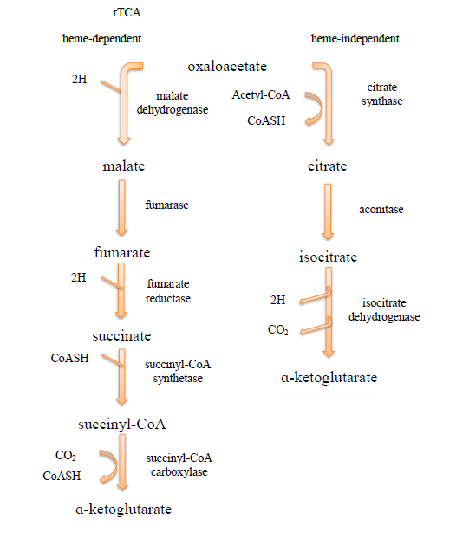

Fig. S2. Examples of the Etest results on modified M9 medium
B. fragilis 638R (A) and B. fragilis 638R/nimA (B) on glucose-supplemented M9 medium, respectively.
A B
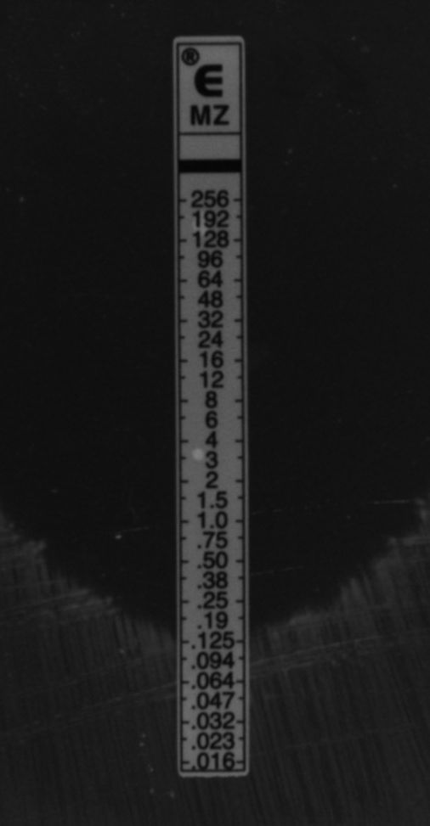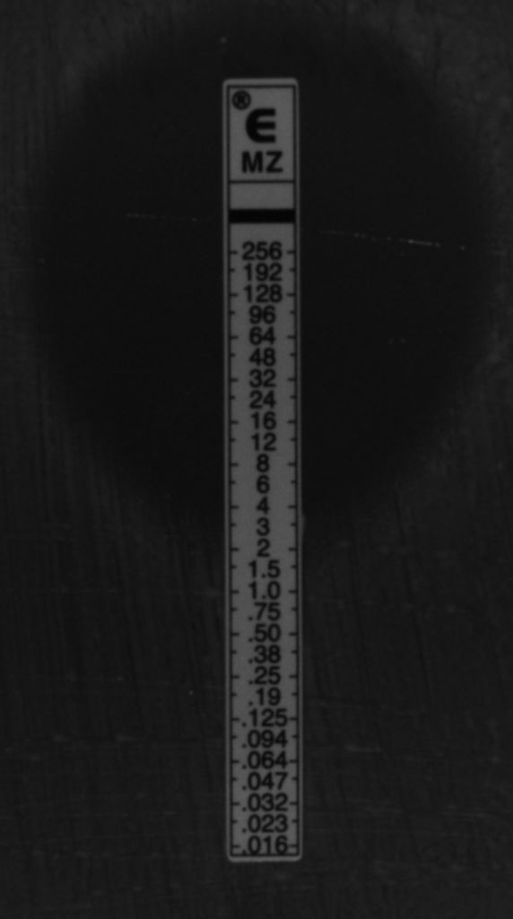

Table S5. Effects of C₄ dicarboxylic acid supplementation on metronidazole MICs of selected nim-positive and negative B. fragilis strains
Strain | nim | Media (MICs in μg/ml)
 |  | SCA | M9-Gª | M9-O | M9-M | M9-F | M9-S
638R | - | 0,125 | 0.25 | 0,064 | 0,032 | 0,032 | 0,032
638R/nimA | nimA | 4 | 4 | 4 | 4 | 2 | 4
KSB-R | nimB | 16 | >256^{b} | 16 | 256 | 16 | >256
19811 | - | 32 | >256 | 64 | >256 | 16 | >256
18807i2 | - | (0,25-)>256^{c} | 0,5 | 0,25 | 0,125 | 0,125 | 0,125
Q5 | nimE | >256 | >256 | >256 | >256 | 256 | >256

ª M9 media supplemented with glucose (G), oxaloacetic acid (O), malate (M), fumarate (F) and succinate (S).
^{b} Significantly increased metronidazole resistance values are highlighted in yellow. ^{c} Heterogeneous resistance phenotype.

