Supplemental figures
Vaccine based on recombinant fusion protein combining HBV PreS with SARS-CoV-2 wild-type- and Omicron-derived RBD strongly induces Omicron-neutralizing antibodies
Pia Gattinger ¹, Bernhard Kratzer ², Al Nasar Ahmed Sehgal ², Anna Ohradanova-Repic ³, Laura Gebetsberger ³, Gabor Tajti ³, Margarete Focke-Tejkl ^{1,4}, Mirjam Schaar ¹, Verena Fuhrmann ¹, Lukas Petrowitsch ⁵, Walter Keller ⁵, Sandra Högler ⁶, Hannes Stockinger ³, Winfried F. Pickl ² and Rudolf Valenta ^{1,4,7,8}*
¹ Medical University of Vienna, Center for Pathophysiology, Infectiology and Immunology, Department of Pathophysiology and Allergy Research, Division of Immunopathology, Vienna, Austria;
² Medical University of Vienna, Center for Pathophysiology, Infectiology and Immunology, Institute of Immunology, Vienna, Austria;
³ Medical University of Vienna, Center for Pathophysiology, Infectiology and Immunology, Institute for Hygiene and Applied Immunology, Vienna, Austria;
⁴ Karl Landsteiner University of Health Sciences, Krems, Austria;
⁵ University of Graz, BioTechMed Graz, Institute of Molecular Biosciences, Graz, Austria;
⁶ University of Veterinary Medicine Vienna, Institute of Pathology, Unit of Laboratory Animal Pathology, Vienna, Austria;
⁷ Sechenov First Moscow State Medical University, Department of Clinical Immunology and Allergology, Laboratory for Immunopathology, Moscow, Russia
⁸ NRC Institute of Immunology FMBA of Russia, Moscow, Russia

* Correspondence: rudolf.valenta@meduniwien.ac.at

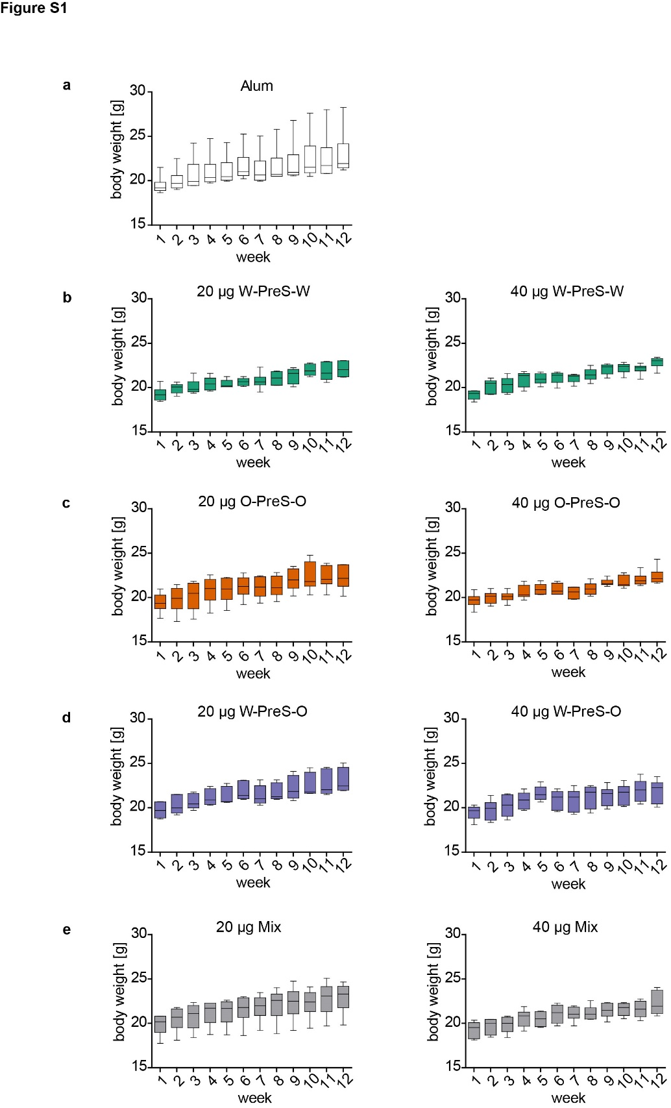
Figure S1. Weight development of mice immunized with (a) alum alone (negative control) or with 20 µg or 40 µg of the PreS-RBD fusion proteins (b-e) as measured weekly (x-axes) as gram body weight (y-axes). Shown are box-plots for each group (n=6 mice per group) with minimum and maximum values and medians indicated.

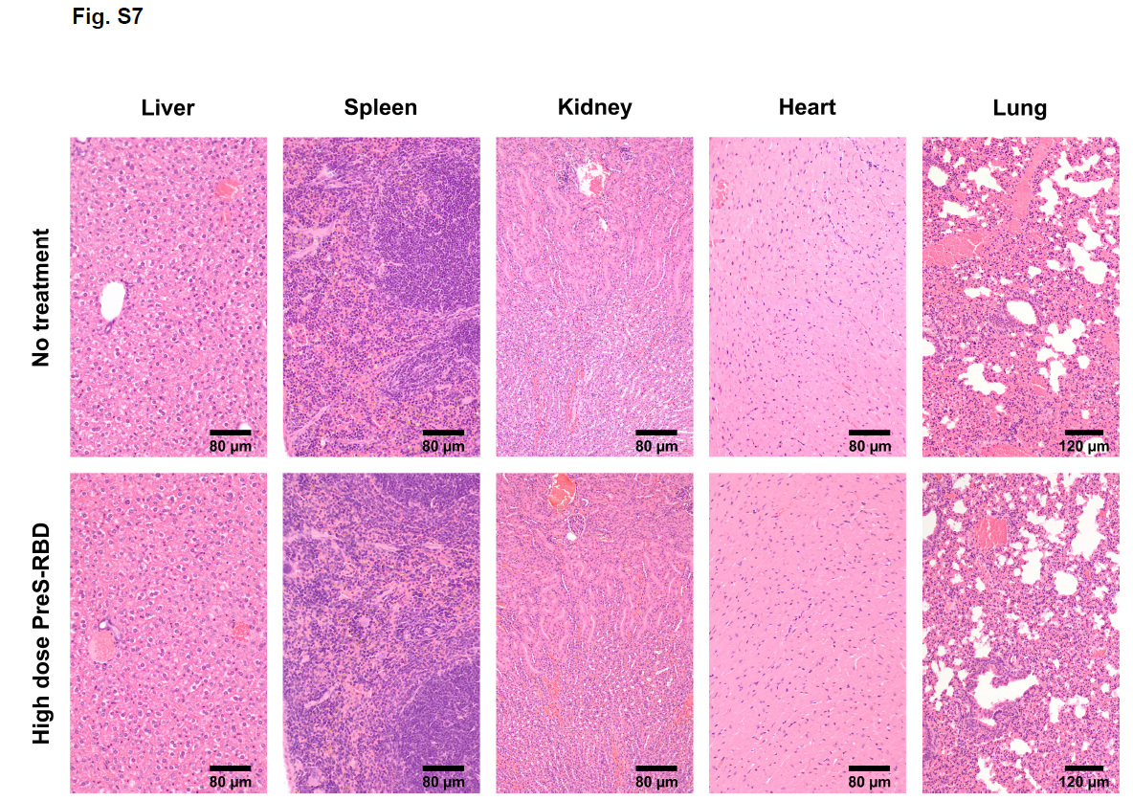

Figure S2. Representative hematoxylin–eosin stains of liver, spleen, kidney, heart and lung sections obtained from a non-immunized mouse (upper panel) or a mouse immunized with 40 µg of the mixture of W-PreS-W and O-PreS-O (high dose of PreS-RBD, lower panel).

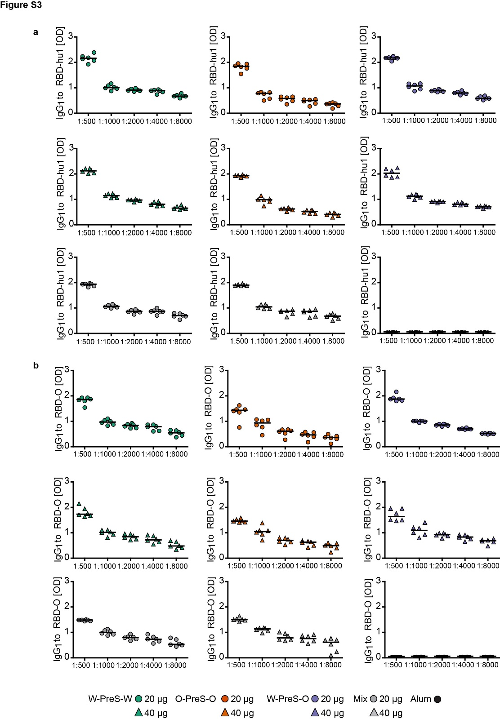
Figure S3. IgG₁ levels specific for (a) RBD-hu1 and (b) RBD-Omicron of mice immunized with 20 µg (circles) or 40 µg (triangles) of the PreS-RBD fusion proteins as indicated below. Specific IgG₁ levels were measured at indicated dilutions of serum samples (x-axes) and OD_{405/492 nm} values corresponding to IgG₁ levels are shown as duplicate determinations for each animal (n= 6 per group) with <5% deviation. Horizontal bars denote median antibody levels.
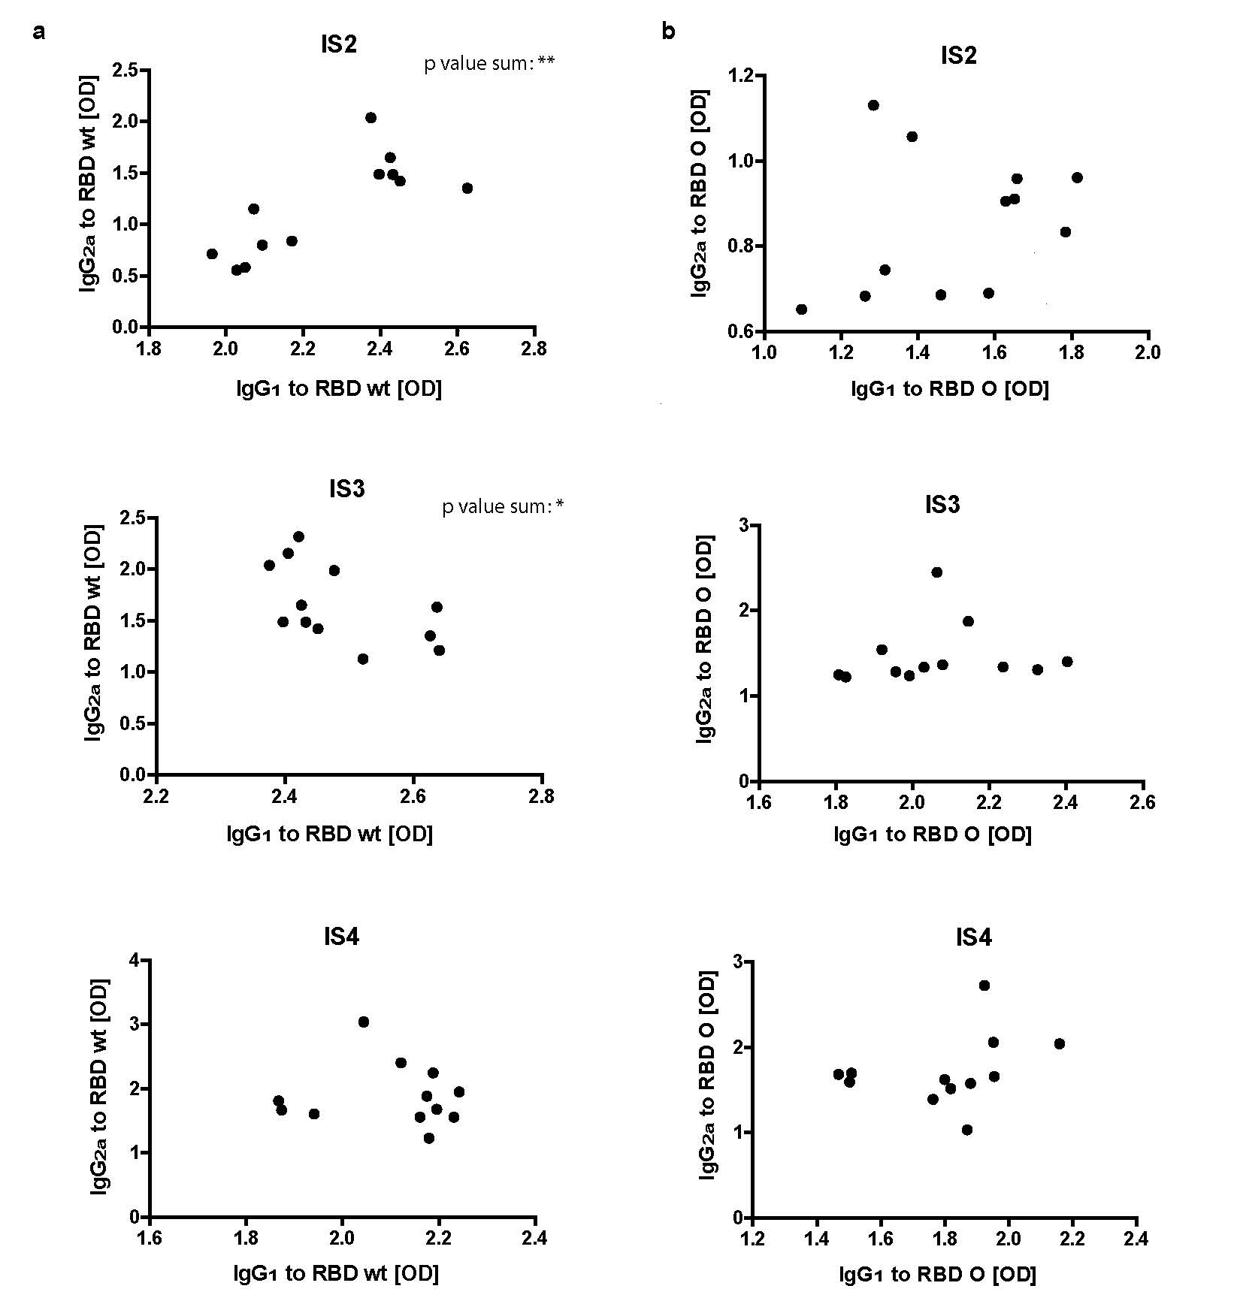
Figure S4. Correlation of IgG₁ and IgG_{2a} antibody levels specific for (a) RBD-hu1 and (b) RBD-Omicron of mice immunized with W-PreS-O at time points IS2, IS3 and IS4. Nonparametric Spearman´s correlation p values of <0.05 (* < 0.05, ** < 0.01) were considered as significant.

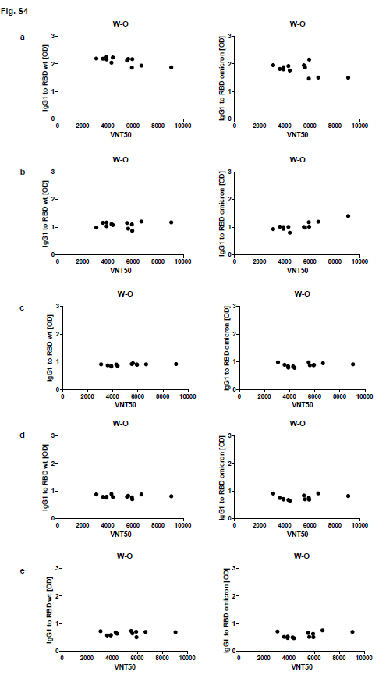
Figure S5. Lack of correlation of virus neutralization titers (VNT50, x-axes) in sera of mice (IS4) immunized with W-PreS-O (W-O) with levels of IgG₁ antibodies (OD values, y-axis) to folded RBD-hu1 (left) and RBD-Omicron (right) measured at dilutions (a) 1:500, (b) 1:1000, (c) 1:2000, (d) 1:4000 and (e)1:8000.

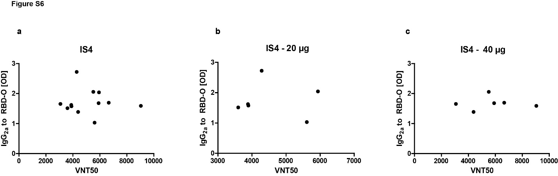
Figure S6. Lack of correlation of virus neutralization titers (VNT50, x-axes) in sera of mice (IS4) immunized with W-PreS-O with levels of IgG antibodies (OD values, y-axis) to folded RBD-Omicron measured at dilutions 1:500 of (a) both (20 µg and 40 µg) groups combined, (b) mice immunized with 20 µg and (c) mice immunized with 40 µg W-PreS-O.

