“Normal” mice have normal telomeres
Ion Udroiu

Supplementary Methods

GenBank reference sequence for RTEL1 protein from laboratory strain C57BL/6 (NP_001001882.3) was aligned onto the genome assemblies in Table S2 using TBLASTN (blast.ncbi.nlm.nih.gov) with cutoff E-value at 1e-10. The genome sequences comprising the aligned nucleotide sequences were further verified by alignment against RTEL1 using GeneWise (ebi.ac.uk/Tools/psa/genewise) for accurate spliced alignments.
For alignment of RTEL1 protein sequences (both already deposied and newly predicted), Constraint-based Multiple Alignment Tool, COBALT (www.ncbi.nlm.nih.gov/tools/cobalt/cobalt.cgi), was used with default settings.

Supplementary Figures and Tables

Species | Strain | Telomere Length
Mus musculus domesticus* | C57BL/6 | 30-120 kb
Mus musculus domesticus* | 129/SvJ | 30-120 kb
Mus musculus domesticus* | FVB/NJ | 30-120 kb
Mus musculus domesticus* | Black Swiss (Outbred) | 30-150 kb
Mus musculus domesticus* | Swiss Webster (Outbred) | 30-60 kb
Mus musculus domesticus* | ICR (Outbred) | 30-120 kb
Mus musculus domesticus |  | 15-20 kb
Mus musculus musculus |  | 15-20 kb
Mus musculus castaneus | CAST/EiJ | 18-20 kb
Mus musculus castaneus |  | 15-20 kb
Mus spicilegus |  | 15-20 kb
Mus macedonicus |  | 15-20 kb
Mus spretus | SPRET/EiJ | 15-20 kb
Mus caroli |  | 15-20 kb
Supplementary Table 1. Telomere length in the Mus genus. Data from Hemann and Greider¹. Asterisks denote “classical” laboratory strains, established in the XX century from European ‘fancy’ mice (M. m. domesticus) bred with East Asian ‘fancy’ mice (M. m. musculus x M. m. molossinus)².

Species | Strain | Type | Assembly accession
M. m. domesticus | BALB/c | Classical laboratory | GenBank: GCA_031761455.1
M. m. domesticus | FVB/NJ | Classical laboratory | GenBank: GCA_001624535.1
M. m. domesticus | PGN2/Ms | Wild-derived | https://molossinus.brc.riken.jp/mogplus/
M. m. domesticus | BFM/Ms | Wild-derived | https://molossinus.brc.riken.jp/mogplus/
M. m. domesticus | WSB/EiJ | Wild-derived | GenBank: GCA_029233295.1
M. m. musculus | PWD/PhJ | Wild-derived | GenBank: GCA_029233825.1
M. m. musculus | PWK/PhJ | Wild-derived | GenBank: GCA_029233695.1
M. m. musculus | BLG/Ms | Wild-derived | https://molossinus.brc.riken.jp/mogplus/
M. m. musculus | NJL/Ms | Wild-derived | https://molossinus.brc.riken.jp/mogplus/
M. m. musculus | CHD/Ms | Wild-derived | https://molossinus.brc.riken.jp/mogplus/
M. m. musculus | KJR/Ms | Wild-derived | https://molossinus.brc.riken.jp/mogplus/
M. m. musculus | SWN/Ms | Wild-derived | https://molossinus.brc.riken.jp/mogplus/
M. m. molossinus | JF1/MsJ | Wild-derived | GenBank: GCA_921999095.2
M. m. molossinus | MSM/MsJ | Wild-derived | https://molossinus.brc.riken.jp/mogplus/
M. m. castaneus | CAST/EiJ | Wild-derived | GenBank: GCA_029237265.1
M. m. castaneus | HMI/Ms | Wild-derived | https://molossinus.brc.riken.jp/mogplus/
Mus spicilegus | ZRU | Wild-derived | GenBank: GCA_003336285.2
Mus spretus | SPRET/EiJ | Wild-derived | GenBank: GCA_921997135.2
Mus caroli | CAROLI/EiJ | Wild-derived | GenBank: GCA_900094665.2
Mus pahari |  | Wild | GenBank: GCA_900095145.2
Mus minutoides |  | Wild | GenBank: GCA_902729485.2
Supplementary Table 2. Genome assemblies used in this study.

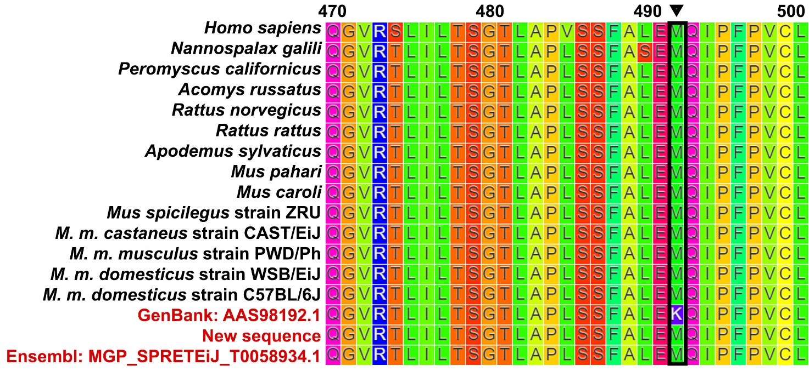
Supplementary Figure 1. Conservation of M492 in RTEL1. Conserved methionine in position 492 is shown by arrow. Red text denotes Mus spretus sequences: AAS98192.1 is the sequence previously deposited in GenBank; New sequence is the one obtained in this study; MGP_SPRETEiJ_T0058934.1 is the sequence present in Ensembl.

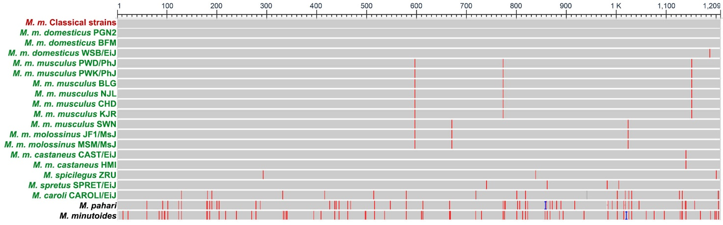
Supplementary Figure 2. Alignment of RTEL1 in the Mus genus. Red bars denote amino acids different from the ones in classical laboratory strains (labels in red). Labels in green denote wild-derived inbred strains (established in the last 20-40 years).

Supplementary References

- Hemann, M.T., Greider, C.W. Wild-derived inbred mouse strains have short telomeres. Nucleic Acids Res 28, 4474-4478 (2000).
- Frazer, K.A., et al. A sequence-based variation map of 8.27 million SNPs in inbred mouse strains. Nature 448, 1050-1053 (2007).

