Supplemental Material

Table S1: Model-Predicted Risk of LS-NVE for 10 Hypothetical Patients
Pt | IVSDT | LVESD | EF | LVPWDT | Aortic Regurg. | Mitral Regurg. | LVOT Velocity | LV Cardiac Index | Medial E:e’ | AVSP Velocity | Predicted  Risk | 95% Confidence Interval
1 | 10 | 32 | 61 | 8 | Mild-Severe | None/Trivial | 1.2 | 3.2 | 6.7 | 1.2 | 29.5% | 14.7%-53.6%
2 | 8 | 33 | 65 | 7 | Mild-Severe | Mild-Severe | 1.2 | 2.8 | 6.8 | 1.1 | 18.2% | 7.1%-42.1%
3 | 10 | 30 | 62 | 9 | None/Trivial | None/Trivial | 1.1 | 3 | 10 | 1.4 | 42.7% | 31.8%-55.5%
4 | 9 | 30 | 63 | 10 | None/Trivial | None/Trivial | 1.1 | 3.5 | 8.2 | 1.4 | 37.1% | 25.2%-52.3%
5 | 10 | 31 | 64 | 11 | None/Trivial | None/Trivial | 1.1 | 2.8 | 10 | 1.5 | 52.3% | 39.5%-66.3%
6 | 9 | 28 | 60 | 10 | Mild-Severe | Mild-Severe | 1 | 3.1 | 7.5 | 1.6 | 17.3% | 8.2%-34.4%
7 | 8 | 31 | 58 | 9 | None/Trivial | Mild-Severe | 0.9 | 3 | 8.7 | 1.3 | 12.8% | 6.2%-25.5%
8 | 12 | 28 | 57 | 8 | Mild-Severe | None/Trivial | 1.3 | 3.1 | 9 | 1.6 | 29.8% | 12.5%-60.9%
9 | 10 | 25 | 55 | 9 | None/Trivial | Mild-Severe | 1 | 3.2 | 8.5 | 1.3 | 18.6% | 9.8%-33.6%
10 | 10 | 29 | 55 | 12 | None/Trivial | Mild-Severe | 1.1 | 3 | 8.6 | 1.4 | 36.3% | 19.3%-61.2%
Predicted risk estimates and 95% CIs are stated in terms of the matched sample and therefore do not represent the risk of LS-NVE in the population.

Figure S1: Logistic Regression Equation for Risk of LS-NVE

Prob{Y=“Case”} = 1 / ( 1+ exp(- Ⅹ β ) , where

Ⅹ β =
-18.116 + 0.045835∙LVESD + 0.099393∙LVPWDT - 0.34641∙(AR= “Mild to Severe”) - 0.042453∙(MR= “Mild to Severe”) +
2.2858∙log(IVSDT) - 13.709∙(log(IVSDT) - 2.1972)³ + 25.116∙(log(IVSDT) - 2.3979)³ - 11.407∙(log(IVSDT) - 2.6391)³ +
0.09037∙LVEF – 0.00009805∙(LVEF-46.8)³ + 0.0002721∙(LVEF-61)³ - 0.0001740∙(LVEF69) ³ +
3.8708∙LVOT vel - 13.626∙(LVOT vel-0.9)³ + 22.71∙(LVOT vel-1.1)³ - 9.0838∙(LVOT vel-1.4)³
+ 0.052538∙LV cardiac index + 0.5282∙log(medial E:e’) + 0.23038∙log(AVSP velocity)

The model equation above is based on original regression coefficients and can be used to estimate LS-NVE “risk” (i.e., predicted probability of developing LS-NVE) relative to the matched sample on which the model was derived.
Although matching resulted in an even distribution of CCI scores between the 2 groups, the matched cases had significantly higher rates of diabetes mellitus and chronic kidney disease. We addressed this residual confounding by performing a secondary analysis in which terms for diabetes mellitus and chronic kidney disease were added to the original model. This yielded similar findings concerning echocardiographic variables, except for medial E: e’ which was no longer significant. In this appended model, “hemodynamic” measures (corrected χ² = 29.3) again outperformed the “anatomical” factors (corrected χ² = 8.5) in addition to the “comorbidities” (corrected χ² = 19.3) (Supplemental Figure 2). To further investigate the robustness of the main results, we re-fit the original logistic regression model ignoring the matching in the analysis (unconditional logistic regression). As presented in Supplemental Figure 3, this unmatched analysis had similar model χ² values for each of the 10 variables (in the same order of importance) and identified the same 3 significant variables as the matched analysis.

Supplemental Figure 2. Secondary model Relative Importance of Individual and Grouped Predictor Variables.
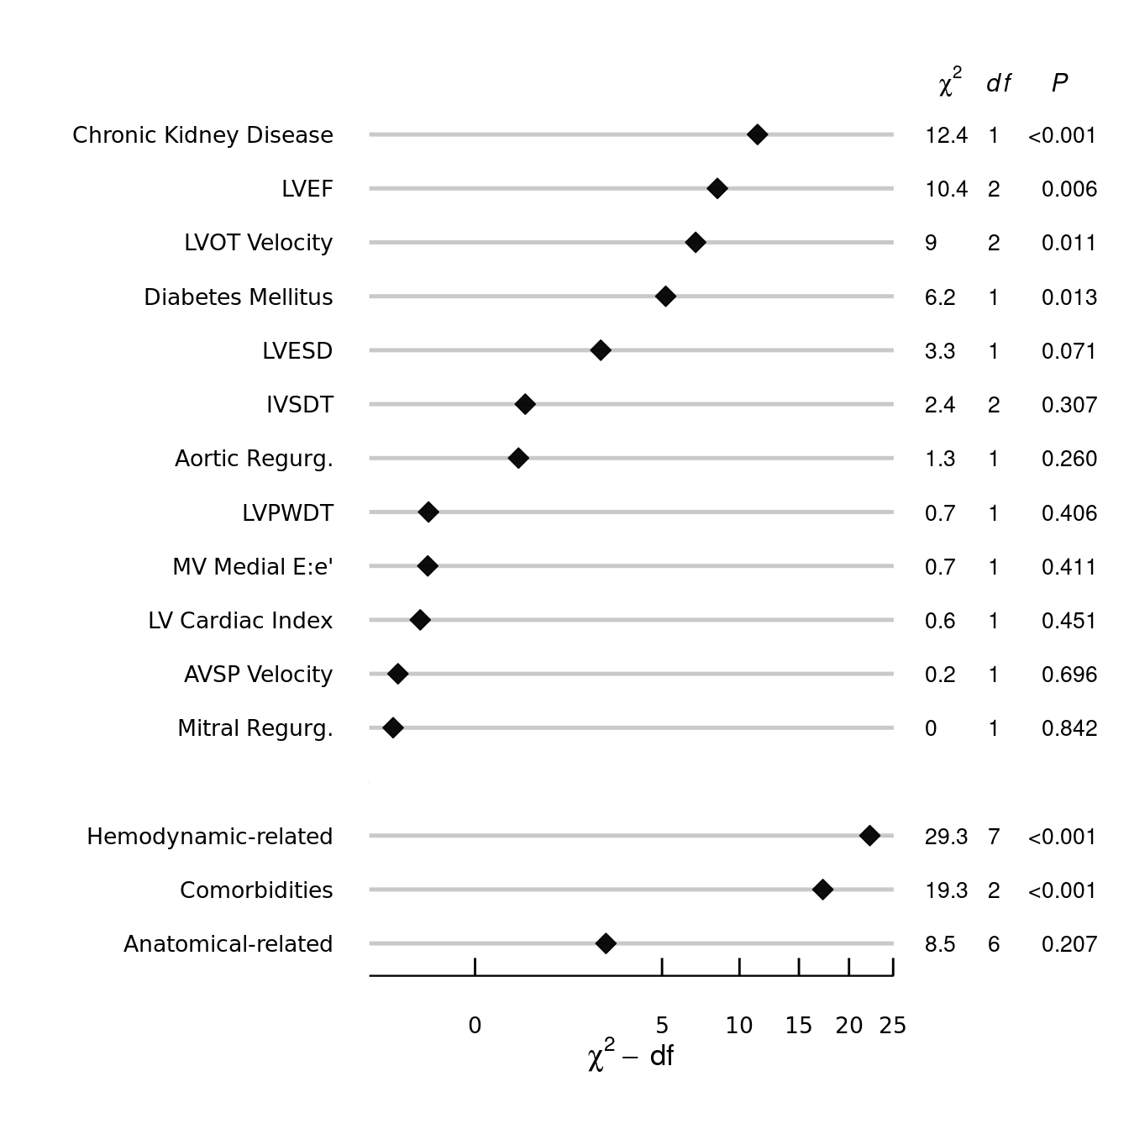

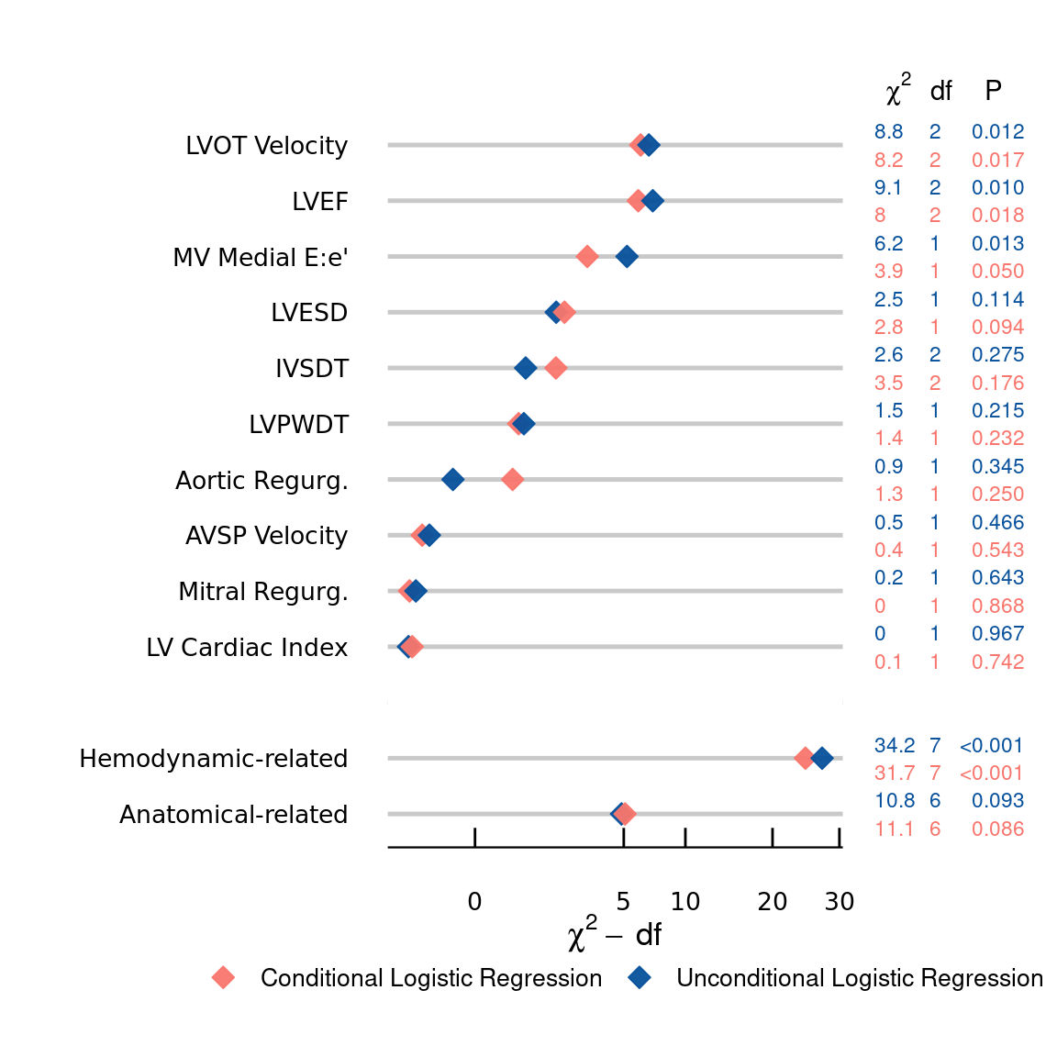
Supplemental Figure 3. Conditional versus Unconditional Logistic Regression

