Supporting information.
Figure S1. ¹H NMR of 3a
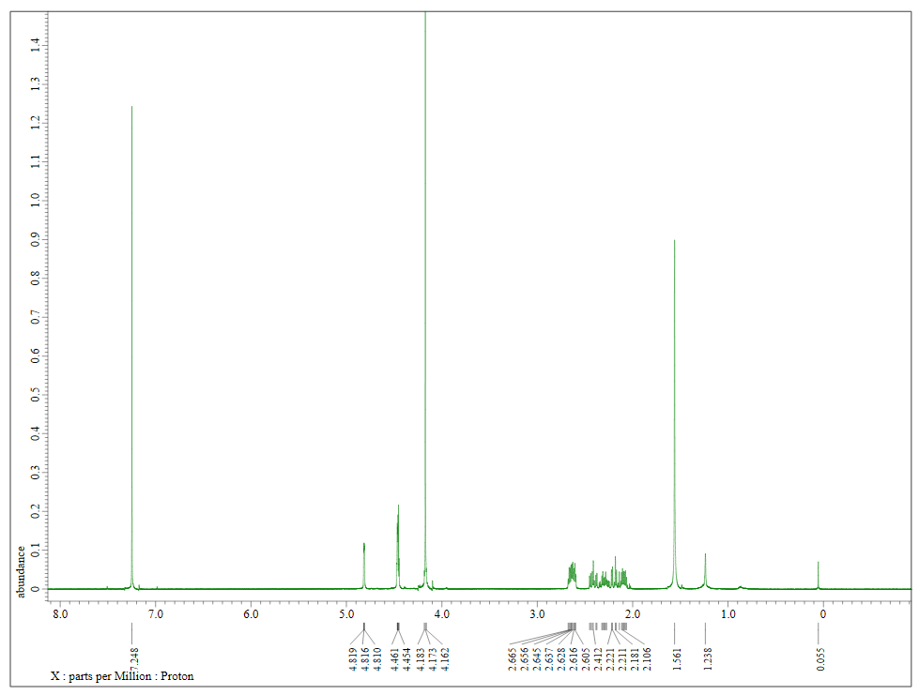

Figure S2. ¹³C NMR of 3a
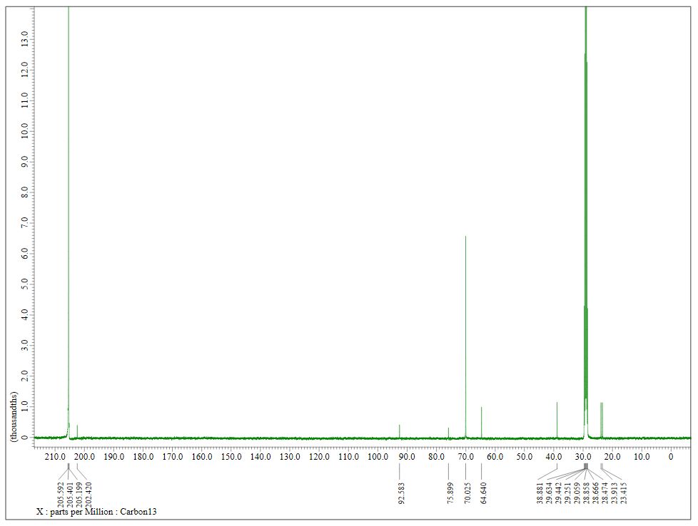

Figure S3. IR spectrum of 3a

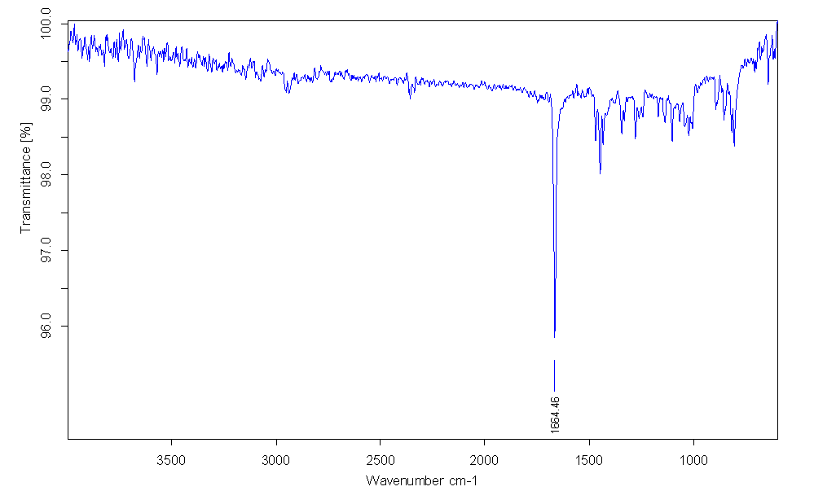
Figure S4. ¹H NMR of 3b
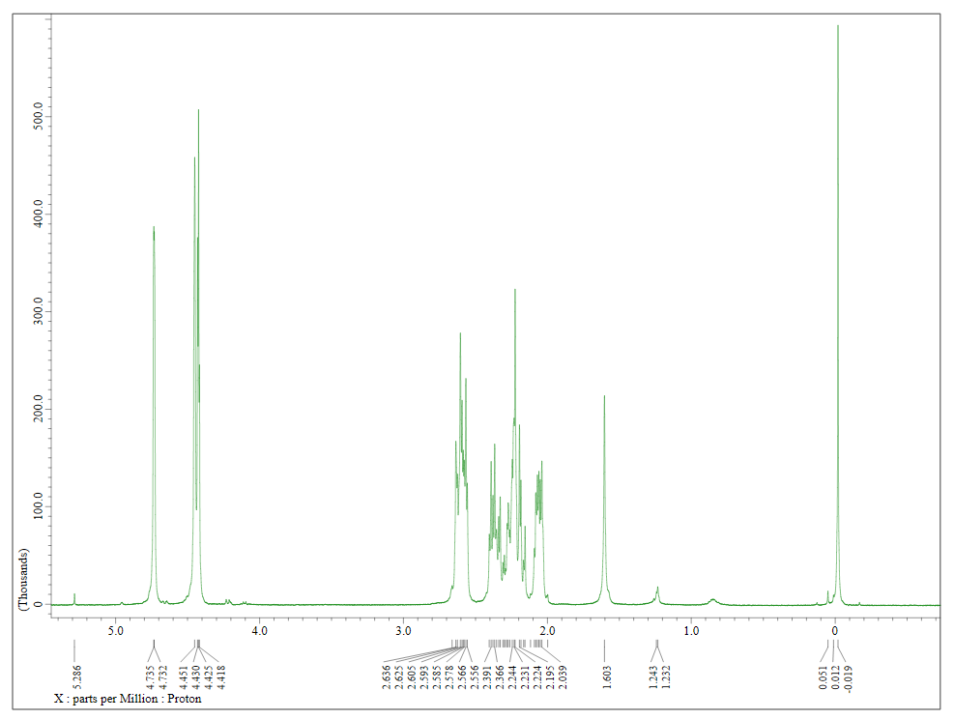

Figure S5. ¹³C NMR of 3b
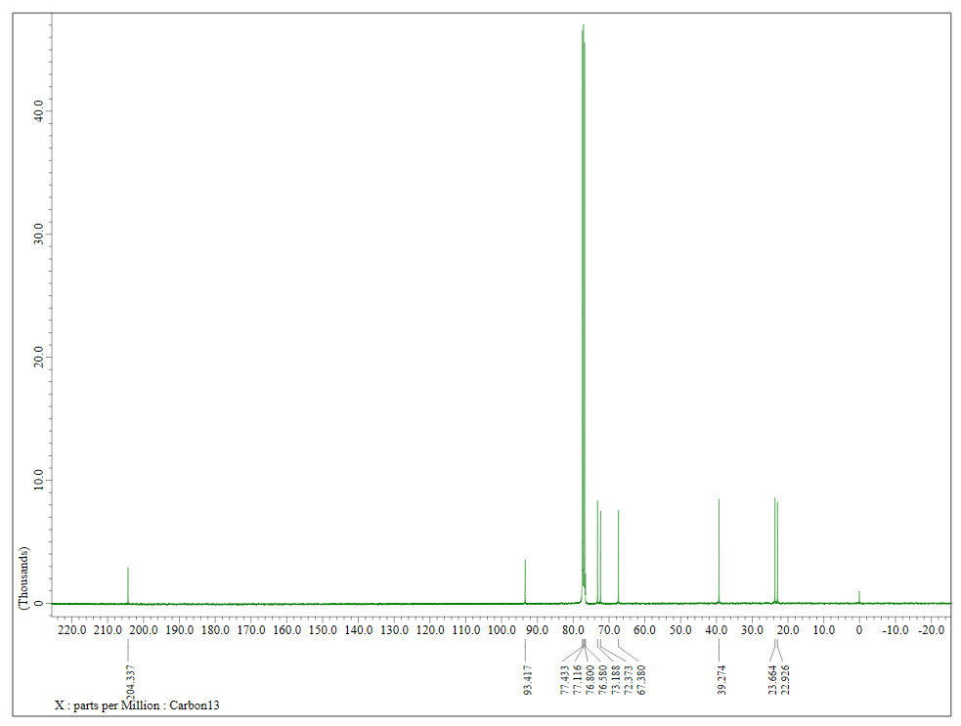

Figure S6. IR spectrum of 3b
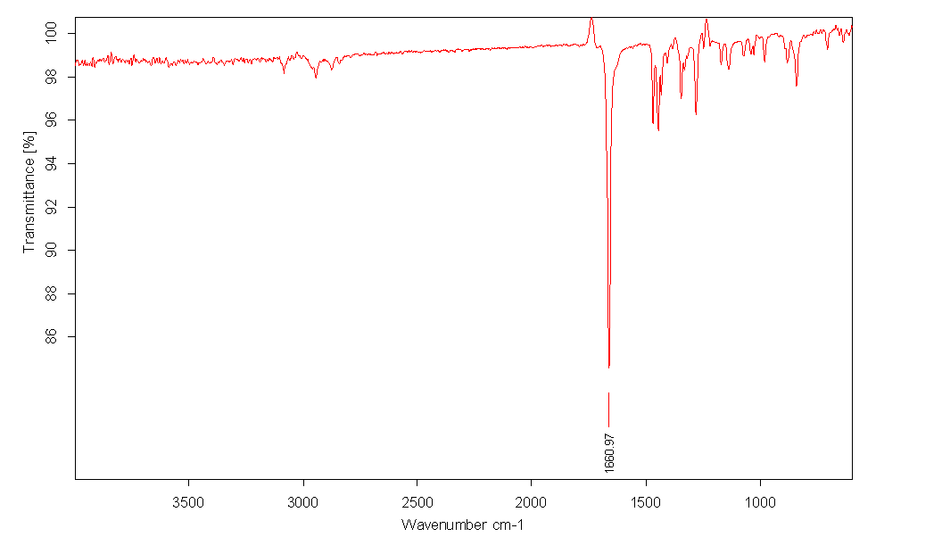

Figure S7. ¹H NMR of 3b’
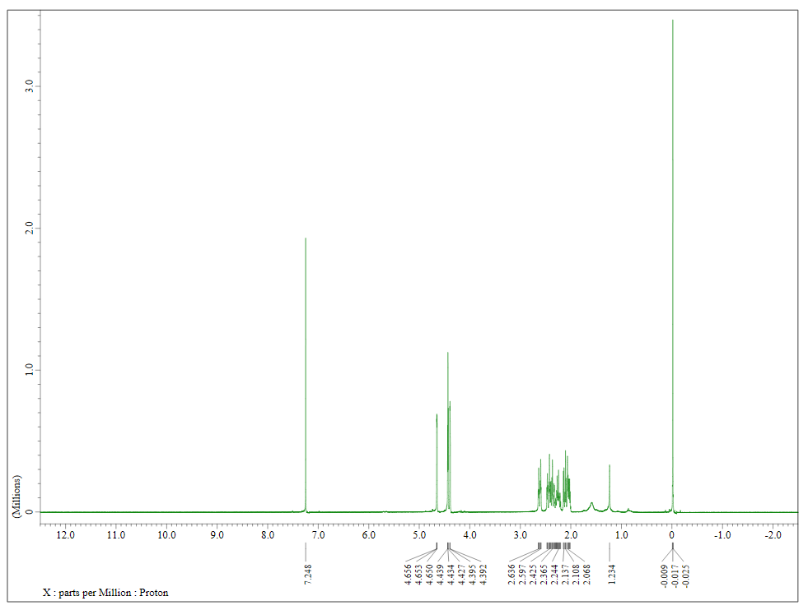

Figure S8. ¹³C NMR of 3b’
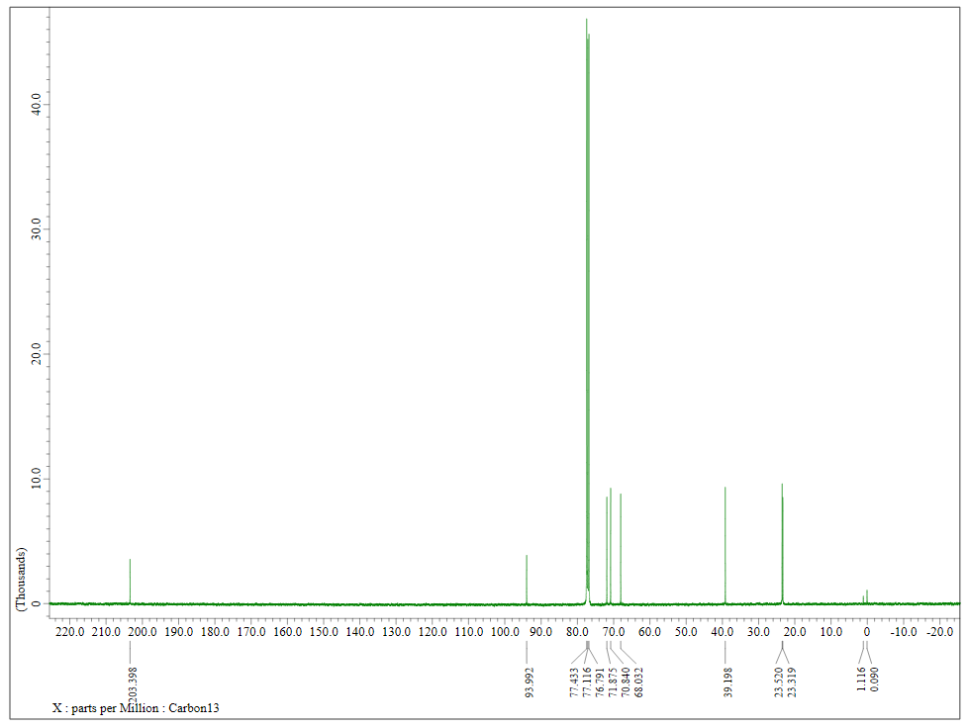

Figure S9. IR spectrum of 3b’
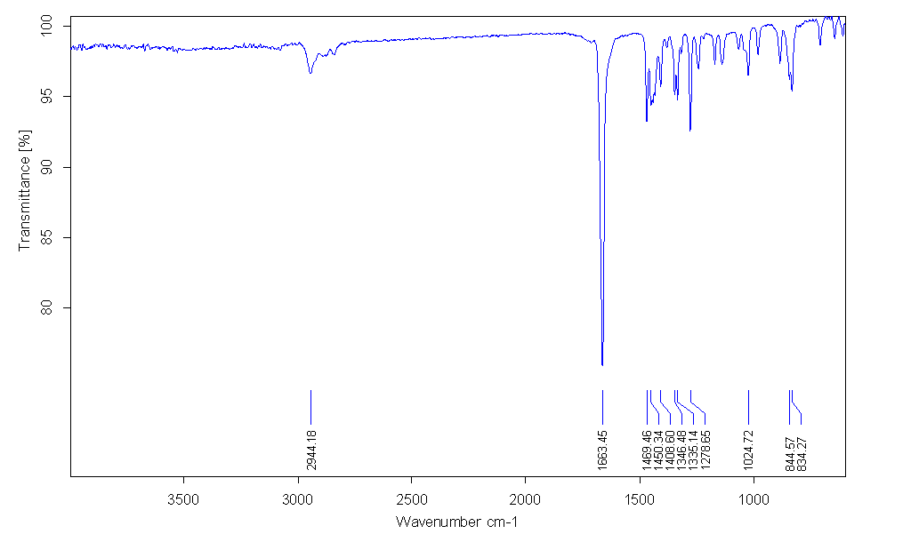
Figure S10. ¹H NMR of 4a
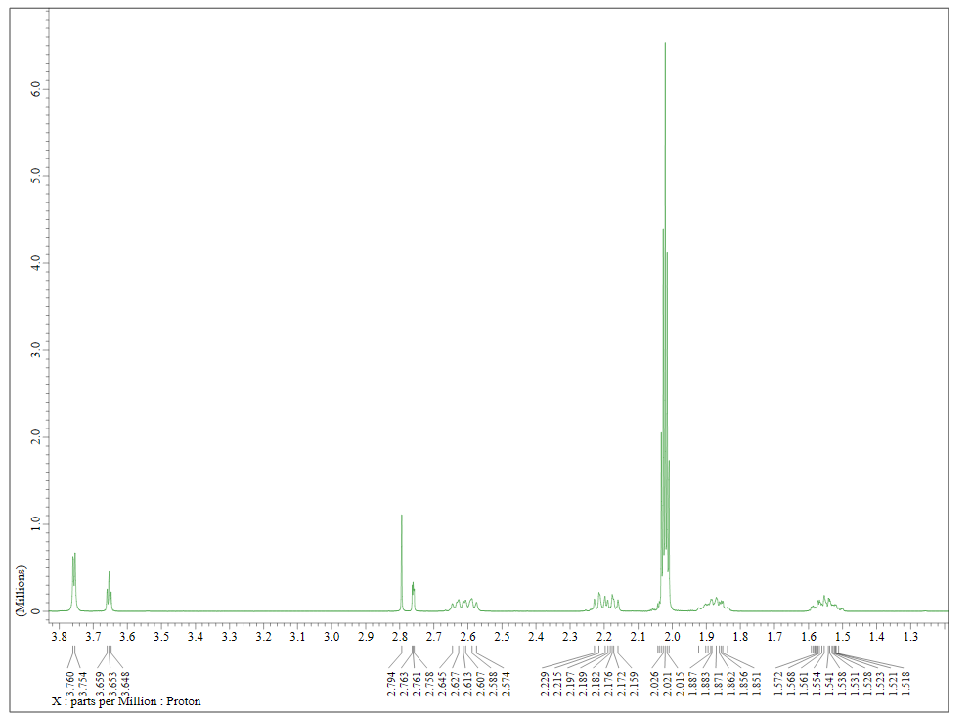

Figure S11. ¹³C NMR of 4a
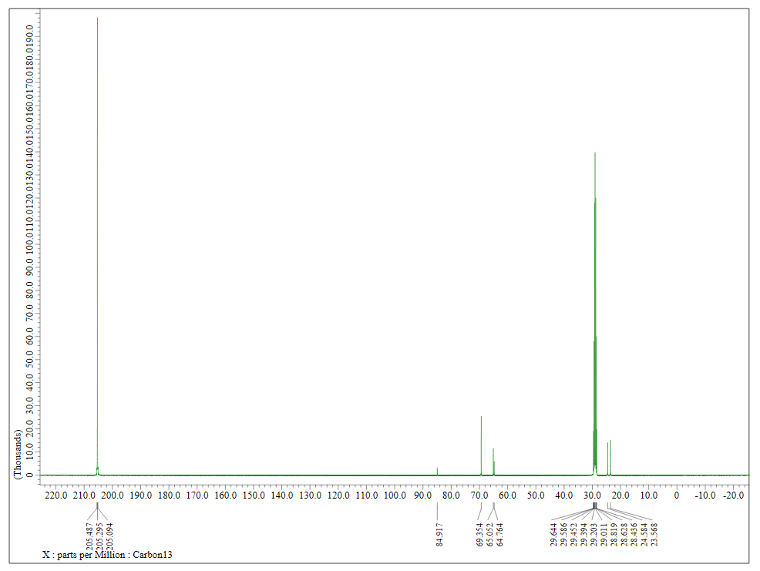

Figure S12. ¹H NMR of 4b

Figure S13. ¹³C NMR of 4b
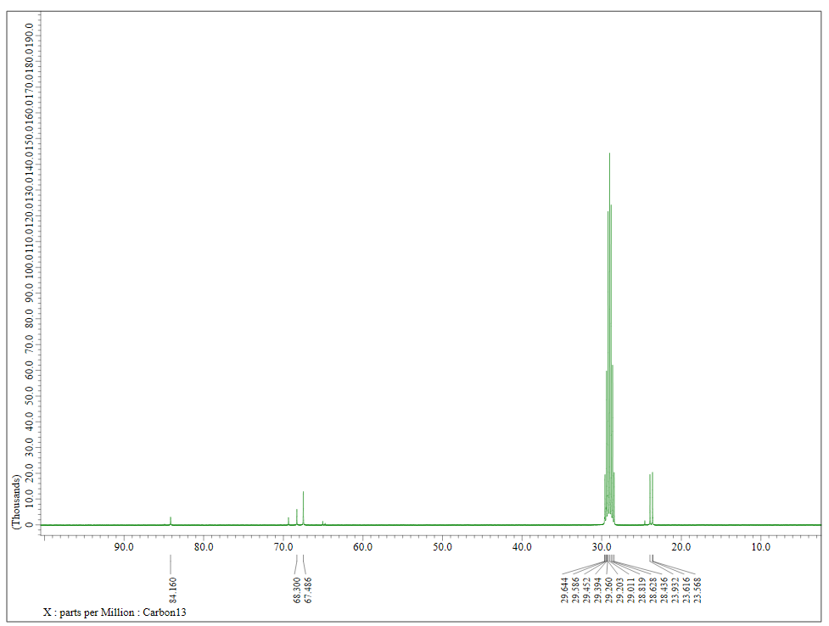

Figure S14. Packing diagram of 3b along b axis

Figure S15. Packing diagram of 4a along a axis.

