Figure S1: Population selection

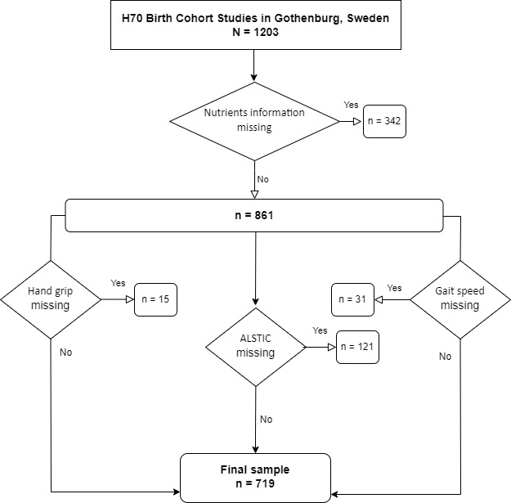

Table S1: Linear association models.
Variable | Appendicular Lean Soft Tissue (kg/m2) |  |  |  |  | Handgrip strength (kPa) |  |  |  |  | Gaitspeed 30 m. (m/s)
 | Estimate | Std. Error | P value | P.adjust | interaction sig. with sex | Estimate | Std. Error | P value | P.adjust | interaction sig. with sex | Estimate | Std. Error | P value | P.adjust | interaction sig. with sex
Protein (g) | 0,0107 | 0,0023 | 0,000 | 0,000 | 0 | 0,0721 | 0,0486 | 0,139 | 0,416 | 0 | -0,0004 | 0,0006 | 0,5060000 | 0,416 | 0
Fat (g) | 0,0021 | 0,0022 | 0,336 | 0,382 | 0 | -0,0213 | 0,0443 | 0,630 | 0,797 | 0 | -0,0005 | 0,0005 | 0,3500000 | 0,797 | 0
Carbohydrates(g) | -0,0015 | 0,0008 | 0,067 | 0,107 | 0 | -0,0006 | 0,0170 | 0,972 | 0,981 | 0 | -0,0002 | 0,0002 | 0,2880000 | 0,981 | 0
Fibers(g) | 0,0063 | 0,0048 | 0,186 | 0,251 | 0 | 0,2197 | 0,0977 | 0,025 | 0,223 | 0 | 0,0021 | 0,0012 | 0,0758000 | 0,223 | 0
Vitamin C(mg) | 0,0008 | 0,0005 | 0,122 | 0,174 | 1 | 0,0016 | 0,0105 | 0,881 | 0,981 | 0 | 0,0001 | 0,0001 | 0,4820000 | 0,981 | 0
Iron (mg) | 0,0439 | 0,0137 | 0,001 | 0,005 | 1 | 0,5741 | 0,2820 | 0,042 | 0,269 | 0 | 0,0031 | 0,0034 | 0,3640000 | 0,269 | 0
Calcium(mg) | 0,0000 | 0,0001 | 0,862 | 0,862 | 0 | 0,0013 | 0,0023 | 0,586 | 0,797 | 0 | -0,0001 | 0,0000 | 0,0164000 | 0,797 | 0
Retinol equivalent (µg) | 0,0001 | 0,0001 | 0,008 | 0,017 | 0 | 0,0005 | 0,0011 | 0,675 | 0,797 | 0 | 0,0000 | 0,0000 | 0,6626000 | 0,797 | 0
Vitamin D(µg) | 0,0292 | 0,0089 | 0,001 | 0,004 | 0 | -0,0060 | 0,1838 | 0,974 | 0,981 | 0 | 0,0007 | 0,0022 | 0,7420000 | 0,981 | 0
Vitamin E(mg) | 0,0032 | 0,0034 | 0,340 | 0,382 | 0 | 0,2116 | 0,0687 | 0,002 | 0,058 | 1 | -0,0002 | 0,0008 | 0,8100000 | 0,058 | 0
Thiamine(mg) | 0,2178 | 0,1240 | 0,079 | 0,119 | 0 | 2,4390 | 2,5400 | 0,337 | 0,759 | 0 | -0,0197 | 0,0308 | 0,5240000 | 0,759 | 0
Riboflavin(mg) | 0,2068 | 0,0838 | 0,014 | 0,029 | 0 | 1,1740 | 1,7240 | 0,496 | 0,797 | 0 | -0,0538 | 0,0208 | 0,0098300 | 0,797 | 1
Niacin equivalent (mg) | 0,0176 | 0,0049 | 0,000 | 0,003 | 0 | 0,0523 | 0,1023 | 0,609 | 0,797 | 0 | 0,0008 | 0,0012 | 0,5100000 | 0,797 | 0
Vitamin B6 (mg) | 0,0957 | 0,0515 | 0,064 | 0,107 | 0 | 2,6402 | 1,0537 | 0,012 | 0,167 | 0 | 0,0120 | 0,0128 | 0,3470000 | 0,167 | 0
Vitamin B12 (µg) | 0,0397 | 0,0104 | 0,000 | 0,001 | 0 | 0,1225 | 0,2165 | 0,571 | 0,797 | 0 | -0,0025 | 0,0026 | 0,3431000 | 0,797 | 0
Phosphorus (mg) | 0,0004 | 0,0001 | 0,007 | 0,016 | 0 | 0,0053 | 0,0027 | 0,050 | 0,269 | 0 | 0,0000 | 0,0000 | 0,4229000 | 0,269 | 0
Magnesium(mg) | 0,0005 | 0,0005 | 0,280 | 0,360 | 0 | 0,0098 | 0,0095 | 0,302 | 0,741 | 0 | 0,0002 | 0,0001 | 0,0571000 | 0,741 | 0
Potassium(mg) | 0,0001 | 0,0000 | 0,027 | 0,048 | 0 | 0,0004 | 0,0010 | 0,665 | 0,797 | 0 | 0,0000 | 0,0000 | 0,2232000 | 0,797 | 0
Zinc (mg) | 0,0604 | 0,0172 | 0,000 | 0,003 | 0 | 0,6027 | 0,3556 | 0,091 | 0,349 | 0 | -0,0079 | 0,0043 | 0,0662000 | 0,349 | 0
Alcohol(g) | -0,0017 | 0,0024 | 0,489 | 0,528 | 0 | 0,0207 | 0,0499 | 0,679 | 0,797 | 0 | 0,0005 | 0,0006 | 0,3696000 | 0,797 | 0
Satturated fatty acids(g) | -0,0019 | 0,0038 | 0,626 | 0,650 | 0 | -0,0019 | 0,0780 | 0,981 | 0,981 | 0 | -0,0016 | 0,0009 | 0,0997000 | 0,981 | 0
Monounsaturated fatty acids (g) | 0,0053 | 0,0052 | 0,308 | 0,378 | 0 | -0,0736 | 0,1066 | 0,490 | 0,797 | 0 | -0,0012 | 0,0013 | 0,3690000 | 0,797 | 0
Polyunsaturated fatty acids (g) | 0,0171 | 0,0072 | 0,017 | 0,034 | 0 | -0,0775 | 0,1477 | 0,600 | 0,737 | 0 | 0,0017 | 0,0018 | 0,3430000 | 0,737 | 0
EPA (Fatty acid 20:5) (g) | 0,5892 | 0,1968 | 0,003 | 0,008 | 0 | 4,4431 | 4,0505 | 0,273 | 0,797 | 0 | 0,0289 | 0,0491 | 0,5570000 | 0,797 | 0
DHA (Fatty acid 22:6) (g) | 0,2978 | 0,0875 | 0,001 | 0,003 | 0 | 0,8009 | 1,8062 | 0,658 | 0,797 | 0 | 0,0195 | 0,0219 | 0,3720000 | 0,797 | 0
Folate (µg) | 0,0012 | 0,0004 | 0,002 | 0,006 | 1 | 0,0048 | 0,0080 | 0,548 | 0,269 | 0 | 0,0001 | 0,0001 | 0,1750000 | 0,269 | 0
Selenium (µg) | 0,0109 | 0,0024 | 0,000 | 0,000 | 0 | 0,0925 | 0,0491 | 0,060 | 0,416 | 0 | 0,0002 | 0,0006 | 0,7120000 | 0,416 | 0

