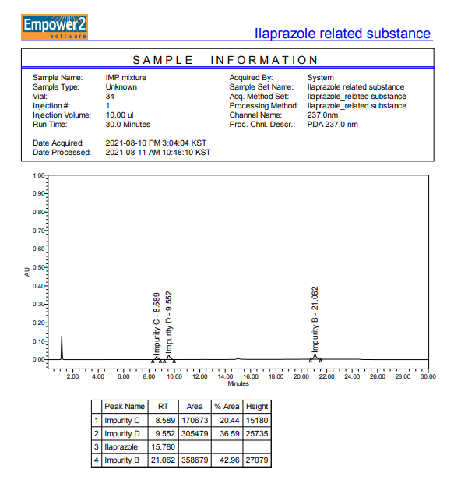
Supporting Information
Ilaprazole sulfur ether (impurity B)
Figure S1. Shows the chromatogram of Ilaprazole (Ila) impurity obtained through High-performance liquid chromatography (HPLC) analysis, depicting the retention time (RT). (RT: 21.062min)
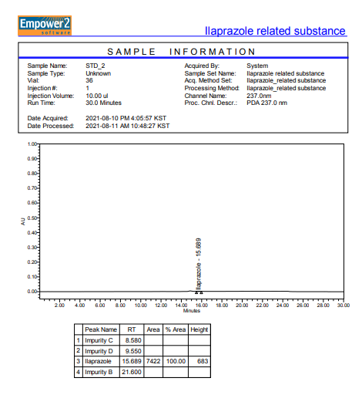
Figure S2. Shows the chromatogram of Ilaprazole (Ila) obtained through High-performance liquid chromatography (HPLC) analysis, depicting the retention time (RT). (RT: 15.689min)

(a) (b)

(c) (d)

(e)

Figure S3. The molecular structures of the coformers presented in Table 1.

Figure S4. PXRD pattern of Ila, Meg, Ila/Meg physical mixture and Ila/Meg obtained by co-crystallization.
Ila
Meg
Mixture
Ila/Meg
Angle [2θ]
Ila
Mixture
Nic
Ila/Nic
Angle [2θ]
Figure S5. PXRD pattern of Ila, Nic, Ila/Nic physical mixture and Ila/Nic obtained by co-crystallization.

Figure S6. Solution-state ¹H-NMR of Ilaprazole (Ila) (solvent: DMSO-d⁶) (Hydrogen numbering for each peak has been completed.)

Figure S7. Solution-state ¹³C-NMR of Ilaprazole (Ila) (solvent: DMSO-d⁶) (Carbon numbering for each peak has been completed.)
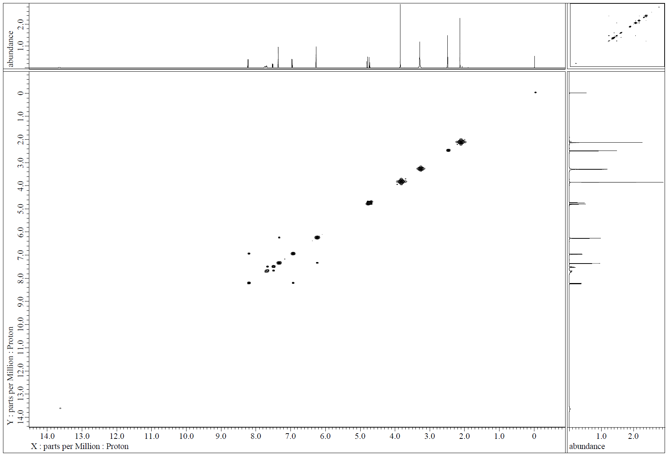
Figure S8. Solution-state 2D NMR (¹H-¹H COSY) of Ilaprazole (Ila)
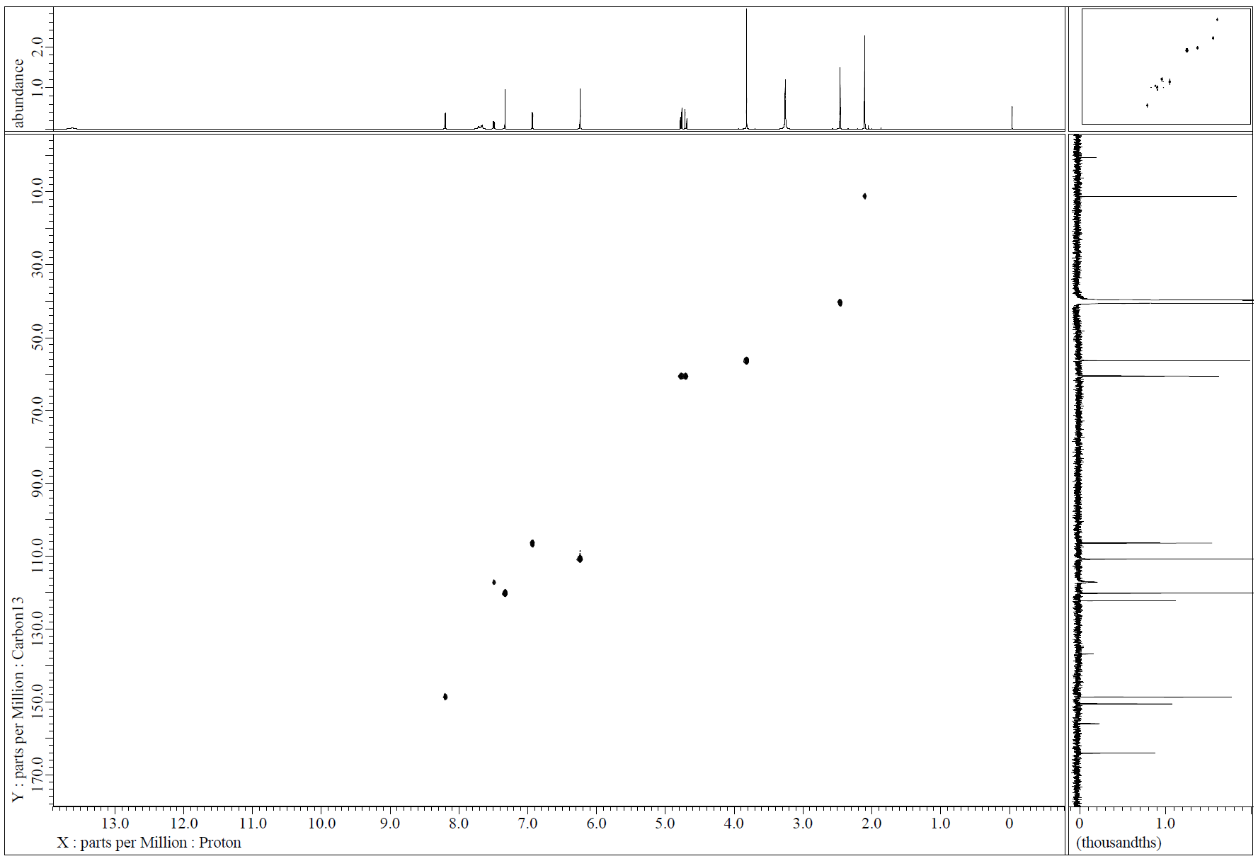
Figure S9. Solution-state 2D NMR (¹H-¹³C HSQC) of Ilaprazole (Ila)
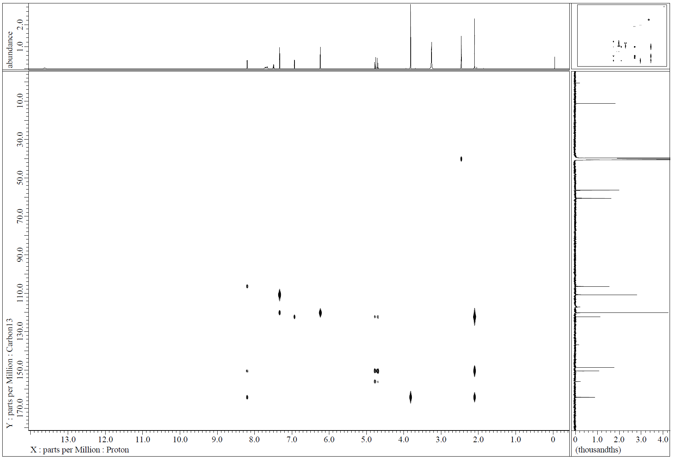
Figure S10. Solution-state 2D NMR (¹H-¹³C HMBC) of Ilaprazole (Ila)

Figure S11. Solution-state ¹H-NMR of Xylitol (Xyl) (solvent: DMSO-d⁶) (Hydrogen numbering for each peak has been completed.)

Figure S12. Solution-state ¹³C-NMR of Xylitol (Xyl) (solvent: DMSO-d⁶) (Hydrogen numbering for each peak has been completed.)

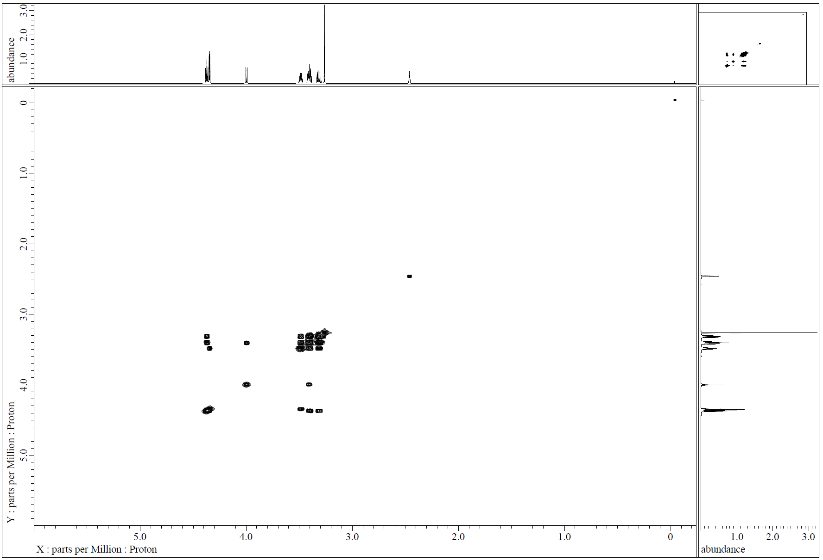

Figure S13. Solution-state 2D NMR (¹H-¹H COSY) of Xylitol (Xyl)

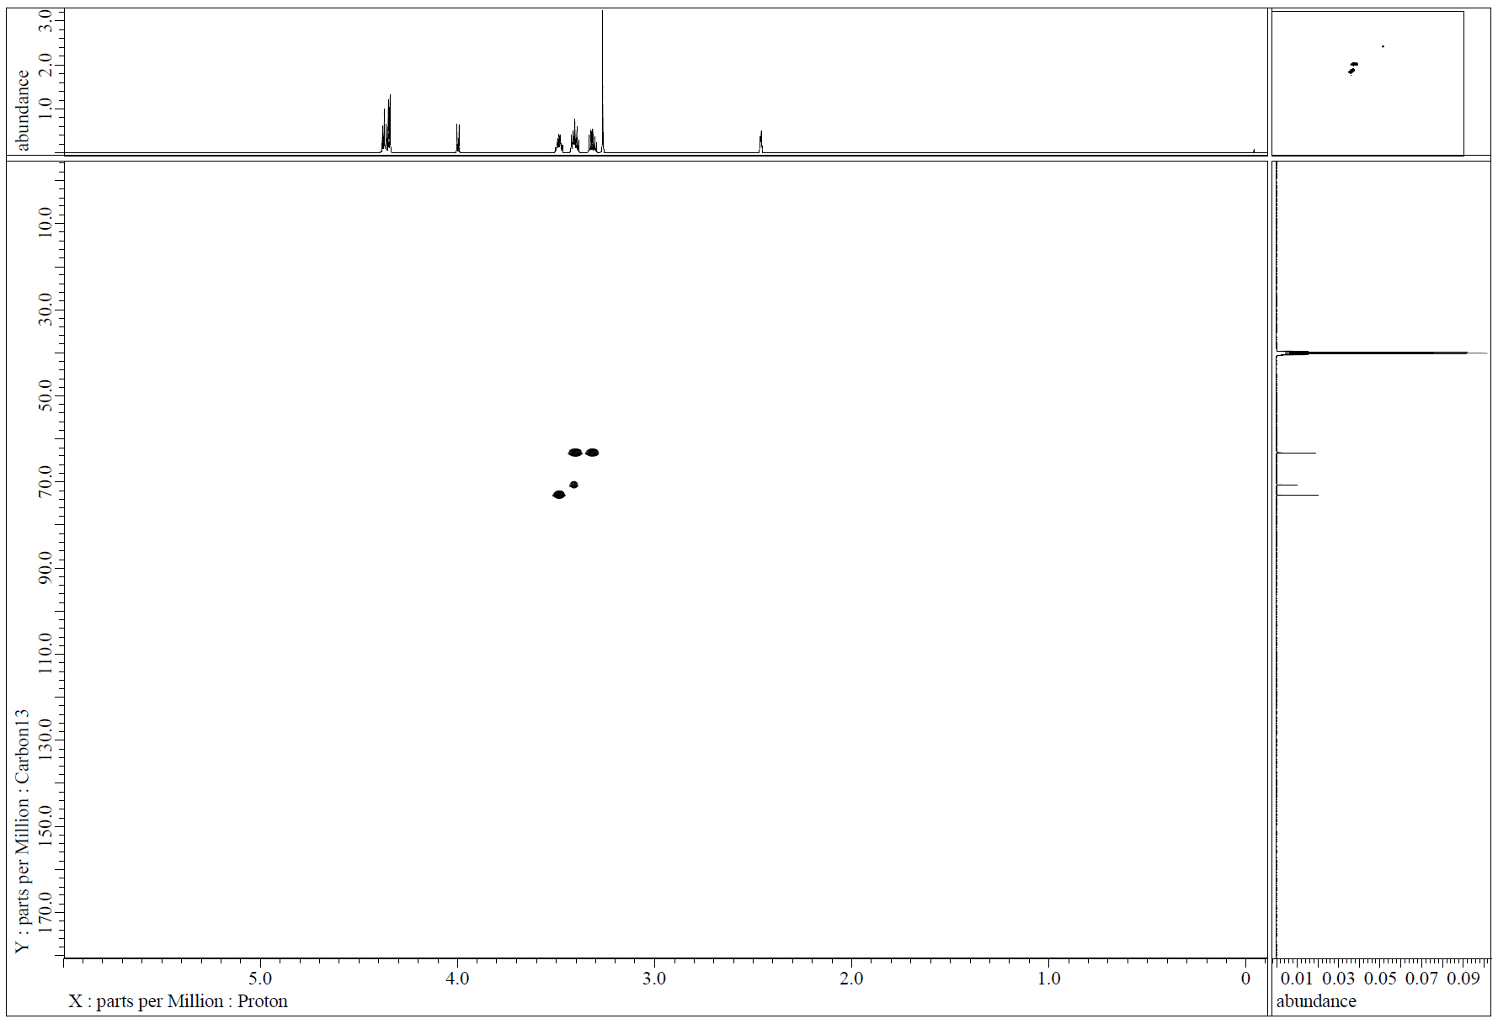

Figure S14. Solution-state 2D NMR (¹H-¹³C HSQC) of Xylitol (Xyl)

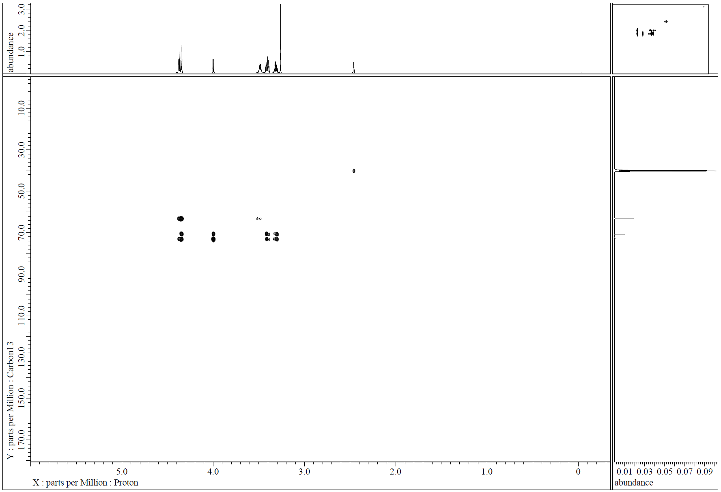

Figure S15. Solution-state 2D NMR (¹H-¹³C HMBC) of Xylitol (Xyl)

Figure S16. Solution-state ¹H-NMR of Ila/Xyl cocrystal (solvent: DMSO-d⁶)

Figure S17. Solution-state ¹³C-NMR of Ila/Xyl cocrystal (solvent: DMSO-d⁶)

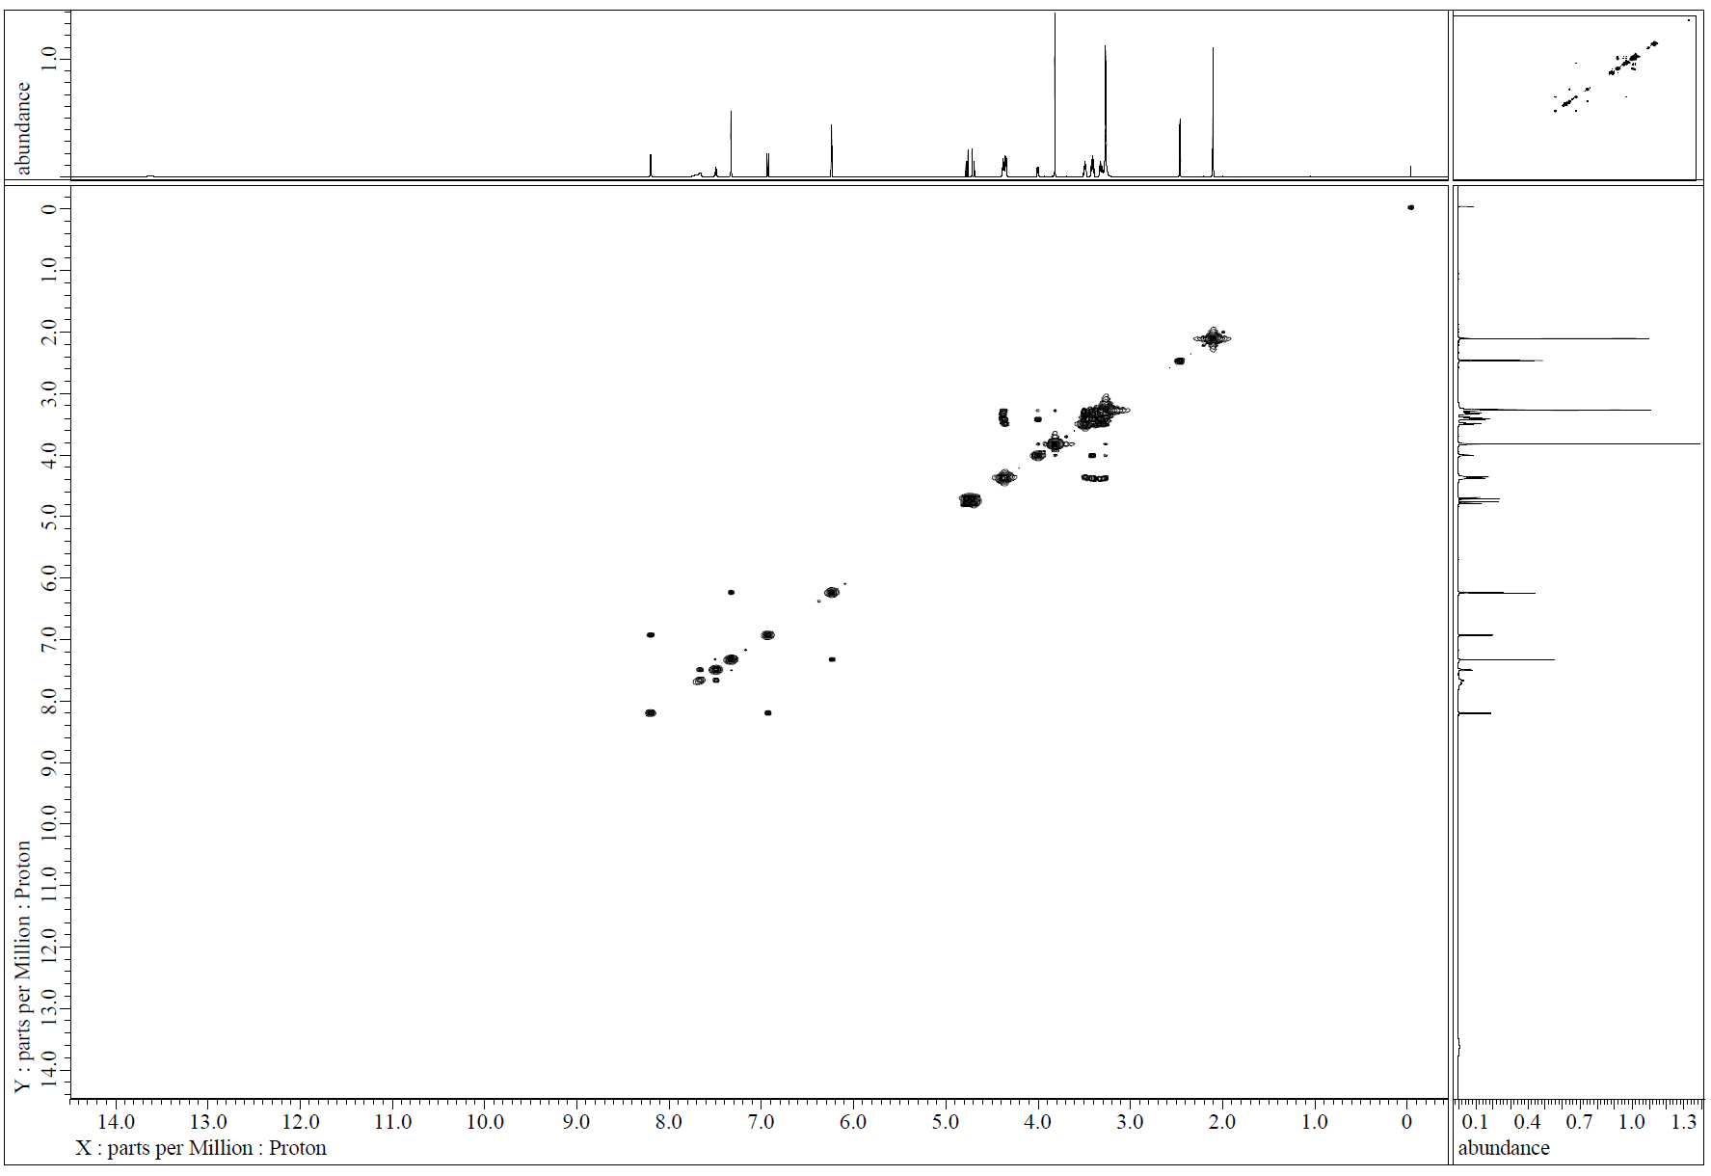

Figure S18. Solution-state 2D NMR (¹H-¹H COSY) of Ila/Xyl cocrystal

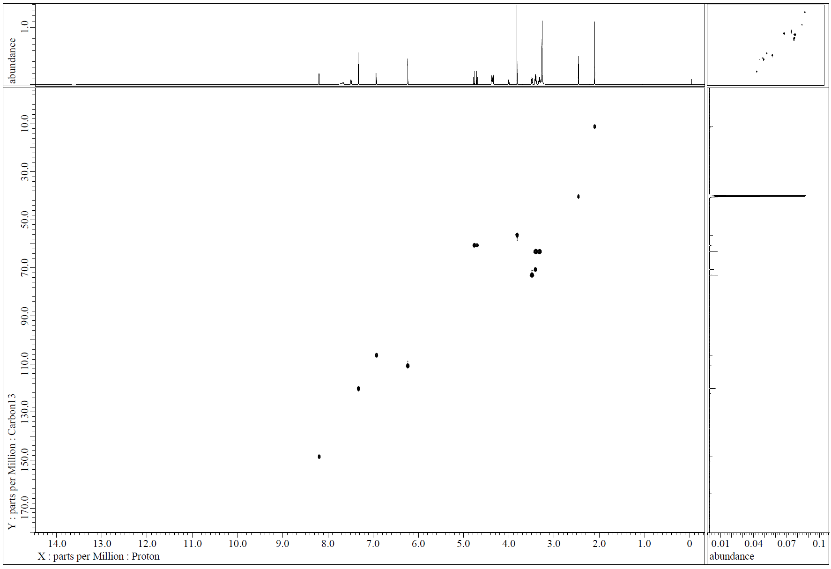

Figure S19. Solution-state 2D NMR (¹H-¹³C HSQC) of Ila/Xyl cocrystal

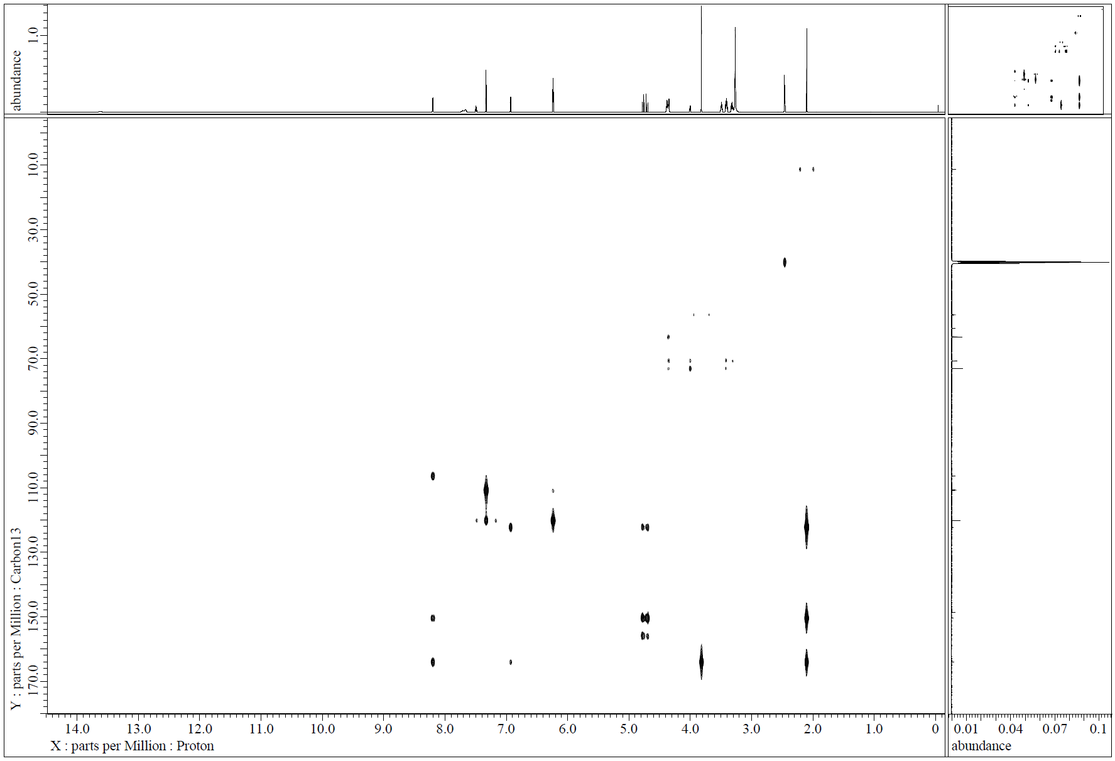

Figure S20. Solution-state 2D NMR (¹H-¹³C HMBC) of Ila/Xyl cocrystal

