Tab. S1 ED XRF limits of quantification [ng/m³].

Na | Mg | Al | Si | S | Cl | K | Ca | Ti | V | Cr | Mn
73 | 89 | 0.46 | 1.1 | 21 | 22 | 10 | 18 | 1.6 | 1.3 | 15 | 5.0
Fe | Ni | Cu | Zn | As | Se | Cd | In | Sb | Ba | Pb
16 | 2.4 | 3.6 | 4.3 | 0.50 | 1.8 | 25 | 57 | 7.7 | 1.2 | 2.7

S2
Tab. S2 ED XRF mean relative uncertainties [%].

Na | Mg | Al | Si | S | Cl | K | Ca | Ti | V | Cr | Mn
2 | 3 | 10 | 5 | 1 | 2 | 1 | 1 | 3 | 49 | 22 | 15
Fe | Ni | Cu | Zn | As | Se | Cd | In | Sb | Ba | Pb
2 | 101 | 21 | 11 | 116 | 39 | 880 | 908 | 18 | 14 | 29

Tab. S3 Minimum, maximum, median and mean concentrations in PM₁₀ and mean relative uncertainties. Min: minimum; Max: maximum; Med: median; Avg: mean; NA: no data available, LVG: levoglucosan, MAN: mannosan; GAL: galactosan. All units in ng/m³, except the PM₁₀ (µg/m³), and relative uncertainty (unitless).

Species | TOBA |  |  |  |  | TOKU |  |  |  |  | TORE
 | Min | Max | Med | Avg | Unc | Min | Max | Med | Avg | Unc | Min | Max | Med | Avg | Unc
OC | 1 827 | 41 557 | 6 955 | 8 940 | 11% | 1 827 | 51 719 | 6 008 | 8 131 | 13% | 1 827 | 48 093 | 7 917 | 10 034 | 9%
EC | 10 | 12 325 | 2 024 | 2 705 | 12% | 10 | 14 746 | 1 621 | 2 363 | 13% | 10 | 14 402 | 2 791 | 3 318 | 10%
OC1 | 290 | 10 472 | 1 035 | 1 624 | 12% | 353 | 14 109 | 1 017 | 1 581 | 15% | 144 | 13 315 | 1 667 | 2 299 | 9%
OC2 | 277 | 5 337 | 943 | 1 215 | 13% | 257 | 6 461 | 856 | 1 139 | 17% | 150 | 6 041 | 1 026 | 1 295 | 10%
OC3 | 446 | 5 758 | 1 309 | 1 565 | 15% | 434 | 6 662 | 1 179 | 1 420 | 19% | 349 | 9 620 | 1 295 | 1 539 | 10%
OC4 | 474 | 4 207 | 1 771 | 1 860 | 16% | 419 | 4 646 | 1 457 | 1 547 | 22% | 432 | 7 598 | 1 940 | 2 089 | 11%
EC1 | 219 | 14 228 | 1 730 | 2 668 | 11% | 214 | 23 328 | 1 545 | 2 501 | 12% | 75 | 19 354 | 1 905 | 2 779 | 11%
EC2 | 140 | 13 887 | 1 233 | 1 938 | 11% | 142 | 12 624 | 1 096 | 1 676 | 12% | 5 | 13 975 | 1 270 | 1 851 | 11%
EC3 | 89 | 2 012 | 455 | 540 | 13% | 137 | 1 775 | 402 | 539 | 14% | 38 | 3 482 | 647 | 827 | 12%
EC4 | 105 | 1 052 | 337 | 378 | 14% | 25 | 999 | 237 | 276 | 17% | 25 | 3 122 | 552 | 735 | 14%
LVG | 5 | 3 177 | 223 | 386 | 19% | 5 | 3 826 | 243 | 392 | 19% | 5 | 3 327 | 229 | 379 | 19%
MAN | 5 | 694 | 33 | 67 | 19% | 5 | 627 | 49 | 75 | 20% | 5 | 641 | 61 | 90 | 20%
GAL | 5 | 148 | 11 | 17 | 21% | 5 | 140 | 13 | 17 | 21% | 5 | 157 | 20 | 25 | 21%
Na⁺ | 217 | 2 450 | 512 | 574 | 15% | 164 | 2 069 | 447 | 507 | 15% | 160 | 3 419 | 560 | 644 | 15%
NH₄⁺ | 2.5 | 12 332 | 1 348 | 1 776 | 15% | 31 | 11 804 | 1 089 | 1 516 | 15% | 48.4 | 11 104 | 981 | 1 502 | 15%
K+ | 37 | 6 173 | 244 | 333 | 15% | 27 | 1 314 | 179 | 243 | 15% | 40 | 9 301 | 346 | 507 | 15%
Ca²⁺ | 58 | 4 413 | 269 | 366 | 15% | 62 | 7 763 | 243 | 448 | 15% | 79 | 7 347 | 595 | 1 561 | 15%
Mg²⁺ | 2.5 | 357 | 39 | 48 | 15% | 2.5 | 1 063 | 35 | 57 | 15% | 2.5 | 1 838 | 74 | 179 | 14%
fluorides | 2.5 | 61 | 22.9 | 19.2 | 15% | 2.5 | 60 | 2.5 | 5.3 | 15% | 2.5 | 184 | 9.2 | 30.4 | 15%
chlorides | 23 | 3 360 | 256 | 437 | 15% | 26 | 4 315 | 208 | 422 | 15% | 44 | 14 329 | 759 | 1 505 | 15%
bromides | 2.5 | 37 | 10.3 | 11.5 | 15% | 2.5 | 18 | 2.5 | 2.8 | 16% | 2.5 | 42 | 7.7 | 10.2 | 15%
nitrates | 79 | 12 552 | 2 473 | 3 139 | 15% | 118 | 14 771 | 2 268 | 2 839 | 15% | 80 | 16 348 | 2 850 | 3 796 | 15%
sulphates | 19 | 18 044 | 2 072 | 2 781 | 15% | 12 | 16 355 | 1 626 | 2 340 | 15% | 378 | 17 889 | 2 883 | 3 634 | 15%
Na | 32 | 181 | 71 | 76 | 1% | 37 | 210 | 74 | 80 | 1% | 35 | 316 | 91 | 106 | 1%
Mg | 45 | 466 | 89 | 104 | 2% | 46 | 597 | 95 | 116 | 2% | 43 | 1 369 | 131 | 201 | 1%
Al | 0.5 | 1 835 | 0.5 | 38 | 2% | 0.5 | 1 802 | 0.5 | 49 | 2% | 0.5 | 2 118 | 0.5 | 52 | 2%
Si | 0.25 | 4 576 | 0.25 | 129 | 1% | 0.25 | 4 788 | 0.25 | 195 | 1% | 0.25 | 5 232 | 72.97 | 238 | 1%
S | 40 | 2 401 | 306 | 410 | 1% | 40 | 2 338 | 290 | 402 | 1% | 74 | 2 326 | 451 | 537 | 1%
Cl | 8.5 | 1 748 | 125 | 250 | 1% | 10.4 | 3 032 | 155 | 296 | 1% | 17.3 | 6 592 | 478 | 784 | 1%
K | 19 | 531 | 118 | 139 | 1% | 10 | 555 | 109 | 139 | 1% | 19 | 3 572 | 168 | 231 | 1%
Ca | 9.1 | 2 613 | 98 | 167 | 1% | 3.6 | 4 663 | 105 | 245 | 1% | 9.2 | 4 934 | 362 | 1 009 | 1%
Ti | 0.16 | 152 | 4.5 | 8.8 | 7% | 0.46 | 160 | 5.6 | 11.4 | 6% | 0.17 | 190 | 8.2 | 12.9 | 6%
V | 0.068 | 4 | 0.67 | 0.79 | 44% | 0.051 | 4.9 | 0.66 | 0.85 | 41% | 0.103 | 7.7 | 1.1 | 1.68 | 23%
Cr | 3.8 | 35 | 6.6 | 7.2 | 8% | 4.5 | 32 | 7.3 | 9.2 | 6% | 4.5 | 62 | 10.2 | 15 | 4%
Mn | 1.7 | 87 | 5 | 9 | 7% | 1.8 | 95 | 6.3 | 12 | 6% | 1.8 | 361 | 15.1 | 60 | 1%
Fe | 14.8 | 4 296 | 123 | 291 | 1% | 14.3 | 3 439 | 181 | 399 | 1% | 9.7 | 17 361 | 526 | 3 142 | 1%
Ni | 0.075 | 17 | 0.62 | 0.88 | 56% | 0.075 | 10 | 0.88 | 1.41 | 38% | 0.075 | 12 | 0.68 | 0.96 | 45%
Cu | 0.97 | 124 | 3.9 | 5.6 | 11% | 1.36 | 64 | 4.5 | 7.2 | 9% | 1.37 | 82 | 7.2 | 10.5 | 7%
Zn | 2.4 | 190 | 22 | 30 | 3% | 3.7 | 318 | 20 | 35 | 3% | 3.3 | 1 888 | 53 | 197 | 1%
As | 0.013 | 5 | 0.29 | 0.4 | 60% | 0.013 | 2.5 | 0.3 | 0.38 | 55% | 0.013 | 10.6 | 0.69 | 1.5 | 21%
Se | 0.01 | 4.2 | 0.76 | 0.89 | 56% | 0.01 | 3.4 | 0.77 | 0.92 | 52% | 0.03 | 4.1 | 0.92 | 1.05 | 50%
Cd | 0.14 | 17 | 5.8 | 6.4 | 203% | 0.14 | 24 | 5.8 | 6.2 | 210% | 0.14 | 156 | 5.9 | 8.4 | 167%
In | 1 | 148 | 10 | 12 | 192% | 1 | 49 | 10 | 12 | 167% | 1 | 51 | 10 | 12 | 192%
Sb | 0.86 | 271 | 20 | 29 | 10% | 0.98 | 447 | 20 | 34 | 9% | 1.61 | 506 | 49 | 95 | 5%
Ba | 0.24 | 32 | 2.3 | 3.4 | 17% | 0.14 | 30 | 3 | 4.6 | 13% | 0.36 | 32 | 3.5 | 5 | 14%
Pb | 0.72 | 50 | 8.1 | 10.8 | 13% | 0.9 | 65 | 6.8 | 9.8 | 12% | 1.28 | 379 | 19.2 | 46.2 | 4%
BaA | 0.35 | 65 | 4 | 8.2 | 26% | 0.32 | 91 | 3.2 | 7.7 | 25% | 0.37 | 224 | 12.5 | 24.3 | 25%
BaP | 0.19 | 41 | 3.4 | 6.1 | 25% | 0.17 | 62 | 2.7 | 5.8 | 24% | 0.2 | 182 | 8.8 | 18.9 | 25%
BbF | 0.32 | 34 | 3.3 | 5.4 | 26% | 0.31 | 45 | 2.7 | 5.3 | 25% | 0.3 | 147 | 9 | 16.4 | 25%
BghiPRL | 0.3 | 26 | 2.5 | 4.2 | 26% | 0.31 | 36 | 2 | 4.1 | 24% | 0.4 | 90 | 6.2 | 11.5 | 25%
BjF | 3 | 20 | 6.8 | 7.7 | 25% | 2.9 | 27 | 6.3 | 7.8 | 24% | 2.9 | 70 | 10.8 | 13.2 | 25%
BkF | 0.29 | 20 | 2 | 3.3 | 25% | 0.29 | 29 | 1.6 | 3.2 | 25% | 0.33 | 93 | 5.6 | 9.5 | 25%
DBahA | 0.59 | 2.3 | 0.82 | 0.96 | 25% | 0.59 | 2.4 | 1.04 | 1.12 | 25% | 0.6 | 12.6 | 1.93 | 2.51 | 25%
CRY | 0.34 | 60 | 5 | 8.9 | 25% | 0.3 | 79 | 3.7 | 8.1 | 25% | 0.42 | 189 | 13.1 | 22.2 | 25%
I123cdP | 0.58 | 22 | 2 | 3.4 | 25% | 0.6 | 31 | 2.1 | 3.6 | 25% | 0.59 | 49 | 5 | 7.7 | 25%
NO_{x} | NA | NA | NA | NA | NA | NA | NA | NA | NA | NA | 4 | 124 | 31 | 37 | 15%
PM₁₀ | 5.1 | 131 | 27 | 35 | 10% | 4.8 | 188 | 27 | 36 | 10% | 5.2 | 150 | 48 | 56 | 10%

Fig. S4 PMF source apportionment of PM₁₀ based on Fpeak Run.

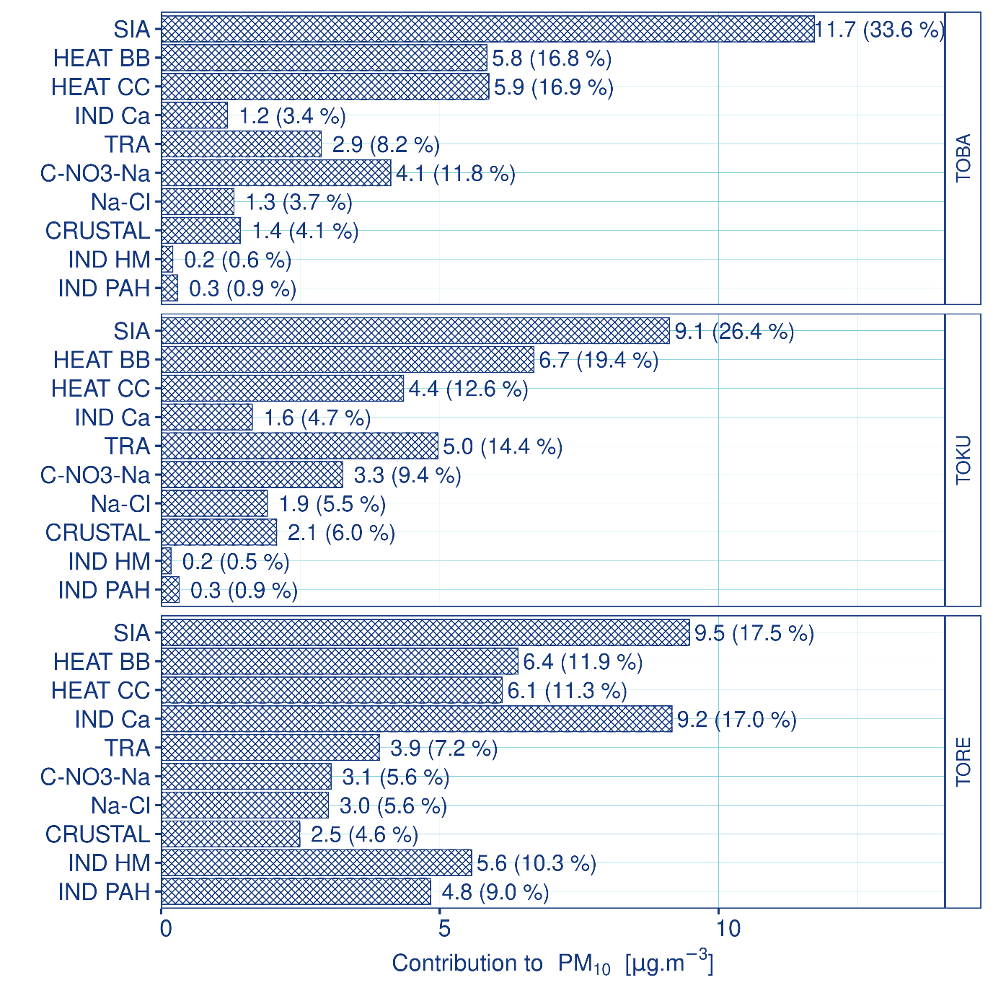

Fig. S5 PMF source apportionment of benzo[a]pyrene based on Fpeak Run.
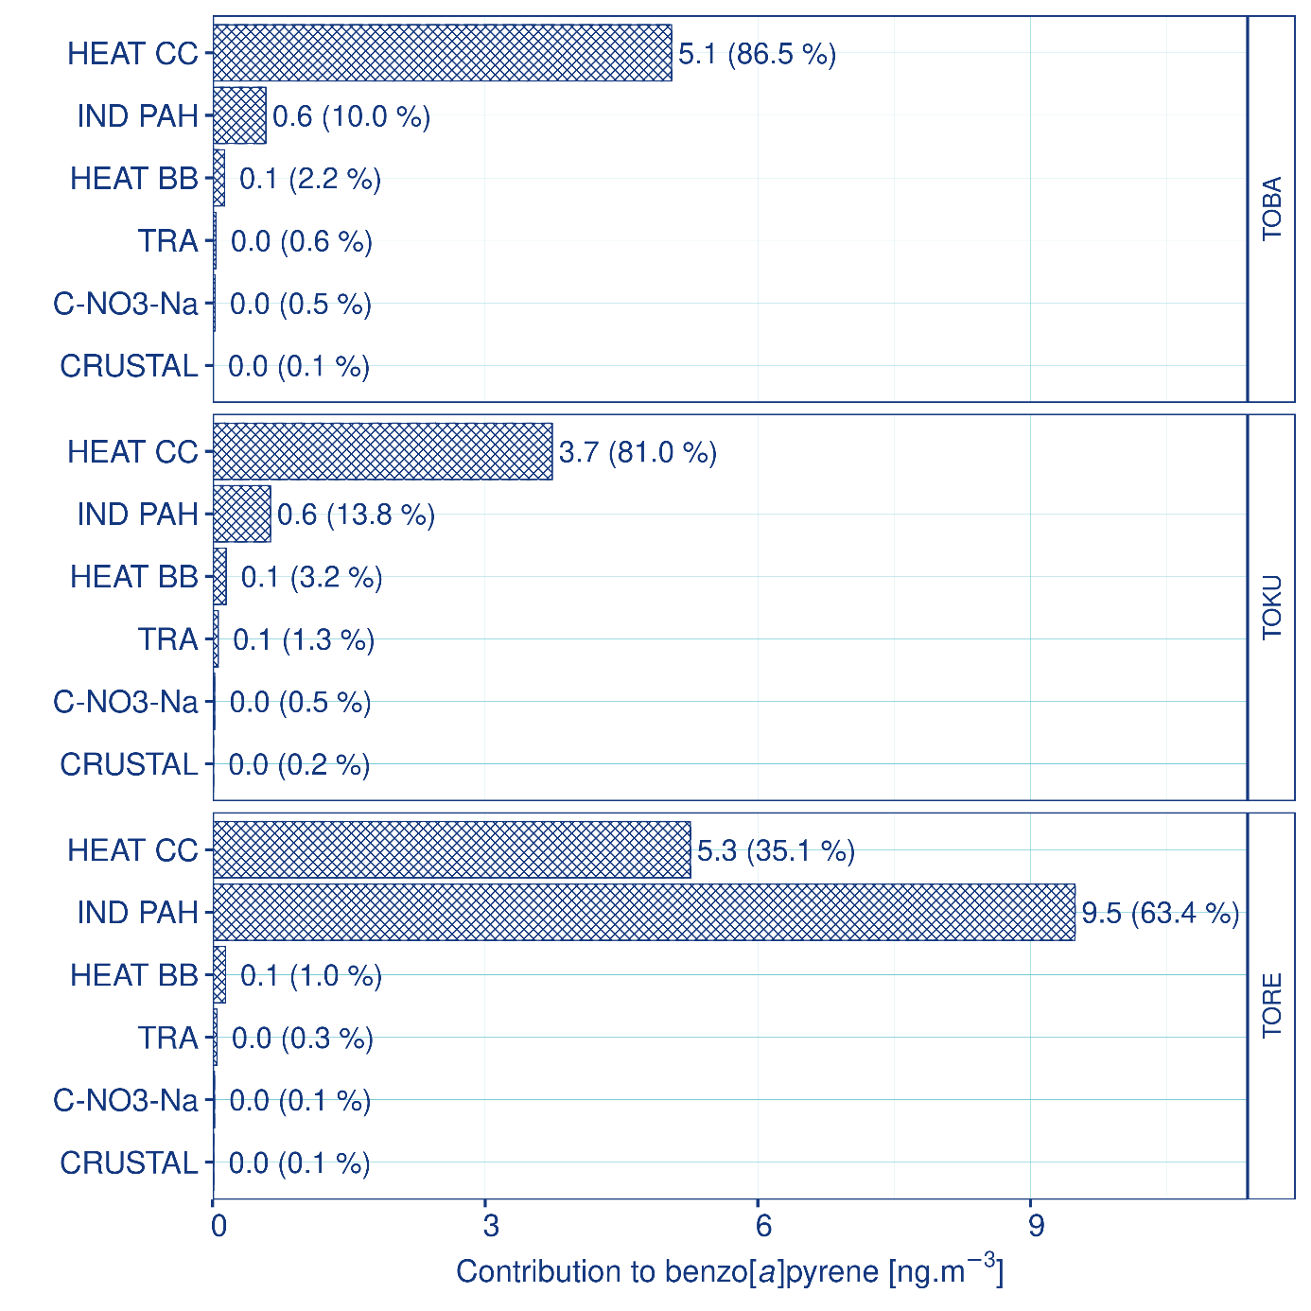

Fig. S6 Time series of absolute PM₁₀ concentrations.
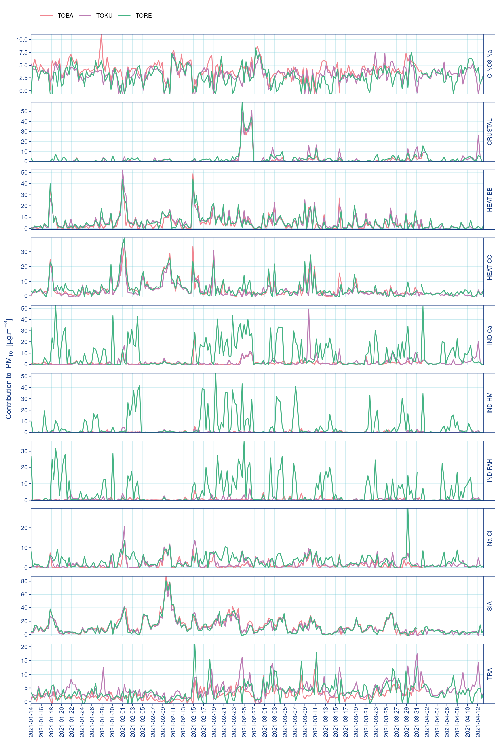

Fig. S7 Absolute contributions of concentrations of identified air pollution factors.
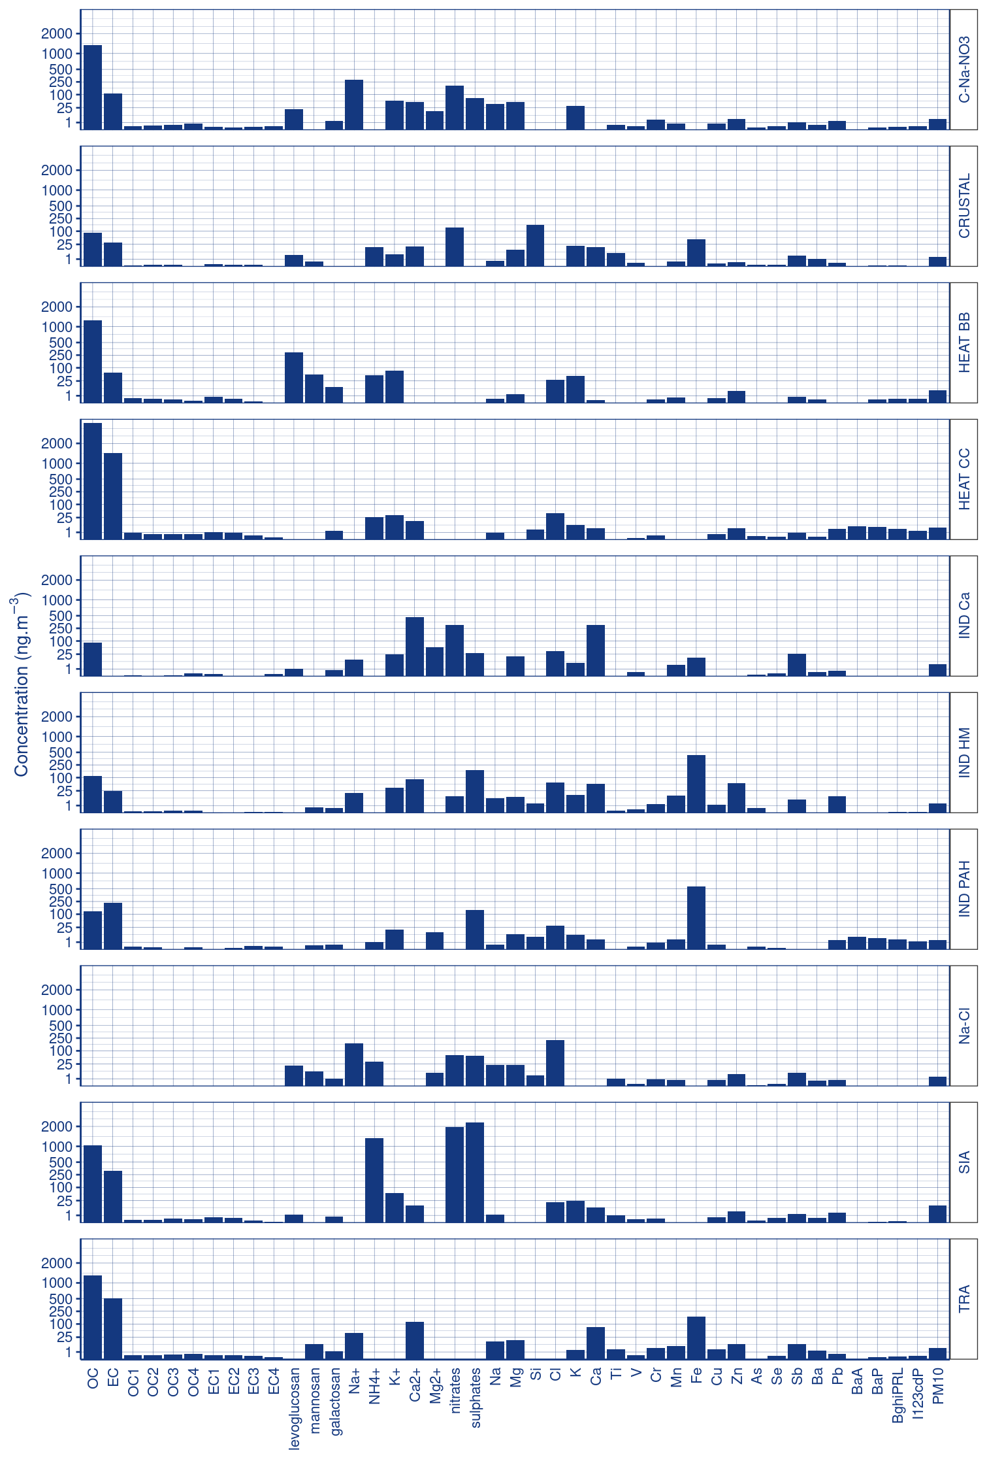

Fig. S8 Relative species concentration of identified air pollution factors.
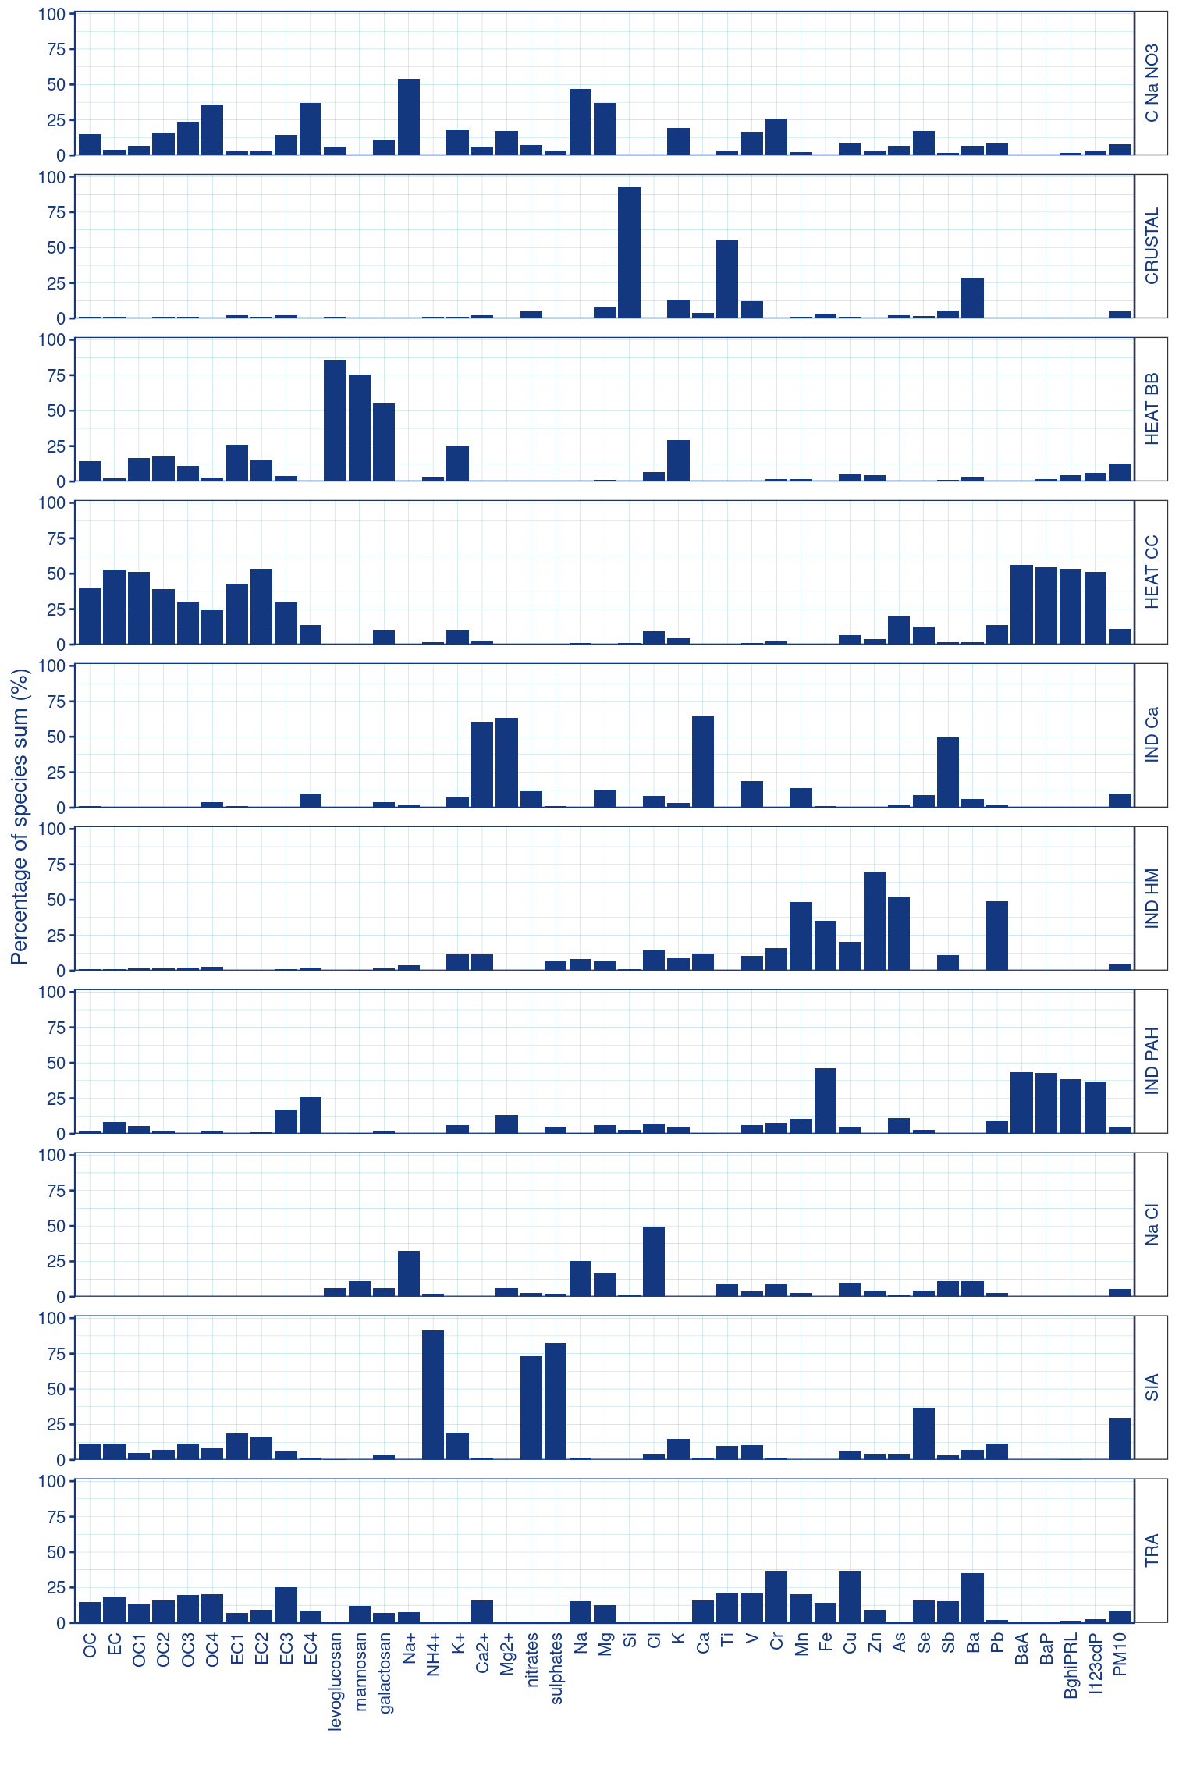

Fig. S9 Polar plots, SIA factor (concentration units in polarPlots are µg/m³, wind speed units are m/s).
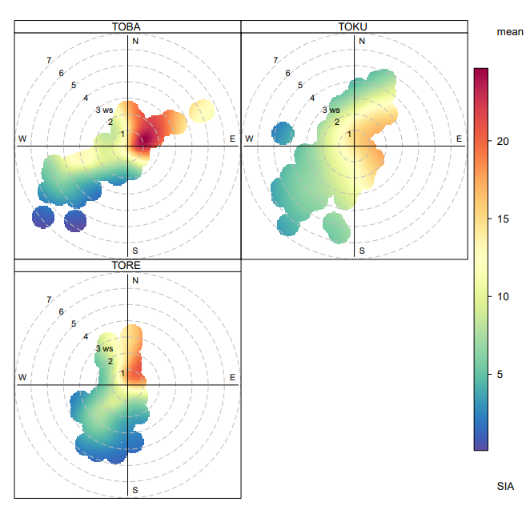

Fig. S10 Polar plots, HEAT BB factor (concentration units in polarPlots are µg/m³, wind speed units are m/s).
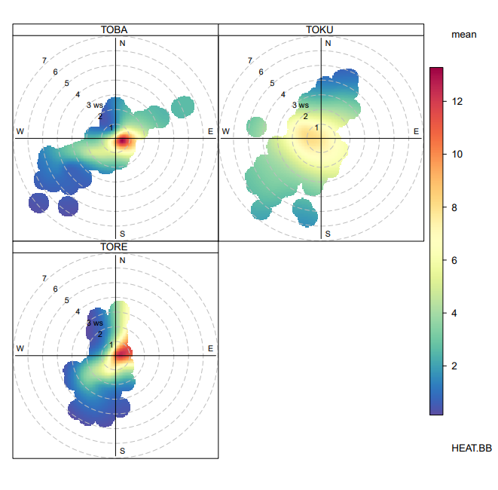

Fig. S11 Polar plots, HEAT CC factor (concentration units in polarPlots are µg/m³, wind speed units are m/s).
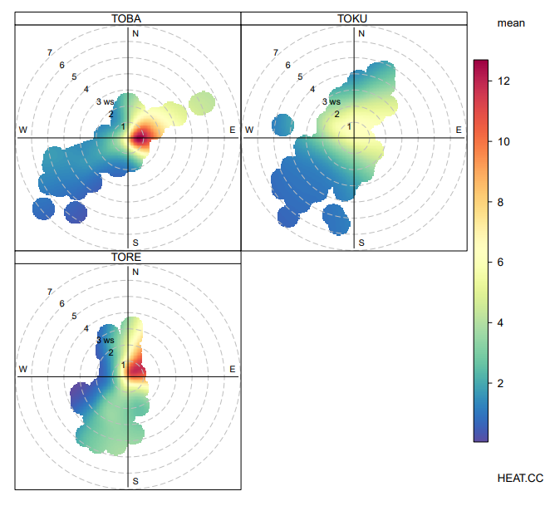

Fig. S12 Polar plots, IND Ca factor (concentration units in polarPlots are µg/m³, wind speed units are m/s).
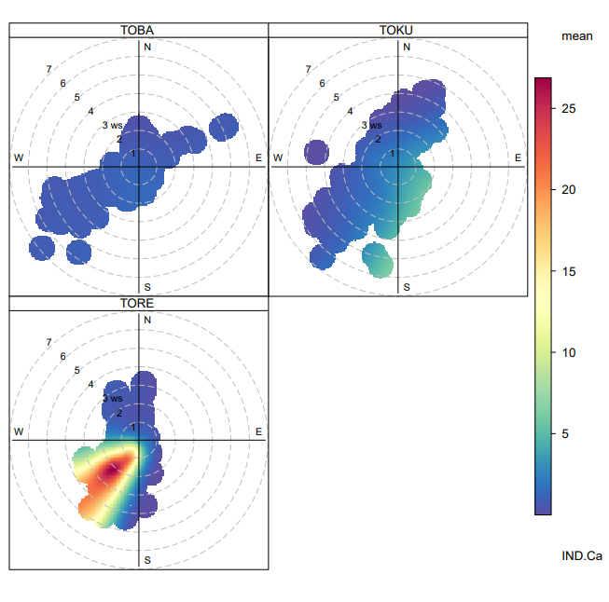

Fig. S13 Polar plots, TRA factor (concentration units in polarPlots are µg/m³, wind speed units are m/s).
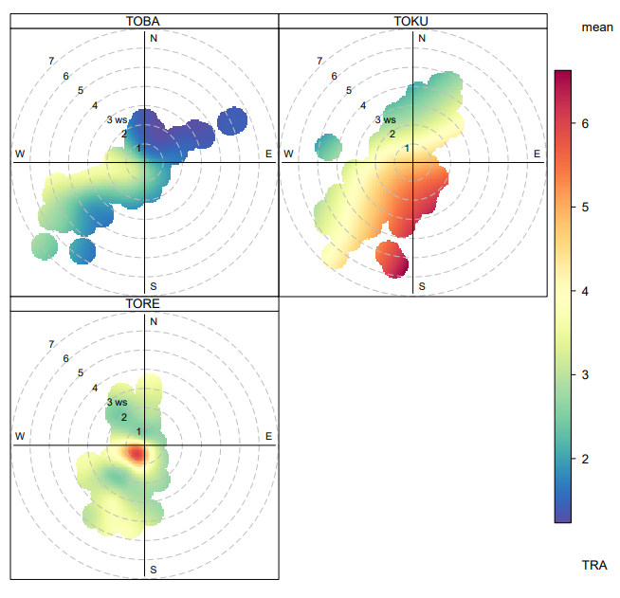

Fig. S14 Polar plots, C-NO3-Na factor (concentration units in polarPlots are µg/m³, wind speed units are m/s).
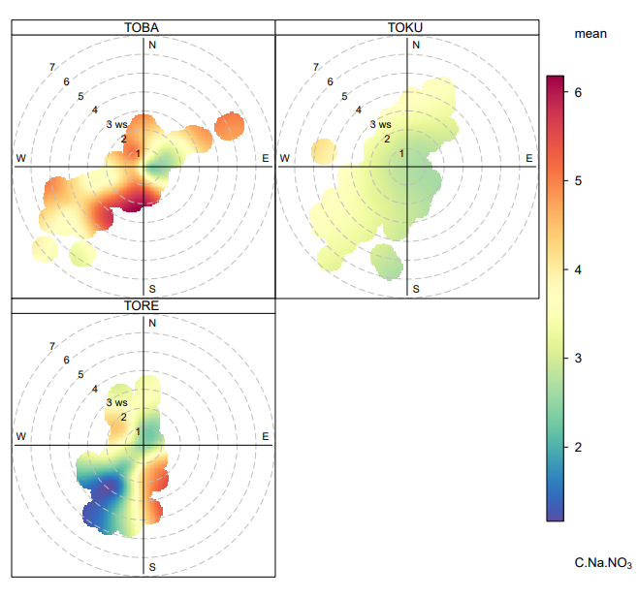

Fig. S15 Polar plots, Na-Cl factor (concentration units in polarPlots are µg/m³, wind speed units are m/s).
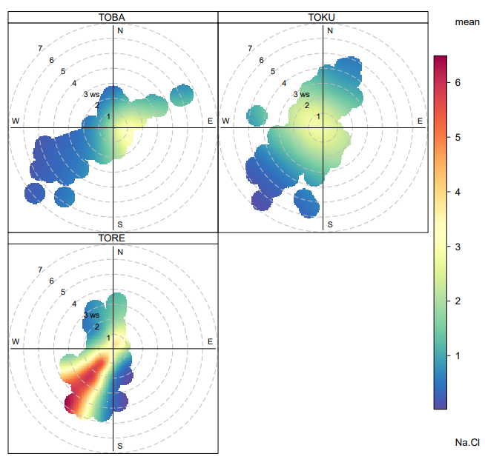

Fig. S16 Polar plots, CRUSTAL factor (concentration units in polarPlots are µg/m³, wind speed units are m/s).
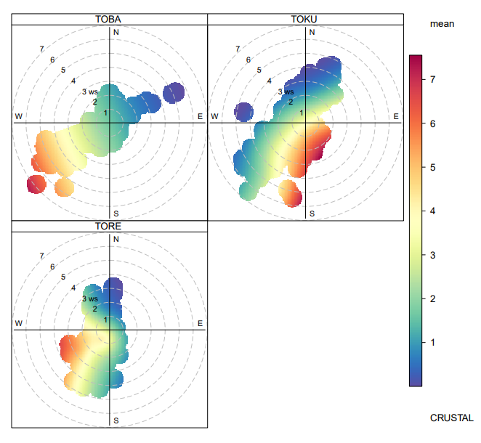

Fig. S17 Polar plots, IND HM factor (concentration units in polarPlots are µg/m³, wind speed units are m/s).
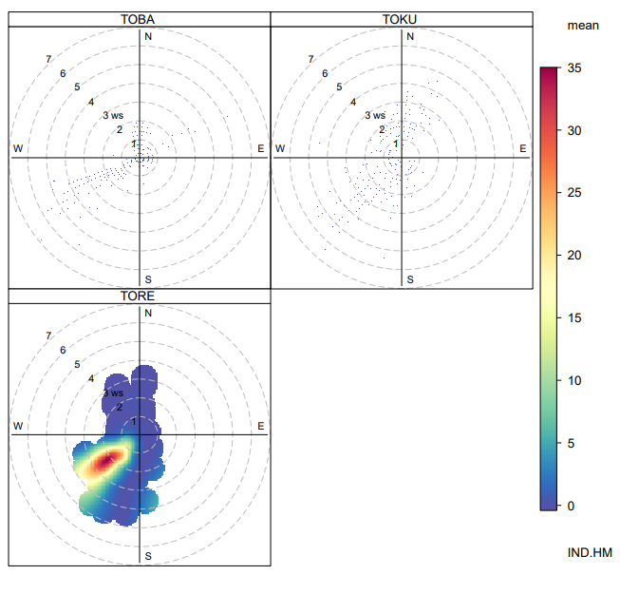
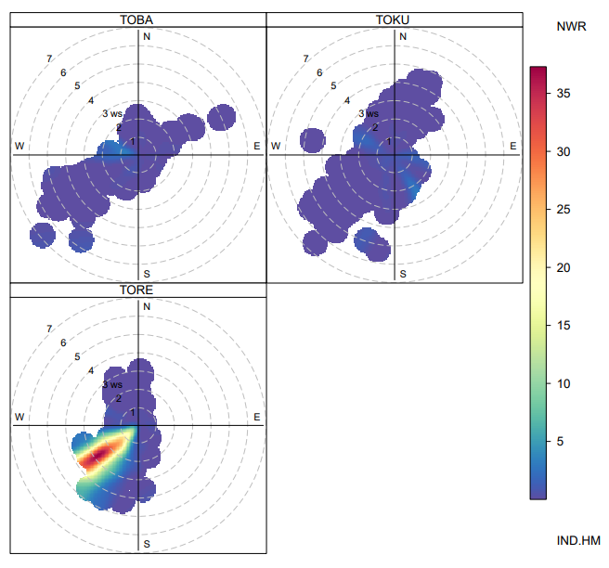

Fig. S18 Polar plots, IND PAH factor (concentration units in polarPlots are µg/m³, wind speed units are m/s).
