Supplementary Information

Impact of Cleaning on Membrane Performance during Surface Water Treatment: A Hybrid Process with Biological Ion Exchange and Gravity-Driven Membranes

Yaser Rasouli ¹, Benoit Barbeau ¹, Raphaël Maltais-Tariant ², Caroline Boudoux ^{2, 3}, Dominique Claveau-Mallet ^{a, *}
¹ Department of Civil, Geological & Mining Engineering, Polytechnique Montréal, 2900 Boulevard Édouard-Montpetit, Montréal, Québec, H3T 1J4, Canada
² Department of Engineering Physics, Polytechnique Montréal, 2900 Édouard-Montpetit, Montréal, Québec, H3T 1J4, Canada
³ Castor Optics, Inc., St-Laurent, Québec, Canada
*Corresponding author. Email: dominique.claveau-mallet@polymtl.ca

Membrane characterizations
The determination of membrane porosity involved the calculation based on the amount of water absorbed by the membrane structure following immersion in a water bath. Initially, the dry membranes, denoted as "W₁," were weighed. Subsequently, these membranes were immersed in pure water at a consistent ambient temperature for a duration of 72 hours. Following this soaking period, the outer surface of the membranes was dried using Kimwipes™ and subsequently reweighed as "W₂." The formula employed to compute membrane porosity was in accordance with the method outlined by (Arzani, Mahdavi et al. 2016):
$$Porosity= \left(\frac{W_{1}- W_{2}}{ρ_{m}V_{m}}\right)$$
where ρ_{m} and V_{m} are the density of pure water at the corresponding temperature and membrane volume, respectively.
The membrane mean pore radius (R_{m}) was calculated using the Guerout-Elford-Ferry equation (Zhang, Lang et al. 2015), where ε is the membrane porosity, L is the membrane thickness, μ is the water viscosity at the filtration temperature, J is the membrane flux, and $∆P$ is the pressure.
$R_{m}= \sqrt{\frac{\left(2.9-1.75 ϵ\right)8μ L J}{ε ∆P}}$

Membrane structure characterization using scanning electron microscopy
A small part of the clean membranes was carefully cut and subjected to SEM analyses. The samples were prepared by vacuum coating with a very thin layer of gold (Polaron SC502 sputter coater) at a pressure of approximately 10 bar and current of 10 mA. The samples were observed on a device (Jeol, JSM-7600TFE, JEOL Ltd., Japan) using low electron voltages (5–10 kV).

Characterization results:
Table S1. Porosity, mean pore size and water flux of the lab-made membranes. Mean ± 95% confidence interval.
Membrane type | Porosity (%) | Mean pore size (µm) | Water flux at 90 mbar (LMH)
M4 (Ceramic lab-made MF) | 35.17 ± 3.55 | 0.62 ± 0.06 | 108.04 ± 4.01

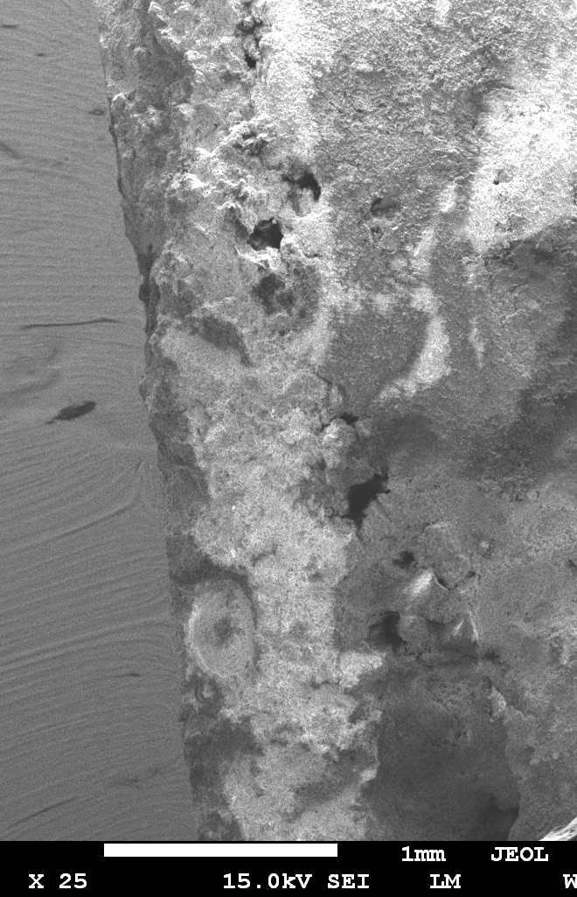
Alumina layer
Kaolin support
Figure S1. SEM micrograph of the Lab-made membrane, demonstrating the kaolin support and the top alumina layer
According to figure S2, point 1 which is in the kaolin support, shows more Si and less Al than Point 2 which is located in the alumina layer.

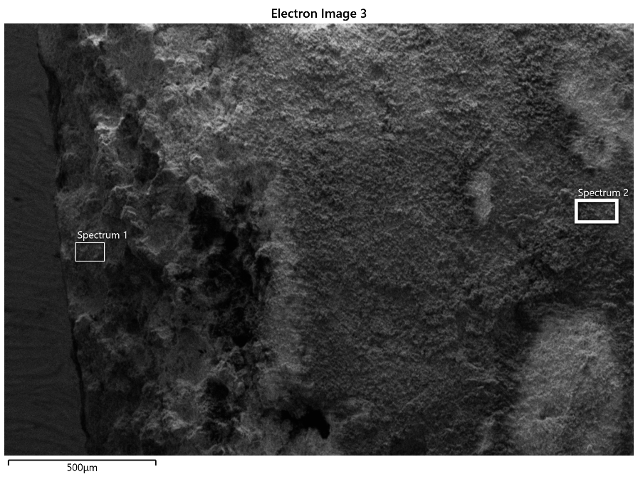
a

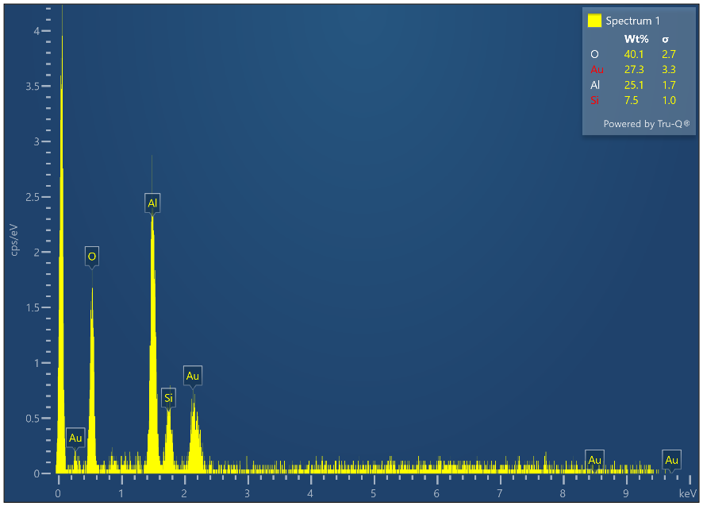
b

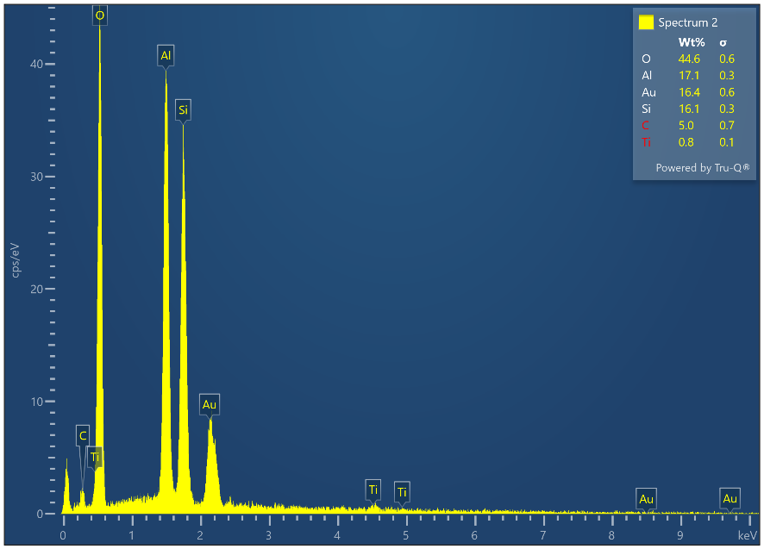
c

Figure S2. a) SEM micrograph of the Lab-made membrane. Spectrums 1 and 2 show a small area in the kaolin support and alumina top layer. b) The Energy Dispersive X-ray (EDX) spectra of point 1 (in kaolin support), and c) EDX spectra of point 2 (in top alumina layer).

Step 1: Turning the membranes face down – Membranes position was turned to face down according to the inlet flow

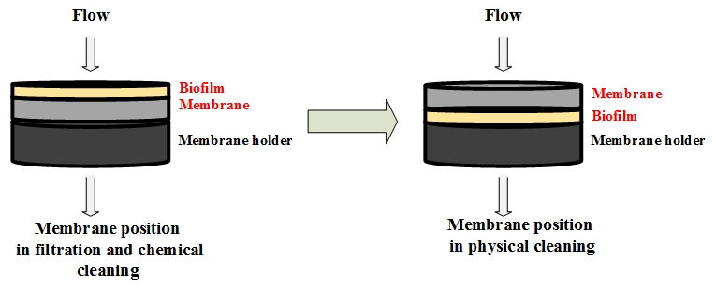
a

Step 2: Backwash with air at section 1) P = 30 psi, Q = 5 L/h, t = 2 min; section 2) P = 15 psi, Q = 2.5 L/h, t = 2 min.

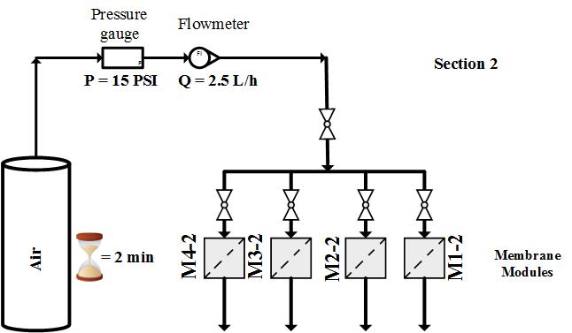
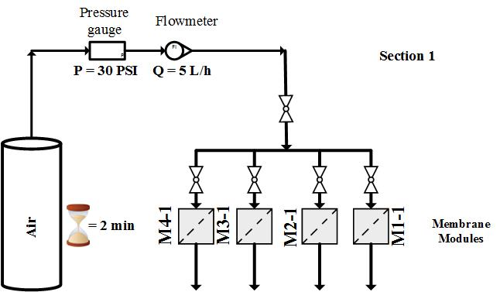
c
b

Step 3: Backwash with DI water at section 1) water head = 120 cm, t = 4 h; section 2) water head = 90 cm, t = 4 h.

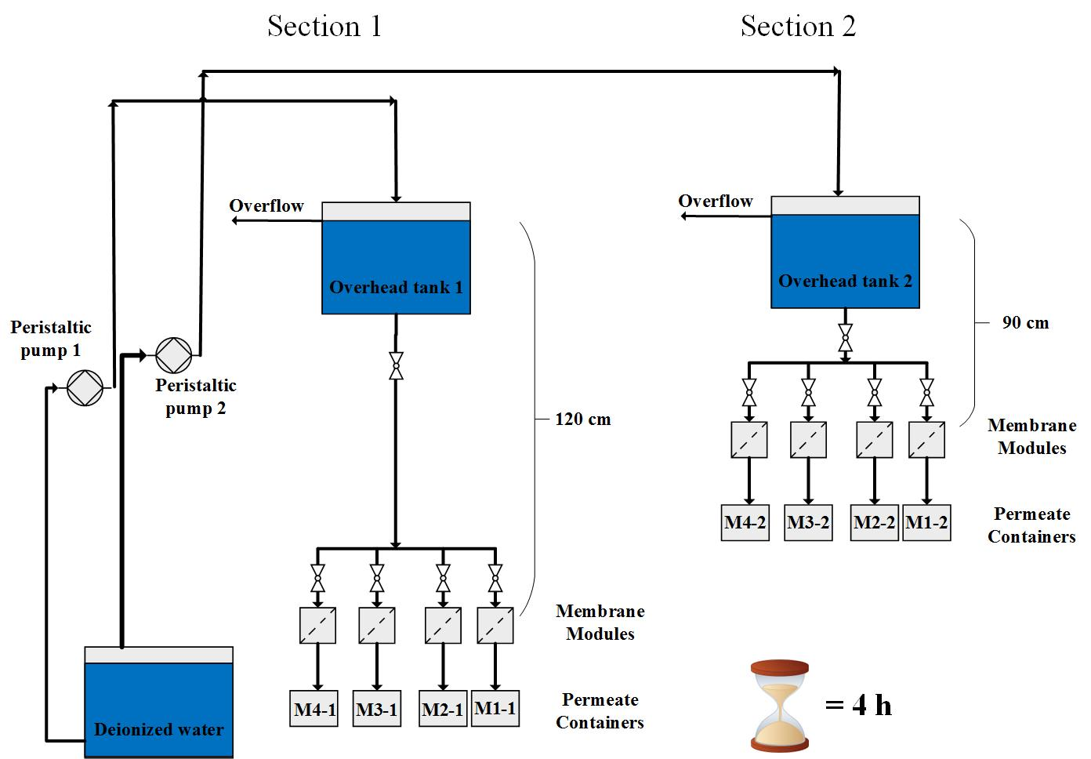
d

Step 4: Returning the membranes to normal position – Membranes position was turned face up again according to the inlet flow.

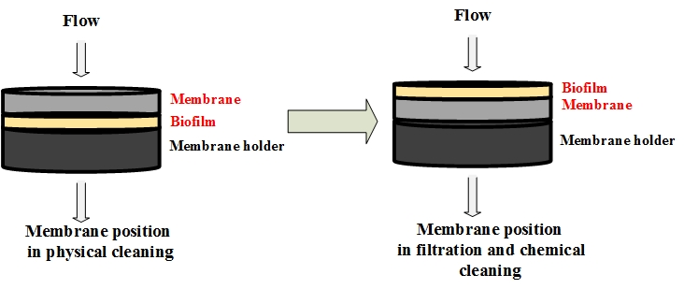
e

Step 5: Measuring DI water flux at water head of 90 cm for 15 min in both sections.

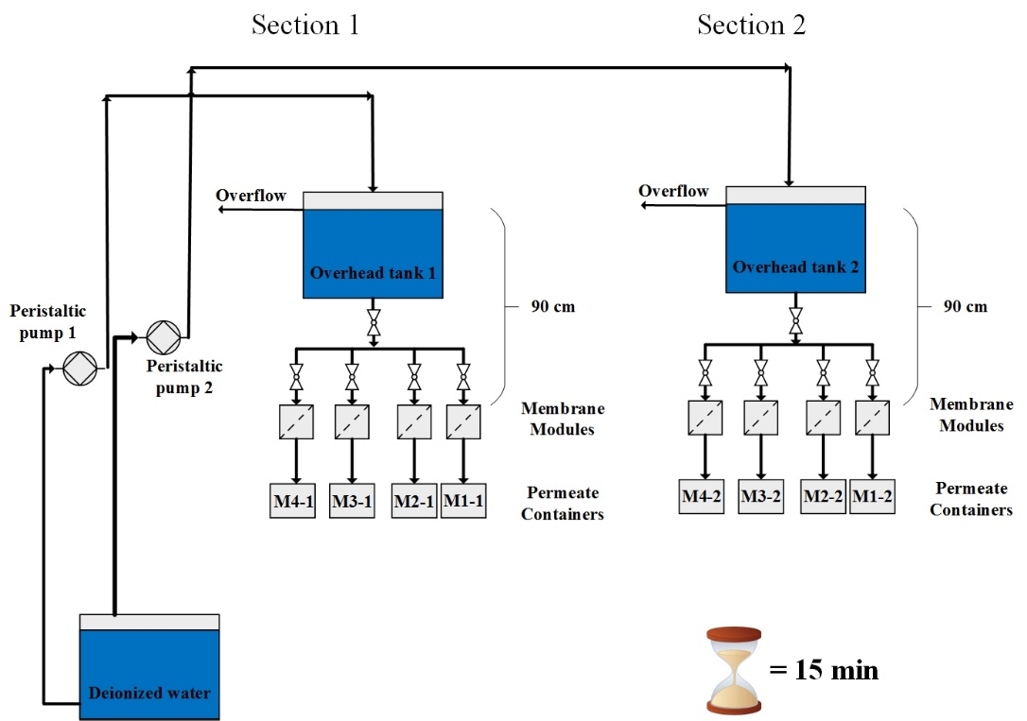
f

Step 6: Chemical cleaning by NaOH 40 mM in section 1 and 20 mM in section 2 both for 6 h at 90 cm water head.

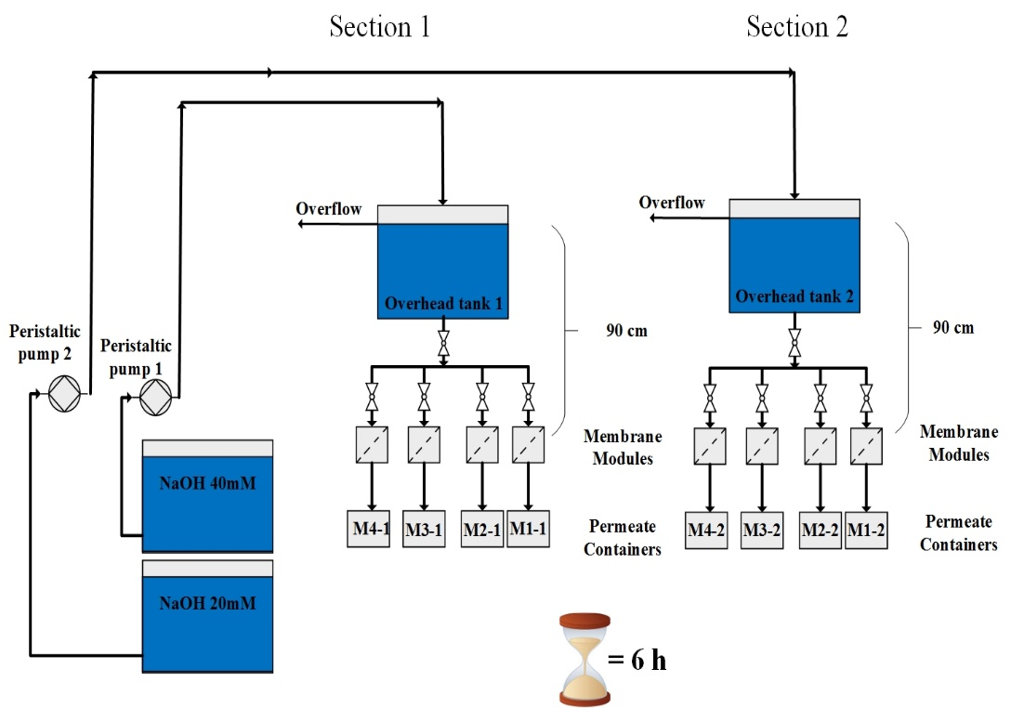
g

Step 7: Measuring DI water flux at water head of 90 cm for 15 min in both sections.

h

Step 8: Chemical cleaning by NaOCl 500 mg Cl2/L in section 1 and 250 mg Cl2/L in section 2 both at 90 cm water head for 6h.

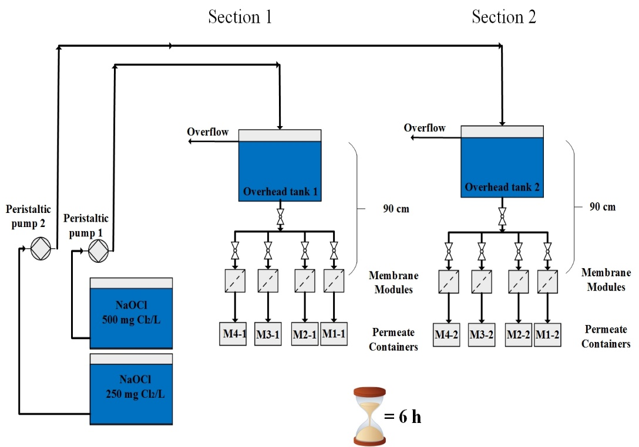
i

Step 9: Measuring DI water flux at water head of 90 cm for 15 min in both sections.

j

Figure S3. Schematic of the steps in physical and chemical cleaning of the membranes

Figure S4. Dynamics of cumulative anion exchange on the resin of BIEX column 2 during the operation. Day 68 and 6,528 BV is the resin regeneration time. The error bars show 95% confidence intervals.

Figure S5. Variations of a) UVA₂₅₄ and b) turbidity of BIEX column effluent during the operation. The error bars show 95% confidence intervals.

Figure S6. a) Variation of fouling resistance of membranes in section 1 during the filtration, and b) Variation of fouling resistance of membranes in section 2 during the filtration. M1 (polymeric 0.1 µm), M2 (polymeric 0.03 µm), M3 (ceramic 300 kDa), and M4 (Lab-made ceramic). Day 30 is the physical and chemical cleaning day. The error bars show 95% confidence intervals.

d
c
Z
b
a
Z

M2-1 (polymeric UF in section 1) after cleaning
M2-1 (polymeric UF in section 1) before cleaning
M1-1 (polymeric MF in section 1) after cleaning
M1-1 (polymeric MF in section 1) before cleaning

h
g
f
e

M3-1 (ceramic UF in section 1) before cleaning
M4-1 (ceramic MF in section 1) after cleaning
M4-1 (ceramic MF in section 1) before cleaning
M3-1 (ceramic UF in section 1) after cleaning

l
k
J
i

M2-2 (polymeric UF in section 2) after cleaning
M2-2 (polymeric UF in section 2) before cleaning
M1-2 (polymeric MF in section 2) after cleaning
M1-2 (polymeric MF in section 2) before cleaning

p
o
n
m

M3-2 (ceramic UF in section 2) before cleaning
M4-2 (ceramic MF in section 2) after cleaning
M4-2 (ceramic MF in section 2) before cleaning
M3-2 (ceramic UF in section 2) after cleaning

Figure S7. OCT images of a) M1-1 (polymeric MF in section 1) before cleaning, b) M1-1 (polymeric MF in section 2) after cleaning, c) M2-1 (polymeric UF in section 1) before cleaning, d) M2-1 (polymeric UF in section 1) after cleaning, e) M3-1 (ceramic UF in section 1) before cleaning, f) M3-1 (ceramic UF in section 1) after cleaning, g) M4-1 (ceramic MF in section 1) before cleaning, h) M4-1 (ceramic MF in section 1) after cleaning, i) M1-2 (polymeric MF in section 2) before cleaning, j) M1-2 (polymeric MF in section 2) after cleaning, k) M2-2 (polymeric UF in section 2) before cleaning, l) M2-2 (polymeric UF in section 2) after cleaning, m) M3-2 (ceramic UF in section 2) before cleaning, n) M3-2 (ceramic UF in section 2) after cleaning, o) M4-2 (ceramic MF in section 2) before cleaning, and p) M4-2 (ceramic MF in section 2) after cleaning. M1 (polymeric 0.1 µm MF), M2 (polymeric 0.03 µm UF), M3 (ceramic 300 kDa UF), and M4 (Lab-made ceramic MF). X and y-axis bars show 1 mm distance.

a

Section 1

Figure S8. a, b) Mean DOC in section 1and section 2 days 1 – 68 c, d) Mean UVA₂₅₄ in section 1 and section 2 days 1 – 68, e. f) Mean turbidity in section 1 and section 2 during the whole operation period. M1 (polymeric 0.1 µm MF), M2 (polymeric 0.03 µm UF), M3 (ceramic 300 kDa UF), and M4 (Lab-made ceramic MF). The error bars show 95% confidence intervals.

