Supplementary Materials

Preparative and catalytic properties of Mo^{VI} mononuclear and metallosupramolecular coordination assemblies bearing hydrazonato ligands

Mirna Mandarić, Edi Topić, Dominique Agustin*, Jana Pisk*, Višnja Vrdoljak*

Contents
Scheme 2
Single-crystal X-ray diffraction 3
NMR spectroscopy 21
Imaginary frequency (cm⁻¹) of the calculated transition states shown in Table S14. 29
DFT Coordinates of all species. 29

Scheme

Scheme S1. Hydrazidato and hydrazonato tautomeric forms.

Single-crystal X-ray diffraction
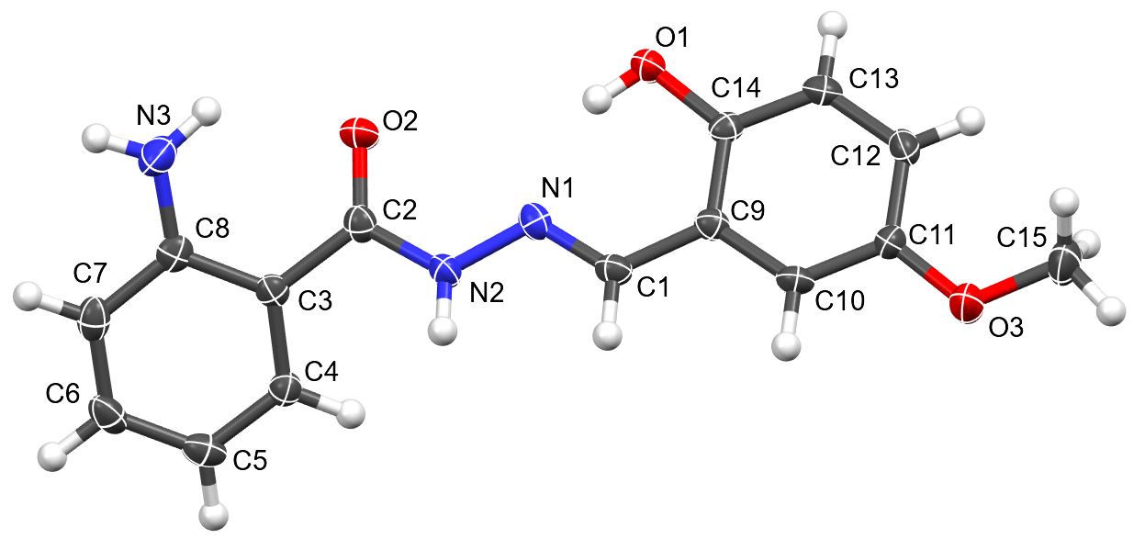
(a)

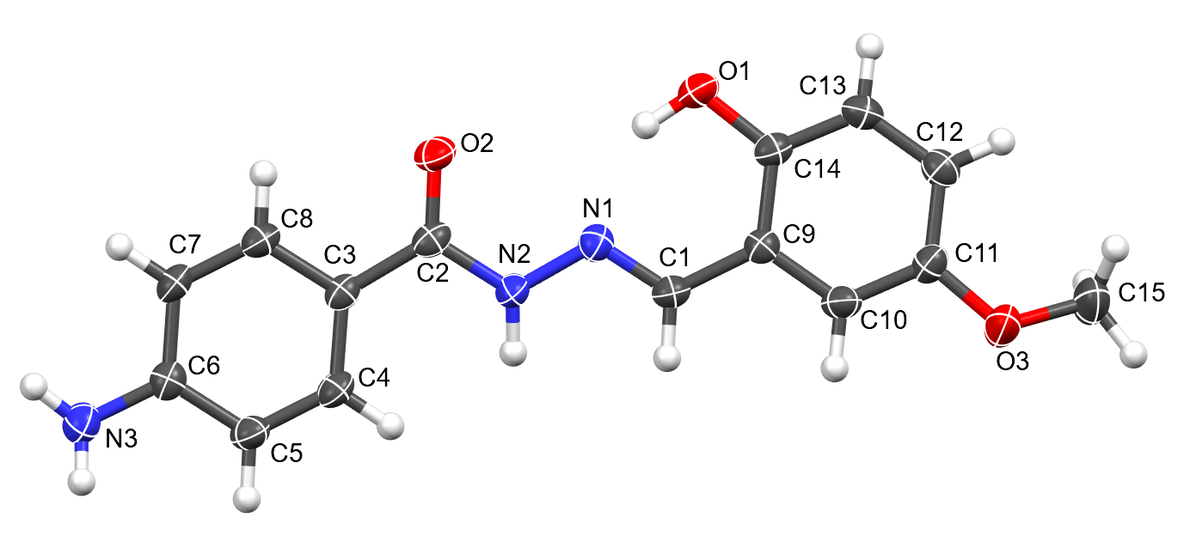
(b)
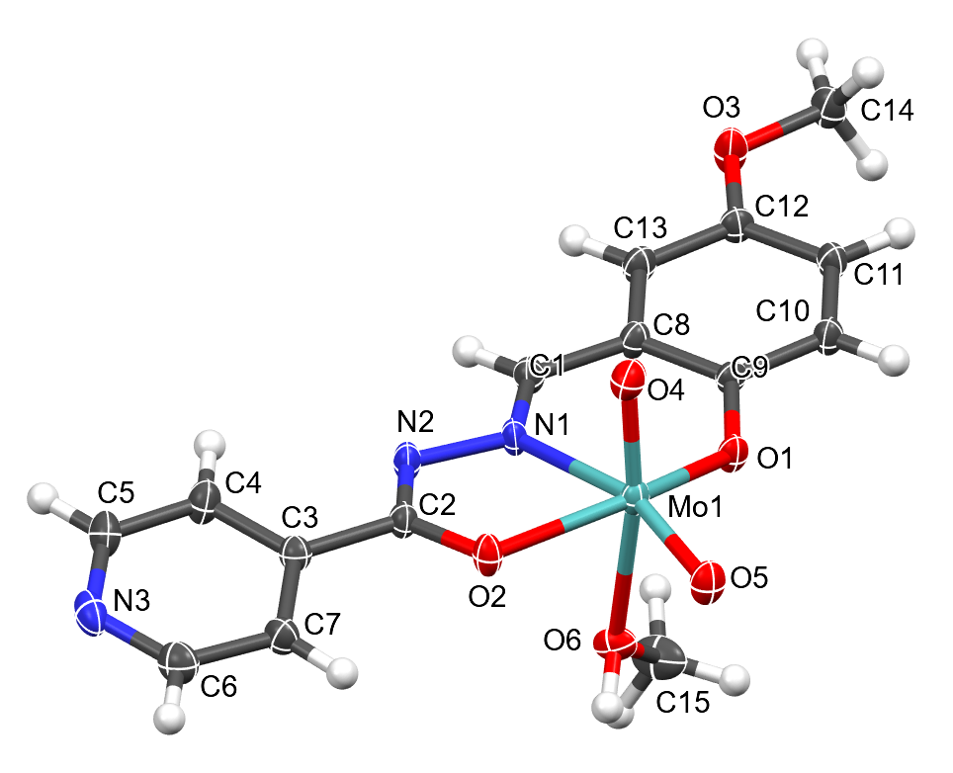
(c)
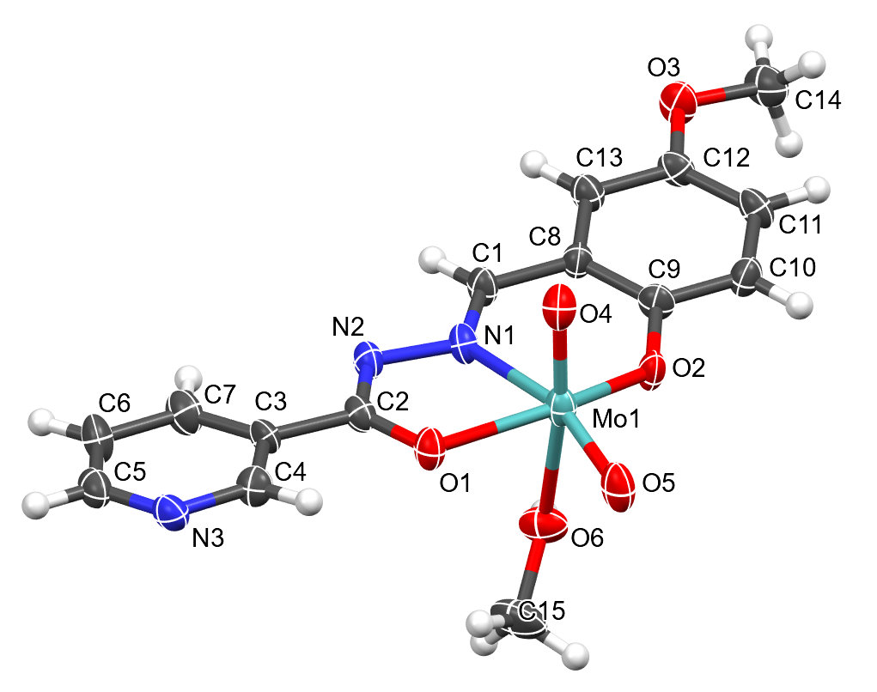
(d)

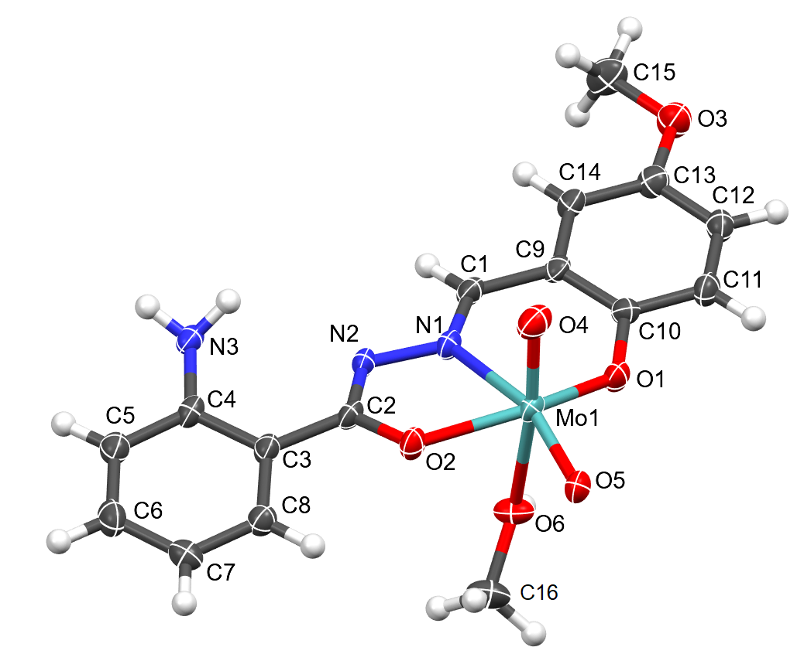
(e)
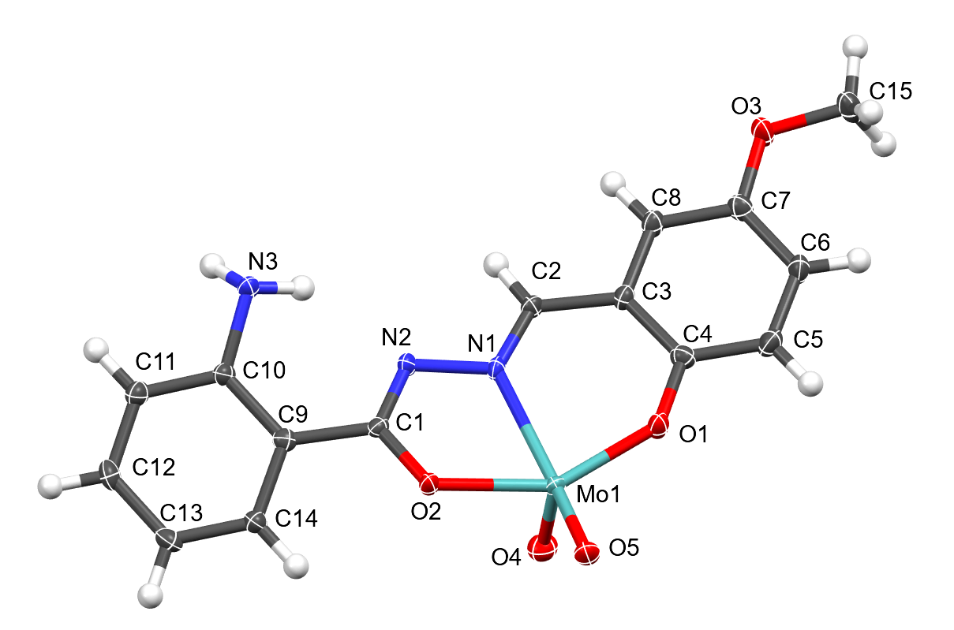
(f)
Figure S1. Molecular structure and enumeration scheme for (a) H₂L³, (b) H₂L⁴, (c) 1a, (d) 2a, (e) 3a, (f) 3. Non-hydrogen atoms are shown as thermal ellipsoids at 30% probability. The second symmetrically inequivalent molecule in (b) is omitted for clarity. In (f), only symmetrically unique molecular fragment is shown.
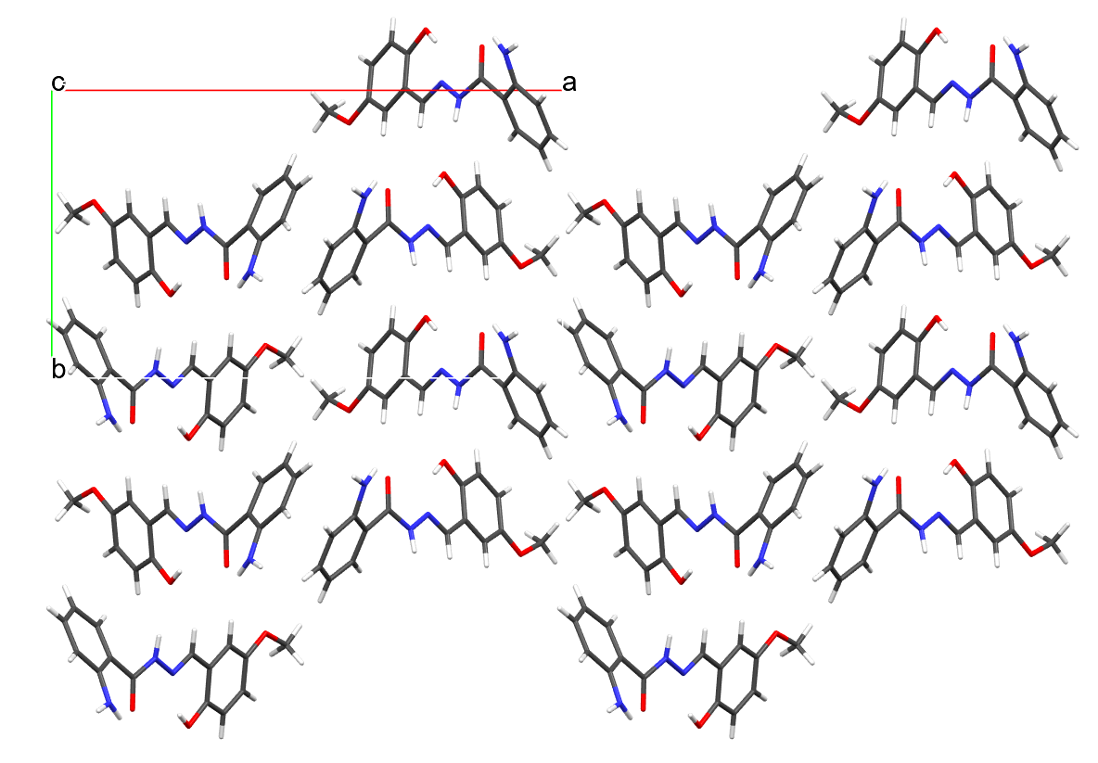
(a)
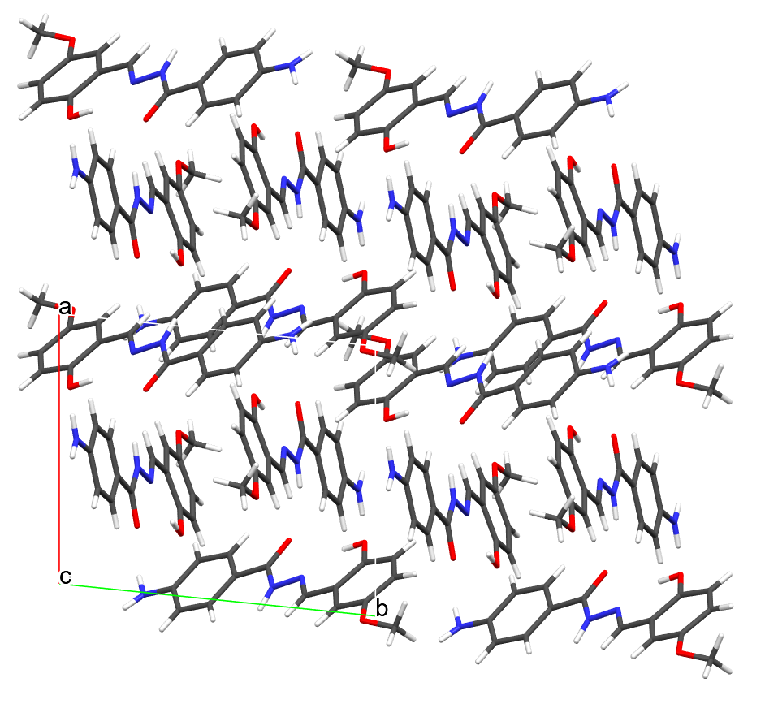
(b)

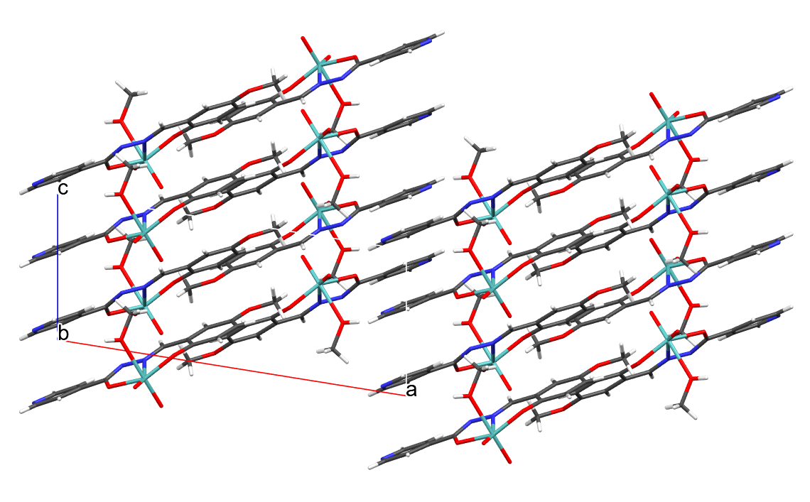
(c)
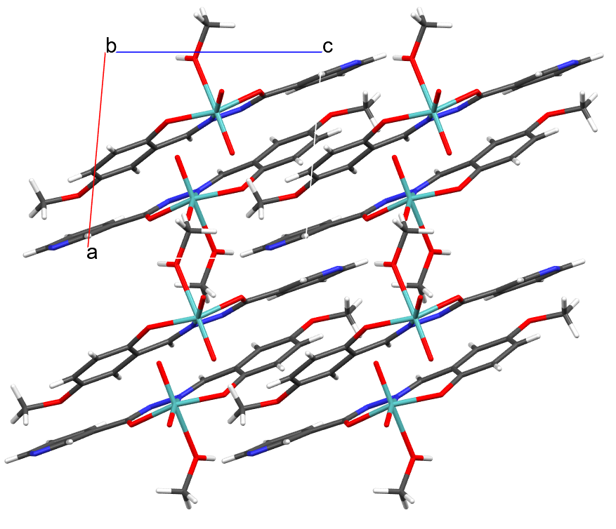
(d)
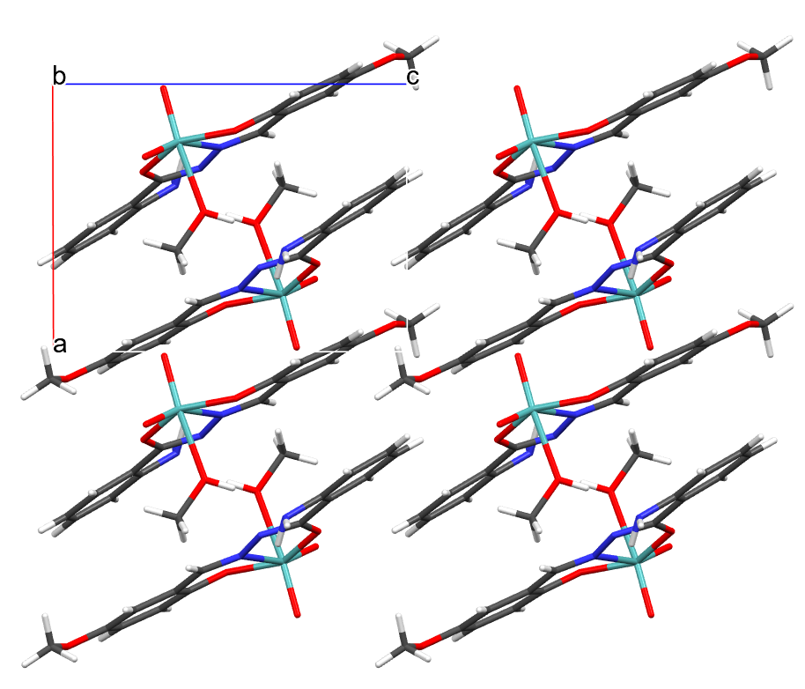
(e)
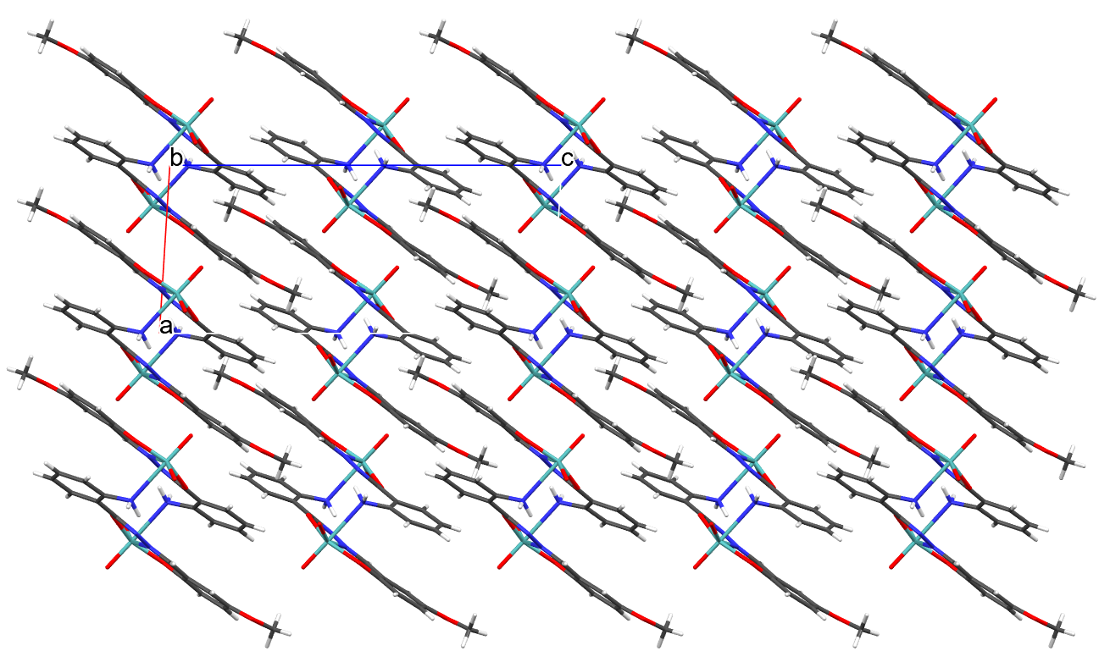
(f)
Figure S2. Packing of molecules in the crystal structure of (a) H₂L³, (b) H₂L⁴, (c) 1a, (d) 2a, (e) 3a, (f) 3, shown along c-axis for ligands (a) and (b) and along b-axis for complexes (c)-(f).

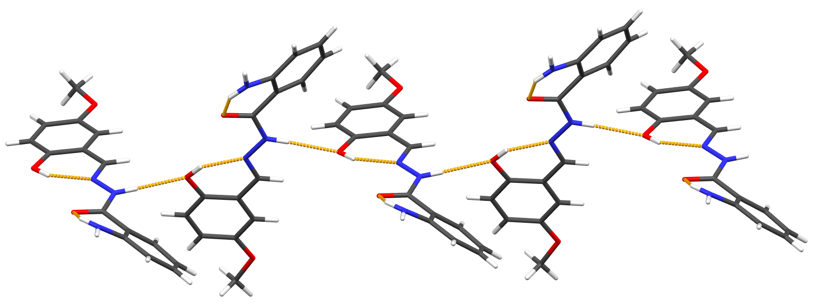
(a)
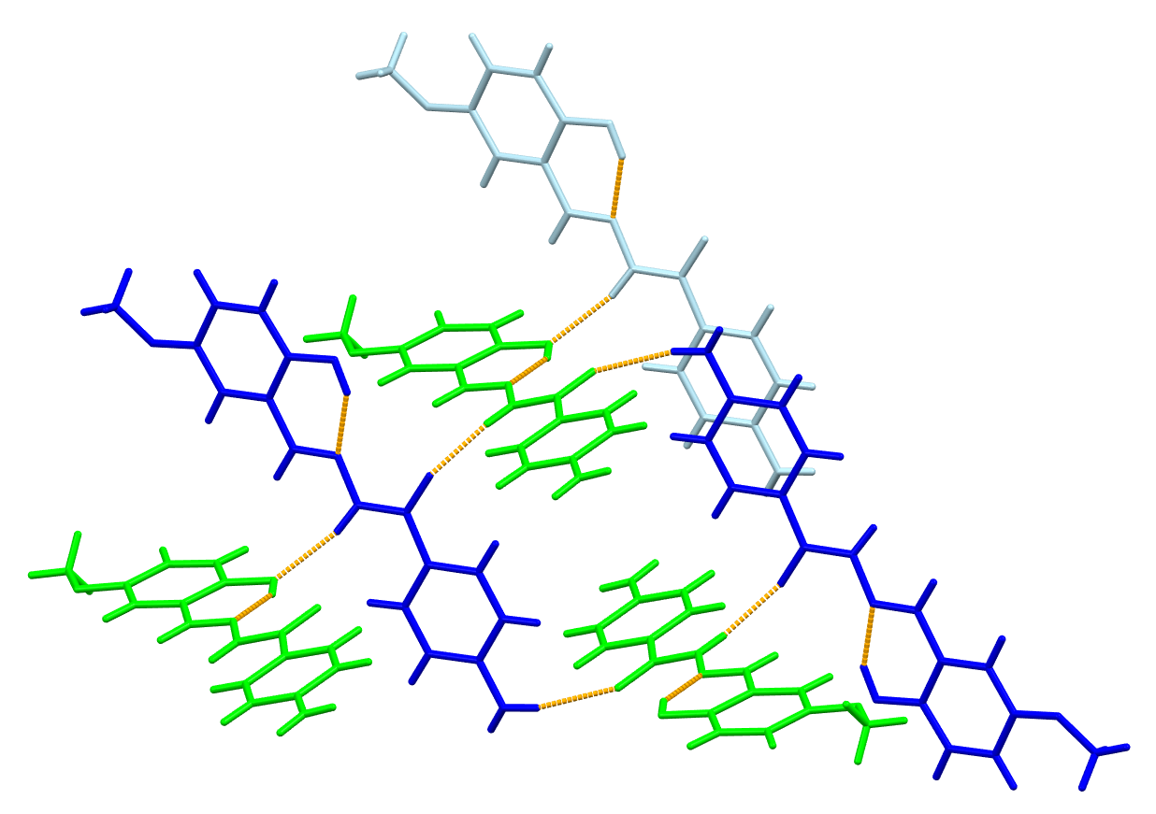
(b)
Figure S3. Supramolecular environment of ligand molecules in (a) H₂L³ and (b) H₂L⁴. In (a), ligand molecules form supramolecular chains through hydrazide N–H∙∙∙O_{ar} hydrogen bond. In (b), symmetrically inequivalent molecules (shown as green and blue) form a complicated hydrogen bond network.
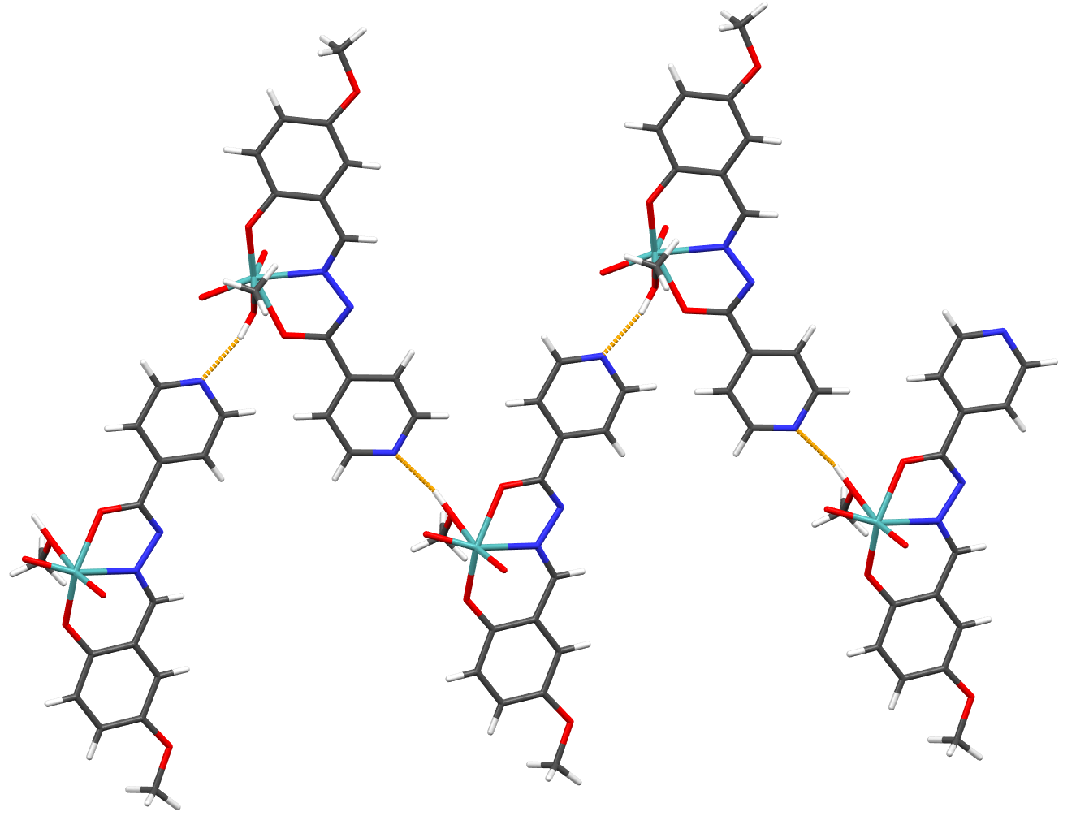
(a)
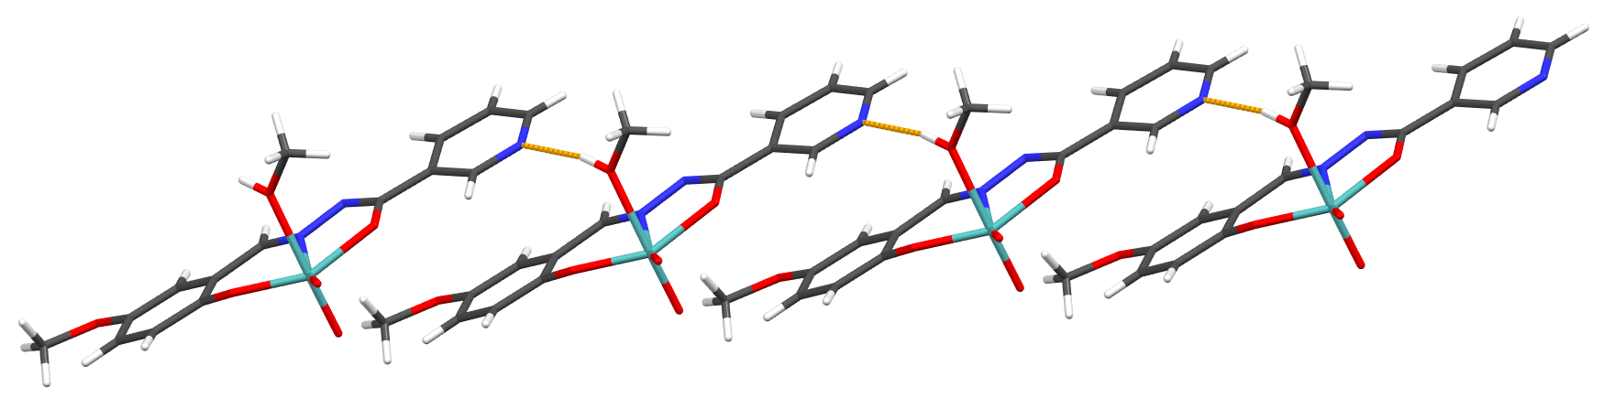
(b)
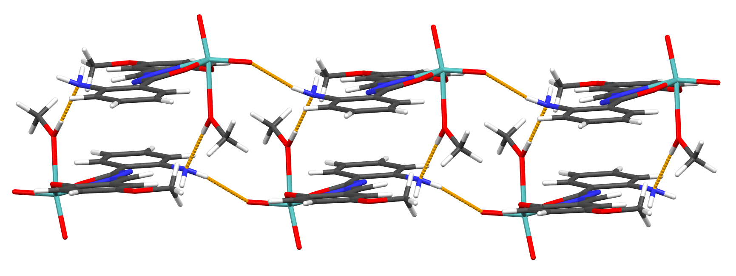
(c)
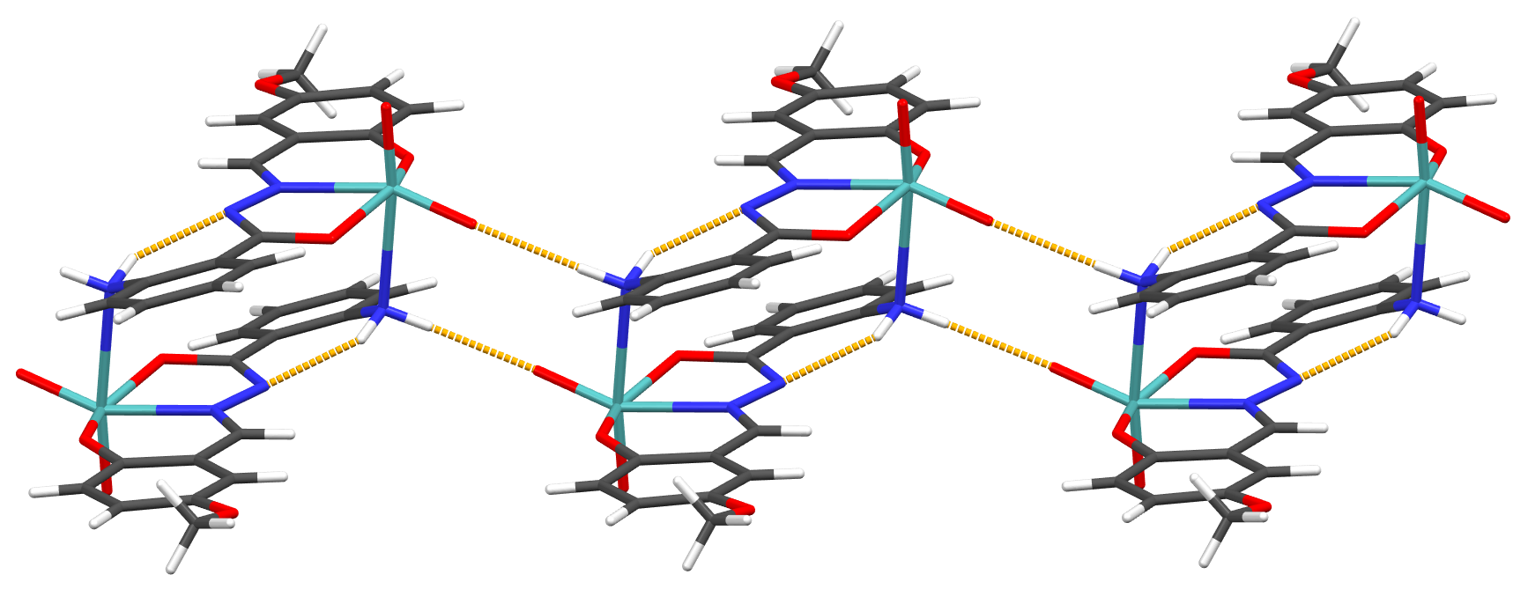
(d)
Figure S4. Supramolecular environment of complex molecules in (a) 1a, (b) 2a, (c) 3a and (d) 3. All complexes have few available hydrogen bond donors (methanol OH moiety or NH2 moiety on the aromatic ring), therefore observed supramolecular networks are relatively simple. In (a) and (b) supramolecular chains are formed between methanol OH group and pyridyl nitrogen atom. In (c), supramolecular dimers are established through methanol OH and amine nitrogen atom, which are further connected in chains through N-H∙∙∙O_{eq}=Mo hydrogen bond. Finally, in (d), only the similar situation is found as in (c), except that dimers are formed through coordination of amine to the MoO₂ core.

Table S1. Experimental and crystallographic data for ligands H₂L³ and H₂L⁴.
Identifier | H₂L³ | H₂L⁴
Empirical formula | C₁₅H₁₅N₃O₃ | C₁₅H₁₅N₃O₃
M_{r} | 285.30 | 285.30
T/K | 150.00 | 150.00
Crystal system | orthorhombic, yellow block | triclinic, yellow prism
Space group | P n a 2₁ | P –1
a/Å | 19.964(2) | 9.6923(6)
b/Å | 11.2493(9) | 11.4322(6)
c/Å | 6.1009(8) | 12.8069(7)
α/° | 90 | 95.232(4)
β/° | 90 | 93.942(5)
γ/° | 90 | 95.427(4)
V/Å³ | 1370.1(3) | 1402.52(14)
Z | 4 | 4
ρ_{calc}/g cm^{–3} | 1.383 | 1.351
μ/mm^{–1} | 0.099 | 0.096
F(000) | 600 | 600
Crystal size/mm³ | 0.7×0.2×0.02 | 0.4×0.2×0.2
Radiation | MoKα (λ = 0.71073Å) | MoKα (λ = 0.71073Å)
2Θ range/° | 8.628 to 51.982 | 8.284 to 51.998
Index ranges | –24 ≤ h ≤ 24,  –13 ≤ k ≤ 13,  –7 ≤ l ≤ 7 | –7 ≤ h ≤ 11,  –14 ≤ k ≤ 14,  –15 ≤ l ≤ 15
Reflections collected | 12063 | 12837
Independent reflections | 2645 [R_{int} = 6.2%, R_{sigma} = 6.71 %] | 5486 [R_{int} = 5.3%, R_{sigma} = 3.11 %]
Data/restraints/parameters | 2645/-/203 | 5486/-/405
g₁, g₂ in wª | 0.0313, 0 | 0.0546, 0
Goodness–of–fit on F², S^{b} | 1.069 | 1.008
Final R and wR^{c} values [I≥2σ(I)] | R₁ = 5.29%, wR₂ = 8.4% | R₁ = 4.92%, wR₂ = 10.86%
Final R and wR^{c} values [all data] | R₁ = 7.08%, wR₂ = 8.95% | R₁ = 8.0%, wR₂ = 12.55%
Largest diff. peak/hole / e Å^{–3} | 0.147/–0.155 | 0.206/–0.211
Flack parameter | 0.1(10) | /
ªw = 1/[σF_{o}² + (g₁P)² + g₂P] where P = (F_{o}² + 2F_{c}²)/3
^{b}S = {Σ[w(F_{o}² – F_{c}²)2]/(N_{r} – N_{p})}^{1/2} where N_{r} = number of independent reflections, N_{p} = number of refined parameters.
^{c}R = Σ||F_{o}| – |F_{c}|/Σ|F_{o}|; wR = {Σ[w(F_{o}² – F_{c}²)2]/Σ[w(F_{o}²)2]}^{1/2}

Table S2. Selected bond lengths in the crystal structures of ligands H₂L³ and H₂L⁴.
H₂L³
Atoms | Bond length/Å | Atoms | Bond length/Å | Atoms | Bond length/Å
C4–C5 | 1.382(5) | C11–C12 | 1.386(5) | N3–H3B | 0.85(3)
C5–C6 | 1.394(6) | N1–C1 | 1.290(4) | O1–C14 | 1.378(4)
C6–C7 | 1.373(5) | N1–N2 | 1.375(4) | O1–H1 | 0.83(4)
C7–C8 | 1.408(5) | N2–C2 | 1.374(4) | O2–C2 | 1.233(4)
C9–C10 | 1.398(5) | N2–H2 | 0.88(2) | O3–C11 | 1.384(4)
C9–C14 | 1.410(5) | N3–C8 | 1.371(5) | O3–C15 | 1.420(5)
C10–C11 | 1.381(5) | N3–H3A | 0.89(4)
H₂L⁴
Atoms | Bond length/Å | Atoms | Bond length/Å | Atoms | Bond length/Å
C4–C5 | 1.376(3) | C25–C26 | 1.388(2) | N6–H6A | 0.87(2)
C5–C6 | 1.394(3) | C26–C27 | 1.386(3) | N6–H6B | 0.859(18)
C6–C7 | 1.394(3) | N1–C1 | 1.279(2) | O1–C14 | 1.365(2)
C7–C8 | 1.376(3) | N1–N2 | 1.378(2) | O1–H1 | 0.904(19)
C9–C10 | 1.393(2) | N2–C2 | 1.370(2) | O2–C2 | 1.231(2)
C9–C14 | 1.406(3) | N2–H2 | 0.906(19) | O3–C11 | 1.376(2)
C10–C11 | 1.383(3) | N3–C6 | 1.381(2) | O3–C15 | 1.397(2)
C11–C12 | 1.389(3) | N3–H3A | 0.872(19) | O4–C29 | 1.374(2)
C19–C20 | 1.381(3) | N3–H3B | 0.89(2) | O4–H4 | 0.849(19)
C20–C21 | 1.394(3) | N4–C16 | 1.282(2) | O5–C17 | 1.238(2)
C21–C22 | 1.395(3) | N4–N5 | 1.375(2) | O6–C26 | 1.370(2)
C22–C23 | 1.375(2) | N5–C17 | 1.367(2) | O6–C30 | 1.426(2)
C24–C25 | 1.392(2) | N5–H5 | 0.847(17)

Table S3. Selected bond angles in the crystal structures of ligands H₂L³ and H₂L⁴.
H₂L³
Atoms | Bond angle/° | Atoms | Bond angle/° | Atoms | Bond angle/°
N1–C1–C9 | 120.6(3) | N3–C8–C3 | 121.7(3) | N2–N1–C1 | 117.5(2)
N2–C2–C3 | 114.4(3) | N3–C8–C7 | 119.9(3) | C2–N2–H2 | 121(3)
O2–C2–C3 | 123.9(3) | C1–C9–C10 | 118.6(3) | N1–N2–C2 | 119.4(2)
O2–C2–N2 | 121.7(3) | C1–C9–C14 | 122.5(3) | N1–N2–H2 | 119(3)
C2–C3–C4 | 120.2(3) | C10–C9–C14 | 118.9(3) | C8–N3–H3A | 120(2)
C2–C3–C8 | 120.4(3) | C9–C10–C11 | 121.0(3) | C8–N3–H3B | 114(2)
C4–C3–C8 | 119.2(3) | C10–C11–C12 | 120.0(3) | H3A–N3–H3B | 121(3)
C3–C4–C5 | 121.3(3) | O3–C11–C10 | 116.0(3) | C14–O1–H1 | 106(2)
C4–C5–C6 | 119.3(3) | O3–C11–C12 | 124.0(3) | C11–O3–C15 | 117.5(3)
C5–C6–C7 | 120.6(3) | C11–C12–C13 | 119.7(3)
C6–C7–C8 | 121.1(4) | C12–C13–C14 | 121.0(3)
C3–C8–C7 | 118.3(3) | O1–C14–C9 | 122.9(3)
H₂L⁴
Atoms | Bond angle/° | Atoms | Bond angle/° | Atoms | Bond angle/°
N1–C1–C9 | 120.61(16) | O1–C14–C9 | 121.99(16) | C27–C28–C29 | 121.25(18)
N2–C2–C3 | 117.03(16) | N4–C16–C24 | 120.02(17) | O4–C29–C24 | 121.88(15)
O2–C2–C3 | 122.84(16) | N5–C17–C18 | 116.57(17) | N2–N1–C1 | 117.30(15)
O2–C2–N2 | 120.10(16) | O5–C17–C18 | 123.06(16) | C2–N2–H2 | 122.8(13)
C2–C3–C4 | 124.96(16) | O5–C17–N5 | 120.37(16) | N1–N2–C2 | 117.91(15)
C2–C3–C8 | 117.16(16) | C17–C18–C19 | 125.24(16) | N1–N2–H2 | 118.7(13)
C4–C3–C8 | 117.85(16) | C17–C18–C23 | 117.18(17) | C6–N3–H3A | 115.7(13)
C3–C4–C5 | 121.17(17) | C19–C18–C23 | 117.58(16) | C6–N3–H3B | 116.0(14)
C4–C5–C6 | 120.65(17) | C18–C19–C20 | 121.09(17) | H3A–N3–H3B | 120.5(19)
C5–C6–C7 | 118.61(16) | C19–C20–C21 | 120.93(18) | N5–N4–C16 | 118.08(16)
N3–C6–C5 | 121.34(17) | C20–C21–C22 | 118.18(17) | C17–N5–H5 | 124.7(15)
N3–C6–C7 | 120.02(16) | N6–C21–C20 | 121.51(18) | N4–N5–C17 | 118.30(16)
C6–C7–C8 | 120.51(16) | N6–C21–C22 | 120.30(18) | N4–N5–H5 | 117.0(15)
C3–C8–C7 | 121.21(17) | C21–C22–C23 | 120.81(17) | C21–N6–H6A | 118.0(13)
C1–C9–C10 | 118.40(16) | C18–C23–C22 | 121.41(18) | C21–N6–H6B | 120.7(14)
C1–C9–C14 | 122.64(15) | C16–C24–C25 | 119.18(17) | H6A–N6–H6B | 121.3(19)
C10–C9–C14 | 118.92(16) | C16–C24–C29 | 121.90(16) | C14–O1–H1 | 108.2(13)
C9–C10–C11 | 121.13(17) | C25–C24–C29 | 118.92(16) | C11–O3–C15 | 118.37(15)
C10–C11–C12 | 119.73(16) | C24–C25–C26 | 121.32(17) | C29–O4–H4 | 106.4(13)
O3–C11–C10 | 115.64(16) | C25–C26–C27 | 119.42(17) | C26–O6–C30 | 117.01(15)
O3–C11–C12 | 124.62(16) | O6–C26–C25 | 115.71(17)

Table S4. Hydrogen bond parameters in the crystal structure of H₂L³ and H₂L⁴
H₂L³
D–H···A | D-H | H···A | D···A | ∠D–H···A | Symmetry code
N2–H2···O1 | 0.88(2) | 2.19(2) | 3.069(3) | 174(4) | –3/2–x, –1/2+y, –1/2+z
C10–H10···O2 | 0.95 | 2.47 | 3.404(4) | 167 | –3/2–x, –1/2+y, 1/2+z
H₂L⁴
D–H···A | D-H | H···A | D···A | ∠D–H···A | Symmetry code
N2–H2···O4 | 0.906(19) | 2.077(19) | 2.930(2) | 156.4(18) | –1+x, y, z
N3–H3A···O3 | 0.872(19) | 2.586(19) | 3.160(2) | 124.2(16) | –x, 1–y, 1–z
N3–H3B···O5 | 0.89(2) | 2.208(19) | 3.075(2) | 166.0(18) | 1–x, 1–y, 2–z
N5–H5···O2 | 0.847(17) | 2.014(17) | 2.823(2) | 159(2) | x, y, z
N6–H6A···O1 | 0.87(2) | 2.30(2) | 3.121(2) | 157.1(18) | 1–x, 2–y, 2–z
C4–H4A···O4 | 0.95 | 2.59 | 3.445(2) | 150 | –1+x, y, z
C15–H15B···O5 | 0.98 | 2.40 | 3.310(3) | 154 | 1–x, 2–y, 1–z
C15–H15C···O2 | 0.98 | 2.59 | 3.476(3) | 151 | –x, 2–y, 1–z
C16–H16···O2 | 0.95 | 2.52 | 3.238(2) | 133 | x, y, z
C19–H19···O2 | 0.95 | 2.55 | 3.444(2) | 158 | x, y, z

Table S5. Experimental and crystallographic data for dioxomolybdenum(VI) complexes 1a, 2a, 3a and 3.
Identifier | 1a | 2a | 3a | 3
Empirical formula | C₁₅H₁₅MoN₃O₆ | C₁₅H₁₅MoN₃O₆ | C₁₆H₁₇MoN₃O₆ | C₃₀H₂₆Mo₂N₆O₁₀
M_{r} | 429.24 | 429.24 | 443.26 | 822.45
T/K | 169.98(10) | 169.99(10) | 169.99(10) | 170.00(10)
Crystal system | monoclinic, orange needle | monoclinic, orange plate | triclinic, orange plate | monoclinic, red block
Space group | P 1 2₁/c 1 | P 1 2₁ 1 | P –1 | P 1 2₁/c 1
a/Å | 17.7236(4) | 7.9094(3) | 8.1385(3) | 8.06221(12)
b/Å | 12.4615(2) | 12.4768(4) | 9.7144(3) | 9.71973(14)
c/Å | 7.32534(17) | 8.2941(2) | 10.9563(4) | 18.7390(3)
α/° | 90 | 90 | 78.178(3) | 90
β/° | 99.127(2) | 95.092(3) | 88.831(3) | 93.5334(14)
γ/° | 90 | 90 | 85.144(3) | 90
V/Å³ | 1597.41(6) | 815.26(5) | 844.79(5) | 1465.64(4)
Z | 4 | 2 | 2 | 2
ρ_{calc}/g cm^{–3} | 1.785 | 1.749 | 1.743 | 1.864
μ/mm^{–1} | 7.087 | 6.943 | 6.722 | 7.641
F(000) | 864 | 432 | 448 | 824
Crystal size/mm³ | 0.15×0.1×0.05 | 0.48×0.14×0.06 | 0.12×0.08×0.03 | 0.15×0.12×0.1
Radiation | CuKα (λ = 1.54184Å)
2Θ range/° | 8.712 to 155.574 | 10.708 to 154.896 | 8.244 to 156.32 | 9.458 to 155.358
Index ranges | –22 ≤ h ≤ 22,  –13 ≤ k ≤ 15,  –8 ≤ l ≤ 9 | –9 ≤ h ≤ 10,  –15 ≤ k ≤ 15,  –8 ≤ l ≤ 10 | –10 ≤ h ≤ 10,  –11 ≤ k ≤ 12,  –13 ≤ l ≤ 13 | –10 ≤ h ≤ 10,  –11 ≤ k ≤ 12,  –23 ≤ l ≤ 23
Reflections collected | 17049 | 6361 | 13040 | 15002
Independent reflections | 3395 [R_{int} = 5.45%, R_{sigma} = 7.58 %] | 2812 [R_{int} = 5.71%, R_{sigma} = 5.9 %] | 3517 [R_{int} = 6.81%, R_{sigma} = 7.14 %] | 3095 [R_{int} = 4.61%, R_{sigma} = 7.69 %]
Data/restraints/parameters | 3395/-/232 | 2812/-/231 | 3517/-/246 | 3095/-/219
g₁, g₂ in wª | 0.0855, 0 | 0.1140, 0 | 0.0001, 7.1347 | 0.0822, 0.3951
Goodness–of–fit on F², S^{b} | 1.086 | 1.113 | 1.099 | 1.078
Final R and wR^{c} values [I≥2σ(I)] | R₁ = 4.22%, wR₂ = 11.35% | R₁ = 5.51%, wR₂ = 14.78% | R₁ = 5.5%, wR₂ = 13.71% | R₁ = 4.1%, wR₂ = 11.38%
Final R and wR^{c} values [all data] | R₁ = 4.77%, wR₂ = 12.32% | R₁ = 5.64%, wR₂ = 15.22% | R₁ = 5.89%, wR₂ = 13.88% | R₁ = 4.18%, wR₂ = 11.52%
Largest diff. peak/hole / e Å^{–3} | 1.227/–1.461 | 1.821/–1.786 | 1.413/–1.063 | 1.384/–1.229
Flack parameter | / | 0.00(2) | / | /
ªw = 1/[σF_{o}² + (g₁P)² + g₂P] where P = (F_{o}² + 2F_{c}²)/3
^{b}S = {Σ[w(F_{o}² – F_{c}²)2]/(N_{r} – N_{p})}^{1/2} where N_{r} = number of independent reflections, N_{p} = number of refined parameters.
^{c}R = Σ||F_{o}| – |F_{c}|/Σ|F_{o}|; wR = {Σ[w(F_{o}² – F_{c}²)2]/Σ[w(F_{o}²)2]}^{1/2}

Table S6. Selected bond lengths in the crystal structures of 1a, 2a, 3a and 3.
1a
Atoms | Bond length/Å | Atoms | Bond length/Å | Atoms | Bond length/Å
C4–C5 | 1.373(5) | Mo1–O1 | 1.916(2) | N3–C6 | 1.334(5)
C6–C7 | 1.392(5) | Mo1–O2 | 2.038(2) | O1–C9 | 1.351(4)
C8–C9 | 1.421(4) | Mo1–O4 | 1.704(2) | O2–C2 | 1.323(3)
C8–C13 | 1.392(4) | Mo1–O5 | 1.706(2) | O3–C12 | 1.364(4)
C9–C10 | 1.392(5) | Mo1–O6 | 2.313(2) | O3–C14 | 1.425(4)
C10–C11 | 1.384(5) | N1–C1 | 1.281(4) | O6–C15 | 1.419(4)
C11–C12 | 1.399(4) | N1–N2 | 1.398(4) | O6–H6 | 0.88(3)
C12–C13 | 1.385(4) | N2–C2 | 1.289(4)
Mo1–N1 | 2.244(2) | N3–C5 | 1.335(5)
2a
Atoms | Bond length/Å | Atoms | Bond length/Å | Atoms | Bond length/Å
C5–C6 | 1.381(14) | Mo1–O1 | 2.024(6) | N3–C5 | 1.327(14)
C6–C7 | 1.395(14) | Mo1–O2 | 1.918(5) | O1–C2 | 1.308(12)
C8–C9 | 1.402(13) | Mo1–O4 | 1.707(7) | O2–C9 | 1.349(12)
C8–C13 | 1.408(12) | Mo1–O5 | 1.704(9) | O3–C12 | 1.371(12)
C9–C10 | 1.399(12) | Mo1–O6 | 2.295(7) | O3–C14 | 1.432(12)
C10–C11 | 1.404(13) | N1–C1 | 1.286(12) | O6–C15 | 1.413(13)
C11–C12 | 1.405(14) | N1–N2 | 1.409(10) | O6–H6 | 0.88(11)
C12–C13 | 1.391(12) | N2–C2 | 1.287(11)
Mo1–N1 | 2.226(8) | N3–C4 | 1.343(12)
3a
Atoms | Bond length/Å | Atoms | Bond length/Å | Atoms | Bond length/Å
C5–C6 | 1.376(9) | Mo1–N1 | 2.243(4) | N3–H3B | 0.88(5)
C6–C7 | 1.396(9) | Mo1–O1 | 1.919(4) | O1–C10 | 1.355(7)
C7–C8 | 1.386(9) | Mo1–O2 | 2.001(4) | O2–C2 | 1.338(6)
C9–C10 | 1.404(8) | Mo1–O4 | 1.700(5) | O3–C13 | 1.369(8)
C9–C14 | 1.414(8) | Mo1–O5 | 1.711(4) | O3–C15 | 1.422(8)
C10–C11 | 1.392(8) | Mo1–O6 | 2.287(4) | O6–C00O | 1.425(9)
C11–C12 | 1.379(9) | N1–N2 | 1.389(6) | O6–H6 | 0.872(16)
C12–C13 | 1.383(8) | N3–H3A | 0.85(4)
3
Atoms | Bond length/Å | Atoms | Bond length/Å | Atoms | Bond length/Å
C3–C4 | 1.410(4) | C11–C12 | 1.385(4) | N1–C2 | 1.291(3)
C3–C8 | 1.395(4) | C12–C13 | 1.386(4) | N1–N2 | 1.391(3)
C4–C5 | 1.389(4) | C13–C14 | 1.383(4) | O1–C4 | 1.351(4)
C5–C6 | 1.390(4) | Mo1–N1 | 2.238(2) | O2–C1 | 1.329(3)
C6–C7 | 1.396(4) | Mo1–N3_a | 2.536(2) | O3–C7 | 1.364(3)
C7–C8 | 1.388(4) | Mo1–O1 | 1.912(2) | O3–C15 | 1.411(4)
C9–C10 | 1.409(4) | Mo1–O2 | 2.0197(18)
C9–C14 | 1.402(4) | Mo1–O4 | 1.705(3)
C10–C11 | 1.393(4) | Mo1–O5 | 1.714(2)

Table S7. Selected bond angles in the crystal structure of 1a, 2a, 3a and 3.
1a
Atoms | Bond angle/° | Atoms | Bond angle/° | Atoms | Bond angle/°
N1–C1–C8 | 123.6(2) | O1–C9–C10 | 118.6(2) | O4–Mo1–O6 | 168.65(10)
N2–C2–C3 | 117.3(3) | C9–C10–C11 | 121.2(3) | O5–Mo1–N1 | 160.79(11)
O2–C2–C3 | 117.5(3) | C10–C11–C12 | 120.2(3) | O5–Mo1–O6 | 85.17(10)
O2–C2–N2 | 125.3(3) | O3–C12–C11 | 125.3(3) | O6–Mo1–N1 | 77.73(9)
C2–C3–C4 | 119.7(3) | O3–C12–C13 | 115.4(3) | Mo1–N1–C1 | 128.5(2)
C2–C3–C7 | 122.0(3) | O1–Mo1–N1 | 81.64(9) | Mo1–N1–N2 | 115.35(17)
C4–C3–C7 | 118.3(3) | O1–Mo1–O2 | 149.36(9) | N2–N1–C1 | 115.8(2)
C3–C4–C5 | 118.7(3) | O1–Mo1–O4 | 98.87(11) | N1–N2–C2 | 109.2(2)
N3–C5–C4 | 123.8(4) | O1–Mo1–O5 | 104.62(10) | C5–N3–C6 | 117.6(3)
N3–C6–C7 | 122.9(3) | O1–Mo1–O6 | 81.58(9) | Mo1–O1–C9 | 134.36(19)
C3–C7–C6 | 118.8(3) | O2–Mo1–N1 | 72.05(9) | Mo1–O2–C2 | 117.62(19)
C1–C8–C9 | 122.7(3) | O2–Mo1–O4 | 97.09(10) | C12–O3–C14 | 117.9(2)
C1–C8–C13 | 117.9(3) | O2–Mo1–O5 | 95.99(10) | C15–O6–H6 | 107.6(15)
C9–C8–C13 | 119.4(3) | O2–Mo1–O6 | 77.78(8) | Mo1–O6–C15 | 127.8(2)
C8–C9–C10 | 118.6(3) | O4–Mo1–N1 | 91.09(10) | Mo1–O6–H6 | 118.4(15)
O1–C9–C8 | 122.8(3) | O4–Mo1–O5 | 105.57(11)
2a
Atoms | Bond angle/° | Atoms | Bond angle/° | Atoms | Bond angle/°
N1–C1–C8 | 123.2(9) | O2–C9–C10 | 116.9(9) | O4–Mo1–O6 | 169.1(3)
N2–C2–C3 | 118.2(9) | C9–C10–C11 | 120.1(8) | O5–Mo1–N1 | 160.8(3)
O1–C2–C3 | 116.9(7) | C10–C11–C12 | 119.6(8) | O5–Mo1–O6 | 85.3(3)
O1–C2–N2 | 124.9(8) | O3–C12–C11 | 124.3(8) | O6–Mo1–N1 | 77.6(3)
C2–C3–C4 | 118.9(9) | O3–C12–C13 | 115.0(9) | Mo1–N1–C1 | 128.3(6)
C2–C3–C7 | 123.3(8) | O1–Mo1–N1 | 71.9(3) | Mo1–N1–N2 | 115.4(5)
C4–C3–C7 | 117.8(8) | O1–Mo1–O2 | 149.4(3) | N2–N1–C1 | 115.8(7)
N3–C4–C3 | 122.2(9) | O1–Mo1–O4 | 96.6(3) | N1–N2–C2 | 108.7(7)
N3–C5–C6 | 123.3(8) | O1–Mo1–O5 | 96.8(3) | C4–N3–C5 | 118.7(8)
C5–C6–C7 | 118.6(10) | O1–Mo1–O6 | 80.0(3) | Mo1–O1–C2 | 118.6(5)
C3–C7–C6 | 119.4(9) | O2–Mo1–N1 | 81.8(4) | Mo1–O2–C9 | 134.1(6)
C1–C8–C9 | 122.8(8) | O2–Mo1–O4 | 99.5(3) | C12–O3–C14 | 117.4(9)
C1–C8–C13 | 116.9(8) | O2–Mo1–O5 | 103.6(4) | C15–O6–H6 | 110(2)
C9–C8–C13 | 120.3(8) | O2–Mo1–O6 | 79.2(2) | Mo1–O6–C15 | 129.4(7)
C8–C9–C10 | 119.9(8) | O4–Mo1–N1 | 91.5(3) | Mo1–O6–H6 | 121(2)
O2–C9–C8 | 123.1(8) | O4–Mo1–O5 | 105.5(4)
3a
Atoms | Bond angle/° | Atoms | Bond angle/° | Atoms | Bond angle/°
N1–C1–C9 | 123.5(5) | O1–C10–C9 | 122.9(5) | O4–Mo1–O6 | 170.5(2)
N2–C2–C3 | 123.1(5) | O1–C10–C11 | 117.8(5) | O5–Mo1–N1 | 159.37(19)
O2–C2–C3 | 114.7(5) | C10–C11–C12 | 120.7(5) | O5–Mo1–O6 | 83.73(18)
O2–C2–N2 | 122.2(5) | C11–C12–C13 | 121.0(6) | O6–Mo1–N1 | 77.55(17)
C2–C3–C4 | 123.2(5) | C12–C13–C14 | 119.6(6) | Mo1–N1–C1 | 127.9(4)
C2–C3–C8 | 118.4(5) | O3–C13–C12 | 115.7(5) | Mo1–N1–N2 | 115.5(3)
C4–C3–C8 | 118.4(5) | O3–C13–C14 | 124.7(6) | N2–N1–C1 | 116.5(4)
C3–C4–C5 | 118.7(6) | O1–Mo1–N1 | 81.21(16) | N1–N2–C2 | 110.2(4)
N3–C4–C3 | 121.9(5) | O1–Mo1–O2 | 147.99(17) | C4–N3–H3B | 116(5)
N3–C4–C5 | 119.4(5) | O1–Mo1–O4 | 99.4(2) | C4–N3–H3A | 119(6)
C4–C5–C6 | 121.8(6) | O1–Mo1–O5 | 103.99(19) | H3A–N3–H3B | 97(8)
C5–C6–C7 | 120.4(6) | O1–Mo1–O6 | 79.55(16) | Mo1–O1–C10 | 134.2(4)
C6–C7–C8 | 118.2(6) | O2–Mo1–N1 | 71.65(16) | Mo1–O2–C2 | 120.5(4)
C3–C8–C7 | 122.5(6) | O2–Mo1–O4 | 98.6(2) | C13–O3–C15 | 117.4(5)
C1–C9–C10 | 122.7(5) | O2–Mo1–O5 | 96.28(18) | C00O–O6–H6 | 109(2)
C1–C9–C14 | 117.6(5) | O2–Mo1–O6 | 78.32(17) | Mo1–O6–C00O | 125.0(4)
C10–C9–C14 | 119.6(5) | O4–Mo1–N1 | 93.0(2) | Mo1–O6–H6 | 127(2)
C9–C10–C11 | 119.2(5) | O4–Mo1–O5 | 105.6(2)
3
Atoms | Bond angle/° | Atoms | Bond angle/° | Atoms | Bond angle/°
N2–C1–C9 | 120.5(3) | C1–C9–C14 | 118.1(3) | O2–Mo1–O5 | 96.85(9)
O2–C1–C9 | 117.0(2) | C10–C9–C14 | 118.9(3) | O4–Mo1–N1 | 94.60(9)
O2–C1–N2 | 122.4(2) | C9–C10–C11 | 118.9(3) | O4–Mo1–N3_a | 172.18(8)
N1–C2–C3 | 123.9(3) | N3–C10–C9 | 122.6(2) | O4–Mo1–O5 | 106.45(10)
C2–C3–C4 | 122.6(2) | N3–C10–C11 | 118.3(2) | O5–Mo1–N1 | 156.83(10)
C2–C3–C8 | 117.1(3) | C10–C11–C12 | 121.2(3) | O5–Mo1–N3_a | 79.87(9)
C4–C3–C8 | 120.2(3) | C11–C12–C13 | 120.4(3) | Mo1–N1–C2 | 129.44(18)
C3–C4–C5 | 118.9(3) | C12–C13–C14 | 119.0(3) | Mo1–N1–N2 | 115.41(15)
O1–C4–C3 | 122.5(3) | N1–Mo1–N3_a | 78.43(8) | N2–N1–C2 | 115.0(2)
O1–C4–C5 | 118.6(3) | O1–Mo1–N1 | 81.32(8) | N1–N2–C1 | 110.0(2)
C4–C5–C6 | 120.5(3) | O1–Mo1–N3_a | 82.28(8) | C10–N3–Mo1_a | 118.94(18)
C5–C6–C7 | 120.6(3) | O1–Mo1–O2 | 149.92(8) | Mo1–O1–C4 | 139.10(18)
C6–C7–C8 | 119.2(3) | O1–Mo1–O4 | 100.31(10) | Mo1–O2–C1 | 119.55(15)
O3–C7–C6 | 124.6(3) | O1–Mo1–O5 | 103.74(9) | C7–O3–C15 | 117.8(2)
O3–C7–C8 | 116.2(3) | O2–Mo1–N1 | 71.45(8)
C3–C8–C7 | 120.5(3) | O2–Mo1–N3_a | 80.00(7)
C1–C9–C10 | 123.0(2) | O2–Mo1–O4 | 94.49(9)

Table S8. Hydrogen bond parameters in the crystal structure of 1a, 2a, 3a and 3.
1a
D–H···A | D-H | H···A | D···A | ∠D–H···A | Symmetry code
O6–H6···N3 | 0.88(3) | 1.82(3) | 2.677(4) | 163(3) | –x, 1/2+y, 1/2–z
C1–H1···O4 | 0.95 | 2.37 | 3.307(4) | 170 | x, 1/2–y, 1/2+z
C6–H6A···O5 | 0.95 | 2.50 | 3.409(4) | 159 | –x, 1–y, –z
C10–H10···O3 | 0.95 | 2.41 | 3.319(3) | 161 | 1–x, 1/2+y, 3/2–z
2a
D–H···A | D-H | H···A | D···A | ∠D–H···A | Symmetry code
O6–H6···N3 | 0.88(11) | 1.82(11) | 2.684(11) | 168(9) | x, y, –1+z
C1–H1···O4 | 0.95 | 2.41 | 3.319(12) | 160 | 1–x, 1/2+y, 1–z
C5–H5···O5 | 0.95 | 2.35 | 3.225(12) | 153 | –x, 1/2+y, 2–z
C11–H11···O4 | 0.95 | 2.55 | 3.303(11) | 136 | x, y, –1+z
C14–H14C···O5 | 0.98 | 2.55 | 3.358(12) | 140 | 1–x, 1/2+y, –z
3a
D–H···A | D-H | H···A | D···A | ∠D–H···A | Symmetry code
O6–H6···N3 | 0.88(3) | 1.82(3) | 2.677(4) | 163(3) | –x, 1/2+y, 1/2–z
C1–H1···O4 | 0.95 | 2.37 | 3.307(4) | 170 | x, 1/2–y, 1/2+z
C6–H6A···O5 | 0.95 | 2.50 | 3.409(4) | 159 | –x, 1–y, –z
C10–H10···O3 | 0.95 | 2.41 | 3.319(3) | 161 | 1–x, 1/2+y, 3/2–z
3
D–H···A | D-H | H···A | D···A | ∠D–H···A | Symmetry code
N3–H3A···O5 | 0.91 | 2.22 | 3.129(3) | 177 | x, 1+y, z
C11–H11···O3 | 0.95 | 2.55 | 3.307(4) | 137 | –1+x, 3/2–y, –1/2+z
C15–H15B···O4 | 0.98 | 2.56 | 3.363(4) | 139 | x, 1/2–y, 1/2+z

NMR spectroscopy

Table S9 ¹H and ¹³C chemical shifts (ppm) of H₂L¹ and 1.
Atom | H₂L¹ |  | 1
Atom | δ / ppm (¹H) | δ / ppm (¹³C) | δ / ppm (¹H) | δ / ppm (¹³C)
1 | 8.75 | 148.07 | 8.98 | 156.73
4 | − | 160.94 | − | 166.63
5 | − | 139.53 | − | 136.90
6 | 7.92 | 121.06 | 7.88 | 120.94
7 | 8.85 | 149.83 | 8.77 | 149.96
8 | − | − | − | −
9 | 8.85 | 149.83 | 8.77 | 149.96
10 | 7.92 | 121.98 | 7.88 | 120.94
11 | − | 118.41 | − | 119.57
12 | − | 151.17 | − | 153.36
13 | 6.94 | 116.87 | 6.93 | 118.78
14 | 6.97 | 118.15 | 7.18 | 121.54
15 | − | 151.71 | − | 153.02
16 | 7.22 | 111.50 | 7.39 | 116.51
OH | 10.66 | − | − | −
NH | 12.37 | − | − | −
OMe | 3.77 | 54.94 | 3.78 | 55.14

H
C
N
N
C
N
O
H
O
H
1
1
1
2
1
3
1
4
1
5
1
2
3
4
5
6
7
9
1
0
1
6
8
CH₃O

Scheme S2. The structural formula of H₂L¹ with the NMR numbering scheme

Table S10 ¹H and ¹³C chemical shifts (ppm) of H₂L² and 2.
Atom | H₂L² |  | 2
Atom | δ / ppm (¹H) | δ / ppm (¹³C) | δ / ppm (¹H) | δ / ppm (¹³C)
1 | 8.73 | 147.66 | 8.95 | 156.94
4 | − | 161.06 | − | 167.80
5 | − | 128.25 | − | 126.64
6 | 9.19 | 148.21 | 9.15 | 149.24
7 | − | − | − | −
8 | 8.83 | 151.90 | 8.76 | 152.86
9 | 7.61 | 123.07 | 7.57 | 124.44
10 | 8.36 | 134.98 | 8.31 | 135.90
11 | − | 118.40 | − | 120.72
12 | − | 151.70 | − | 154.30
13 | 6.94 | 116.84 | 6.92 | 119.79
14 | 6.97 | 117.98 | 7.16 | 122.31
15 | − | 151.13 | − | 154.08
16 | 7.21 | 111.66 | 7.38 | 117.48
OH | 10.72 | − | − | −
NH | 12.33 | − | − | −
OMe | 3.77 | 54.94 | 3.78 | 56.20

H
C
N
N
C
O
H
O
H
1
1
1
2
1
3
1
4
1
5
1
2
3
4
1
6
CH₃O
N
5
6
7
8
9
1
0

Scheme S4. The structural formula of H₂L² with the NMR numbering scheme

Table S11 ¹H and ¹³C chemical shifts (ppm) of H₂L³ and 3.
Atom | H₂L³ |  | 3
Atom | δ / ppm (¹H) | δ / ppm (¹³C) | δ / ppm (¹H) | δ / ppm (¹³C)
1 | 8.63 | 146.73 | 8.93 | 154.04
4 | − | 164.59 | − | 169.14
5 | − | 112.09 | − | 108.85
6 | − | 149.79 | − | 148.89
7 | 6.84 | 116.03 | 6.79 | 115.40
8 | 7.25 | 132.06 | 7.20 | 132.06
9 | 6.63 | 114.17 | 6.57 | 114.31
10 | 7.67 | 127.81 | 7.69 | 129.38
11 | − | 118.37 | − | 119.83
12 | − | 151.04 | − | 153.06
13 | 6.92 | 116.73 | 6.90 | 118.67
14 | 6.92 | 117.37 | 7.13 | 120.66
15 | − | 151.59 | − | 152.83
16 | 7.12 | 112.23 | 7.27 | 115.91
OH | 11.02 | − | − | −
NH | 11.96 | − | − | −
OMe | 3.74 | 54.90 | 3.77 | 55.05
NH2 | 6.54 | − | 7.00 | −

N
H
2
5
6
7
8
9
1
0
H
C
N
N
C
O
H
O
H
1
1
1
2
1
3
1
4
1
5
1
2
3
4
1
6
CH₃O

Scheme S4. The structural formula of H₂L³ with the NMR numbering scheme

Table S12 ¹H and ¹³C chemical shifts (ppm) of H₂L⁴ and 4.

Atom | H₂L⁴ |  | 4
Atom | δ / ppm (¹H) | δ / ppm (¹³C) | δ / ppm (¹H) | δ / ppm (¹³C)
1 | 8.64 | 145.95 | 8.73 | 152.14
4 | − | 162.45 | − | 169.04
5 | − | 118.33 | − | 115.14
6 | 6.71 | 112.25 | 6.60 | 112.49
7 | 7.80 | 128.98 | 7.68 | 129.30
8 | − | 152.03 | − | 152.09
9 | 7.80 | 128.98 | 7.68 | 129.30
10 | 6.71 | 112.25 | 6.60 | 112.49
11 | − | 118.51 | − | 120.13
12 | − | 150.91 | − | 152.87
13 | 6.91 | 116.69 | 6.86 | 118.47
14 | 6.91 | 117.18 | 7.08 | 120.02
15 |  | 151.57 | − | 152.79
16 | 7.12 | 112.10 | 7.28 | 115.79
OH | 11.03 | − | − | −
NH | 11.88 | − | − | −
OMe | 3.73 | 54.89 | 3.76 | 55.08
NH2 | 5.89 | − | 5.93 | −

N
H
2
5
6
7
8
9
1
0

H
C
N
N
C
O
H
O
H
1
1
1
2
1
3
1
4
1
5
1
2
3
4
1
6
CH₃O

Scheme S5. The structural formula of H₂L⁴ with the NMR numbering scheme

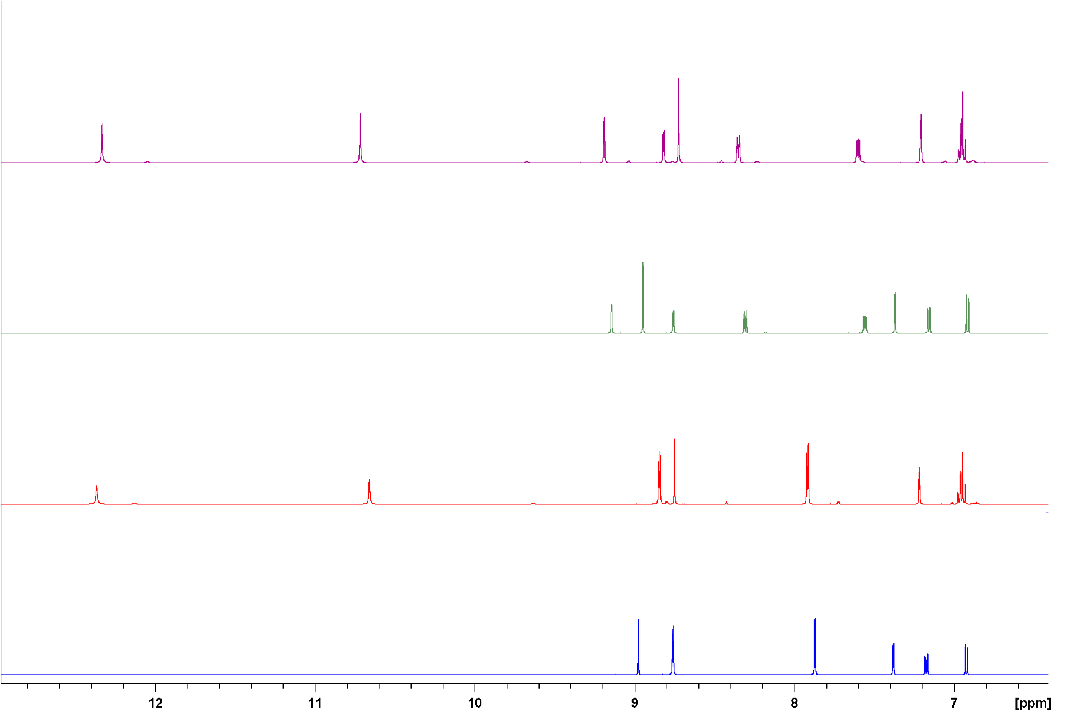

Figure S5. A portion of the ¹H NMR spectra in dmso-d₆ of: [MoO₂(L¹)]_{n} (1) - blue line; H₂L¹ - red line, [MoO₂(L¹)]_{n} (2) – green line , H₂L² – purple line

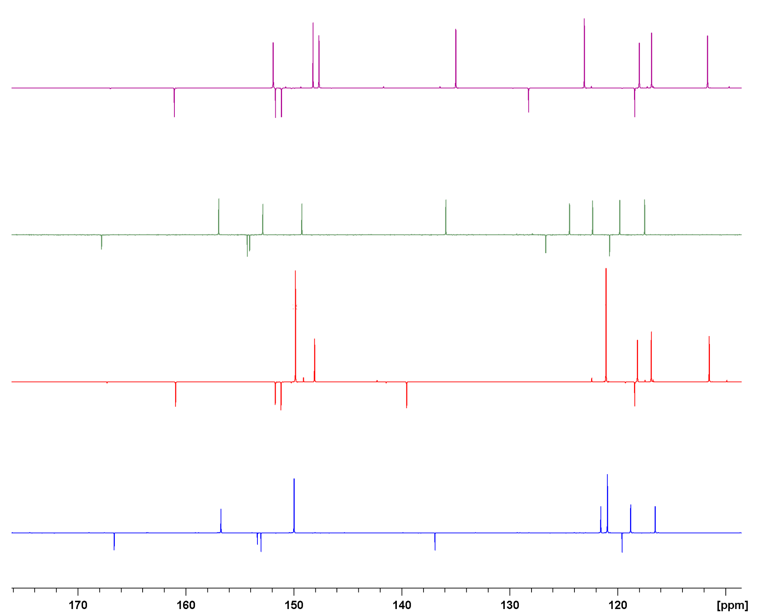

Figure S6. A portion of the ¹³C NMR spectra in dmso-d₆ of: [MoO₂(L¹)]_{n} (1) - blue line; H₂L¹ - red line, [MoO₂(L¹)]_{n} (2) – green line , H₂L² – purple line
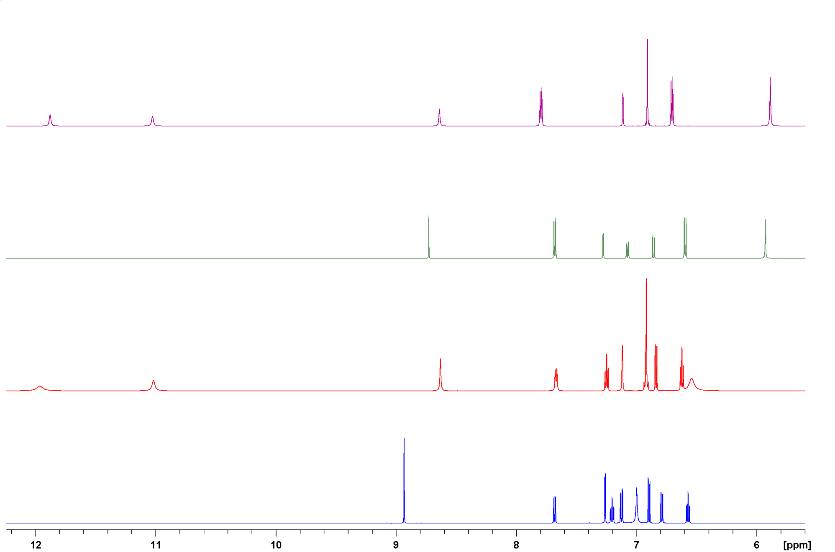

Figure S7. A portion of the ¹H NMR spectra in dmso-d₆ of: [MoO₂(L³)]₂ (3) - blue line; H₂L³ - red line, [MoO₂(L⁴)]₂ (4) – green line, H₂L⁴ – purple line

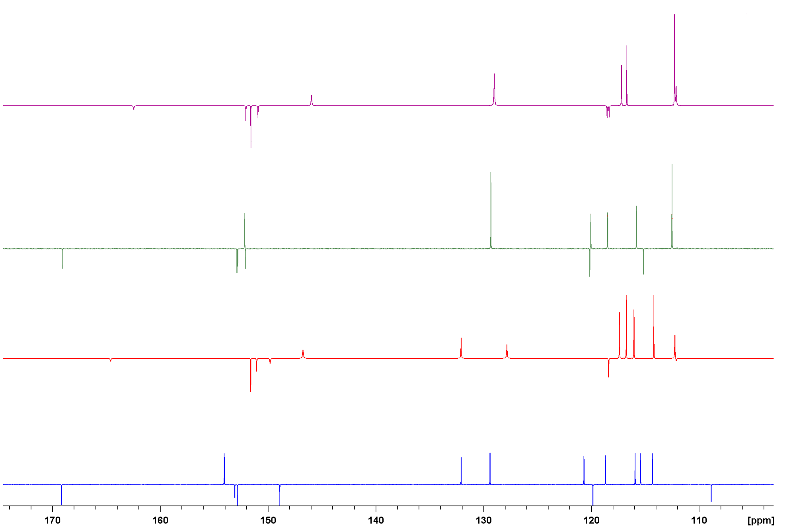

Figure S8. A portion of the ¹³C NMR spectra in dmso-d₆ of: [MoO₂(L³)]₂ (3) - blue line; H₂L³ - red line, [MoO₂(L⁴)]₂ (4) – green line, H₂L⁴ – purple line

Table S13. Imaginary frequency (cm⁻¹) of the calculated transition states shown in Table S14.

 | L1 | L2 | L3 | L4
TS | 471i | 470i | 473i | 476i

Table S14. DFT Coordinates of all species.
A - DFT coordinates of organic molecules

A0-MeOH
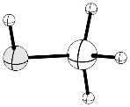
8 -0.748606000 -0.122482000 0.000001000
6 0.661940000 0.019648000 0.000035000
1 1.036807000 0.543842000 0.893075000
1 1.036822000 0.543722000 -0.893232000
1 1.079608000 -0.990888000 -0.000013000
1 -1.136031000 0.765290000 -0.000051000

A1 – C₂H₄

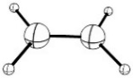
6 0.000000000 0.665616000 0.000000000
1 0.923789000 1.239603000 0.000000000
1 -0.923751000 1.239647000 0.000000000
6 0.000000000 -0.665616000 0.000000000
1 -0.923789000 -1.239603000 0.000000000
1 0.923751000 -1.239647000 0.000000000

A2– epo

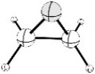
6 0.000000000 0.823033000 0.000000000
6 0.663277000 -0.487998000 0.000000000
1 -0.044284000 1.406100000 0.920513000
1 1.105429000 -0.869573000 0.920803000
8 -0.762744000 -0.385408000 0.000000000
1 -0.044284000 1.406100000 -0.920513000
1 1.105429000 -0.869573000 -0.920803000

A3 – TBHP

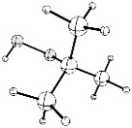
6 0.386063000 0.000211000 0.035516000
8 -0.724877000 -0.051131000 -0.892876000
8 -1.972121000 0.107335000 -0.155683000
6 1.585594000 -0.148364000 -0.908710000
6 0.308477000 -1.169459000 1.023961000
6 0.408392000 1.352799000 0.755437000
1 -2.332288000 -0.792908000 -0.245178000
1 1.280879000 1.423828000 1.414956000
1 1.184972000 -1.179544000 1.681110000
1 2.518340000 -0.109351000 -0.336278000
1 -0.583795000 -1.085739000 1.651566000
1 0.273436000 -2.124477000 0.486863000
1 1.545636000 -1.103632000 -1.442442000
1 1.596327000 0.660559000 -1.645981000
1 0.455220000 2.169404000 0.027401000
1 -0.493901000 1.481099000 1.359235000

A4 – tBuOH

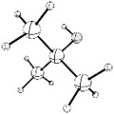

6 -0.005589000 -0.000026000 0.014420000
8 0.015118000 -0.000431000 1.451985000
1 0.945639000 0.001902000 1.728630000
6 -1.490947000 -0.005338000 -0.356041000
6 0.694937000 -1.262772000 -0.510972000
6 0.685524000 1.268259000 -0.510112000
1 0.646742000 1.325318000 -1.604317000
1 0.656167000 -1.319650000 -1.605180000
1 -1.623187000 -0.004815000 -1.443350000
1 1.752964000 -1.271531000 -0.216357000
1 0.219546000 -2.158915000 -0.098630000
1 -1.981082000 -0.894002000 0.055230000
1 -1.987701000 0.878867000 0.056897000
1 0.203120000 2.160551000 -0.097564000
1 1.743307000 1.284985000 -0.215007000

B- DFT coordinates for TBHP as oxidant – Gas phase
B1 - With Ligand L¹

MoO₂L¹(MeOH)

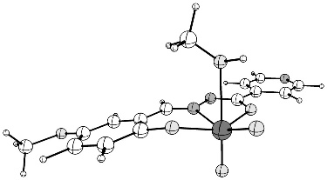
42 0.287666000 -1.514676000 -0.504120000
8 2.144014000 -0.752365000 -0.294954000
8 -1.565353000 -1.411090000 0.082883000
8 0.645363000 -1.424014000 2.021257000
1 1.022133000 -2.319978000 2.057454000
8 -5.624978000 2.342528000 -0.094947000
8 0.108712000 -1.406015000 -2.185325000
8 0.703090000 -3.125229000 -0.109334000
7 0.142879000 0.712702000 -0.023676000
7 6.385133000 1.929815000 0.010732000
7 1.345001000 1.380290000 0.076735000
6 3.724151000 1.024081000 -0.060427000
6 -2.272172000 0.906463000 0.014416000
6 -2.539511000 -0.488793000 -0.007227000
6 -4.921762000 -0.010062000 -0.100932000
1 -5.937399000 -0.385934000 -0.149143000
6 -4.666595000 1.371263000 -0.070131000
6 2.328295000 0.539090000 -0.096256000
6 -3.867804000 -0.921211000 -0.066366000
1 -4.060855000 -1.988940000 -0.081053000
6 4.790253000 0.138240000 -0.253309000
1 4.603904000 -0.914183000 -0.434553000
6 -3.346895000 1.813422000 -0.007801000
1 -3.157402000 2.882601000 0.012215000
6 4.018770000 2.375365000 0.167166000
1 3.219202000 3.091178000 0.319357000
6 -0.931308000 1.434271000 0.079755000
1 -0.800238000 2.509051000 0.212184000
6 6.090244000 0.642697000 -0.208336000
1 6.938353000 -0.023687000 -0.356031000
6 5.354420000 2.768014000 0.193007000
1 5.612969000 3.810804000 0.368842000
6 -6.984409000 1.943800000 -0.175304000
1 -7.184752000 1.374025000 -1.092380000
1 -7.565691000 2.867247000 -0.191324000
1 -7.282326000 1.344269000 0.695383000
6 -0.414593000 -1.326707000 2.981485000
1 -1.206470000 -2.056779000 2.782677000
1 -0.825328000 -0.320143000 2.892063000
1 -0.022459000 -1.462911000 3.995748000

MoO₂L¹

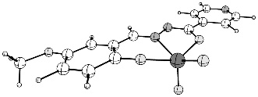

42 0.300712000 1.662152000 0.087558000
8 2.131126000 0.868342000 -0.157018000
8 -1.543841000 1.455504000 -0.481142000
8 -5.630245000 -2.209257000 0.156519000
8 0.225834000 1.990496000 1.749401000
8 0.669789000 3.074243000 -0.778435000
7 0.145197000 -0.600811000 -0.069358000
7 6.392482000 -1.800863000 -0.007601000
7 1.342419000 -1.288922000 -0.067994000
6 3.727298000 -0.912974000 -0.059047000
6 -2.270159000 -0.815108000 -0.092462000
6 -2.530092000 0.566999000 -0.284022000
6 -4.911996000 0.114421000 -0.177960000
1 -5.926944000 0.493371000 -0.212643000
6 -4.664984000 -1.258787000 0.006929000
6 2.330083000 -0.438522000 -0.086999000
6 -3.855864000 1.009770000 -0.324720000
1 -4.042961000 2.067151000 -0.479305000
6 4.788157000 -0.000879000 -0.095367000
1 4.596485000 1.064921000 -0.144699000
6 -3.348662000 -1.710094000 0.042008000
1 -3.163758000 -2.770657000 0.183887000
6 4.028122000 -2.280661000 0.003791000
1 3.232849000 -3.016664000 0.033977000
6 -0.932089000 -1.334077000 -0.063664000
1 -0.790437000 -2.414537000 -0.028710000
6 6.091498000 -0.498081000 -0.066703000
1 6.936485000 0.187537000 -0.093181000
6 5.366646000 -2.663593000 0.026201000
1 5.631457000 -3.718319000 0.074453000
6 -6.990511000 -1.802689000 0.126139000
1 -7.220071000 -1.099047000 0.937103000
1 -7.575795000 -2.713181000 0.263920000
1 -7.253897000 -1.345764000 -0.836904000

MoO₂L¹(TBHP)

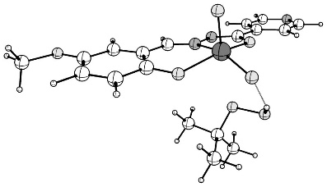

42 -0.200539000 0.318714000 1.597070000
8 -2.024500000 -0.201903000 0.966892000
8 1.608686000 0.708141000 1.024988000
8 5.803066000 -2.129558000 -1.192853000
8 0.041564000 -0.744004000 2.890367000
8 -0.669602000 1.848953000 2.211773000
7 -0.013600000 -1.090092000 -0.170877000
7 -6.229456000 -2.188571000 -0.943908000
7 -1.197745000 -1.590814000 -0.669697000
6 -3.584013000 -1.467361000 -0.331038000
6 2.403221000 -1.113035000 -0.353952000
6 2.624092000 -0.012739000 0.515019000
6 5.019590000 -0.312918000 0.259861000
1 6.022983000 0.010651000 0.511591000
6 4.811631000 -1.400696000 -0.606453000
6 -2.197538000 -1.081243000 -0.005342000
6 3.935696000 0.370678000 0.806967000
1 4.091723000 1.217242000 1.467378000
6 -4.662057000 -0.870418000 0.332002000
1 -4.490959000 -0.114728000 1.089856000
6 3.507130000 -1.784758000 -0.909567000
1 3.353729000 -2.624875000 -1.580252000
6 -3.857347000 -2.433641000 -1.308963000
1 -3.047878000 -2.917216000 -1.843669000
6 1.077558000 -1.543009000 -0.714226000
1 0.966198000 -2.300338000 -1.490558000
6 -5.954430000 -1.266983000 -0.012965000
1 -6.812487000 -0.819200000 0.485038000
6 -5.187156000 -2.751683000 -1.571865000
1 -5.430702000 -3.498357000 -2.325648000
6 7.151290000 -1.782421000 -0.914035000
1 7.379881000 -1.878801000 0.155530000
1 7.762936000 -2.488655000 -1.477697000
1 7.381652000 -0.760722000 -1.243916000
1 -1.608235000 2.793260000 0.905892000
8 -1.969909000 2.861220000 -0.006449000
8 -0.978379000 2.057130000 -0.708141000
6 -0.224636000 2.926920000 -1.606441000
6 -1.194558000 3.604470000 -2.580376000
1 -1.771308000 2.852762000 -3.129558000
1 -1.892277000 4.251078000 -2.043607000
1 -0.639555000 4.213424000 -3.302930000
1 -0.085268000 4.592289000 -0.219613000
6 0.582107000 3.947216000 -0.797521000
6 0.689837000 1.944232000 -2.344124000
1 0.098899000 1.170252000 -2.844729000
1 1.268678000 2.481437000 -3.103008000
1 1.391556000 1.465065000 -1.655898000
1 1.174608000 4.581387000 -1.466535000
1 1.264143000 3.438893000 -0.107737000

TS

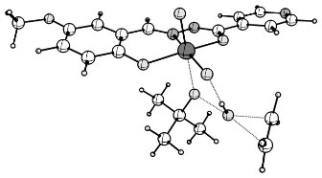
42 0.442669000 1.041296000 1.399288000
8 -1.297058000 0.222217000 0.762924000
8 2.262441000 1.562163000 0.968882000
8 0.823365000 -0.103332000 2.587051000
8 -0.265388000 2.377284000 2.246976000
7 -0.213692000 -1.109378000 -0.784762000
6 -2.606265000 -1.262673000 -0.573088000
6 4.608964000 1.336513000 1.037660000
1 4.643792000 2.243597000 1.632155000
6 4.492533000 -0.972672000 -0.510705000
1 4.462302000 -1.873645000 -1.116291000
7 0.882208000 -0.471353000 -0.246799000
6 3.358701000 0.854101000 0.639821000
8 6.821893000 -1.204704000 -0.505143000
6 3.296795000 -0.328428000 -0.148220000
6 -4.986441000 -1.447360000 -0.304802000
6 2.050737000 -0.887780000 -0.620818000
1 2.088540000 -1.719204000 -1.325891000
7 -5.104317000 -2.335884000 -1.298898000
6 -3.976699000 -2.692807000 -1.930935000
1 -4.090186000 -3.416930000 -2.735913000
6 -1.297445000 -0.691919000 -0.185850000
6 8.107435000 -0.751035000 -0.113122000
1 8.319942000 0.251977000 -0.507035000
1 8.217006000 -0.740544000 0.979589000
1 8.817666000 -1.462082000 -0.538671000
6 5.784395000 0.677881000 0.681299000
1 6.733272000 1.082213000 1.014725000
6 -3.775440000 -0.883048000 0.095606000
1 -3.732266000 -0.169194000 0.910130000
6 -2.715238000 -2.195964000 -1.612891000
1 -1.831916000 -2.517190000 -2.152629000
6 5.732862000 -0.487931000 -0.099831000
1 -1.040647000 3.265236000 1.071115000
8 -1.471127000 3.520047000 0.206803000
8 -0.114032000 2.395103000 -0.494736000
1 2.002054000 4.048337000 -0.298402000
6 1.226805000 4.363867000 -1.004057000
6 0.480970000 3.138795000 -1.557296000
6 -0.616658000 3.560768000 -2.550804000
1 -0.177164000 4.056566000 -3.424403000
1 -1.171912000 2.681278000 -2.894007000
1 -1.320022000 4.251900000 -2.079638000
1 0.529640000 5.024249000 -0.479242000
1 1.701931000 4.934702000 -1.811085000
6 1.464223000 2.201559000 -2.289119000
1 2.293474000 1.910033000 -1.642160000
1 0.948163000 1.300933000 -2.635751000
1 1.880153000 2.718628000 -3.162021000
1 -2.248779000 5.059022000 2.283639000
6 -2.671760000 4.974449000 1.287686000
1 -2.642405000 5.853075000 0.653307000
6 -3.172748000 3.775675000 0.824385000
1 -3.316919000 2.936361000 1.497123000
1 -3.710342000 3.725682000 -0.115929000
1 -5.910399000 -1.170967000 0.200777000

MoO(OR)(OH)L¹
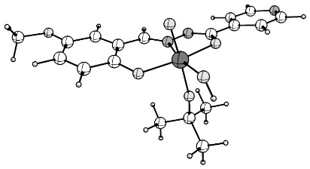
42 0.186435000 0.907250000 -1.131216000
8 2.016452000 0.090270000 -0.896490000
8 -1.662138000 1.091154000 -0.580431000
8 -5.779218000 -2.366780000 0.691713000
8 -0.240146000 -0.092879000 -2.437374000
8 0.731849000 2.373588000 -2.215740000
7 0.014876000 -0.913235000 0.187339000
7 6.192126000 -2.427989000 0.329053000
7 1.201857000 -1.534986000 0.515042000
6 3.565384000 -1.467964000 0.039680000
6 -2.408186000 -1.031837000 0.282622000
6 -2.655587000 0.226622000 -0.327243000
6 -5.040132000 -0.233480000 -0.274131000
1 -6.048430000 0.091682000 -0.503548000
6 -4.806801000 -1.476606000 0.336563000
6 2.188009000 -0.953915000 -0.114115000
6 -3.973898000 0.605252000 -0.594932000
1 -4.151223000 1.571066000 -1.056440000
6 4.628303000 -0.871621000 -0.647981000
1 4.452637000 -0.028853000 -1.306896000
6 -3.495608000 -1.859176000 0.612975000
1 -3.323602000 -2.824210000 1.080364000
6 3.845114000 -2.558015000 0.874868000
1 3.047144000 -3.046983000 1.421721000
6 -1.074942000 -1.498336000 0.578718000
1 -0.963810000 -2.425013000 1.142035000
6 5.910989000 -1.389807000 -0.467621000
1 6.756152000 -0.946336000 -0.991273000
6 5.164436000 -2.990608000 0.981289000
1 5.411477000 -3.834112000 1.623626000
6 -7.129120000 -2.034979000 0.408785000
1 -7.294291000 -1.898003000 -0.668238000
1 -7.724017000 -2.880172000 0.759187000
1 -7.443373000 -1.126979000 0.940969000
1 1.086908000 3.092968000 -1.663392000
8 0.596799000 1.983677000 0.432459000
6 0.667506000 2.571289000 1.718172000
6 1.787028000 1.868304000 2.504726000
1 1.571753000 0.799117000 2.601772000
1 2.745561000 1.980206000 1.987003000
1 1.883789000 2.295529000 3.509582000
1 1.946977000 4.185338000 1.009410000
6 0.991801000 4.064075000 1.533006000
6 -0.688612000 2.397955000 2.422652000
1 -0.924096000 1.336073000 2.547631000
1 -0.670123000 2.865762000 3.413921000
1 -1.487549000 2.858870000 1.833593000
1 1.066166000 4.572131000 2.501239000
1 0.206776000 4.555736000 0.947478000

B2 - With Ligand L²

MoO₂L²(MeOH)

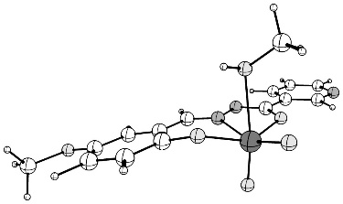

42 0.227751000 -1.433078000 -0.567858000
8 2.073895000 -0.662662000 -0.318689000
8 -1.591271000 -1.405056000 0.157720000
8 -0.053075000 -1.132358000 -2.212166000
8 0.479929000 -1.466194000 1.918391000
1 -0.406082000 -1.789601000 2.152923000
8 0.652908000 -3.076516000 -0.403993000
7 1.256893000 1.450529000 0.143995000
6 3.633354000 1.127048000 -0.056774000
6 -3.904607000 -0.957226000 0.030592000
1 -4.072336000 -2.028624000 -0.010928000
6 -3.446520000 1.783795000 0.159802000
1 -3.282333000 2.856316000 0.206703000
7 0.061775000 0.774329000 0.043272000
6 -2.586729000 -0.496055000 0.091742000
8 -5.736849000 2.262990000 0.103728000
6 -2.350167000 0.903958000 0.147546000
7 5.990865000 0.642239000 -0.272890000
6 -1.020859000 1.466334000 0.210944000
1 -0.915152000 2.536532000 0.394778000
6 6.241812000 1.934165000 -0.028667000
1 7.291627000 2.223447000 -0.023684000
6 5.245937000 2.886457000 0.209673000
1 5.511010000 3.922010000 0.400397000
6 2.246717000 0.628314000 -0.080816000
6 -7.086816000 1.835467000 0.018133000
1 -7.367120000 1.205717000 0.873289000
1 -7.278390000 1.285959000 -0.913172000
1 -7.689505000 2.745236000 0.029487000
6 -4.981085000 -0.071689000 0.028955000
1 -5.987930000 -0.470045000 -0.021797000
6 4.710765000 0.256689000 -0.285892000
1 4.520160000 -0.793499000 -0.489643000
6 1.473600000 -2.315568000 2.519210000
1 1.366720000 -3.349131000 2.176459000
1 1.405553000 -2.259946000 3.611151000
1 2.440001000 -1.929082000 2.195018000
6 3.918334000 2.477206000 0.195791000
1 3.104358000 3.171576000 0.374173000
6 -4.756598000 1.312954000 0.095484000

MoO₂L²
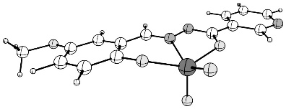

42 -0.305616000 -1.655195000 0.089458000
8 -2.133738000 -0.859062000 -0.155329000
8 1.538174000 -1.453051000 -0.483503000
8 -0.227376000 -1.979417000 1.752115000
8 -0.676160000 -3.069255000 -0.772685000
7 -1.341901000 1.297720000 -0.068623000
6 -3.724191000 0.924208000 -0.057964000
6 3.851473000 -1.013441000 -0.328394000
1 4.035379000 -2.071179000 -0.484508000
6 3.351444000 1.706642000 0.042341000
1 3.169617000 2.767562000 0.185720000
7 -0.146186000 0.608238000 -0.069657000
6 2.526950000 -0.567145000 -0.286183000
8 5.634626000 2.200171000 0.156283000
6 2.270458000 0.815100000 -0.092879000
7 -6.076144000 0.376414000 -0.081431000
6 0.933175000 1.337902000 -0.063715000
1 0.795226000 2.418855000 -0.028494000
6 -6.343911000 1.686308000 -0.016287000
1 -7.398449000 1.957115000 -0.001236000
6 -5.359803000 2.678904000 0.031781000
1 -5.639077000 3.726756000 0.084864000
6 -2.332564000 0.448533000 -0.085966000
6 6.993452000 1.789627000 0.125278000
1 7.255608000 1.333213000 -0.838392000
1 7.221019000 1.083937000 0.935075000
1 7.581709000 2.698050000 0.264430000
6 4.910395000 -0.121346000 -0.181109000
1 5.924301000 -0.502963000 -0.216961000
6 -4.790651000 0.011790000 -0.101728000
1 -4.586378000 -1.053995000 -0.155763000
6 -4.025681000 2.292670000 0.011234000
1 -3.220960000 3.019277000 0.047036000
6 4.666669000 1.251891000 0.005908000

MoO₂L²(TBHP)

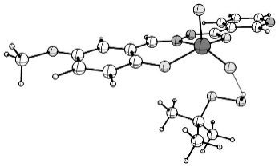
42 -0.207381000 0.305002000 1.593394000
8 -2.029337000 -0.212509000 0.958198000
8 1.602777000 0.700210000 1.027465000
8 0.034918000 -0.764556000 2.881248000
8 -0.678043000 1.831871000 2.215004000
7 -1.199943000 -1.588418000 -0.688520000
6 -3.583455000 -1.470806000 -0.348822000
6 3.930465000 0.364367000 0.813717000
1 4.084343000 1.207090000 1.479551000
6 3.506568000 -1.780738000 -0.916094000
1 3.355239000 -2.616987000 -1.592096000
7 -0.017278000 -1.091607000 -0.184282000
6 2.619719000 -0.017555000 0.515979000
8 5.803536000 -2.123932000 -1.195610000
6 2.400995000 -1.112560000 -0.359885000
7 -5.944158000 -1.186887000 0.073384000
6 1.075873000 -1.540323000 -0.726814000
1 0.967556000 -2.292620000 -1.508457000
6 -6.185415000 -2.102752000 -0.872531000
1 -7.233640000 -2.333498000 -1.056220000
6 -5.182695000 -2.747665000 -1.603483000
1 -5.440884000 -3.482511000 -2.359927000
6 -2.202681000 -1.085229000 -0.020866000
6 7.150613000 -1.778415000 -0.910465000
1 7.382077000 -0.754661000 -1.233276000
1 7.375953000 -1.881081000 0.159247000
1 7.764332000 -2.481107000 -1.476387000
6 5.016182000 -0.315706000 0.265696000
1 6.018827000 0.006524000 0.522063000
6 -4.667062000 -0.882296000 0.322876000
1 -4.483604000 -0.133531000 1.088220000
6 -3.857368000 -2.427682000 -1.337293000
1 -3.038713000 -2.897051000 -1.872283000
6 4.810278000 -1.398255000 -0.607301000
1 -1.617373000 2.780067000 0.910837000
8 -1.971204000 2.857565000 -0.003794000
8 -0.974284000 2.060823000 -0.705976000
1 1.267035000 3.430102000 -0.072621000
6 0.590490000 3.948486000 -0.760293000
6 -0.212437000 2.940081000 -1.587776000
6 -1.173718000 3.632125000 -2.560144000
1 -0.611880000 4.247751000 -3.271753000
1 -1.749042000 2.888644000 -3.121919000
1 -1.873162000 4.274495000 -2.020569000
1 -0.080002000 4.586697000 -0.178401000
1 1.188414000 4.590620000 -1.416831000
6 0.705243000 1.964849000 -2.331320000
1 1.399836000 1.474333000 -1.643979000
1 0.116094000 1.199319000 -2.846858000
1 1.291761000 2.510394000 -3.078340000

TS
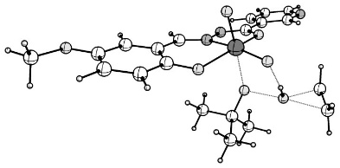

42 0.455243000 1.040208000 1.400969000
8 -1.285749000 0.222523000 0.770933000
8 2.273682000 1.560220000 0.965164000
8 0.836832000 -0.096869000 2.595945000
8 -0.251758000 2.383278000 2.237539000
7 -0.208514000 -1.111874000 -0.779002000
6 -2.600691000 -1.244880000 -0.573792000
6 4.620400000 1.334207000 1.029025000
1 4.656510000 2.242889000 1.621025000
6 4.499715000 -0.978340000 -0.513086000
1 4.468105000 -1.880701000 -1.116572000
7 0.889521000 -0.478335000 -0.241342000
6 3.369246000 0.850832000 0.635444000
8 6.829324000 -1.210725000 -0.513405000
6 3.304927000 -0.333465000 -0.149383000
7 -4.996727000 -1.268115000 -0.252037000
6 2.057212000 -0.893304000 -0.618819000
1 2.094021000 -1.723620000 -1.325288000
6 -5.082094000 -2.184727000 -1.224175000
1 -6.084801000 -2.537519000 -1.460761000
6 -3.975575000 -2.684820000 -1.917049000
1 -4.106886000 -3.430193000 -2.695693000
6 -1.292008000 -0.689453000 -0.180584000
6 8.115637000 -0.755513000 -0.126469000
1 8.326552000 0.246692000 -0.523391000
1 8.228630000 -0.742084000 0.965897000
1 8.825111000 -1.467198000 -0.552330000
6 5.795215000 0.674873000 0.671440000
1 6.744911000 1.080107000 1.001416000
6 -3.777510000 -0.816524000 0.058972000
1 -3.719268000 -0.077031000 0.852792000
6 -2.712653000 -2.207896000 -1.587048000
1 -1.819162000 -2.559380000 -2.091624000
6 5.741237000 -0.492604000 -0.106598000
1 -1.059157000 3.238518000 1.049310000
8 -1.500845000 3.463120000 0.182786000
8 -0.109048000 2.375078000 -0.508849000
1 1.983992000 4.054471000 -0.267693000
6 1.212185000 4.367214000 -0.978344000
6 0.489906000 3.138534000 -1.554453000
6 -0.599630000 3.557840000 -2.558074000
1 -0.154633000 4.067803000 -3.420726000
1 -1.139822000 2.675362000 -2.917339000
1 -1.317389000 4.235429000 -2.089006000
1 0.499425000 5.011083000 -0.453766000
1 1.687949000 4.954899000 -1.772811000
6 1.494093000 2.220864000 -2.283006000
1 2.316544000 1.929908000 -1.627324000
1 0.992457000 1.318941000 -2.647170000
1 1.917168000 2.752313000 -3.143841000
1 -2.338151000 4.997000000 2.242214000
6 -2.758431000 4.882457000 1.248085000
1 -2.765853000 5.753422000 0.602559000
6 -3.211295000 3.658517000 0.801309000
1 -3.320625000 2.822402000 1.484479000
1 -3.747702000 3.574369000 -0.137212000

MoO(OR)(OH)L²
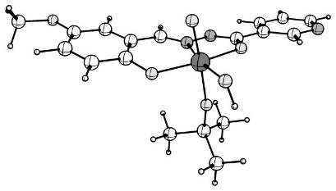
42 0.189384000 0.895975000 -1.132356000
8 2.015564000 0.073076000 -0.900397000
8 -1.656332000 1.093366000 -0.572913000
8 -0.254067000 -0.107160000 -2.430513000
8 0.739619000 2.353103000 -2.226504000
7 1.200615000 -1.538885000 0.526472000
6 3.561081000 -1.477920000 0.048753000
6 -3.969491000 0.613059000 -0.591192000
1 -4.143494000 1.579159000 -1.053415000
6 -3.499114000 -1.851397000 0.618695000
1 -3.330424000 -2.816592000 1.087018000
7 0.014942000 -0.918042000 0.194639000
6 -2.652514000 0.231181000 -0.321576000
8 -5.784311000 -2.353588000 0.694622000
6 -2.409052000 -1.027421000 0.289364000
7 5.901083000 -1.277039000 -0.517697000
6 -1.076988000 -1.497021000 0.588522000
1 -0.969718000 -2.421304000 1.156542000
6 6.145024000 -2.329757000 0.272339000
1 7.185415000 -2.643963000 0.340543000
6 5.153355000 -3.012686000 0.983246000
1 5.412202000 -3.862184000 1.608025000
6 2.188601000 -0.964950000 -0.109110000
6 -7.132591000 -2.018564000 0.408888000
1 -7.445781000 -1.109491000 0.939960000
1 -7.295406000 -1.881456000 -0.668518000
1 -7.730513000 -2.862056000 0.758384000
6 -5.038626000 -0.222548000 -0.271517000
1 -6.045752000 0.105109000 -0.502545000
6 4.632814000 -0.867546000 -0.621316000
1 4.447106000 -0.013888000 -1.267525000
6 3.837656000 -2.580601000 0.869959000
1 3.027433000 -3.072467000 1.397429000
6 -4.809003000 -1.465661000 0.340127000
1 1.107484000 3.070913000 -1.680544000
8 0.608652000 1.979179000 0.425075000
1 0.214119000 4.553207000 0.927413000
6 0.997892000 4.064905000 1.517393000
6 0.674250000 2.572629000 1.708042000
6 1.792222000 1.874179000 2.501030000
1 1.885723000 2.305801000 3.504376000
1 1.577320000 0.805222000 2.601702000
1 2.752054000 1.984738000 1.985425000
1 1.954350000 4.184616000 0.995845000
1 1.069067000 4.577310000 2.483613000
6 -0.683429000 2.401414000 2.410132000
1 -1.481343000 2.858985000 1.817186000
1 -0.918487000 1.339921000 2.539137000
1 -0.667497000 2.873652000 3.399391000

B3 - With Ligand L³

[MoO₂L³]₂

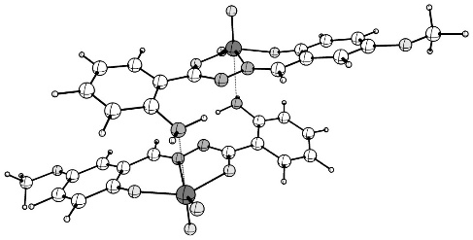

42 2.205517000 -2.731399000 -0.540364000
8 2.817790000 -3.208164000 1.240762000
8 1.156231000 -1.419242000 -1.671221000
7 2.323864000 -0.650453000 0.398865000
8 5.935074000 -0.881489000 5.174129000
8 3.679566000 -2.658741000 -1.378363000
7 1.724036000 0.359021000 -0.324667000
8 1.381050000 -4.144093000 -1.029451000
7 0.106432000 2.601149000 -0.827563000
1 0.234161000 3.609205000 -0.785899000
1 0.774089000 2.132123000 -0.212227000
6 1.173735000 -0.126540000 -1.411972000
6 0.584587000 0.770357000 -2.425859000
6 -0.341046000 2.409655000 -4.504859000
1 -0.691497000 3.057478000 -5.303652000
6 -0.284970000 2.899073000 -3.204145000
1 -0.611132000 3.912185000 -2.986899000
6 3.686716000 -1.217590000 2.319712000
6 0.495384000 0.287792000 -3.744946000
1 0.812337000 -0.731127000 -3.937586000
6 0.041150000 1.093682000 -4.781065000
1 -0.006610000 0.704774000 -5.793482000
6 2.976767000 -0.298689000 1.463105000
1 3.007126000 0.763725000 1.708114000
6 0.165815000 2.095705000 -2.146880000
6 4.476593000 -0.686004000 3.353840000
1 4.540907000 0.389271000 3.491671000
6 3.608303000 -2.626665000 2.160525000
6 5.124375000 -2.903983000 4.041795000
1 5.674605000 -3.573882000 4.692670000
6 4.335393000 -3.446086000 3.028332000
1 4.267621000 -4.521276000 2.897915000
6 5.198071000 -1.512258000 4.213312000
6 6.695832000 -1.677969000 6.067838000
1 7.446683000 -2.278097000 5.536575000
1 6.055672000 -2.344212000 6.661894000
1 7.201864000 -0.977887000 6.734852000
42 -2.205517000 2.731399000 0.540364000
8 -2.817790000 3.208164000 -1.240762000
8 -1.156231000 1.419242000 1.671221000
7 -2.323864000 0.650453000 -0.398865000
8 -5.935074000 0.881489000 -5.174129000
8 -3.679566000 2.658741000 1.378363000
7 -1.724036000 -0.359021000 0.324667000
8 -1.381050000 4.144093000 1.029451000
7 -0.106432000 -2.601149000 0.827563000
1 -0.234161000 -3.609205000 0.785899000
1 -0.774089000 -2.132123000 0.212227000
6 -1.173735000 0.126540000 1.411972000
6 -0.584587000 -0.770357000 2.425859000
6 0.341046000 -2.409655000 4.504859000
1 0.691497000 -3.057478000 5.303652000
6 0.284970000 -2.899073000 3.204145000
1 0.611132000 -3.912185000 2.986899000
6 -3.686716000 1.217590000 -2.319712000
6 -0.495384000 -0.287792000 3.744946000
1 -0.812337000 0.731127000 3.937586000
6 -0.041150000 -1.093682000 4.781065000
1 0.006610000 -0.704774000 5.793482000
6 -2.976767000 0.298689000 -1.463105000
1 -3.007126000 -0.763725000 -1.708114000
6 -0.165815000 -2.095705000 2.146880000
6 -4.476593000 0.686004000 -3.353840000
1 -4.540907000 -0.389271000 -3.491671000
6 -3.608303000 2.626665000 -2.160525000
6 -5.124375000 2.903983000 -4.041795000
1 -5.674605000 3.573882000 -4.692670000
6 -4.335393000 3.446086000 -3.028332000
1 -4.267621000 4.521276000 -2.897915000
6 -5.198071000 1.512258000 -4.213312000
6 -6.695832000 1.677969000 -6.067838000
1 -7.446683000 2.278097000 -5.536575000
1 -6.055672000 2.344212000 -6.661894000
1 -7.201864000 0.977887000 -6.734852000

MoO₂L³(MeOH)

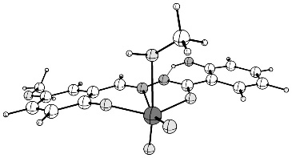

42 0.057873000 -1.618291000 -0.533534000
8 1.887717000 -0.844000000 -0.283766000
8 -1.771613000 -1.573380000 0.173124000
8 0.474209000 -3.259324000 -0.319938000
8 0.274583000 -1.592025000 1.960913000
1 -0.605100000 -1.936810000 2.188434000
7 2.940980000 3.240904000 0.489648000
8 -6.058498000 1.911472000 -0.004680000
7 1.078609000 1.275537000 0.111170000
7 -0.113800000 0.601375000 0.015236000
8 -0.213333000 -1.363912000 -2.188027000
6 -2.763951000 -0.666608000 0.082409000
6 2.089380000 0.453996000 -0.083638000
6 -3.632093000 1.618192000 0.075813000
1 -3.430059000 2.683603000 0.089460000
6 3.851219000 2.273659000 0.157449000
6 -2.530516000 0.728978000 0.094061000
6 -4.934570000 1.137343000 0.026807000
6 4.488477000 -0.032013000 -0.362460000
1 4.182820000 -1.055857000 -0.545085000
6 3.478238000 0.915011000 -0.084988000
6 5.223156000 2.608811000 0.087157000
1 5.512338000 3.641509000 0.269130000
6 -1.202807000 1.292319000 0.151289000
1 -1.104341000 2.368268000 0.305812000
6 -4.087039000 -1.136723000 0.037188000
1 -4.250437000 -2.209509000 0.029248000
6 -5.153353000 -0.253835000 0.007316000
1 -6.176411000 -0.614645000 -0.030483000
6 5.826418000 0.318519000 -0.419149000
1 6.581476000 -0.429270000 -0.639740000
6 1.282964000 -2.401941000 2.589797000
1 2.242359000 -1.993541000 2.271726000
1 1.209490000 -3.444088000 2.264205000
1 1.198636000 -2.329815000 3.679767000
6 -5.898842000 3.320075000 -0.001237000
1 -5.332759000 3.663679000 -0.877623000
1 -5.395775000 3.667113000 0.911656000
1 -6.906794000 3.737028000 -0.037173000
6 6.187110000 1.656013000 -0.194384000
1 7.231642000 1.954016000 -0.239503000
1 3.225160000 4.205496000 0.404762000
1 1.959310000 3.014916000 0.369868000

MoO₂L³

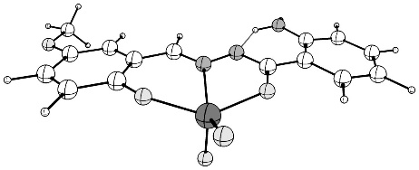

42 -0.115035000 -1.827918000 0.101699000
8 -1.924330000 -1.035092000 -0.176508000
8 1.732765000 -1.639083000 -0.475948000
8 -0.474294000 -3.267582000 -0.724204000
7 -3.024632000 3.108147000 -0.118635000
8 5.983885000 1.830543000 0.093248000
7 -1.141638000 1.116841000 -0.106359000
7 0.051364000 0.430582000 -0.091233000
8 -0.034828000 -2.109597000 1.772886000
6 2.721176000 -0.752928000 -0.293456000
6 -2.152179000 0.273987000 -0.117867000
6 3.560837000 1.525930000 0.010016000
1 3.345394000 2.580547000 0.141312000
6 -3.930535000 2.085294000 -0.052271000
6 2.471771000 0.627106000 -0.114800000
6 4.866946000 1.058291000 -0.026502000
6 -4.548005000 -0.285765000 -0.073117000
1 -4.231906000 -1.322078000 -0.105237000
6 -3.544556000 0.709090000 -0.087153000
6 -5.310547000 2.385952000 0.016512000
1 -5.611047000 3.430884000 0.044714000
6 1.136976000 1.153027000 -0.094416000
1 1.007326000 2.235763000 -0.076716000
6 4.049429000 -1.210591000 -0.336811000
1 4.225316000 -2.271208000 -0.481801000
6 5.101268000 -0.322354000 -0.202023000
1 6.129842000 -0.667923000 -0.231410000
6 -5.892502000 0.033934000 -0.012373000
1 -6.643357000 -0.749435000 0.000068000
6 5.814837000 3.227283000 0.274319000
1 5.261409000 3.449209000 1.196715000
1 5.294396000 3.683687000 -0.578500000
1 6.820509000 3.644284000 0.347907000
6 -6.267248000 1.386153000 0.036160000
1 -7.318432000 1.658202000 0.088267000
1 -3.332017000 4.033960000 0.138895000
1 -2.043242000 2.877714000 -0.015095000

MoO₂L³(TBHP)
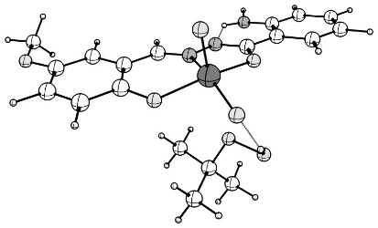

42 -0.074846000 -0.702266000 -1.570721000
8 -1.882163000 -0.127859000 -0.990991000
8 1.748064000 -0.979024000 -0.963726000
8 -0.512181000 -2.316630000 -1.952027000
7 -2.926458000 3.125829000 1.597143000
8 6.071045000 2.091713000 0.570473000
7 -1.071105000 1.522250000 0.377586000
7 0.112146000 0.969213000 -0.049351000
8 0.144258000 0.163385000 -3.008253000
6 2.756950000 -0.170713000 -0.597444000
6 -2.091233000 0.903294000 -0.179404000
6 3.642306000 1.830575000 0.492840000
1 3.448798000 2.762635000 1.012108000
6 -3.842622000 2.401966000 0.884804000
6 2.534882000 1.051321000 0.077360000
6 4.939793000 1.412545000 0.227061000
6 -4.491025000 0.566624000 -0.603375000
1 -4.189729000 -0.270798000 -1.221818000
6 -3.475681000 1.300050000 0.050707000
6 -5.215333000 2.722946000 0.994918000
1 -5.500903000 3.561860000 1.625532000
6 1.209332000 1.515062000 0.389269000
1 1.104983000 2.388317000 1.034229000
6 4.074608000 -0.586704000 -0.849929000
1 4.228543000 -1.530049000 -1.363231000
6 5.146196000 0.192363000 -0.448932000
1 6.166973000 -0.120165000 -0.645098000
6 -5.828346000 0.895012000 -0.472888000
1 -6.588789000 0.315719000 -0.986468000
6 5.928264000 3.333612000 1.240823000
1 5.373182000 4.058535000 0.630390000
1 5.422885000 3.213438000 2.208643000
1 6.941493000 3.702986000 1.407181000
6 -6.183611000 1.988677000 0.332707000
1 -7.228857000 2.265793000 0.444359000
1 -3.211507000 4.016815000 1.974859000
1 -1.944830000 2.974872000 1.395431000
8 -1.710506000 -3.103577000 0.409472000
8 -0.767673000 -2.153097000 0.983964000
6 0.021329000 -2.836333000 2.001866000
6 -0.919078000 -3.400408000 3.072716000
1 -1.579953000 -4.157622000 2.645136000
1 -1.536606000 -2.601364000 3.496283000
1 -0.338797000 -3.858490000 3.881826000
1 0.244954000 -4.694255000 0.901321000
6 0.879205000 -3.930441000 1.359401000
1 1.529559000 -3.505137000 0.587810000
1 1.507863000 -4.415528000 2.114839000
1 1.565397000 -1.307822000 1.819564000
6 0.884819000 -1.708347000 2.575973000
1 0.254893000 -0.895155000 2.951456000
1 1.485402000 -2.092323000 3.407523000
1 -1.364792000 -3.124047000 -0.511376000

TS
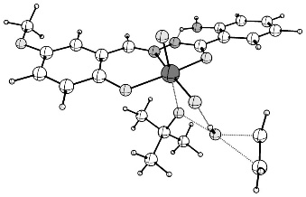
42 -0.064539000 -0.909551000 -1.057168000
8 -1.786167000 -0.047263000 -0.482234000
8 1.765330000 -1.380003000 -0.595267000
8 -0.775696000 -2.334582000 -1.742235000
7 -2.301748000 3.058415000 2.422216000
8 6.441924000 1.390878000 0.393360000
7 -0.708127000 1.427772000 0.917347000
7 0.384495000 0.758957000 0.422788000
8 0.304965000 0.097467000 -2.367427000
6 2.858727000 -0.634686000 -0.360998000
6 -1.815201000 0.956918000 0.378323000
6 4.003849000 1.314575000 0.568968000
1 3.937426000 2.270964000 1.076039000
6 -3.322245000 2.565926000 1.653245000
6 2.801707000 0.618796000 0.295695000
6 5.232649000 0.791428000 0.186085000
6 -4.245457000 1.039437000 -0.019853000
1 -4.071696000 0.257671000 -0.750363000
6 -3.127967000 1.529188000 0.688967000
6 -4.632802000 3.063187000 1.840181000
1 -4.785996000 3.851905000 2.573474000
6 1.559439000 1.211305000 0.733538000
1 1.607569000 2.105971000 1.356505000
6 4.110395000 -1.155635000 -0.730158000
1 4.138460000 -2.120803000 -1.225151000
6 5.275600000 -0.455469000 -0.467333000
1 6.243236000 -0.852904000 -0.757139000
6 -5.521094000 1.539045000 0.181700000
1 -6.361292000 1.148184000 -0.383674000
6 6.458548000 2.651913000 1.040352000
1 5.900898000 3.406045000 0.468478000
1 6.043502000 2.590313000 2.055702000
1 7.507848000 2.946699000 1.097922000
6 -5.706042000 2.563450000 1.122524000
1 -6.698050000 2.973735000 1.294475000
1 -2.450744000 3.936954000 2.896008000
1 -1.356473000 2.814929000 2.144869000
6 -3.272168000 -4.728872000 -0.482664000
1 -2.897637000 -4.914670000 -1.484262000
1 -3.255344000 -5.553407000 0.221081000
1 -4.182767000 -3.317287000 0.854677000
6 -3.684728000 -3.468944000 -0.096599000
1 -3.825681000 -2.681665000 -0.830207000
1 -1.551394000 -3.080944000 -0.463688000
8 -1.968932000 -3.231614000 0.430852000
8 -0.578863000 -2.073653000 0.992120000
6 0.048624000 -2.732264000 2.089728000
1 1.538087000 -3.734574000 0.865448000
6 1.048789000 -1.736761000 2.714461000
1 1.858940000 -1.500122000 2.022558000
1 0.537925000 -0.810869000 2.996742000
1 1.489858000 -2.178136000 3.616268000
1 1.278605000 -4.504939000 2.448099000
6 0.782082000 -3.996208000 1.612697000
6 -1.016724000 -3.076411000 3.146969000
1 -0.547511000 -3.491284000 4.047058000
1 -1.725434000 -3.811505000 2.757256000
1 -1.571622000 -2.174953000 3.428227000
1 0.072131000 -4.693853000 1.157639000
MoO(OR)(OH)L³
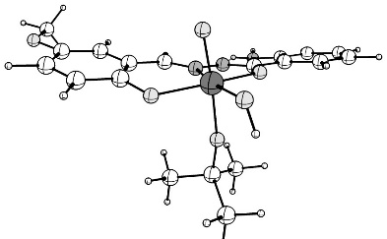
42 -0.047265000 -1.174109000 -1.064491000
8 -1.862657000 -0.353604000 -0.904957000
8 1.816962000 -1.278276000 -0.517754000
8 -0.590834000 -2.768514000 -1.956790000
7 -2.928795000 3.161288000 1.297101000
8 6.060316000 2.170850000 0.215643000
7 -1.063339000 1.422292000 0.303003000
7 0.125176000 0.789302000 0.019838000
8 0.380079000 -0.354842000 -2.491177000
6 2.801139000 -0.383392000 -0.378890000
6 -2.071128000 0.769332000 -0.238512000
6 3.640740000 1.817161000 0.275739000
1 3.426729000 2.825498000 0.612812000
6 -3.825430000 2.424006000 0.569129000
6 2.551796000 0.938195000 0.059560000
6 4.945598000 1.399891000 0.047695000
6 -4.448614000 0.510123000 -0.824129000
1 -4.140775000 -0.378956000 -1.362691000
6 -3.451481000 1.246436000 -0.148449000
6 -5.186067000 2.807298000 0.552551000
1 -5.477113000 3.703020000 1.096732000
6 1.218828000 1.424462000 0.314480000
1 1.110888000 2.411894000 0.764500000
6 4.127168000 -0.794587000 -0.596812000
1 4.304367000 -1.812710000 -0.927249000
6 5.179087000 0.081887000 -0.392296000
1 6.204599000 -0.228516000 -0.566465000
6 -5.776254000 0.902271000 -0.821969000
1 -6.522107000 0.320233000 -1.353822000
6 5.886159000 3.508338000 0.651090000
1 5.287749000 4.090471000 -0.062913000
1 5.409771000 3.552243000 1.640160000
1 6.887897000 3.936866000 0.714935000
6 -6.138180000 2.065902000 -0.126244000
1 -7.174465000 2.394323000 -0.115150000
1 -3.197628000 4.097226000 1.562653000
1 -1.943897000 2.972257000 1.145067000
8 -0.410656000 -2.069968000 0.622999000
6 -0.417755000 -2.520957000 1.963703000
6 -1.547030000 -1.785354000 2.705908000
1 -2.511797000 -1.987308000 2.228795000
1 -1.375832000 -0.704058000 2.686125000
1 -1.601573000 -2.109927000 3.751689000
1 -1.642611000 -4.254023000 1.471924000
6 -0.679538000 -4.037373000 1.948346000
1 0.110112000 -4.555804000 1.392908000
1 -0.704830000 -4.441899000 2.966763000
1 1.750025000 -2.709857000 2.049578000
6 0.946510000 -2.217006000 2.605375000
1 1.139561000 -1.139344000 2.602593000
1 0.971041000 -2.569489000 3.643304000
1 -0.935244000 -3.414682000 -1.314608000

B4- With Ligand L⁴

[MoO₂L⁴]₂
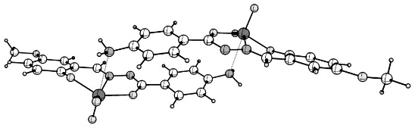
42 4.358866000 1.901492000 -0.482770000
7 4.292467000 -0.364827000 -0.818005000
7 3.091036000 -0.868481000 -1.261172000
8 2.521766000 1.359634000 -1.077971000
8 5.909285000 1.345180000 0.562423000
8 3.919565000 3.348911000 0.311757000
6 -1.921053000 -0.746599000 -1.962248000
6 2.217408000 0.102380000 -1.365389000
6 -0.983270000 -1.792889000 -1.947433000
1 -1.328798000 -2.822531000 -1.977980000
6 0.369228000 -1.513015000 -1.824629000
1 1.090645000 -2.320604000 -1.768779000
6 0.819906000 -0.185123000 -1.711709000
6 -0.115198000 0.857217000 -1.799706000
1 0.225965000 1.883588000 -1.726083000
6 -1.471074000 0.580545000 -1.933294000
1 -2.189397000 1.395864000 -1.965153000
6 5.279485000 -1.201790000 -0.715312000
1 5.100184000 -2.231057000 -1.029121000
6 6.590261000 -0.848276000 -0.221679000
6 6.863269000 0.411141000 0.375963000
6 8.153406000 0.672410000 0.844811000
1 8.348665000 1.637016000 1.302076000
6 9.167766000 -0.277995000 0.735557000
1 10.156090000 -0.035386000 1.108796000
6 8.904725000 -1.527986000 0.152796000
6 7.619443000 -1.801369000 -0.312454000
1 7.425534000 -2.770339000 -0.763046000
8 5.075791000 2.303196000 -1.965765000
7 -3.304197000 -1.037685000 -1.901274000
1 -3.553640000 -1.916572000 -2.347717000
1 -3.897427000 -0.290677000 -2.251134000
42 -4.358741000 -1.901470000 0.482429000
7 -4.292479000 0.364796000 0.818080000
7 -3.091015000 0.868518000 1.261083000
8 -2.521620000 -1.359532000 1.077635000
8 -5.909266000 -1.345059000 -0.562512000
8 -3.919350000 -3.348589000 -0.312606000
6 1.921165000 0.746971000 1.961629000
6 -2.217303000 -0.102306000 1.365093000
6 0.983295000 1.793178000 1.947004000
1 1.328724000 2.822850000 1.977679000
6 -0.369194000 1.513202000 1.824277000
1 -1.090686000 2.320736000 1.768605000
6 -0.819765000 0.185287000 1.711237000
6 0.115440000 -0.856981000 1.798993000
1 -0.225640000 -1.883374000 1.725272000
6 1.471305000 -0.580210000 1.932509000
1 2.189703000 -1.395468000 1.964212000
6 -5.279617000 1.201644000 0.715702000
1 -5.100391000 2.230900000 1.029598000
6 -6.590493000 0.848055000 0.222345000
6 -6.863457000 -0.411279000 -0.375549000
6 -8.153631000 -0.672673000 -0.844079000
1 -8.348920000 -1.637188000 -1.301520000
6 -9.168171000 0.277540000 -0.734291000
1 -10.156569000 0.034757000 -1.107197000
6 -8.905180000 1.527430000 -0.151365000
6 -7.619777000 1.800941000 0.313584000
1 -7.425959000 2.769858000 0.764328000
8 -5.075406000 -2.303720000 1.965402000
7 3.304301000 1.038193000 1.900692000
1 3.553600000 1.917076000 2.347229000
1 3.897570000 0.291233000 2.250603000
8 9.823054000 -2.526805000 0.000142000
6 11.152559000 -2.287938000 0.433550000
1 11.606105000 -1.442640000 -0.101035000
1 11.198513000 -2.098155000 1.514441000
1 11.709207000 -3.198463000 0.205152000
8 -9.823623000 2.526045000 0.002095000
6 -11.152657000 2.288277000 -0.433486000
1 -11.607847000 1.443447000 0.100405000
1 -11.708869000 3.199305000 -0.206047000
1 -11.196921000 2.098476000 -1.514436000

MoO₂L⁴(MeOH)

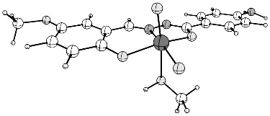
42 0.151482000 -1.516816000 -0.565604000
7 0.171958000 0.696921000 0.037475000
7 -1.061613000 1.291230000 0.140148000
7 -7.471105000 1.923329000 -0.055122000
1 -7.709414000 2.774401000 0.436562000
1 -8.151396000 1.186994000 0.078711000
8 -1.731427000 -0.873545000 -0.318065000
8 1.966377000 -1.371265000 0.160274000
8 -0.161952000 -3.185182000 -0.380942000
8 0.415247000 -1.215402000 -2.213443000
8 -0.085578000 -1.549077000 1.932953000
1 0.820459000 -1.826148000 2.149620000
6 -2.002095000 0.406525000 -0.082826000
6 -3.413079000 0.797674000 -0.063342000
6 -4.421697000 -0.150626000 -0.305366000
1 -4.141855000 -1.178181000 -0.511205000
6 -5.760249000 0.213156000 -0.285872000
1 -6.527976000 -0.531911000 -0.481452000
6 -6.137550000 1.544387000 -0.023302000
6 -5.125396000 2.496563000 0.219087000
1 -5.400526000 3.529815000 0.418206000
6 -3.790563000 2.128338000 0.197198000
1 -3.017169000 2.865306000 0.384363000
6 1.209720000 1.456933000 0.199313000
1 1.035521000 2.518838000 0.378294000
6 2.573527000 0.981596000 0.137669000
6 2.901409000 -0.399944000 0.092841000
6 4.246352000 -0.775606000 0.039456000
1 4.482375000 -1.834452000 0.006431000
6 5.264407000 0.176944000 0.034417000
1 6.294986000 -0.156285000 -0.009987000
6 4.949602000 1.543750000 0.088776000
6 3.611424000 1.929449000 0.145226000
1 3.378321000 2.989506000 0.183708000
6 -1.022105000 -2.455665000 2.537730000
1 -2.012066000 -2.120033000 2.227783000
1 -0.945233000 -2.406034000 3.629757000
1 -0.863270000 -3.479389000 2.185081000
8 5.867167000 2.556523000 0.092487000
6 7.240830000 2.215339000 0.012326000
1 7.559579000 1.610764000 0.872409000
1 7.469783000 1.671952000 -0.914343000
1 7.785066000 3.161495000 0.017799000

MoO₂L⁴
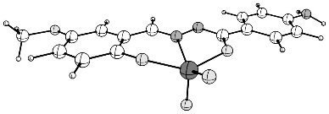
42 -0.102549000 1.737629000 0.090447000
7 -0.132709000 -0.530555000 -0.086424000
7 1.097127000 -1.147936000 -0.093519000
8 1.757703000 1.052806000 -0.163722000
8 -1.937840000 1.438669000 -0.469903000
8 0.176725000 3.174772000 -0.771526000
6 6.183099000 -1.345752000 -0.009227000
6 2.044540000 -0.244046000 -0.101989000
6 5.175009000 -2.332460000 0.034816000
1 5.456486000 -3.381417000 0.090837000
6 3.837911000 -1.975766000 0.004359000
1 3.068611000 -2.739499000 0.042042000
6 3.454539000 -0.623121000 -0.072080000
6 4.458758000 0.359964000 -0.117428000
1 4.173243000 1.404675000 -0.175305000
6 5.799159000 0.007798000 -0.085937000
1 6.563983000 0.779746000 -0.124523000
6 -1.171043000 -1.318176000 -0.083676000
1 -0.972862000 -2.389878000 -0.058208000
6 -2.537223000 -0.871232000 -0.101908000
6 -2.873804000 0.495458000 -0.277641000
6 -4.221440000 0.866696000 -0.305899000
1 -4.465082000 1.914310000 -0.448373000
6 -5.228610000 -0.084733000 -0.162722000
1 -6.262526000 0.239932000 -0.187823000
6 -4.905179000 -1.442814000 0.006458000
6 -3.565724000 -1.822591000 0.029688000
1 -3.323653000 -2.873109000 0.160288000
8 -0.191859000 2.052362000 1.755838000
7 7.520224000 -1.704464000 -0.027781000
1 7.749928000 -2.620368000 0.334055000
1 8.184778000 -0.991816000 0.242703000
8 -5.817391000 -2.447752000 0.152667000
6 -7.196047000 -2.113265000 0.135193000
1 -7.457124000 -1.429545000 0.953921000
1 -7.490812000 -1.661259000 -0.821343000
1 -7.732792000 -3.054148000 0.268155000

MoO₂L⁴(TBHP)
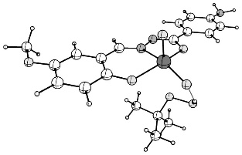
42 -0.127246000 0.619230000 -1.599940000
8 1.718261000 0.149769000 -1.035604000
8 -1.947710000 0.845367000 -0.966322000
8 0.236839000 2.238804000 -2.036556000
8 -6.106995000 -2.337777000 0.779057000
7 0.997096000 -1.475498000 0.423286000
7 -0.213664000 -0.991259000 -0.009036000
8 -0.332261000 -0.302785000 -3.004690000
6 -2.914996000 0.011057000 -0.547435000
6 1.968469000 -0.836342000 -0.179976000
6 -3.693268000 -1.979087000 0.639074000
1 -3.449908000 -2.880159000 1.190951000
6 3.712043000 -2.243987000 0.915660000
6 -2.628004000 -1.172151000 0.170422000
6 -5.012260000 -1.626319000 0.384127000
6 4.397969000 -0.429119000 -0.530569000
1 4.141318000 0.400450000 -1.180082000
6 3.366838000 -1.172526000 0.070153000
6 5.038555000 -2.561934000 1.151067000
1 5.290643000 -3.390387000 1.808998000
6 -1.277857000 -1.565750000 0.473839000
1 -1.117657000 -2.405105000 1.151063000
6 -4.253390000 0.361192000 -0.789417000
1 -4.456845000 1.275685000 -1.336663000
6 -5.283542000 -0.444736000 -0.335585000
1 -6.320210000 -0.183053000 -0.522671000
6 5.727839000 -0.744108000 -0.298416000
1 6.514160000 -0.156276000 -0.765882000
6 -5.897461000 -3.541331000 1.499683000
1 -5.325505000 -4.269625000 0.909136000
1 -5.376611000 -3.357432000 2.449104000
1 -6.890394000 -3.944426000 1.705864000
6 6.073613000 -1.816929000 0.546887000
8 1.446404000 3.170876000 0.264605000
8 0.571045000 2.197585000 0.904386000
6 -0.229987000 2.881297000 1.911351000
6 0.702785000 3.538262000 2.934991000
1 1.312965000 4.309518000 2.459527000
1 1.371014000 2.791081000 3.376086000
1 0.117834000 4.000105000 3.738589000
1 -0.578024000 4.673611000 0.736348000
6 -1.159636000 3.901271000 1.246749000
1 -1.808727000 3.408986000 0.514937000
1 -1.791166000 4.388471000 1.998483000
1 -1.698712000 1.272380000 1.828270000
6 -1.019941000 1.734463000 2.550589000
1 -0.339799000 0.968065000 2.936712000
1 -1.617331000 2.119112000 3.384240000
1 1.079212000 3.128774000 -0.647427000
1 2.921281000 -2.822358000 1.381112000
7 7.400709000 -2.103185000 0.821099000
1 7.603136000 -3.034524000 1.159093000
1 8.083408000 -1.764991000 0.156091000

TS
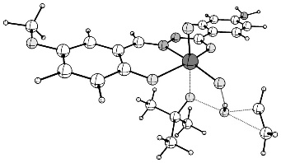
42 -0.071661000 -0.941016000 -1.085163000
8 -1.812020000 -0.100033000 -0.530456000
8 1.757641000 -1.386883000 -0.601503000
8 -0.760086000 -2.386935000 -1.753133000
8 6.398054000 1.428687000 0.432087000
7 -0.755601000 1.412718000 0.859080000
7 0.345464000 0.743778000 0.383067000
8 0.289713000 0.053127000 -2.407224000
6 2.842389000 -0.631039000 -0.357570000
6 -1.841736000 0.917958000 0.315771000
6 3.958297000 1.332559000 0.575595000
1 3.876728000 2.291054000 1.076397000
6 -3.277618000 2.554786000 1.544645000
6 2.765745000 0.625495000 0.290736000
6 5.196430000 0.817447000 0.211772000
6 -4.316248000 0.997691000 0.017919000
1 -4.229644000 0.184950000 -0.694964000
6 -3.153152000 1.492675000 0.630318000
6 -4.517479000 3.099034000 1.837519000
1 -4.596833000 3.916390000 2.550764000
6 1.512122000 1.209897000 0.706850000
1 1.537544000 2.109824000 1.322959000
6 4.102567000 -1.143392000 -0.708493000
1 4.145044000 -2.110989000 -1.197761000
6 5.258716000 -0.432109000 -0.434412000
1 6.233338000 -0.822958000 -0.709434000
6 -5.560465000 1.541266000 0.304144000
1 -6.450704000 1.146211000 -0.180103000
6 6.394462000 2.692553000 1.073417000
1 5.837840000 3.439217000 0.490808000
1 5.965999000 2.631964000 2.083257000
1 7.440218000 2.997191000 1.144012000
6 -5.684306000 2.602410000 1.221080000
6 -3.180146000 -4.849219000 -0.529628000
1 -2.787120000 -5.018345000 -1.527010000
1 -3.147940000 -5.676301000 0.170547000
1 -4.145150000 -3.470120000 0.803406000
6 -3.627120000 -3.600958000 -0.140411000
1 -3.784866000 -2.816301000 -0.873608000
1 -1.512209000 -3.144510000 -0.482468000
8 -1.937658000 -3.312213000 0.406383000
8 -0.596767000 -2.101261000 0.981625000
6 0.028877000 -2.728520000 2.097138000
1 1.562404000 -3.711049000 0.911825000
6 0.994354000 -1.699607000 2.722588000
1 1.810277000 -1.454763000 2.040365000
1 0.457422000 -0.781440000 2.980358000
1 1.430278000 -2.116129000 3.638678000
1 1.297507000 -4.463778000 2.502079000
6 0.801488000 -3.980688000 1.651214000
6 -1.043973000 -3.084427000 3.143120000
1 -0.579375000 -3.477113000 4.055553000
1 -1.729595000 -3.840629000 2.752112000
1 -1.623814000 -2.192638000 3.404341000
1 0.116706000 -4.702805000 1.195738000
1 -2.383740000 2.944995000 2.018905000
7 -6.932345000 3.114321000 1.551376000
1 -6.940789000 4.049766000 1.936724000
1 -7.666351000 2.968942000 0.870401000

MoO(OR)(OH)L⁴
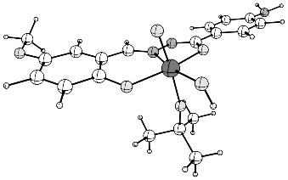
42 -0.151828000 1.107799000 -1.094943000
8 1.709969000 0.404144000 -0.897008000
8 -2.019895000 1.133112000 -0.546413000
8 0.327224000 2.682017000 -2.062338000
8 -6.062222000 -2.515150000 0.344586000
7 1.004547000 -1.365417000 0.391095000
7 -0.214155000 -0.808381000 0.079782000
8 -0.540806000 0.211106000 -2.485179000
6 -2.952323000 0.190376000 -0.369963000
6 1.963635000 -0.679411000 -0.180290000
6 -3.666897000 -2.019996000 0.389763000
1 -3.396505000 -2.996686000 0.775918000
6 3.712711000 -2.234034000 0.692457000
6 -2.629160000 -1.091912000 0.132361000
6 -4.992663000 -1.689912000 0.139549000
6 4.384610000 -0.354142000 -0.671304000
1 4.124055000 0.524589000 -1.251412000
6 3.362283000 -1.091676000 -0.050659000
6 5.036238000 -2.623915000 0.812348000
1 5.291982000 -3.506759000 1.393838000
6 -1.271062000 -1.488087000 0.410142000
1 -1.102289000 -2.442823000 0.908738000
6 -4.298526000 0.513196000 -0.611067000
1 -4.532432000 1.502109000 -0.991345000
6 -5.299744000 -0.411263000 -0.365549000
1 -6.340575000 -0.169247000 -0.556627000
6 5.711582000 -0.741852000 -0.556458000
1 6.491102000 -0.159376000 -1.042007000
6 -5.812052000 -3.816188000 0.847208000
1 -5.178335000 -4.398181000 0.164174000
1 -5.337095000 -3.782317000 1.837394000
1 -6.787373000 -4.298744000 0.932453000
6 6.062432000 -1.884508000 0.188119000
8 0.146009000 2.114544000 0.544294000
6 0.083347000 2.651450000 1.850710000
6 1.233248000 2.037437000 2.668232000
1 2.197321000 2.268811000 2.203040000
1 1.128037000 0.948482000 2.713245000
1 1.237936000 2.430039000 3.692003000
1 1.214014000 4.423059000 1.276951000
6 0.252058000 4.177328000 1.741528000
1 -0.550530000 4.607136000 1.131576000
1 0.221013000 4.648872000 2.730620000
1 -2.093578000 2.711167000 1.874375000
6 -1.277075000 2.304548000 2.478605000
1 -1.405024000 1.219021000 2.539664000
1 -1.350765000 2.718635000 3.491246000
1 0.639593000 3.368805000 -1.446705000
1 2.927977000 -2.810184000 1.170637000
7 7.392133000 -2.246749000 0.348465000
1 7.565724000 -3.211876000 0.596832000
1 8.036778000 -1.901085000 -0.3503070

