Hierarchically porous S/N/O enriched carbons from polyacrylonitrile-based block copolymers for selective separation of gas streams

Diego Gómez-Díaz 1,*, Lidia Domínguez-Ramos 1,2,3, Giulio Malucelli 4,
María Sonia Freire 1, Julia González-Álvarez 1, Massimo Lazzari 2,3,*

1 Departamento de Ingeniería Química, ETSE, Universidade de Santiago de Compostela, Rua Lope Gómez de Marzoa s/n, 15782 Santiago de Compostela, Spain; lidia.dominguez2@usc.es (L.D.-R.); mariasonia.freire@usc.es (M.S.F.); julia.gonzalez@usc.es (J.G.-Á.)
2 Departamento de Química Física, Facultade de Química, Universidade de Santiago de Compostela,
Avenida das Ciencias s/n, 15782 Santiago de Compostela, Spain;
3 Centro Singular de Investigación en Química Biolóxica e Materiais Moleculares (CiQUS), Universidade de Santiago de Compostela, 15782 Santiago de Compostela, Spain;
3 Department of Applied Science and Technology, Politecnico di Torino, Viale Teresa Michel 5,
15121 Alessandria, Italy; giulio.malucelli@polito.it

* Correspondence: diego.gomez@usc.es (D.G.-D.); massimo.lazzari@usc.es (M.L.)

Supplementary Materials: Scheme S1. Schematic illustration of the formation of graphitic carbon from a PAN-based BC precursor; Scheme S2. Possible positions of sulphur incorporated into the graphitic carbon network; Figure S1. Raman spectra of BC10/90-O (solid line) and BC10/90-S (dashed line) in the 900-1900 cm-1 range

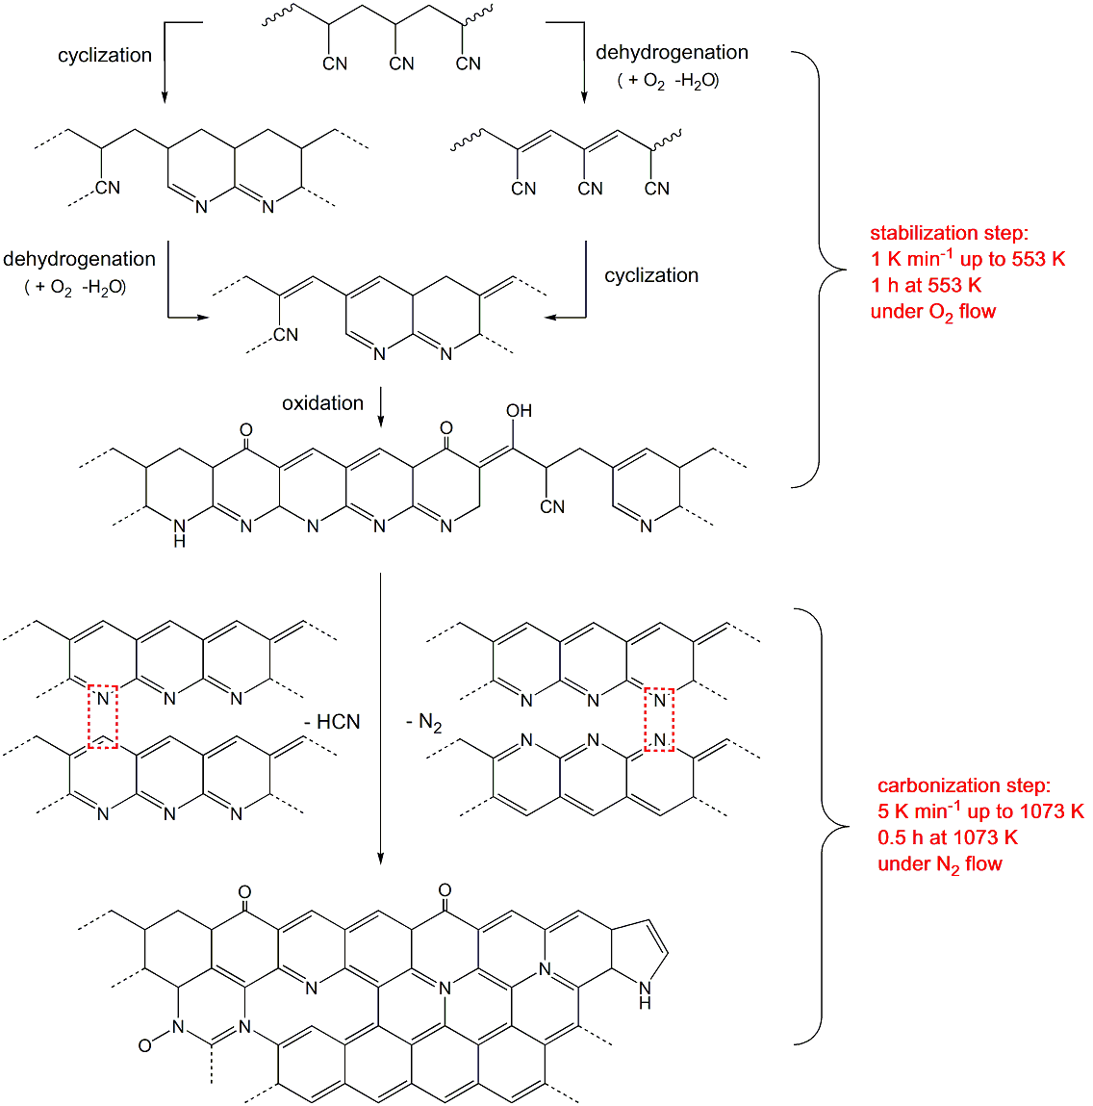
Scheme S1. Schematic illustration of the formation of graphitic carbon from a PAN-based BC precursor, also including the information resulting from XPS measurements (see examples in Figure 2 and corresponding discussion). PMMA decomposition is not reported, as it essentially consists of volatilization by unzipping. Adapted from: Fitzer, E. Carbon 1989, 27, 621–645.

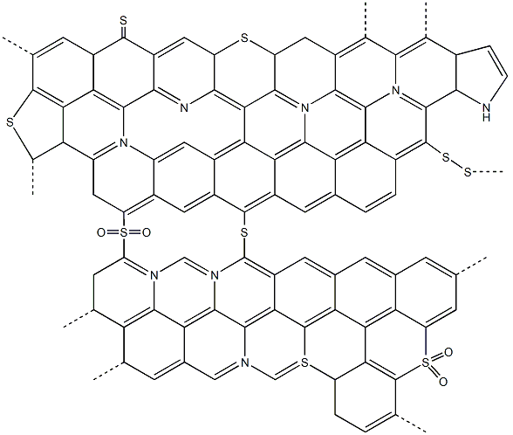
Scheme S2. Possible positions of sulphur incorporated into the graphitic carbon network, taking into account the information resulting from XPS measurements (see examples in Figure 2 and corresponding discussion). Adapted from: Kiciński, W.; Szala, M.; Bystrzejewski, M. Carbon N. Y. 2014, 68, 1–32.

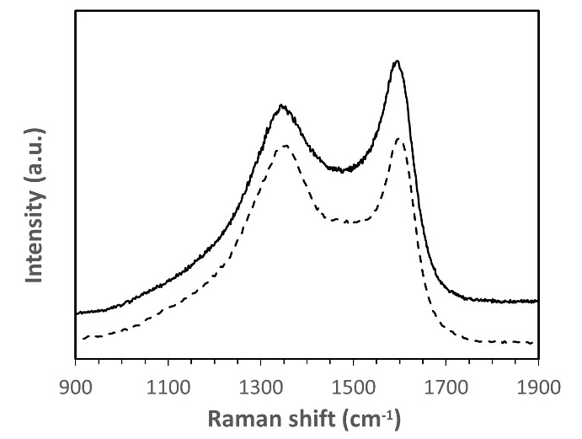
Figure S1. Raman spectra of BC10/90-O (solid line) and BC10/90-S (dashed line) in the 900-1900 cm-1 range.

