Supplementary Information

Study of the Conformation of Bromated Guanidines with Potential anti-leishmania activity

Eduardo Henrique Zampieri ¹, Luana Ribeiro dos Anjos ¹, Pedro Henrique de Oliveira Santiago ², Tainara Rosário da Silva Nascimento ¹, Javier Alcides Ellena ², Eduardo René Pérez González ^{1*}.

¹ Fine Organic Chemistry Lab, School of Sciences and Technology, São Paulo State University (UNESP), Presidente Prudente 19060-080, Brazil
² Multiuser Structural Crystallography Laboratory, São Carlos Institute of Physics, University of São Paulo (USP), São Carlos 13566-590, Brazil
* Corresponding authors: eduardo.gonzalez@unesp.br

Table of contents
1. EI-MS analysis 4
Figure S1. EI-MS (70 eV) spectrum of compound LQOF-G2. 4
Figure S2. EI-MS (70 eV) spectrum of compound LQOF-G35. 4
Figure S3. EI-MS (70 eV) spectrum of compound LQOF-G30. 4
Figure S4. EI-MS (70 eV) spectrum of compound LQOF-G35-Br. 5
2. HRESI-MS analysis 6
Figure S5. HRESI-MS Spectrum of LQOF-G35-Br. 6
3. LC/MS with UV/Vis detection analysis 7
Figure. S6. HPLC-UV analysis of LQOF-G30. 7
Figure. S7. HPLC-UV analysis of LQOF-G35. 8
Figure. S8. HRESI-(+) MS analysis of LQOF-G30. 9
Figure. S9. HRESI-(+) MS analysis of LQOF-G35. 9
Figure. S10. HRESI-(+) MS/MS analysis of LQOF-G35. 10
4. NMR spectra 11
4.1. Spectra for structural characterization 11
Figure S11. ¹H NMR spectrum for LQOF-G2 at 263K in CDCl₃. 11
Figure S12. ¹³C DEPTQ-135 NMR spectrum for LQOF-G2 at 263K in CDCl₃. 11
Figure S13. HSQC ¹Hx¹³C NMR spectrum for LQOF-G2 at 263K in CDCl₃. 12
Figure S14. HMBC ¹Hx¹³C NMR spectrum for LQOF-G2 at 263K in CDCl₃. 12
Figure S15. NOESY ¹Hx¹H NMR spectrum for LQOF-G2 at 263K in CDCl₃. 13
Figure S16. ¹H NMR spectrum for LQOF-G35 at 263K in CDCl₃. 13
Figure S17. ¹³C DEPTQ-135 NMR spectrum for LQOF-G35 at 263K in CDCl₃. 14
Figure S18. HSQC ¹Hx¹³C NMR spectrum for LQOF-G35 at 263K in CDCl₃. 14
Figure S19. HMBC ¹Hx¹³C NMR spectrum for LQOF-G35 at 263K in CDCl₃. 15
Figure S20. HMBC ¹Hx¹⁵N NMR spectrum for LQOF-G35 at 263K in CDCl₃. 15
Figure S21. NOESY ¹Hx¹H NMR spectrum for LQOF-G35 at 263K in CDCl₃. 16
Figure S22. ¹H NMR spectrum for LQOF-G30 at 263K in CDCl₃. 16
Figure S23. ¹³C DEPTQ-135 NMR spectrum for LQOF-G30 at 263K in CDCl₃. 17
Figure S24. HSQC ¹Hx¹³C NMR spectrum for LQOF-G30 at 263K in CDCl₃. 17
Figure S25. HMBC ¹Hx¹³C NMR spectrum for LQOF-G30 at 263K in CDCl₃. 18
Figure S26. NOESY ¹Hx¹H NMR spectrum for LQOF-G30 at 263K in CDCl₃. 18
Figure S27. ¹H NMR spectrum for LQOF-G35-Br at 263K in CDCl₃. 19
Figure S28. ¹³C DEPTQ-135 NMR spectrum for LQOF-G35-Br at 263K in CDCl₃. 19
Figure S29. HSQC ¹Hx¹³C NMR spectrum for LQOF-G35-Br at 263K in CDCl₃. 20
Figure S30. HMBC ¹Hx¹³C NMR spectrum for LQOF-G35-Br at 263K in CDCl₃. 20
Figure S31. NOESY ¹Hx¹H NMR spectrum for LQOF-G35-Br at 263K in CDCl₃. 21
4.2. Spectra for %E/Z study 21
Figure S32. ¹H NMR spectrum for LQOF-G2 at 253K in CDCl₃ to %E/Z. 21
Figure S33. ¹H NMR spectrum for LQOF-G35 at 253K in CDCl₃ to %E/Z. 22
Figure S34. ¹H NMR spectrum for LQOF-G30 at 253K in CDCl₃ to %E/Z. 22
Figure S35. ¹H NMR spectrum for LQOF-G35-Br at 253K in CDCl₃ to %E/Z. 23
5. XRD data 24
Table S1. Crystal data and refinement parameters of LQOF-G35 and LQOF-G35-Br. 24
Table S2. Selected bond lengths and angles for LQOF-G35. 25
Table S3. Selected bond lengths and angles for LQOF-G35-Br. 25

1. EI-MS analysis

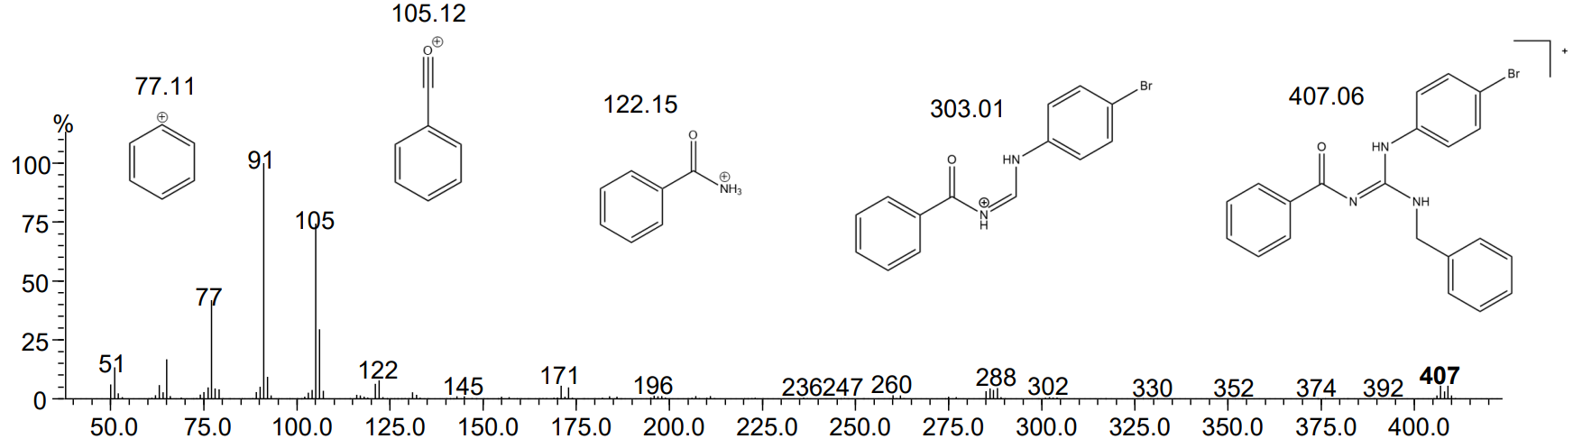

Figure S1. EI-MS (70 eV) spectrum of compound LQOF-G2.
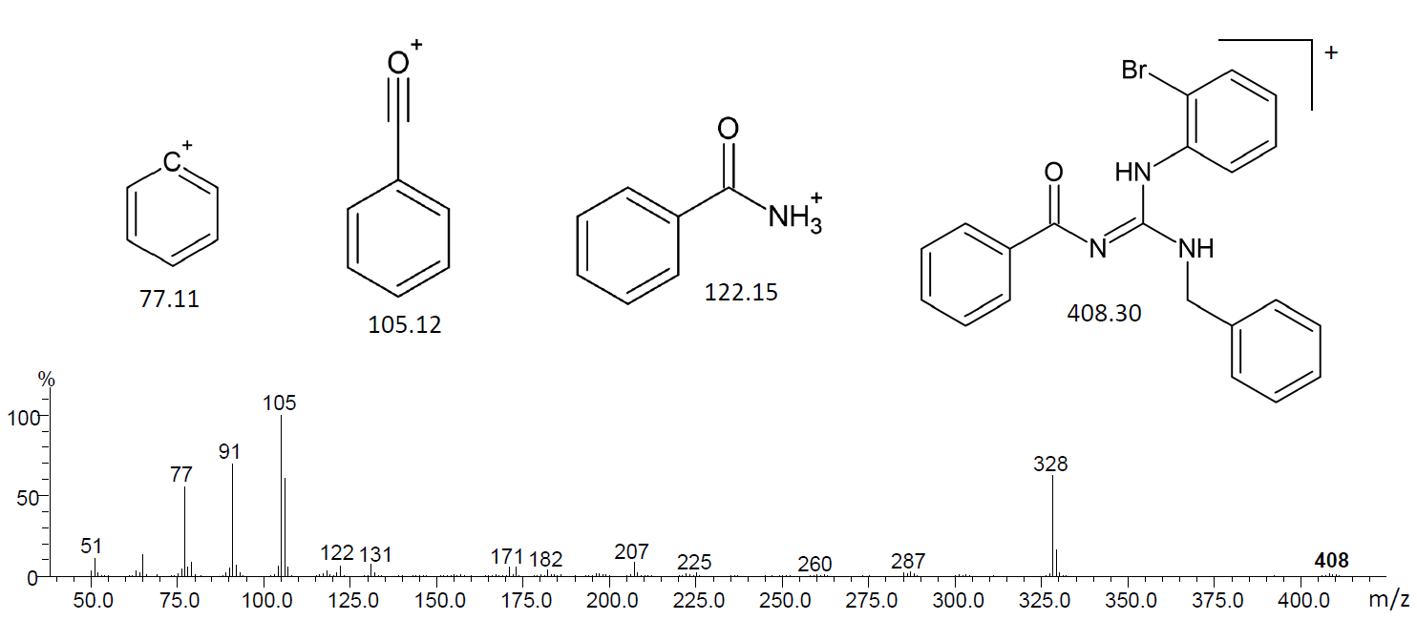

Figure S2. EI-MS (70 eV) spectrum of compound LQOF-G35.

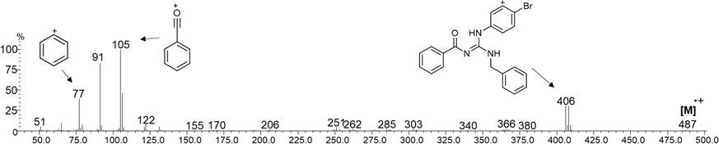

Figure S3. EI-MS (70 eV) spectrum of compound LQOF-G30.

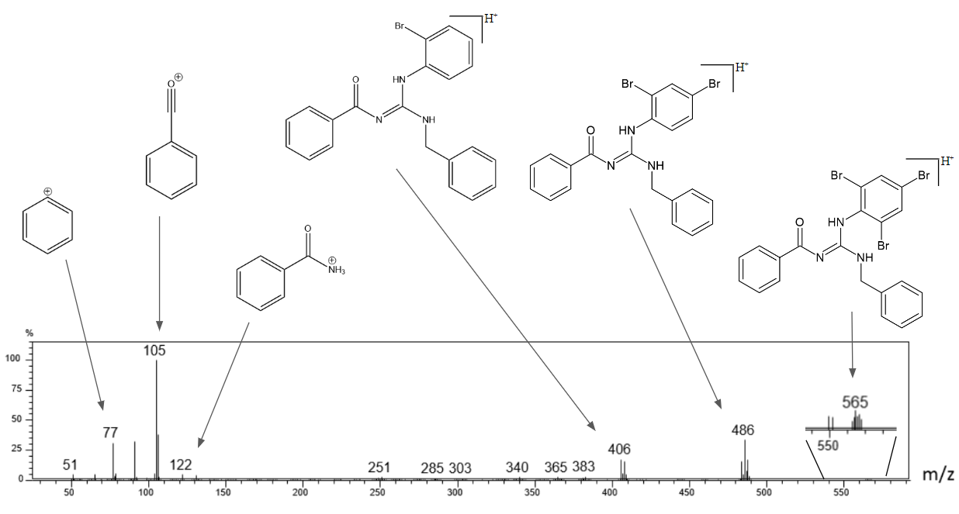

Figure S4. EI-MS (70 eV) spectrum of compound LQOF-G35-Br.

2. HRESI-MS analysis

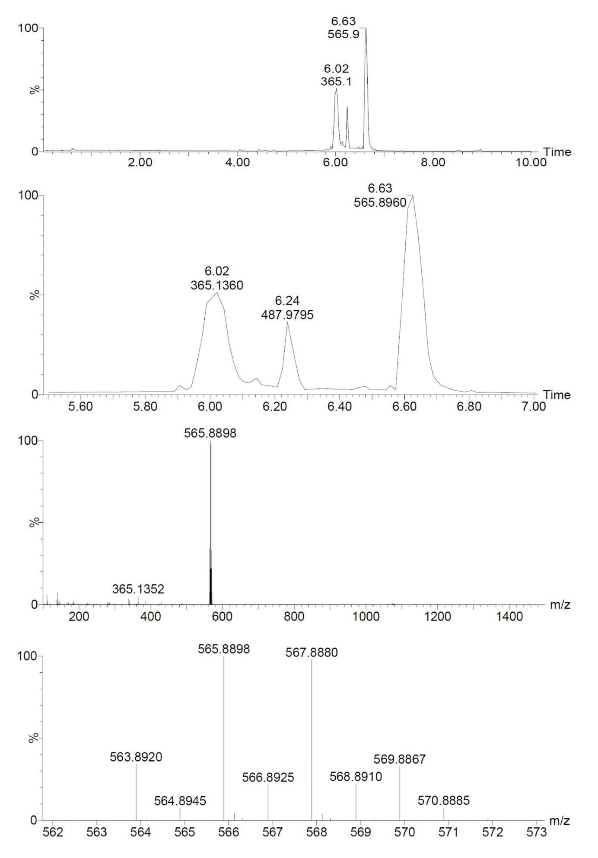

Figure S5. HRESI-MS Spectrum of LQOF-G35-Br.

3. LC/MS with UV/Vis detection analysis

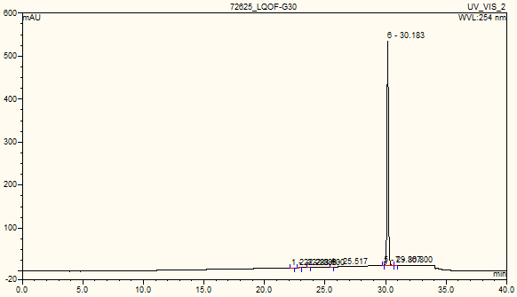
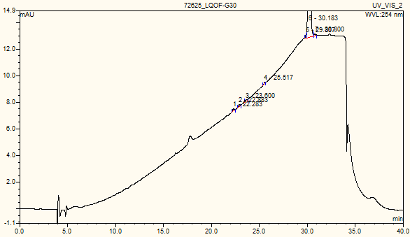
Retention Time: 30.18 min
Relative Peak Area: 99.82 %

Figure. S6. HPLC-UV analysis of LQOF-G30.

Retention Time: 26.58 min
Relative Peak Area: 99.84 %

Figure. S7. HPLC-UV analysis of LQOF-G35.

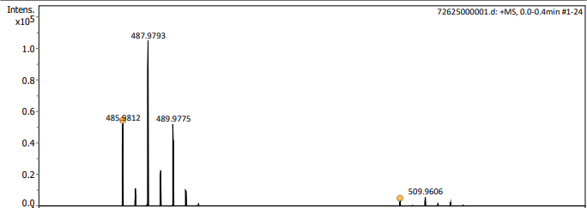
m/z 485,9812: C₂₁H₁₉BrN₃O
m/z 507,9627: C₂₁H₁₈BrN₃NaO

Figure. S8. HRESI-(+) MS analysis of LQOF-G30.

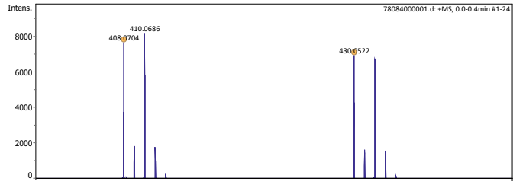
m/z 408,0704: C₂₁H₁₉BrN₃O
m/z 430,0522: C₂₁H₁₈BrN₃NaO

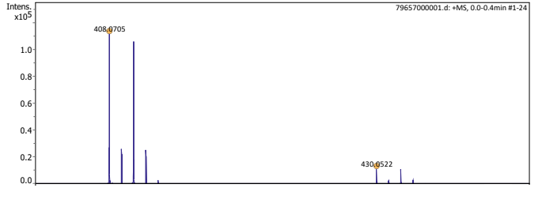
m/z 408,0705: C₂₁H₁₉BrN₃O
m/z 430,0522: C₂₁H₁₈BrN₃NaO

Figure. S9. HRESI-(+) MS analysis of LQOF-G35.

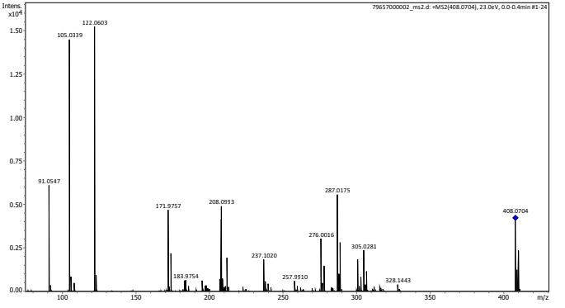

Figure. S10. HRESI-(+) MS/MS analysis of LQOF-G35.

4. NMR spectra

4.1. Spectra for structural characterization

Figure S11. ¹H NMR spectrum for LQOF-G2 at 263K in CDCl₃.

Figure S12. ¹³C DEPTQ-135 NMR spectrum for LQOF-G2 at 263K in CDCl₃.

Figure S13. HSQC ¹Hx¹³C NMR spectrum for LQOF-G2 at 263K in CDCl₃.

Figure S14. HMBC ¹Hx¹³C NMR spectrum for LQOF-G2 at 263K in CDCl₃.

Figure S15. NOESY ¹Hx¹H NMR spectrum for LQOF-G2 at 263K in CDCl₃.

Figure S16. ¹H NMR spectrum for LQOF-G35 at 263K in CDCl₃.

Figure S17. ¹³C DEPTQ-135 NMR spectrum for LQOF-G35 at 263K in CDCl₃.

Figure S18. HSQC ¹Hx¹³C NMR spectrum for LQOF-G35 at 263K in CDCl₃.

Figure S19. HMBC ¹Hx¹³C NMR spectrum for LQOF-G35 at 263K in CDCl₃.

Figure S20. HMBC ¹Hx¹⁵N NMR spectrum for LQOF-G35 at 263K in CDCl₃.

Figure S21. NOESY ¹Hx¹H NMR spectrum for LQOF-G35 at 263K in CDCl₃.

Figure S22. ¹H NMR spectrum for LQOF-G30 at 263K in CDCl₃.

Figure S23. ¹³C DEPTQ-135 NMR spectrum for LQOF-G30 at 263K in CDCl₃.

Figure S24. HSQC ¹Hx¹³C NMR spectrum for LQOF-G30 at 263K in CDCl₃.

Figure S25. HMBC ¹Hx¹³C NMR spectrum for LQOF-G30 at 263K in CDCl₃.

Figure S26. NOESY ¹Hx¹H NMR spectrum for LQOF-G30 at 263K in CDCl₃.

Figure S27. ¹H NMR spectrum for LQOF-G35-Br at 263K in CDCl₃.

Figure S28. ¹³C DEPTQ-135 NMR spectrum for LQOF-G35-Br at 263K in CDCl₃.

Figure S29. HSQC ¹Hx¹³C NMR spectrum for LQOF-G35-Br at 263K in CDCl₃.

Figure S30. HMBC ¹Hx¹³C NMR spectrum for LQOF-G35-Br at 263K in CDCl₃.

Figure S31. NOESY ¹Hx¹H NMR spectrum for LQOF-G35-Br at 263K in CDCl₃.

4.2. Spectra for %E/Z study

Figure S32. ¹H NMR spectrum for LQOF-G2 at 253K in CDCl₃ to %E/Z.

Figure S33. ¹H NMR spectrum for LQOF-G35 at 253K in CDCl₃ to %E/Z.

Figure S34. ¹H NMR spectrum for LQOF-G30 at 253K in CDCl₃ to %E/Z.

Figure S35. ¹H NMR spectrum for LQOF-G35-Br at 253K in CDCl₃ to %E/Z.

5. XRD data

Table S1. Crystal data and refinement parameters of LQOF-G35 and LQOF-G35-Br.
 | LQOF-G35 | LQOF-G35-Br
Chemical formula | C₆₃H₅₄N₉O₃Br₃ | C₂₁H₁₆N₃OBr₃
Molar mass (g mol⁻¹) | 1224.88 | 566.10
Crystal system | Trigonal | Monoclinic
Space group | P3₂ | P2₁/c
a (Å) | 16.1319(1) | 5.18050(10)
b (Å) | 16.1319(1) | 23.4855(3)
c (Å) | 18.6340(1) | 16.5670(2)
α (°) | 90 | 90
β (°) | 90 | 96.8430(10)
γ (°) | 120 | 90
V (Å³) | 4199.60(9) | 2001.29(5)
Z | 3 | 4
Density/g cm⁻³ | 1.453 | 1.879
θmin, θmax/º | 9.492, 140.072 | 9.254, 140.14
Index ranges | −19 ≤ h ≤ 18 | −6 ≤ h ≤ 6
 | −19 ≤ k ≤ 19 | −28 ≤ k ≤ 28
 | −22 ≤ l ≤ 22 | −20 ≤ l ≤ 14
F(000) | 1872.0 | 1104.0
μ/mm⁻¹ | 3.112 | 1.204
Absorption correction | Gaussian | Gaussian
Max./min. transmission | 1.000/0.911 | 0.964/0.680
Measured reflections | 34,537 | 37,069
Independent reflections/R_{int} | 9,905/0.0434 | 3,812/0.0432
Refined parameters | 704 | 253
Final R indexes [I ≥ 2σ(I)] | R₁ = 0.0222/wR₂ = 0.0516 | R₁ = 0.0249/wR₂ = 0.0665
Final R indexes [all data] | R₁ = 0.0224/wR₂ = 0.0517 | R₁ = 0.0273/wR₂ = 0.0681
GooF | 1.025 | 1.072
Largest diff. peak and hole (eÅ⁻³) | 0.22/−0.21 | 0.8/−0.73
Flack parameter | -0.026(6) | —

Table S2. Selected bond lengths and angles for LQOF-G35.
O1—C8 | 1.253 (5) | N2—C7 | 1.331 (5)
O1B—C8B | 1.259 (5) | N1B—C7B | 1.349 (5)
O1A—C8A | 1.253 (5) | N3A—C7A | 1.330 (5)
N3—C7 | 1.350 (5) | N2B—C7B | 1.351 (5)
N1—C7 | 1.357 (5) | N1A—C7A | 1.349 (5)
N3B—C7B | 1.339 (5) | N2A—C7A | 1.341 (5)
O1—C8—N2 | 127.2 (4) | N3A—C7A—N2A | 116.9 (3)
O1B—C8B—N2B | 126.7 (3) | N2A—C7A—N1A | 123.8 (3)
N3—C7—N1 | 118.1 (3) | O1A—C8A—N2A | 126.9 (4)
N2—C7—N3 | 117.1 (3) | N3B—C7B—N1B | 119.5 (3)
N2—C7—N1 | 124.8 (3) | N3B—C7B—N2B | 117.2 (3)
N3A—C7A—N1A | 119.3 (3) | N1B—C7B—N2B | 123.2 (3)

Table S3. Selected bond lengths and angles for LQOF-G35-Br.
O1—C8 | 1.222 (3) | N3—C7 | 1.348 (3)
N2—C7 | 1.409 (3) | N1—C7 | 1.290 (3)
O1—C8—N2 | 123.4 (2) | N1—C7—N2 | 121.5 (2)
N3—C7—N2 | 116.45 (19) | N1—C7—N3 | 122.0 (2)

