**Supplementary Information**

**Study of the Conformation of Bromated Guanidines with Potential anti-leishmania activity**

Eduardo Henrique Zampieri 1, Luana Ribeiro dos Anjos 1, Pedro Henrique de Oliveira Santiago 2, Tainara Rosário da Silva Nascimento 1, Javier Alcides Ellena 2, Eduardo René Pérez González 1*.

1 Fine Organic Chemistry Lab, School of Sciences and Technology, São Paulo State University (UNESP), Presidente Prudente 19060-080, Brazil

2 Multiuser Structural Crystallography Laboratory, São Carlos Institute of Physics, University of São Paulo (USP), São Carlos 13566-590, Brazil

* Corresponding authors: [eduardo.gonzalez@unesp.br](mailto:eduardo.gonzalez@unesp.br)

**Table of contents**

**1. EI-MS analysis** 3

**Figure S1.** EI-MS (70 eV) spectrum of compound **LQOF-G35** is displayed below. 3

**Figure S2.** EI-MS (70 eV) spectrum of compound **LQOF-G35-Br** is displayed below. 3

**2. HRESI-MS analysis** 4

**Figure S3.** HRESI-MS Spectrum of **LQOF-G35-Br**. 4

**3. LC/MS with UV/Vis detection analysis for LQOF-G35** 5

**Figure. S4.** HPLC-UV analysis of **LQOF-G35**. 5

**Figure. S5.** HRESI-(+) MS analysis of **LQOF-G35**. 6

**Figure. S6.** HRESI-(+) MS/MS analysis of **LQOF-G35**. 7

**4. NMR spectra** 7

**Figure S7.** 1H NMR spectrum of the aromatic region for **LQOF-G35** at 263K in CDCl3. 7

**Figure S8.** 13C DEPTQ-135 NMR spectrum for **LQOF-G35** at 263K in CDCl3. 8

**Figure S10.** HSQC 1Hx13C NMR spectrum for **LQOF-G35** at 263K in CDCl3. 9

**Figure S12.** NOESY 1Hx1H NMR spectrum for **LQOF-G35** at 263K in CDCl3. 10

**Figure S13.** 1H NMR spectrum for **LQOF-G35-Br** at 283K in CDCl3. 10

**Figure S14.** 13C DEPTQ-135 NMR spectrum for **LQOF-G35-Br** at 283K in CDCl3. 11

**Figure S15.** HMBC 1Hx13C NMR spectrum for **LQOF-G35-Br** at 283K in CDCl3. 11

**Figure S16.** HSQC 1Hx13C NMR spectrum for **LQOF-G35-Br** at 283K in CDCl3. 12

**Figure S17.** NOESY 1Hx1H NMR spectrum for **LQOF-G35-Br** at 283K in CDCl3. 12

**5. XRD data** 13

**Table S1.** Crystal data and refinement parameters of **LQOF-G35** and **LQOF-G35-Br**. 13

**Table S2.** Selected bond lengths and angles for **LQOF-G35**. 14

**Table S3.** Selected bond lengths and angles for **LQOF-G35-Br**. 14

# **1. EI-MS analysis**

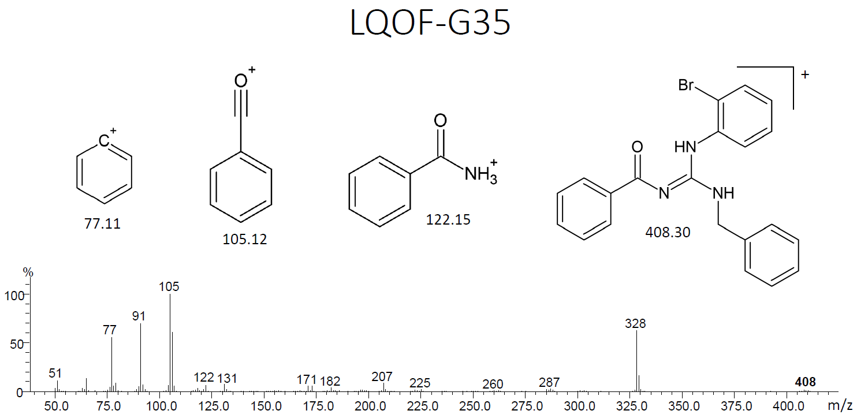

## **Figure S1.** EI-MS (70 eV) spectrum of compound **LQOF-G35** is displayed below.

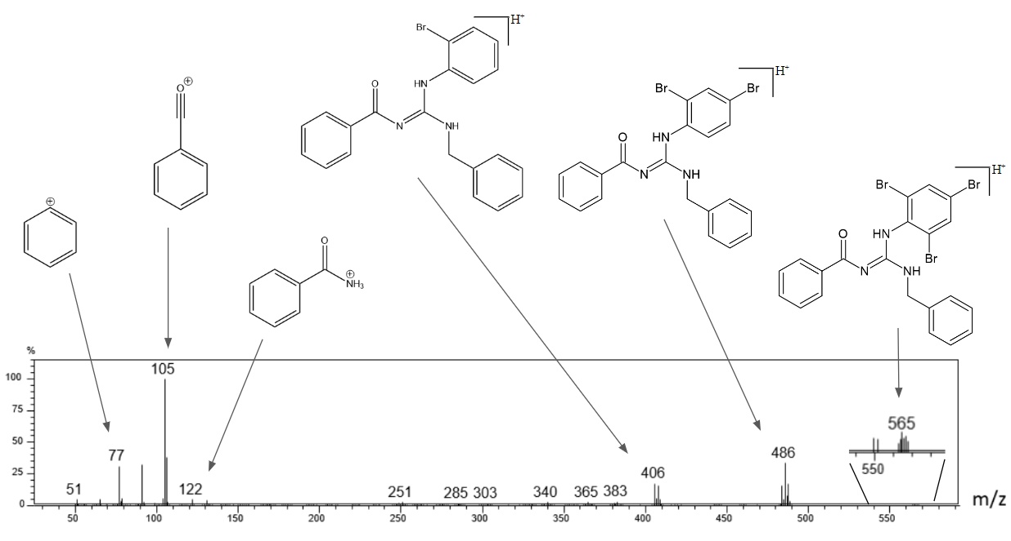

## **Figure S2.** EI-MS (70 eV) spectrum of compound **LQOF-G35-Br** is displayed below.

# **2. HRESI-MS analysis**

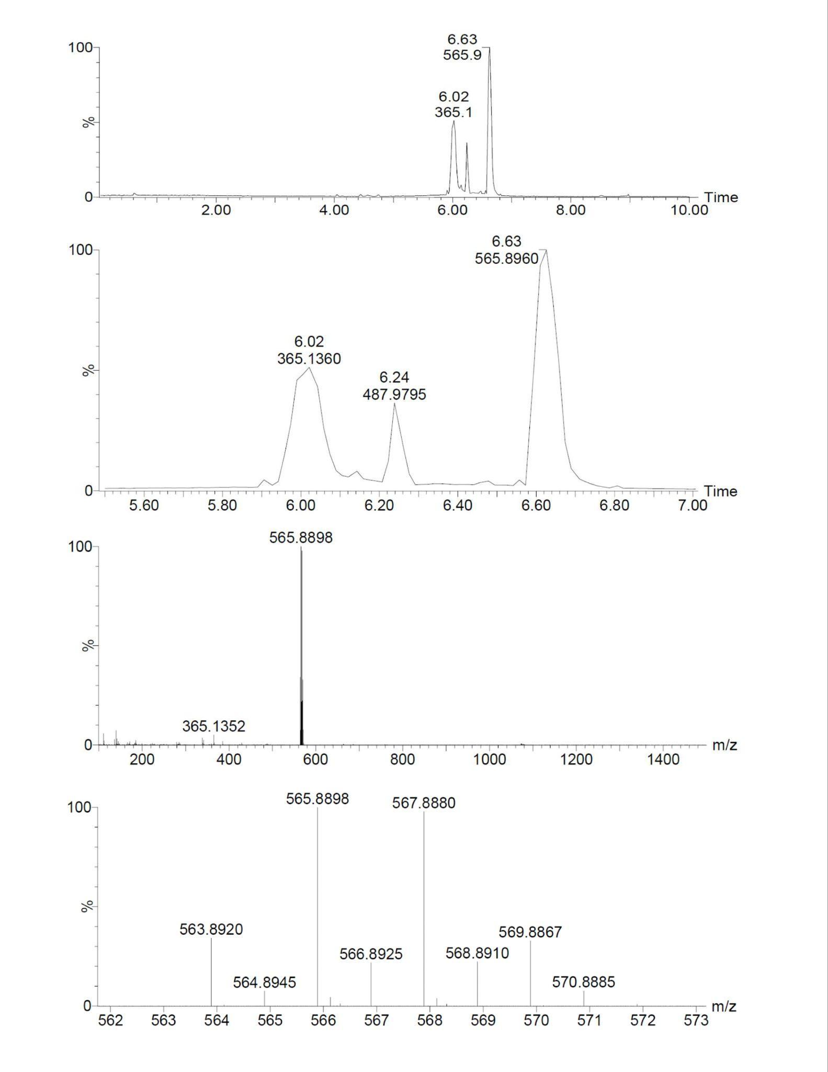

## **Figure S3.** HRESI-MS Spectrum of **LQOF-G35-Br**.

**3. LC/MS with UV/Vis detection analysis for LQOF-G35**





Retention Time: **26.58 min**

Relative Peak Area: **99.84 %**

**Figure. S4.** HPLC-UV analysis of **LQOF-G35**.

**m/z 408,0704**: C21H19BrN3O

**m/z 430,0522**: C21H18BrN3NaO

**m/z 408,0705**: C21H19BrN3O

**m/z 430,0522**: C21H18BrN3NaO

**Figure. S5.** HRESI-(+) MS analysis of **LQOF-G35**.

**Figure. S6.** HRESI-(+) MS/MS analysis of **LQOF-G35**.

# **4. NMR spectra**

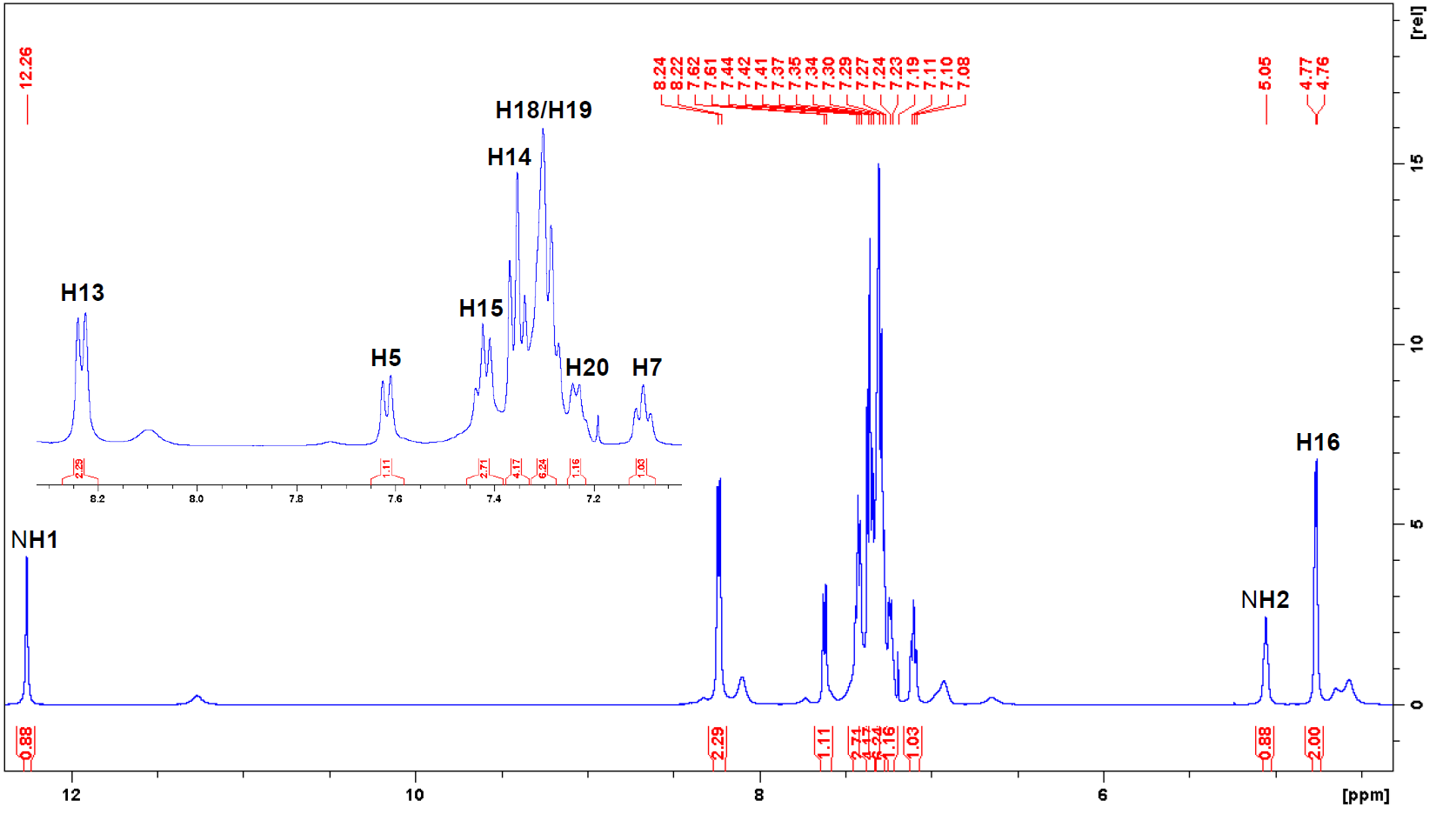

## **Figure S7.** 1H NMR spectrum of the aromatic region for **LQOF-G35** at 263K in CDCl3.

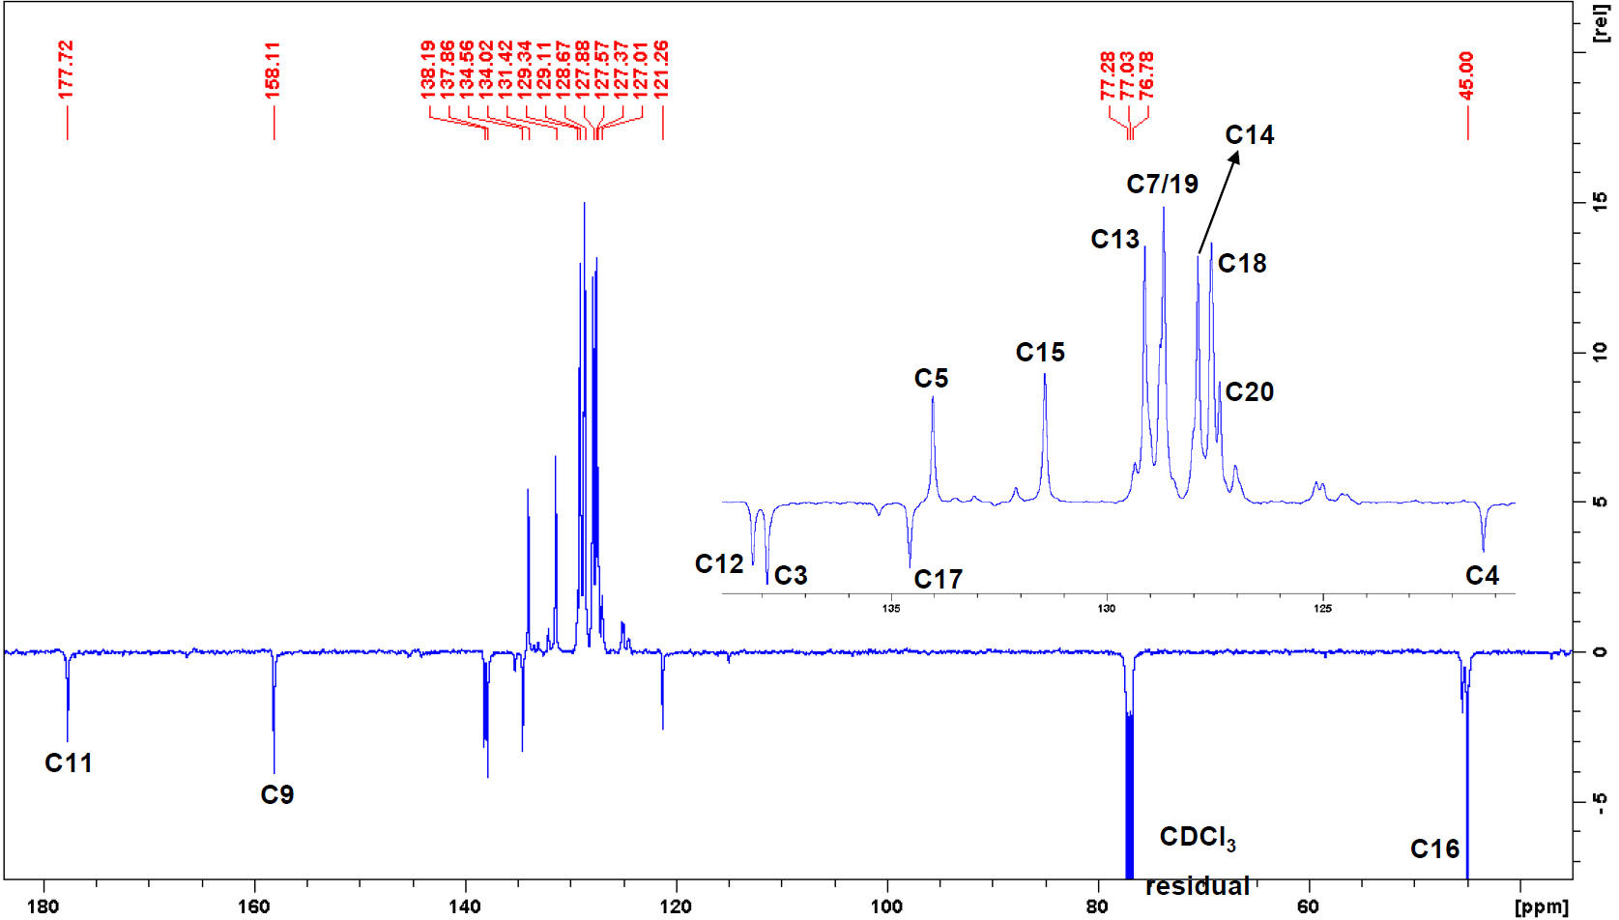

## **Figure S8.** 13C DEPTQ-135 NMR spectrum for **LQOF-G35** at 263K in CDCl3.

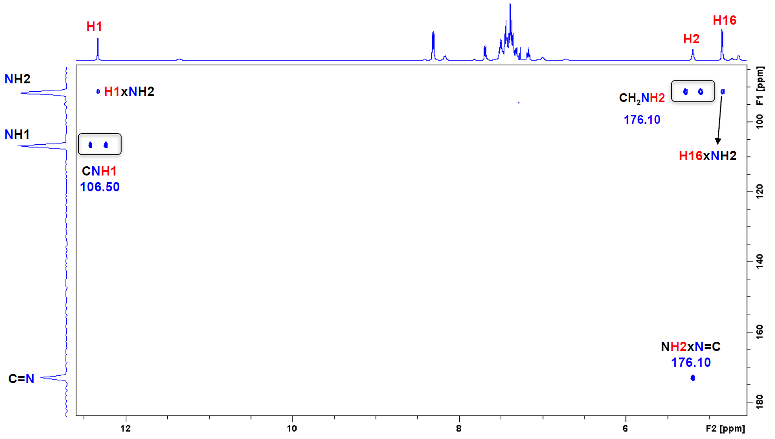**Figure S9.** HMBC 1Hx15N NMR spectrum for **LQOF-G35** at 263K in CDCl3.

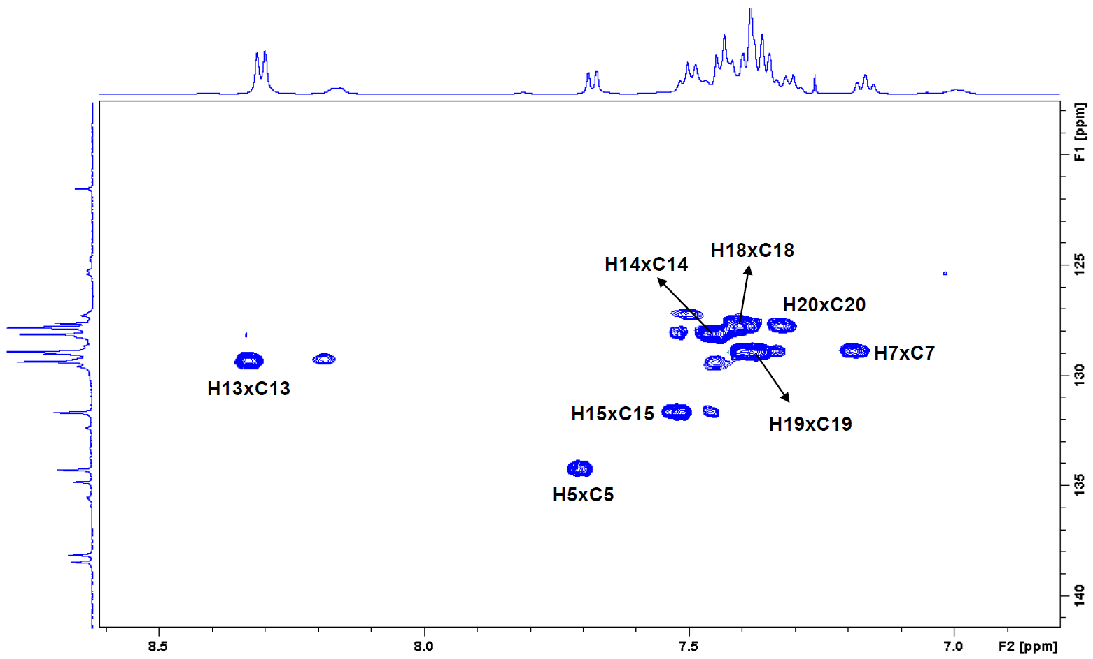

## **Figure S10.** HSQC 1Hx13C NMR spectrum for **LQOF-G35** at 263K in CDCl3.

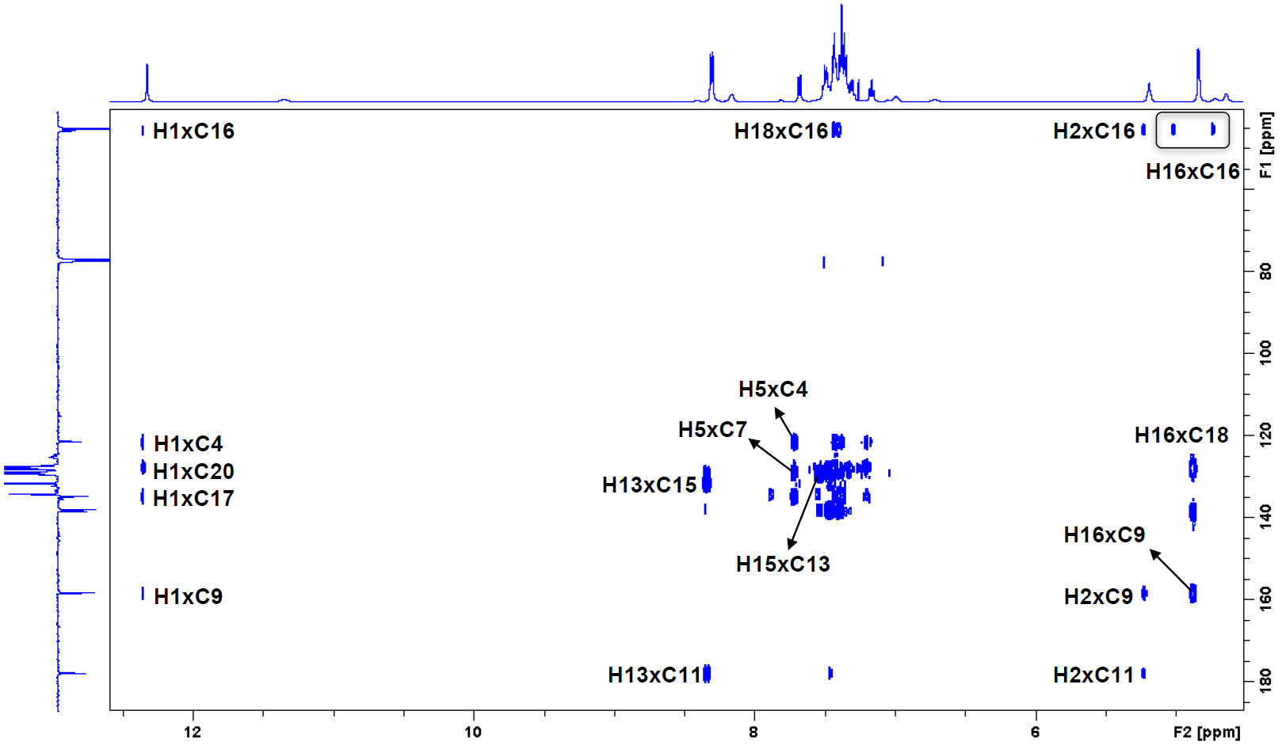**Figure S11.** HMBC 1Hx13C NMR spectrum for **LQOF-G35** at 263K in CDCl3.

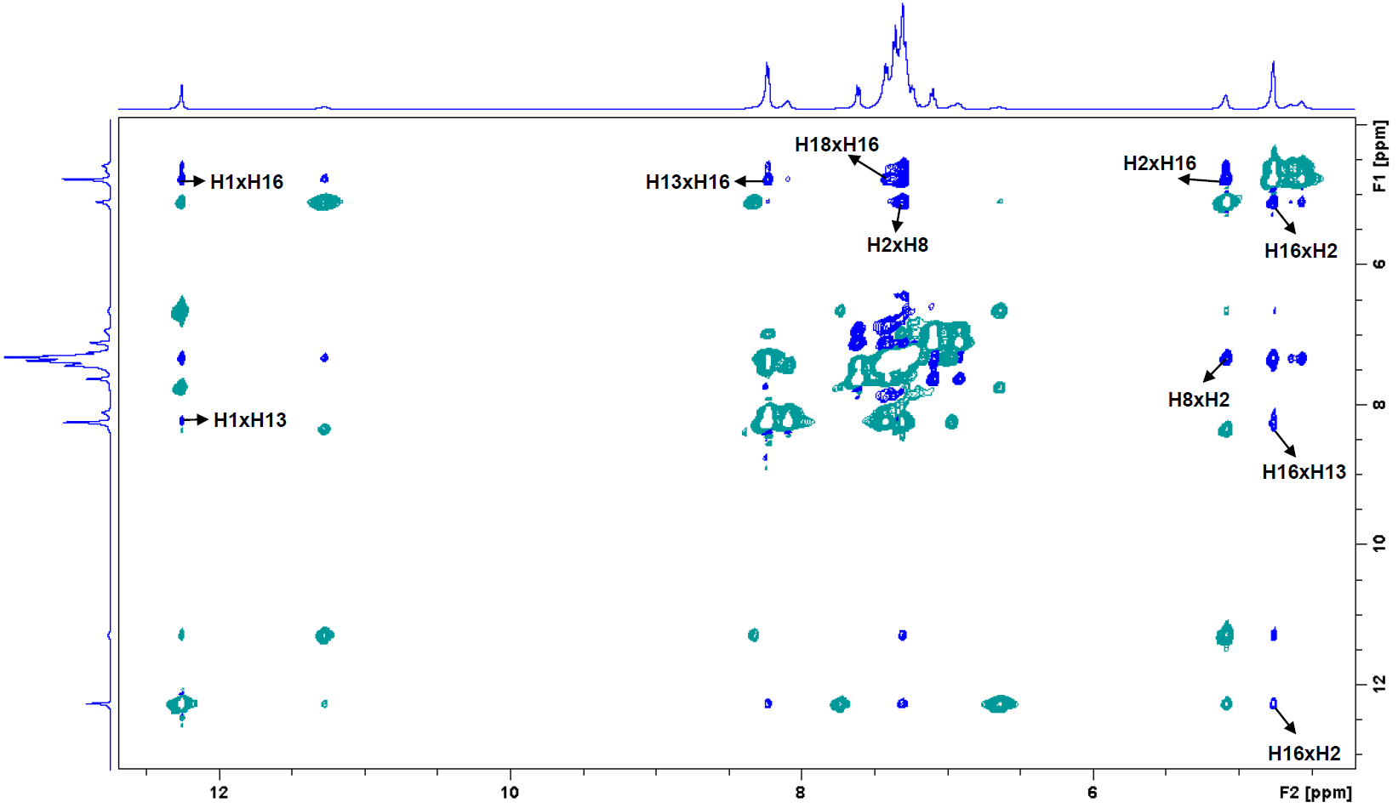

## **Figure S12.** NOESY 1Hx1H NMR spectrum for **LQOF-G35** at 263K in CDCl3.

## **Figure S13.** 1H NMR spectrum for **LQOF-G35-Br** at 283K in CDCl3.

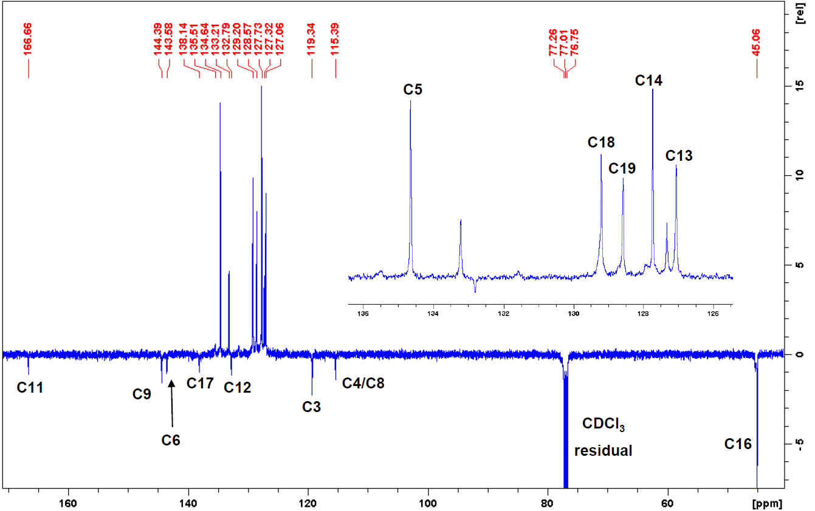

## **Figure S14.** 13C DEPTQ-135 NMR spectrum for **LQOF-G35-Br** at 283K in CDCl3.

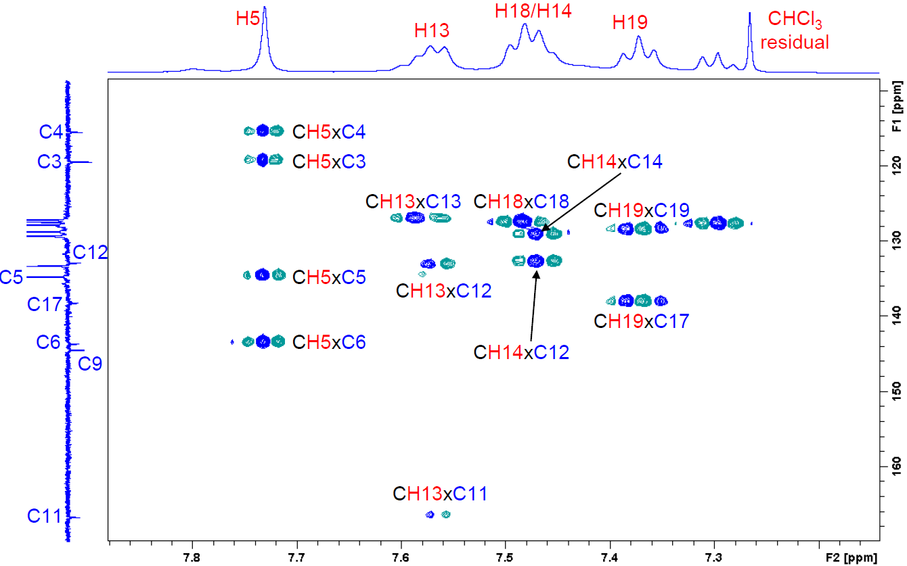

## **Figure S15.** HMBC 1Hx13C NMR spectrum for **LQOF-G35-Br** at 283K in CDCl3.

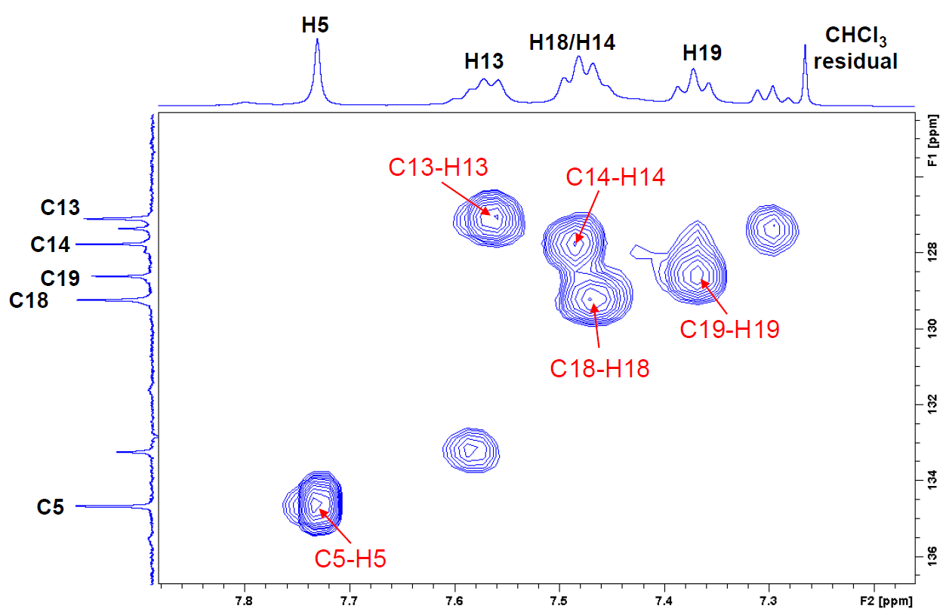

## **Figure S16.** HSQC 1Hx13C NMR spectrum for **LQOF-G35-Br** at 283K in CDCl3.

## **Figure S17.** NOESY 1Hx1H NMR spectrum for **LQOF-G35-Br** at 283K in CDCl3.

# **5. XRD data**

## **Table S1.** Crystal data and refinement parameters of **LQOF-G35** and **LQOF-G35-Br**.

|  |  |  |
| --- | --- | --- |
|  | **LQOF-G35** | **LQOF-G35-Br** |
| Chemical formula | C63H54N9O3Br3 | C21H16N3OBr3 |
| Molar mass (g mol−1) | 1224.88 | 566.10 |
| Crystal system | Trigonal | Monoclinic |
| Space group | P32 | P21/c |
| *a* (Å) | 16.1319(1) | 5.18050(10) |
| *b* (Å) | 16.1319(1) | 23.4855(3) |
| *c* (Å) | 18.6340(1) | 16.5670(2) |
| α (°) | 90 | 90 |
| β (°) | 90 | 96.8430(10) |
| γ (°) | 120 | 90 |
| V (Å3) | 4199.60(9) | 2001.29(5) |
| Z | 3 | 4 |
| Density/g cm−3 | 1.453 | 1.879 |
| θmin, θmax/o | 9.492, 140.072 | 9.254, 140.14 |
| Index ranges | −19 ≤ *h* ≤ 18 | −6 ≤ *h* ≤ 6 |
|  | −19 ≤ *k* ≤ 19 | −28 ≤ *k* ≤ 28 |
|  | −22 ≤ *l* ≤ 22 | −20 ≤ *l* ≤ 14 |
| F(000) | 1872.0 | 1104.0 |
| μ/mm−1 | 3.112 | 1.204 |
| Absorption correction | Gaussian | Gaussian |
| Max./min. transmission | 1.000/0.911 | 0.964/0.680 |
| Measured reflections | 34,537 | 37,069 |
| Independent reflections/Rint | 9,905/0.0434 | 3,812/0.0432 |
| Refined parameters | 704 | 253 |
| Final R indexes [I ≥ 2σ(I)] | R1 = 0.0222/wR2 = 0.0516 | R1 = 0.0249/wR2 = 0.0665 |
| Final R indexes [all data] | R1 = 0.0224/wR2 = 0.0517 | R1 = 0.0273/wR2 = 0.0681 |
| GooF | 1.025 | 1.072 |
| Largest diff. peak and hole (eÅ−3) | 0.22/−0.21 | 0.8/−0.73 |
| Flack parameter | -0.026(6) | — |

## **Table S2.** Selected bond lengths and angles for **LQOF-G35**.

|  |  |  |  |
| --- | --- | --- | --- |
| O1—C8 | 1.253 (5) | N2—C7 | 1.331 (5) |
| O1B—C8B | 1.259 (5) | N1B—C7B | 1.349 (5) |
| O1A—C8A | 1.253 (5) | N3A—C7A | 1.330 (5) |
| N3—C7 | 1.350 (5) | N2B—C7B | 1.351 (5) |
| N1—C7 | 1.357 (5) | N1A—C7A | 1.349 (5) |
| N3B—C7B | 1.339 (5) | N2A—C7A | 1.341 (5) |
|  | | | |
| O1—C8—N2 | 127.2 (4) | N3A—C7A—N2A | 116.9 (3) |
| O1B—C8B—N2B | 126.7 (3) | N2A—C7A—N1A | 123.8 (3) |
| N3—C7—N1 | 118.1 (3) | O1A—C8A—N2A | 126.9 (4) |
| N2—C7—N3 | 117.1 (3) | N3B—C7B—N1B | 119.5 (3) |
| N2—C7—N1 | 124.8 (3) | N3B—C7B—N2B | 117.2 (3) |
| N3A—C7A—N1A | 119.3 (3) | N1B—C7B—N2B | 123.2 (3) |

## **Table S3.** Selected bond lengths and angles for **LQOF-G35-Br**.

|  |  |  |  |
| --- | --- | --- | --- |
| O1—C8 | 1.222 (3) | N3—C7 | 1.348 (3) |
| N2—C7 | 1.409 (3) | N1—C7 | 1.290 (3) |
|  | | | |
| O1—C8—N2 | 123.4 (2) | N1—C7—N2 | 121.5 (2) |
| N3—C7—N2 | 116.45 (19) | N1—C7—N3 | 122.0 (2) |