Supplement
Structural geological interpretation of settlement patterns of red wood ants (Formica rufa group) in Southwest Germany between the Black Forest and the Swabian Alb
Maresch, L.¹, Schreiber, U.²
Supplement 1: Indirect detection of outgassing in the field (Fe-precipitation, floating iron)
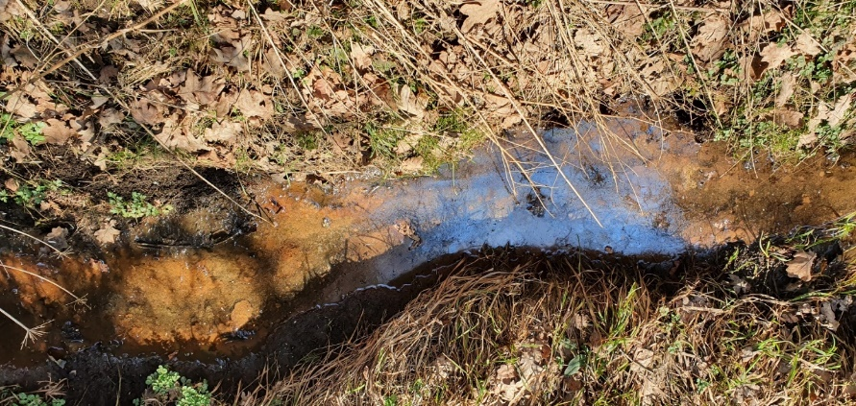
Colloidal Fe-precipitations (red-brown deposits in the water), March 27, 2022 (long. 8° 40‘ 19.45 / lat. 48° 3‘ 10.96)
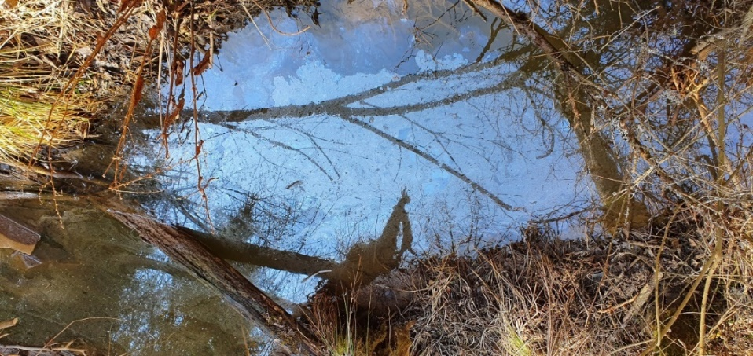
Floating iron (reflective surfaces with sharp edges on water-bearing sites), 27.03.2022 (long. 8° 40‘ 30.68 / lat. 48° 3‘ 7.45)

Supplement 2: Tectonic setting
Geology
The study area is located in the southwestern part of the South German scarplands, where Triassic and Jurassic sediments, with a total thickness of 1 to 2 km, were deposited. These sediments overlie Variscan gneisses and magmatic rocks, comparable to those emerging in the Black Forest to the west and the Bohemian Massif to the east. The oldest Mesozoic units consist of sandstones from the Middle Buntsandstein, which discordant overlay the bedrock at the eastern edge of the Black Forest. To the east, southeast, and southwards, younger units from the Triassic are overlayed by Jurassic strata. The youngest sedimentary rocks in the area are Upper Jurassic limestones, occurring in reef facies or in layered strata. An uplift and simultaneous tilting of the entire South German block, associated with the Alpine orogenesis, displaced the layers, causing them to dip at an angle of 5 to 10° to the south-southeast. Subsequently, widespread erosion from the north set in, leading to the development of the characteristic scarpland since the Miocene. The study area encompasses a north-south section at the eastern edge of the Black Forest, representing all stratigraphic units from the Middle Buntsandstein to the Upper Jurassic.
Major tectonic framework
The South German scarplands east of the Black Forest have been characterized since the Upper Jurassic by multiple changes in the stress field's orientation and intensity (Schwarz, 2012). Apart from the reactivation of ancient Variscan fault systems, new directions were established before and during the Alpine orogenesis. In the gridded areas of larger fault zones, small interlocking crustal block fields developed, the majority of whose structures are characterized by horizontal movements. Often associated with these are transpression and transtension zones of various magnitudes, coupled with numerous closely spaced secondary faults. Transition zones between (often "invisible" for mapping [Geyer, Gwinner, 2011]) lateral displacements led to rhomboid to graben-like delimited block fields with locally stronger vertical offsets. Additionally, block rotations further complicate the structural inventory (Geyer, Gwinner, 2011).

The recent deformations of shear zones in southwest Germany are broadly related to the development of the Cenozoic rift system in Europe and the northern Molasse basin of the Alps (Reicherter et al., 2008). The tectonic structures visible today in southern Germany are characterized by a NW-SE-directed shortening with NE-SW-oriented extension (Reiter et al., 2015; Heidbach et al., 2016), interpreted as a consequence of plate tectonic processes within the Alpine orogenesis (Ring, Bolhar, 2020). This led to conjugate shear systems, correlating with the present seismic activity.

Tectonically relevant for the study area is the sinistral Albstadt shear zone (ASZ) running north-northeast / south-southwest in the east. Its existence has only been known since 1911 when earthquakes became frequent in its vicinity. It parallels the Upper Rhine Graben, whose tectonics, in addition to the graben-forming normal faults, is also marked by sinistral strike-slip faults. After analyzing earthquake mechanisms, the tectonics of the South German scarplands is dominated by dextral strike-slip faults with accompanying normal faults, while the ASZ, as a conjugate system, is characterized by sinistral strike-slip faults (Werner, Franzke, 2001; Stange, Strehlau, 2002; Sawatzki, Hann, 2003). South of the study area, the ASZ nearly intersects at a right angle with the also recently active Freiburg-Bonndorf-Bodensee shear zone (FBBSZ, Fig. 7c). The FBBSZ is a pronounced deformation zone running in a west-northwest/east-southeast direction from Freiburg in the west to Lake Constance in the southeast. In this zone, the bedrock in the west is overlain to the east by Mesozoic cover, Tertiary molasse, and Quaternary sediments (near Lake Constance).

The study area is characterized by multiple changes in tectonic stress with different principal stress directions in the last 200 million years. Part of the old fault planes was reactivated with each new stress, resulting in a complex fracture pattern dominated by strike-slip faults today. During the Alpine orogenesis, a horizontal principal stress direction in the northwest-southeast direction developed in Central Europe, leading to the recent formation of a conjugate shear system with the sinistral Albstadt shear zone (ASZ) and the dextral Freiburg-Bonndorf-Bodensee shear zone (FBBSZ) in southwest Germany. This system is marked by some of the strongest seismic activity in Germany. The repeated imprint of tectonic structures with a high strike-slip component, combined with poor outcrop conditions, often precludes detailed mapping of secondary and tertiary faults. However, using specific fault indicators and the mapped nests, a rough assessment of the existence and course of gas-permeable faults can be obtained.

Supplement 3: Isotope measurements of methane

Institute for Marine and Atmospheric research (IMAU) - Report CH₄ isotope analysis (WG Prof. Dr. Thomas Roeckmann; done by Carina van der Veen) November 8. 2021

Sample description:
Stainless steel gas sample containers “gas frog” (20 mL) filled with gas samples from six locations. The gas is different from normal atmospheric air, and the CH₄ mole fraction reported is up to 80 %.

Measurements:
The samples were diluted to 2 ppm with N₂, in 2L foil air sample bags. The prepared dilutions were measured on the Picarro optical analyzer before the isotopic measurement. The IRMS CH₄ measurements were performed on IVAN on November 5. and 6. 2021.

Method
The CH₄ from 60 mL of the diluted gas was extracted for each δ²H measurement, and from 40 mL for δ¹³C measurements.

Calibration
A one-point calibration was done using the Ref cylinder NAT350, with the following assigned values:
CH₄: 1907 ppb; δ²H: -83.38 ‰ (VSMOW); δ¹³C: -47.75 ‰ (VPDB)

Precision
The measurement error in the reported δ¹³C is ± 0.2 ‰; and in δ²H ± 2 ‰ for the bag samples.

Tab. 1: Isotope Analysis Data (δ¹³C-CH₄, δ²H-CH₄) of 6 Sampling Points with varied geotectonic positions and high methane emissions (methane concentration >80%). Analysis conducted by the Institute for Marine and Atmospheric Research (IMAU).

Supplement References
Egli, D., Mosar, J., Ibele, T., Madritsch, H. (2017). The role of precursory structures on Tertiary deformation in the Black Forest—Hegau region. International Journal of Earth Sciences, 106, 2297-2318.
Heidbach, O., Barth, A., Müller, B., Reinecker, J., Stephansson, O., Tingay, M., Zang, A. (2016). WSM quality ranking scheme, database description and analysis guidelines for stress indicator.
Ibele, T. (2015). Tectonics of the Hegau and Lake Constance Region: A synthesis based on existing Literature. Nagra Working Report, NAB 12–23, Wettingen, Nagra.
Ring, U., Bolhar, R. (2020). Tilting, uplift, volcanism and disintegration of the South German block. Tectonophysics, 795, 228611.
Reicherter, K., Froitzheim, N., Jarosiński, M., Badura, J., Franzke, H. J., Hansen, M., ... Zuchiewicz, W. (2008). Alpine tectonics north of the Alps.
Reinecker, J., Schneider, G. (2002). Zur Neotektonik der Zollernalb: Der Hohenzollerngraben und die Albstadt-Erdbeben. Jahresberichte und Mitteilungen des oberrheinischen geologischen Vereins, 391-417.
Reiter, W., Elfert, S., Glotzbach, C., Spiegel, C. (2015). Plio-Pleistocene evolution of the north Alpine drainage system: new constraints from detrital thermochronology of foreland deposits. International Journal of Earth Sciences, 104, 891-907.
Sawatzki, G., Hann, E. (2003). Badenweiler-Lenzkirch-Zone (Südschwarzwald). Erläuterung mit Hinweisen für Exkursionen. Landesamt für Geologie, Rohstoffe und Bergbau Baden-Württemberg, Freiburg i. Br.
Schreiner, A. (1992). Erläuterungen zur geologischen Karte Hegau und westlicher Bodensee 1: 50.000–290 pp. Freiburg (Geologisches Landesamt Baden-Württemberg).
Schwarz, H. U. (2012). Das Schwäbisch-Fränkische Bruchmuster. Zeitschrift der Deutschen Gesellschaft für Geowissenschaften, 411-446.
Songchitruksa, P., Zeng, X. (2010). Getis–Ord spatial statistics to identify hot spots by using incident management data. Transportation research record, 2165(1), 42-51.
Ufrecht, W. (2006). Zusammensetzung und Herkunft der Gase in den Säuerlingen von Stuttgart-Bad Canstatt und-Berg [Origin and composition of the gases in the mineral water of Stuttgart-Bad Canstatt and Berg]. Schriftenreihe Amtes Umweltschutz, 3(2006), 103-114.

