Electronic Supplementary Information

Red cabbage modulates composition and co-occurrence networks of gut microbiota in a rodent diet-induced obesity model

Yanbei Wu ¹, Mengmeng Xin ¹, Quynhchi Pham ², Yu Gao ¹, Haiqiu Huang ³, Xiaojing Jiang ³, Robert W. Li ⁴, Liangli Yu ³, Yaguang Luo ⁵, Jing Wang ¹, and Thomas T.Y. Wang ^{2,*}
1 China-Canada Joint Lab of Food Nutrition and Health (Beijing), Beijing Technology &Business University, Beijing 100084, PR China
2 Diet Genomics and Immunology Laboratory, BHNRC, ARS, USDA, Beltsville, MD 20705, USA
3 Animal Parasitic Diseases Laboratory, BARC, ARS, USDA, Beltsville, MD 20705, USA
4 Department of Nutrition and Food Science, University of Maryland, College Park, MD 20742, USA
5 Food Quality Laboratory, BARC, ARS, USDA, Beltsville, MD 20705, USA

Table S1. Primer sequence used for microbial analysis by real-time PCR.
Bacteria | Direction | Sequence (5′–3′)
Bacteroidetes | Forward | GGARCATGTGGTTTAATTCGATGAT
 | Reverse | AGCTGACGACAACCATGCAG
Firmicutes | Forward | GGAGYATGTGGTTTAATTCGAAGCA
 | Reverse | AGCTGACGACAACCATGCAC
Prevotella | Forward | TCCTACGGGAGGCAGCAGT
 | Reverse | CAATCGGAGTTCTTCGTG
Enterobacteriaceae | Forward | CATTGACGTTACCCGCAGAAGAAGC
 | Reverse | CTCTACGAGACTCAAGCTTGC
Ruminococcus | Forward | GGCGGCCTACTGGGCTTT
 | Reverse | CCA GGT GGA TAA CTT ATT GTG TTAA
Bifidobacteria | Forward | TCGCGTCYGGTGTGAAAG
 | Reverse | CCACATCCAGCRTCCAC
Lactobacillus | Forward | GAGGCAGCAGTAGGGAATCTTC
 | Reverse | GGCCAGTTACTACCTCTATCCTTCTTC
Akkermansia muciniphila | Forward | CAGCACGTGAAGGTGGGGAC
 | Reverse | CCT TGCGGTTGGCTTCAGAT

Table S2. Relative abundance (%) of the bacterial taxa at phylum level in cecal samples of mice grouped by diet (LF: LF diet, HF: HF diet, LFRC: LF diet supplemented with RC powder, HFRC: HF diet sup-plemented with RC powder).
Phylum | Diet
 | LF | HF | LFRC | HFRC
Bacteroidetes | 60. 00±2. 45 | 53. 47±6. 21 | 47. 31±10. 30 | 42. 6±6. 53
Firmicutes | 34. 41±2. 19 | 39. 19±5. 92 | 42. 17±11. 50 | 50. 58±7. 34
Proteobacteria | 3. 18±0. 61 | 4. 78±0. 26 | 2. 57±0. 61 | 3. 81±0. 68
Deferribacteres | 2. 17±0. 78 | 2. 38±1. 24 | 4. 06±1. 43 | 2. 93±1. 09
TM7 | 0. 08±0. 04 | 0. 09±0. 11 | 0. 09±0. 09 | 0. 05±0. 04
Actinobacteria | 0. 01±0. 00 | 0. 01±0. 00 | 0. 02±0. 01 | 0. 02±0. 01

Table S3. The topological properties of the global network are inferred by using the network pipeline based on random matrix theory (RMT) under various experimental conditions.
Network Indexes | LF | HF | LFRC | HFRC
Total nodes | 247 | 245 | 233 | 217
Total links | 416 | 483 | 314 | 406
Total modules | 23 | 23 | 38 | 27
Modularity (M) | 0. 819 | 0. 72 | 0. 772 | 0. 704
R square of power-law | 0. 71 | 0. 80 | 0. 818 | 0. 825
Average degree (avgK) | 3. 368 | 3. 94 | 2. 695 | 3. 742
Average clustering coefficient (avgCC) | 0. 304 | 0. 32 | 0. 145 | 0. 17
Average path distance (GD) | 8. 217 | 6. 97 | 6. 603 | 4. 905
Geodesic efficiency (E) | 0. 166 | 0. 20 | 0. 2 | 0. 261
Harmonic geodesic distance (HD) | 6. 039 | 4. 92 | 4. 992 | 3. 826
Maximal degree | 13 | 16 | 12 | 15
Nodes with max degree | OTU 262625 | OTU 1136443  OTU 1684221  OTU 329790  OTU 317633 | OTU 263705 | OTU 336691
Centralization of degree (CD) | 0. 039 | 0. 05 | 0. 04 | 0. 053
Maximal betweenness | 6815. 31 | 4996. 26 | 3378. 541 | 2751. 546
Nodes with max betweenness | OTU 262677 | OTU 275366 | OTU 275366 | OTU 339031
Centralization of betweenness (CB) | 0. 204 | 0. 15 | 0. 114 | 0. 11
Maximal stress centrality | 48167 | 33304 | 20539 | 31008
Nodes with max stress centrality | 262677 | 418501 | 275366 | 339031
Centralization of stress centrality (CS) | 1. 451 | 1. 04 | 0. 713 | 1. 262
Maximal eigenvector centrality | 0. 355 | 0. 31 | 0. 435 | 0. 31
Nodes with max eigenvector centrality | OTU 353012 | OTU 317633 | OTU 263705 | OTU 277208
Centralization of eigenvector centrality (CE) | 0. 335 | 0. 28 | 0. 416 | 0. 279
Density (D) | 0. 014 | 0. 02 | 0. 012 | 0. 017
Reciprocity | 1. 00 | 1. 00 | 1. 00 | 1. 00
Transitivity (Trans) | 0. 359 | 0. 35 | 0. 182 | 0. 214
Connectedness (Con) | 0. 78 | 0. 63 | 0. 515 | 0. 481
Efficiency | 0. 987 | 0. 98 | 0. 985 | 0. 972
Hierarchy | 0. 00 | 0. 00 | 0. 00 | 0. 00
Lubness | 1. 00 | 1. 00 | 1. 00 | 1. 00

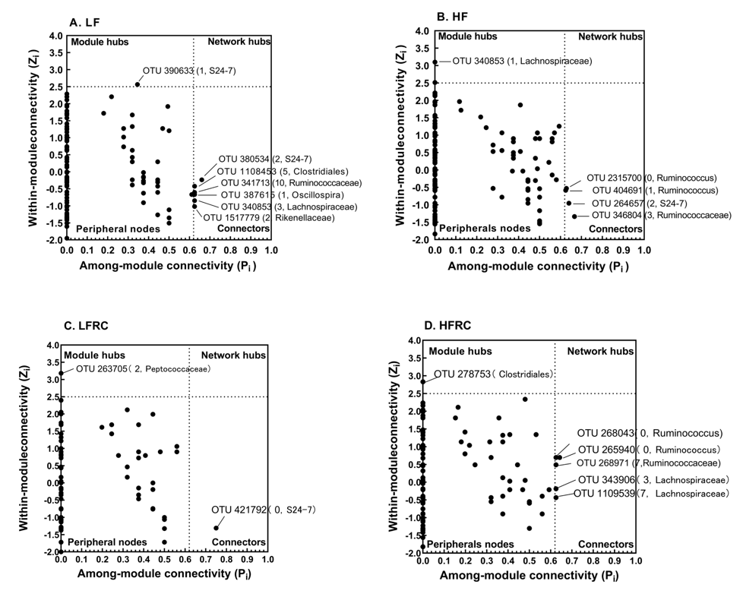
Fig. S1. The Zi-Pi diagram shows the distribution of the topological role of OTU in the network. Each point represents an OTU under different dietary groups (LF: LF diet, HF: HF diet, LFRC: LF diet with RC powder, HFRC: HF diet with RC powder). According to the scatter diagram of in-tra-module connectivity (Zi) and inter-module connectivity (Pi), the topological function of each OTU is determined. The module hub and connector are marked with OTU number. In parentheses are the module number and phylogenetic associations

