Supporting Information

Responsive microgels based on RAFT-HDA dynamic covalent bonding

Jingkai Nie ¹, Hang Yin ¹,*, Ruyue Cao¹, Changyuan Huang2, Xiang Luo2, and Jun Ji 1

1 State Grid Smart Grid Research Institute Co. Ltd.; zhaoweimei@geiri.sgcc.com.cn
2 China Electric Power Research Institute Co. Ltd.; shaoshuai@epri.sgcc.com.cn
* Correspondence: yinhang@geiri.sgcc.com.cn; Tel.:+86 66601587

Keywords: responsive microgels, hetero Diels-Alder (HDA) reactions, dynamic covalent bonding

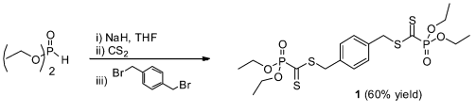
Scheme. S1. Synthetic routes of (a) 1,4-phenylenebis (methylene) bis((diethoxyphosphoryl)methanedithioformate) (P-Di-linker)
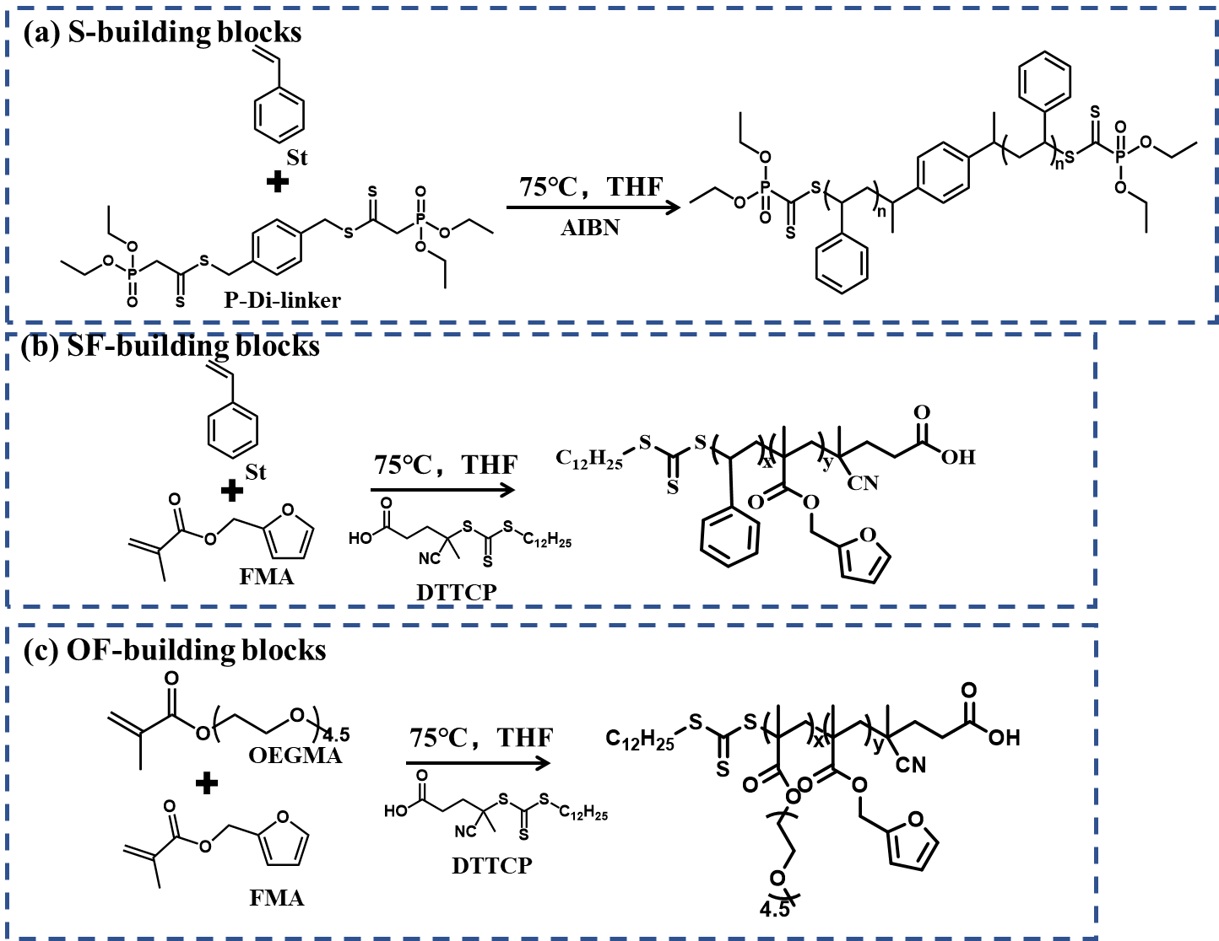
Scheme. S2(a-c) Synthetic routes of building blocks.

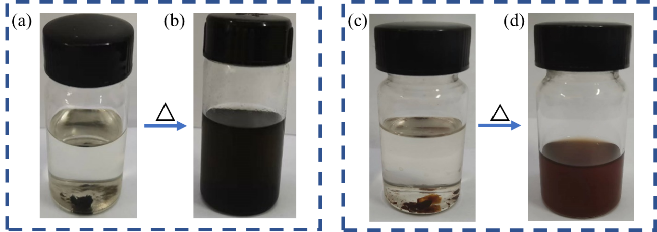
Figure S1 (a) DA product soaked in toluene at room temperature for 5 days. (b) DA product heated in toluene 120℃ for 2h. (c) DA product soaked in THF at room temperature for 5 days. (d) DA product heated in toluene 120℃ for 8h.

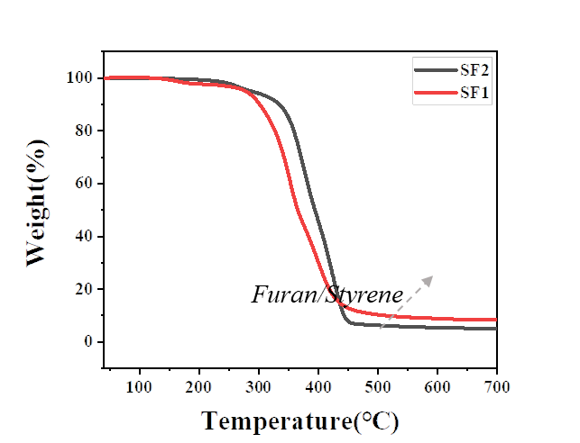
Figure S2 Comparative thermal weight loss spectra of SF1 and SF2 systems.

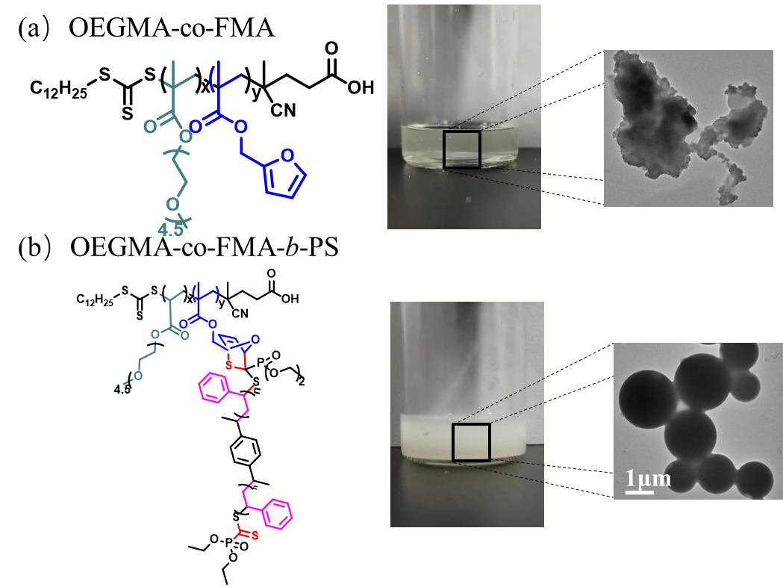
Figure S3(a) OEGMA and FMA copolymer. (b) Furan with dithioester HDA to obtain OEGMA-co-FMA-b-PS.

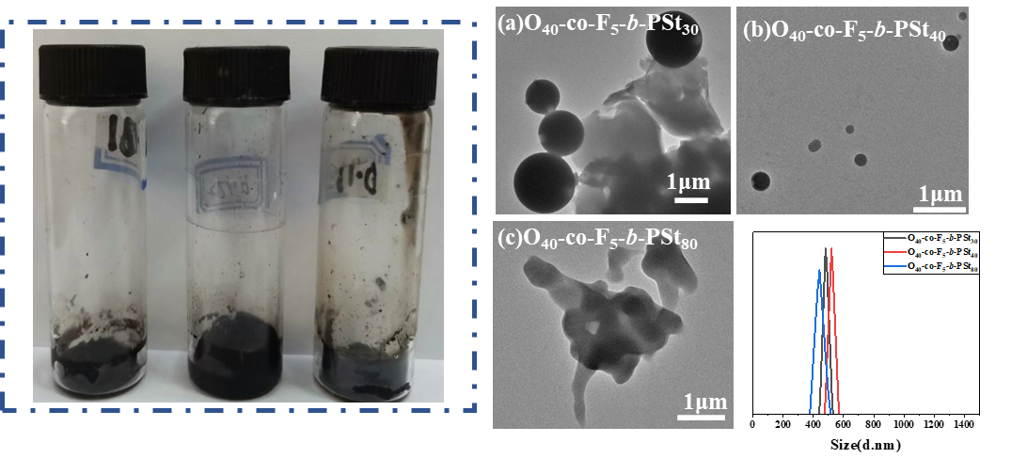
Figure S4
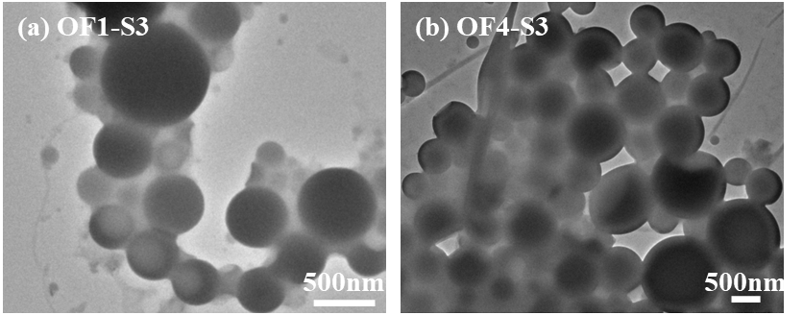
Figure S5 TEM images of microgels after 36 days at room temperature.

