Supplementary Files
Suppl. Table 1. Buckwheat’s yield parameters of height
Consortium | height of the plants after 2 weeks, cm | height of the plants after 4 weeks, cm | height of the plants after 6 weeks, cm
A | 1,53 ± 0,06 | 7,72 ± 2,44 | 51,11 ± 13,21
B | 1,40 ± 0,36 | 7,67 ± 1,61 | 58,67 ± 9,29
C | 1,80 ± 0,28 | 7,25 ± 0,82 | 58,00 ± 4,24
D | 1,67 ± 0,29 | 7,06 ± 1,06 | 49,56 ± 3,40
E | 1,70 ± 0,44 | 7,67 ± 0,76 | 52,89 ± 6,11
F | 1,63 ± 0,32 | 8,06 ± 1,42 | 58,56 ± 4,86
G | 1,45 ± 0,21 | 8,58 ± 0,12 | 61,50 ± 4,01
H | 1,10 ± 0,17 | 6,72 ± 2,25 | 51,11 ± 3,91
I | 1,13 ± 0,23 | 7,61 ± 1,55 | 49,22 ± 6,99
J | 1,10 ± 0,10 | 6,06 ± 0,54 | 52,89 ± 5,70
K | 1,33 ± 0,21 | 7,33 ± 1,01 | 47,00 ± 3,28
L | 1,47 ± 0,21 | 6,61 ± 2,59 | 51,67 ± 8,82
M | 1,77 ± 0,40 | 7,94 ± 1,49 | 49,78 ± 13,04
N | 1,70 ± 0,26 | 7,89 ± 1,50 | 58,44 ± 8,00
O | 1,53 ± 0,47 | 7,00 ± 2,49 | 49,22 ± 11,36
P | 1,17 ± 0,76 | 6,89 ± 0,77 | 49,11 ± 5,00
Q | 1,13 ± 0,23 | 7,89 ± 0,63 | 48,44 ± 3,85
R | 1,17 ± 0,25 | 6,78 ± 1,54 | 54,44 ± 2,69
S | 1,77 ± 0,59 | 7,89 ± 1,68 | 51,44 ± 8,68
T | 1,17 ± 0,59 | 8,22 ± 0,69 | 55,00 ± 8,09
Blank | 1,33 ± 0,29 | 6,56 ± 0,69 | 47,00 ± 4,81
Suppl. Table 2. Buckwheat’s yield parameters estimated by weight of grain, straw and roots
Consortium | mass of dry straw, g | Mass of grain weight, g (mean ± SE) | average weight of grain from the plot, g | Average weight gain from the plot versus control, % | mass of dry roots, g | Mass of dry roots from the plot versus control, %
A | 6,18 ± 1,93 | 4,70 ± 0,79 | 7,99 | 11,4 | 2,50 ± 0,83 | -62,3
B | 8,63 ± 1,36 | 4,11 ± 0,23 | 6,74 | -6,0 | 10,70 ± 3,57 | 61,1
C | 10,13 ± 5,13 | 7,27 ± 0,75 | 10,7 | 49,2 | 16,72 ± 5,57 | 151,8
D | 3,81 ± 0,39 | 3,07 ± 1,99 | 5,38 | -25,0 | 4,88 ± 1,63 | -26,5
E | 5,65 ± 2,49 | 6,61 ± 3,29 | 7,64 | 6,56 | 5,92 ± 1,97 | -10,8
F | 6,39 ± 2,66 | 6,51 ± 4,14 | 7,88 | 9,9 | 8,96 ± 2,99 | 34,9
G | 8,33 ± 3,15 | 4,12 ± 2,26 | 8,80 | -18,4 | 7,78 ± 2,59 | 17,2
H | 5,61 ± 0,82 | 6,43 ± 0,47 | 7,05 | -1,7 | 8,24 ± 2,75 | 24,1
I | 5,23 ± 2,74 | 3,47 ± 2,06 | 5,57 | -22,3 | 6,40 ± 2,13 | -3,6
J | 4,55 ± 1,25 | 4,64 ± 2,39 | 5,53 | -22,9 | 7,44 ± 2,48 | 12,0
K | 5,27 ± 2,04 | 3,64 ± 0,53 | 6,26 | -12,7 | 10,02 ± 3,34 | 50,9
L | 6,47 ± 5,32 | 6,55 ± 5,82 | 8,05 | 12,3 | 6,52 ± 2,17 | -1,8
M | 6,97 ± 1,90 | 7,35 ± 3,25 | 8,77 | 22,3 | 9,10 ± 3,03 | 37,0
N | 7,02 ± 1,09 | 6,22 ± 1,55 | 7,36 | 2,6 | 9,78 ± 3,26 | 47,3
O | 5,27 ± 0,60 | 4,13 ±1,52 | 6,23 | -13,1 | 9,92 ± 3,31 | 49,4
P | 3,80 ± 3,32 | 2,03 ± 1,18 | 3,12 | -56,5 | 4,74 ± 1,58 | -28,6
Q | 5,59 ± 1,40 | 5,48 ± 1,16 | 6,06 | -15,4 | 6,20 ± 2,07 | -6,6
R | 6,47 ± 3,19 | 4,39 ± 2,00 | 7,00 | -2,3 | 10,06 ± 3,35 | 51,5
S | 5,98 ± 2,38 | 6,05 ± 2,45 | 6,76 | -5,7 | 8,24 ± 2,75 | 24,1
T | 6,43 ± 0,81 | 3,13 ± 1,64 | 7,02 | -2,1 | 7,64 ± 2,55 | 15,1
Blank | 6,05 ± 2,55 | 6,08 ± 5,13 | 7,17 | control | 6,64 ± 2,21 | control
Suppl. Table 3. Wheat’s yield parameters of height
One asterisk (*) marks the level of statistical significance of the differences of 0.05 compared to the control plot (Blank).
Consortium | height of the plants after 4 weeks, cm | height of the plants after 6 weeks, cm | Stem length (straw), cm | Ear length, cm | Stem/ear ratio
А | 6,4 ± 1,1 | 30,3 ± 3,6 | 67,0 ± 4,8* | 4,3 ± 0,4 | 16
В | 6,1 ± 1,0 | 28,9 ±3,0 | 52,3 ± 7,6 | 4,5 ± 0,9 | 12
C | 5,5 ± 0,4 | 30,6 ± 4,0 | 53,3 ± 6,5 | 3,6 ± 0,5 | 15
D | 5,8 ±1,1 | 30,9 ± 3,0 | 52,1 ± 7,1 | 3,5 ± 0,8 | 15
E | 6,8 ± 2,2 | 34,3 ± 6,3 | 57,4 ± 6,0 | 4,5 ± 0,6 | 13
F | 6,3 ± 1,4 | 29,8 ± 3,9 | 52,6 ± 6,7 | 4,6 ± 0,9 | 11
G | 5,2 ± 0,9 | 29,1 ± 3,5 | 49,5 ± 5,1 | 3,3 ± 0,8 | 15
H | 5,4 ± 0,8 | 30,0 ± 3,1 | 56,8 ± 5,7 | 3,4 ± 0,2 | 17
I | 6,2 ± 1,1 | 32,9 ± 3,1 | 56,0 ± 6,9 | 4,1 ± 0,8 | 14
J | 6,4 ± 1,2 | 31,1 ± 4,8 | 53,3 ± 3,4 | 3,3 ± 0,1 | 16
K | 6,2 ± 0,7 | 34,1 ± 5,0 | 57,5 ± 7,0 | 3,9 ± 0,7 | 15
L | 6,6 ±1,5 | 29,0 ± 4,2 | 58,4 ± 4,4 | 4,1 ± 0,4 | 14
M | 6,1 ± 1,0 | 34,0 ± 3,9 | 56,8 ± 6,9 | 4,8 ± 0,5 | 12
N | 6,2 ± 0,5 | 30,9 ± 6,1 | 57,1 ± 7,8 | 3,9 ± 1,2 | 15
O | 5,3 ± 0,4 | 26,7 ± 3,9 | 47,7 ± 2,8 | 3,0 ± 0,6 | 16
P | 7,3 ± 1,5 | 33,4 ± 2,6 | 57,4 ± 4,9 | 3,7 ± 0,2 | 15
Q | 5,8 ± 0,9 | 31,2 ± 2,3 | 63,2 ± 5,7 | 3,8 ± 0,8 | 17
R | 5,9 ± 1,6 | 29,1 ± 4,4 | 48,7 ± 2,8 | 4,1 ± 0,4 | 12
S | 6,3 ± 1,7 | 32,4 ± 4,3 | 57,5 ± 8,6 | 4,1 ± 0,3 | 14
T | 6,1 ± 0,6 | 32,3 ± 6,0 | 52,0 ± 2,7 | 3,8 ± 0,4 | 14
Blank | 5,6 ± 0,5 | 30,4 ± 2,5 | 55,1 ± 5,1 | 3,8 ± 0,8 | 15

Suppl. Fig.1. Wheat’s height on 4 and 6 weeks.
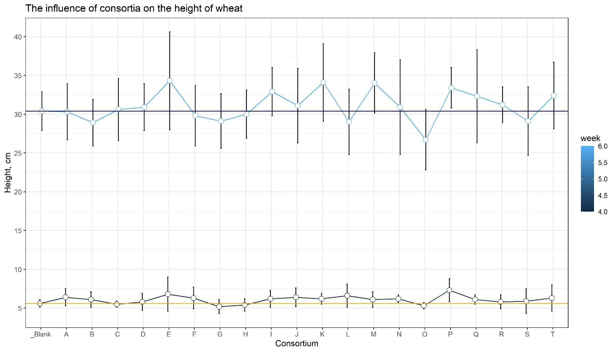

Suppl. Fig.2. Wheat’s length of ear and steam of after 3 months.
The red line is corresponding on length of ear, the light blue one – of steam. Orange line corresponds the mean ear’s length of control plants, the blue ones the mean and SD of steam’s length. One asterisk (*) marks the level of statistical significance of the differences of 0.05 compared to the control plot (Blank).
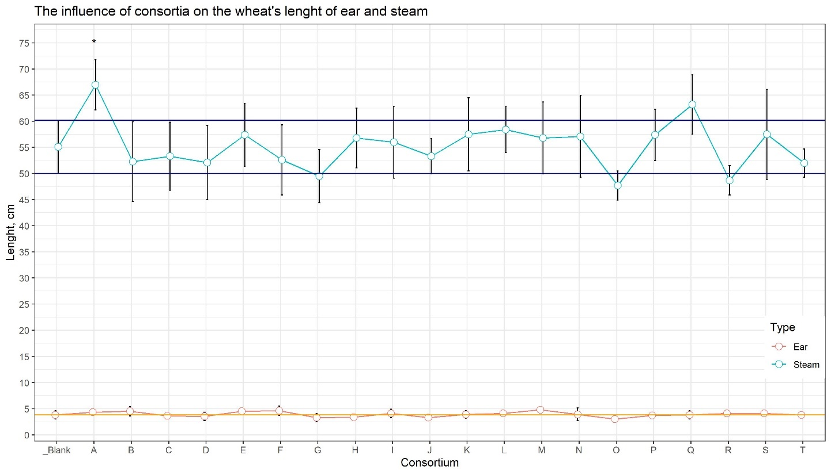

Suppl. Fig.3. Weight of wheat's ear and grain
The red line is corresponding on weight of wheat’s ear, the blue points are the weight of grain without a floor.
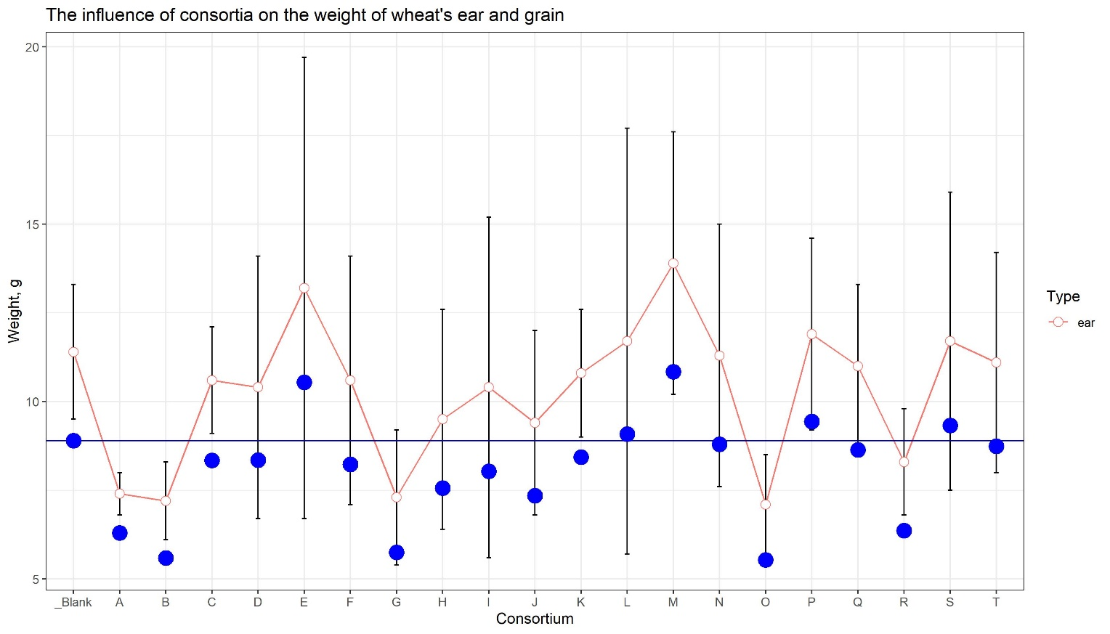

Suppl. Table 4. Corn’s yield parameters
Consortium | height of the plants after 4 weeks, cm | height of the plants after 6 weeks, cm | Weight of wet ears of corn, g | Weight of dry ears of corn, g | Weight of dry roots of corn, g
А | 9,7 ± 2,5 | 31,6 ± 7,1 | 236,7 | 19,8 | 551,7
В | 8,9 ± 2,9 | 32,1 ± 8,7 | 295,0 | 15,3 | 481,1
C | 9,8 ± 1,2 | 32,1 ± 4,1 | 376,7 | 19,7 | 577,2
D | 9,8 ± 4,1 | 30,6 ± 10,4 | 223,3 | 17,2 | 387,4
E | 10,8 ± 3,5 | 33,1 ± 8,5 | 520,0 | 37,2 | 690,9
F | 8,8 ± 1,4 | 26,8 ± 5,8 | 221,7 | 10,7 | 412
G | 10,6 ± 2,2 | 27,2 ± 10,8 | 315,0 | 29,0 | 421,9
H | 10,5 ± 2,7 | 30,3 ± 5,7 | 411,7 | 30,5 | 564,1
I | 10,0 ± 3,1 | 36,9 ± 2,7 | 420,0 | 22,3 | 524,4
J | 8,5 ± 2,5 | 27,5 ± 6,8 | 325,0 | 22,6 | 620
K | 10,3 ± 2,2 | 27,3 ± 6,4 | 301,7 | 17,7 | 555,6
L | 11,4 ± 2,0 | 37,4 ± 5,3 | 366,7 | 20,9 | 505,1
M | 8,1 ± 2,4 | 27,3 ± 9,9 | 348,3 | 22,5 | 387,4
N | 8,3 ± 2,7 | 23,1 ± 6,7 | 181,7 | 9,9 | 292,8
O | 10,4 ± 2,0 | 29,1 ± 28,8 | 173,3 | 13,7 | 421,2
P | 9,7 ± 2,0 | 28,8 ± 6,2 | 338,3 | 27,8 | 492,2
Q | 9,8 ± 3,4 | 34,5 ± 7,4 | 293,3 | 15,2 | 386,4
R | 9,7 ± 2,1 | 34,3 ± 5,7 | 138,3 | 18,6 | 558,4
S | 8,9 ± 2,0 | 27,5 ± 8,0 | 339,0 | 7,2 | 238,7
T | 10,1 ± 1,6 | 31,7 ± 7,1 | 275,0 | 15,9 | 630,76
Blank | 9,7 ± 2,7 | 36,5 ± 6,0 | 521,7 | 30,2 | 1133,5

Suppl. Fig.4. Corn’s height on 4 and 6 weeks.
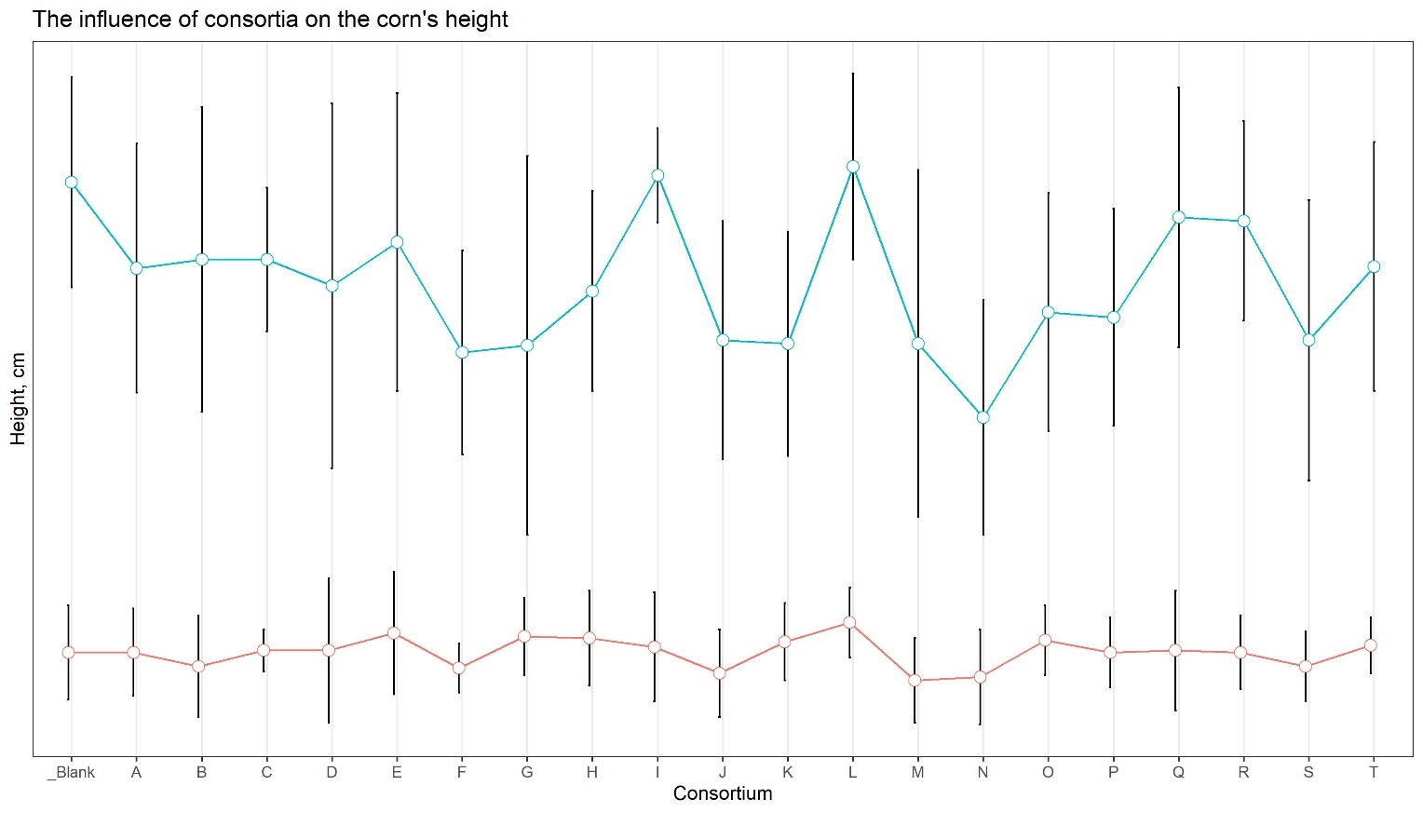

Suppl. Fig.5. Weight of corn's ears and roots
The red line is corresponding on weight of wheat’s ear, the blue points are the weight of grain without a floor.
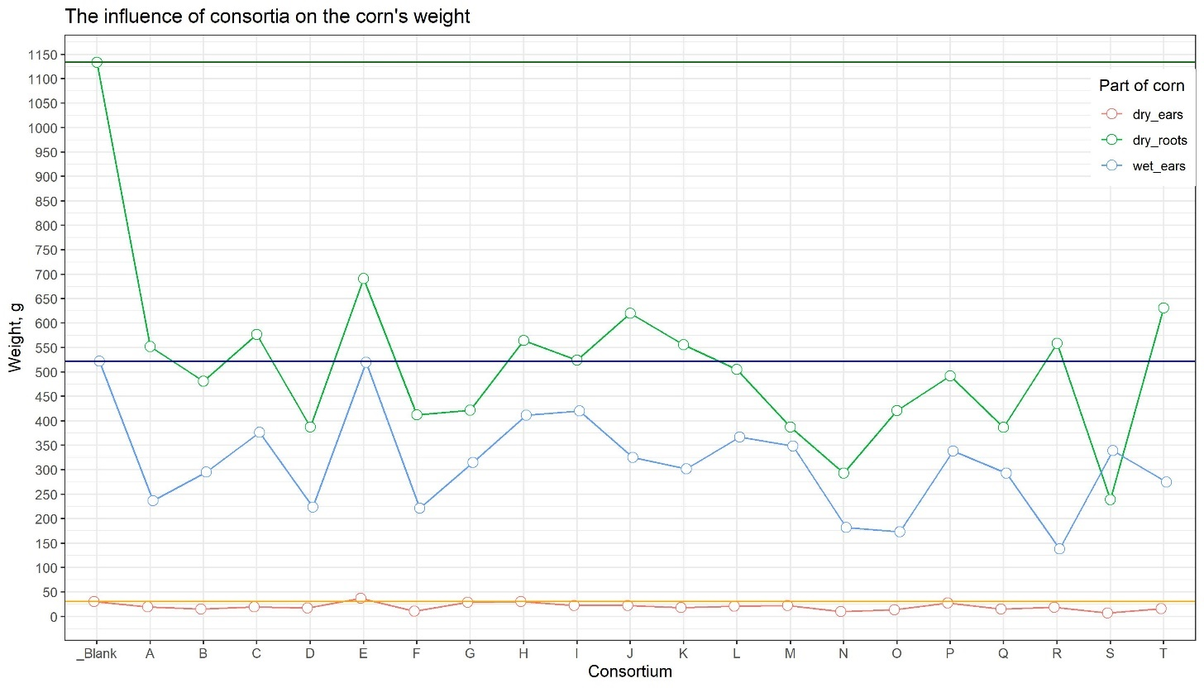

Suppl. Table 5. Soil nutrient status
SIC - soil inorganic carbon, SOC - soil organic carbon, AP - exchangeable potassium, Ex-K - exchangeable potassium, STC - soil total carbon
Cons | AN-NH4 | AN-NO3 | AP | Ex-K | SOC | SIC | STC
Buckweat
A | 2,35 ± 0,35 | 4,60 ± 1,38 | 1,70 ± 0,01 | 184 ± 18,4 | 4,40 | 0,21 | 4,61
B | 1,99 ± 0,30 | 5,26 ± 1,58 | 2,14 ±0,024 | 184 ± 18,4 | 4,66 | 0,18 | 4,84
C | 1,55 ± 0,23 | 4,81 ± 1,44 | 9,87 ± 0,019 | 166 ± 16,6 | 4,45 | 0,19 | 4,64
D | 1,12 ± 0,17 | 5,50 ± 1,65 | 1,43 ± 0,024 | 184 ± 18,4 | 4,81 | 0,21 | 5,02
E | 1,38 ± 0,21 | 4,40 ± 1,32 | 1,66 ± 0,029 | 184 ± 18,4 | 4,59 | 0,18 | 4,77
F | 1,17 ± 0,17 | 4,81 ± 1,44 | 1,68 ± 0,005 | 166 ± 16,6 | 4,69 | 0,17 | 4,87
G | 2,01 ± 0,30 | 5,03 ± 1,51 | 1,71 ± 0,010 | 184 ± 18,4 | 4,61 | 0,22 | 4,83
H | 4,69 ± 0,70 | 5,03 ± 1,51 | 1,59 ± 0,014 | 184 ± 18,4 | 4,41 | 0,20 | 4,61
I | 3,69 ± 0,55 | 4,81 ± 1,44 | 1,32 ± 0,010 | 166 ± 16,6 | 4,71 | 0,17 | 4,89
J | 4,58 ± 0,69 | 5,26 ± 1,58 | 1,23 ± 0,024 | 166 ± 16,6 | 4,34 | 0,20 | 4,54
K | 5,07 ± 0,76 | 5,26 ± 1,58 | 3,04 ± 0,00 | 166 ± 16,6 | 4,33 | 0,18 | 4,50
L | 2,46 ± 0,37 | 4,81 ± 1,44 | 1,59 ± 0,010 | 150 ± 15,0 | 4,51 | 0,19 | 4,70
M | 3,29 ± 0,49 | 4,81 ± 1,44 | 1,63 ± 0,005 | 166 ± 16,6 | 4,37 | 0,19 | 4,57
N | 3,75 ± 0,56 | 4,81 ± 1,44 | 1,76 ± 0,010 | 166 ± 16,6 | 4,61 | 0,19 | 4,81
O | 2,31 ± 0,35 | 4,21 ± 1,26 | 1,18 ± 0,029 | 150 ± 15,0 | 4,69 | 0,20 | 4,89
P | 1,57 ± 0,24 | 4,40 ± 1,32 | 1,52 ± 0,00 | 166 ± 16,6 | 4,37 | 0,19 | 4,57
R | 2,16 ± 0,32 | 4,40 ± 1,32 | 1,58 ± 0,014 | 150 ± 15,0 | 4,34 | 0,22 | 4,56
S | 2,40 ± 0,36 | 4,40 ± 1,32 | 1,56 ± 0,014 | 166 ± 16,6 | 4,54 | 0,20 | 4,73
T | 1,95 ± 0,29 | 4,21 ± 1,26 | 1,22 ± 0,010 | 150 ± 15,0 | 4,77 | 0,20 | 4,97
Q | 2,16 ± 0,32 | 4,60 ± 1,38 | 1,51 ± 0,010 | 184 ± 18,4 | 4,71 | 0,18 | 4,89
Blank | 5,30 ± 0,80 | 5,26 ± 1,58 | 1,91 ± 0,000 | 184 ± 18,4 | 4,66 | 0,19 | 4,85
Soil | 3,51 ± 0,53 | 4,03 ± 1,21 | 1,01 ± 0,024 | 134 ± 13,4 | 4,68 | 0,22 | 4,91
Wheat
A | 1,99 ± 0,30 | 6,05 ± 1,82 | 0,82 ± 0,009 | 165 ± 16,5 | 4,89 | 0,18 | 5,07
B | 2,06 ± 0,31 | 5,02 ± 1,51 | 0,64 ± 0,014 | 175 ± 17,5 | 4,86 | 0,19 | 5,06
C | 2,57 ± 0,38 | 4,57 ± 1,37 | 1,01 ± 0,005 | 170 ± 17,0 | 4,64 | 0,18 | 4,82
D | 1,93 ± 0,29 | 4,16 ± 1,25 | 0,62 ± 0,019 | 160 ± 16,0 | 4,41 | 0,18 | 4,58
E | 2,44 ± 0,37 | 5,02 ± 1,51 | 0,86 ± 0,014 | 175 ± 17,5 | 4,67 | 0,17 | 4,84
F | 2,99 ± 0,45 | 3,97 ± 1,19 | 0,72 ± 0,024 | 155 ± 15,5 | 4,12 | 0,18 | 4,30
G | 0,95 ± 0,14 | 3,97 ± 1,19 | 0,59 ± 0,00 | 160 ± 16,0 | 4,00 | 0,20 | 4,21
H | 1,44 ± 0,22 | 4,57 ± 1,37 | 1,05 ± 0,005 | 180 ± 18,0 | 4,74 | 0,19 | 4,93
I | 0,64 ± 0,10 | 4,36 ± 1,31 | 0,69 ± 0,019 | 170 ± 17,0 | 4,66 | 0,18 | 4,84
J | 0,72 ± 0,11 | 4,36 ± 1,31 | 0,58 ± 0,009 | 160 ± 16,0 | 4,17 | 0,17 | 4,34
K | 1,84 ± 0,28 | 3,97 ± 1,19 | 0,72 ± 0,024 | 175 ± 17,5 | 4,67 | 0,18 | 4,85
L | 0,64 ± 0,10 | 4,79 ± 1,44 | 1,03 ± 0,024 | 206 ± 20,6 | 4,61 | 0,18 | 4,79
M | 1,55 ± 0,23 | 3,79 ± 1,14 | 0,63 ± 0,019 | 165 ± 16,5 | 4,55 | 0,19 | 4,74
N | 0,98 ± 0,15 | 4,16 ± 1,25 | 0,88 ± 0,005 | 165 ± 16,5 | 4,16 | 0,25 | 4,41
O | 1,27 ± 0,19 | 3,97 ± 1,19 | 1,00 ± 0,009 | 175 ± 17,5 | 4,70 | 0,17 | 4,87
P | 4,85 ± 0,73 | 3,97 ± 1,19 | 1,21 ± 0,00 | 175 ± 17,5 | 4,64 | 0,19 | 4,82
Q | 2,12 ± 0,32 | 3,97 ± 1,19 | 0,72 ± 0,005 | 165 ± 16,5 | 4,63 | 0,20 | 4,83
R | 1,97 ± 0,30 | 3,97 ± 1,19 | 0,69 ± 0,019 | 180 ± 18,0 | 4,50 | 0,18 | 4,68
S | 1,34 ± 0,20 | 3,62 ± 1,09 | 0,80 ± 0,024 | 180 ± 18,0 | 4,09 | 0,20 | 4,29
T | 3,18 ± 0,48 | 4,16 ± 1,25 | 0,75 ± 0,024 | 165 ± 16,5 | 4,07 | 0,16 | 4,23
Blank | 2,12 ± 0,32 | 3,97 ± 1,19 | 1,11 ± 0,009 | 165 ± 16,5 | 4,52 | 0,17 | 4,69
Soil | 3,40 ± 0,51 | 3,97 ± 1,19 | 0,65 ± 0,009 | 150 ± 15,0 | 3,96 | 0,17 | 4,13
Corn
A | 0,95 ± 0,14 | 6,34 ± 1,90 | 0,40 ± 0,009 | 112 ± 11,2 | 2,11 | 0,13 | 2,24
B | 1,44 ± 0,22 | 7,30 ± 2,19 | 0,28 ± 0,014 | 120 ± 12,0 | 3,22 | 0,15 | 3,37
C | 0,76 ± 0,11 | 6,65 ± 1,99 | 0,28 ± 0,005 | 124 ± 12,4 | 3,03 | 0,14 | 3,17
D | 0,21 ± 0,03 | 5,02 ± 1,51 | 0,21 ± 0,024 | 137 ± 13,7 | 2,97 | 0,14 | 3,11
E | 1,34 ± 0,20 | 6,34 ± 1,90 | 0,25 ± 0,005 | 124 ± 12,4 | 3,24 | 0,16 | 3,40
F | 0,83 ± 0,12 | 5,78 ± 1,73 | 0,35 ± 0,009 | 116 ± 11,6 | 3,13 | 0,15 | 3,28
G | 1,78 ± 0,27 | 5,51 ± 1,65 | 0,25 ± 0,014 | 108 ± 10,8 | 2,57 | 0,14 | 2,72
H | 1,51 ± 0,23 | 5,02 ± 1,51 | 0,32 ± 0,014 | 112 ± 11,2 | 2,41 | 0,16 | 2,58
I | 1,06 ± 0,16 | 5,78 ± 1,73 | 0,29 ± 0,009 | 165 ± 16,2 | 2,97 | 0,17 | 3,14
J | 0,66 ± 0,10 | 5,78 ± 1,73 | 0,31 ± 0,005 | 120 ± 12,0 | 2,82 | 0,30 | 3,12
K | 1,34 ± 0,20 | 6,05 ± 1,82 | 0,37 ± 0,000 | 96 ± 48,0 | 2,69 | 0,13 | 2,82
L | 1,97 ± 0,30 | 4,79 ± 1,44 | 0,23 ± 0,009 | 137 ± 13,7 | 2,80 | 0,17 | 2,97
M | 1,95 ± 0,29 | 4,79 ± 1,44 | 0,25 ± 0,009 | 100 ± 10,0 | 2,51 | 0,12 | 2,63
N | 2,14 ± 0,32 | 4,57 ± 1,37 | 0,38 ± 0,014 | 87 ± 13,1 | 2,96 | 0,15 | 3,11
O | 1,19 ± 0,18 | 4,79 ± 1,44 | 0,27 ± 0,009 | 129 ± 12,9 | 2,32 | 0,11 | 2,43
P | 1,51 ± 0,23 | 5,02 ± 1,51 | 0,31 ± 0,024 | 150 ± 15,0 | 3,12 | 0,14 | 3,27
R | 1,25 ± 0,19 | 4,16 ± 1,25 | 0,27 ± 0,000 | 124 ± 12,4 | 2,61 | 0,14 | 2,75
S | 0,28 ± 0,04 | 5,78 ± 1,73 | 0,28 ± 0,005 | 120 ± 12,0 | 2,81 | 0,14 | 2,95
T | 0,81 ± 0,12 | 4,36 ± 1,31 | 0,34 ± 0,014 | 146 ± 14,6 | 3,10 | 0,18 | 3,28
Q | 0,91 ± 0,14 | 4,79 ± 1,44 | 0,25 ± 0,019 | 146 ± 14,6 | 3,43 | 0,17 | 3,60
Blank | 1,51 ± 0,23 | 5,02 ± 1,51 | 0,36 ± 0,005 | 116 ± 11,6 | 2,88 | 0,14 | 3,03
Soil | 1,38 ± 0,21 | 6,05 ± 1,82 | 0,37 ± 0,000 | 108 ± 10,8 | 2,95 | 0,14 | 3,10

Suppl. Fig. 6. Dependence of detection of the number of taxa (OTUs) on the number of sequences (N). The dependence of the detection of the number of taxa (OTU) on the number of sequences (N). The x-axis shows the number of sequences, the ordinate axis shows the observed species (OTU). The curves on the graph correspond to all the soil samples studied. As the sequencing depth increased, so did the number of OTU. After 700 sequences, the curves for all samples reached a plateau, indicating that as the number of extracted sequences increased, the number of detectable OTU no longer increased.
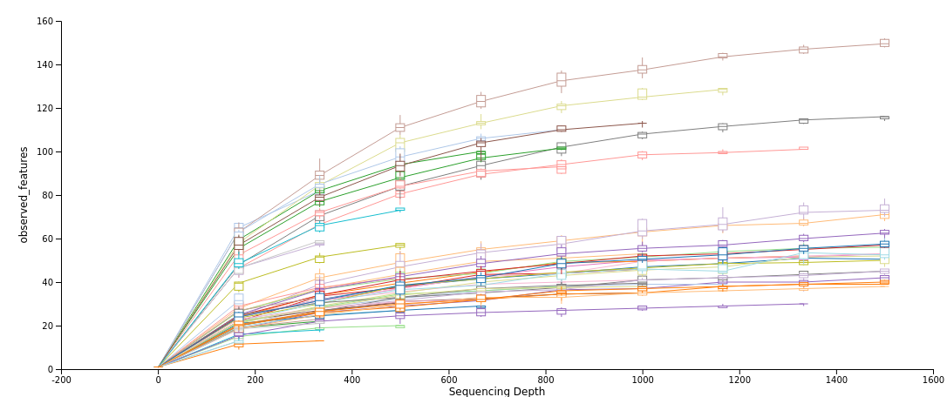

Suppl. Table 6. Statistical table of α-diversity index under different consortium on wheat, corn and гречихи.
Consortsium | Obs | Chao1 | ACE | Shannon
A | 40,5 ± 38,9 | 62,2 ± 49,4 | 61,5 ± 48,2 | 2,51 ± 1,50
B | 42,3 ± 28,4 | 65,5 ± 46,2 | 67,8 ± 49,2 | 2,64 ± 0,97
C | 34 ± 13,5 | 56,5 ± 31,5 | 79,5 ± 51,6 | 2,30 ± 0,51
D | 38,3 ± 25,7 | 63,3 ± 47,1 | 71,9 ± 53,6 | 2,43 ± 0,75
E | 31,7 ± 25,8 | 58,2 ± 63,9 | 58,2 ± 62,9 | 2,27 ± 0,67
F | 40,7 ± 23,0 | 64,1 ± 51,9 | 72,9 ± 61,6 | 2,50 ± 0,69
G | 25,7 ± 3,8 | 32,0 ± 9,8 | 35,4 ± 11,9 | 2,12 ± 0,16
H | 23,7 ± 4,0 | 29,8 ± 8,7 | 58,3 ± 7,7 | 2,11 ± 0,12
I | 31,7 ± 6,0 | 50,1 ± 7,0 | 61,8 ± 12,3 | 2,23 ± 0,46
J | 35,0 ± 11,1 | 53,6 ± 7,9 | 30,9 ± 11,4 | 2,39 ± 0,46
K | 23,0 ± 5,7 | 29,0 ± 12,8 | 44,0 ± 21,1 | 2,03 ± 0,04
L | 32,0 ± 15,9 | 40,0 ± 18,7 | 29,7 ± 11,6 | 2,36 ± 0,70
M | 21,5 ± 3,54 | 26,4 ± 9,3 | 63,8 ± 51,5 | 1,95 ± 0,06
N | 43,5 ± 34,6 | 54,6 ± 44,4 | 57,1 ± 40,7 | 2,72 ± 1,28
O | 35,7 ± 22,0 | 53,1 ± 42,6 | 57,1 ± 40,7 | 2,31 ± 0,93
P | 34,0 ± 20,2 | 52,9 ± 35,6 | 59,1 ± 38,2 | 2,36 ± 0,73
Q | 36,3 ± 17,9 | 66,8 ± 40,4 | 70,9 ± 44,3 | 2,42 ± 0,56
S | 21,0 ± 5,7 | 32,1 ± 21,0 | 29,8 ± 16,3 | 1,92 ± 0,06
T | 25,7 ± 4,5 | 36,7 ± 13,7 | 39,6 ± 13,7 | 2,18 ± 0,24
Soil | 27,3 ± 16,9 | 34,3 ± 28,7 | 36,5 ± 32,2 | 2,28 ± 0,74
Blank | 31,0 ± 12,7 | 45,0 ± 12,7 | 57,1 ± 9,6 | 2,25 ± 0,18
Plant | Obs | Chao1 | ACE | Shannon
bw | 27,5 ± 9,1 | 41,9 ± 19,6 | 48,9 ± 27,1 | 2,18 ± 0,37
corn | 46 ± 18,8 | 73,1 ± 37,8 | 80,3 ± 39,4 | 2,78 ± 0,64
wheat | 22,85 ± 6,5 | 30,8 ± 12,8 | 33,1 ± 13,8 | 1,98 ± 0,26

Suppl. Fig. 7. Box plot of indices of alpha diversity of microorganisms in soil plots.
From A to T — different types of consortia. Blank is a soil sample on which seeds not inoculated with microorganisms grew. Soil - a soil sample on which the tested plant culture did not grow
