Type of the Paper (Article, Review, Communication, etc.)
What Roles are the Silane APTES as a Primer in Polystyrene Coated AA2024-T3?
John Halford IV ¹ and Cheng-fu Chen ^{2,}*
Citation: Lastname, F.; Lastname, F.; Lastname, F. Title. Micromachines 2022, 13, x. https://doi.org/10.3390/xxxxx
Academic Editor: Firstname Lastname
Received: date
Accepted: date
Published: date
Publisher’s Note: MDPI stays neutral with regard to jurisdictional claims in published maps and institutional affiliations.
Copyright: © 2022 by the authors. Submitted for possible open access publication under the terms and conditions of the Creative Commons Attribution (CC BY) license (https://creativecommons.org/licenses/by/4.0/).
¹ Department of Mechanical Engineering, University of Alaska Fairbanks 1; jhhalfordiv@alaska.edu
² Department of Mechanical Engineering, University of Alaska Fairbanks 2; cchen4@alaska.edu
* Correspondence: cchen4@alaska.edu; Tel.: +1 (907) 474-7265
Abstract: A.
Keywords: keyword 1; keyword 2; keyword 3 (List three to ten pertinent keywords specific to the article yet reasonably common within the subject discipline.)

Supplementary Materials

- Summary of Data Fitting with Python Module "impedance.py"
The low-frequency portions of the spectra, demonstrating a deviation of more than 5% from a linear KK-transform, were systematically truncated. Subsequently, models representing oxide, coating, and Randles cells were fitted, with their capacitors combinatorically replaced by CPE elements. Additionally, a single Warburg element was introduced in series with one resistor for each model.
The impedance circuits that demonstrated the best fit across all samples and analyses for various time periods were carefully selected to advance the analysis. To mitigate the risk of overfitting and evident misfitting, constraints were applied to the solution resistance. In experiments involving two CPE elements, a deliberate effort was made to create asymmetry and distinctiveness between them. Analyses featuring a capacitance exceeding 5 mF were systematically discarded.

- CPE Parameters
The CPE used in the Randles circuit model is of the form $\frac{1}{Qs^{n}}$. The fitted parameters are shown in Figure S1 in which the magnitude of Q is referred to the label “CEP1”.

- SEM Images of Topcoated PS
Figure S2 compares the dewetted PS patterns.
Figure S3 shows that the dried PS topcoating that covers the underneath APTES layer, as evidenced by its observable thickness through the step along the articulately made step or groove. The topcoating is not uniformly; dewetted patterns of various sizes and shapes are evident, and crazing can be observed from some large patterns.

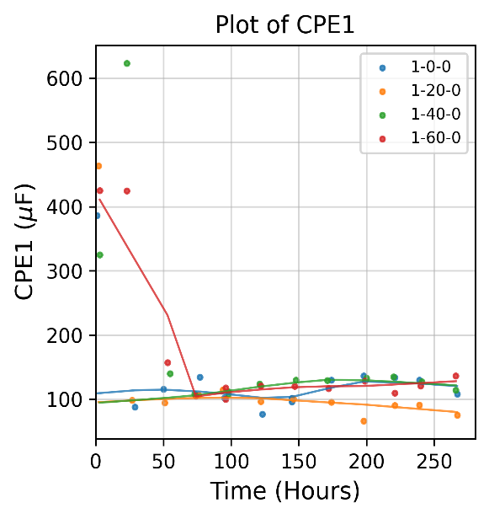 | 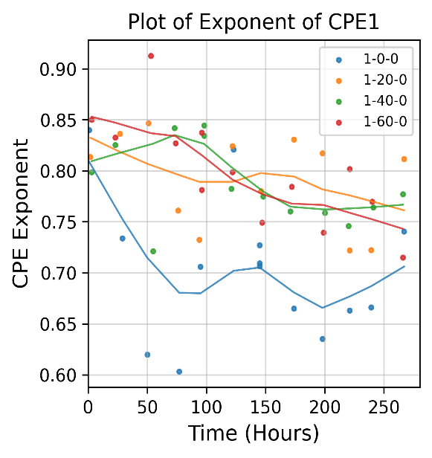
(a) | (b)
Figure S1. Fitted CPE parameters. (a) Capacitance of CPE. (b) Exponent of CPE.

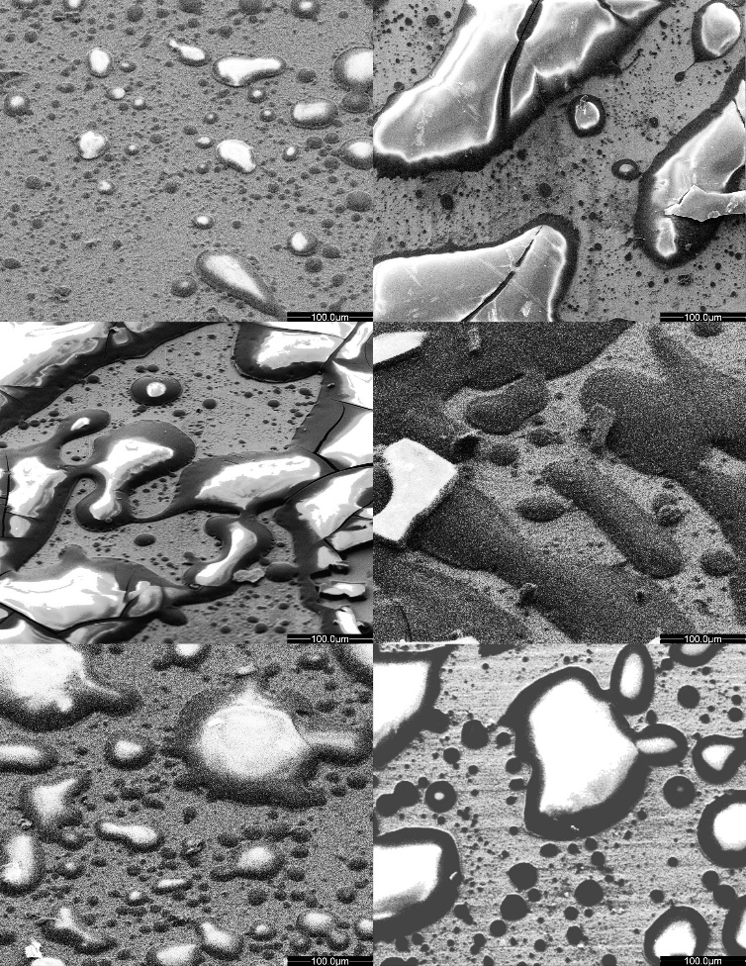
1-20-1
1-40-1
1-60-1
1-20-2
1-40-2
1-60-2
Figure S2. SEM images of top-coated PS, dried, on the APTES-primed samples. The images are resized (and trimmed) to the same scale to compare the dewetted PS patterns.

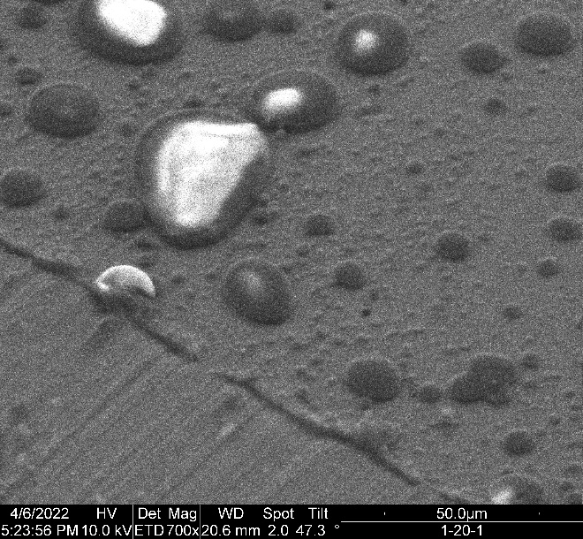 | 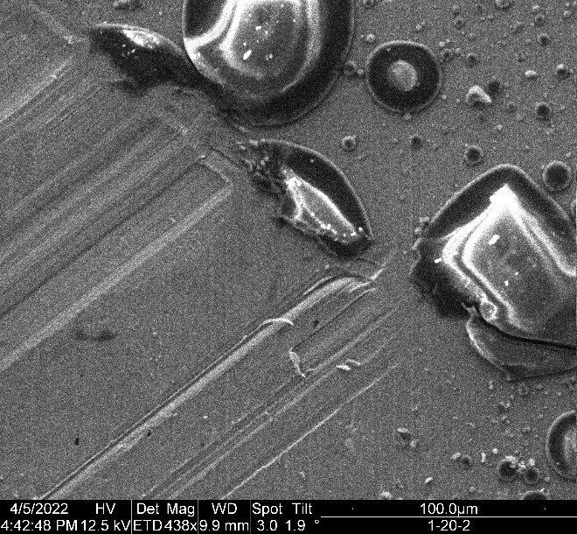
(a) | (b)
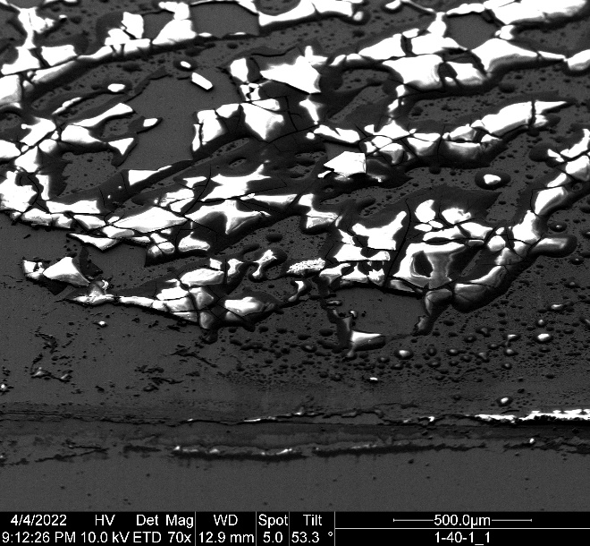
(c) | (d)
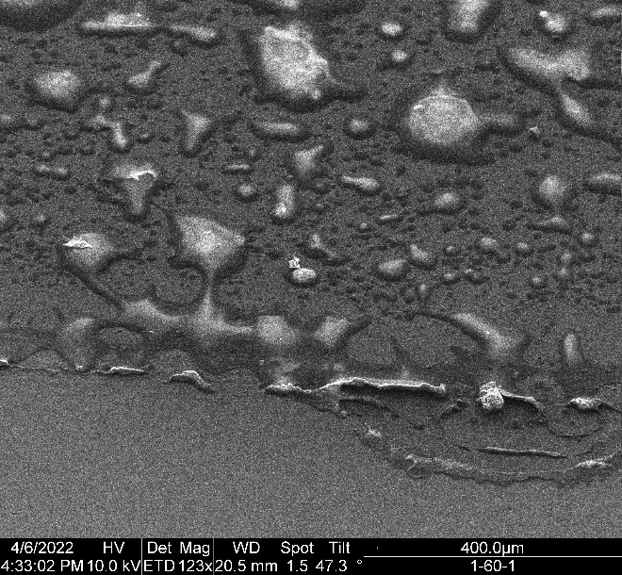 | 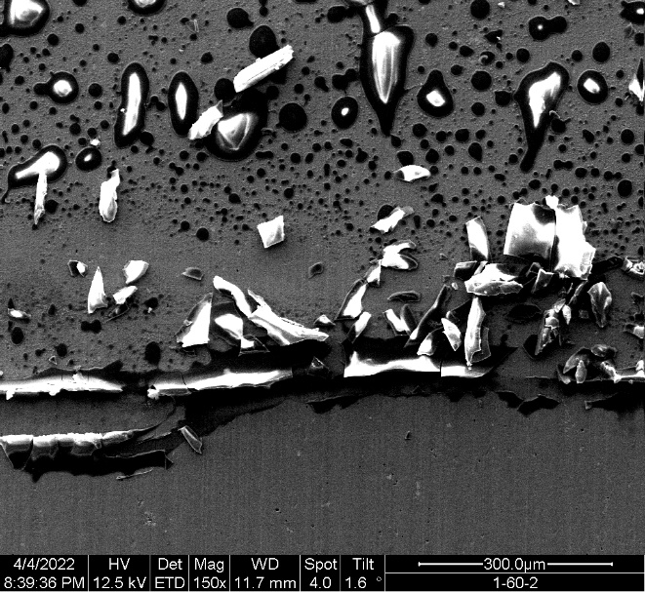
(e) | (f)
Figure S3. SEM images of dewetted PS patterns on APTES with an articulately made edge or groove. (a) 1-20-1, (b) 1-20-2, (c) 1-40-1, (d) 1-40-2, (e) 1-60-1, (f) 1-60-2.

