Supplementary Materials

A
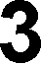

HyPer signal
(490/420)
Figure S1. A detailed view of the HyPer signal increase during the exposure to hydrogen peroxide for fibroblasts cultured in normal (empty circles) and high glucose (filled circles) conditions. Data correspond to the average ± SE of the same number of cells described in A1 and B1. .

A B
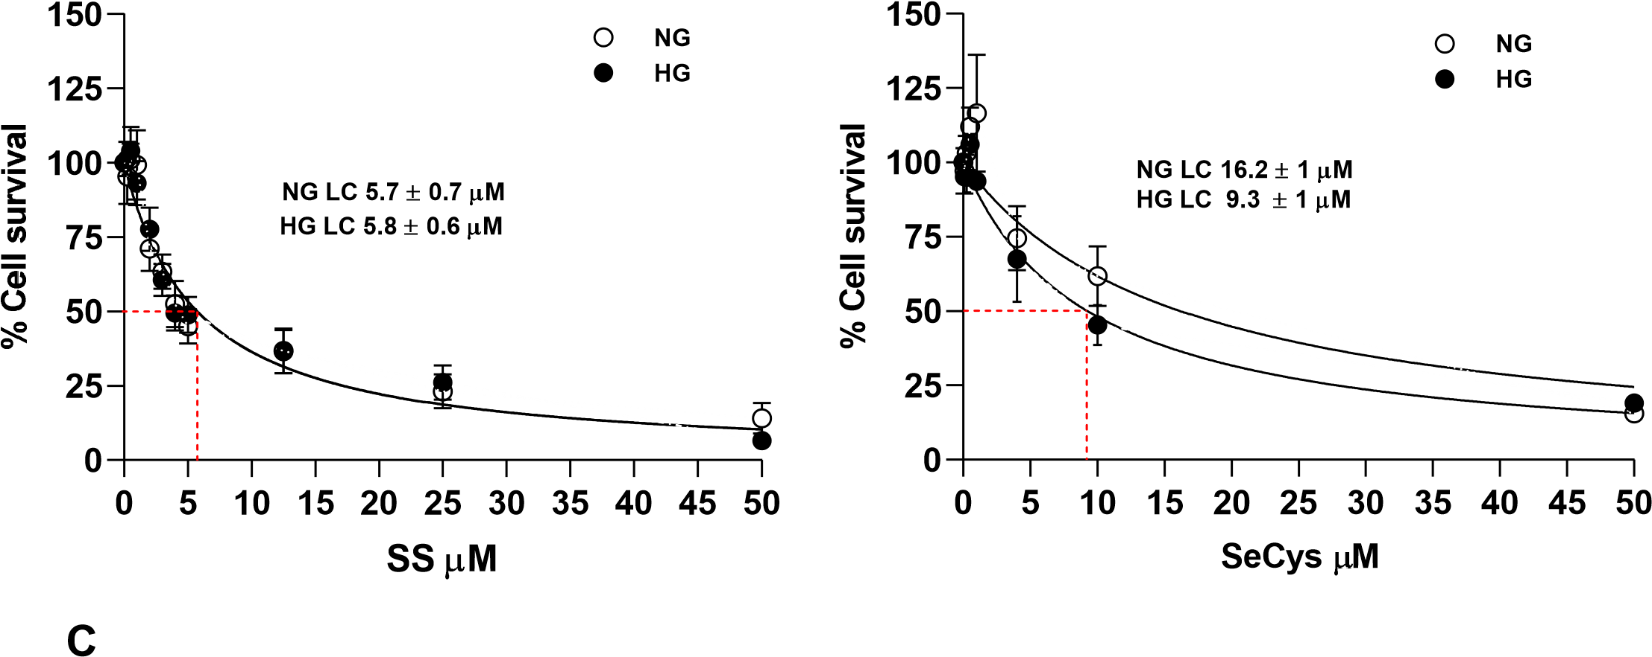
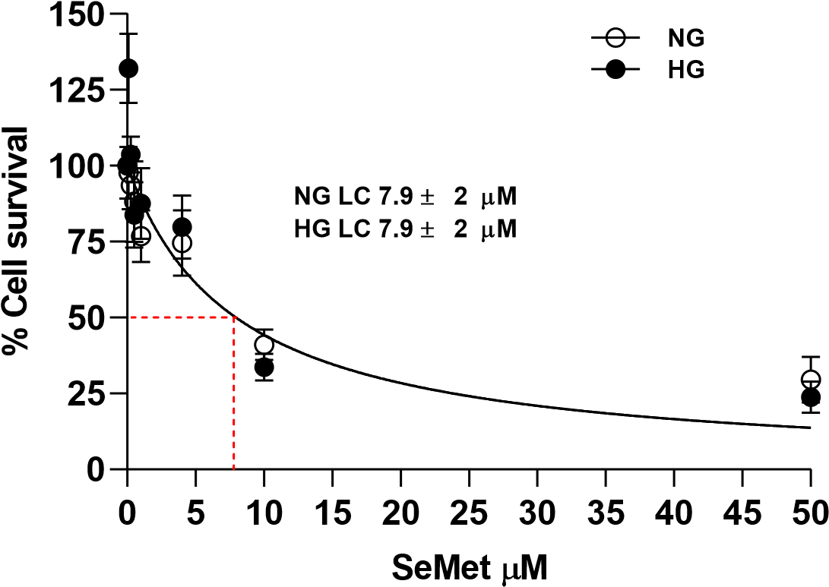

Figure S2. LC50 of cell survival assays in CCD1068Sk cells in normal and high glucose with selenium compounds. CCD1068Sk p10-25 cells were maintained in 5 (NG) or 25 (HG) mM glucose and treated with A. Sodium selenite (Na2SeO3), (B) Selenocysteine (SeCys) and (C) Selenomethionine (SeMet), for 10 days. The percentage of live cells was quantified using vital trypan blue staining under brightfield microscopy with the Neubauer chamber, evaluating three independent assays in triplicate. Empty circles represent cells maintained in NG and filled circles in HG condition; these represent average ± SE. They were fi ed to the equation 𝑦 = 100/((1 + 𝑋)/𝐼𝐶50) to estimate the LC50. Data fit is shown by the solid line.

A B

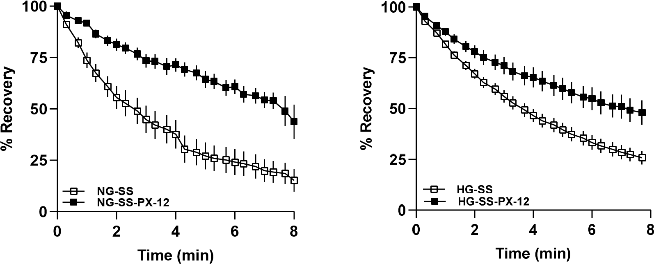
C D

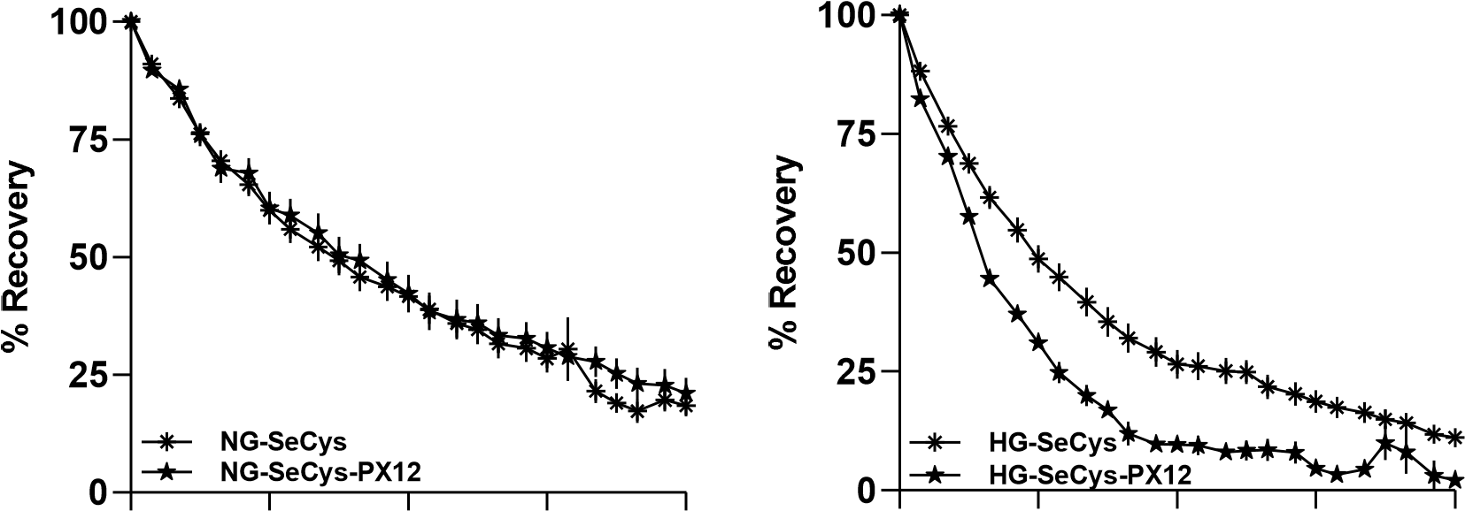
0 2 4 6 8 0 2 4 6 8
Time (min) Time (min)

E F
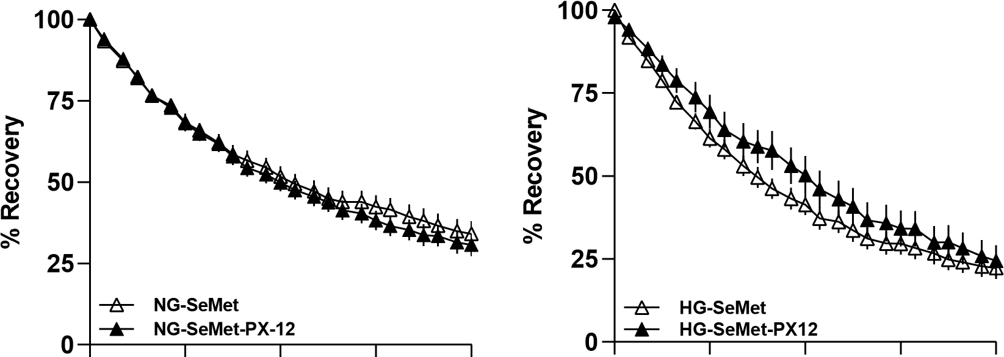
0 2 4 6 8 0 2 4 6 8

Time (min) Time (min)

Figure S3. Effects of thioredoxin inhibitor on the recovery of HyPer biosensor in human fibroblasts treated with selenium compounds maintained in normal and high glucose. Spontaneous HyPer signal recovery was measured right after the H2O2 removal, assigning 100% to this maximal signal at zero time in 5 (NG) and 25 (HG) mM glucose conditions respectively. Data correspond to the same register used for se ing in Figure 2 more the register with thioredoxin- 1 inhibitor (PX-12). The graph is shown in this order: A. and B. NG- and HG fibroblast, respectively, treated with sodium selenite. C and D, NG- and HG fibroblast respectively treated with selenocysteine and E and F, and B. NG- and HG fibroblast respectively treated with selenomethionine. .
A B

Co
n
trol
SS
Se
Cy
s

S
e
Met
Control
SS
SeCys
S
eMe
t
0
2
4
6
NG
HG
Co
n
trol
SS
SeCys
SeMe
t

Control
SS
Se
Cy
s

Se
Me
t
0
1
2
3
4
5
NG
HG

C D

Co
n
trol
SS
SeCys
SeM
e
t
Control
SS
S
e
Cy
s

S
e
Met
0
1
2
3
4
5
NG
HG
*
Contro
l
SS
SeCys
SeM
e
t
Co
n
tro
l
SS
Se
Cy
s

Se
M
et
0
1
2
3
4
NG
HG

Figure S4. Non-conclusive effects of selenium compounds on the relative expression of selenoenzymes or enzymes to control oxidation status. CCD1068Sk p10-25 cells were maintained in 5 (NG) or 25 (HG) mM glucose at 90 - 100 % confluence for 10 days with the selenium compounds. Then RNA was isolated, messengers were detected, and the data were expressed relativized with the expression of each control. A. Glutation peroxidase 1 B. Thioredoxin Reductase, C. Peroxiredoxin 1 y D. Aquaporin 1. Bars represent average ± SE from 3 independent experiments. Β-actin was used as the internal control. Significant differences were not found with one-way ANOVA with Bonferroni post-hoc.
A

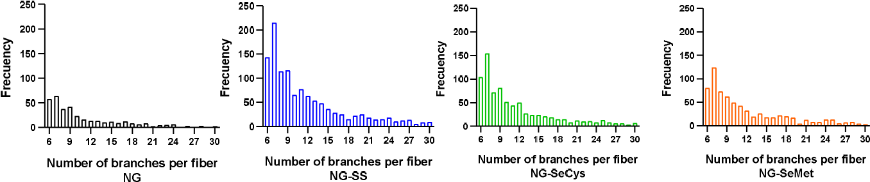

B
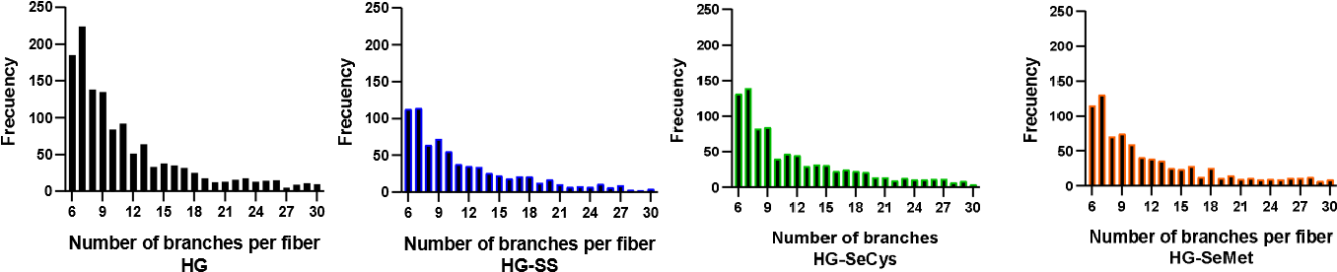

Figure S5. Distribution of data of the branches per fiber. These data were used in figure 4, histograms are presented the frequency distribution of the number of branches from fibers secreted by fibroblasts maintained in A.NG and B. HG, through the analysis of images obtained with a scanning electron microscope and analyzed with Fiji, Image J.

