Supplementary Materials
Voice-Cloning Artificial-Intelligence Speakers Can Also Mimic Human-Specific Vocal Expression

Wenjun Chen ª, Xiaoming Jiang ^{ab,}*

- Institute of Linguistics, Shanghai International Studies University, Shanghai 201620, China
- Key Laboratory of Language Science and Multilingual Intelligence Applications, Shanghai International Studies University, Shanghai 201620, China
* Correspondence: xiaoming.jiang@shisu.edu.cn (X.J.)

Supplementary Figure Captions

Supplementary Figure 1 Contrasting (a) Spectral Contrast, (b) Spectral Bandwith, (c) RMS in decibels (dB), and (d) Chroma_stft in AI-Trivia, and AI-Geography by biological sex and confidence levels.
Supplementary Figure 2 Comparison of (a) Tonnetz, (b) Spectral Flatness, (c) Spectral Centroid, and (d) Spectral Rolloff in AI-Trivia, and AI-Geography by biological sex and confidence levels.
Supplementary Figure 3 Comparison of (a) Zero Crossing Rate in Hz (Hertz), (b) Tempo in beats per minute (BPM), and (c) Harmonic to Noise Ratio in decibels (dB) in AI-Trivia and AI-Geography by biological sex and confidence levels.
Supplementary Figure 4 MFCC for Human, AI-Trivia, and AI-Geography in Confident, Neutral, and Doubtful Levels. All producing ‘Mohe is the coldest place in China in winter’. The visualisation is performed through Zafar’s Audio Functions in MATLAB for audio signal analysis; Version 1.0 (https://github.com/zafarrafii/Zaf-Matlab). Note two AI models have a shorter time length in the X-axis than Human. The colour bar on the right represents the logarithmic power or magnitude of the signal in decibels (dB), which is a measure of the amplitude or intensity of the sound. A Mel spectrogram is a representation of a sound signal where the frequency axes have been transformed according to the Mel scale, which approximates the human ear’s response to different frequencies. The higher the dB value, the louder the sound at that frequency and time.
Supplementary Figure 5 Mean VTL in three confidence levels by 10 speakers of different heights. Speakers 1-5 are male, and 6-10 are female. For male speakers 5, 4, and 2, VTL is ranked as Neutral > Confident, while for 1 and 3, it is ranked as Confident > Neutral. For female speakers 8 and 9, VTL is ranked as Neutral > Confident, and for 7, 6, and 10, it is ranked as Confident > Neutral. The circles for each speaker correspond to their height, as shown on the right-side y-axis.

Supplementary Figure 1

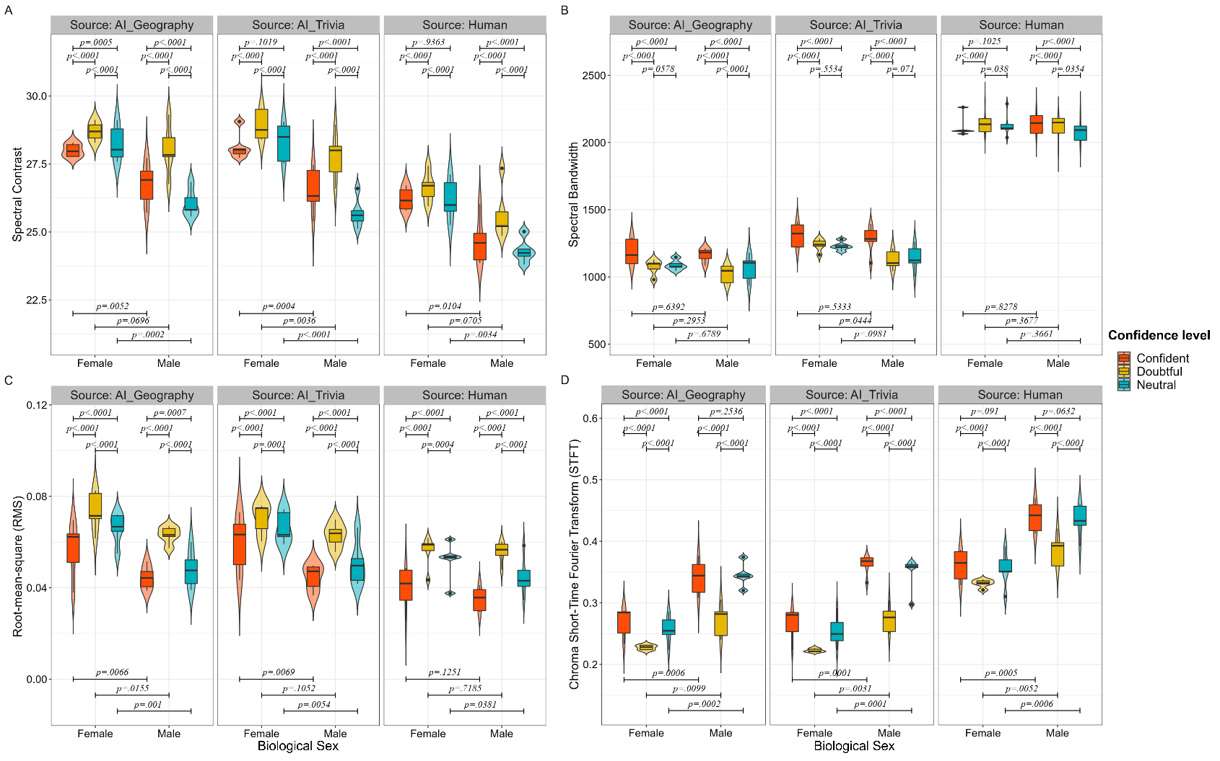

Supplementary Figure 2

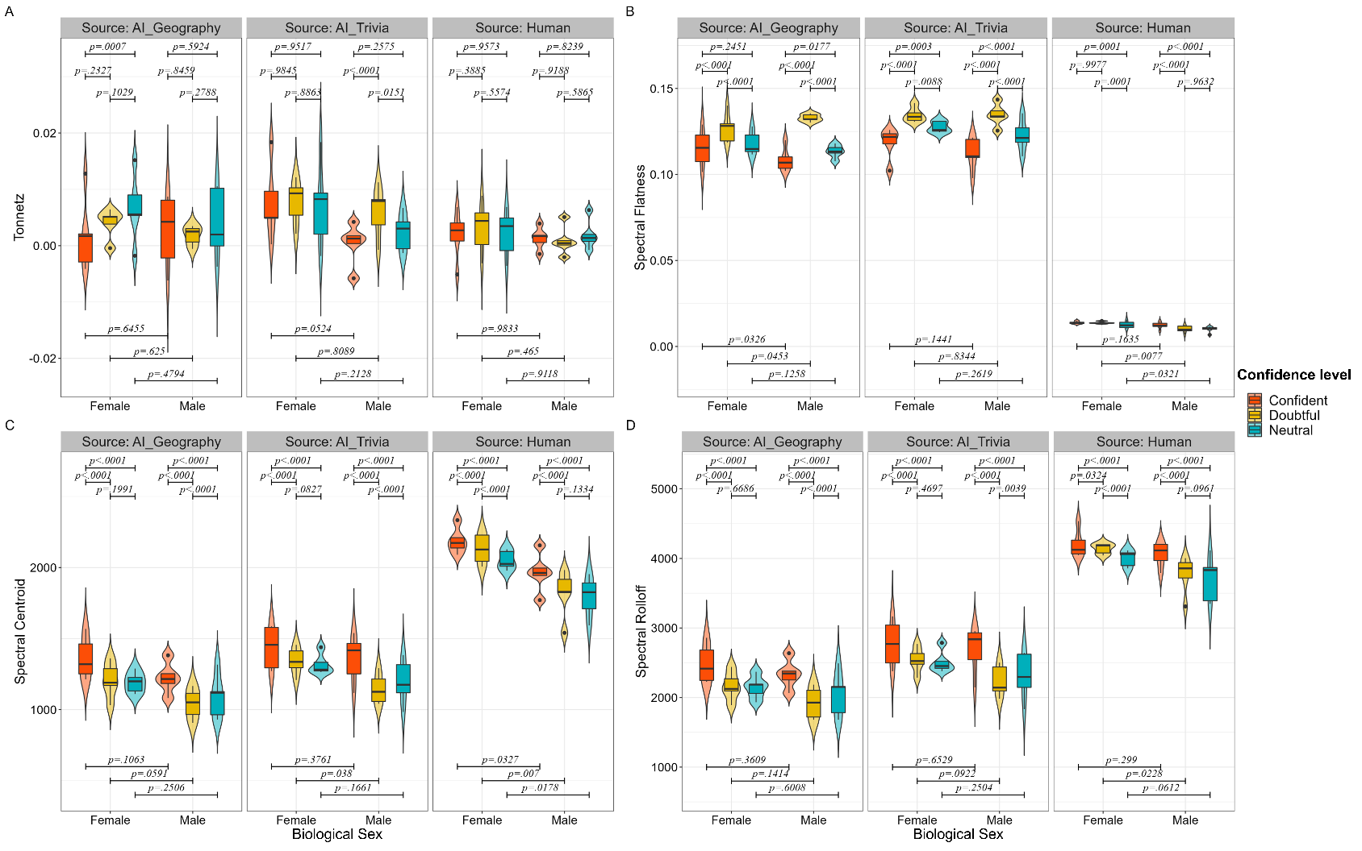

Supplementary Figure 3

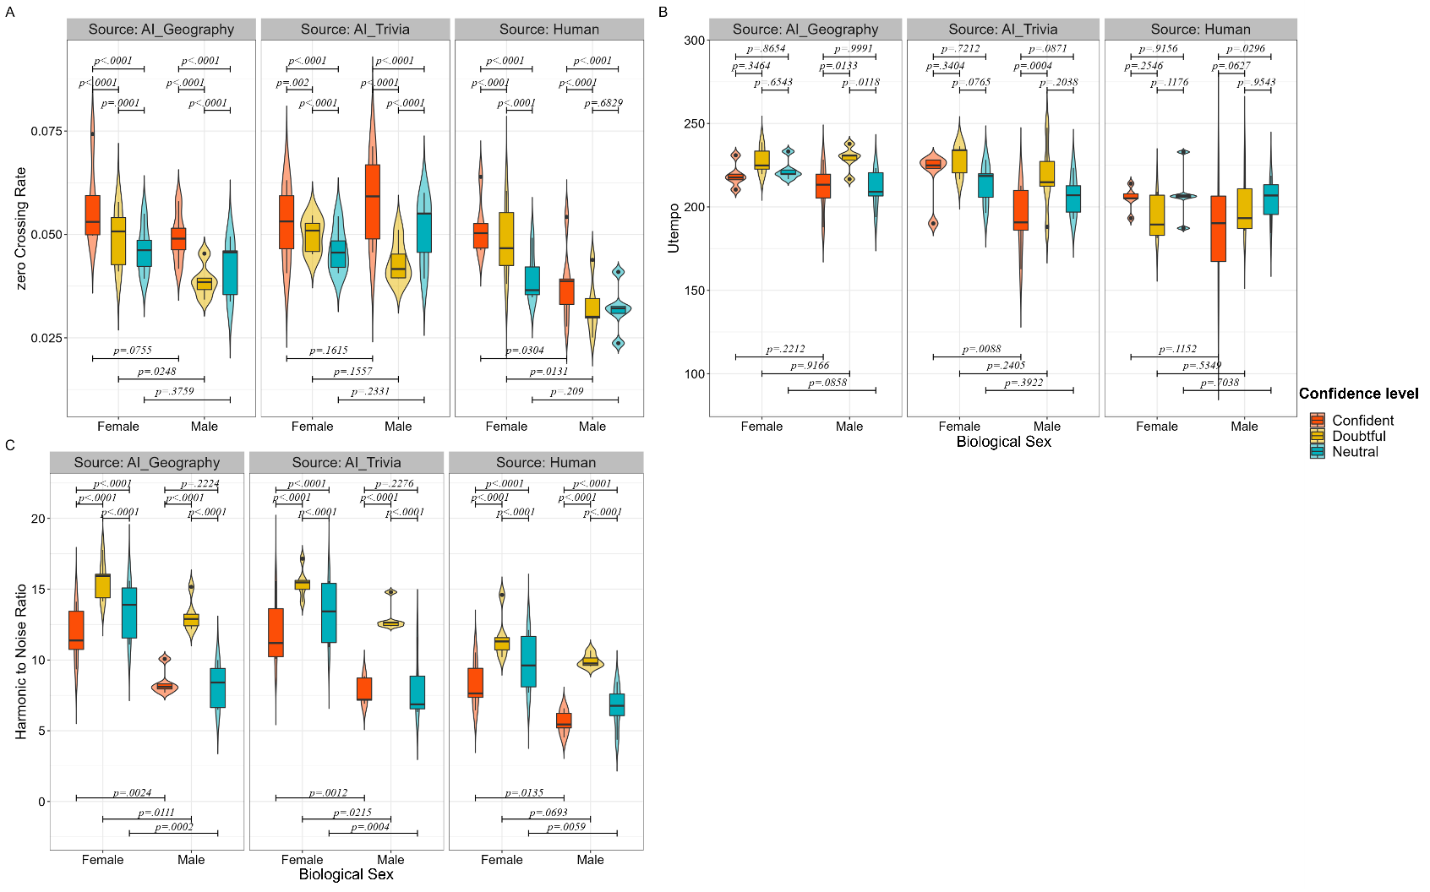

Supplementary Figure 4

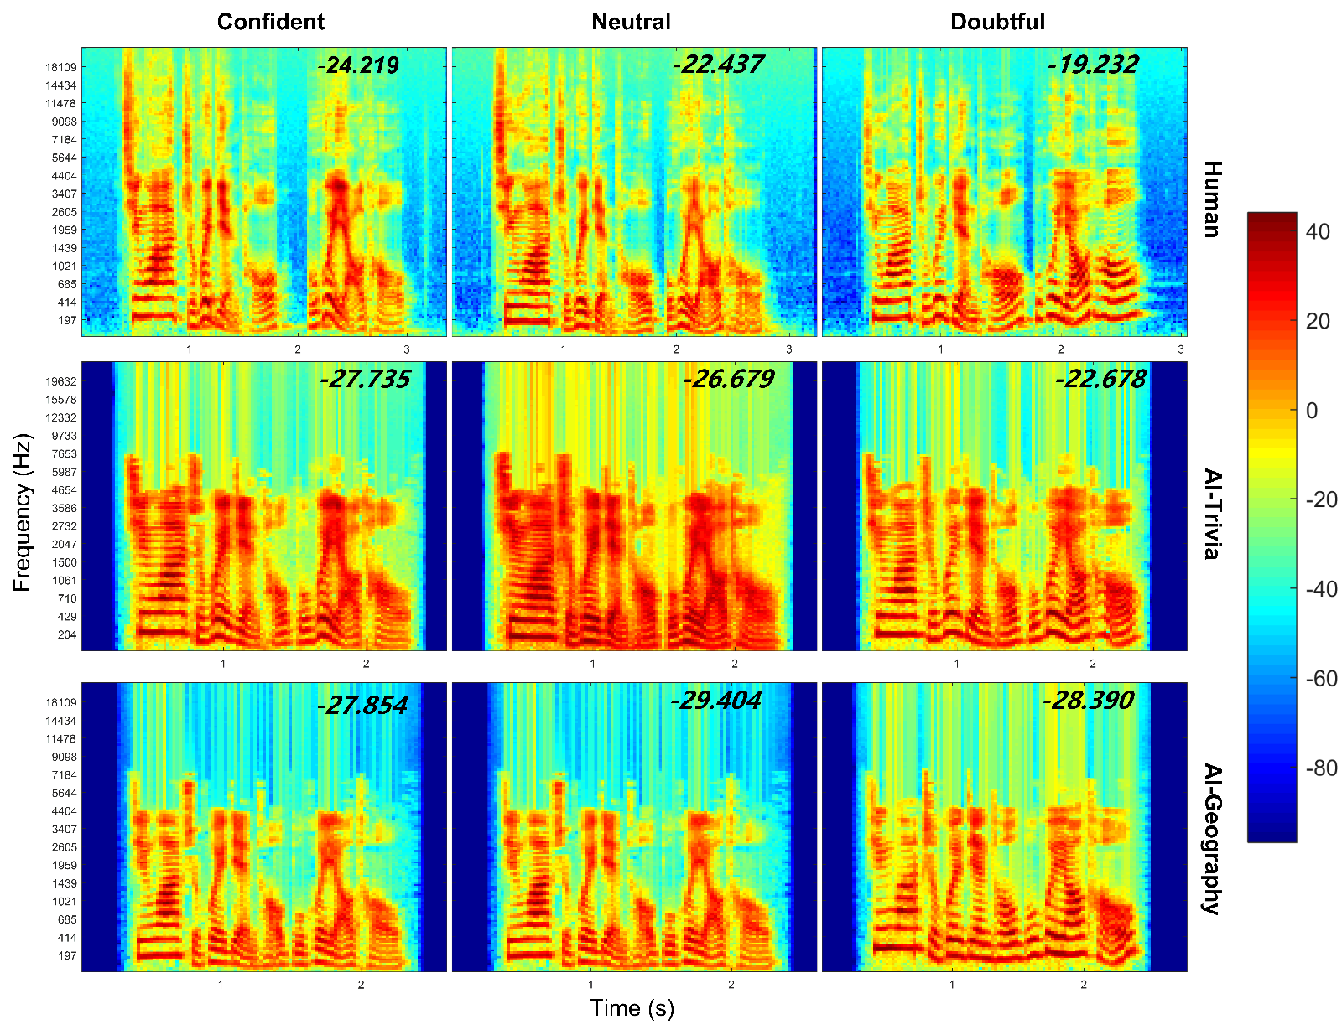

Supplementary Figure 5

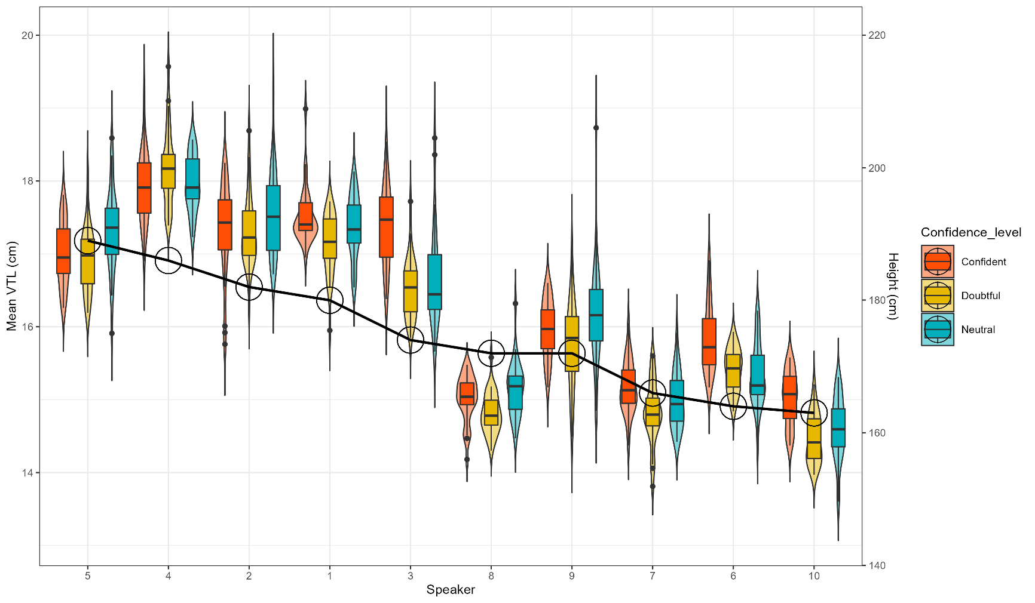

Supplementary Tables

Supplementary Table 1
List of 30 Prescribed Sentences for AI Model Training
Item ª | Sentence in Chinese | Sentence in English
1 | 中国最大的岛屿是台湾岛。 | The largest island in China is the island of Taiwan.
2 | 山东威海是中国最早看到日出的地方。 | Weihai in Shandong is the first place in China to see the sunrise.
3 | 拉萨每年的日照时间比较长，被称为“日光城。 | Lhasa is known as the ‘Sunshine City’ because of the long hours of sunshine each year.
4 | 三沙市是中国陆地面积最小的地级市。 | Sansha is the smallest prefecture-level city in China in terms of land area.
5 | 中国是世界上最早发明瓷器的国家。 | China was the first country in the world to invent porcelain.
6 | 甘肃是古代丝绸之路的必经之地。 | Gansu was a necessary route along the ancient Silk Road.
7 | 新疆是世界上离海最远的地方。 | Xinjiang is the farthest place in the world from the sea.
8 | 中国最大的瀑布是黄果树瀑布。 | The largest waterfall in China is the Huangguoshu Waterfall.
9 | 泰山气势雄伟，为“五岳之首。 | Mount Tai is the most majestic of the five mountains.
10 | 长白山天池是中国最深的湖泊。 | Tianchi in Changbai Mountain is the deepest lake in China.
11 | 黑龙江省的大庆油田是中国最大的油田。 | The Daqing Oilfield in Heilongjiang Province is the largest oilfield in China.
12 | 浙江是中国岛屿最多的省份。 | Zhejiang is the province with the largest number of islands in China.
13 | 漠河是中国冬季最冷的地方。 | Mohe is the coldest place in China in winter.
14 | 世界上开挖最早的人工运河是京杭大运河。 | The earliest man-made canal dug in the world is the Beijing-Hangzhou Grand Canal.
15 | 青海湖是中国面积最大水容量最多的湖泊。 | Qinghai Lake is the largest lake in China in terms of area and water capacity.
16 | 拉斯维加斯的赌场没有钟。 | The casinos in Las Vegas do not have clocks.
17 | 可口可乐最初是绿色的。 | Coca-Cola was originally green.
18 | 冥王星的表面积加起来还没有俄罗斯的国土面积大。 | Pluto’s surface area doesn’t add up to the size of Russia’s territory.
19 | 达芬奇可以一只手写字，同时另一只手作画。 | Leonardo da Vinci could write with one hand while painting with the other.
20 | 世界上第一个鼠标是拿木头制作的。 | The world’s first mouse was made from wood.
21 | 阿拉伯数字最早由印度人发明，后来被阿拉伯人掌握和改进。 | Arabic numerals were first invented by the Indians and later mastered and improved by the Arabs.
22 | 打火机要比火柴出现的时间早约两个世纪。 | The lighter predates the advent of matches by about two centuries.
23 | 青蛙只会点头不会摇头。 | Frogs only nod their heads and do not shake them.
24 | 大熊猫没有固定的睡觉地点，它们走到哪里就睡到哪里。 | Giant pandas do not have a set place to sleep, and they sleep wherever they go.
25 | 飞机黑匣子并不是黑色的，而是橙色的。 | The black box of an aircraft is not black but orange.
26 | 显微镜下的人体组织，就像无数根橡皮筋。 | The human tissue under the microscope is like a million rubber bands.
27 | 当你情不自禁地开始抖腿，可能是身体想起来走走了。 | When you can’t help but start shaking your legs, it could be that your body wants to get up and go.
28 | 汗水本身没有气味，与皮肤上的细菌混合后才会产生体臭。 | Sweat itself has no odour; it is when it mixes with the bacteria on the skin that it produces body odour.
29 | 阿根廷人可以自己选择性别。 | Argentines can choose their own biological sex.
30 | 世界上跑的最快的鸟是鸵鸟。 | The fastest-running bird in the world is the ostrich.
ª Item 1-15 are for AI-Geography, and Item 16-30 are for AI-Trivia.

Supplementary Table 2
Post Hoc Contrast Analysis of Source and Confidence Level Effects on 19 Acoustic Features
Feature | Contrastª | Contrast across sources |  |  | Contrast across confidence levels
 |  | β | t | p | Contrast^{b} | β | t | p
Mean VTL | AIg - AIt | -.01 | -.27 | .962 | C - D | .5 | 18.11 | <.0001
 | AIg - H | .16 | 5.83 | <.0001 | C - N | .17 | 6.28 | <.0001
 | AIt - H | .17 | 6.09 | <.0001 | D - N | -.33 | -11.83 | <.0001
Δ VTL | AIg - AIt | .64 | 10.35 | <.0001 | C - D | -.44 | -7.14 | <.0001
 | AIg - H | 1.07 | 17.38 | <.0001 | C - N | -.34 | -5.46 | <.0001
 | AIt - H | .43 | 7.04 | <.0001 | D - N | .1 | 1.67 | .2159
Mean F0 | AIg - AIt | 4.33 | 5.9 | <.0001 | C - D | -17.16 | -23.42 | <.0001
 | AIg - H | -.06 | -.08 | .9968 | C - N | 25.03 | 34.16 | <.0001
 | AIt - H | -4.38 | -5.98 | <.0001 | D - N | 42.19 | 57.58 | <.0001
Δ F0 | AIg - AIt | 5.19 | 3.51 | .0013 | C - D | 12.79 | 8.64 | <.0001
 | AIg - H | -15.55 | -10.51 | <.0001 | C - N | 38.82 | 26.23 | <.0001
 | AIt - H | -20.74 | -14.02 | <.0001 | D - N | 26.03 | 17.59 | <.0001
Chroma_cqt | AIg - AIt | .0 | .43 | .9018 | C - D | .08 | 54.93 | <.0001
 | AIg - H | -.05 | -36.33 | <.0001 | C - N | .03 | 18.34 | <.0001
 | AIt - H | -.05 | -36.76 | <.0001 | D - N | -.05 | -36.59 | <.0001
Chroma_cens | AIg - AIt | .0 | 4.85 | <.0001 | C - D | .02 | 42.43 | <.0001
 | AIg - H | -.01 | -27.11 | <.0001 | C - N | .01 | 24.26 | <.0001
 | AIt - H | -.01 | -31.96 | <.0001 | D - N | -.01 | -18.17 | <.0001
Chroma_stft | AIg - AIt | .0 | -2.16 | .079 | C - D | .05 | 47.36 | <.0001
 | AIg - H | -.1 | -87.18 | <.0001 | C - N | .01 | 6.39 | <.0001
 | AIt - H | -.1 | -85.02 | <.0001 | D - N | -.05 | -40.97 | <.0001
MFCC | AIg - AIt | -1.61 | -17.04 | <.0001 | C - D | -1.05 | -11.11 | <.0001
 | AIg - H | -5.67 | -59.83 | <.0001 | C - N | -3.55 | -37.42 | <.0001
 | AIt - H | -4.05 | -42.79 | <.0001 | D - N | -2.49 | -26.31 | <.0001
Spectral Contrast | AIg - AIt | .07 | 1.98 | .1181 | C - D | -.91 | -26.76 | <.0001
 | AIg - H | 2.02 | 59.57 | <.0001 | C - N | .25 | 7.38 | <.0001
 | AIt - H | 1.95 | 57.59 | <.0001 | D - N | 1.16 | 34.14 | <.0001
Spectral Bandwidth | AIg - AIt | -120.35 | -30.07 | <.0001 | C - D | 80.37 | 20.08 | <.0001
 | AIg - H | -1022.69 | -255.51 | <.0001 | C - N | 76.02 | 18.99 | <.0001
 | AIt - H | -902.34 | -225.44 | <.0001 | D - N | -4.35 | -1.09 | .5225
Root Mean Square | AIg - AIt | .0 | -.94 | .6164 | C - D | -.02 | -37.95 | <.0001
 | AIg - H | .01 | 25.94 | <.0001 | C - N | -.01 | -17.93 | <.0001
 | AIt - H | .01 | 26.87 | <.0001 | D - N | .01 | 20.03 | <.0001
Amplitude | AIg - AIt | 1.9 | 5.28 | <.0001 | C - D | 1.38 | 3.83 | .0004
 | AIg - H | -34.86 | -96.86 | <.0001 | C - N | -.28 | -.79 | .7101
 | AIt - H | -36.76 | -102.14 | <.0001 | D - N | -1.66 | -4.62 | <.0001
Tonnetz | AIg - AIt | .0 | -3.53 | .0012 | C - D | .0 | -2.71 | .0188
 | AIg - H | .0 | 3.05 | .0064 | C - N | .0 | -2.81 | .0139
 | AIt - H | .0 | 6.58 | <.0001 | D - N | .0 | -.1 | .9943
Spectral Flatness | AIg - AIt | -.01 | -5.7 | <.0001 | C - D | -.01 | -12.14 | <.0001
 | AIg - H | .11 | 107.05 | <.0001 | C - N | .0 | -4.05 | .0002
 | AIt - H | .11 | 112.75 | <.0001 | D - N | .01 | 8.09 | <.0001
Spectral Centroid | AIg - AIt | -113.25 | -20.97 | <.0001 | C - D | 142.29 | 26.34 | <.0001
 | AIg - H | -804.56 | -148.95 | <.0001 | C - N | 149.13 | 27.61 | <.0001
 | AIt - H | -691.31 | -127.98 | <.0001 | D - N | 6.85 | 1.27 | .4138
Spectral Rolloff | AIg - AIt | -322.13 | -29.77 | <.0001 | C - D | 295.66 | 27.32 | <.0001
 | AIg - H | -1795.59 | -165.94 | <.0001 | C - N | 301.07 | 27.82 | <.0001
 | AIt - H | -1473.46 | -136.17 | <.0001 | D - N | 5.41 | .5 | .8715
ZCR | AIg - AIt | .0 | -8.25 | <.0001 | C - D | .01 | 20.38 | <.0001
 | AIg - H | .01 | 17.75 | <.0001 | C - N | .01 | 22.76 | <.0001
 | AIt - H | .01 | 26.0 | <.0001 | D - N | .0 | 2.38 | .0462
Utempo | AIg - AIt | 6.94 | 2.4 | .0437 | C - D | -11.1 | -3.84 | .0004
 | AIg - H | 20.22 | 6.99 | <.0001 | C - N | -5.45 | -1.88 | .1439
 | AIt - H | 13.28 | 4.59 | <.0001 | D - N | 5.65 | 1.95 | .1244
HNR | AIg - AIt | .16 | 2.33 | .0518 | C - D | -4.15 | -58.93 | <.0001
 | AIg - H | 3.12 | 44.29 | <.0001 | C - N | -.91 | -12.9 | <.0001
 | AIt - H | 2.95 | 41.96 | <.0001 | D - N | 3.24 | 46.03 | <.0001
ª AIg for AI-Geography; AIt for AI-Trivia; H for Human.
^{b} C for Confident; D for Doubtful; N for Neutral.

Supplementary Table 3
Post Hoc Contrast Results of Confidence Level on 19 Acoustic Features Grouped by Source
Featureª | Contrast^{b} | AI-Geography |  |  | AI-Trivia |  |  | Human
 |  | β | t | p | β | t | p | β | t | p
Mean VTL | C - D | .69 | 13.96 | <.0001 | .52 | 12.45 | <.0001 | .28 | 6.76 | <.0001
 | C - N | .36 | 7.22 | <.0001 | .06 | 1.38 | .3508 | .1 | 2.44 | .0397
 | D - N | -.33 | -6.74 | <.0001 | -.46 | -11.06 | <.0001 | -.18 | -4.32 | <.0001
Δ VTL | C - D | .15 | 1.32 | .384 | -.6 | -6.43 | <.0001 | -.87 | -8.94 | <.0001
 | C - N | .15 | 1.3 | .3969 | -.56 | -6.01 | <.0001 | -.59 | -6.13 | <.0001
 | D - N | .0 | -.02 | .9997 | .04 | .42 | .9073 | .27 | 2.81 | .0142
Mean F0 | C - D | -16.71 | -17.26 | <.0001 | -23.0 | -18.79 | <.0001 | -11.77 | -8.96 | <.0001
 | C - N | 25.02 | 25.83 | <.0001 | 18.35 | 14.99 | <.0001 | 31.72 | 24.14 | <.0001
 | D - N | 41.73 | 43.09 | <.0001 | 41.35 | 33.78 | <.0001 | 43.49 | 33.1 | <.0001
Δ F0 | C - D | 20.67 | 9.98 | <.0001 | 11.36 | 5.58 | <.0001 | 6.34 | 2.04 | .1026
 | C - N | 40.1 | 19.35 | <.0001 | 27.52 | 13.53 | <.0001 | 48.84 | 15.74 | <.0001
 | D - N | 19.43 | 9.38 | <.0001 | 16.16 | 7.94 | <.0001 | 42.5 | 13.7 | <.0001
Chroma_cqt | C - D | .08 | 38.34 | <.0001 | .08 | 36.15 | <.0001 | .08 | 31.16 | <.0001
 | C - N | .02 | 9.35 | <.0001 | .02 | 9.79 | <.0001 | .04 | 15.14 | <.0001
 | D - N | -.06 | -28.98 | <.0001 | -.06 | -26.36 | <.0001 | -.04 | -16.02 | <.0001
Chroma_cens | C - D | .02 | 30.63 | <.0001 | .02 | 25.76 | <.0001 | .02 | 23.45 | <.0001
 | C - N | .01 | 17.07 | <.0001 | .01 | 11.35 | <.0001 | .01 | 17.55 | <.0001
 | D - N | -.01 | -13.56 | <.0001 | -.01 | -14.41 | <.0001 | .0 | -5.9 | <.0001
Chroma_stft | C - D | .06 | 35.68 | <.0001 | .07 | 38.97 | <.0001 | .04 | 21.46 | <.0001
 | C - N | .0 | 2.5 | .0333 | .01 | 7.19 | <.0001 | .01 | 3.08 | .0061
 | D - N | -.05 | -33.17 | <.0001 | -.05 | -31.78 | <.0001 | -.04 | -18.38 | <.0001
MFCC | C - D | -.33 | -2.79 | .0148 | .19 | 1.47 | .3037 | -3.01 | -15.87 | <.0001
 | C - N | -2.77 | -23.1 | <.0001 | -1.96 | -15.57 | <.0001 | -5.91 | -31.15 | <.0001
 | D - N | -2.43 | -20.31 | <.0001 | -2.15 | -17.04 | <.0001 | -2.9 | -15.28 | <.0001
Spectral Contrast | C - D | -.99 | -20.9 | <.0001 | -1.02 | -17.79 | <.0001 | -.71 | -14.9 | <.0001
 | C - N | .22 | 4.77 | <.0001 | .33 | 5.66 | <.0001 | .2 | 4.19 | <.0001
 | D - N | 1.21 | 25.66 | <.0001 | 1.35 | 23.44 | <.0001 | .91 | 19.1 | <.0001
Spectral Bandwidth | C - D | 125.55 | 29.6 | <.0001 | 113.77 | 22.22 | <.0001 | 1.78 | .32 | .9436
 | C - N | 97.55 | 23.0 | <.0001 | 109.54 | 21.39 | <.0001 | 20.96 | 3.81 | .0004
 | D - N | -28.0 | -6.6 | <.0001 | -4.22 | -.82 | .6876 | 19.18 | 3.49 | .0015
Root Mean Square | C - D | -.02 | -24.91 | <.0001 | -.01 | -21.5 | <.0001 | -.02 | -24.31 | <.0001
 | C - N | -.01 | -9.05 | <.0001 | -.01 | -9.58 | <.0001 | -.01 | -14.54 | <.0001
 | D - N | .01 | 15.86 | <.0001 | .01 | 11.92 | <.0001 | .01 | 9.78 | <.0001
Amplitude | C - D | 4.04 | 8.6 | <.0001 | 4.55 | 7.14 | <.0001 | -4.46 | -23.66 | <.0001
 | C - N | .54 | 1.15 | .4865 | 2.58 | 4.06 | .0002 | -3.97 | -21.1 | <.0001
 | D - N | -3.51 | -7.46 | <.0001 | -1.96 | -3.08 | .006 | .48 | 2.56 | .0283
Tonnetz | C - D | .0 | -.76 | .725 | .0 | -3.2 | .0041 | .0 | -.65 | .7919
 | C - N | .0 | -3.29 | .003 | .0 | -.9 | .6397 | .0 | -.62 | .8101
 | D - N | .0 | -2.52 | .0316 | .0 | 2.3 | .0564 | .0 | .03 | .9994
Spectral Flatness | C - D | -.02 | -14.26 | <.0001 | -.02 | -11.57 | <.0001 | .0 | 5.98 | <.0001
 | C - N | .0 | -3.06 | .0064 | -.01 | -5.92 | <.0001 | .0 | 9.13 | <.0001
 | D - N | .01 | 11.2 | <.0001 | .01 | 5.65 | <.0001 | .0 | 3.16 | .0047
Spectral Centroid | C - D | 168.57 | 23.96 | <.0001 | 153.96 | 19.68 | <.0001 | 104.33 | 12.22 | <.0001
 | C - N | 151.92 | 21.59 | <.0001 | 141.32 | 18.07 | <.0001 | 154.16 | 18.05 | <.0001
 | D - N | -16.65 | -2.37 | .0477 | -12.64 | -1.62 | .2391 | 49.83 | 5.84 | <.0001
Spectral Rolloff | C - D | 367.65 | 26.64 | <.0001 | 341.07 | 20.72 | <.0001 | 178.27 | 9.61 | <.0001
 | C - N | 310.86 | 22.52 | <.0001 | 317.33 | 19.28 | <.0001 | 275.02 | 14.82 | <.0001
 | D - N | -56.79 | -4.11 | .0001 | -23.73 | -1.44 | .3199 | 96.75 | 5.21 | <.0001
ZCR | C - D | .01 | 17.74 | <.0001 | .01 | 15.79 | <.0001 | .0 | 9.17 | <.0001
 | C - N | .01 | 17.52 | <.0001 | .01 | 12.17 | <.0001 | .01 | 18.63 | <.0001
 | D - N | .0 | -.22 | .9732 | .0 | -3.61 | .0009 | .0 | 9.46 | <.0001
Utempo | C - D | -13.45 | -2.98 | .0083 | -17.48 | -3.69 | .0007 | -2.37 | -.48 | .8817
 | C - N | -1.5 | -.33 | .9407 | -4.5 | -.95 | .6078 | -10.34 | -2.08 | .0937
 | D - N | 11.94 | 2.65 | .0224 | 12.97 | 2.74 | .0171 | -7.97 | -1.61 | .2435
HNR | C - D | -4.3 | -41.6 | <.0001 | -4.27 | -36.15 | <.0001 | -3.87 | -36.68 | <.0001
 | C - N | -.7 | -6.77 | <.0001 | -.72 | -6.1 | <.0001 | -1.3 | -12.35 | <.0001
 | D - N | 3.6 | 34.83 | <.0001 | 3.55 | 30.05 | <.0001 | 2.57 | 24.33 | <.0001
ª All statements are mean values unless otherwise indicated.
^{b} C for Confident; D for Doubtful; N for Neutral.

Supplementary Table 4
Post Hoc Contrast Results of Biological Sex on 19 Acoustic Features per Source
Feature | Contrastª | AI-Geography |  |  | AI-Trivia |  |  | Human
 |  | β | t | p | β | t | p | β | t | p
Mean VTL | F - M | -2.1 | -4.08 | <.0001 | -2.23 | -5.55 | <.0001 | -2.17 | -7.69 | <.0001
Δ VTL | F - M | .42 | .58 | .58 | .23 | .31 | .77 | .24 | .62 | .55
Mean F0 | F - M | 97.43 | 6.2 | <.0001 | 103.56 | 6.85 | <.0001 | 10.3 | 5.98 | <.0001
Δ F0 | F - M | 43.28 | 2.77 | .03 | 48.91 | 3.07 | .02 | 54.88 | 2.79 | .03
Chroma_cqt | F - M | -.05 | -5.32 | <.0001 | -.06 | -4.15 | <.0001 | -.04 | -3.7 | .01
Chroma_cens | F - M | -.01 | -2.05 | .08 | -.01 | -1.58 | .16 | .0 | -1.3 | .24
Chroma_stft | F - M | -.07 | -5.48 | <.0001 | -.08 | -6.99 | <.0001 | -.07 | -5.23 | <.0001
MFCC | F - M | -6.53 | -4.15 | <.0001 | -6.47 | -4.01 | .01 | -7.03 | -3.15 | .02
Spectral Contrast | F - M | 1.38 | 4.37 | <.0001 | 1.8 | 6.59 | <.0001 | 1.39 | 3.3 | .01
Spectral Bandwidth | F - M | 27.96 | .69 | .51 | 73.48 | 1.67 | .14 | 35.09 | .57 | .59
Root Mean Square | F - M | .01 | 4.07 | <.0001 | .01 | 3.19 | .02 | .0 | 1.58 | .16
Amplitude | F - M | 1.08 | 1.09 | .31 | .48 | .44 | .67 | 1.3 | 1.25 | .25
Tonnetz | F - M | .0 | .27 | .79 | .0 | 1.37 | .21 | .0 | .24 | .82
Spectral Flatness | F - M | .0 | .71 | .5 | .0 | .99 | .35 | .0 | 2.64 | .03
Spectral Centroid | F - M | 121.22 | 1.79 | .12 | 122.11 | 1.69 | .14 | 247.27 | 3.16 | .02
Spectral Rolloff | F - M | 140.83 | 1.07 | .32 | 180.25 | 1.23 | .26 | 264.93 | 2.09 | .07
ZCR | F - M | .01 | 1.97 | .09 | .0 | -.43 | .68 | .01 | 2.46 | .04
Utempo | F - M | 6.57 | 1.51 | .18 | 15.59 | 2.1 | .07 | 5.56 | .56 | .6
HNR | F - M | 3.86 | 4.99 | <.0001 | 4.07 | 4.77 | <.0001 | 2.62 | 3.1 | .02
ª F for Female; M for Male.

Supplementary Table 5
Detailed Post Hoc Contrast Results of Biological Sex and Confidence Level on 19 Acoustic Features per Source
Feature | Contrast on BSª | Contrast on CL^{b} | AI-Geography |  |  | AI-Trivia |  |  | Human
 |  |  | β | t | p | β | t | p | β | t | p
Mean VTL | F - M | C | -2.07 | -4.0 | .005 | -2.03 | -5.02 | .0014 | -2.1 | -7.32 | .0001
 | F - M | D | -1.84 | -3.55 | .0089 | -2.34 | -5.78 | .0006 | -2.22 | -7.76 | <.0001
 | F - M | N | -2.38 | -4.61 | .0023 | -2.31 | -5.72 | .0007 | -2.19 | -7.66 | <.0001
Δ VTL | F - M | C | .69 | .95 | .3703 | .64 | .85 | .4224 | .4 | .98 | .3575
 | F - M | D | .2 | .27 | .7938 | -.13 | -.17 | .8716 | .04 | .09 | .9309
 | F - M | N | .36 | .49 | .6348 | .17 | .23 | .826 | .3 | .73 | .4845
Mean F0 | F - M | C | 87.82 | 5.57 | .0008 | 93.15 | 6.14 | .0004 | 85.74 | 5.09 | .0014
 | F - M | D | 103.54 | 6.57 | .0003 | 114.58 | 7.55 | .0001 | 116.77 | 6.93 | .0002
 | F - M | N | 10.92 | 6.4 | .0004 | 102.96 | 6.78 | .0002 | 98.4 | 5.84 | .0006
Δ F0 | F - M | C | 41.38 | 2.61 | .0333 | 37.43 | 2.33 | .0514 | 33.16 | 1.66 | .1389
 | F - M | D | 45.55 | 2.88 | .0226 | 56.05 | 3.48 | .0095 | 76.05 | 3.8 | .006
 | F - M | N | 42.91 | 2.71 | .0289 | 53.24 | 3.31 | .0122 | 55.43 | 2.77 | .026
Chroma_cqt | F - M | C | -.06 | -5.4 | .0007 | -.08 | -5.6 | .0006 | -.06 | -4.92 | .0012
 | F - M | D | -.02 | -2.28 | .053 | -.02 | -1.64 | .1428 | -.02 | -1.42 | .1927
 | F - M | N | -.08 | -7.9 | <.0001 | -.07 | -5.0 | .0013 | -.05 | -4.39 | .0023
Chroma_cens | F - M | C | -.01 | -2.37 | .0474 | -.02 | -2.97 | .0195 | -.01 | -2.13 | .0665
 | F - M | D | .0 | -.09 | .927 | .0 | .44 | .6754 | .0 | .76 | .467
 | F - M | N | -.01 | -3.59 | .0079 | -.01 | -2.13 | .0682 | -.01 | -2.41 | .0429
Chroma_stft | F - M | C | -.07 | -5.81 | .0006 | -.09 | -8.24 | <.0001 | -.08 | -5.8 | .0005
 | F - M | D | -.04 | -3.46 | .0099 | -.05 | -4.31 | .0031 | -.05 | -3.91 | .0052
 | F - M | N | -.09 | -7.0 | .0002 | -.09 | -8.12 | <.0001 | -.08 | -5.77 | .0006
MFCC | F - M | C | -5.68 | -3.6 | .0085 | -5.63 | -3.47 | .0101 | -5.95 | -2.65 | .0321
 | F - M | D | -6.93 | -4.38 | .0031 | -7.16 | -4.42 | .003 | -7.47 | -3.33 | .0122
 | F - M | N | -6.98 | -4.42 | .003 | -6.61 | -4.08 | .0045 | -7.67 | -3.42 | .0108
Spectral Contrast | F - M | C | 1.26 | 3.91 | .0052 | 1.63 | 5.8 | .0004 | 1.46 | 3.43 | .0104
 | F - M | D | .68 | 2.12 | .0696 | 1.15 | 4.1 | .0036 | .9 | 2.12 | .0705
 | F - M | N | 2.21 | 6.88 | .0002 | 2.61 | 9.3 | <.0001 | 1.81 | 4.27 | .0034
Spectral Bandwidth | F - M | C | 20.03 | .49 | .6392 | 28.95 | .65 | .5333 | -13.97 | -.23 | .8278
 | F - M | D | 46.19 | 1.13 | .2953 | 107.49 | 2.43 | .0444 | 59.51 | .96 | .3677
 | F - M | N | 17.65 | .43 | .6789 | 84.01 | 1.9 | .0981 | 59.72 | .96 | .3661
Root Mean Square | F - M | C | .01 | 3.68 | .0066 | .01 | 3.67 | .0069 | .01 | 1.71 | .1251
 | F - M | D | .01 | 3.09 | .0155 | .01 | 1.84 | .1052 | .0 | .37 | .7185
 | F - M | N | .02 | 5.13 | .001 | .02 | 3.86 | .0054 | .01 | 2.47 | .0381
Amplitude | F - M | C | -.3 | -.27 | .7941 | .34 | .26 | .8008 | 2.11 | 1.98 | .0849
 | F - M | D | 2.67 | 2.36 | .0362 | .79 | .61 | .5536 | .58 | .55 | .6006
 | F - M | N | .86 | .76 | .463 | .3 | .23 | .8235 | 1.22 | 1.15 | .2858
Tonnetz | F - M | C | .0 | -.48 | .6455 | .01 | 2.21 | .0524 | .0 | .02 | .9833
 | F - M | D | .0 | .51 | .625 | .0 | .25 | .8089 | .0 | .76 | .465
 | F - M | N | .0 | .74 | .4794 | .0 | 1.33 | .2128 | .0 | -.11 | .9118
Spectral Flatness | F - M | C | .01 | 2.38 | .0326 | .01 | 1.55 | .1441 | .0 | 1.54 | .1635
 | F - M | D | -.01 | -2.2 | .0453 | .0 | -.21 | .8344 | .0 | 3.59 | .0077
 | F - M | N | .0 | 1.63 | .1258 | .0 | 1.17 | .2619 | .0 | 2.62 | .0321
Spectral Centroid | F - M | C | 125.82 | 1.85 | .1063 | 68.85 | .94 | .3761 | 207.65 | 2.64 | .0327
 | F - M | D | 152.67 | 2.24 | .0591 | 185.05 | 2.54 | .038 | 293.71 | 3.73 | .007
 | F - M | N | 85.18 | 1.25 | .2506 | 112.44 | 1.54 | .1661 | 240.45 | 3.05 | .0178
Spectral Rolloff | F - M | C | 129.85 | .98 | .3609 | 69.3 | .47 | .6529 | 143.48 | 1.12 | .299
 | F - M | D | 219.8 | 1.65 | .1414 | 286.76 | 1.94 | .0922 | 367.99 | 2.86 | .0228
 | F - M | N | 72.83 | .55 | .6008 | 184.68 | 1.25 | .2504 | 283.33 | 2.21 | .0612
ZCR | F - M | C | .01 | 2.06 | .0755 | -.01 | -1.56 | .1615 | .01 | 2.68 | .0304
 | F - M | D | .01 | 2.8 | .0248 | .01 | 1.58 | .1557 | .01 | 3.27 | .0131
 | F - M | N | .0 | .94 | .3759 | -.01 | -1.3 | .2331 | .01 | 1.38 | .209
Utempo | F - M | C | 8.45 | 1.24 | .2212 | 27.42 | 2.97 | .0088 | 19.55 | 1.7 | .1152
 | F - M | D | -.72 | -.11 | .9166 | 11.23 | 1.22 | .2405 | -7.36 | -.64 | .5349
 | F - M | N | 11.98 | 1.76 | .0858 | 8.1 | .88 | .3922 | 4.49 | .39 | .7038
HNR | F - M | C | 3.53 | 4.51 | .0024 | 4.4 | 5.09 | .0012 | 2.76 | 3.24 | .0135
 | F - M | D | 2.64 | 3.37 | .0111 | 2.51 | 2.91 | .0215 | 1.81 | 2.13 | .0693
 | F - M | N | 5.42 | 6.92 | .0002 | 5.29 | 6.13 | .0004 | 3.27 | 3.84 | .0059
ª F for Female; M for Male. BS for Biological Sex.
^{b} C for Confident; D for Doubtful; N for Neutral. CL for Confidence Levels.

Supplementary Table 6
Detailed Post Hoc Contrast Results of Confidence Level and Biological Sex on 19 Acoustic Features per Source
Feature | Contrast on CL^{b} | Contrast on BSª | AI-Geography |  |  | AI-Trivia |  |  | Human
 |  |  | β | t | p | β | t | p | β | t | p
Mean VTL | C - D | F | .58 | 8.24 | <.0001 | .67 | 11.39 | <.0001 | .35 | 5.84 | <.0001
 | C - N | F | .52 | 7.38 | <.0001 | .2 | 3.37 | .0022 | .15 | 2.54 | .0302
 | D - N | F | -.06 | -.86 | .6634 | -.47 | -8.02 | <.0001 | -.2 | -3.3 | .0029
 | C - D | M | .81 | 11.5 | <.0001 | .36 | 6.21 | <.0001 | .22 | 3.72 | .0006
 | C - N | M | .2 | 2.84 | .0129 | -.08 | -1.42 | .3308 | .05 | .91 | .6358
 | D - N | M | -.61 | -8.66 | <.0001 | -.45 | -7.63 | <.0001 | -.17 | -2.81 | .0139
Δ VTL | C - D | F | .4 | 2.47 | .0361 | -.22 | -1.65 | .2263 | -.68 | -5.0 | <.0001
 | C - N | F | .31 | 1.95 | .1249 | -.33 | -2.48 | .0359 | -.54 | -3.98 | .0002
 | D - N | F | -.08 | -.52 | .8605 | -.11 | -.83 | .6855 | .14 | 1.03 | .5603
 | C - D | M | -.1 | -.61 | .8165 | -.98 | -7.44 | <.0001 | -1.05 | -7.64 | <.0001
 | C - N | M | -.02 | -.12 | .9925 | -.79 | -6.02 | <.0001 | -.64 | -4.7 | <.0001
 | D - N | M | .08 | .49 | .8763 | .19 | 1.42 | .3296 | .4 | 2.94 | .0094
Mean F0 | C - D | F | -24.57 | -17.94 | <.0001 | -33.71 | -19.48 | <.0001 | -27.29 | -14.69 | <.0001
 | C - N | F | 18.47 | 13.48 | <.0001 | 13.45 | 7.77 | <.0001 | 25.39 | 13.66 | <.0001
 | D - N | F | 43.04 | 31.42 | <.0001 | 47.16 | 27.24 | <.0001 | 52.68 | 28.35 | <.0001
 | C - D | M | -8.86 | -6.47 | <.0001 | -12.29 | -7.1 | <.0001 | 3.74 | 2.01 | .1093
 | C - N | M | 31.57 | 23.05 | <.0001 | 23.25 | 13.43 | <.0001 | 38.05 | 20.48 | <.0001
 | D - N | M | 40.42 | 29.51 | <.0001 | 35.54 | 20.53 | <.0001 | 34.31 | 18.46 | <.0001
Δ F0 | C - D | F | 18.59 | 6.34 | <.0001 | 2.05 | .71 | .7567 | -15.1 | -3.44 | .0018
 | C - N | F | 39.34 | 13.42 | <.0001 | 19.62 | 6.82 | <.0001 | 37.7 | 8.59 | <.0001
 | D - N | F | 20.75 | 7.08 | <.0001 | 17.57 | 6.11 | <.0001 | 52.81 | 12.03 | <.0001
 | C - D | M | 22.76 | 7.76 | <.0001 | 20.67 | 7.19 | <.0001 | 27.79 | 6.33 | <.0001
 | C - N | M | 40.87 | 13.95 | <.0001 | 35.43 | 12.31 | <.0001 | 59.98 | 13.67 | <.0001
 | D - N | M | 18.11 | 6.18 | <.0001 | 14.75 | 5.13 | <.0001 | 32.19 | 7.34 | <.0001
Chroma_cqt | C - D | F | .06 | 21.36 | <.0001 | .05 | 16.86 | <.0001 | .06 | 16.38 | <.0001
 | C - N | F | .03 | 11.22 | <.0001 | .02 | 5.61 | <.0001 | .04 | 9.85 | <.0001
 | D - N | F | -.03 | -10.14 | <.0001 | -.04 | -11.24 | <.0001 | -.02 | -6.52 | <.0001
 | C - D | M | .09 | 32.85 | <.0001 | .11 | 34.26 | <.0001 | .1 | 27.68 | <.0001
 | C - N | M | .01 | 2.0 | .1117 | .03 | 8.23 | <.0001 | .04 | 11.55 | <.0001
 | D - N | M | -.09 | -30.85 | <.0001 | -.08 | -26.03 | <.0001 | -.06 | -16.13 | <.0001
Chroma_cens | C - D | F | .02 | 16.8 | <.0001 | .01 | 10.44 | <.0001 | .01 | 11.8 | <.0001
 | C - N | F | .01 | 14.68 | <.0001 | .01 | 6.11 | <.0001 | .01 | 12.88 | <.0001
 | D - N | F | .0 | -2.12 | .0861 | .0 | -4.32 | <.0001 | .0 | 1.07 | .532
 | C - D | M | .03 | 26.51 | <.0001 | .03 | 25.99 | <.0001 | .02 | 21.36 | <.0001
 | C - N | M | .01 | 9.46 | <.0001 | .01 | 9.93 | <.0001 | .01 | 11.94 | <.0001
 | D - N | M | -.02 | -17.05 | <.0001 | -.02 | -16.06 | <.0001 | -.01 | -9.42 | <.0001
Chroma_stft | C - D | F | .04 | 18.57 | <.0001 | .04 | 18.06 | <.0001 | .03 | 10.54 | <.0001
 | C - N | F | .01 | 5.12 | <.0001 | .01 | 4.78 | <.0001 | .01 | 2.1 | .091
 | D - N | F | -.03 | -13.44 | <.0001 | -.03 | -13.28 | <.0001 | -.02 | -8.44 | <.0001
 | C - D | M | .07 | 31.89 | <.0001 | .09 | 37.05 | <.0001 | .05 | 19.81 | <.0001
 | C - N | M | .0 | -1.58 | .2536 | .01 | 5.39 | <.0001 | .01 | 2.25 | .0632
 | D - N | M | -.07 | -33.47 | <.0001 | -.07 | -31.66 | <.0001 | -.05 | -17.55 | <.0001
MFCC | C - D | F | .29 | 1.7 | .206 | .95 | 5.34 | <.0001 | -2.25 | -8.39 | <.0001
 | C - N | F | -2.12 | -12.5 | <.0001 | -1.47 | -8.24 | <.0001 | -5.05 | -18.82 | <.0001
 | D - N | F | -2.4 | -14.2 | <.0001 | -2.42 | -13.59 | <.0001 | -2.8 | -10.43 | <.0001
 | C - D | M | -.96 | -5.65 | <.0001 | -.58 | -3.26 | .0033 | -3.77 | -14.05 | <.0001
 | C - N | M | -3.41 | -20.17 | <.0001 | -2.46 | -13.77 | <.0001 | -6.77 | -25.24 | <.0001
 | D - N | M | -2.46 | -14.52 | <.0001 | -1.88 | -10.52 | <.0001 | -3.0 | -11.19 | <.0001
Spectral Contrast | C - D | F | -.7 | -10.47 | <.0001 | -.78 | -9.63 | <.0001 | -.43 | -6.41 | <.0001
 | C - N | F | -.25 | -3.78 | .0005 | -.17 | -2.05 | .1019 | .02 | .35 | .9363
 | D - N | F | .45 | 6.69 | <.0001 | .62 | 7.58 | <.0001 | .46 | 6.75 | <.0001
 | C - D | M | -1.27 | -19.08 | <.0001 | -1.26 | -15.52 | <.0001 | -.99 | -14.67 | <.0001
 | C - N | M | .7 | 10.52 | <.0001 | .82 | 10.05 | <.0001 | .38 | 5.59 | <.0001
 | D - N | M | 1.98 | 29.61 | <.0001 | 2.08 | 25.57 | <.0001 | 1.37 | 20.26 | <.0001
Spectral Bandwidth | C - D | F | 112.47 | 18.75 | <.0001 | 74.5 | 10.29 | <.0001 | -34.96 | -4.5 | <.0001
 | C - N | F | 98.74 | 16.46 | <.0001 | 82.01 | 11.32 | <.0001 | -15.88 | -2.04 | .1025
 | D - N | F | -13.73 | -2.29 | .0578 | 7.51 | 1.04 | .5534 | 19.07 | 2.45 | .038
 | C - D | M | 138.63 | 23.11 | <.0001 | 153.03 | 21.13 | <.0001 | 38.52 | 4.96 | <.0001
 | C - N | M | 96.36 | 16.06 | <.0001 | 137.07 | 18.93 | <.0001 | 57.81 | 7.44 | <.0001
 | D - N | M | -42.27 | -7.05 | <.0001 | -15.96 | -2.2 | .071 | 19.29 | 2.48 | .0354
Root Mean Square | C - D | F | -.02 | -16.51 | <.0001 | -.01 | -11.31 | <.0001 | -.02 | -15.24 | <.0001
 | C - N | F | -.01 | -9.11 | <.0001 | -.01 | -7.17 | <.0001 | -.01 | -11.39 | <.0001
 | D - N | F | .01 | 7.4 | <.0001 | .0 | 4.14 | .0001 | .0 | 3.84 | .0004
 | C - D | M | -.02 | -18.73 | <.0001 | -.02 | -19.1 | <.0001 | -.02 | -19.15 | <.0001
 | C - N | M | .0 | -3.69 | .0007 | -.01 | -6.38 | <.0001 | -.01 | -9.16 | <.0001
 | D - N | M | .02 | 15.03 | <.0001 | .01 | 12.72 | <.0001 | .01 | 9.98 | <.0001
Amplitude | C - D | F | 2.56 | 3.85 | .0004 | 4.32 | 4.8 | <.0001 | -3.69 | -13.87 | <.0001
 | C - N | F | -.04 | -.06 | .9979 | 2.6 | 2.89 | .0109 | -3.53 | -13.26 | <.0001
 | D - N | F | -2.6 | -3.91 | .0003 | -1.71 | -1.9 | .138 | .16 | .61 | .814
 | C - D | M | 5.53 | 8.32 | <.0001 | 4.77 | 5.3 | <.0001 | -5.22 | -19.59 | <.0001
 | C - N | M | 1.12 | 1.68 | .2131 | 2.56 | 2.85 | .0125 | -4.42 | -16.58 | <.0001
 | D - N | M | -4.41 | -6.64 | <.0001 | -2.21 | -2.46 | .0379 | .8 | 3.01 | .0075
Tonnetz | C - D | F | .0 | -1.63 | .2327 | .0 | -.17 | .9845 | .0 | -1.31 | .3885
 | C - N | F | .0 | -3.67 | .0007 | .0 | .3 | .9517 | .0 | -.28 | .9573
 | D - N | F | .0 | -2.04 | .1029 | .0 | .47 | .8863 | .0 | 1.03 | .5574
 | C - D | M | .0 | .55 | .8459 | -.01 | -4.36 | <.0001 | .0 | .39 | .9188
 | C - N | M | .0 | -.98 | .5924 | .0 | -1.57 | .2575 | .0 | -.59 | .8239
 | D - N | M | .0 | -1.53 | .2788 | .0 | 2.78 | .0151 | .0 | -.99 | .5865
Spectral Flatness | C - D | F | -.01 | -6.62 | <.0001 | -.02 | -6.86 | <.0001 | .0 | .06 | .9977
 | C - N | F | .0 | -1.6 | .2451 | -.01 | -3.9 | .0003 | .0 | 4.27 | <.0001
 | D - N | F | .01 | 5.02 | <.0001 | .01 | 2.96 | .0088 | .0 | 4.2 | <.0001
 | C - D | M | -.02 | -13.55 | <.0001 | -.02 | -9.5 | <.0001 | .0 | 8.39 | <.0001
 | C - N | M | .0 | -2.73 | .0177 | -.01 | -4.47 | <.0001 | .0 | 8.65 | <.0001
 | D - N | M | .02 | 10.82 | <.0001 | .01 | 5.03 | <.0001 | .0 | .26 | .9632
Spectral Centroid | C - D | F | 155.15 | 15.59 | <.0001 | 95.86 | 8.67 | <.0001 | 61.3 | 5.08 | <.0001
 | C - N | F | 172.24 | 17.31 | <.0001 | 119.52 | 10.81 | <.0001 | 137.77 | 11.41 | <.0001
 | D - N | F | 17.09 | 1.72 | .1991 | 23.66 | 2.14 | .0827 | 76.46 | 6.33 | <.0001
 | C - D | M | 181.99 | 18.29 | <.0001 | 212.07 | 19.17 | <.0001 | 147.36 | 12.2 | <.0001
 | C - N | M | 131.6 | 13.23 | <.0001 | 163.12 | 14.75 | <.0001 | 170.56 | 14.12 | <.0001
 | D - N | M | -50.39 | -5.06 | <.0001 | -48.95 | -4.43 | <.0001 | 23.2 | 1.92 | .1334
Spectral Rolloff | C - D | F | 322.67 | 16.53 | <.0001 | 232.34 | 9.98 | <.0001 | 66.02 | 2.52 | .0324
 | C - N | F | 339.37 | 17.39 | <.0001 | 259.64 | 11.15 | <.0001 | 205.09 | 7.81 | <.0001
 | D - N | F | 16.7 | .86 | .6686 | 27.3 | 1.17 | .4697 | 139.08 | 5.3 | <.0001
 | C - D | M | 412.63 | 21.14 | <.0001 | 449.79 | 19.32 | <.0001 | 290.52 | 11.07 | <.0001
 | C - N | M | 282.35 | 14.47 | <.0001 | 375.02 | 16.11 | <.0001 | 344.94 | 13.14 | <.0001
 | D - N | M | -130.28 | -6.67 | <.0001 | -74.77 | -3.21 | .0039 | 54.42 | 2.07 | .0961
ZCR | C - D | F | .01 | 10.85 | <.0001 | .0 | 3.4 | .002 | .0 | 4.67 | <.0001
 | C - N | F | .01 | 14.95 | <.0001 | .01 | 7.97 | <.0001 | .01 | 17.22 | <.0001
 | D - N | F | .0 | 4.1 | .0001 | .0 | 4.57 | <.0001 | .01 | 12.55 | <.0001
 | C - D | M | .01 | 14.23 | <.0001 | .02 | 18.93 | <.0001 | .01 | 8.3 | <.0001
 | C - N | M | .01 | 9.82 | <.0001 | .01 | 9.24 | <.0001 | .01 | 9.13 | <.0001
 | D - N | M | .0 | -4.41 | <.0001 | -.01 | -9.68 | <.0001 | .0 | .83 | .6829
Utempo | C - D | F | -8.86 | -1.39 | .3464 | -9.38 | -1.4 | .3404 | 11.09 | 1.58 | .2546
 | C - N | F | -3.27 | -.51 | .8654 | 5.16 | .77 | .7212 | -2.81 | -.4 | .9156
 | D - N | F | 5.6 | .88 | .6543 | 14.54 | 2.17 | .0765 | -13.89 | -1.98 | .1176
 | C - D | M | -18.03 | -2.83 | .0133 | -25.57 | -3.82 | .0004 | -15.83 | -2.26 | .0627
 | C - N | M | .26 | .04 | .9991 | -14.16 | -2.12 | .0871 | -17.87 | -2.55 | .0296
 | D - N | M | 18.29 | 2.87 | .0118 | 11.41 | 1.71 | .2038 | -2.04 | -.29 | .9543
HNR | C - D | F | -3.85 | -26.35 | <.0001 | -3.33 | -19.92 | <.0001 | -3.4 | -22.77 | <.0001
 | C - N | F | -1.64 | -11.23 | <.0001 | -1.17 | -6.99 | <.0001 | -1.56 | -10.44 | <.0001
 | D - N | F | 2.21 | 15.12 | <.0001 | 2.16 | 12.94 | <.0001 | 1.84 | 12.33 | <.0001
 | C - D | M | -4.75 | -32.48 | <.0001 | -5.22 | -31.21 | <.0001 | -4.35 | -29.11 | <.0001
 | C - N | M | .24 | 1.66 | .2224 | -.27 | -1.64 | .2276 | -1.05 | -7.03 | <.0001
 | D - N | M | 4.99 | 34.14 | <.0001 | 4.94 | 29.56 | <.0001 | 3.3 | 22.08 | <.0001
ª C for Confident; D for Doubtful; N for Neutral. CL for Confidence Levels.
^{b} F for Female; M for Male. BS for Biological Sex.

Supplementary Table 7
Post-hoc Pairwise Analysis of Training and Testing Accuracies for AI-Geography, AI-Human, and AI-Trivia Datasets
Contrast ª | β | SE | df | t | p ^{b}
AIg/AIg - H/AIg | 0.22 | 0.00 | 8991 | 126.96 | <.0001
AIg/AIg - AIt/AIg | 0.06 | 0.00 | 8991 | 37.3 | <.0001
AIg/AIg - AIg/H | 0.24 | 0.00 | 8991 | 141.39 | <.0001
AIg/AIg - H/H | 0.03 | 0.00 | 8991 | 17.73 | <.0001
AIg/AIg - AIt/H | 0.38 | 0.00 | 8991 | 219.91 | <.0001
AIg/AIg - AIg/AIt | 0.08 | 0.00 | 8991 | 47.45 | <.0001
AIg/AIg - H/AIt | 0.22 | 0.00 | 8991 | 130.83 | <.0001
AIg/AIg - AIt/AIt | 0.07 | 0.00 | 8991 | 39.39 | <.0001
H/AIg - AIt/AIg | -0.15 | 0.00 | 8991 | -89.66 | <.0001
H/AIg - AIg/H | 0.02 | 0.00 | 8991 | 14.43 | <.0001
H/AIg - H/H | -0.19 | 0.00 | 8991 | -109.23 | <.0001
H/AIg - AIt/H | 0.16 | 0.00 | 8991 | 92.95 | <.0001
H/AIg - AIg/AIt | -0.14 | 0.00 | 8991 | -79.51 | <.0001
H/AIg - H/AIt | 0.01 | 0.00 | 8991 | 3.87 | 0.004
H/AIg - AIt/AIt | -0.15 | 0.00 | 8991 | -87.57 | <.0001
AIt/AIg - AIg/H | 0.18 | 0.00 | 8991 | 104.09 | <.0001
AIt/AIg - H/H | -0.03 | 0.00 | 8991 | -19.57 | <.0001
AIt/AIg - AIt/H | 0.31 | 0.00 | 8991 | 182.61 | <.0001
AIt/AIg - AIg/AIt | 0.02 | 0.00 | 8991 | 10.15 | <.0001
AIt/AIg - H/AIt | 0.16 | 0.00 | 8991 | 93.53 | <.0001
AIt/AIg - AIt/AIt | 0 | 0.00 | 8991 | 2.09 | 1
AIg/H - H/H | -0.21 | 0.00 | 8991 | -123.66 | <.0001
AIg/H - AIt/H | 0.13 | 0.00 | 8991 | 78.52 | <.0001
AIg/H - AIg/AIt | -0.16 | 0.00 | 8991 | -93.94 | <.0001
AIg/H - H/AIt | -0.02 | 0.00 | 8991 | -10.56 | <.0001
AIg/H - AIt/AIt | -0.17 | 0.00 | 8991 | -102 | <.0001
H/H - AIt/H | 0.34 | 0.00 | 8991 | 202.18 | <.0001
H/H - AIg/AIt | 0.05 | 0.00 | 8991 | 29.72 | <.0001
H/H - H/AIt | 0.19 | 0.00 | 8991 | 113.1 | <.0001
H/H - AIt/AIt | 0.04 | 0.00 | 8991 | 21.66 | <.0001
AIt/H - AIg/AIt | -0.29 | 0.00 | 8991 | -172.46 | <.0001
AIt/H - H/AIt | -0.15 | 0.00 | 8991 | -89.08 | <.0001
AIt/H - AIt/AIt | -0.31 | 0.00 | 8991 | -180.52 | <.0001
AIg/AIt - H/AIt | 0.14 | 0.00 | 8991 | 83.38 | <.0001
AIg/AIt - AIt/AIt | -0.01 | 0.00 | 8991 | -8.06 | <.0001
H/AIt - AIt/AIt | -0.16 | 0.00 | 8991 | -91.44 | <.0001
ª AIg for AI-Geography; Ait for AI-Trivia; H for Human.
^{b} P value adjustment: Bonferroni method for 36 tests.

