Supplementary Materials:
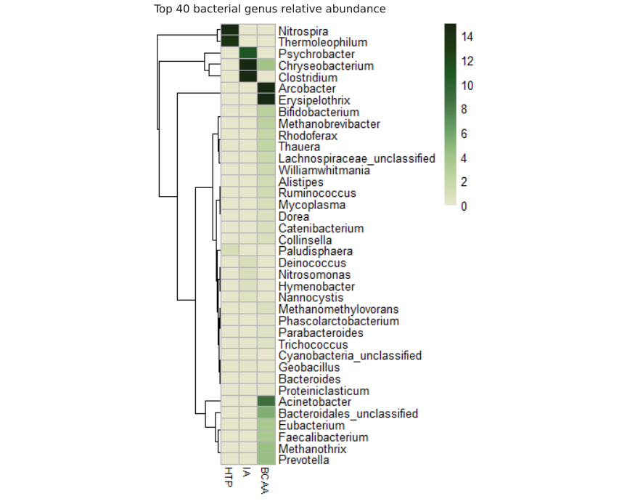
Supplementary Figure 1. Heatmap of relative abundance of different genus in the three metagenomes sequenced. Community profile was done with Metaphlan4 and the 40 most abundant genus are shown.
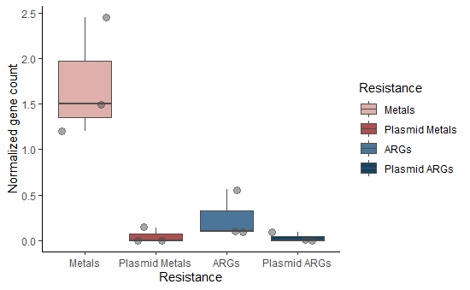
Supplementary Figure 2. Normalized gene count of MRGs and ARGs in total assemblies and plasmidic contigs. Gene count was normalized using 16S rRNA count for each metagenomic assembly.
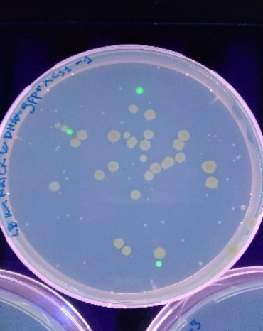
Supplementary Figure 3. Transconjugants colonies obtained from 1 of the exogenous plasmids capture assays with BCAA sample. Three colonies with fluorescent phenotype are observed, culture media was supplemented with kanamycin (50 μg/mL) (Km), nalidixic acid (25 μg/mL) (Nal), cycloheximide (10 μg/mL) (Ch) and tetracycline (Tc) (10 μg/mL).

