FRET probes in micellar systems: micelle formation indicator and the enzymes catalytic activity signal enhancer
Igor D. Zlotnikov, Ivan V. Savchenko and Elena V. Kudryashova *
Faculty of Chemistry, Lomonosov Moscow State University, Leninskie Gory, 1/3, 119991 Moscow, Russia;
zlotnikovid@my.msu.ru (I.D.Z.); ivan.savchenko@chemistry.msu.ru (I.V.S.)
* Correspondence: helenakoudriachova@yandex.ru

Figure S1. The scheme of synthesis grafted chitosan with lipoic acid – Chit5-LA.
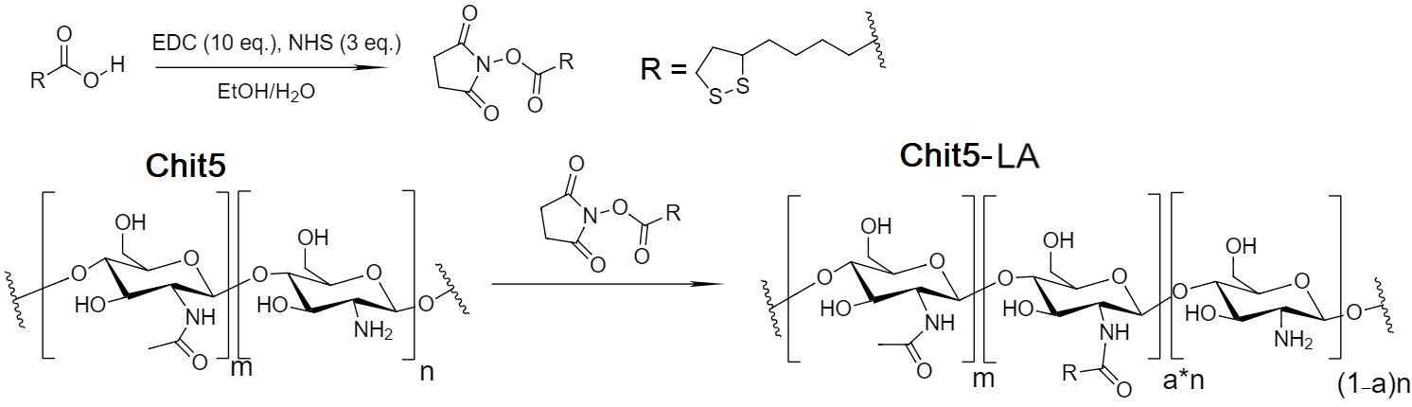

Figure S2. (a) AFM image of Chit5-LA particles and (b) the corresponding section along the blue line in height, respectively.

(a) 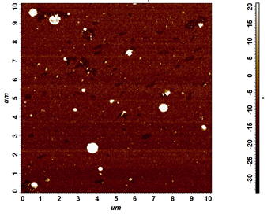 (b) 