Absorption and biotransformation of selenomethionine and selenomethionine-oxide by wheat seedlings (Triticum aestivum L.)
Qi Wang, Siyu Huang, Qingqing Huang, Yao Yu, Huafen Li, Yanan Wan*
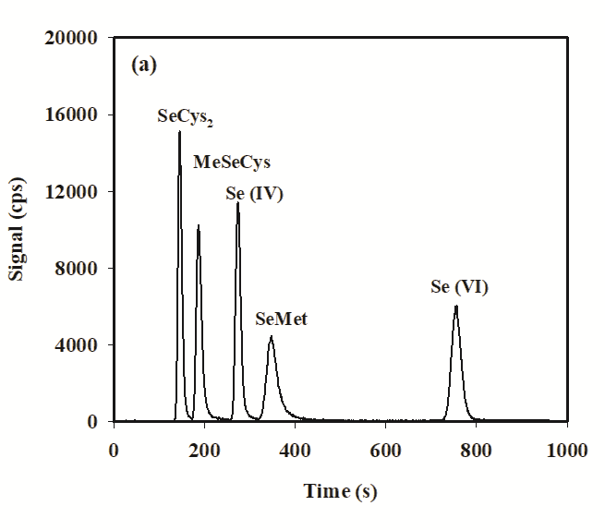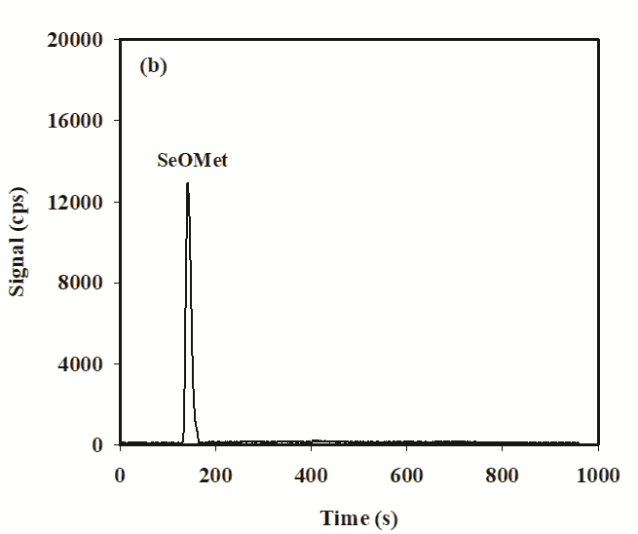
Figure S1. Analytical HPLC-ICP-MS chromatogram of six standard Se species (100 µg L⁻¹): (a) SeCys₂, MeSeCys, Se (IV), SeMet and Se (VI); (b) SeOMet.

