Dogs | Region | Diagnosis | n
Symptomatic | Croatia | Leishmania Dipstick Rapydtest, Apacor/IFAT | 66
Asymptomatic | Croatia | „ | 27
Healthy endemic controls | Croatia | „ | 88
Other infection | Croatia | parasitological examination | 51
Symptomatic | Brazil | parasitological examination/ DPP® | 13
Oligosymptomatic | Brazil | parasitological examination/ DPP® | 12
Asymptomatic | Brazil | parasitological examination/ DPP® | 11
Healthy endemic controls | Brazil | parasitological examination/ DPP® | 16
Healthy vaccinated | Brazil | parasitological examination/ DPP® | 20
T. cruzi infected (Chagas) | Brazil | parasitological examination | 40
Total |  |  | 344
Supplemental Table 1. Panel of canine sera from Croatia and Brazil that have been pre-examined for CVL by indicated tests and were used for re-evaluation by VetLine® ELISA, rKLi8.3 ELISA and LFT (INgezim® Leishma CROM) tests.

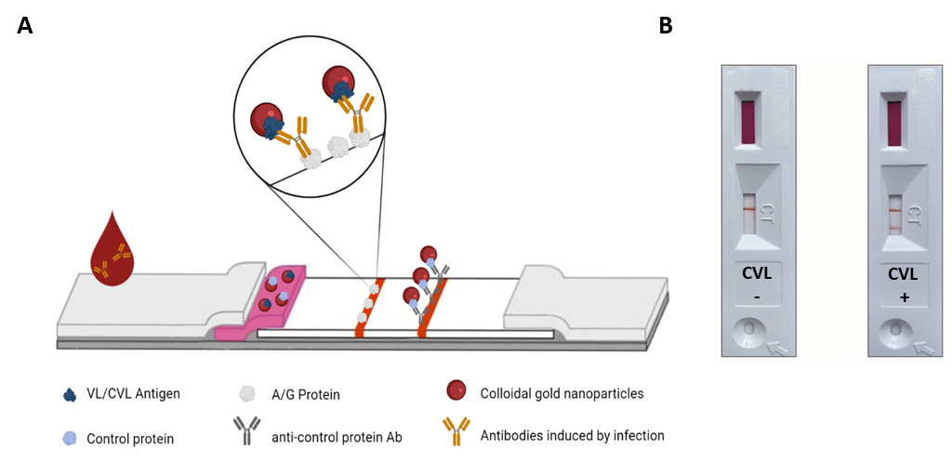
Supplemental Figure 1. A) Scheme of the lateral flow assay (INgezim® Leishma CROM, Spain) for the detection of antibodies to Leishmania. B) Representative result of LFT with negative and positive CVL sera.

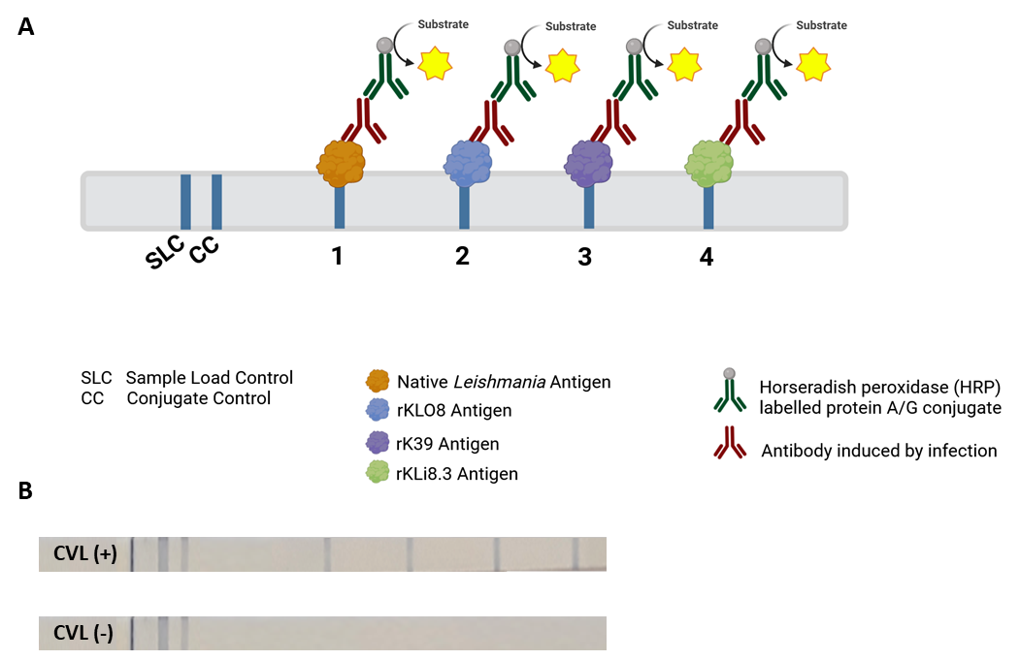
Supplemental Figure 2. A) Scheme of the VetBlot® Leishmania Lineblot for the detection of CanL antibodies. Line 1, native Leishmania antigen and line 2-4, recombinant antigens of Leishmania are printed onto a nitrocellulose membrane. B) Representative result of a lineblot with negative and positive CanL sera.

Supplemental Table 2. Comparison of CVL seropositivity by rKLi8.3 based LFT and ELISA and ELISAs based on other recombinant antigens.
Grupo AD | Animals | LFT | rKLi8.3 | rK28 | rK39
 | AD1 | ˗ | ˗ | ˗ | ˗
 | AD2 | ND | ND | ˗ | +
 | AD3 | ˗ | ˗ | ˗ | ˗
 | AD4 | + | + | + | +
 | AD5 | ˗ | - | + | ˗
 | AD6 | + | + | + | +
 | AD7 | + | + | + | +
 | AD8 | ND | ND | + | +
 | AD9 | + | + | + | +
 | AD10 | ND | ND | + | +
 | AD11 | + | + | + | +
Grupo OD | OD2 | ˗ | ˗ | ˗ | ˗
 | OD3 | + | + | + | +
 | OD4 | + | + | + | +
 | OD5 | + | + | + | +
 | OD6 | + | + | + | +
 | OD7 | ND | ND | + | +
 | OD8 | ND | ND | + | +
 | OD9 | + | + | + | +
 | OD10 | + | + | + | +
 | OD11 | ND | - | ˗ | ˗
 | OD12 | ND | ND | + | +
Grupo SD | SD1 | + | + | + | +
 | SD2 | + | + | + | +
 | SD3 | + | + | + | +
 | SD4 | + | + | + | +
 | SD5 | + | + | + | +
 | SD6 | + | + | + | +
 | SD7 | + | + | + | +
 | SD8 | + | + | + | +
 | SD9 | + | + | + | ˗
 | SD10 | + | + | + | +
 | SD11 | ND | ND | + | +
 | SD12 | + | + | + | +
 | SD13 | + | + | + | +
IgG seropositivity of dogs divided into asymptomatic (AD), oligosymptomatic (OD) and symptomatic (SD) CVL, based on the cut-off point established for each antigen. Animals whose optical density was greater than the cutoff point were considered positive (+) and those whose optical density was less than or equal to the cutoff point were considered negative (-). LFT = Lateral flow test based on the rKLi8.3 antigen.

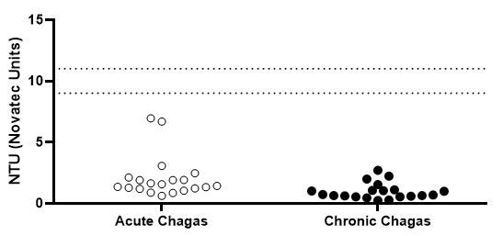
Supplemental Figure 3. Sera from T. cruzi infected dogs with acute and chronic Chagas disease were tested by rKLi8.3 ELISA.

Supplemental Table 3. Comparison of CVL seropositivity by rKLi8.3 based LFT and -ELISA in acute and chronic T.cruzi infected dogs.
Groups | Animals | LFT | ELISA
Acute  Chagas | AC2 | ˗ | ˗
 | AC3 | - | -
 | AC4 | ˗ | ˗
 | AC5 | - | -
 | AC11 | ˗ | -
 | AC12 | - | -
 | AC13 | - | -
 | AC16 | - | -
 | AC18 | - | -
 | AC19 | - | -
Chronic  Chagas | CC1 | ˗ | ˗
 | CC6 | - | -
 | CC7 | - | -
 | CC8 | - | -
 | CC9 | - | -
 | CC10 | - | -
 | CC14 | - | -
 | CC15 | - | -
 | CC17 | - | -
 | CC20 | - | -
IgG seropositivity of dogs divided into acute and chronic Chagas. Animals whose optical density was greater than the cutoff point were considered positive (+) and those whose optical density was less than or equal to the cutoff point were considered negative (-). LFT = Lateral flow test based on the rKLi8.3 antigen.

Supplemental Figure 4. Comparison of anti-Leishmania antibody responses in rK28- rK39- and rLb6H ELISA using symptomatic (SD), oligosymptomatic (OD), asymptomatic (AD) and endemic control sera from Brazil.

Supplemental Table 4. Croatian dog sera tested by lineblot: reactivity with individual antigens are shown.
Groups | Animals | LineBlot (native, rKLO8, rK39, rKLi8.3)
SD | 3280 | 1+, 2+, 3+, 4+
 | 3285 | 1+, 2+, 3+, 4+
 | 3286 | 1+, 2+, 3+, 4+
 | 3288 | 1+, 2+, 3+, 4+
 | 3292 | 1+, 2+, 3+, 4+
 | 3293 | 1+, 2+, 3+, 4+
 | 3297 | 1+, 2+, 3+, 4+
 | 3298 | 1+, 2+, 3+, 4+
 | 3299 | 1+, 2+, 3+, 4+
 | 3302 | 1+, 2+, 3+, 4+
 | 3303 | 1+, 2+, 3+, 4+
 | 3304 | 1+, 2+, 3+, 4+
 | 3308 | 1+, 2+, 3+, 4+
 | 3309 | 1+, 2+, 3+, 4+
 | 3310 | 1+, 2+, 3+, 4+
 | 3334 | 1+, 2+, 3+, 4+
 | 3341 | 1+, 2+, 3+, 4+
 | 3347 | 1+, 2+, 3+, 4+
 | 3348 | 1+, 2+, 3+, 4+
 | 3357 | 1+, 2+, 3+, 4+
 | 3358 | 1+, 2+, 3+, 4+
 | 3361 | 1+, 2+, 3+, 4+
 | 3365 | 1+, 2+, 3+, 4+
 | 3371 | 1+, 2+, 3+,4+
AC | 3254 | 1-, 2-, 3-, 4-
 | 3289 | 1+, 2+, 3+, 4+
 | 3307 | 1+, 2+, 3+, 4+
 | 3312 | 1+, 2+, 3+, 4+
 | 3336 | 1+, 2+, 3+, 4+
 | 3337 | 1+, 2+, 3+, 4+
 | 3338 | 1+, 2+, 3+, 4+
 | 3354 | 1w+,2+,3+,4+
 | 3355 | 1+, 2+, 3+, 4+
 | 3356 | 1+, 2+, 3+, 4+
 | 3364 | 1+, 2w+, 3+, 4+
 | 3368 | 1w+, 2+, 3+, 4+
 | 3373 | 1w+, 2-, 3-, 4-
 | 3375 | 1-, 2-, 3-, 4-
 | 3377 | 1w+, 2w+, 3+, 4+
EC

EC
 | 3262 | 1w+, 2-, 3-, 4-
 | 3278 | 1w+, 2-, 3-, 4-
 | 3279 | 1w+, 2-, 3-, 4-
 | 3281 | 1w+, 2-, 3-, 4-
 | 3282 | 1-, 2-, 3-, 4-
 | 3283 | 1-, 2-, 3-, 4-
 | 3284 | 1-, 2-, 3-, 4-
 | 3287 | 1-, 2-, 3-, 4-
 | 3290 | 1w+, 2-, 3-, 4-
 | 3296 | 1w+, 2-, 3-, 4-
 | 3300 | 1w+, 2-, 3-, 4-
 | 3301 | 1+, 2-, 3-, 4-
 | 3305 | 1w+, 2-, 3-, 4-
 | 3306 | 1w+, 2-, 3-, 4-
 | 3311 | 1w+, 2-, 3-, 4-
 | 3313 | 1-, 2-, 3-, 4-
 | 3314 | 1-, 2-, 3-, 4-
 | 3315 | 1w+, 2-, 3-, 4-
 | 3322 | 1w+, 2-, 3-, 4-
 | 3323 | 1-, 2-, 3-, 4-
 | 3331 | 1-, 2-, 3-, 4-
 | 3332 | 1w+, 2-, 3-, 4-
 | 3335 | 1-, 2-, 3-, 4-
 | 3339 | 1-, 2-, 3-, 4-
 | 3340 | 1w+, 2-, 3-, 4-
 | 3343 | 1-, 2-, 3-, 4-
 | 3346 | 1-, 2-, 3-, 4-
 | 3349 | 1-, 2-, 3-, 4-
 | 3350 | 1-, 2-, 3-, 4-
 | 3353 | 1-, 2-, 3-, 4-
 | 3359 | 1w+,2-,3-,4-
 | 3360 | 1-, 2-, 3-, 4-
 | 3362 | 1+, 2w+, 3+, 4+
 | 3363 | 1-, 2-, 3-, 4-
 | 3366 | 1-, 2-, 3-, 4-
 | 3367 | 1-, 2-, 3-, 4-
 | 3369 | 1+, 2-, 3-, 4-
 | 3372 | 1w+, 2-, 3-, 4-
 | 3374 | 1+, 2-, 3-, 4-
 | 3376 | 1+, 2-, 3-, 4-
 | 3378 | 1+, 2-, 3+, 4w+
 | 3379 | 1w+, 2-, 3-, 4-
 | 3380 | 1w+, 2-, 3w+, 4-
 | 3381 | 1w+, 2-, 3-, 4-
 | 3382 | 1+, 2-, 3+, 4w+
 | 3294 | 1w+, 2-, 3-, 4-
 | 3295 | 1w+, 2-, 3-, 4-
 | 3317 | 1-, 2-, 3-, 4-
 | 3318 | 1-, 2-, 3-, 4-
 | 3320 | 1w+, 2-, 3-, 4-
 | 3344 | 1w+, 2-, 3-, 4-
 | 3345 | 1w+, 2-, 3-, 4-

Supplemental Table 5. Brazilian dog sera tested by lineblot: reactivity with individual antigens are shown.
Groups |  | Animals | LineBlot (native, rKLO8, rK39, rKLi8.3)
SD |  | SD1 | 1w+, 2+, 3+, 4+
 |  | SD2 | 1+, 2+, 3+, 4+
 |  | SD3 | 1+, 2+, 3+, 4+
 |  | SD4 | 1+, 2+, 3+, 4+
 |  | SD5 | 1+, 2+, 3+, 4+
 |  | SD6 | 1+, 2+, 3+, 4w+
 |  | SD7 | 1+, 2+, 3+, 4+
 |  | SD8 | 1+, 2+, 3+, 4+
 |  | SD9 | 1+, 2+, 3+, 4+
 |  | SD10 | 1+, 2+, 3+, 4+
 |  | SD12 | 1+, 2w+, 3+, 4+
 |  | SD13 | 1+, 2+, 3+, 4+
 |  | SD14 | 1+, 2+, 3+, 4+
AD |  | AD1 | 1-, 2-, 3-, 4-
 |  | AD2 | 1-, 2-, 3-, 4-
 |  | AD3 | 1-, 2-, 3-, 4-
 |  | AD4 | 1+, 2+, 3+, 4+
 |  | AD5 | 1w+, 2-, 3-, 4-
 |  | AD6 | 1+, 2+, 3+, 4+
 |  | AD7 | 1+, 2w+, 3+, 4+
 |  | AD8 | 1+,2+,3+,4+
 |  | AD9 | 1+, 2+, 3+, 4+
 |  | AD10 | 1+, 2w+, 3w+, 4-
 |  | AD11 | 1+, 2+, 3+, 4+
 |  | OD1 | 1w+, 2-, 3-, 4-
 |  | OD2 | 1w+, 2-, 3-, 4-
 |  | OD3 | 1+, 2+, 3+, 4+
 |  | OD4 | 1+, 2+, 3+, 4+
OD |  | OD5 | 1+, 2+, 3+, 4+
 |  | OD6 | 1+, 2+, 3+, 4w+
 |  | OD8 | 1+, 2+, 3+, 4+
 |  | OD9 | 1+,2+,3+,4+
 |  | OD10 | 1+, 2+, 3+, 4+
 |  | OD11 | 1w+, 2-, 3-, 4-
 |  | OD12 | 1+,2+,3+,4+
 |  | SAE1 | 1-, 2-, 3-, 4-
 |  | SAE2 | 1-, 2-, 3-, 4-
 |  | SAE3 | 1-, 2-, 3-, 4-
 |  | SAE4 | 1-, 2-, 3-, 4-
 |  | SAE8 | 1-, 2-, 3-, 4-
EC |  | SAE9 | 1-, 2-, 3-, 4-
 |  | SAE10 | 1-, 2-, 3-, 4-
 |  | SAE11 | 1-, 2-, 3-, 4-
 |  | SAE12 | 1-, 2-, 3-, 4-
 |  | SAE13 | 1-, 2-, 3-, 4-
 |  | SAE14 | 1-, 2-, 3-, 4-
 |  | SAE16 | 1-, 2-, 3-, 4-
 |  | LEIVT 01 | 1-, 2-, 3-, 4-
 |  | LEIVT 02 | 1-, 2-, 3-, 4-
 |  | LEIVT 03 | 1-, 2-, 3-, 4-
 |  | LEIVT 04 | 1-, 2-, 3-, 4-
 |  | LEIVT 05 | 1-, 2-, 3-, 4-
 |  | LEIVT 05 | 1-, 2-, 3-, 4-
 |  | LEIVT 06 | 1-, 2-, 3-, 4-
VAC |  | LEIVT 07 | 1-, 2-, 3-, 4-
 |  | LEIVT 08 | 1-, 2-, 3-, 4-
 |  | LEIVT 09 | 1-, 2-, 3-, 4-
 |  | LEIVT 10 | 1-, 2-, 3-, 4-
 |  | LEIVT 12 | 1-, 2-, 3-, 4-
 |  | LEIVT 13 | 1-, 2-, 3-, 4-
 |  | LEIVT 14 | 1-, 2-, 3-, 4-
 |  | LEIVT 15 | 1-, 2-, 3-, 4-
 |  | LEIVT 16 | 1-, 2-, 3-, 4-

