Supplementary Information

Nutritional Status and Physical Activity are Associated with Cognitive Function in Chinese Community-Dwelling Older Adults: the Role of Happiness
Jianghong Liu ^{1,} *, Dingyudu Pan ^{1, 2}, Mckenna Angela Sun ^{1, 3}, Haoer Shi ¹ and Rui Feng ⁴
¹ School of Nursing, University of Pennsylvania, Philadelphia, PA 19104, USA; jhliu@nursing.upenn.edu (J.L.); haoershi@nursing.upenn.edu (H.S.)
² School of Engineering and Applied Science, University of Pennsylvania, Philadelphia, PA 19104, USA; pdyd@seas.upenn.edu
³ College of Arts & Sciences, University of Pennsylvania, Philadelphia, PA 19104, USA; masun@sas.upenn.edu
⁴ Department of Biostatistics, Epidemiology, and Informatics, Perelman School of Medicine, University of Pennsylvania, Philadelphia, PA 19104, USA; ruifeng@pennmedicine.upenn.edu

* Correspondence: jhliu@nursing.upenn.com; Tel.: +1-(215)-898-8293

Table S1. Bivariate Pearson’s correlation between variables.
Predictors | Nutrition | Exercise | Happiness | Cognitive decline
Nutrition
Exercise | 0.15***
Happiness | 0.21*** | 0.15***
Cognitive decline | -0.25*** | -0.13*** | -0.17***
Age | -0.13*** | -0.08* | -0.01 | 0.10
Note: Nutrition, MNA nutritional status; Exercise, physical activity, 1 = not doing exercise, 2 = doing exercise. *: p-value < 0.05, **: p-value < 0.01, ***: p-value < 0.001. † Indicated marginal significance.
Table S2. Adjusted association of cognitive decline with nutritional status, stratified by age.
 | Young-old  (N = 524) | Old-old  (N = 173)
Predictors | β (SE) | β (SE)
Nutrition (Normal as reference)
At-risk | 2.96 (0.95)** | 2.90 (1.53)†
Malnutrition | 11.10 (2.30)*** | 9.05 (5.61)
Exercise (No as reference)
Yes | -2.35 (0.96)* | -1.16 (1.64)
Note: All models adjusted for age, gender, income, education, marital status. β, estimated regression coefficient; SE, standard error; *: p-value < 0.05, **: p-value < 0.01, ***: p-value < 0.001. † Indicated marginal significance.

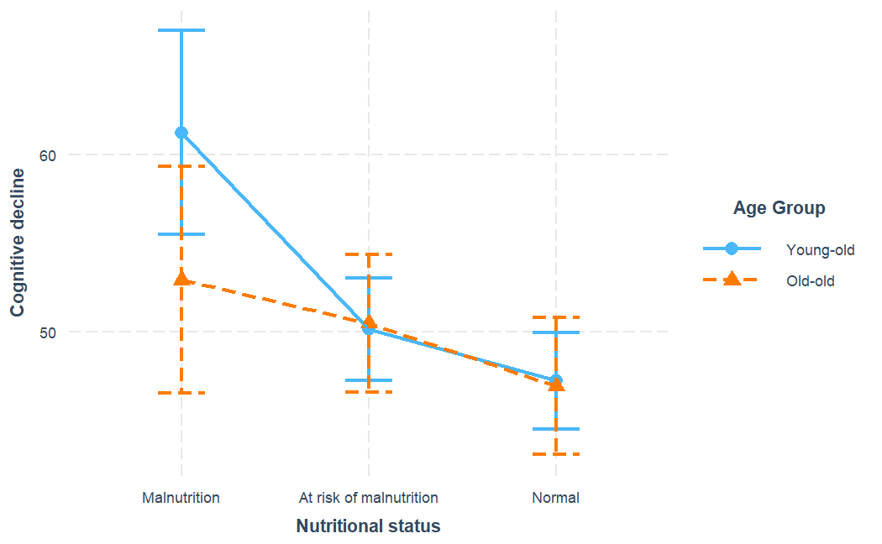
Figure S1. Stratified associations of cognitive decline with nutritional status across young-old (age < 74) and old-old (age >= 74) age sub-groups. Models adjusted for age, gender, income, education, marital status.

