Supplementary material
Nanoparticulated WO₃/NiO using microcrystalline cellulose as a template and its application as auxiliary oxides to Pt for ethanol and glycerol electro-oxidation to produce green hydrogen
Munique G. Guimarães, Júlio L. Macedo, José J. Linares and Grace F. Ghesti
Table S1 collects the main thermal parameters of the raw microcrystalline cellulose (MCC) used as raw matter for preparing the nanocrystalline cellulose (NCC). As can be observed, the final ash content of the material is null, which is crucial for its application as a template and subsequent calcination.

Table S1. Thermal parameters of the original MCC
Parameter | (%)
Moisture content (%) | 4.69
Volatiles (%) | 94.11
Ash content (%) | 0.00
Fixed carbon content (%) | 5.90

Figure S1 presents the thermograms of the original MCC and one of the prepared NCC, from the hydrolysis with water, 1 mol L⁻¹ PWA). As observed, both materials present similar features. In both cases, an initial decrease in the weight is associated with the moisture release up to 150 °C. Afterward, there is an abrupt weight decrease, beginning earlier in the NCC compared to the MCC, and achieving its maximum rate at 327.5 °C for the NCC and 351.0 °C for the MCC. This decrease is related to the cellulose structure's degradation, including the cellulose structure's ring scission (beginning from the β-1,4 glycosidic bonds) and the COO groups' decarboxylation, leading to polymer decomposition [1,2]. The slight drop in thermal stability can be due to the decrease in the crystallinity that can have occurred during the acid hydrolysis. Also, the presence of P and W on the surface of the NCC can catalyze an earlier decomposition.

(a) | (b)
Figure S1. (a) Thermogravimetric profiles of the MCC and NCC, and (b) their corresponding weight derivate
Figure S2 shows the diffractograms of the MCC and NCC (from the hydrolysis with water, 1 mol L⁻¹ PWA). As can be observed, both samples present similar diffraction peaks, indicating the preservation of the basic crystalline structure after the acid hydrolysis. The slight decrease in the intensity may be attributed to the decrease in the extension of the crystalline arrangement due to the transition from a microcrystalline to a nanocrystalline cellulose. No signal of PWA is visible, indicative of the high dispersion of the acid over the entire structure of the NCC.
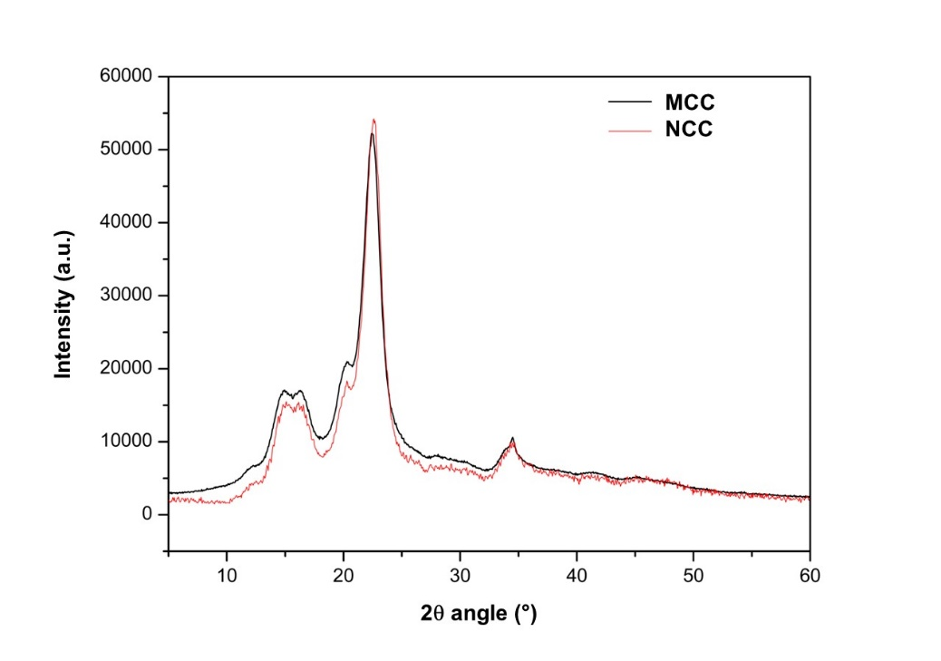
Figure S2. Diffractograms of the MCC and NCC samples
Figure S3 displays the transmission electron micrographs of the samples, MCC and NCC (from the hydrolysis with water, 1 mol L⁻¹ PWA, lower PWA concentrations led to larger NCC particles). As can be observed, there is a notable drop in the particle size because of the acid hydrolysis to convert the MCC to NCC. Only the nanocrystalline structure remains in the NCC, leading to the smaller particle sizes observed in Fig. S3.

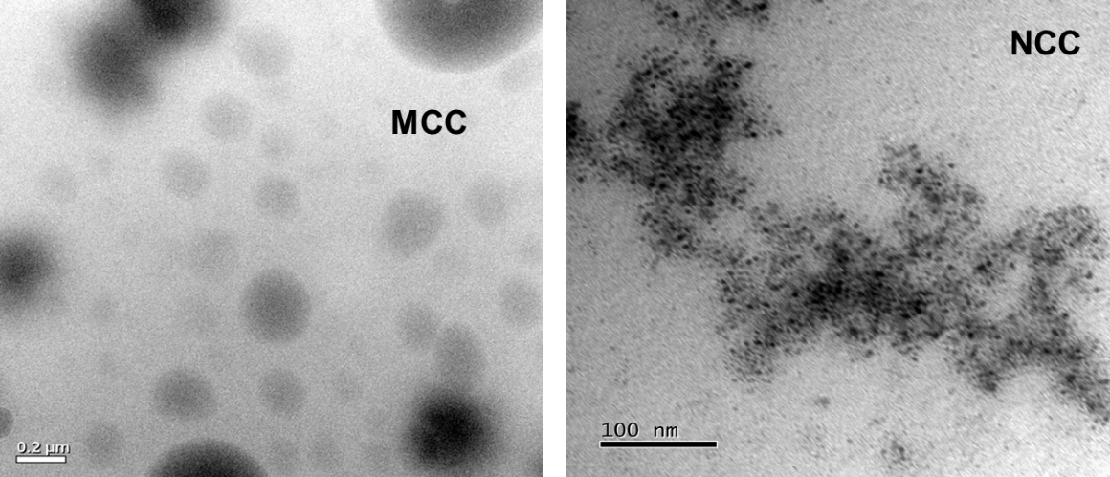
Figure S3. TEM images of the MCC and NCC samples
Figure S4 shows the TEM images of the calcinated samples with the different solvents and impregnation time. As observed, in accordance with the XRD results, the sample prepared with ethanol and impregnated for 1 h presents the smallest and most homogeneous particle sizes and distribution compared to the other materials.
Figure S5 displays the chronoamperograms of the different materials for 30 min at a fixed potential of −0.25 V vs. MMO. As can be seen, the prepared materials with TO and, especially, with NiT-TO display higher current densities as a result of the positive effect of these species in terms of alleviating the accumulation of adsorbed carbonaceous residues during the ethanol and glycerol electro-oxidation.
E1 | W1
E6 | W6
Figure S4. TEM images of the resulting NiT materials after the thermal treatment of the NCC as a function of the solvent and impregnation treatment time.
(a) | (b)
Figure S5. Chronoamperometry profiles of the different materials for in 1 mol L⁻¹ alcohol and in 1 mol L⁻¹ KOH (a) ethanol electro-oxidation (b) glycerol electro-oxidation at a potential of −0.25 V vs. MMO.

