Supplementary Materials

A Novel Red-Emitting NaYS₂ Phosphor under 1550 nm Excitation
Jiulong Wu, Ying Tian*, Limin Wei, Ke Cai, Xixian Luo, Hong Wang*
School of Science, Dalian Maritime University, Dalian 116026, China

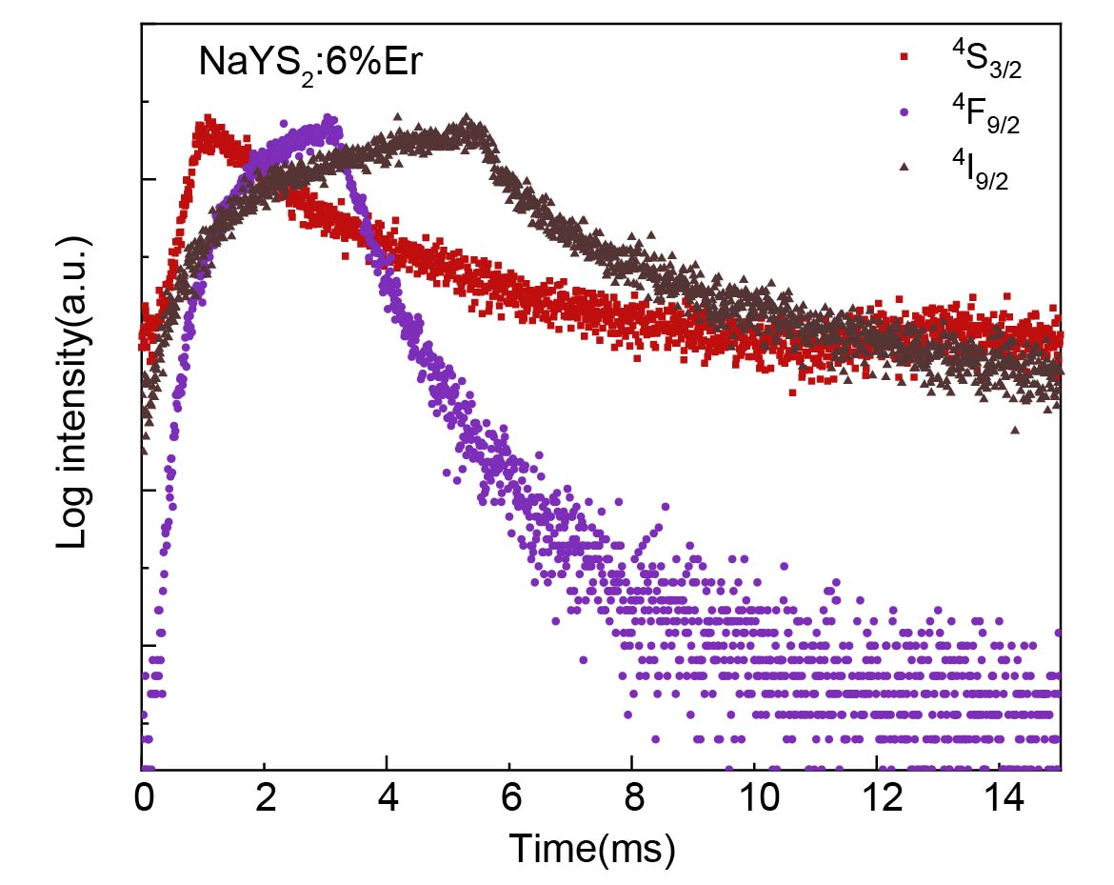
Figure S1. Fluoresce decay dynamics of ⁴S_{3/2} (555 nm), ⁴F_{9/2} (655 nm), ⁴I_{9/2} (800 nm) energy levels of Er³⁺ ions in NaYS₂:6%Er³⁺.

