Type of the Paper (Article, Review, Communication, etc.)
Wharton’s Jelly Tissue Allograft for Connective Tissue Defects Surrounding Nerves in the Tarsal Tunnel: A Retrospective Case Series
By: Ronald Bruton¹, Tracie L. Gilliland¹, John J. Shou², Crislyn G. Woods³, Naomi E. Lambert³ and Tyler C. Barrett ³
1: Advanced Medicine of the Ozarks, Mountain Home, AR 72653, USA
2: Baylor College of Medicine, Houston, TX 77030, USA
3: Regenative Labs, Pensacola, FL 32501, USA
Abstract: Background: Caused by age or trauma, collapsed connective tissue can cause nerve entrapment and damage within the tarsal tunnel. With an unknown incidence rate Tarsal tunnel syndrome is relatively underdiagnosed. , and current literature is inconclusive on best practices for patient care. While most standard treatments involve symptom management, This retrospective case series highlights a novel approach, targeting the damaged study presents an intervention targeting damaged tissues surrounding the nerves and replacing the structural cushioning with a Wharton’s jelly tissue allograft. Methods: This cohort was selected from the retrospective repository at Regenativelabs. The eight selected patients from four clinical sites had tarsal tunnel-related defects. Patient outcomes were tracked on a 90-day calendar utilizing the Numeric Pain Rating Scale (NPRS) and the Western Ontario and McMaster University Arthritis Index (WOMAC). All patients had failed standard care practices for at least six weeks. Each patient received one 2mL application of 150mg minimally manipulated Wharton’s jelly tissue allograft to strategic sites around the affected tarsal tunnel. No patients experienced adverse reactions. Red light and laser therapies were recommended post-application. Results: The percent change of improvement in patient pain scales was calculated with the cohort averages at initial application, 30- and 90-day30-day follow-up, and 90-day follow-up appointments. All patients reported decreased pain on both scales. Percent change calculated from the initial application to the 90-day follow-up showed an improvement of 59.43% in NPRS and a 37.58% improvement in WOMAC. Conclusions: Given the reported pain improvements on various pain rating scales, this study provides evidence that WJ allograft applications are safe, minimally invasive, and efficacious for patients who have failed standard care treatments for connective tissue defects associated with Tarsal Tunnel syndrome. Limitations include the small cohort size and nonblinded nature. The results of this study warrant further research to confirm the efficacy, optimal dose, protocol, and durability of Wharton's jelly added to conservative care protocols to clarify WJ allograft application's optimal dose, protocol, and durability.
Keywords: Tarsal Tunnel; Nerve damage; Neuropathy; Wharton’s Jelly; Regenerative Medicine

1. Introduction
Tarsal Tunnel syndrome is an entrapment neuropathy of the posterior tibial nerve and potentially its terminal branches under the flexor retinaculum and behind the medial malleolus of the ankle [1]. Tarsal Tunnel syndrome can be characterized by local tenderness, pain, paresthesia, and heat, followed by numbness and tingling. Symptoms may become more permanent and severe, spreading toward the posterior, medial, or distal aspect of the lower extremity [1].
The occurrence of nerve damage in the tarsal tunnel is unclear and thought to be underdiagnosed. However, it has been found to have a higher incidence in females and can be witnessed at any age [2]. Contributing factors to the incidence of tarsal tunnel syndrome include trauma, tight-fitting shoes, abnormal biomechanics, and systemic diseases, which may induce nerve or surrounding tissue inflammation [3]. Left untreated, posterior tibial nerve compression can cause permanent nerve damage, atrophy, and persistent pain [2].
While many intervention strategies exist for treating tarsal tunnel, there is limited robust evidence to guide the clinical management of the syndrome [4]. Currently, standard conservative management includes activity modification, physical rehabilitation, corticosteroid injections, and non-steroidal anti-inflammatory drugs (NSAIDs) [5]. It remains unclear when to intervene with surgical procedures as opposed to conservative management due to the various stages of the disease and the need for a structured, stepwise approach when treating patients [4]. Although the initiation of surgical intervention is unclear, there are a few different surgical approaches that are available. Three methods for decompression of the tibial nerve and its branches include open surgery, endoscopic surgery, and ultrasound-guided surgery [6]. Any surgical tarsal tunnel intervention can range in out-of-pocket costs from 3,000 to 7,000 USD with up to six weeks of recovery time for the patient. Novel alternative interventions are necessary for refractory connective tissue nerve damage, as surgery does not guarantee improvement given that surgical success rates vary from 44% to 96% [5]. These interventions can require much of a patient's time to be dedicated to the recovery process without a guarantee of lasting success. With uncertainty surrounding the treatment of Tarsal Tunnel defects, this study aims to propose an alternative intervention that targets explicit damage to the connective tissues surrounding the related nerves for patients who have failed conservative management and desire to avoid surgical intervention.
Compression of nerves can have varying etiologies, but most equate to breakdown, rearrangement from trauma, and damage to the surrounding structural tissues. This collapse of connective tissue puts excess pressure on specific points along a given nerve, deteriorating the protective cushioning surrounding nerve fascicles. Most connective tissues, including nerve extracellular matrix (ECM), comprise collagenic matrices as their primary structural support component [7]. Wharton’s jelly is a loose connective tissue found in the umbilical cord that cushions and protects the vessels within the cord from external forces and stretching. It contains collagen types I and III, hyaluronic acid, proteoglycans, growth factors, and cytokines. Hydrodissection of a compressed nerve with Wharton’s jelly can supplement the damaged protective coating and provide additional cushioning to the nerve, as well as replace surrounding collapsed connective tissues, promoting proper function.
The retrospective repository used in this study is facilitated by Regenative Labs, containing data on over 180+ beneficial homologous uses for Wharton’s jelly tissue allografts, including musculoskeletal defects. This case series presents data from patient-reported pain scales in the retrospective repository of eight patients who received one application of Wharton’s jelly to refractory nerve damage and compression within the tarsal tunnel. This study serves to fill the literature gap regarding the use of Wharton’s Jelly for degenerative tissue defects. The purpose of the study is to examine and present the effect of Wharton’s Jelly application on supplementing structural defects in the connective tissue surrounding nerve damage and compression within the tarsal tunnel.
2. Materials and Methods
All methods complied with the FDA and American Association of Tissue Banks (AATB) standards. This study was conducted under an Institute of Regenerative and Cellular Medicine IRB-approved protocol (RL-UCT-001), and informed consent was obtained from the study participant. Human umbilical cords were obtained from consenting donors following full-term Cesarean section deliveries. Prior to delivery, donors underwent comprehensive medical, social, and blood testing. Qualtex Laboratories in San Antonio, TX tested all donations for infectious disease in accordance with Clinical Laboratory Improvement Amendments (CLIA) of 1988, 42 CFR part 493, and FDA regulations. Each donor was tested for Hepatitis B Core Antibody (HBcAb), Hepatitis B, Surface Antigen (HBsAg), Hepatitis C Antibody (HCV), Human Immunodeficiency Virus Antibody, (HIV1/HIV-2 Plus O), Human T-Lymphotropic Virus Antibody (HLTV-I/11), Syphilis (RPR), Cytomegalovirus (CMV), HIV1/HCV/HBV, NAT, and West Nile Virus (WNV). Each test was performed with an FDA-Approved testing kit. All test results were negative or non-reactive. All procedures were performed in accordance with strict aseptic techniques. In an ISO class 5 biologic safety cabinet, the umbilical cord was rinsed with saline to remove excess blood residue and clots. Wharton's jelly was aseptically dissociated from the rinsed umbilical cord. After dissociation, 150 mg of Wharton’s Jelly was suspended in approximately 2mL of sterile Sodium Chloride 0.9% solution (normal saline). The sample was not combined with cells, tissues, or articles other than the exceptions outlined in 21 CFR Part 1271.10(a) (3) (Human Cells, Tissues, and Cellular and Tissue-Based Product Regulation). The manufacture of the HCT/P does not involve the combination of the cells or tissues with another article, except for water, crystalloids, or a sterilizing, preserving, or storage agent, provided that the addition of water, crystalloids, or the sterilizing, preserving, or storage agent does not raise new clinical safety concerns with respect to the HCT/P. Because the WJ has been tested for infectious diseases and it is not combined with another article except for water, crystalloids, and preservation agents, it has a very minimal risk of negative reactions. Likely due to the minimal risk of negative reactions, there have been no reported negative side effects or contraindications of WJ. Wharton’s jelly tissue allograft was then distributed by Regenative Labs.
2.1. Case Presentation
This retrospective case study pulled patients from the Regenative Labs repository with the following inclusion criteria: documented tarsal tunnel nerve-related defects who received only one 2mL application of the 150mg Wharton’s jelly tissue allograft and had complete data sets. Complete data sets are defined as having pain scales recorded at initial, 30-day, and 90-day visits with less than four blanks. Following these requirements, eight patients with nerve damage on one or both legs were identified from four clinics that submitted data. The contributing clinics in this study included Enhanced Healthcare of the Ozarks, Baycity Associates in Podiatry, Regenerative Health 360, and Advanced Medicine of the Ozarks. Data sets were completed for each extremity separately. The pain scales utilized in this study were the Numeric Pain Rating Scale (NPRS) and the function rating scale, the Western Ontario and McMaster University Arthritis Index (WOMAC) Figure 1 [8][9]. The severity of neuropathy among the participants in this study was determined at each clinic through several tests that assess the different nerve senses.
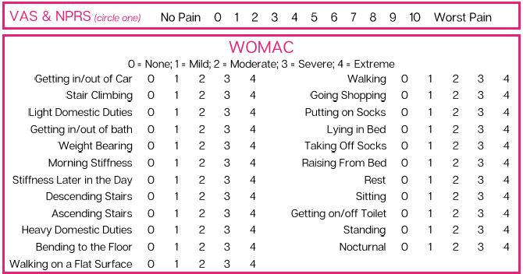
Figure 1. Pain scales used for the study

The tests could include Graphesthesia, Rebuilder Mitt Test, reflex reactions, Romberg test, and Tandem test. The Graphesthesia test interprets ambiguous tactile symbols from different spatial perspectives [10]. The Rebuilder Mitt test uses medical device mitts that send electrical signals to the nerves and muscles that are an exacerbated sensation of the typical nerve signals. The signals from the mitts function to stimulate the nerves and strengthen the muscles. Reflex reactions were tested in the ankle as neuropathy affects sensory and motor components [11]. The Romberg test removes the visual and vestibular components that contribute to balance to identify a particular impairment in patients with proprioception difficulties [12]. The Tandem test is used to screen for neurological and vestibular disorders by having the patient close their eyes and walk. While the patient walks, the test administrator counts the number of consecutive tandem steps out of ten [13]. Additional devices to assess patient neuropathy include cold sensitivity, a pinwheel device to evaluate the ability to feel sharp or pointed sensations, vibrations through the use of a tuning fork, a medi-tip to test pinprick sensation and determine between sharp and dull sensations, and 10g monofilament [14]. Temperatures in the feet, forearms, and face, along with oxygen in the feet and hands, are compared to assure symmetrical sensation. The purpose of these tests is to provide a baseline of sensory loss. If the results of the sensory test show that sensory loss is only in the feet, then a specific amount of Wharton’s jelly is applied in specific anatomical sites of the foot.
This study included eight patients, one female and seven males, who presented with nerve defects in the tarsal tunnel aspect of their lower extremities. Two patients received WJ in their right foot only, and four patients received WJ in their left foot. Two patients received WJ in both their feet. The age distribution included one patient in the range of 40-49, six in the range of 70-79, and one in the range of 80-89. BMI distribution included four patients who were categorically overweight, two patients who were obese, and two patients who had an unreported BMI.
2.2. Procedure
A 25-gauge needle was used in the application of the WJ tissue allograft. The application is not a guided entry. If sensory loss was present only in the foot, a total of 2mL WJ was applied in 3 separate injection sites. The sites include 0.5 cc of WJ at the posterior tibial nerve, 0.5 cc at the medial plantar nerve, and one cc at the intermediate dorsal cutaneous branch of the superficial fibular nerve. If the neuropathy extended upwards towards the patella, then a total of 2mL WJ was applied in four different injection sites. 0.5 cc into the lateral calcaneus branch, 0.5 cc to the lateral peroneal nerve just below the patella, 0.5 cc to the medial plantar nerve, and 0.5 cc to the posterior tibial nerve. Some providers recommended that the patient receive high-powered laser therapy or red-light therapy as well as vibration therapy at home daily.
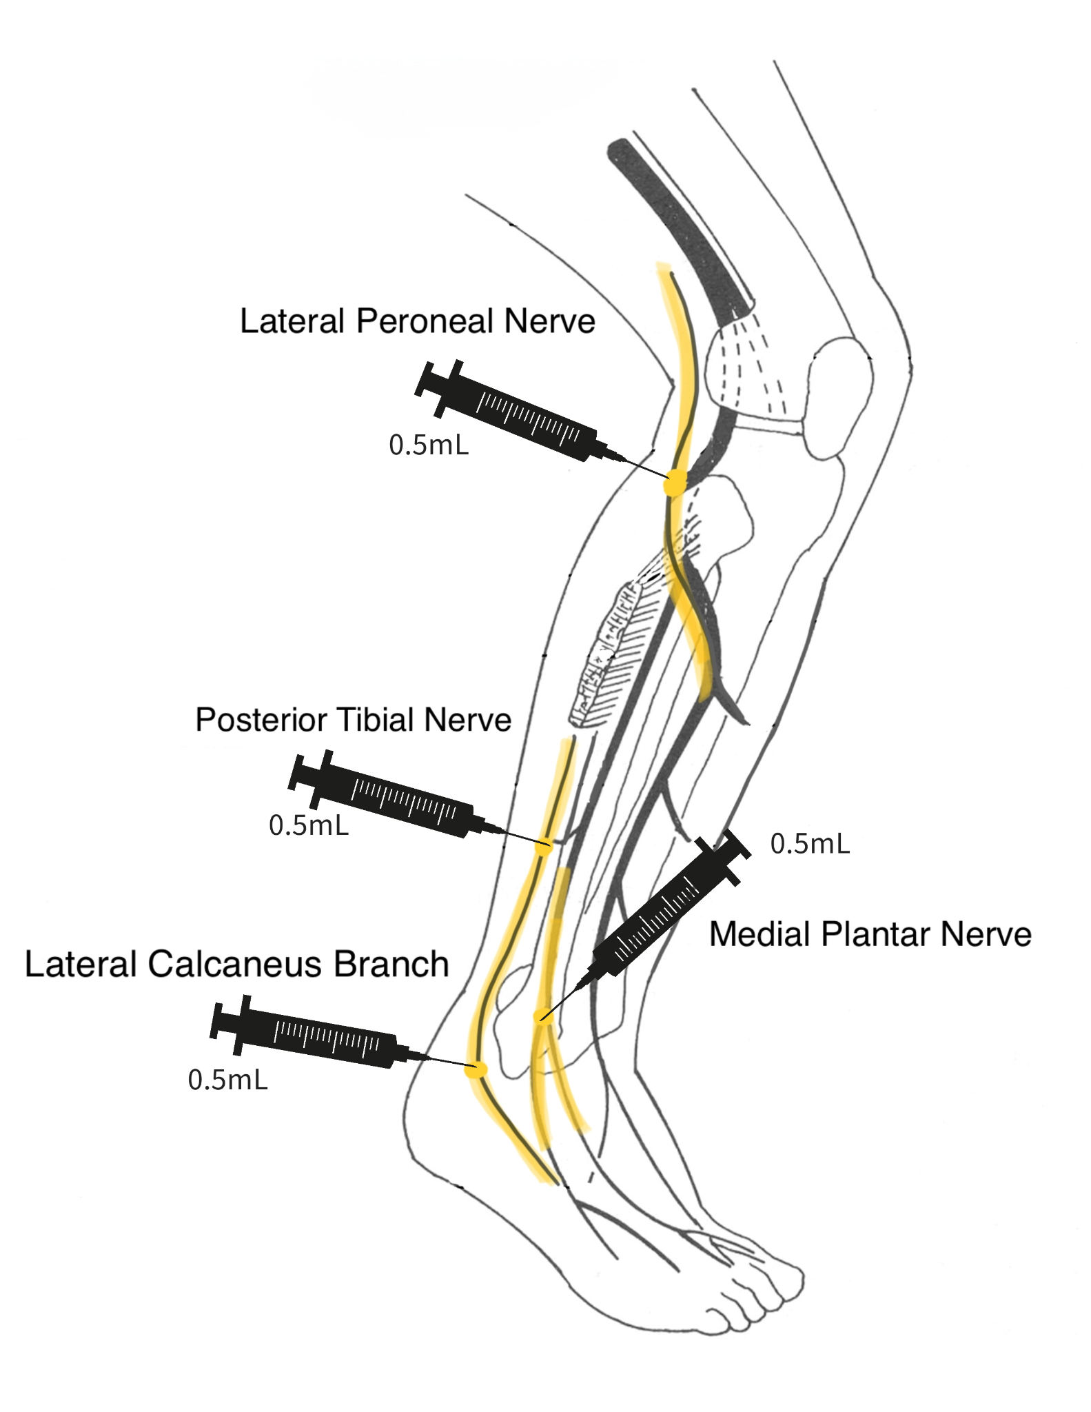
Diagram 1. Approximate application sites when sensory loss extends past the foot
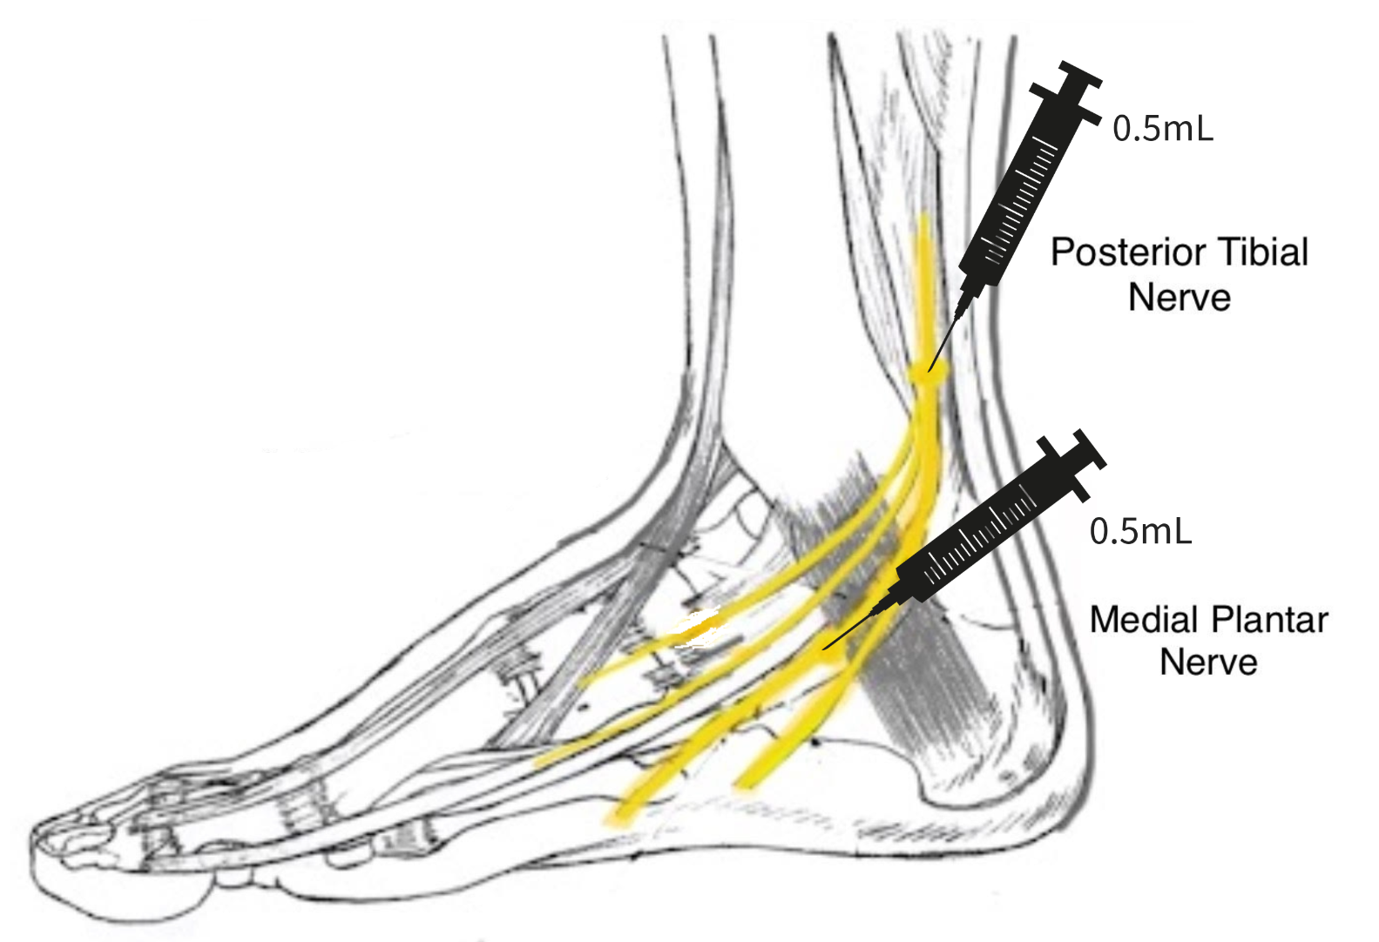
Diagram 2. Approximate application sites when sensory loss is solely in the foot
3. Results
The percent change of improvement in patient pain scales was calculated with the cohort averages at initial application, 30-day follow-up, and 90-day follow-up appointments. The average NPRS score was 6.7 at the initial application appointment, and WOMAC was 30.6. At the 30-day follow-up, NPRS was 4.8, and WOMAC was 26.8. At the 90-day follow-up, NPRS was 2.75, and WOMAC was 19.1. The standard deviation of each mean is represented in Figure 2. The large deviation in WOMAC averages is due to some patients not maintaining any feeling in their lower extremities, while others reported physical pain with some numbness before the application. Individual patients’ total score for each scale at the data collection dates can be found in Appendix A. Percent improvement was calculated for NPRS and WOMAC from initial to 30-day and 90-day follow-up appointments. From the initial application to the 30-day follow-up, there was a 41.20% improvement in NPRS and a 14.18% improvement in WOMAC. Finally, the initial application to 90-day follow-up showed an improvement of 59.43% in NPRS and a 37.58% improvement in WOMAC. Overall, the most significant improvement was seen in the NPRS category from initial application to the 90-day follow-up, but all patients experienced significant improvements in pain. Figure 3 compares the percent improvement in the NPRS and WOMAC scales. The figure illustrates a steep improvement in NPRS from initial application to 30 days after application and a gradual improvement from 30 to 90 days. In comparison, WOMAC has a steady, gradual improvement from application to 90-day follow-up. Figure 4 illustrates individual Tarsal Tunnel data sets for the WOMAC scale. It is essential to recognize that a higher WOMAC score correlates to increased pain.

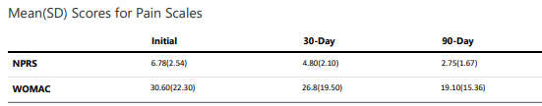
Figure 2. The average score reported at each interval, and the standard deviation
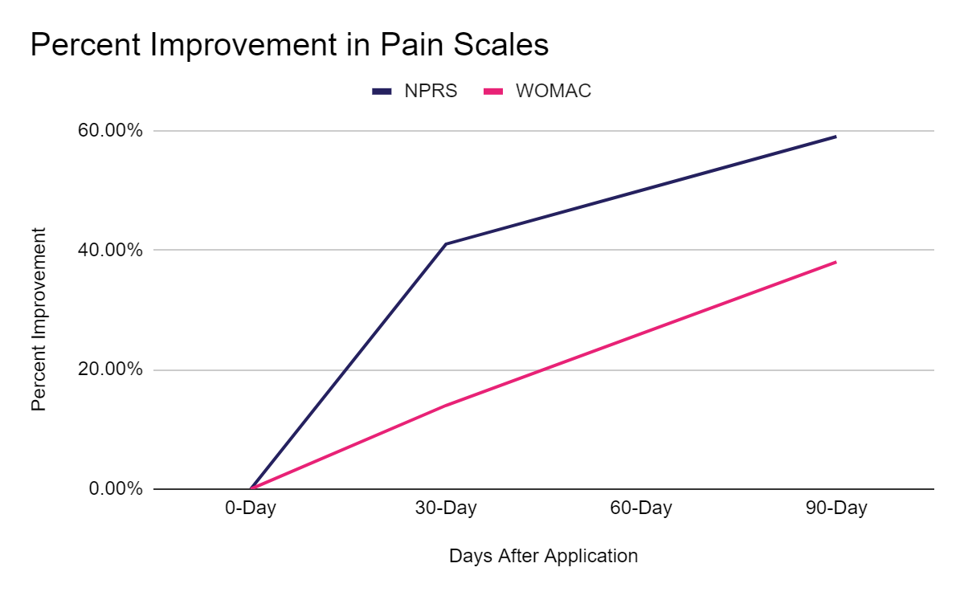
Figure 3. Percent change in pain scores over time
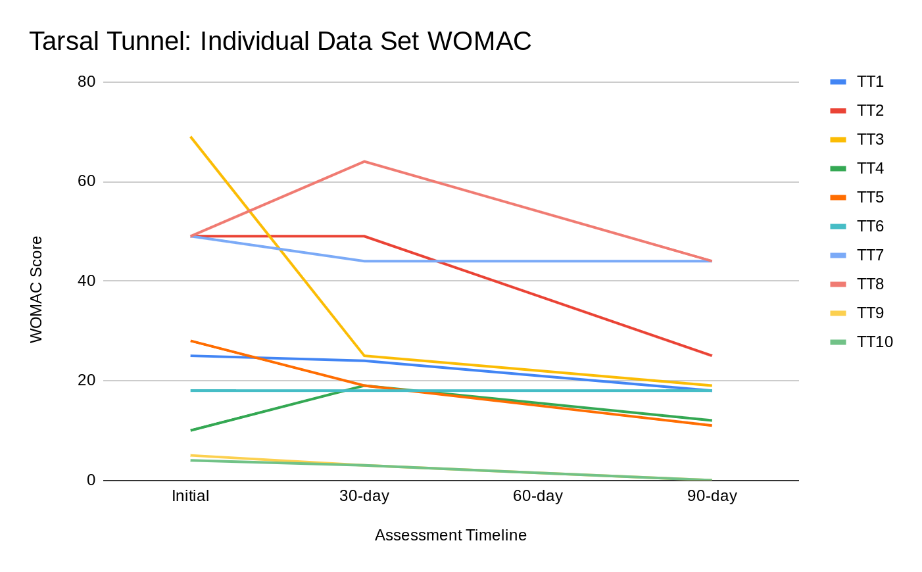
Figure 4. A higher WOMAC score correlates to increased pain.
4. Discussion
Given the reported pain improvements on various pain rating scales, this study provides evidence that WJ allograft applications are safe, minimally invasive, and efficacious for patients who have failed standard care treatments for connective tissue defects associated with Tarsal Tunnel syndrome. Of the patients in this study, no adverse reactions were reported. Wharton’s jelly is extracted from a human umbilical cord, classifying it as an immune-privileged tissue, meaning it will not elicit an immune reaction. Although the umbilical cord tissue is thoroughly tested for infectious diseases, minimal risk remains for reaction. It should also be noted that the tissue is cryopreserved and protected with DMSO. If the patient receiving the tissue allograft has an allergy to sulfonamides, there is a DMSO-free allograft available. Provided that a physician applies the product, human error can exist in the application process that could potentially lead to an adverse reaction from injection site irritation. The results of this study warrant further research to confirm the efficacy of Wharton's jelly added to conservative care protocols. Additional studies may clarify the optimal dose, protocol, and durability of WJ allograft application.
Limitations of this study include its small cohort size and non-blinded trial design. The small cohort size may produce less precise results. In addition, it may not
accurately represent how the product would work for the more generalized. In future studies, an effort will be made to attain a larger sample size to produce more reliable and statistically analyzable results. However, The effect of the survey being non-blinded is minimized by using patient-reported scales of NPRS and WOMAC, which quantize patient pain, functionality, and stiffness based on an array of questions based on the patient's perception of their own pain. Additionally, the study is retrospective, which limits the use of site-specific scales and ultimately limits data collection, affecting the specificity of results. Future prospective
The positive results presented in this retrospective case series align with current literature on human tissue defects associated with knee pain and articular cartilage defects affiliated with the sacroiliac joint [15] [16], degenerative tissue in sacral decubitus ulcers (Lavor, 2023), and more. Patient-reported pain, joint stiffness, and physical function had a significant improvement in the knee study by Timmons. The study shows lasting pain relief maintained for more than 24 months after just one WJ application.The patient’s pain and progress were determined through the use of the Visual Analogue Scale (VAS) and WOMAC scale. The study included 30 adults with an average age of 63 years old. There was a statistically significant improvement in VAS scores with activity and with rest. Figure 5 shows the mean VAS scores at rest and with activity over time along with the standard deviation. Similarly, Womac scores improved from baseline over time with a p-value less than 0.001. Figure 6 shows the decrease in WOMAC scores over time. Overall, the study showed an improvement in NPRS and WOMAC scores along with a reduction in opiate and NSAID use. and an In the sacroiliac study by Lai, there was an 84% of the patients reported a reduction in NPRS, and a 76% of the patients reported a reduction in WOMAC scores. The study analyzed a total of 38 patients with a mean age of 71 years old. Overall, the percent change analysis shows an average improvement of 42% in NPRS scores and an average of 22% in WOMAC scores at the 90-day mark. Figure 7 shows the statistical significance of WOMAC scores from initial to final average scores. in the sacroiliac joint study by Lai. The sacral decubitus ulcer study by Lavor showed one patient reporting a 94% decrease in wound volume and the other patient reporting a 100% decrease in wound volume after both patients had failed at least 30 months of conservative and procedural management before WJ application.Of these studies, no adverse reactions were reported, and significant pain improvement was seen in each study, aligning with the positive results in the presented case series, confirming WJ allografts as a promising alternative intervention for musculoskeletal and tissue defects.

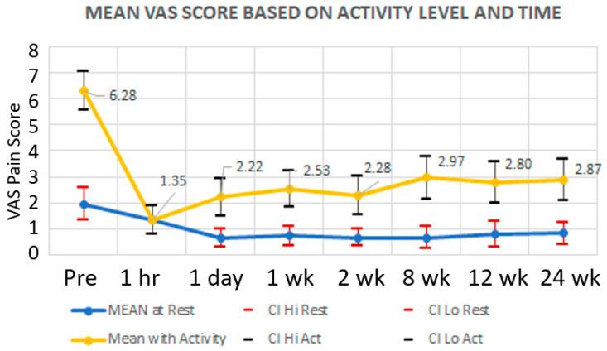
Figure 5. Mean VAS scores at rest and with activity over time, including standard deviation.

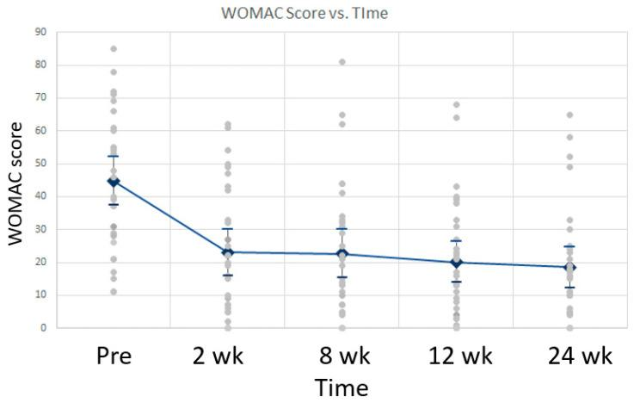
Figure 6. Mean WOMAC scores over time with standard deviation.

Figure 7. Percent change analysis for initial and final NPRS and WOMAC scores

This study implies significant importance in the potential of WJ to aid in tissue repair of collapsed connective tissues surrounding nerves and potentially nerve ECM as it demonstrates improved nerve sensation of patients enduring neuropathy associated with Tarsal Tunnel syndrome. WJ can be utilized homologously in patients suffering from neuropathy when directly addressing the connective tissues surrounding individual nerve fibers in three distinct components: the endoneurium, perineurium, and epineurium [17]. The individual nerve fiber is surrounded by the endoneurium, which is comprised of a network of collagen fibrils that function to hold together the nerve fibers and blood capillaries in larger nerve fiber bundles. The perineurium, followed by the epineurium, surrounds the endoneurium. The endoneurium, perineurium, and epineurium are all connective tissues with individual responsibilities that function together as shielding and cushioning barriers for the impulse-conducting elements of the myelin sheath covering the nerve [18]. Specifically important to this study is the function of the epineurium.
The epineurium primarily comprises a collagenous extracellular matrix surrounding the entire nerve, contributing to nerve tensile strength [18]. Nerve damage leading to neuropathy may occur if the tissue surrounding the nerve does not fully support the nerve. When tissues endure pressure, they deform and create pressure gradients. Often, compression occurs at sites where a nerve runs through a tunnel that is formed by stiff tissue boundaries [19]. A study by Rempel tested the effects of compression damage on nerve sensation and found that axonal degeneration occurred with compression and correlated with endoneurial edema [19]. A study by Gao explains that the ECM begins to participate in the nerve regeneration process in that the epineurium, perineurium, and endoneurium, which are comprised composed of collagen, provide structural support for nerve regeneration [7]. Like the ECM of the nerve fiber, the primary function of WJ is to provide cushion, protection, and structural support to umbilical vessels by preventing their compression, torsion, and bending [20]. This study proposes that the application of WJ to the surrounding area of the affected nerve can supplement and promote the repair of the damaged connective tissue that is contributing to nerve compression. When WJ is applied directly to the nerve, it can replace the missing ECM and provide cushioning and support to the nerve fascicles, promoting standard functionality. This homologous supplementation is supported by the positive outcomes reported in this study.
Given the function and components of WJ and the significant results in this study, WJ presents a promising alternative to the current standard of care practices and could potentially prevent further invasive procedures. Additional research with randomized control trials can statistically compare the efficacy and durability of WJ in connective nerve tissue supplementation for neuropathy patients with other standard non-invasive procedures.
5. Conclusions
The utilization of WJ allografts in supplementing tissue defects associated with tarsal tunnel syndrome shows improvement in patient pain and function. WJ can replace the damaged ECM and connective layers of the affected nerves, as well as cushion the nerve from exterior soft tissue damage, which leads to improved nerve sensation, ultimately decreasing neuropathy associated with Tarsal Tunnel syndrome. After failing other standard-of-care treatment options, the patients in this study were able to find relief with one application of WJ allografts. These findings suggest that WJ allografts can be used as an effective intervention for defects related to tarsal tunnel syndrome when the standard of care treatments have failed. The utilization of WJ allografts could decrease the occurrence of surgical procedures and ultimately be more time and cost-effective. Future research may include a larger and more diverse cohort and a blinded control group to evaluate the safety and efficacy of WJ further and assist in defining dosage protocols in the application of tissue defects associated with Tarsal Tunnel syndrome.
Author Contributions: Conceptualization, R.B., T.G, J.S. and T.B.; methodology, R.B., T.G. ; software, T.Y.; validation, N.L., C.W. and T.Y.; formal analysis, N.L., C.W.; investigation, R.B, T.G..; resources, N.L., C.W.; data curation, R.B., T.G.; writing—original draft preparation, R.B., T.G., N.L., C.W.; writing—review and editing, R.B., T.G., N.L., C.W.; visualization, R.B., T.G., T.B.; supervision, J.S., T.B.; project administration, T.B.; funding acquisition, R.B., T.G., T.B. All authors have read and agreed to the published version of the manuscript.

Funding: This research received no external funding
Institutional Review Board Statement: The study was conducted in accordance with the Declaration of Helsinki, and approved by the Institutional Review Board of the Institute of Regenerative and Cellular Medicine (protocol code IRCM-2022-311 and approved on 12 January 2022).
Informed Consent Statement: Informed consent was obtained from all subjects involved in the study.
Data Availability Statement: Data can be found in Appendix A
Acknowledgments: In this section, you can acknowledge any support given which is not covered by the author contribution or funding sections. This may include administrative and technical support, or donations in kind (e.g., materials used for experiments).
Conflicts of Interest: Ronald Bruton and Tracie Gilliland are associated with Advanced Medicine of the Ozarks. John Shou is associated with Baylor College of Medicine and is also the principle investigator of the retrospective repository at Regenative Labs. Crislyn Woods, Naomi Lambert, and Tyler Barrett are associated with Regenative Labs. Regenerative Labs was involved in the design of the study, data analysis, and writing. Regenative Labs influenced the decision to publish.
Appendix A. Patient Reported Scores
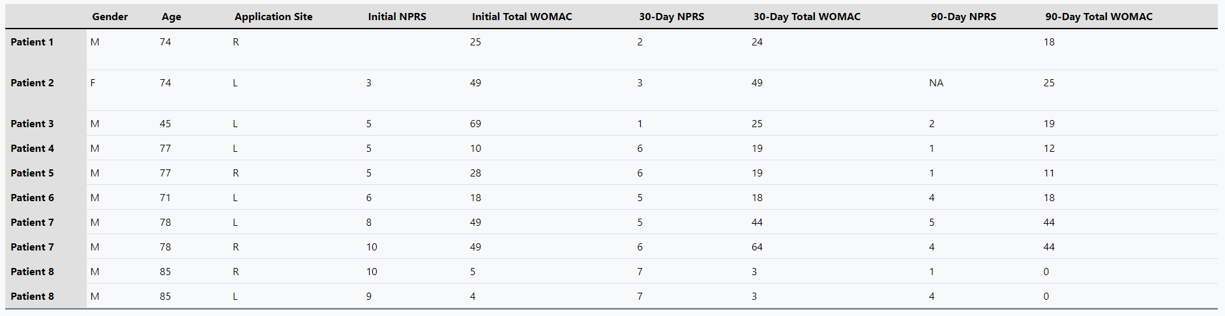

References
- Kalçık Ünan, M., Ardıçoğlu, Ö., Pıhtılı Taş, N., Aydoğan Baykara, R., & Kamanlı, A. (2021). Assessment of the frequency of tarsal tunnel syndrome in rheumatoid arthritis. Turkish journal of physical medicine and rehabilitation, 67(4), 421–427. https://doi.org/10.5606/tftrd.2021.6797
- Kiel J, Kaiser K. Tarsal Tunnel Syndrome. [Updated 2022 Aug 8]. In: StatPearls [Internet]. Treasure Island (FL): StatPearls Publishing; 2023 Jan-. Available from: https://www.ncbi.nlm.nih.gov/books/NBK513273/
- Dreyer, M. A., & Gibboney, M. D. (2023). Anterior Tarsal Tunnel Syndrome. In StatPearls. StatPearls Publishing.
- McSweeney, S. C., & Cichero, M. (2015). Tarsal tunnel syndrome—A narrative literature review. The Foot, 25(4), 244-250.
- Rodríguez-Merchán EC, Moracia-Ochagavía I. Tarsal tunnel syndrome: current rationale, indications and results. EFORT Open Rev. 2021 Dec 10;6(12):1140-1147. doi: 10.1302/2058-5241.6.210031. PMID: 35839088; PMCID: PMC8693231.
- Iborra, A., Villanueva, M. & Sanz-Ruiz, P. Results of ultrasound-guided release of tarsal tunnel syndrome: a review of 81 cases with a minimum follow-up of 18 months. J Orthop Surg Res 15, 30 (2020). https://doi.org/10.1186/s13018-020-1559-1
- Gao X, Wang Y, Chen J, Peng J. The role of peripheral nerve ECM components in the tissue engineering nerve construction. Rev Neurosci. 2013;24(4):443-53. doi: 10.1515/revneuro-2013-0022. PMID: 23907421.
- Hawker GA, Mian S, Kendzerska T, French M. Measures of adult pain: Visual Analog Scale for Pain (VAS Pain), Numeric Rating Scale for Pain (NRS Pain), McGill Pain Questionnaire (MPQ), Short-Form McGill Pain Questionnaire (SF-MPQ), Chronic Pain Grade Scale (CPGS), Short Form-36 Bodily Pain Scale (SF-36 BPS), and Measure of Intermittent and Constant Osteoarthritis Pain (ICOAP). Arthritis Care Res (Hoboken). 2011 Nov;63 Suppl 11:S240-52. doi: 10.1002/acr.20543.
- Kim MJ, Kang BH, Park SH, Kim B, Lee GY, Seo YM, Park KS, Yoo JI. Association of the Western Ontario and McMaster Universities Osteoarthritis Index (WOMAC) with Muscle Strength in Community-Dwelling Elderly with Knee Osteoarthritis. Int J Environ Res Public Health. 2020 Mar 27;17(7):2260. doi: 10.3390/ijerph17072260.
- Arnold, G., & Auvray, M. (2017). The Graphesthesia Paradigm: Drawing Letters on the Body to Investigate the Embodied Nature of Perspective-Taking. i-Perception, 8(1), 2041669517690163. https://doi.org/10.1177/2041669517690163
- Malik, M. M., Jindal, S., Bansal, S., Saxena, V., & Shukla, U. S. (2013). Relevance of ankle reflex as a screening test for diabetic peripheral neuropathy. Indian journal of endocrinology and metabolism, 17(Suppl 1), S340–S341. https://doi.org/10.4103/2230-8210.11964.
- Forbes J, Munakomi S, Cronovich H. Romberg Test. [Updated 2023 Aug 13]. In: StatPearls [Internet]. Treasure Island (FL): StatPearls Publishing; 2023 Jan-. Available from: https://www.ncbi.nlm.nih.gov/books/NBK563187/
- Cohen, H. S., Stitz, J., Sangi-Haghpeykar, H., Williams, S. P., Mulavara, A. P., Peters, B. T., & Bloomberg, J. J. (2018). Tandem walking as a quick screening test for vestibular disorders. The Laryngoscope, 128(7), 1687–1691. https://doi.org/10.1002/lary.27022
- Fred R.T. Nelson, Carolyn Taliaferro Blauvelt. 12 - Physical Medicine and Rehabilitation: Physical Therapy and Occupational Therapy. A Manual of Orthopaedic Terminology (Eighth Edition). W.B. Saunders. 2015. Pages 365-375. ISBN 9780323221580. https://doi.org/10.1016/B978-0-323-22158-0.00012-3.
- Timmons RB, Sugaya K, Bane LD. Homologous Use of Allogeneic Umbilical Cord Tissue to Reduce Knee Pain and Improve Knee Function. Life 2022,12,260. https:// doi.org/10.3390/life12020260
- Lai A, Shou J, Traina SA, Barrett T. The Durability and Efficacy of Cryopreserved Human Umbilical Cord Tissue Allograft for the Supplementation of Cartilage Defects Associated with the Sacroiliac Joint: A Case Series. Reports. 2023; 6(1):12. https://doi.org/10.3390/reports6010012
Lavor M, Shou J, Mobarak R, Lambert N, Barrett T. Novel Application of Umbilical Cord Flowable Tissue Allografts in Sacral Decubitus Ulcers: A Case Study. 2023 Jan 05; 4(1): 014-022. doi: 10.37871/jbres1644, Article ID: JBRES1644, Available at: https://www.jelsciences.com/articles/jbres1644.pdf
- Pavelka, M., Roth, J. (2010). Peripheral Nerve: Connective Tissue Components. In: Functional Ultrastructure. Springer, Vienna. https://doi.org/10.1007/978-3-211-99390-3_166
- Peltonen, S., Alanne, M., & Peltonen, J. (2013). Barriers of the peripheral nerve. Tissue barriers, 1(3), e24956. https://doi.org/10.4161/tisb.24956
- National Research Council (US) Steering Committee for the Workshop on Work-Related Musculoskeletal Injuries: The Research Base. Work-Related Musculoskeletal Disorders: Report, Workshop Summary, and Workshop Papers. Washington (DC): National Academies Press (US); 1999. Biological Response of Peripheral Nerves to Loading: Pathophysiology of Nerve Compression Syndromes and Vibration Induced Neuropathy. Available from: https://www.ncbi.nlm.nih.gov/books/NBK230871/
- Gupta, A., El-Amin, S.F., Levy, H.J. et al. Umbilical cord-derived Wharton’s jelly for regenerative medicine applications. J Orthop Surg Res 15, 49 (2020). https://doi.org/10.1186/s13018-020-1553-7
Disclaimer/Publisher’s Note: The statements, opinions and data contained in all publications are solely those of the individual author(s) and contributor(s) and not of MDPI and/or the editor(s). MDPI and/or the editor(s) disclaim responsibility for any injury to people or property resulting from any ideas, methods, instructions or products referred to in the content.

