Figure Supplementary 1.- Immunohistochemical identification of type I glomus cells (a-c) and type II glomus cells (b-d) in the human carotid body. NSE: neuron-specific enolase; S100P: S100 protein.

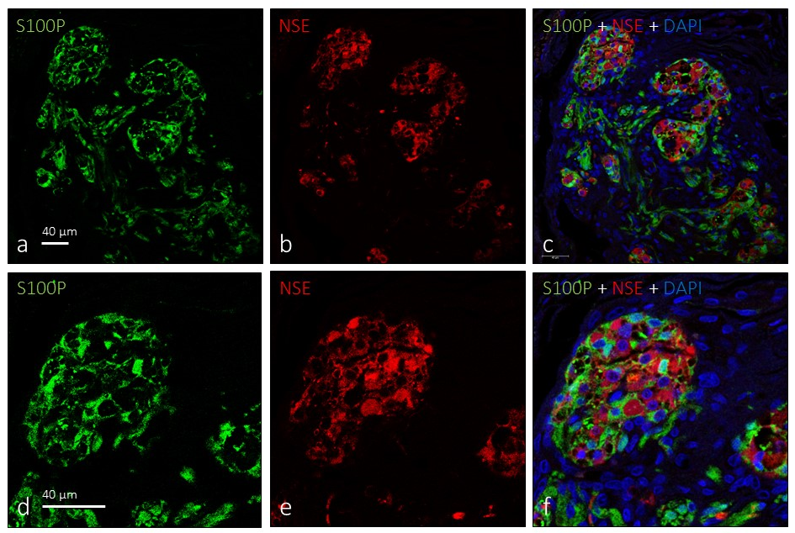
Figure Supplementary 2.- Identification of glomus cell types using immunofluorescence for NSE and S100P. The type I glomus cells displayed a strong immunofluorescence for neurons specific enolase (NSE, red fluorescence) while type II glomus cells were intensely immunolabelled by S100 protein (S100P, green fluorescence. Lens 60/1.25 oil; pinhole resolution 1.XY 156 nm and resolution Z 334 nm.
Figure Supplementary 3.- Distribution of nerve profiles in sections of the human carotid body immunolabelled for neurofilament proteins (NFP) Lens 60/1.25 oil; pinhole resolution 1.XY 156 nm and resolution Z 334 nm.

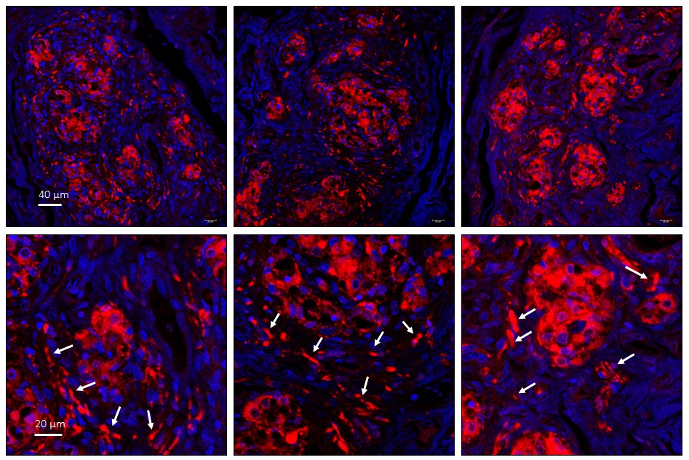
Figure Supplementary 4.- Identification of type I glomus cells and nerve profiles (white arrows) in the human carotid body immunolabelled for neuron specific enolase (NSE). Lens 60/1.25 oil; pinhole resolution 1.XY 156 nm and resolution Z 334 nm.

