Article
End-to-End Continuous Small-Scale Drug Substance Manufacturing: From Continuous in-situ Nucleator to Free-Flowing Crystalline Particles
Anne Cathrine Kufner, Marc Meier and Kerstin Wohlgemuth *
Table S1. Results of gravimetric concentration measurements at 5, 10 and 15 min RT for the 90° T-mixer designed for the SFC coupling according to the procedure described in section 3.2.1.
$τ$ / min | 5 | 10 | 15
$w_{solid}$ / wt.-% | 0.088 ± 0.011 | 0.151 ± 0.030 | 0.265 ± 0.043

Table S2: Different operating points for the T-mixer with 180° inlets based on the graphical construction in the ternary solubility diagram for l-alanine/water/ethanol at 20 °C and 1 bar.
T-mixer configuration | 180° | 180° | 180° | 180° | 180°
$ϑ$ / °C | 20 | 20 | 20 | 20 | 20
$\frac{Q_{Feed}}{Q_{AS}}$ / - | 1 | 1 | 1 | 1 | 1
$w_{EtOH,AS}$ / wt.-% | 37.50 | 43.75 | 50 | 62.5 | 75
$w_{solid}$ / wt.-% | 0.88 | 1.86 | 2.26 | 3.93 | 5.02
${Re}_{M}$ / - | 374 | 367 | 362 | 350 | 349

Table S3: Design and process parameters as well as the experimental results of this study. The results of the characterization experiments of the T-mixer with 180° and 90° inlets as continuous in-situ nucleator and coupling experiments of the T-mixer with 90° inlet configuration with the SFC as well as with the SFC and the CVSF are listed.
 | T-mixer configuration | 180° | 90° | 90° | 90
 | $ϑ$ / °C | 20 | 20 | 20 | 50
Design & process parameters  (NZ) | $d_{i, AS}$ / mm | 0.75 | 0.75 | 0.75 | 0.75
 | $d_{i,Feed}$ / mm | 0.75 | 2.61 | 1.83 | 2.27
 | $d_{i,M}$ / mm | 1.06 | 2.61 | 1.83 | 2.27
 | $w_{EtOH,mix}$ / wt.-% | 23 | 5 | 10 | 5
 | $w_{solid,th}$ / wt.-% | 2.26 | 1 | 1 | 1
 | $Q_{Feed}$ / mL min⁻¹ | 10 | 10 | 10 | 5
 | $Q_{AS}$ / mL min⁻¹ | 10 | 0.83 | 1.68 | 0.55
 | $w_{EtOH,AS}$ / wt.-% | 50 | 72 | 51 | 61
 | ${Re}_{M}$ / - | 362 | 88 | 131 | 95
Characterization experiments  (NZ) | $w_{solid,τ=5min}$ / wt.-% | 0.170 | 0.088 ± 0.011 | 0.082 ± 0.005 | -
 | $w_{solid,τ=10min}$ / wt.-% | 0.257 | 0.151 ± 0.030 | 0.059 ± 0.002 | -
 | $w_{solid,τ=15min}$ / wt.-% | 0.600 | 0.265 ± 0.043 | 0.090 ± 0.007 | -
 | $n_{particle,τ=15min}$ / - | 35541 | - | - | -
 | ${MIL}_{ch,τ=15min}$ / µm | 11.92 | - | - | -
 | ${MAL}_{ch,τ=15min}$ / µm | 73.56 | - | - | -
 | ${AR}_{ch,τ=15min}$ / - | 6.17 | - | - | -
 | $n_{particle,τ=10s}$ / - | - | 93 ± 7 | 196 ± 162 | -
 | $d_{50,3,τ=10s}$ / µm | - | 36.05 ± 0.89 | 39.43 ± 6.14 | -
 | $d_{90-10,3,τ=10s}$ / µm | - | 27.40 ± 2.67 | 57.85 ± 19.24 | -
 | $n_{particle,τ=15min}$ / - | - | 25908 ± 3353 | 11474 ± 3737 | -
 | $d_{50,3,τ=15min}$ / µm | - | 52.54 ± 4.20 | 47.58 ± 0.26 | -
 | $d_{90-10,3,τ=15min}$ / µm | - | 64.82 ± 1.85 | 72.68 ± 5.98 | -
Coupling experiments (I)  (NZ + SFC) | $L_{tubing}$ / m | - | - | - | 26.54
 | $Q_{L}$ / mL min⁻¹ | - | - | - | 5.55
 | $ε_{L,0}$ / - | - | - | - | 0.43 ± 0.03
 | $τ_{NZ+SFC}$ / min | - | - | - | 16.44 ± 1.21
 | $ϑ_{SFC,start}$ / °C | - | - | - | 50.35 ± 0.11
 | $ϑ_{SFC,end}$ / °C | - | - | - | 25.64 ± 0.41
 | $\overline{κ}$ / K min⁻¹ | - | - | - | 1.51 ± 0.09
 | $Y_{rel}$ / % | - | - | - | 81.52 ± 3.61
 | $n_{particle}$ / - | - | - | - | 494 ± 248
 | $d_{50,3}$ / µm | - | - | - | 484.14 ± 54.60
 | $d_{90-10,3}$ / µm | - | - | - | 530.47 ± 50.21
Coupling experiments (II)  (NZ+ SFC) | $L_{tubing}$ / m | - | - | - | 26.54
 | $Q_{L}$ / mL min⁻¹ | - | - | - | 11.09
 | $ε_{L,0}$ / - | - | - | - | 0.41 ± 0.01
 | $τ_{NZ+SFC}$ / min | - | - | - | 7.74 ± 0.13
 | $ϑ_{SFC,start}$ / °C | - | - | - | 49.46 ± 0.01
 | $ϑ_{SFC,end}$ / °C | - | - | - | 34.75 ± 0.08
 | $\overline{κ}$ / K min⁻¹ | - | - | - | 1.90 ± 0.02
 | $Y_{rel}$ / % | - | - | - | 65.65 ± 2.07
 | $n_{particle}$ / - | - | - | - | n.a.
 | $d_{50,3}$ / µm | - | - | - | n.a.
 | $d_{90-10,3}$ / µm | - | - | - | n.a.
Coupling experiments  (NZ + SFC + CVSF) | $L_{tubing}$ / m | - | - | - | 26.54
 | $Q_{L}$ / mL min⁻¹ | - | - | - | 5.55
 | $ε_{L,0}$ / - | - | - | - | 0.44 ± 0.00
 | $τ_{SFC}$ / min | - | - | - | 16.72 ± 0.04
 | $ϑ_{SFC,start}$ / °C | - | - | - | 48.89 ± 0.24
 | $ϑ_{SFC,end}$ / °C | - | - | - | 23.63 ± 0.19
 | $\overline{κ}$ / K min⁻¹ | - | - | - | 1.51 ± 0.03
 | $w_{solid}$ / wt.-% | - | - | - | 2.73 ± 0.56
 | $ϑ_{heater,TM,IN}$ / °C | - | - | - | 51
 | $ϑ_{heater,TM,OUT}$ / °C | - | - | - | 31
 | $n_{screw}$ / rpm | - | - | - | 1
 | ${∆p}_{set}$ / mbar | - | - | - | 400
 | $Q_{wash}$ / mL min⁻¹ | - | - | - | 15
 | $α$ / % | - | - | - | 5
 | $τ_{CVSF,id}$ / min | - | - | - | 32
 | $Y_{rel}$ / % | - | - | - | 87.50 ± 2.50
 | $n_{particle,IN}$ / - | - | - | - | 2755 ± 1222
 | $d_{50,3,IN}$ / µm | - | - | - | 412.15 ± 49.36
 | $d_{90-10,3,IN}$ / µm | - | - | - | 263.85 ± 6.97
 | $n_{particle,OUT}$ / - | - | - | - | 3634
 | $d_{50,3,OUT}$ / µm | - | - | - | 353.29
 | $d_{90-10,3,OUT}$ / µm | - | - | - | 267.60
 | $φ_{RM}$ / % | - | - | - | 3.00 ± 0.16

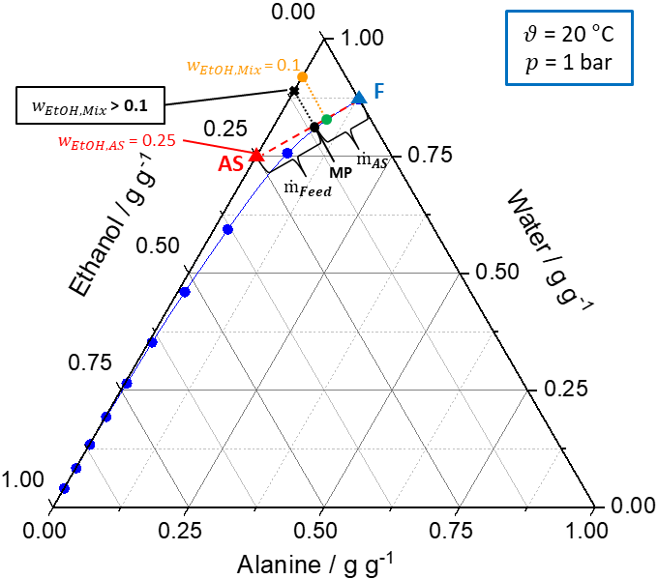
Figure S1: Ternary solubility diagram of l-alanine/water/ethanol at 20 °C and 1 bar. The solid blue line represents the solubility curve based on the experimental data from An et al. [36]. The solid green line describes the underlying conode of the nucleation process until thermodynamic equilibrium is reached. The dashed red line connects the feed (F, blue triangle) and antisolvent mixture (AS, red triangle, $w_{EtOH, AS}$) to be mixed and the intersection between the dashed red line and the green line defines the MP (black dot). By using the lever rule, $w_{solid}$ as well as the ratio of the feed and antisolvent mass flow rate can be calculated based on the location of the MP on the conode. Graphical construction of nucleation process using the 180° inlet T-mixer.

