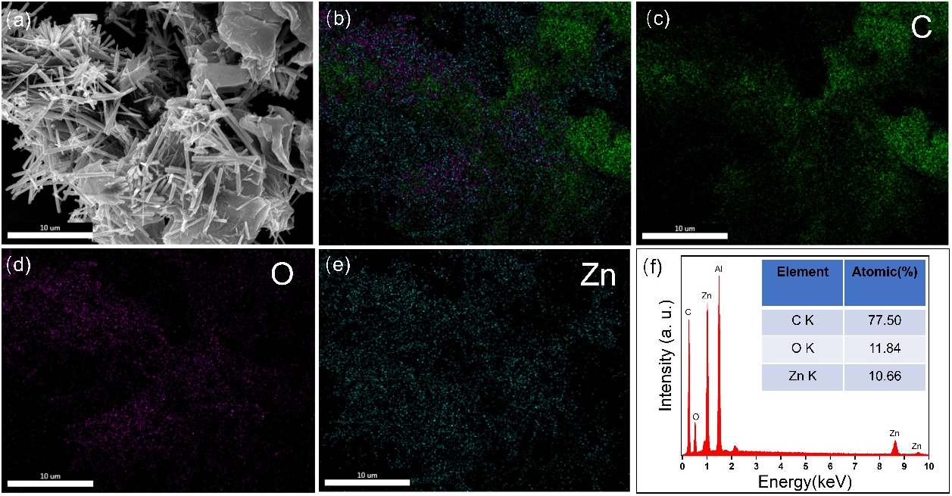
Figure S1. (a-e) SEM images of the ZnO/CBC-60% and corresponding mapping images of C, O and Zn; (f) the EDS analysis of the prepared ZnO/CBC-60%.
Figure S2. Mott-Schottky curves of (a) CBC, (b) ZnO/CBC-60%

