Supplementray material

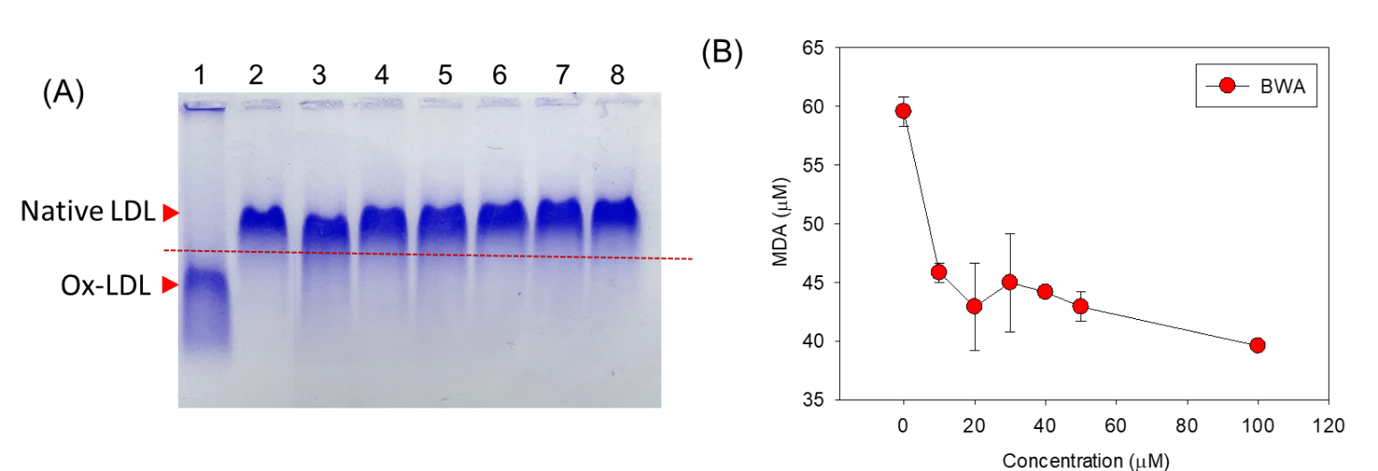
Supplementary Figure S1. Effect of beeswax alcohol (BWA) on CuSO₄ induced oxidation of LDL. (A) Electrophoretic mobility of apo-B fraction of LDL. Lanes 1 represent LDL+CuSO₄ (Ox LDL), Lane 2 represent Native LDL, Lane 3, 4, 4, 5, 7, 8 represent LDL+CuSO₄ treated with 10, 20, 30, 40, 50 and 100 μM BWA. Electrophoresis was performed on 0.5% agarose gel using Tris-EDTA buffer (pH 8.0) at a constant voltage (50 V). The red dotted line indicates different electromobility from the loading position depends on the extent of oxidation. (B) Quantification of CuSO₄-induced LDL oxidation in the presence and absence of BWA. The LDL oxidation was quantified by thiobarbituric acid reactive substance (TBARS) assay using malondialdehyde (MDA) as reference.

