Supplementary Materials

Characterization and preclinical in silico safety assessment of three virulent bacteriophages targeting carbapenem-resistant uropathogenic Escherichia coli
Gunaraj Dhungana ^{1,2*}, Roshan Nepal ^{3,4,5*}, Ghais Houtak ^{3,4}, George Bouras ^{3,4}, Sarah Vreugde ^{3,4}, Rajani Malla¹
¹ Central Department of Biotechnology, Institute of Science and Technology, Tribhuvan University, Kirtipur, Nepal
² Nepal Health Research Council, Government of Nepal, Kathmandu, Nepal
³ Adelaide Medical School, Faculty of Health and Medical Sciences, The University of Adelaide, Adelaide, SA, Australia
⁴ The Department of Surgery-Otolaryngology Head and Neck Surgery, The Basil Hetzel Institute for Translational Health Research, Central Adelaide Local Health Network, South Australia, Australia.
⁵ Commonwealth Scientific and Industrial Research Organization (CSIRO), Agriculture and Food, Hobart, Tasmania, Australia

*Corresponding author(s):
Dr. Gunaraj Dhungana, grdhungana79@gmail.com
Dr. Roshan Nepal, roshan.nepal@adelaide.edu.au
Prof. Rajani Malla, rajanimalla2000@gmail.com

Supplementary Figures

Figure S1 | MAUVE alignment of three Escherichia phages (øEc_Makalu_001, øEc_Makalu_002 and øEc_Makalu_003) compared with the most closely related Escherichia phage Phi1.

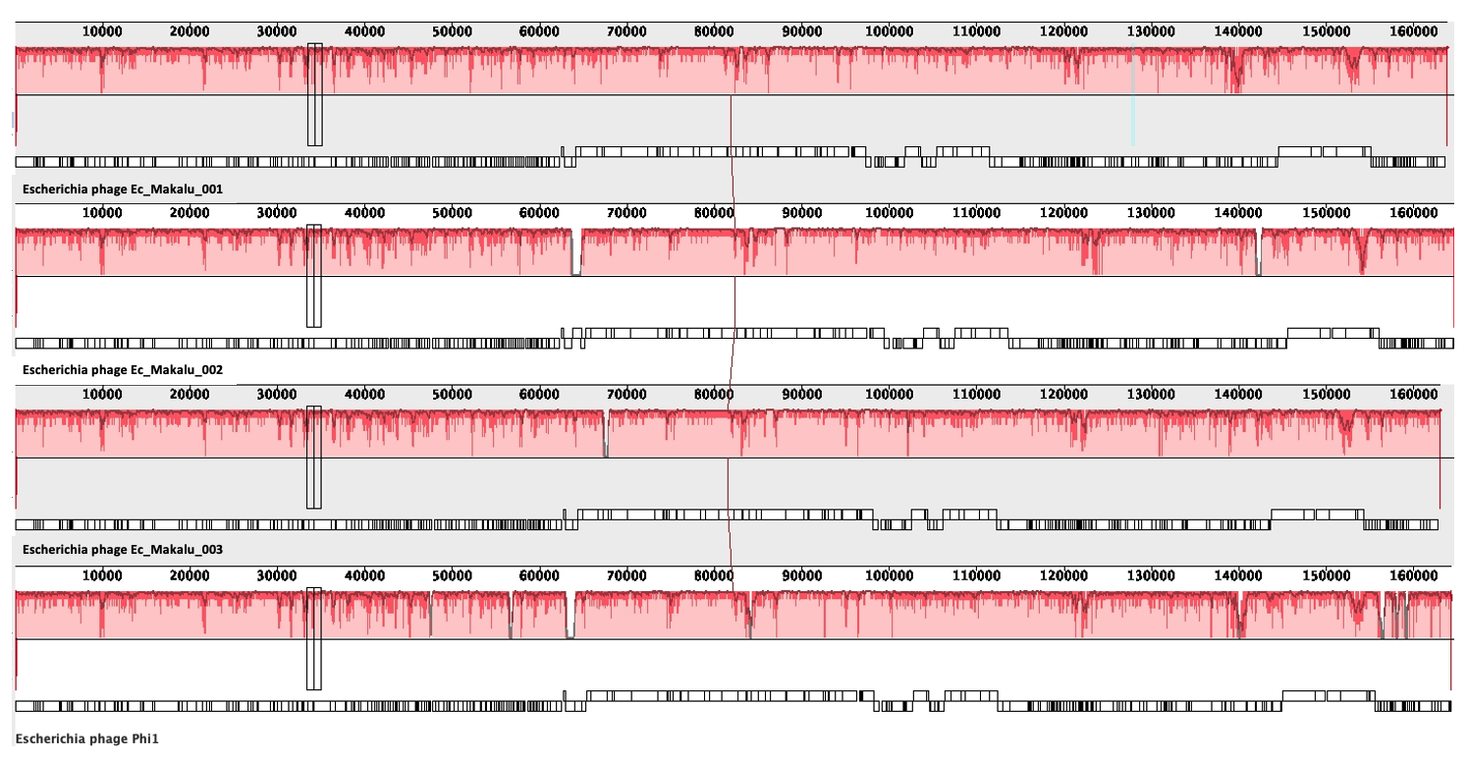

Figure S2 | Consensus alignment of long tail fiber protein. Amino acids that match the reference are marked with yellow highlighting. Consensus threshold = 50%.

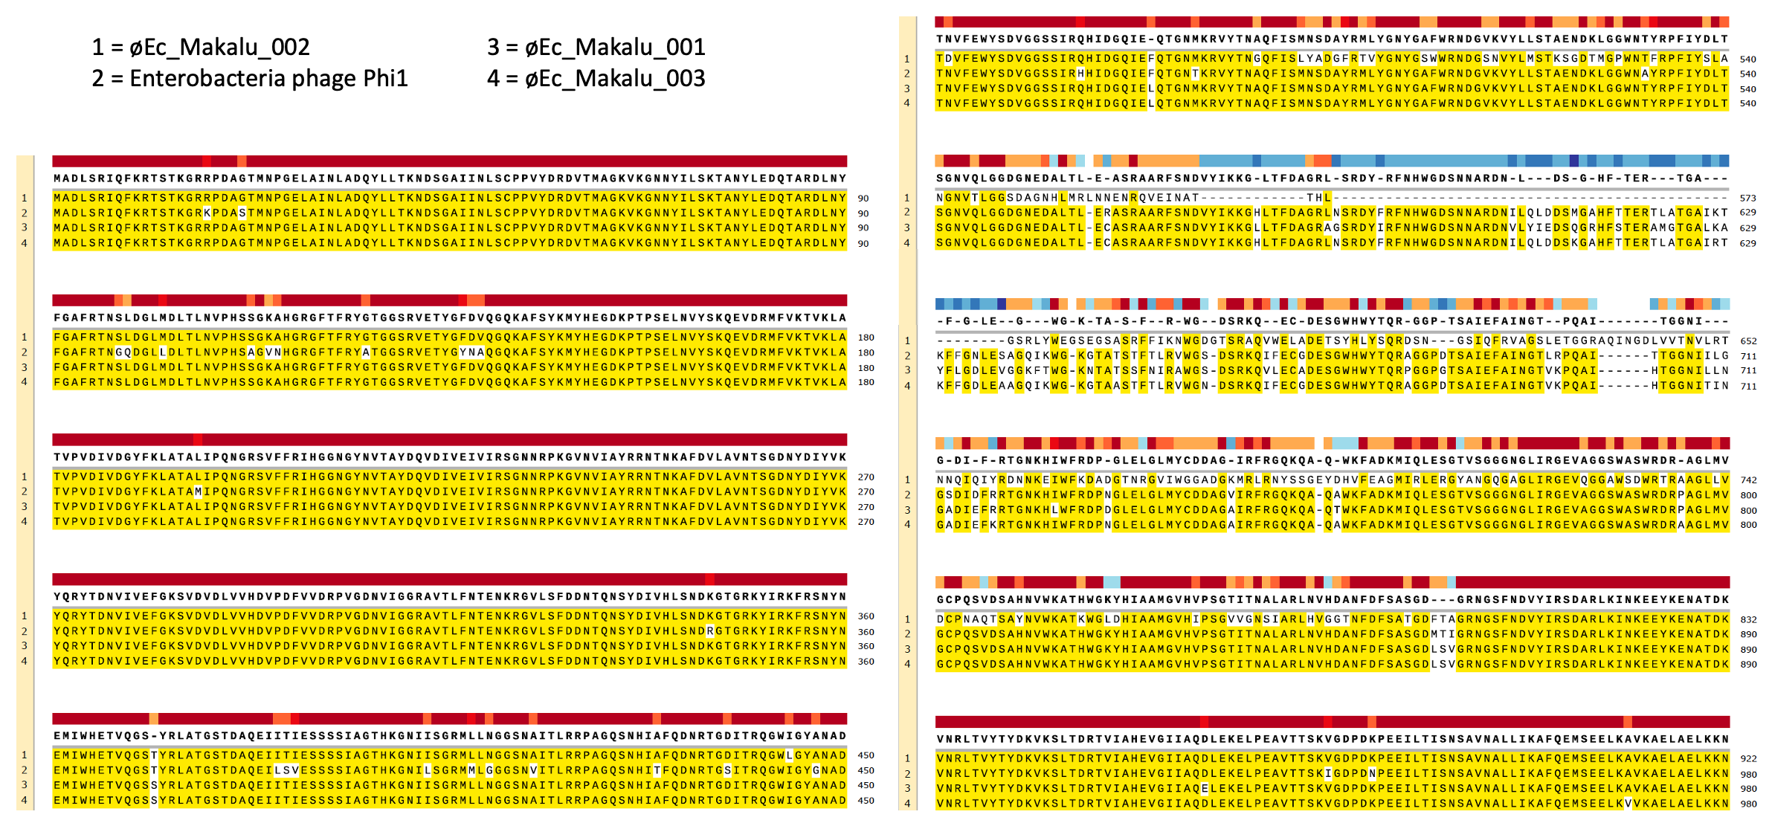
Figure S3 | The Genome-BLAST Distance Phylogeny (GBDP) tree of phages øEc_Makalu_001, øEc_Makalu_002, and øEc_Makalu_003 inferred using formula D4 and yielding average support of 6 %. The analysis reveals that all three phages belong to the same family and genus level and share maximum sequence similarity with other phages in the NCBI database, including Shigella phages.

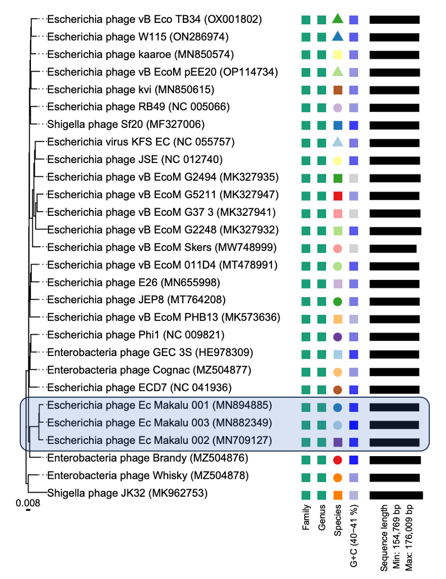

Supplementary Table
Table S1 | Sequences producing significant alignments with reference genome of Escherichia phage Ec_Makalu_001

SN | Scientific Name | Accession | Max Score | Total Score | Query Coverage | Per. identity | Total Per. identity | Acc. Length
1 | Escherichia phage Ec_Makalu_001 | MN894885.1 | 3.02E+05 | 3.05E+05 | 100% | 100 | 100.00 | 163752
2 | Escherichia phage Ec_Makalu_002 | MN709127.1 | 1.12E+05 | 2.87E+05 | 98% | 98.49 | 96.52 | 164674
3 | Escherichia phage Ec_Makalu_003 | MN882349.1 | 77484 | 2.89E+05 | 98% | 98.79 | 96.81 | 162966
4 | Escherichia phage Phi1 | EF437941.1 | 62462 | 2.59E+05 | 96% | 97.07 | 93.19 | 164270
5 | Escherichia phage kvi | MN850615.1 | 58362 | 2.55E+05 | 94% | 96.74 | 90.94 | 163673
6 | Escherichia phage JEP8 | MT764208.1 | 57899 | 2.59E+05 | 96% | 96.51 | 92.65 | 165295
7 | Escherichia phage vB_EcoM_PHB13 | MK573636.1 | 55118 | 2.56E+05 | 96% | 97.31 | 93.42 | 165641
8 | Enterobacteria phage GEC-3S | HE978309.1 | 51849 | 2.61E+05 | 97% | 95.04 | 92.19 | 163424
9 | Escherichia phage ECD7 | NC_041936.1 | 49807 | 2.59E+05 | 97% | 97.29 | 94.37 | 164706
10 | Escherichia virus KFS-EC | NC_055757.1 | 49748 | 2.47E+05 | 94% | 93.29 | 87.69 | 164715
11 | Escherichia phage vB_EcoM_011D4 | MT478991.1 | 49543 | 2.59E+05 | 96% | 95.1 | 91.30 | 163764
12 | Escherichia phage RB49 | AY343333.1 | 43674 | 2.60E+05 | 96% | 97.33 | 93.44 | 164018
13 | Escherichia phage kaaroe | MN850574.1 | 43120 | 2.60E+05 | 96% | 96.94 | 93.06 | 163719
14 | Escherichia phage E26 | MN655998.1 | 42911 | 2.60E+05 | 96% | 96.43 | 92.57 | 164572
15 | Escherichia phage vB_EcoM_G2248 | MK327932.1 | 42475 | 2.38E+05 | 93% | 95.48 | 88.80 | 170678
16 | Escherichia phage vB_EcoM_Skers | MW748999.1 | 41539 | 2.33E+05 | 88% | 95.08 | 83.67 | 154769
17 | Enterobacteria phage Brandy | MZ504876.1 | 40470 | 2.57E+05 | 96% | 95.83 | 92.00 | 169232
18 | Escherichia phage W115 | ON286974.1 | 39548 | 2.61E+05 | 96% | 95.18 | 91.37 | 163997
19 | Shigella phage JK32 | MK962753.1 | 38428 | 2.29E+05 | 93% | 93.65 | 87.09 | 176009
20 | Escherichia phage vB_EcoM_G37-3 | MK327941.1 | 37096 | 2.44E+05 | 94% | 96 | 90.24 | 167832
21 | Enterobacteria phage Whisky | MZ504878.1 | 34915 | 2.46E+05 | 95% | 95.62 | 90.84 | 165615
22 | Shigella phage Sf20 | MF327006.1 | 33787 | 2.60E+05 | 96% | 97.75 | 93.84 | 163982
23 | Escherichia phage vB_Eco_TB34 | OX001802.1 | 33606 | 2.62E+05 | 96% | 96.56 | 92.70 | 165220
24 | Enterobacteria phage Cognac | MZ504877.1 | 31490 | 2.53E+05 | 95% | 96.94 | 92.09 | 164031
25 | Escherichia phage vB_EcoM_G5211 | MK327947.1 | 31242 | 2.40E+05 | 93% | 96.21 | 89.48 | 164278
26 | Escherichia phage vB_EcoM_G2494 | MK327935.1 | 28801 | 2.45E+05 | 94% | 97.15 | 91.32 | 168327
27 | Escherichia phage JSE | EU863408.1 | 27253 | 2.45E+05 | 95% | 96.97 | 92.12 | 166418
28 | Myoviridae sp. | BK017805.1 | 24912 | 59131 | 22% | 97.7 | 21.49 | 40781
29 | Myoviridae sp. | BK016552.1 | 16460 | 47240 | 24% | 89.23 | 21.42 | 43086
30 | Myoviridae sp. | BK016985.1 | 11300 | 11300 | 5% | 90.13 | 4.51 | 12469
31 | Myoviridae sp. | BK024305.1 | 7638 | 46483 | 21% | 92.82 | 19.49 | 38377
32 | Escherichia phage RB49 | AF203974.1 | 3251 | 3251 | 1% | 98.79 | 0.99 | 1824
33 | Escherichia phage RB49 | AJ489481.1 | 3020 | 3020 | 1% | 97.25 | 0.97 | 1783
34 | Escherichia phage RB49 | AB084150.1 | 2900 | 2900 | 1% | 95.73 | 0.96 | 1803
35 | Escherichia coli | CP071263.1 | 2765 | 3398 | 1% | 85.4 | 0.85 | 5241795
36 | Escherichia phage RB49 | AJ550428.1 | 2488 | 2488 | 0% | 96.78 | 0.00 | 1491
37 | Escherichia coli | CP057368.1 | 2183 | 3209 | 2% | 81.65 | 1.63 | 4743602
38 | Escherichia coli | CP028733.1 | 1978 | 2617 | 1% | 80.31 | 0.80 | 4816573
39 | Escherichia coli | CP063720.1 | 1930 | 2541 | 1% | 79.99 | 0.80 | 4771390
40 | Escherichia coli | CP057861.1 | 1925 | 2585 | 1% | 79.95 | 0.80 | 4899428
41 | Escherichia coli | CP057166.1 | 1842 | 2901 | 2% | 79.41 | 1.59 | 4935063
42 | Escherichia coli | CP091038.1 | 1646 | 3133 | 2% | 84.75 | 1.70 | 4911746
43 | Enterobacteria phage MV BS | DQ485346.1 | 1290 | 1290 | 0% | 95.76 | 0.00 | 799
44 | Escherichia coli | CP024131.1 | 1229 | 2819 | 1% | 83.54 | 0.84 | 5084741
45 | Escherichia fergusonii | CP057093.1 | 1201 | 2777 | 1% | 82.99 | 0.83 | 4730551
46 | Myoviridae sp. | BK030387.1 | 1184 | 2199 | 1% | 82.03 | 0.82 | 36350
47 | Escherichia fergusonii | CP079891.1 | 1109 | 2645 | 2% | 83.67 | 1.67 | 4934492
48 | Shigella dysenteriae | CP055055.1 | 1086 | 1086 | 0% | 83.35 | 0.00 | 5075418
49 | Shigella dysenteriae | CP055052.1 | 1086 | 1086 | 0% | 83.35 | 0.00 | 5075418
50 | Myoviridae sp. | BK043428.1 | 1081 | 1081 | 0% | 83.25 | 0.00 | 36352

