**Supplementary materials**

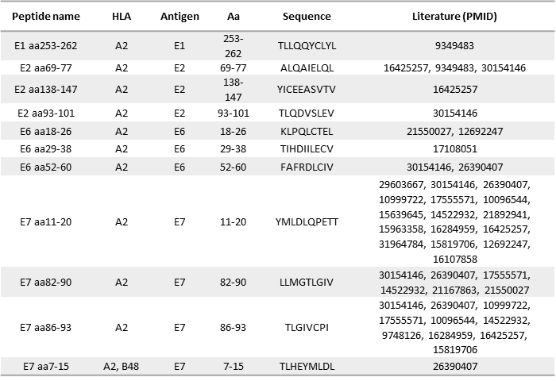

**Supplementary Figure 1. Selection of HLA-A2-restricted HPV16 peptides based on existing relevant literature.** Selected HLA-A2-restricted HPV16 peptides were used to screen healthy donors’ PBMCs to discriminate between HPV16 responders and non-responders, in addition to elucidate the specificity and the breadth of the response.

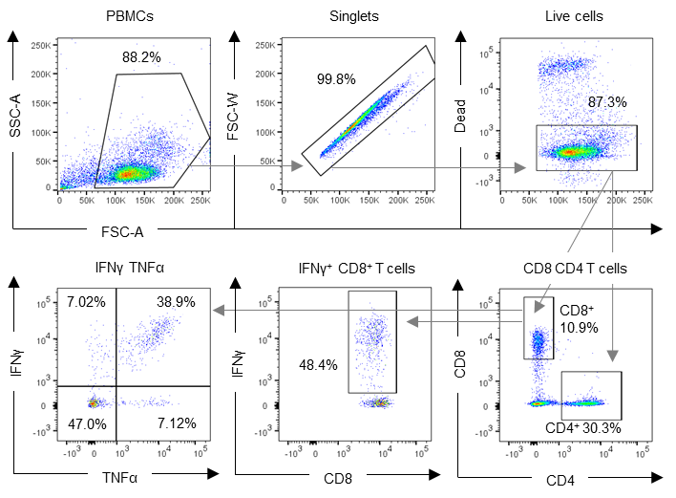

**Supplementary Figure 2. Gating strategy used for flow cytometry data analysis.** Representation of the gating strategy used to assess responsiveness of healthy donors to HPV16 (CD8 IFNγand TNFα secretion) after stimulation of PBMCs from healthy donors with HPV16 HLA-A2 single peptides or HPV16 E1, E2, E6 or E7 peptide pools. These gates applied also for CD4+ T cells.

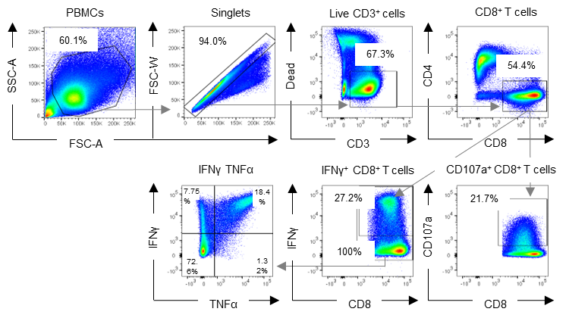

**Supplementary Figure 3. General gating strategy used for flow cytometry data analysis.** Representation of the gating strategy used to assess CD8 T cell IFNγ, TNFα and CD107a production after HPV16 HLA-A2 single peptide, HPV16 E1, E2, E6 or E7 peptide pool, or Ca Ski cells stimulation. These gates were also applicable for CD4+ T cells.

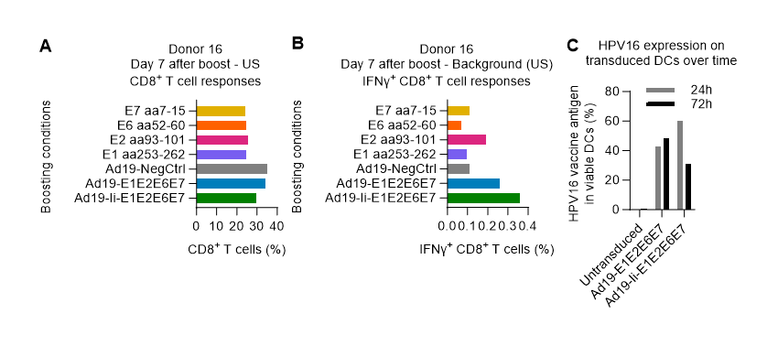

**Supplementary Figure 4. Background comparison of different T cell prime-boost expansion regimens.** PBMCs from donor 16 were primed with HPV16 E1 aa253-262, E2 aa93-101, E6 aa52-60 or E7 aa7-15 peptides and boosted two weeks later with either the cognate peptides, or Ad19-transduced DCs without a transgene (Ad19-NegCtrl) or encoding HPV16 with Ii (Ad19-Ii-E1E2E6E7) and without (Ad19-E1E2E6E7). One week later, cells were left unstimulated or were stimulated with HPV16 E1 aa253-262, E2 aa93-101, E6 aa52-60 or E7 aa7-15 peptides and IFNγ+ CD8+ T cell responses were evaluated by flow cytometry. Here, we were specifically looking at the unstimulated samples to evaluate the background responses and therefore choose the most suitable controls. (**A**) Fraction (%) of CD8+ T cells out of the alive CD3+ cells for the different booster regimens showing that Ad19-transduced DCs tended to generate more CD8+ T cells compared to single peptide stimulation. (**B**) Fraction (%) of IFNγ+ in CD8+ T cells for the different booster regimens showing that Ad19-HPV16-transduced DCs, especially when bearing Ii (Ad19-Ii-E1E2E6E7), elicited higher IFNγ+ CD8+ T cell responses when left unstimulated. (**C**) Evaluation of HPV16 vaccine antigen expression 24 and 72 h after Ad19-Ii-E1E2E6E7 or Ad19-E1E2E6E7 transduction showing that the vaccine encoded antigen was still detected 72 h after transduction. This continuous antigen expression upon transduction probably translated into a prolonged T cell stimulation and activation and thus, increased IFNγ production. In contrast, peptide stimulated T cells received a shorter and thus transient activation. Therefore Ad19-NegCtrl (empty vector) was used to subtract the background of T cells stimulated with Ad19-transduced DC in Figure 3 and Figure 4.



**Supplementary Figure 5. HPV16 T cell responses acquired E1 immunodominance over time.** Donor 13 and 14 PBMCs primed with Ad19-Ii-E1E2E6E7-transduced DCs and boosted with either Ad5- or Ad5f35-Ii-E1E2E6E7-transduced DCs were shortly restimulated with either E1 HPV16 peptide pool (E1pp) or with Ad5- or Ad5f35-Ii-E1E2E6E7-transduced DCs (not matching the boost vector) for IFNγ sorting and REP. 15 days after REP, the different effector T cells were restimulated with HPV16 peptide pools (E1pp, E2pp, E6pp or E7pp) and T cells were stained intracellularly for both IFNγand TNFαand analyzed by flow cytometry. T cells left unstimulated during ICS were used as background and were subtracted from the peptide pool stimulated samples. (**A-B**) Fraction (%) of double positive T cells in CD8+ T cells from donor 13 and 14 showing solely E1-specific reactivity. Interestingly, donor 13 showed strong reactivity against E1 peptide pool stimulation and secreted high amounts of IFNγ and TNFα cytokines. (**C-D**) Fraction (%) of double positive cells in CD4+ T cells from donor 13 and 14. CD4+ T cells showed poor reactivity and secreted low amounts of IFNγ and TNFα in response to E1, E2, and E7.



**Supplementary Figure 6. Donor 13 CD8+ T cell responses upon stimulation with HPV16 peptide pools.** The remaining effector T cells from the ICS and killing assays were frozen. Donor 13 T cells were thawed and after letting them recover for 5 days, they were restimulated with different HPV16 peptide pools or Ca Ski cells. CD8 T cells were surface stained for CD107a and intracellularly stained for IFNγ and analyzed by flow cytometry. (**A**) Fraction (%) of IFNγ+ in CD8+ T cells showing retention of E1 immunodominance. (**B**) Fraction (%) of CD107a+ in CD8+ T cells exhibiting degranulation only when stimulated with E1 HPV16 peptide pool.