Supplementary material to the manuscript " Reduced levels of lacrimal glial cell line-derived neurotrophic factor (GDNF) in patients with focal epilepsy and focal epilepsy with comorbid depression: A biomarker candidate?" by Alexander A. Shpak, Flora K. Rider, Tatiana A. Druzhkova, Marina Y. Zhanina, Sofya B. Popova, Alla B. Guekht, Natalia V. Gulyaeva

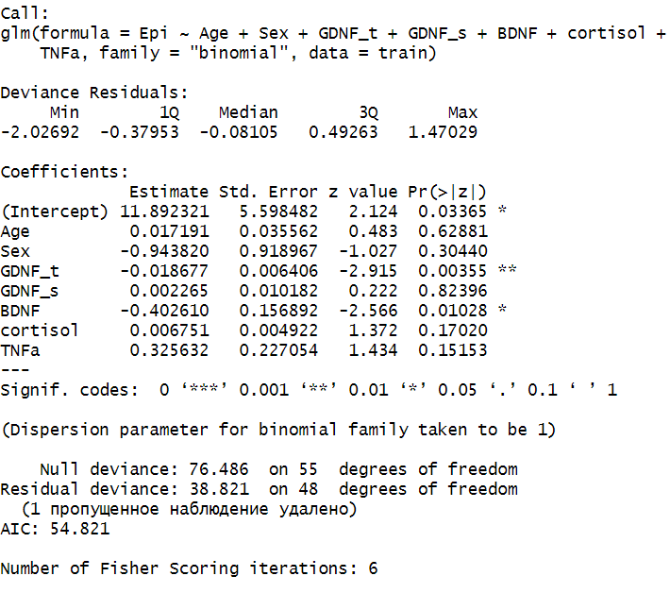  (a) | 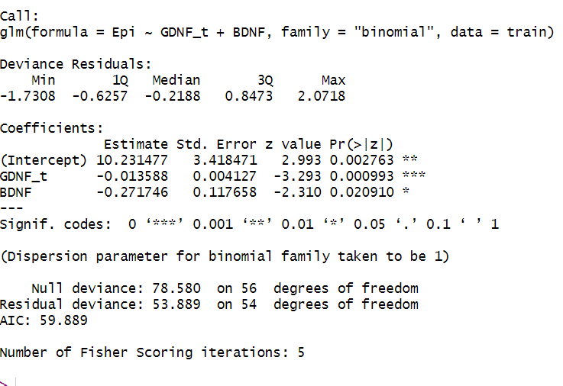  (b)
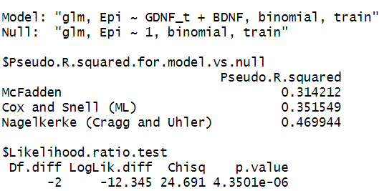  (c) | parameter estimate Std error statistic p-value  GDNF in LF 0.987 0.004 -3.29 0.001  BDNF in BS 0.762 0.12 -2.31 0.02  (d)
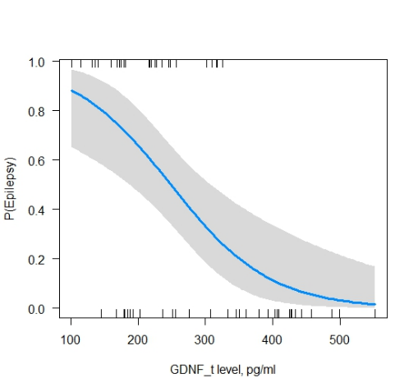 | 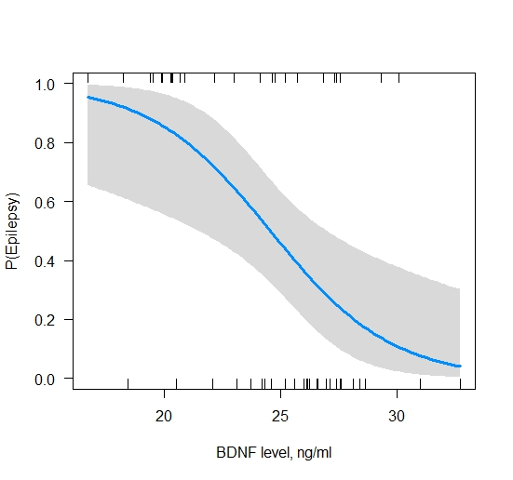
(e) | (f)
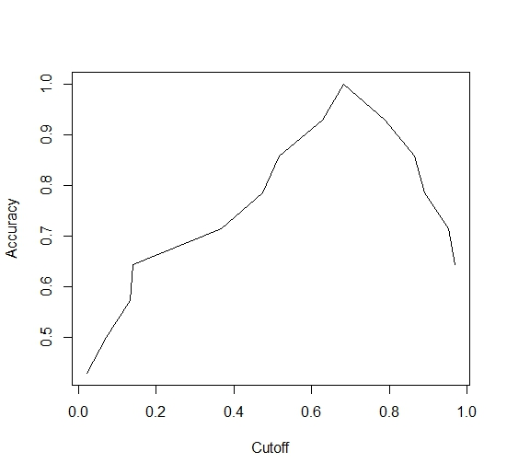
(g)
Figure 1S. Predictors of focal epilepsy development. Model involving all predictors (a); model involving only significant predictors (b); Pseudo R squared for model with only significant predictors (c); Odds ratio of predictors for model with only significant predictors (d); Dependence of changes in GDNF in LF (e) and BDNF (f) levels on the likelihood of developing epilepsy. Vertical lines along the x-axis indicate observations; A grey bar along the blue line indicates a 95% confidence interval; Determination of the accuracy of the selected model with a cut-off point of 0.5 for the binary classification (85%). Determination the optimal value of the cut-off point, depending on the accuracy for the model that predicts focal epilepsy development (0.68) (g).

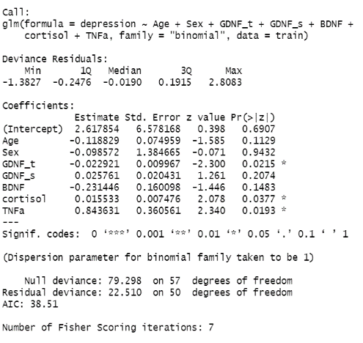 | 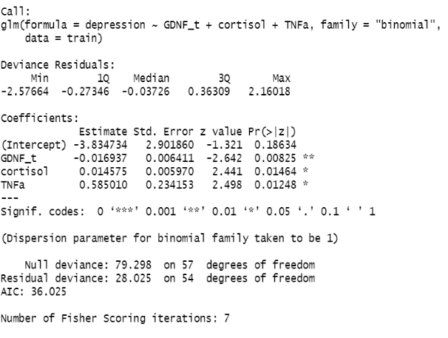
(a) | (b)
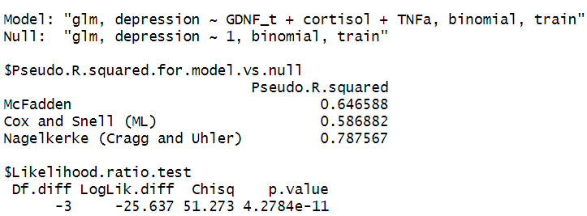 | parameter estimate Std error statistic p-value  GDNF in LF 0.983 0.0064 -2.64 0.0083  cortisol in BS 1.01 0.0060 2.44 0.015  TNF-α in BS 1.8 0.23 2.50 0.013
(c) | (d)
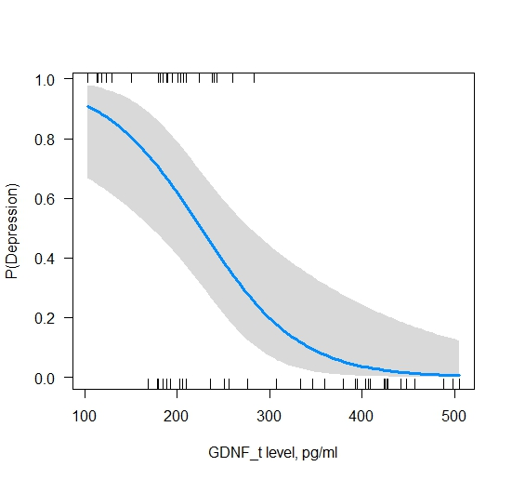 | 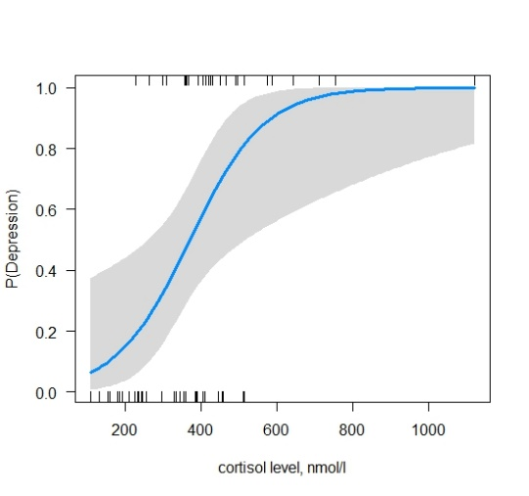
(e) | (f)
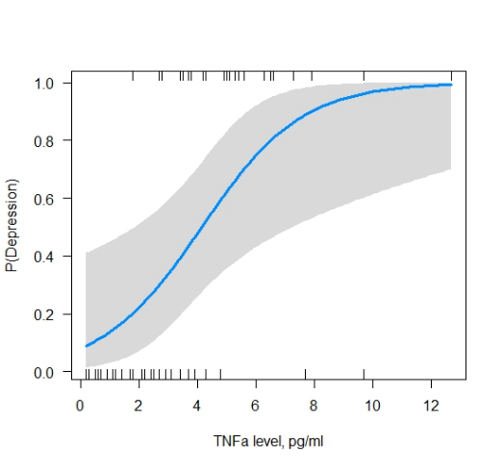 | 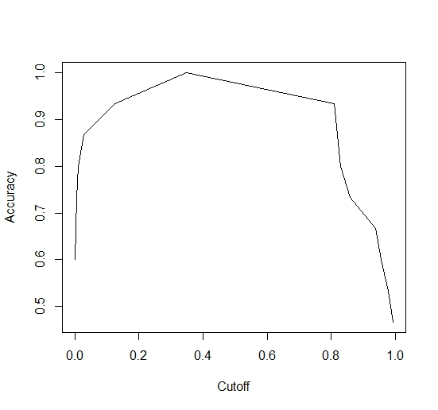
(g) | (h)
Figure 2S. Predictors of depression development. Model involving all predictors (a); model involving only significant predictors (b); Pseudo R squared for model with only significant predictors (c); Odds ratio of predictors for model with only significant predictors (d); Dependence of changes in GDNF in LF (e), cortisol (f) and TNF-α (g) levels on the likelihood of developing depression. Vertical lines along the x-axis indicate observations; A grey bar along the blue line indicates a 95% confidence interval; Determination of the accuracy of the selected model with a cut-off point of 0.5 for the binary classification (93%). Determination the optimal value of the cut-off point, depending on the accuracy for the model that predicts depression development (0.35). (h).

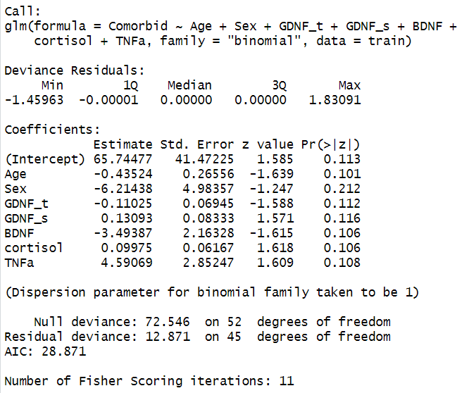 | 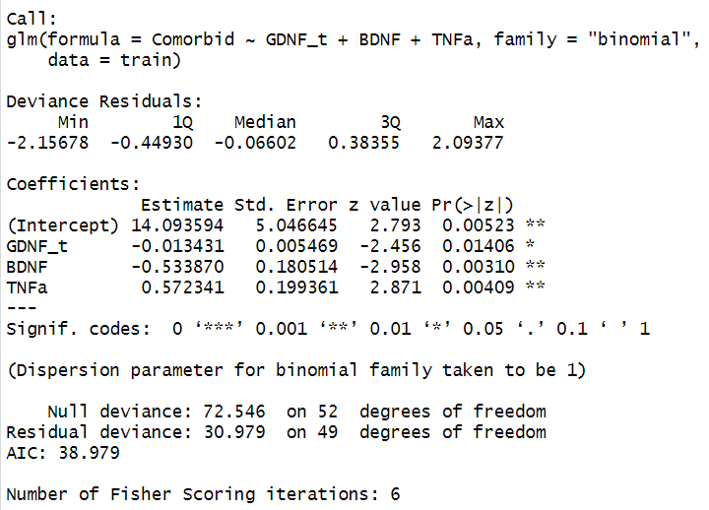
(a) | (b)
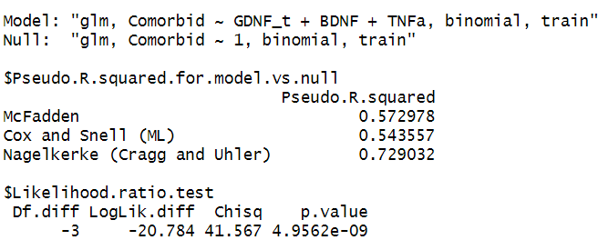 | parameter estimate Std error statistic p-value  GDNF in LF 0.99 0.0055 -2.46 0.014  BDNF in BS 0.59 0.181 -2.96 0.0031  TNF-α in BS 1.77 0.199 2.87 0.0041
(c) | (d)
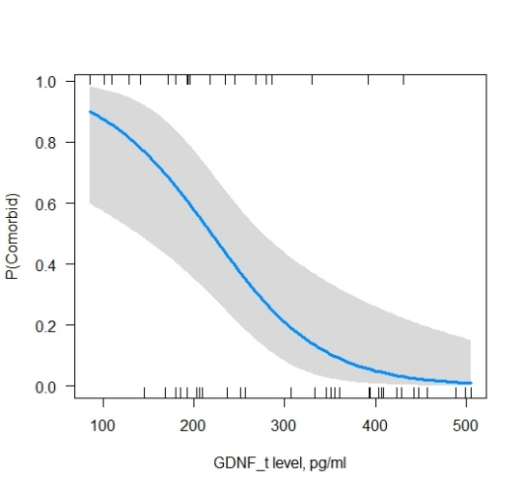 | 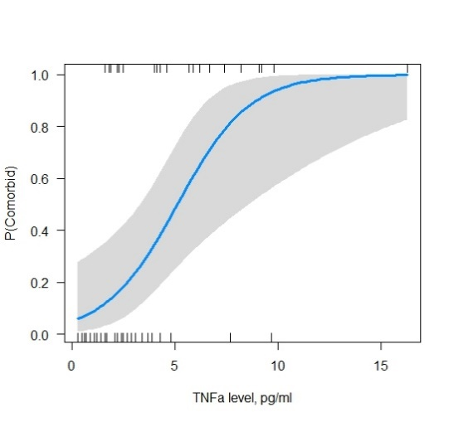
(e) | (f)
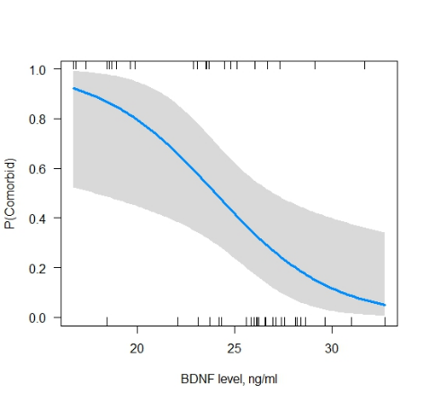 | 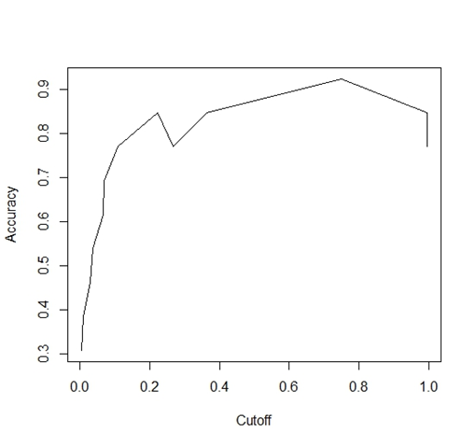
(g) | (h)
Figure 3S. Predictors of development of comorbid depression and epilepsy. Model involving all predictors (a); model involving only significant predictors (b); Pseudo R squared for model with only significant predictors (c); Odds ratio of predictors for model with only significant predictors (d); Dependence of changes in GDNF in LF (e), TNF-α (f) and BDNF (g) levels on the likelihood of developing comorbid depression and epilepsy. Vertical lines along the x-axis indicate observations; A grey bar along the blue line indicates a 95% confidence interval; Determination of the accuracy of the selected model with a cut-off point of 0.5 for the binary classification (92%). Determination the optimal value of the cut-off point, depending on the accuracy for the model that predicts focal depression and epilepsy (0.75). (h).

