Supplementary material

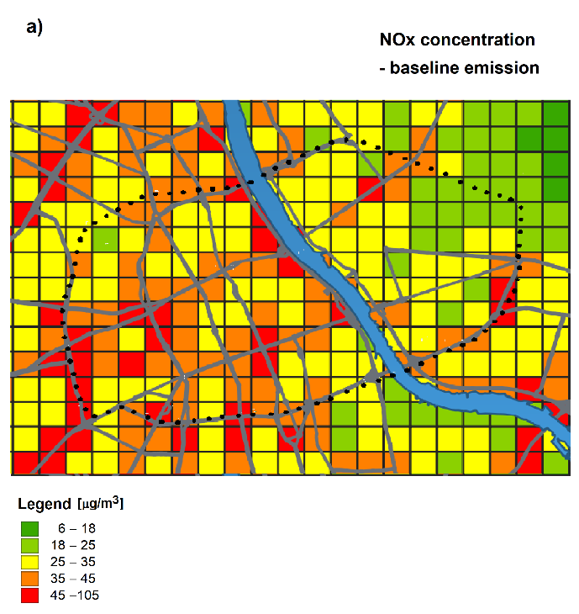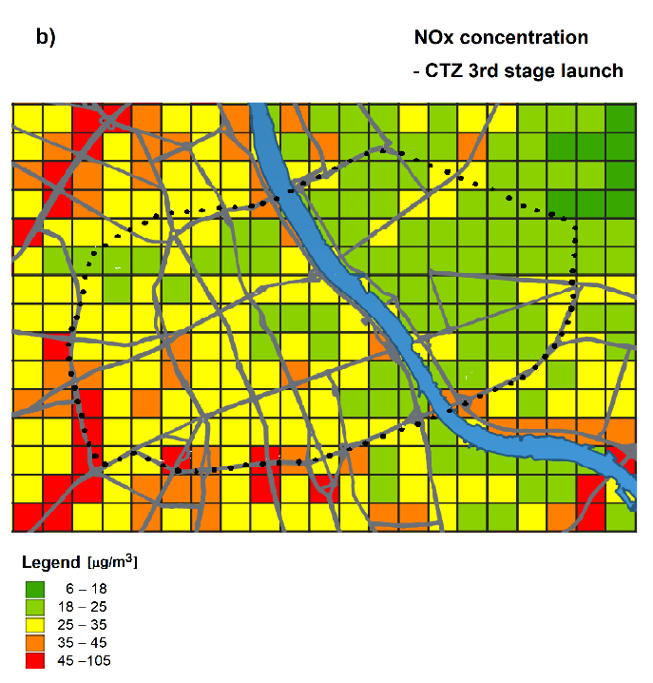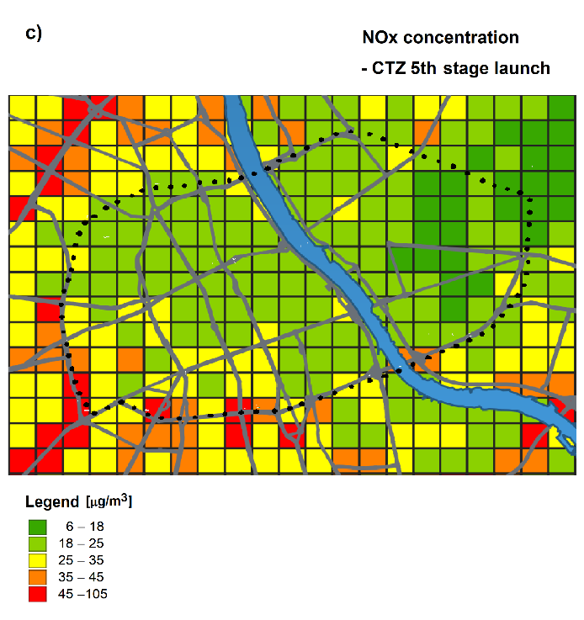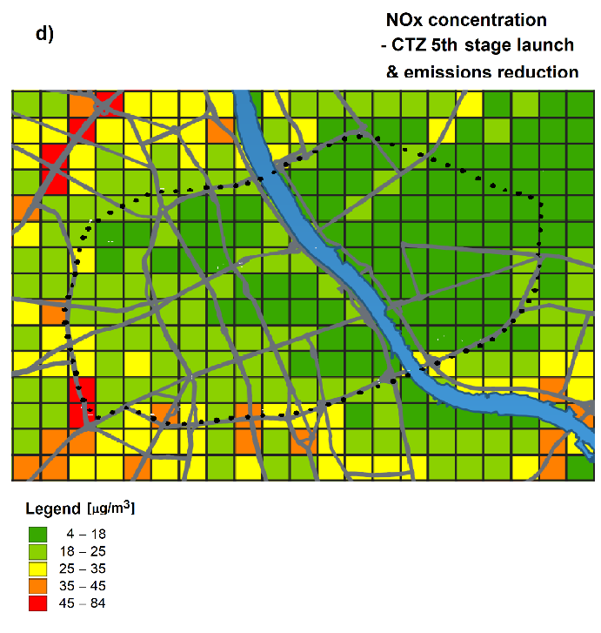
Figure S1. NOx concentration map inside LEZ: (a) baseline emission, (b) 3rd stage LEZ,
(c) 5th stage LEZ, (d) 5th stage LEZ+25% total emissions reduction.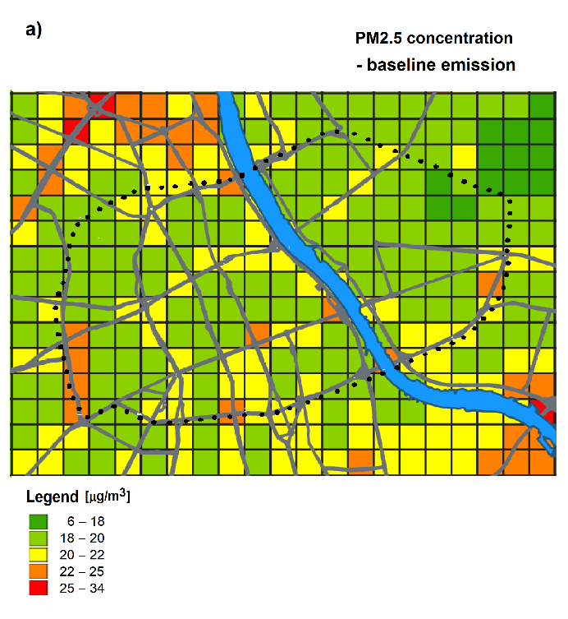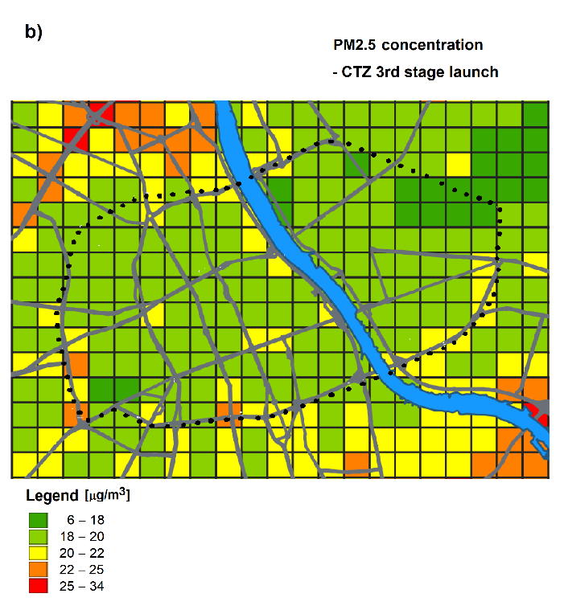 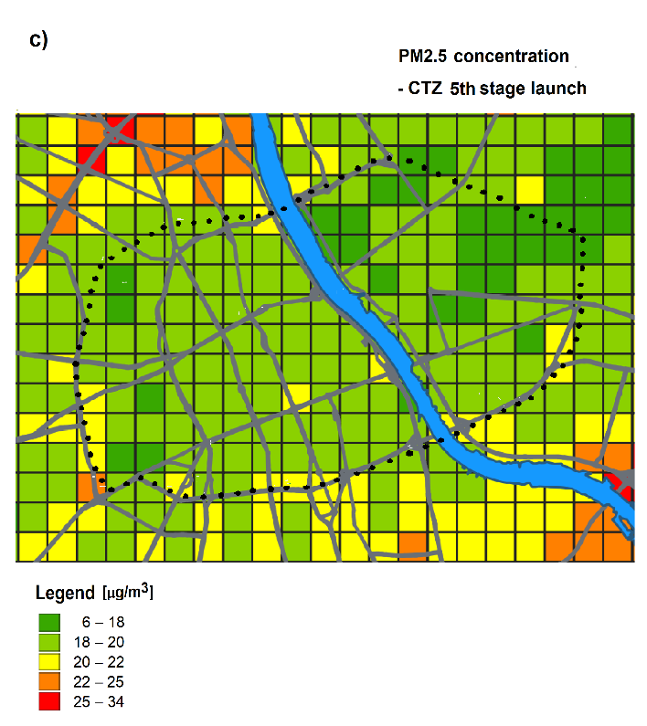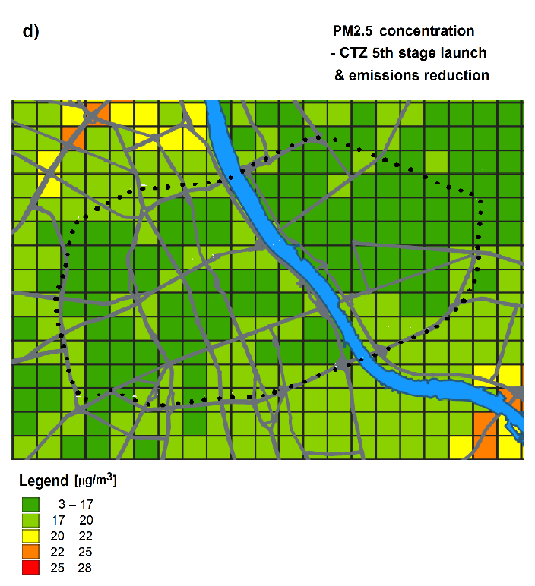
Figure S2. PM_{2.5} concentration map inside LEZ: (a) baseline emission, (b) 3rd stage LEZ,
(c) 5th stage LEZ, (d) 5th stage LEZ+25% total emissions reduction.

