Supplementary Materials
Metabolite Profiling of the Leaves of Allium hookeri using UPLC-qTOF-MS/MS and Senomorphic Activity of Phenolamides
Thi-Phuong Doan ¹, Mi Zhang ¹, Jin-Pyo An ¹, Jorge-Eduardo Ponce-Zea ¹, Van-Hieu Mai ¹, Byeol Ryu ¹, Eun Jin Park ¹, and Won-Keun Oh ^{1,}*
¹ Research Institute of Pharmaceutical Sciences, College of Pharmacy, Seoul National University, Seoul 08826, Republic of Korea; phuongdoan@snu.ac.kr (T.P.D); mintazhang@snu.ac.kr (M.Z); ntopjp77@gmail.com (J.P.A); jepz210689@snu.ac.kr (J.E.P); maihieu@snu.ac.kr (V.H.M); estrella56@snu.ac.kr (B.R); eunjin_p@snu.ac.kr (E.J.P); wkoh1@snu.ac.kr (W.K.O)
* Correspondence: wkoh1@snu.ac.kr; Tel.: +82-2-880-7872

Table of contents

Figure S1. HR-ESI -qTOF-MS/MS chromatography of A. hookeri leaves extract (positive mode) 4
Figure S2. Feature-based molecular networking of fractions and crude extract from leaves of Allium hookeri using HRESI-qTOF-MS/MS. Mass data was recorded in positive mode. 5
Figure S3. Chemical structures of putative identification of components from leaves of Allium hookeri using HRESI-qTOF-MS/MS-based molecular networking. 6
Figure S4. Mass/mass fragmentation of triterpenoid cluster in FBMN 7
Figure S5. HRESIMS data of compound 2 8
Figure S6. IR(KBr) spectrum of compound 2 8
Figure S7. ¹H NMR spectrum of compound 2 (600 MHz, pyridine-d₅) 9
Figure S8. ¹³C NMR spectrum of compound 2 (150 MHz, pyridine-d₅) 10
Figure S9. HSQC spectrum of compound 2 11
Figure S10. HMBC spectrum of compound 2 12
Figure S11. COSY spectrum of compound 2 13
Figure S12. HRESIMS/MS of compound 1 14
Figure S13. IR(KBr) spectrum of compound 1 14
Figure S14. ¹H NMR spectrum of compound 1 (400 MHz, DMSO-d₆) 15
Figure S15. HRESIMS/MS of compound 3 16
Figure S16. IR(KBr) spectrum of compound 3 16
Figure S17. ¹H NMR spectrum of compound 3 (600 MHz, DMSO-d₆) 17
Figure S18. ¹³C NMR spectrum of compound 3 (150 MHz, DMSO-d₆) 18
Figure S19. HRESIMS data of compound 4 19
Figure S20. UV spectrum of compound 4 19
Figure S21. IR(KBr) spectrum of compound 4 19
Figure S22. ¹H NMR spectrum of compound 4 (500MHz, DMSO-d₆) 20
Figure S23. ¹³C NMR spectrum of compound 4 (125 MHz, DMSO-d₆) 21
Figure S24. HRESIMS data of compound 5 22
Figure S25. UV spectrum of compound 5 22
Figure S26. IR(KBr) spectrum of compound 5 22
Figure S27. ¹H NMR spectrum of compound 5 (600 MHz, DMSO-d₆) 23
Figure S28. ¹³C NMR spectrum of compound 5 (150 MHz, DMSO-d₆) 24
Figure S29. HRESIMS data of compound 6 25
Figure S30. IR(KBr) spectrum of compound 6 25
Figure S31. ¹H NMR spectrum of compound 6 (500 MHz, DMSO-d₆) 26
Figure S32. ¹³C NMR spectrum of compound 6 (125 MHz, DMSO-d₆) 27
Figure S33. HRESIMS data of compound 7 28
Figure S34. IR(KBr) spectrum of compound 7 28
Figure S35. ¹H NMR spectrum of compound 7 (400 MHz, DMSO-d₆) 29
Figure S36. ¹³C NMR spectrum of compound 7 (100 MHz, DMSO-d₆) 30
Figure S37. HRESIMS data of compound 8 31
Figure S38. UV spectrum of compound 8 31
Figure S39. IR(KBr) spectrum of compound 8 31
Figure S40. ¹H NMR spectrum of compound 8 (600 MHz, DMSO-d₆) 32
Figure S41. ¹³C NMR spectrum of compound 8 (150 MHz, DMSO-d₆) 33
Figure S42. HRESIMS/MS data of compound 9 34
Figure S43. UV spectrum of compound 9 34
Figure S44. IR(KBr) spectrum of compound 9 34
Figure S45. ¹H NMR spectrum of compound 9 (600 MHz, DMSO-d₆) 35
Figure S46. ¹³C NMR spectrum of compound 9 (150 MHz, DMSO-d₆) 36
Figure S47. HRESIMS/MS data of compound 10 37
Figure S48. IR(KBr) spectrum of compound 10 37
Figure S49. ¹H NMR spectrum of compound 10 (500 MHz, pyridine-d₅) 38
Figure S50. ¹³C NMR spectrum of compound 10 (125 MHz, pyridine-d₅) 39
Figure S51. Inhibitory effects of fractions and single compounds from A. hookeri on BLM-induced senescence system in RAW 264.7 cells using nitric oxide (NO) assay kit. 40
Figure S52. SA-β-gal-positive senescent cells on replicative senescent HDF cell. 41

Table S1. Putative identification of components from leaves of Allium hookeri using HRESI-qTOF-MS/MS-based molecular networking…………………………………………………42

Figure S1. HR-ESI -qTOF-MS/MS chromatography of A. hookeri leaves extract (positive mode)

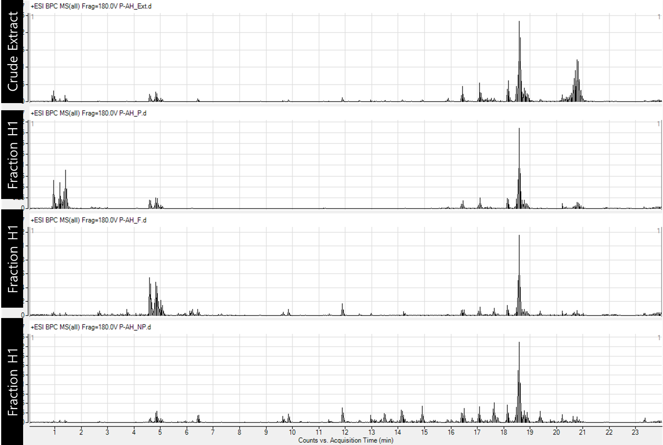

Figure S2. Feature-based molecular networking of fractions and crude extract from leaves of Allium hookeri using HRESI-qTOF-MS/MS. Mass data was recorded in positive mode.
Data pre-processing using Mzmine3, FBMN was created at GNPS platform and can be found at https://gnps.ucsd.edu/ProteoSAFe/status.jsp?task=b6f262ecf9994b82bab562336b008eeb. Data visualzation using Cytoscape software.
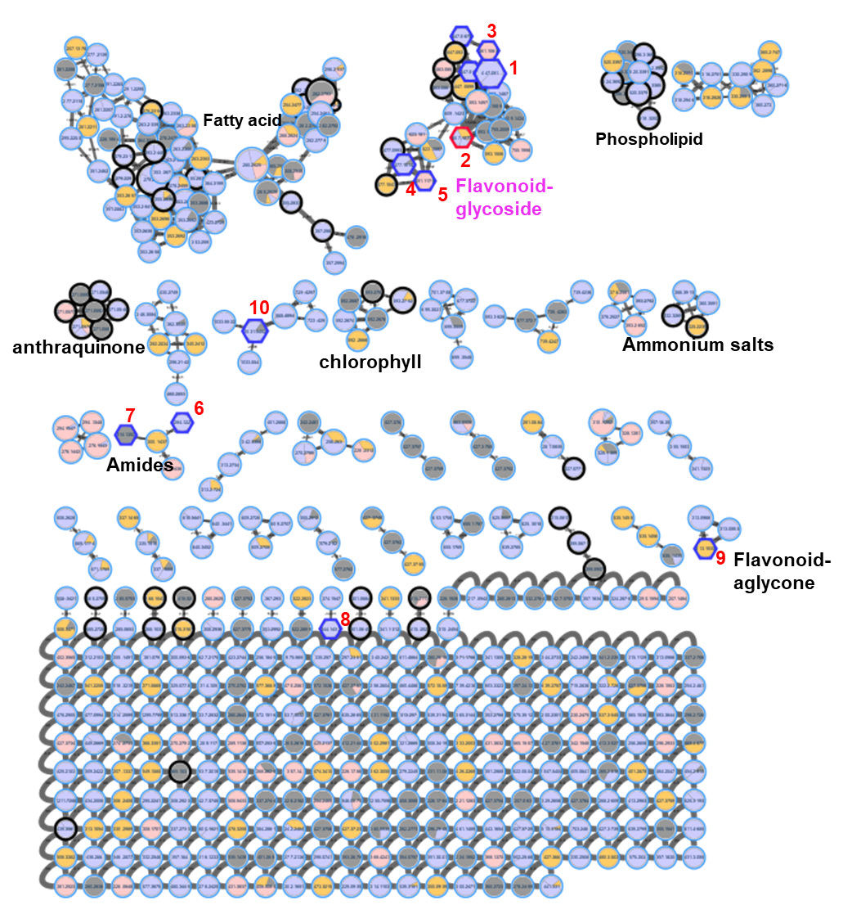
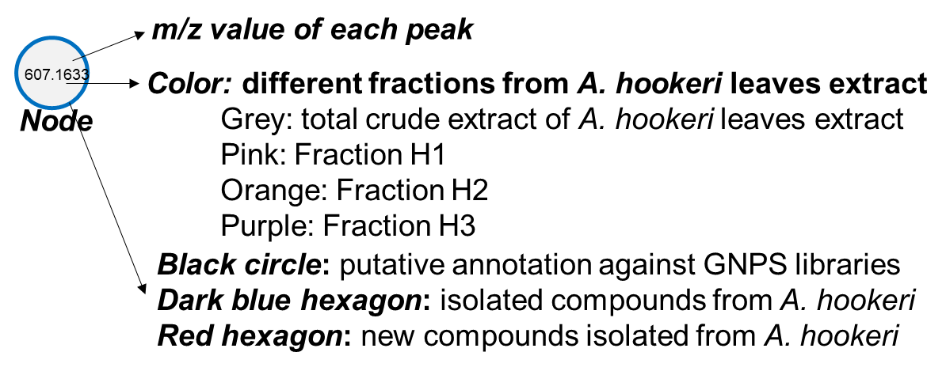
Figure S3. Chemical structures of putative identification of components from leaves of Allium hookeri using HRESI-qTOF-MS/MS-based molecular networking.
HRESI-qTOF-MS/MS data recorded in positive mode selective for assignment with m/z error less than 10 ppm. Details of each compound including retention, m/z, m/z error, and GNPS link of compound assignment can be found in Table S1. Molecular networking was created at GNPS (https://gnps.ucsd.edu/ProteoSAFe/status.jsp?task=b6f262ecf9994b82bab562336b008eeb)

Figure S4. Mass/mass fragmentation of triterpenoid cluster in FBMN
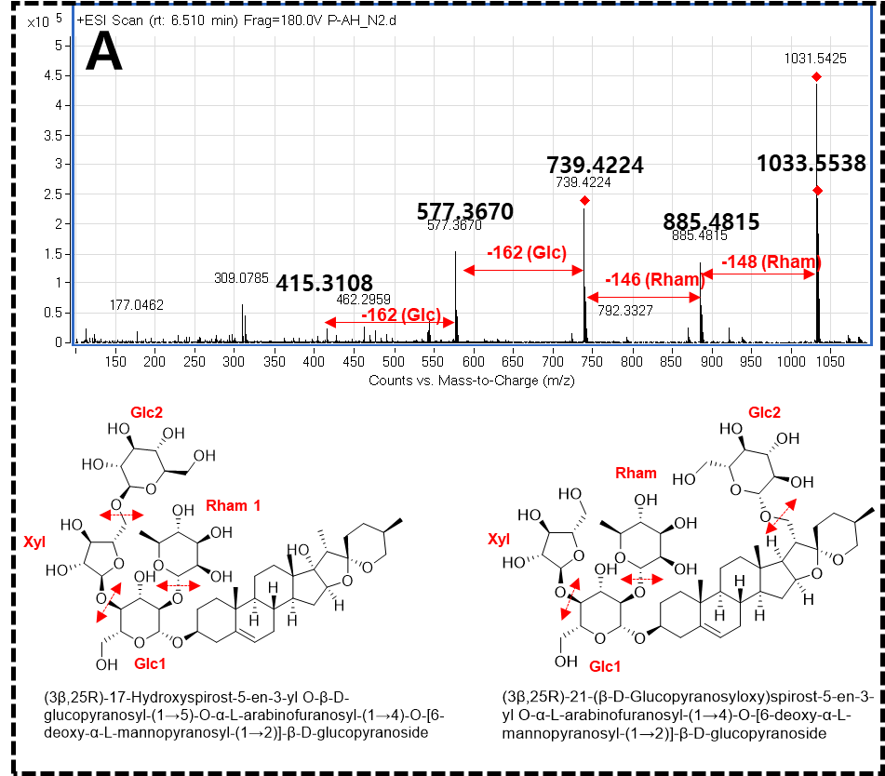 | 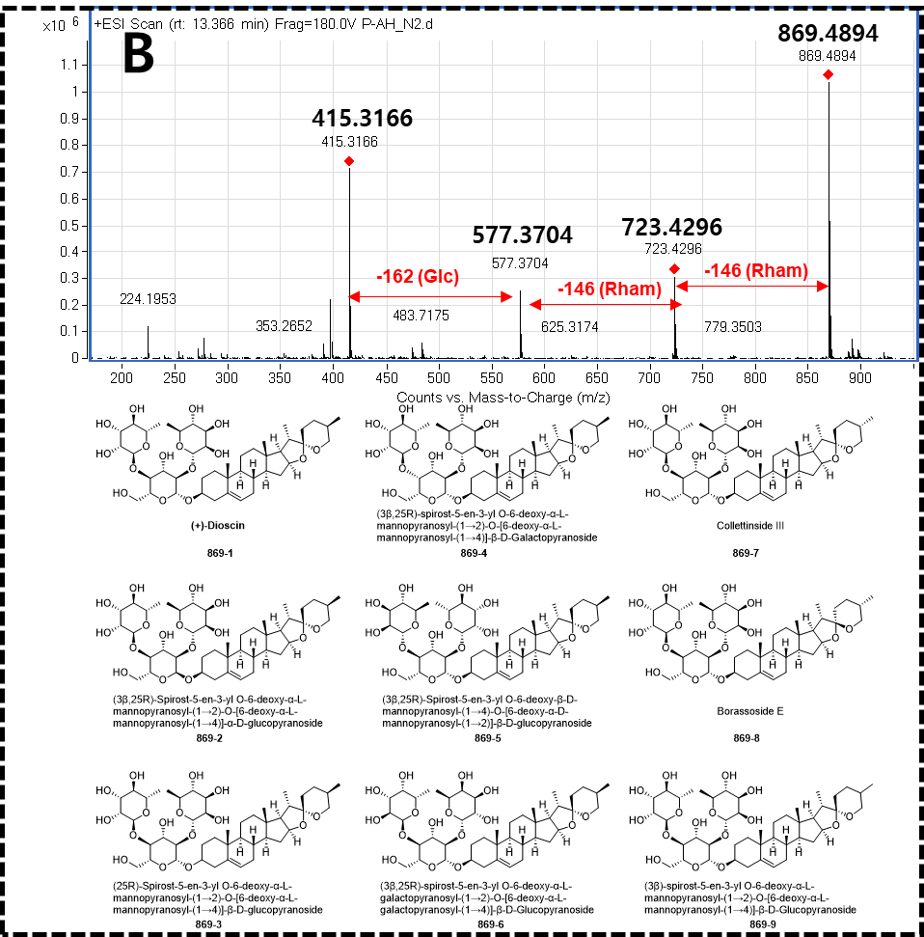
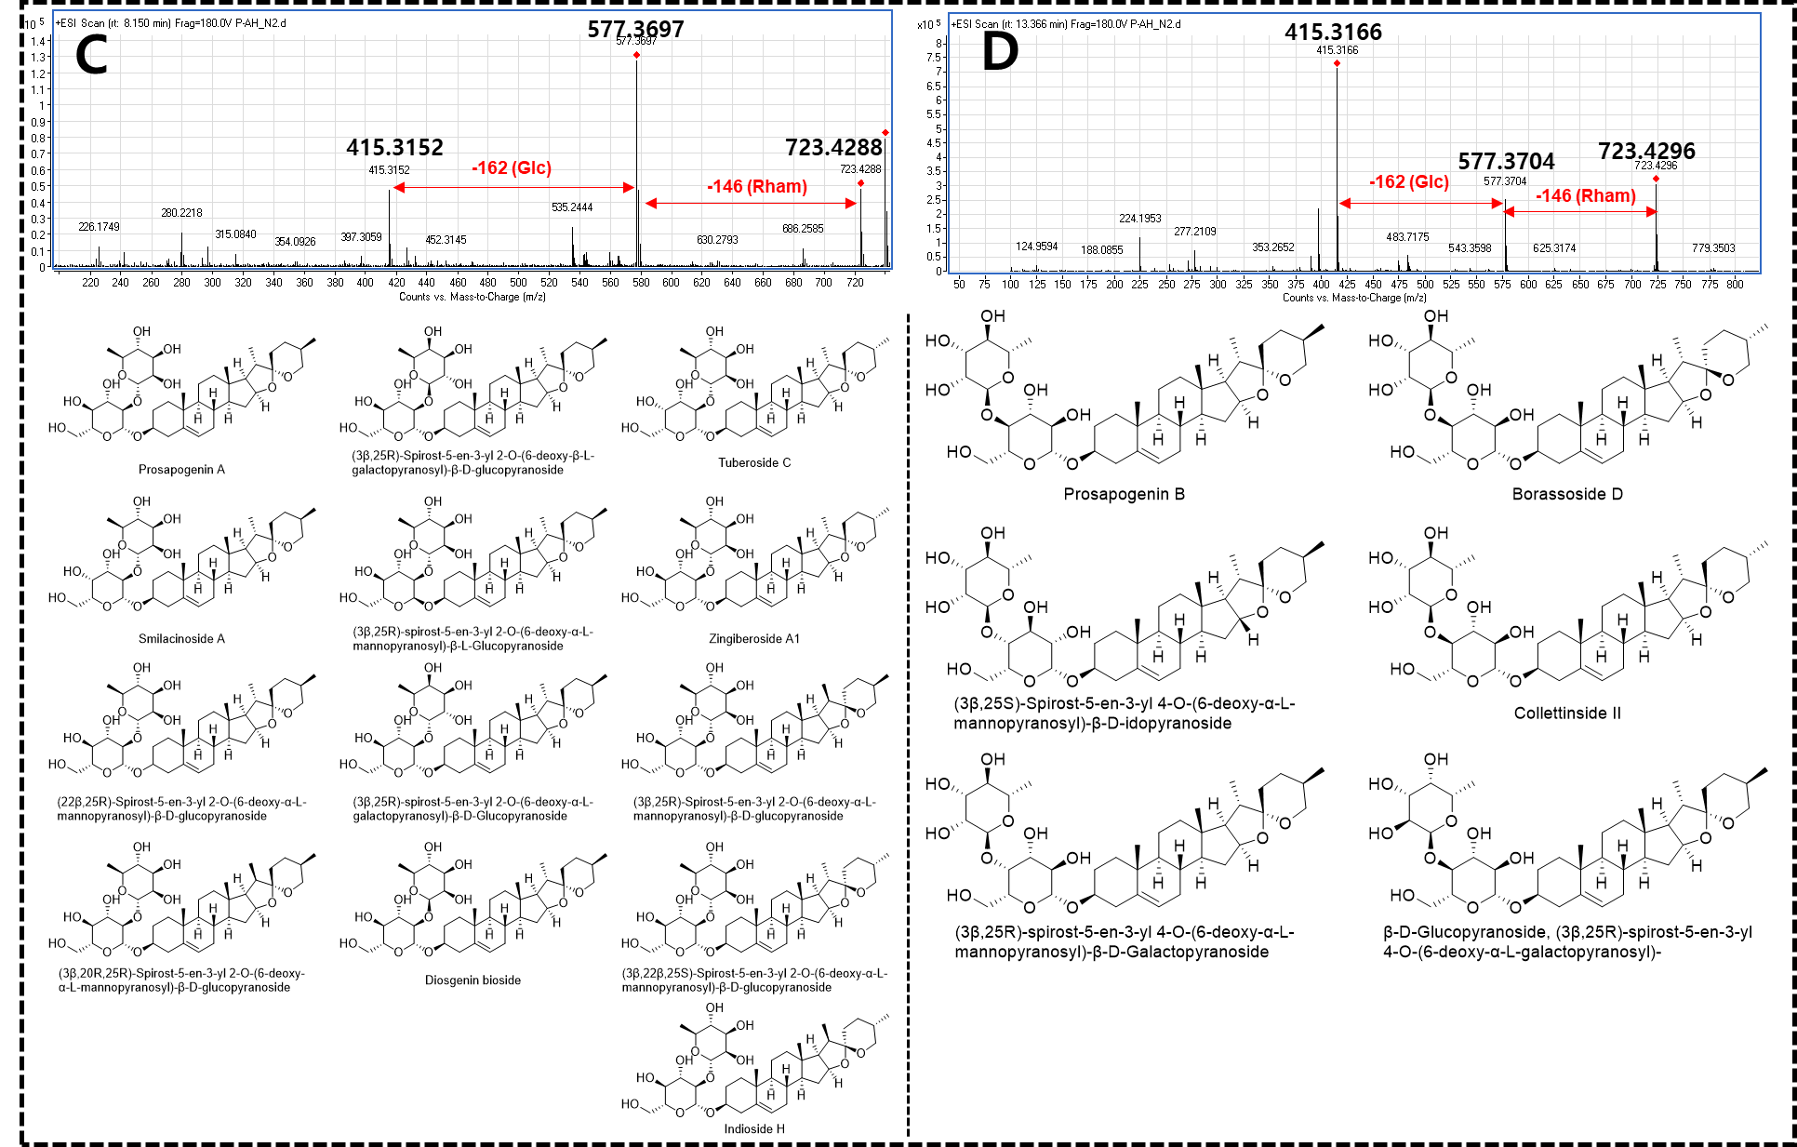

Figure S5. HRESIMS data of compound 2
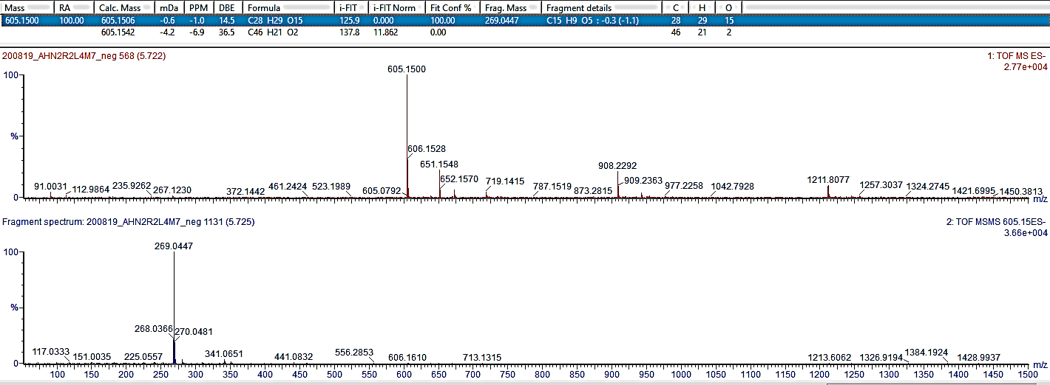

Figure S6. IR(KBr) spectrum of compound 2
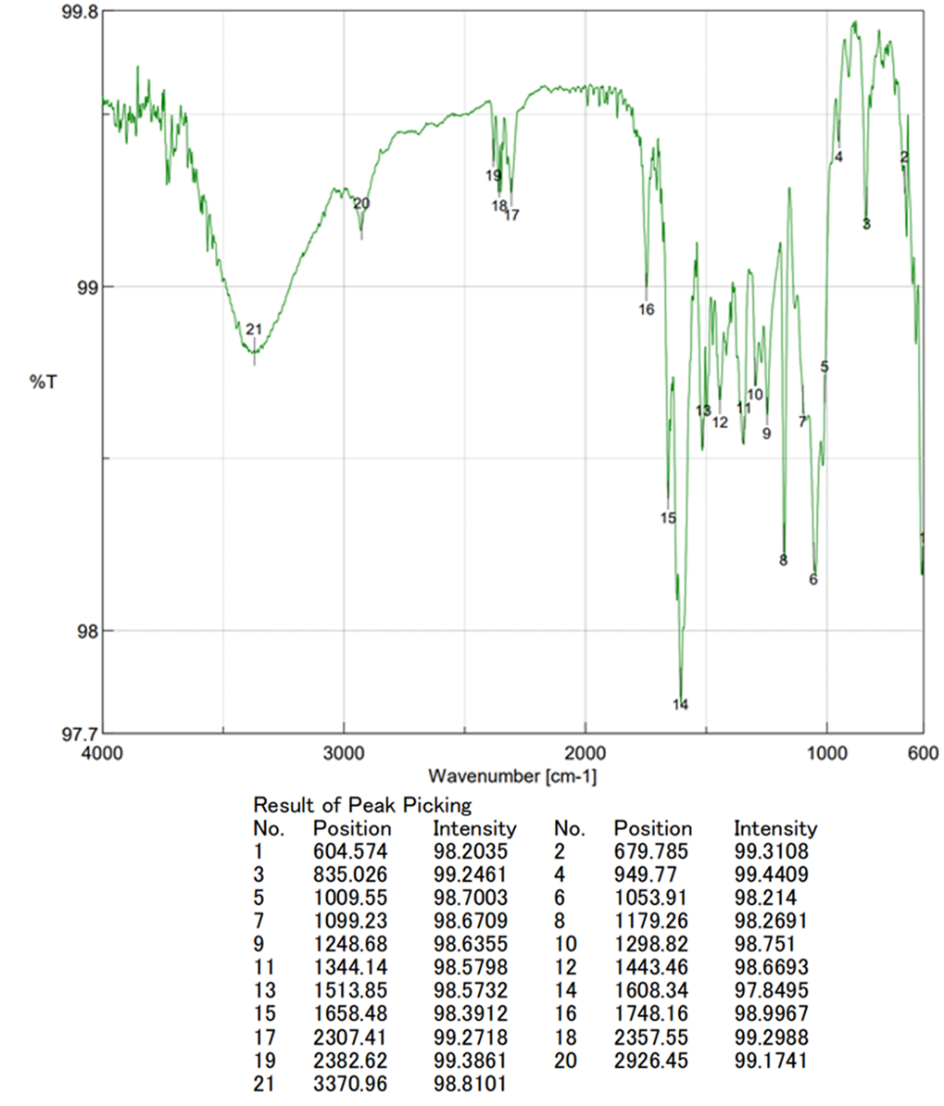

Figure S7. ¹H NMR spectrum of compound 2 (600 MHz, pyridine-d₅)
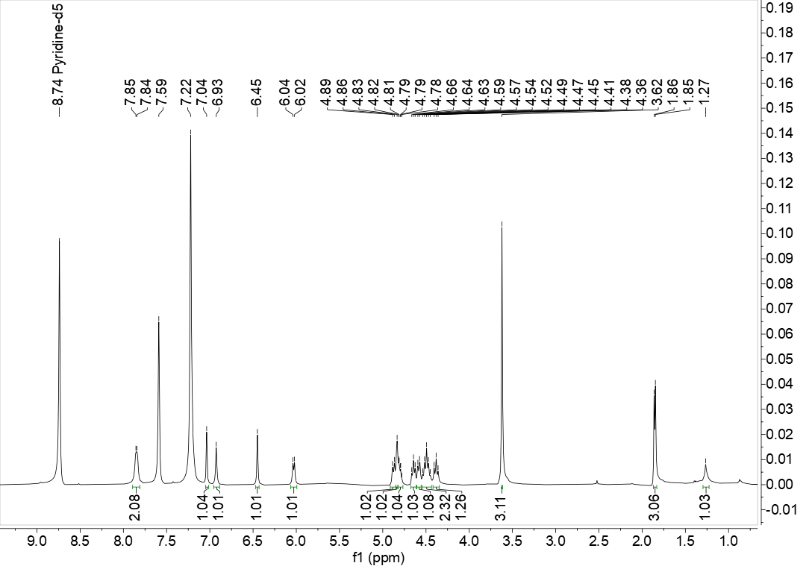
Figure S8. ¹³C NMR spectrum of compound 2 (150 MHz, pyridine-d₅)

Figure S9. HSQC spectrum of compound 2
Figure S10. HMBC spectrum of compound 2

Figure S11. COSY spectrum of compound 2
Figure S12. HRESIMS/MS of compound 1
Figure S13. IR(KBr) spectrum of compound 1

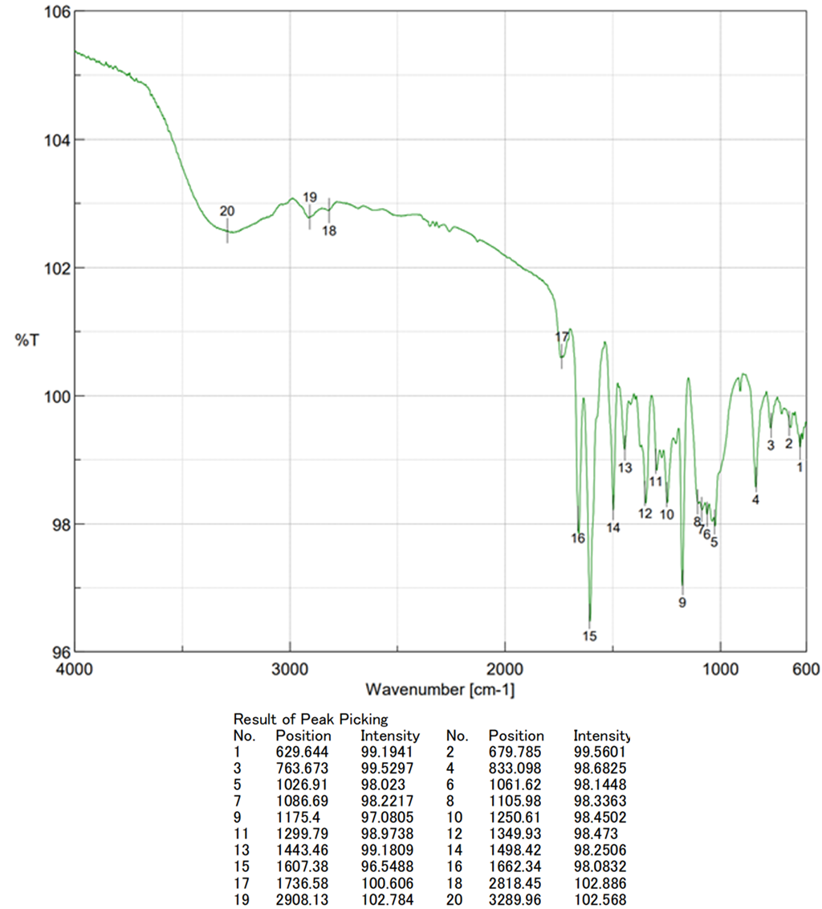
Figure S14. ¹H NMR spectrum of compound 1 (400 MHz, DMSO-d₆)
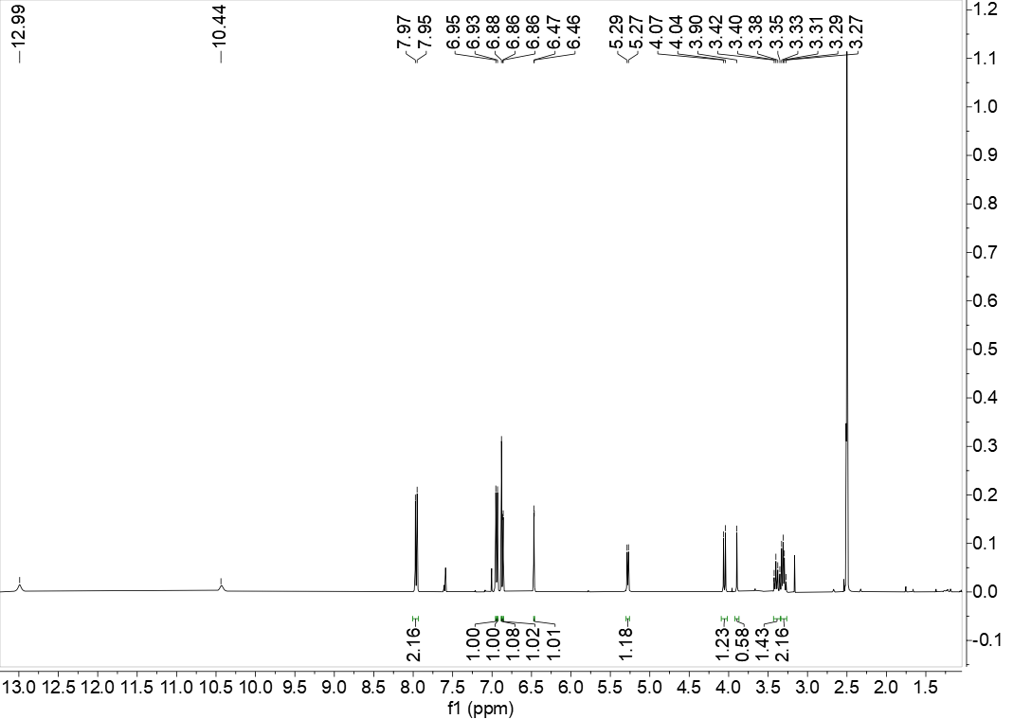

Figure S15. HRESIMS/MS of compound 3
Figure S16. IR(KBr) spectrum of compound 3

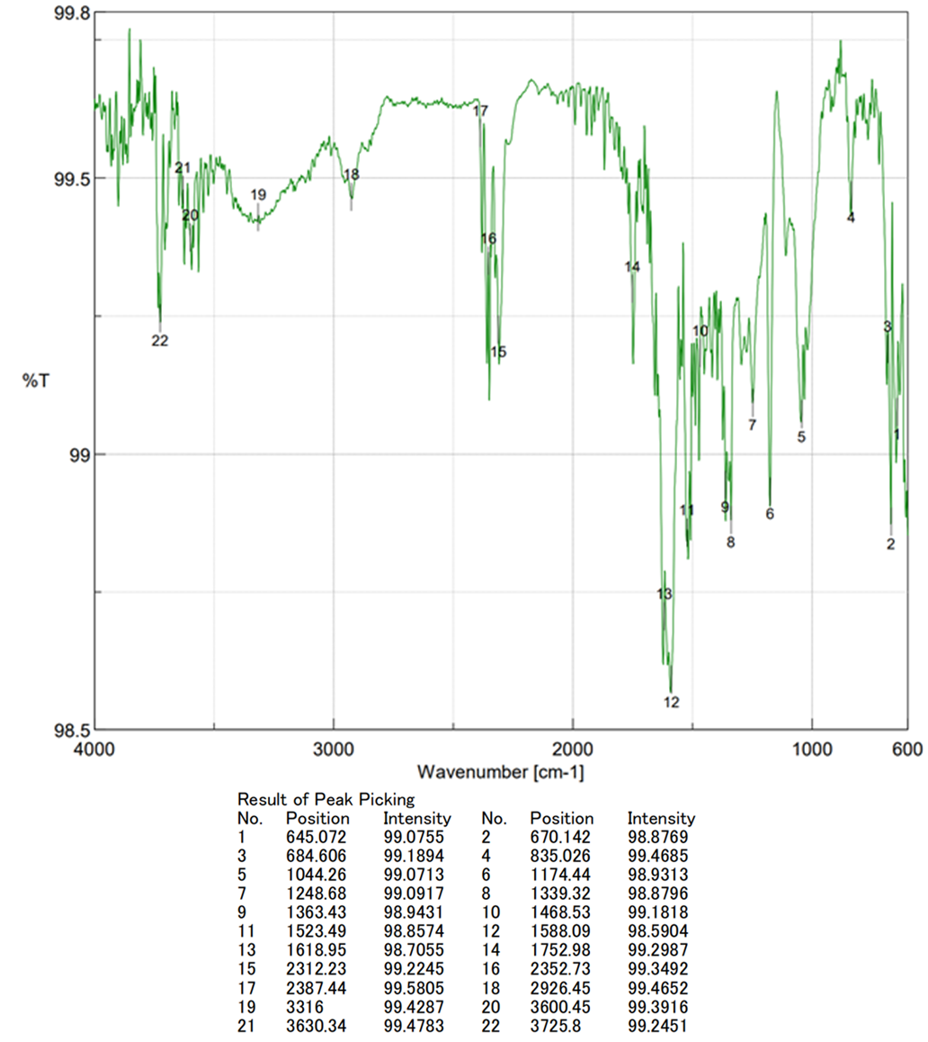
Figure S17. ¹H NMR spectrum of compound 3 (600 MHz, DMSO-d₆)
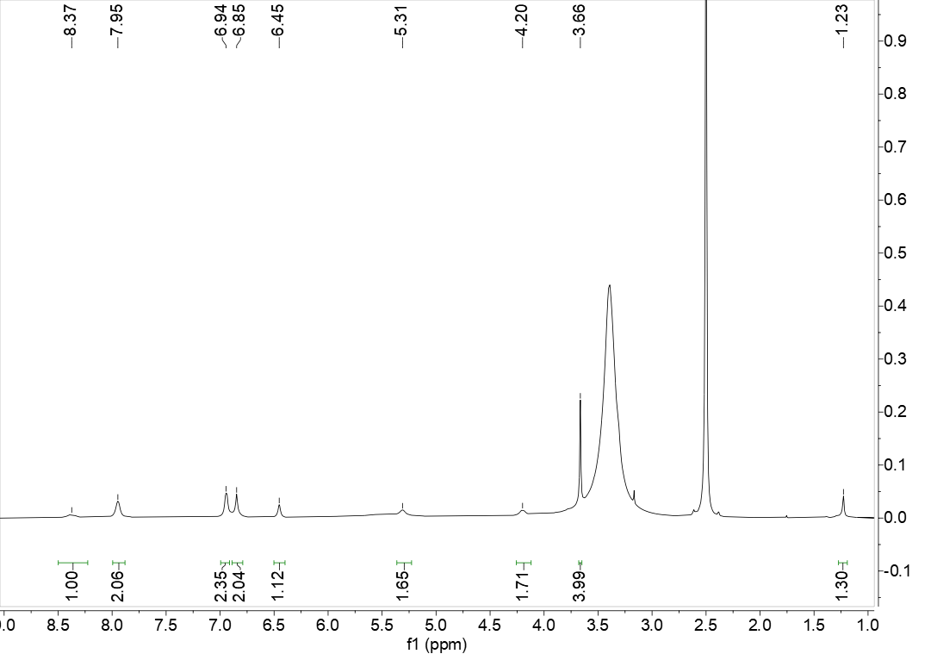
Figure S18. ¹³C NMR spectrum of compound 3 (150 MHz, DMSO-d₆)
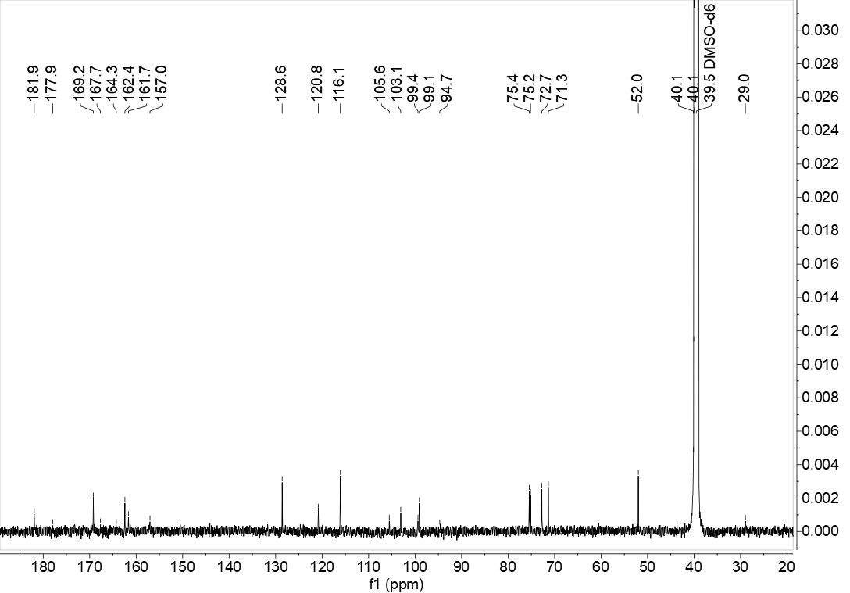
Figure S19. HRESIMS data of compound 4
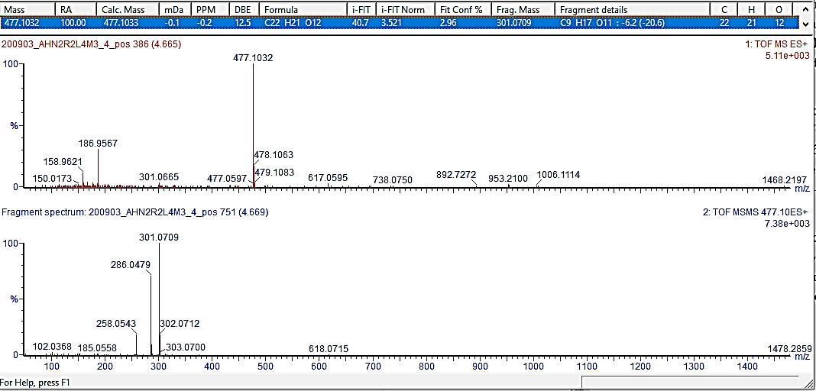
Figure S20. UV spectrum of compound 4
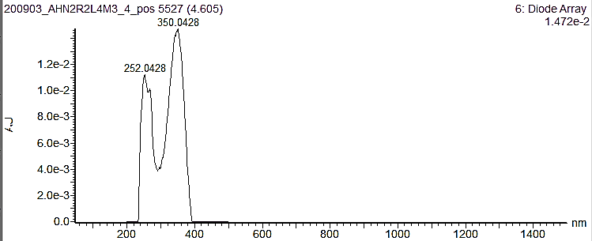
Figure S21. IR(KBr) spectrum of compound 4
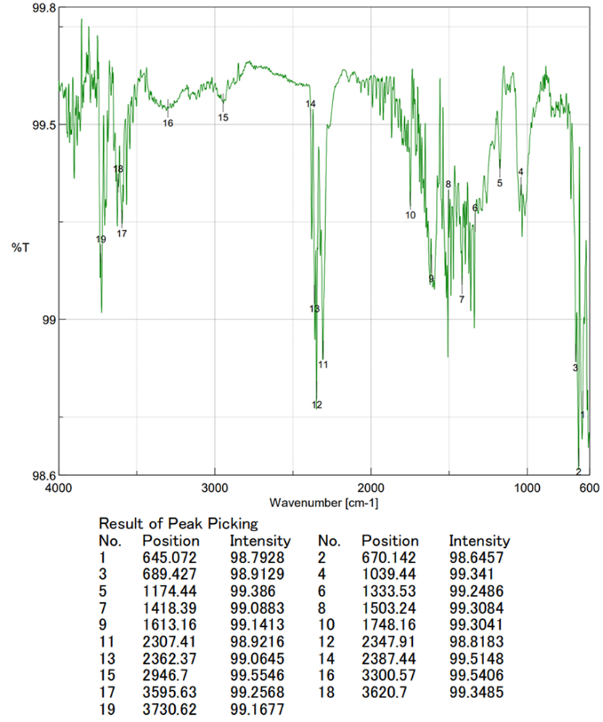

Figure S22. ¹H NMR spectrum of compound 4 (500MHz, DMSO-d₆)
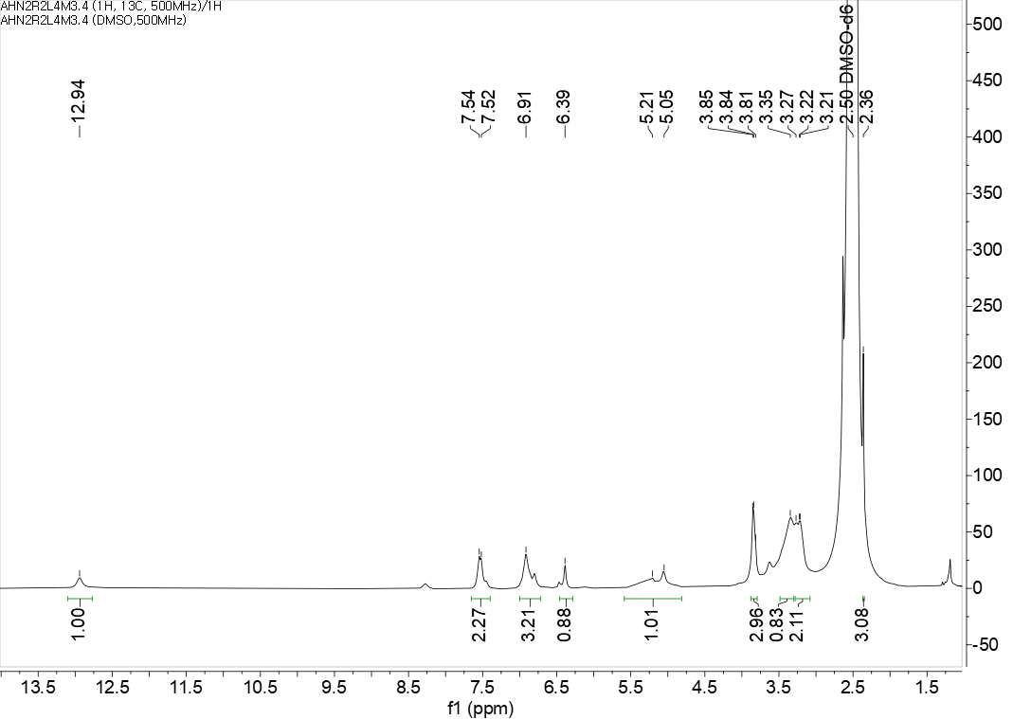

Figure S23. ¹³C NMR spectrum of compound 4 (125 MHz, DMSO-d₆)
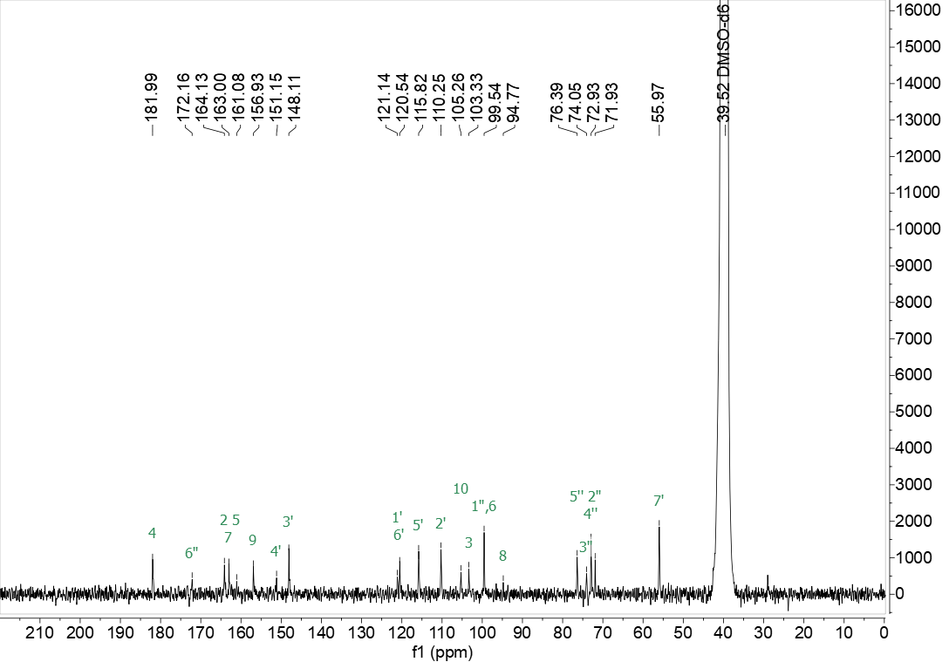

Figure S24. HRESIMS data of compound 5
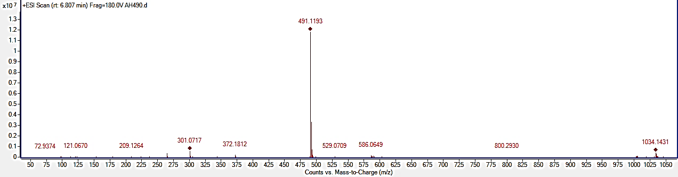
Figure S25. UV spectrum of compound 5

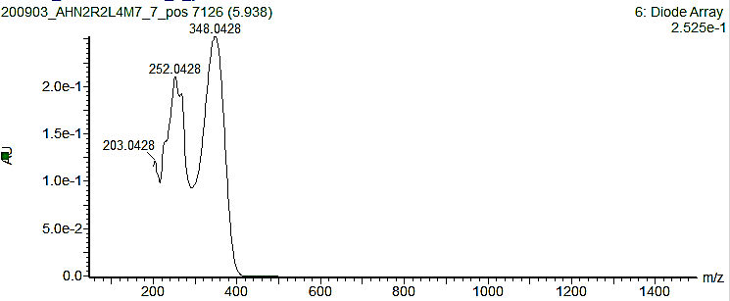
Figure S26. IR(KBr) spectrum of compound 5
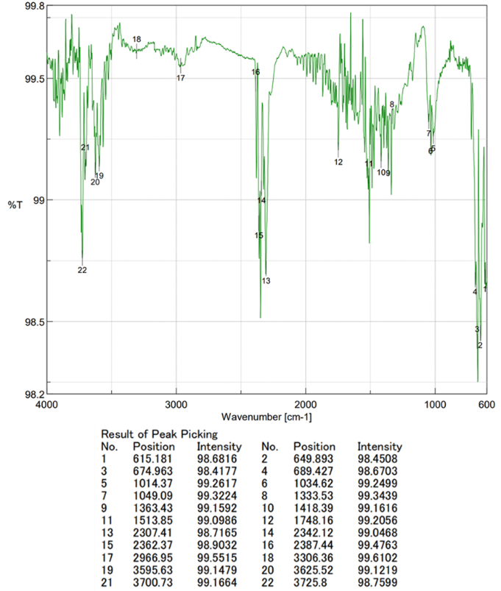
Figure S27. ¹H NMR spectrum of compound 5 (600 MHz, DMSO-d₆)
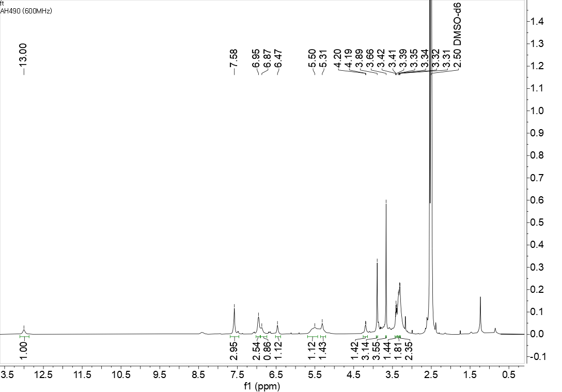

Figure S28. ¹³C NMR spectrum of compound 5 (150 MHz, DMSO-d₆)
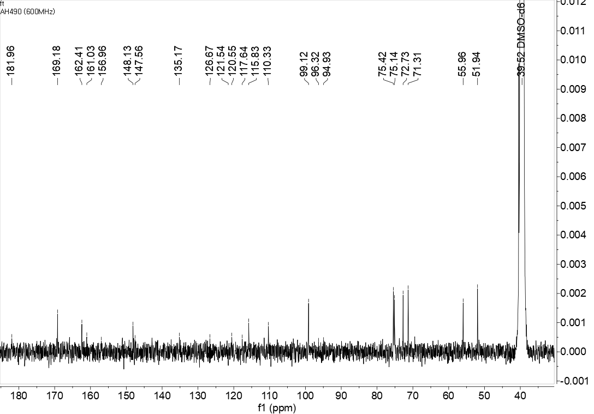

Figure S29. HRESIMS data of compound 6
Figure S30. IR(KBr) spectrum of compound 6

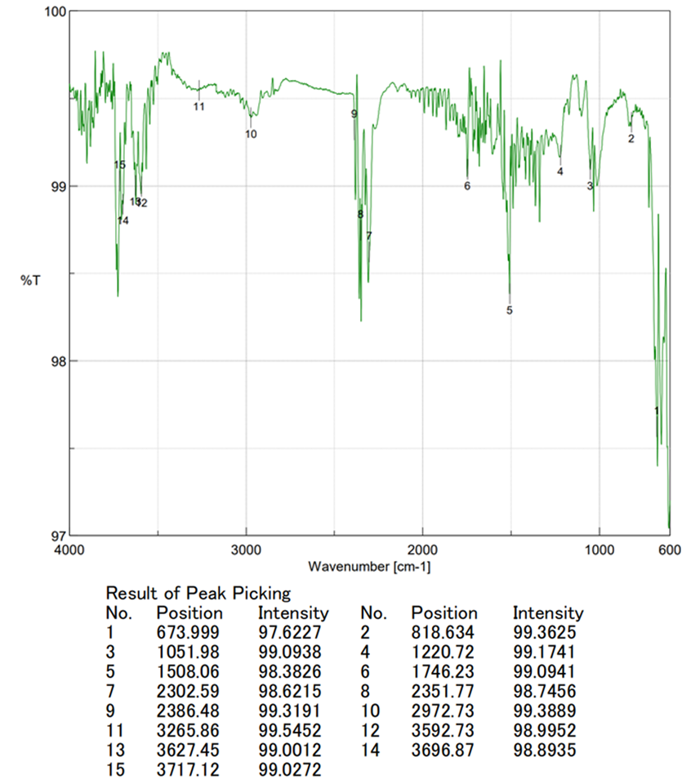

Figure S31. ¹H NMR spectrum of compound 6 (500 MHz, DMSO-d₆)
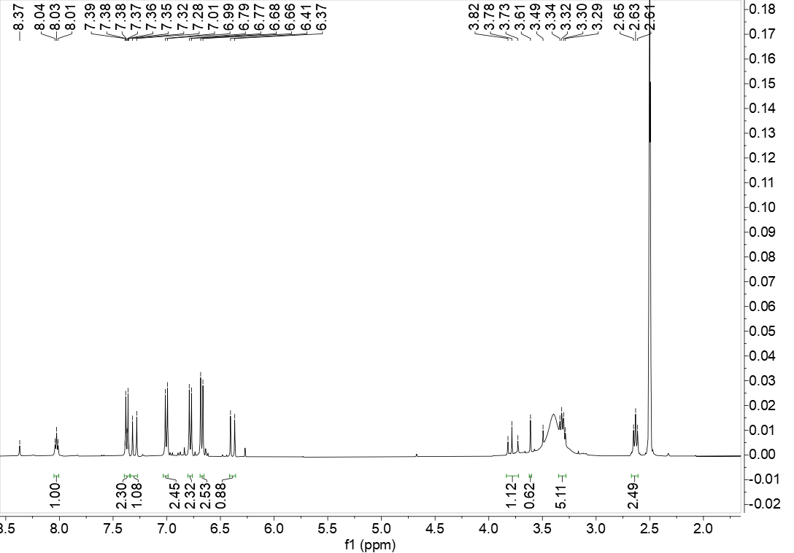
Figure S32. ¹³C NMR spectrum of compound 6 (125 MHz, DMSO-d₆)
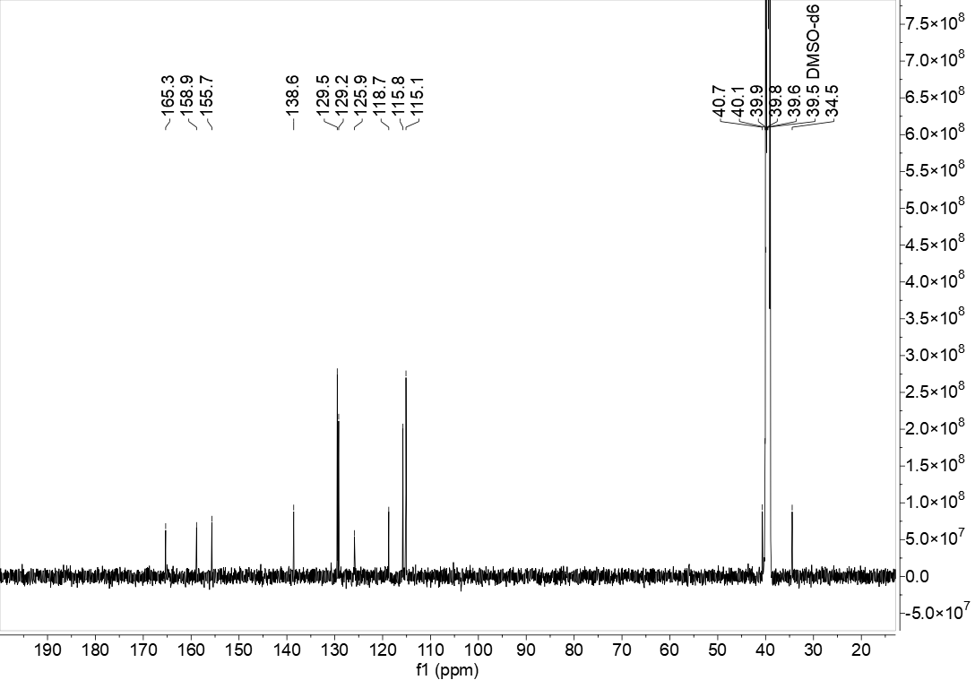

Figure S33. HRESIMS data of compound 7
Figure S34. IR(KBr) spectrum of compound 7
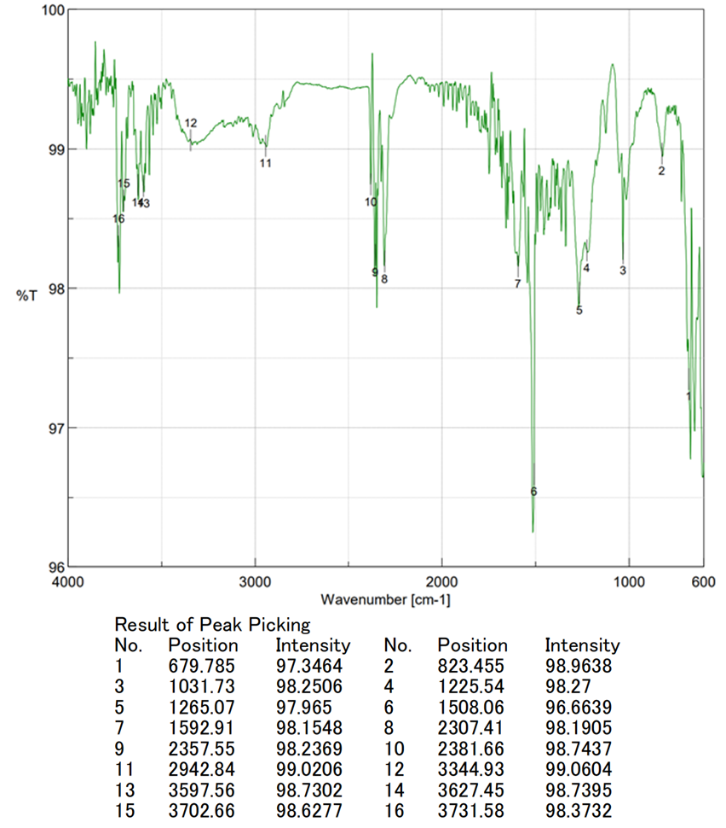
Figure S35. ¹H NMR spectrum of compound 7 (400 MHz, DMSO-d₆)
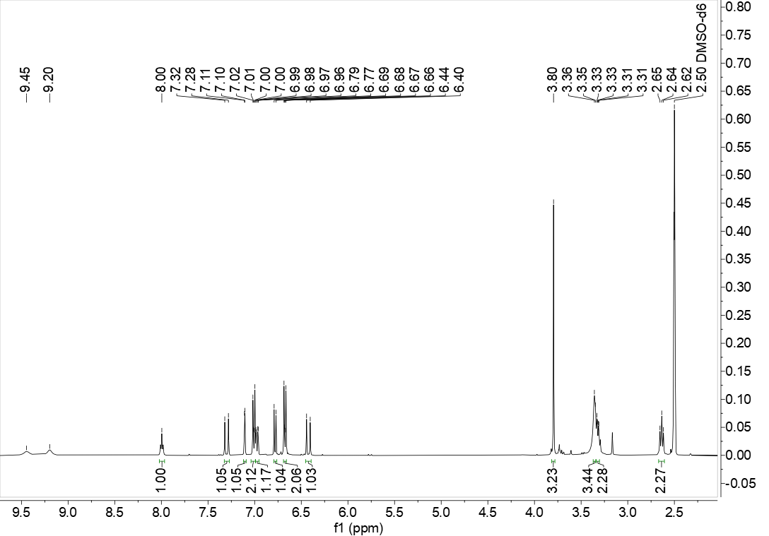
Figure S36. ¹³C NMR spectrum of compound 7 (100 MHz, DMSO-d₆)
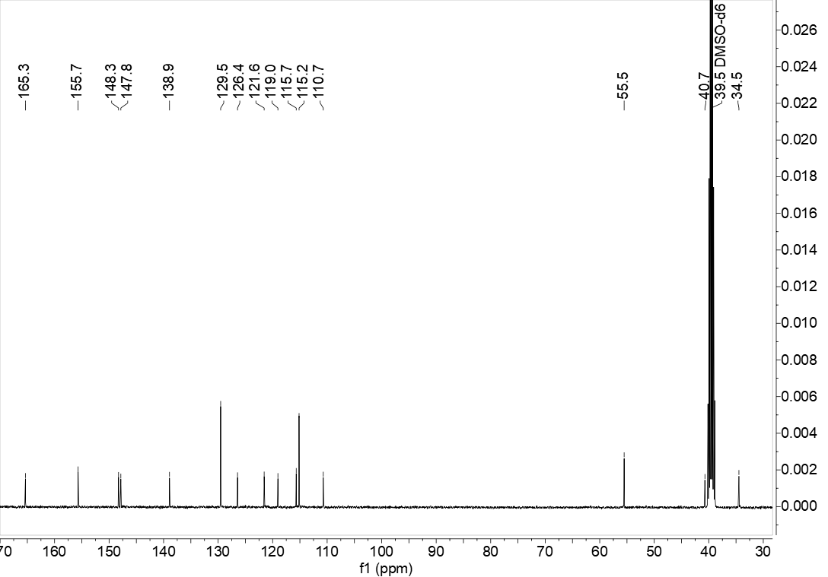
Figure S37. HRESIMS data of compound 8
Figure S38. UV spectrum of compound 8
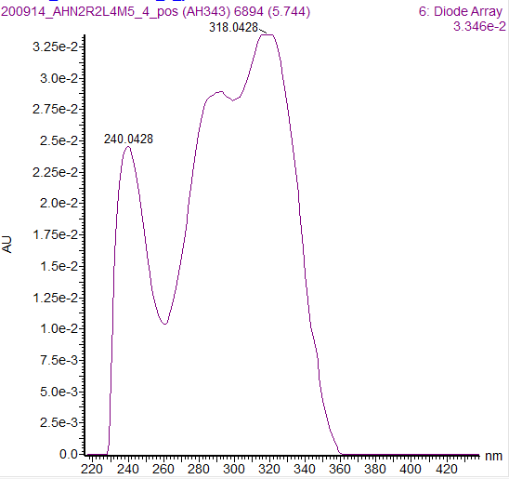
Figure S39. IR(KBr) spectrum of compound 8
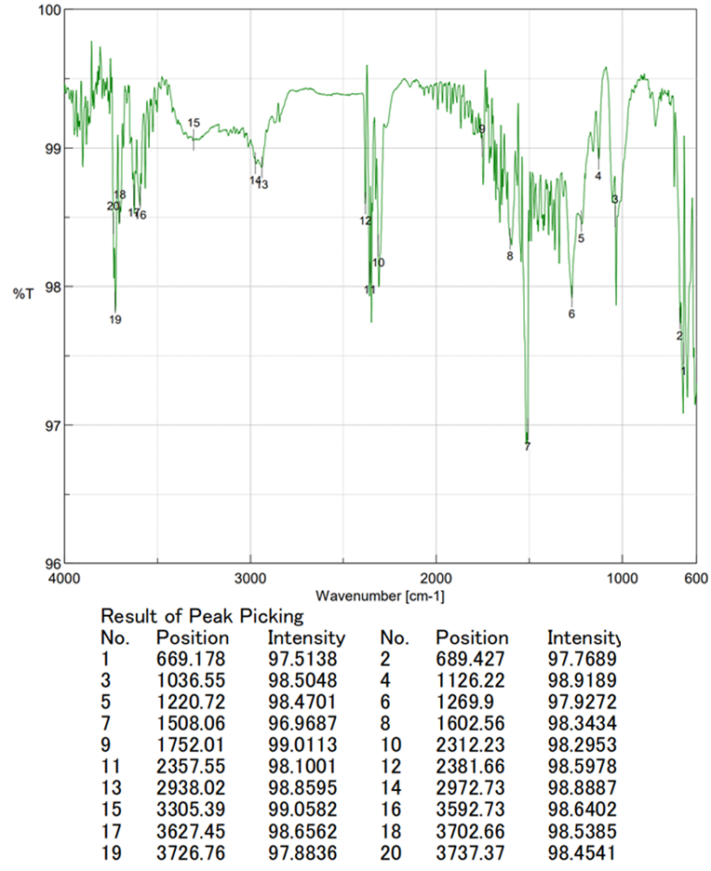

Figure S40. ¹H NMR spectrum of compound 8 (600 MHz, DMSO-d₆)

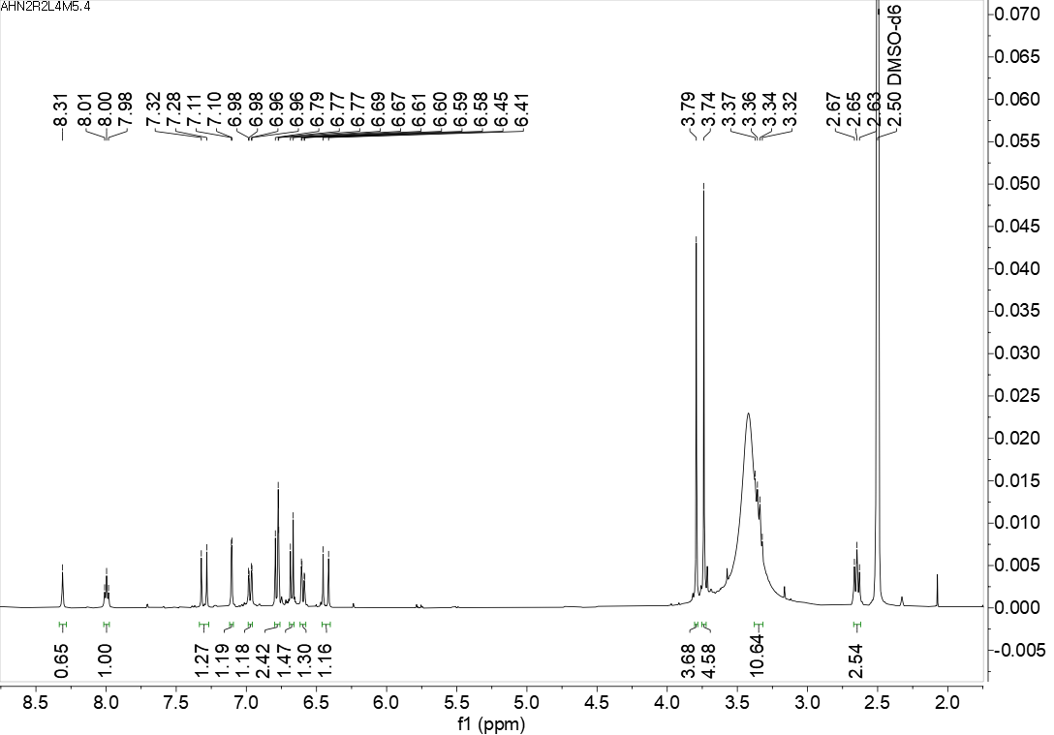
Figure S41. ¹³C NMR spectrum of compound 8 (150 MHz, DMSO-d₆)
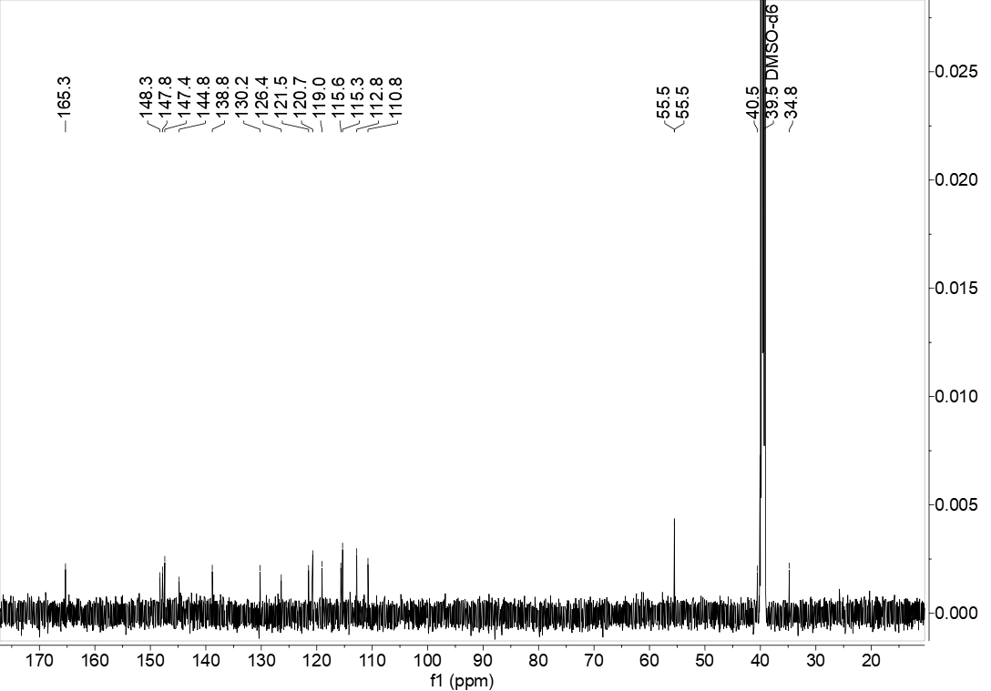

Figure S42. HRESIMS/MS data of compound 9
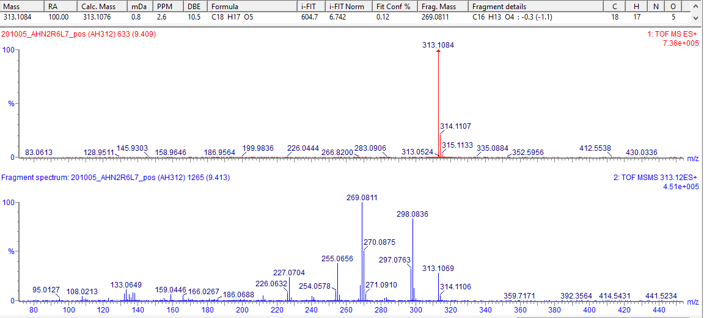
Figure S43. UV spectrum of compound 9
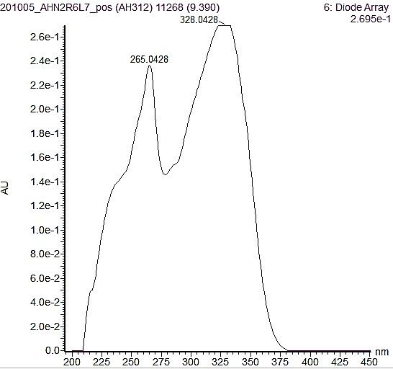
Figure S44. IR(KBr) spectrum of compound 9
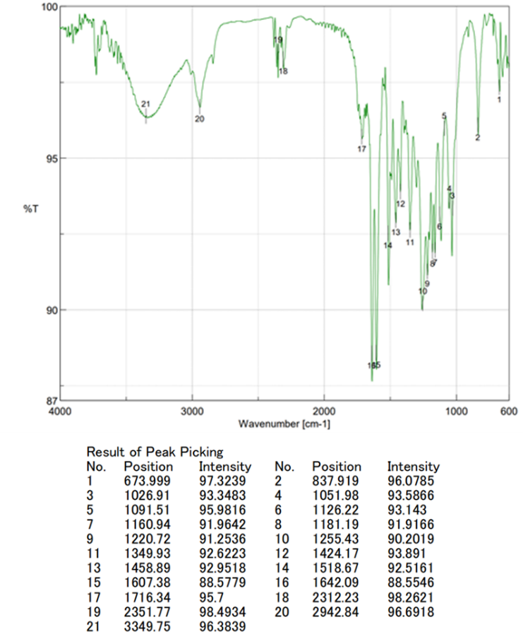

Figure S45. ¹H NMR spectrum of compound 9 (600 MHz, DMSO-d₆)
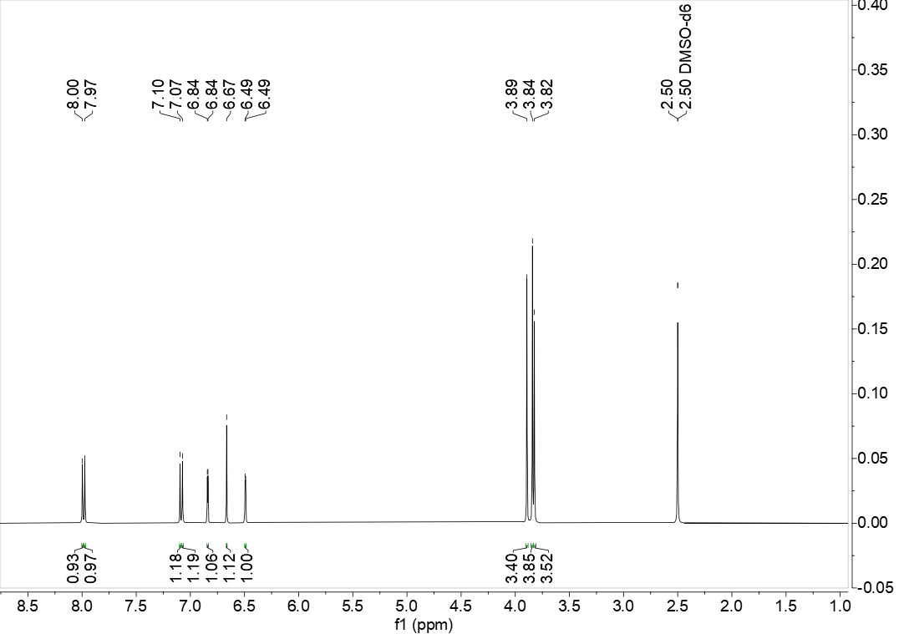
Figure S46. ¹³C NMR spectrum of compound 9 (150 MHz, DMSO-d₆)
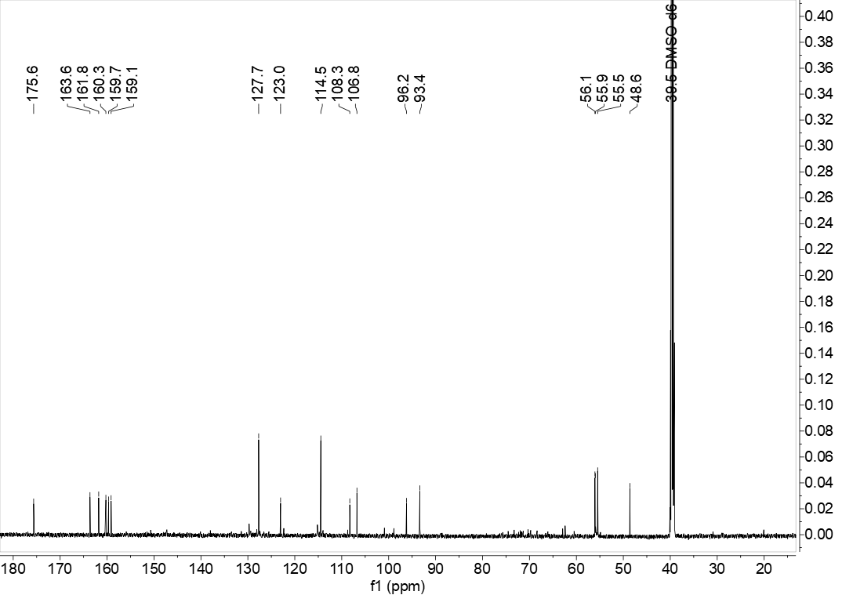
Figure S47. HRESIMS/MS data of compound 10
Figure S48. IR(KBr) spectrum of compound 10

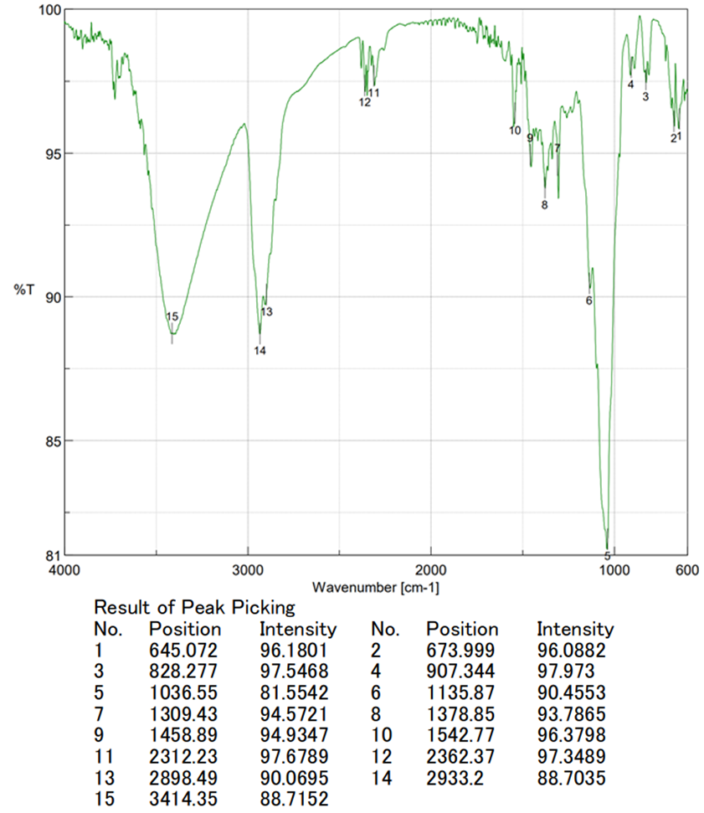
Figure S49. ¹H NMR spectrum of compound 10 (500 MHz, pyridine-d₅)

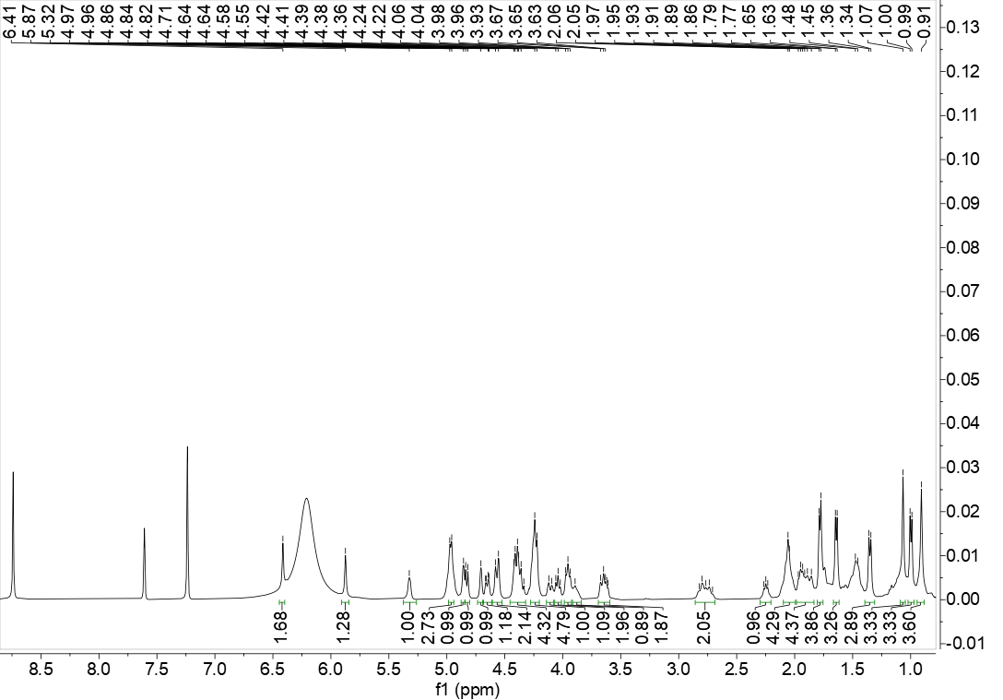
Figure S50. ¹³C NMR spectrum of compound 10 (125 MHz, pyridine-d₅)
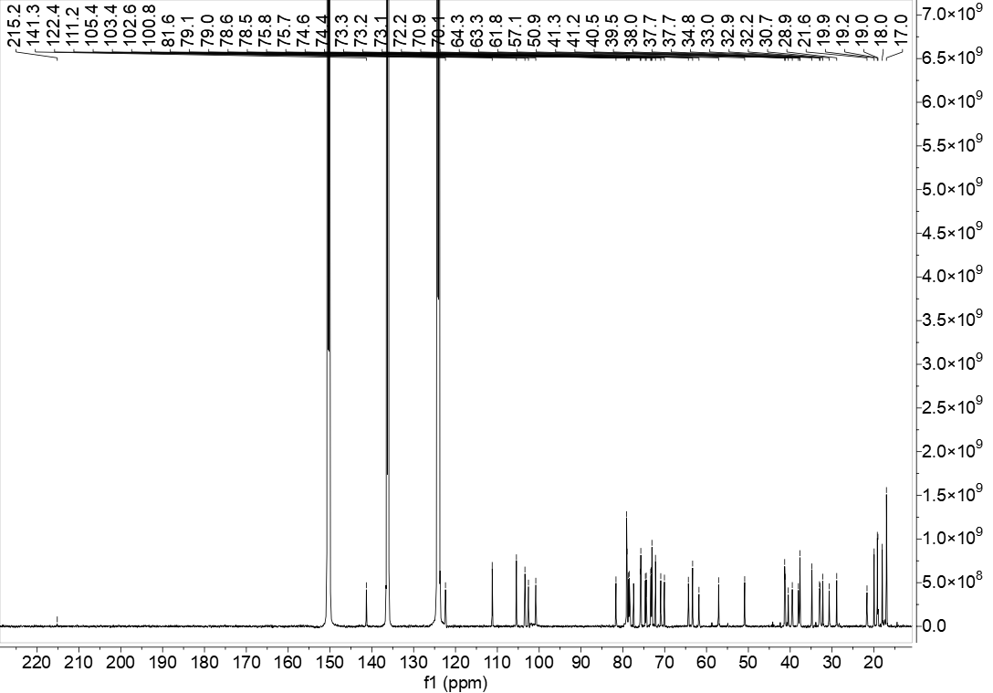
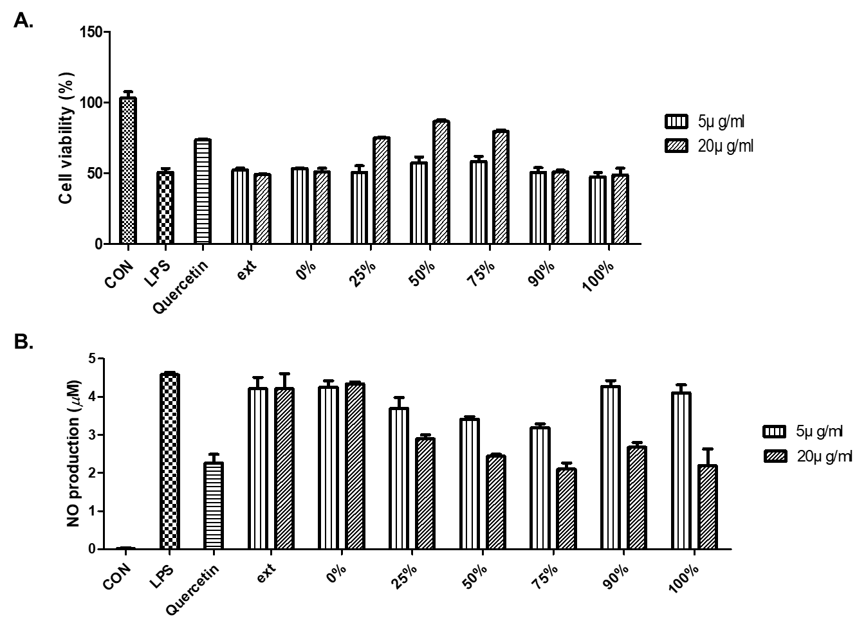
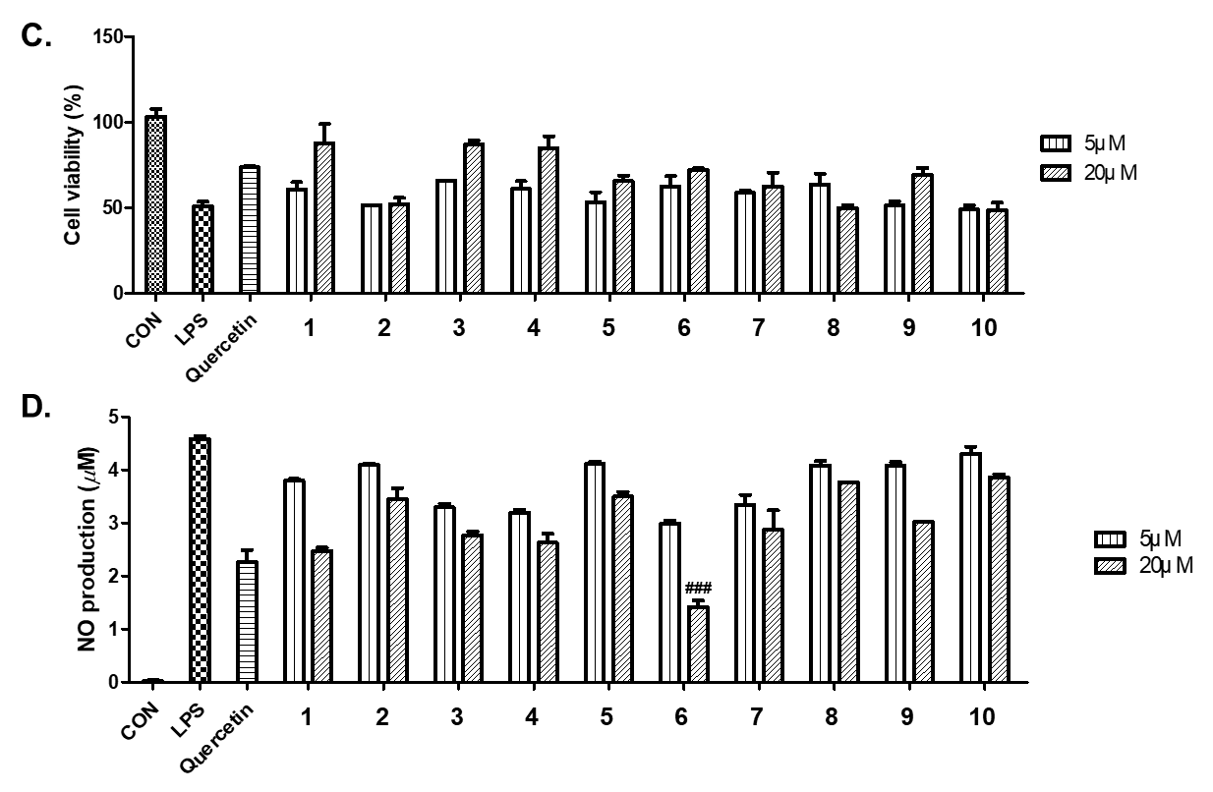
Figure S51. Inhibitory effects of fractions and single compounds from A. hookeri on BLM-induced senescence system in RAW 264.7 cells using nitric oxide (NO) assay kit.
- Cell viability of total extract and subfractions (0–100% of MeOH) of A. hookeri at 5 and 20 µg/mL. (B) NO production level of total extract and subfractions (0–100% of MeOH) of A. hookeri at 5 and 20 µg/mL. (C) Cell viability of single compounds (1–10) at 5 and 20 µM. (D) NO production level of single compounds (1–10) at 5 and 20 µM.

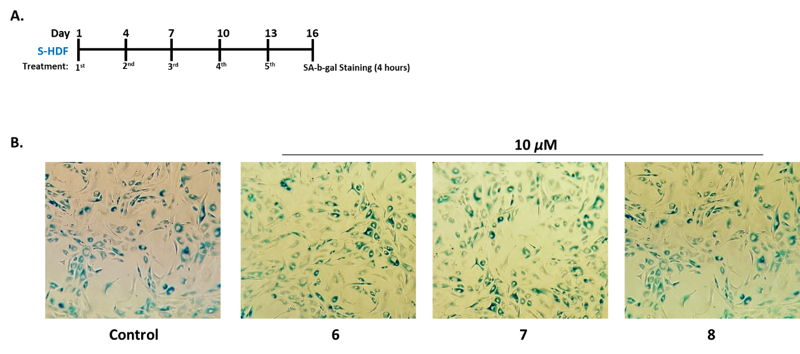
Figure S52. SA-β-gal-positive senescent cells on replicative senescent HDF cell.
Tested compounds (6–8) were treated at 10 µM of on replicative senescent HDF cell for 15 days by every 3 internal days. No effect on reducing SA-β-gal staining was detected.

Table S1. Putative identification of components from leaves of Allium hookeri using HRESI-qTOF-MS/MS-based molecular networking. HRESI-qTOF-MS/MS data recorded in positive mode selective for assignment with m/z error less than 10 ppm. Molecular networking was created at GNPS (https://gnps.ucsd.edu/ProteoSAFe/status.jsp?task=b6f262ecf9994b82bab562336b008eeb)

No. | Retention time  (min) | m/z | Compound_Name | GNPSLibraryURL | MZ Error  (ppm)
1 | 3.13 | 565.1531 | 5,7-dihydroxy-2-(4-hydroxyphenyl)-8-[3,4,5-trihydroxy-6-(hydroxymethyl)oxan-2-yl]-6-(3,4,5-trihydroxyoxan-2-yl)chromen-4-one | http://gnps.ucsd.edu/ProteoSAFe/gnpslibraryspectrum.jsp?SpectrumID=CCMSLIB00004709143 | 3.46
2 | 4.08 | 463.0861 | (2S,3S,4S,5R,6S)-6-[2-(3,4-dihydroxyphenyl)-5-hydroxy-4-oxochromen-7-yl]oxy-3,4,5-trihydroxyoxane-2-carboxylic acid | http://gnps.ucsd.edu/ProteoSAFe/gnpslibraryspectrum.jsp?SpectrumID=CCMSLIB00004719166 | 1.98
3 | 4.58 | 271.0577 | 5,7-dihydroxy-2-(4-hydroxyphenyl)-4H-chromen-4-one | http://gnps.ucsd.edu/ProteoSAFe/gnpslibraryspectrum.jsp?SpectrumID=CCMSLIB00006576166 | 8.44
4 | 4.82 | 271.0592 | Genistein | http://gnps.ucsd.edu/ProteoSAFe/gnpslibraryspectrum.jsp?SpectrumID=CCMSLIB00005767064 | 2.93
5 | 5.02 | 301.0684 | Chrysoeriol | http://gnps.ucsd.edu/ProteoSAFe/gnpslibraryspectrum.jsp?SpectrumID=CCMSLIB00000205348 | 8.72
6 | 5.32 | 447.0930 | apigenin-7-O-glucuronide | http://gnps.ucsd.edu/ProteoSAFe/gnpslibraryspectrum.jsp?SpectrumID=CCMSLIB00004720077 | 2.18
7 | 5.42 | 477.1043 | (2S,3S,4S,5R,6S)-3,4,5-trihydroxy-6-[5-hydroxy-2-(4-hydroxyphenyl)-6-methoxy-4-oxochromen-7-yl]oxyoxane-2-carboxylic acid | http://gnps.ucsd.edu/ProteoSAFe/gnpslibraryspectrum.jsp?SpectrumID=CCMSLIB00004720062 | 2.75
8 | 6.41 | 1031.5452 | beta-D-Glucopyranoside, (3beta,22beta,25R)-26-(beta-D-glucopyranosyloxy)-22-hydroxyfurost-5-en-3-yl O-6-deoxy-alpha-L-mannopyranosyl-(1->2)-O-[6-deoxy-alpha-L-mannopyranosyl-(1->4)] | http://gnps.ucsd.edu/ProteoSAFe/gnpslibraryspectrum.jsp?SpectrumID=CCMSLIB00000856131 | 4.97
9 | 6.96 | 685.2728 | (1R,2S)-7-hydroxy-1-(4-hydroxy-3,5-dimethoxyphenyl)-2-N,3-N-bis[2-(4-hydroxyphenyl)ethyl]-6,8-dimethoxy-1,2-dihydronaphthalene-2,3-dicarboxamide | http://gnps.ucsd.edu/ProteoSAFe/gnpslibraryspectrum.jsp?SpectrumID=CCMSLIB00005722109 | 4.63
10 | 7.21 | 325.2239 | Denatonium | http://gnps.ucsd.edu/ProteoSAFe/gnpslibraryspectrum.jsp?SpectrumID=CCMSLIB00005755211 | 9.48
11 | 7.31 | 271.0593 | Aloe-emodin | http://gnps.ucsd.edu/ProteoSAFe/gnpslibraryspectrum.jsp?SpectrumID=CCMSLIB00005761593 | 2.59
12 | 12.13 | 415.2113 | 1-({[2-(2-furylmethyl)-5-methylpyrrolidinyl]amino}methylene)-7-[8-({[2-(2-fury lmethyl)pyrrolidinyl]amino}methylene) -1,6-dihydroxy-3-methyl-5-(methylethyl)-7 -oxo(2-naphthyl)]-3,8-dihydroxy-6-methyl-4-(methylethyl)naphthalen-2-one | http://gnps.ucsd.edu/ProteoSAFe/gnpslibraryspectrum.jsp?SpectrumID=CCMSLIB00010124460 | 1.69
13 | 13.07 | 299.0907 | 7,4-Di-O-methylapigenin | http://gnps.ucsd.edu/ProteoSAFe/gnpslibraryspectrum.jsp?SpectrumID=CCMSLIB00006421404 | 2.35
14 | 13.37 | 415.3200 | Diosgenin | http://gnps.ucsd.edu/ProteoSAFe/gnpslibraryspectrum.jsp?SpectrumID=CCMSLIB00005770460 | 2.42
15 | 14.11 | 520.3379 | PR310844 LPC 18:2 | http://gnps.ucsd.edu/ProteoSAFe/gnpslibraryspectrum.jsp?SpectrumID=CCMSLIB00005747189 | 5.98
16 | 14.91 | 518.3202 | 1-Hexadecanoyl-sn-glycero-3-phosphocholine | http://gnps.ucsd.edu/ProteoSAFe/gnpslibraryspectrum.jsp?SpectrumID=CCMSLIB00003134510 | 3.53
17 | 15.38 | 522.3552 | 1-(9Z-Octadecenoyl)-sn-glycero-3-phosphocholine | http://gnps.ucsd.edu/ProteoSAFe/gnpslibraryspectrum.jsp?SpectrumID=CCMSLIB00003139797 | 1.52
18 | 16.89 | 293.2449 | 14-(hydroxymethyl)-5,9-dimethyltetracyclo[11.2.1.0 , ?.0?,?]hexadecan-5-ol | http://gnps.ucsd.edu/ProteoSAFe/gnpslibraryspectrum.jsp?SpectrumID=CCMSLIB00004713902 | 7.18
19 | 16.94 | 524.3692 | 1-Stearoyl-2-hydroxy-sn-glycero-3-phosphocholine | http://gnps.ucsd.edu/ProteoSAFe/gnpslibraryspectrum.jsp?SpectrumID=CCMSLIB00003139075 | 4.19
20 | 17.64 | 439.3561 | 18-hydroxy-1,2,5,8,15,19,19-heptamethylpentacyclo[12.8.0.0<2,11>.0<5,10>.0<15, 20>]docos-11-ene-8-carboxylic acid | http://gnps.ucsd.edu/ProteoSAFe/gnpslibraryspectrum.jsp?SpectrumID=CCMSLIB00010125896 | 2.01
21 | 17.64 | 279.2317 | linolenic acid | http://gnps.ucsd.edu/ProteoSAFe/gnpslibraryspectrum.jsp?SpectrumID=CCMSLIB00005738688 | 1.09
22 | 17.76 | 355.2836 | monolinolein | http://gnps.ucsd.edu/ProteoSAFe/gnpslibraryspectrum.jsp?SpectrumID=CCMSLIB00004692320 | 1.12
23 | 18.78 | 282.2793 | 9 (Z)-Octadecenamide | http://gnps.ucsd.edu/ProteoSAFe/gnpslibraryspectrum.jsp?SpectrumID=CCMSLIB00003139405 | 1.08
24 | 19.28 | 357.2980 | monoolein | http://gnps.ucsd.edu/ProteoSAFe/gnpslibraryspectrum.jsp?SpectrumID=CCMSLIB00004720009 | 5.55
25 | 19.48 | 593.2750 | Phaeophorbide a | http://gnps.ucsd.edu/ProteoSAFe/gnpslibraryspectrum.jsp?SpectrumID=CCMSLIB00010128702 | 1.75

