Table S1. List of cabbage, kohlrabi, and broccoli materials used in this study with their flowering time.
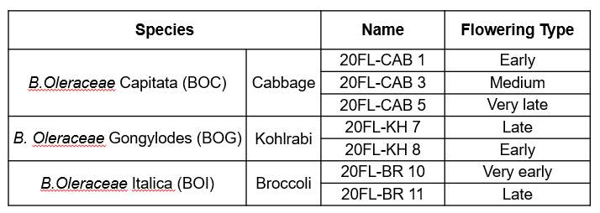

Table S2. List of primers used in this study.
Purpose | Gene  identification number | Gene name | Primer information
 |  |  | Forward primer |  | Reverse primer
 |  |  | Name | Sequence (5'-3') | Name | Sequence (5'-3')
genomic DNA cloning | Bo9g173400 | BoFLC1 | BoFLC1-gF | AGATCAAATTAGGGCGCAAAGC | BoFLC1-gR | ATTCGCCGATTAAAGGTAAC
 | Bo3g100540 | BoFLC2 | BoFLC2-gF | ACCGAACCGAACCTCAGGATC | BoFLC2-gR | GTAGTTTTTACACACGGGGTC
 | Bo3g005470 | BoFLC3 | BoFLC3-gF | CACTTGAACCGAACCTCTGG | BoFLC3-gR | ATTTCAGCCCCGTCTAAAGG
genomic DNA cloning  (Contig) | Bo9g173400 | BoFLC1 | BoFLC1-F1 | CGCTGTGAGGTTGATGCT | BoFLC1-R1 | AGCATCAACCTCACAGCG
 |  |  | BoFLC1-F2 | CCAAGCGTTTAGTTTCGC | BoFLC1-R2 | GCGAAACTAAACGCTTGG
 |  |  | BoFLC1-F3 | ACGATTGCGTTTGCATGT | BoFLC1-R3 | ACATGCAAACGCAATCGT
 |  |  | BoFLC1-F4 | ATGTATTGGCATGCCCGC | BoFLC1-R4 | GCGGGCATGCCAATACAT
 |  |  | BoFLC1-F5 | AGTCTGCTTCATGAGGCC | BoFLC1-R5 | GGCCTCATGAAGCAGACT
 | Bo3g100540 | BoFLC2 | BoFLC2-F1 | GAGCAATGTCCTGATGAGC | BoFLC2-R1 | GCTCATCAGGACATTGCTC
 |  |  | BoFLC2-F2 | ATTGTGCAGCCATTAACC | BoFLC2-R2 | GGTTAATGGCTGCACAAT
 |  |  | BoFLC2-F3 | TGGTTCACACCATGAGCTAC | BoFLC2-R3 | GTAGCTCATGGTGTGAACCA
 |  |  | BoFLC2-F4 | GAACCAGGGTTTGGCTAG | BoFLC2-R4 | CTAGCCAAACCCTGGTTC
 |  |  | BoFLC2-F5 | AATGAAGCCTGGATCTGG | BoFLC2-R5 | CCAGATCCAGGCTTCATT
 | Bo3g005470 | BoFLC3 | BoFLC3-F1 | TTTGCATGTCCGTCAAGA | BoFLC3-R1 | TCTTGACGGACATGCAAA
 |  |  | BoFLC3-F2 | AGGAACAAGCATTCCTTTTC | BoFLC3-R2 | GAAAAGGAATGCTTGTTCCT
 |  |  | BoFLC3-F3 | GCCAACTCATAGCCTCAA | BoFLC3-R3 | TTGAGGCTATGAGTTGGC
 |  |  | BoFLC3-F4 | TGGAGGGTGTCCTTGAGA | BoFLC3-R4 | TCTCAAGGACACCCTCCA
 |  |  | BoFLC3-F5 | GAAGAAGAAACAACCAAGGC | BoFLC3-R5 | GCCTTGGTTGTTTCTTCTTC
Expression analysis | Bo9g173400 | BoFLC1 | BoFLC1-F | CGATAATGTAAGTGTGGGTTCC | BoFLC1-R | GGAGATTTGTCCAGGTGACACC
 | Bo3g100540 | BoFLC2 | BoFLC2-F | TCTGATGTAAGCGTCGATTCC | BoFLC2-R | CGGACAATTGATGTCAGAGATC
 | Bo3g005470 | BoFLC3 | BoFLC3-F | GAGCTATGGTTCACACAATGAGTTAC | BoFLC3-R | GGCTATCAACAAGCTTCAACATTAG
 | Bo5g038860 | BoGI | BoGI-F | TGGCAAGTGCATCTGATCTC | BoGI-R | TGGGTGTGATAAGCACCGTA
 | Bo9g173400 | BoCOOLAIR | BoCOOLAIR-F | TGATGGTTGGTAGGAAAAGA | BoCOOLAIR-R | CCGCAAGATTATTCTTCTCCA
 | Bo3g019340 | BoVIN3 | BoVIN3-F | TGGATTGCTTGTGAGGGTTGT | BoVIN3-R | TACATGCCGAGTCTCCTTCG
 | Bol030974 | BoACTIN1 | BoACTIN1-F | TTCTCTCTTCCACACGCCAT | BoACTIN1-R | CTTGTCCTGCGGGTAATTCG

Table S3. Percent identity matrix of CDS multiple sequence alignment cabbage (FLC-CA1, -CA3, and -CA5), kohlrabi (FLC-KH7 and -KH8), and broccoli (FLC-BR10 and –BR11) (shown as in Table S1) having different flowering time.
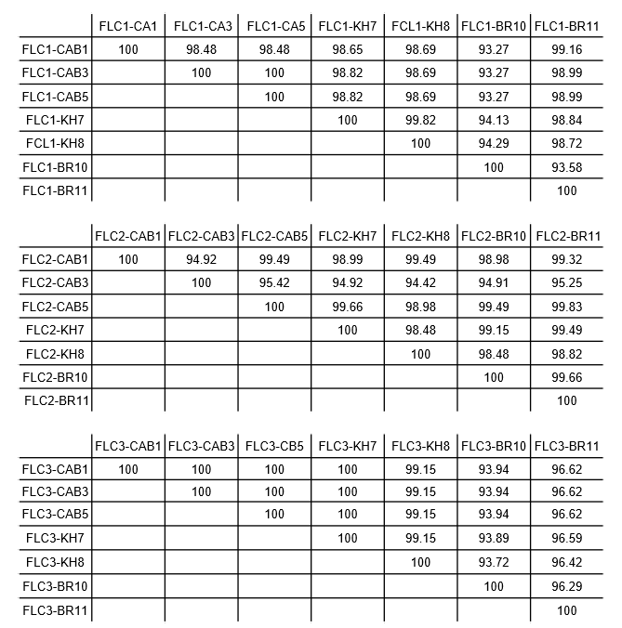

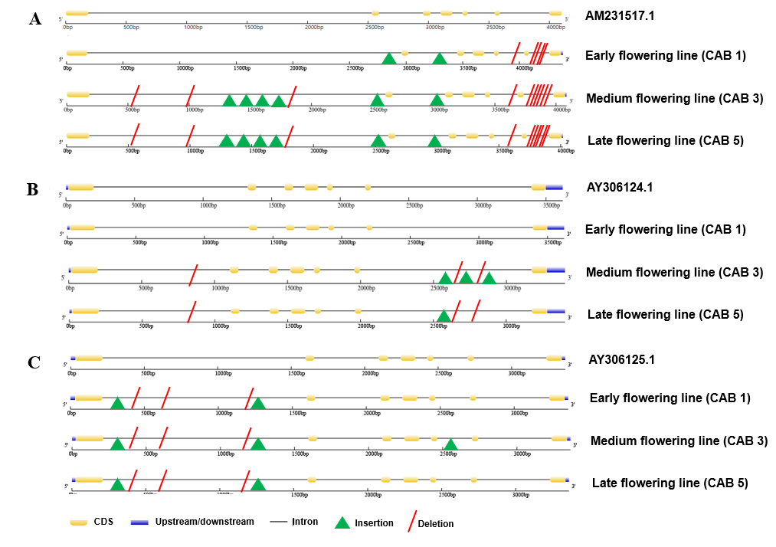
Supplementary Figure 1. Comparisons of BoFLC1 (A), BoFLC2 (B), and BoFLC3 (C) gene structure, respectively, between reference and early- (CAB1), Mid- (CAB3) and late- (CAB5) flowering lines.

