Supplementary Material:
 | Control diet | High-fat diet | Standard diet
Period | P0 until P1 |  | P21 until sacrifice
Reference | SAFE A03 | Research diets D12331 | SAFE A04
% protein | 25.2 | 16.5 | 19.3
% lipid | 13.5 | 58.0 | 8.4
% carbohydrates | 61.3 | 25.5 | 72.4
Kcal/Kg | 3395 | 5558.5 | 3339
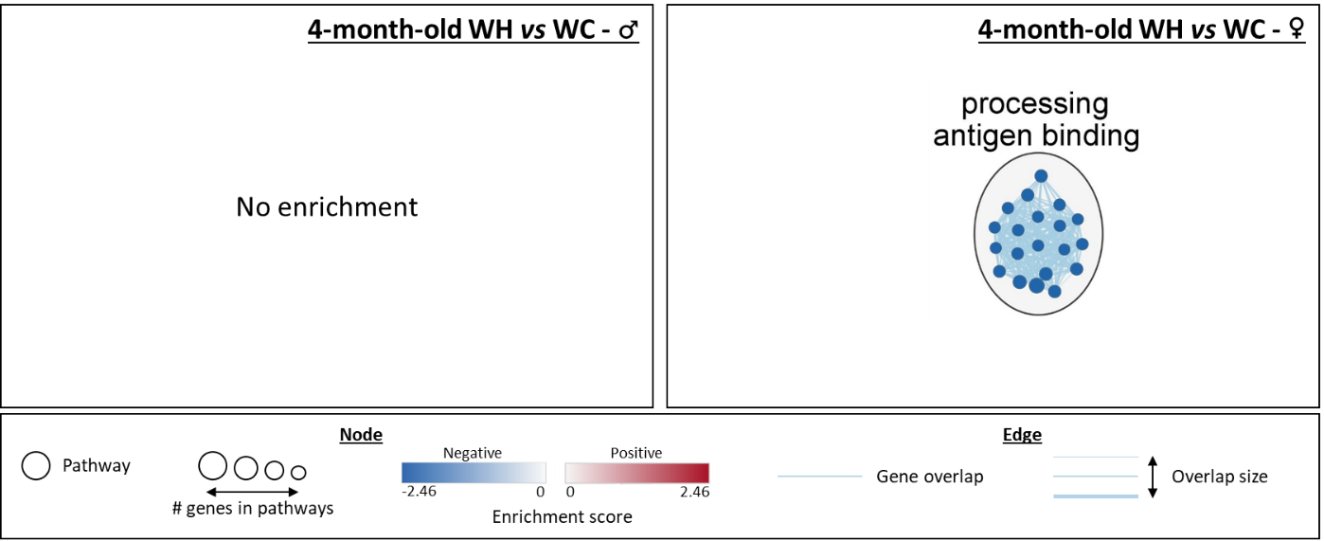
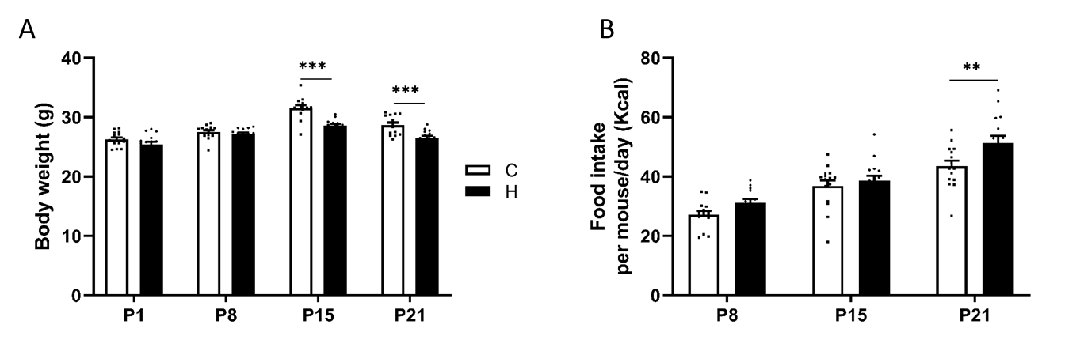
Supplementary table 1: Diet composition. Percentages of protein, fat and carbohydrates in each diet, and associated total amount of kilocalories per kilogram of body weight.

Supplementary data 2: Network analysis of gene set enrichment analysis (GSEA) results from the hippocampal transcriptome of 4-month-old male and female offspring. The network, built using Cytoscpape, shows gene ontology (GO) terms significantly enriched (false discovery rate < 0.25) in terms of cellular components, biological pathways and molecular functions in GSEA (males on the left and females on the right). Groups with fewer than 5 gene sets were deleted.

Supplementary data 1: Body weight and food intake of dams during lactation. (A) Body weight of dams that fed a chow (C) or high-fat (H) diet during lactation at different post-natal day (P1, P8, P15 and P21). (B) Food intake of dams that fed a C or H diet during lactation at different post-natal day (P8, P15 and P21). Values are represented as mean ± SEM. **p < 0.01, ***p < 0.001 vs C mice using two-way ANOVA followed by Tukey’s post hoc test.

SEM. **p < 0.01, ***p < 0.001 vs C mice using two-way ANOVA followed by Tukey’s post hoc test.

Supplementary data 2: Network analysis of gene set enrichment analysis (GSEA) results from the hippocampal transcriptome of 4-month-old male and female offspring. The network, built using Cytoscpape, shows gene ontology (GO) terms significantly enriched (false discovery rate < 0.25) in terms of cellular components, biological pathways and molecular functions in GSEA (males on the left and females on the right). Groups with fewer than 5 gene sets were deleted.
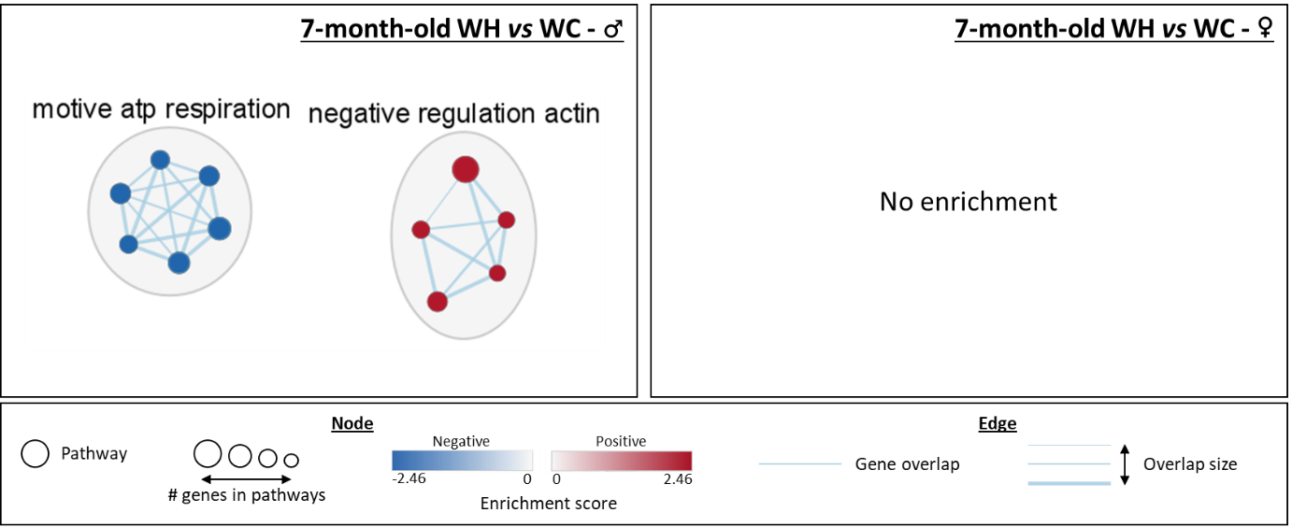
Supplementary data 3: Network analysis of gene set enrichment analysis (GSEA) results from the hippocampal proteomic of 7-month-old male and female offspring. The network, built using Cytoscpape, shows gene ontology (GO) terms significantly enriched (false discovery rate < 0.25) in terms of cellular components, biological pathways and molecular functions in GSEA (males on the left and females on the right). Groups with fewer than 5 gene sets were deleted.

