Supplementary Materials: Mineralogical, Petrological, and Geochemical Characterisation of Chrysotile, Amosite and Crocidolite Asbestos Mine Waste From Southern Africa in Context of Risk Assessment and Re-habilitation
Jessica Schapira, Robert Bolhar, Sharad Master and Allan H. Wilson
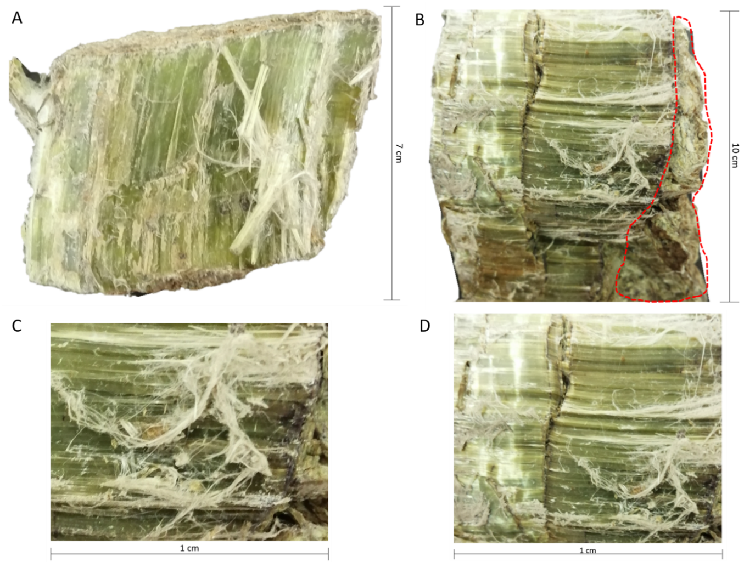
Figure S1. Sample Ch1. (A) Chrysotile rock sample; (B) length of fibres spanning the width of the veins; (C) shows individual masses of matted white, silky fibres and (D) a parting at the centre of the vein width halving the length of the cross-vein fibres.

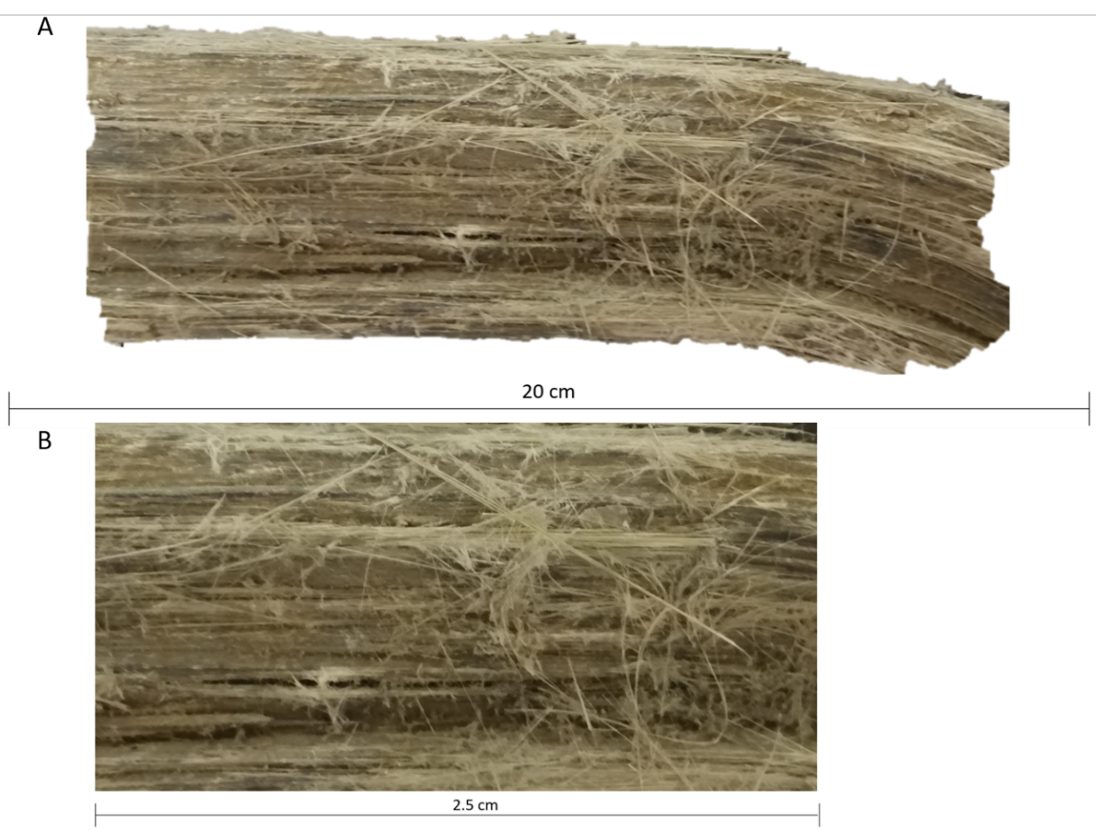
Figure S2. Sample Am2. (A) Amosite rock sample and (B) matted and splintery fibres.
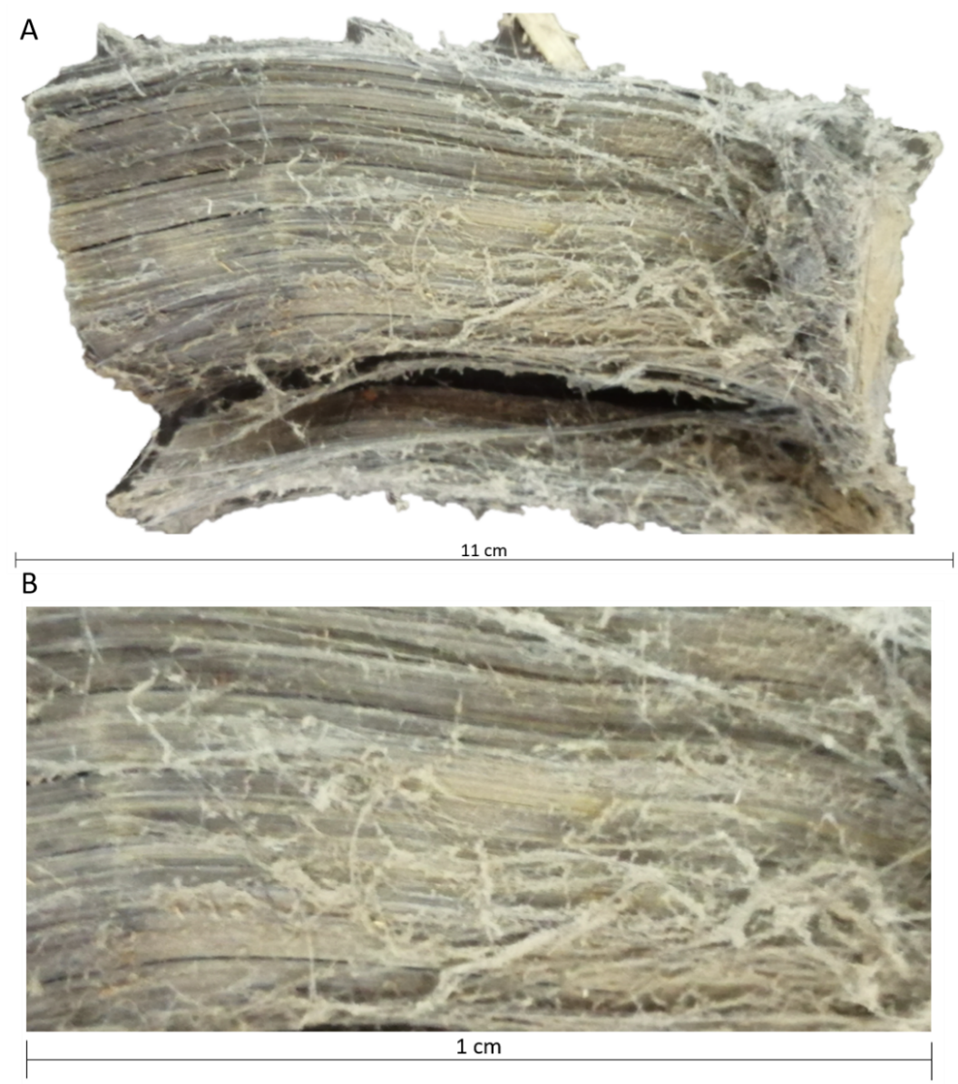
Figure S3. Sample Cr3. (A) Crocidolite rock sample and (B) showing slight curvature of poly-filamentous bundles.
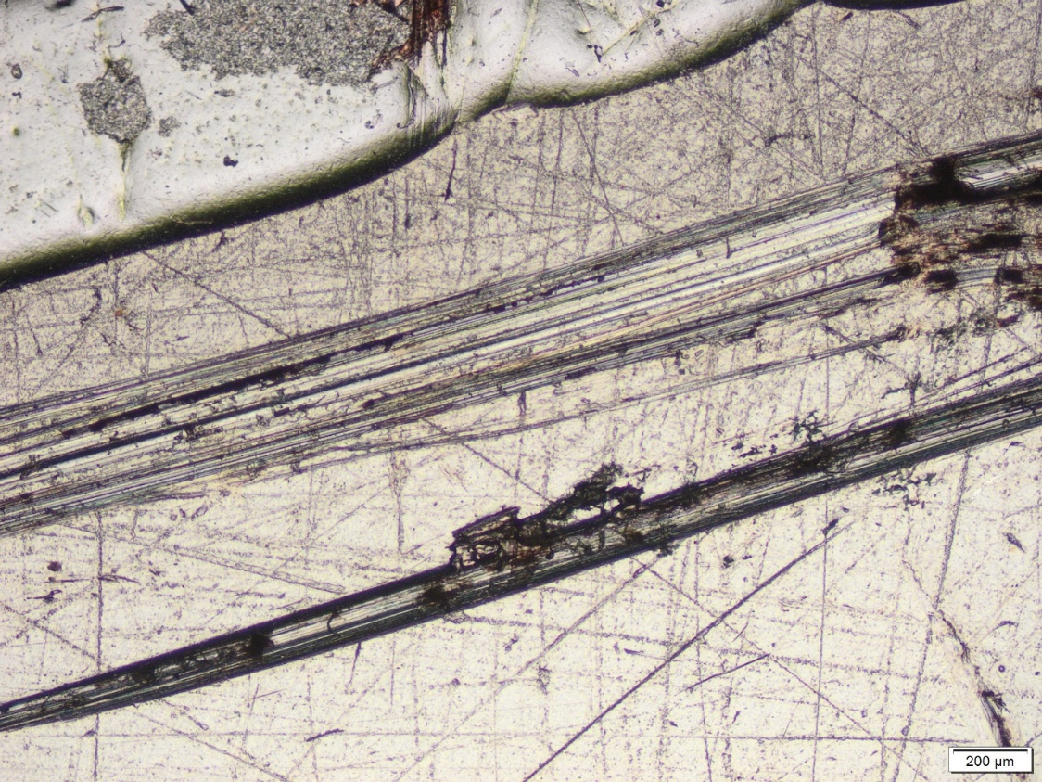
Figure S4. Sample Ch1. Chrysotile fibre bundle (PPL). Notice the break in the bundle in the top right.
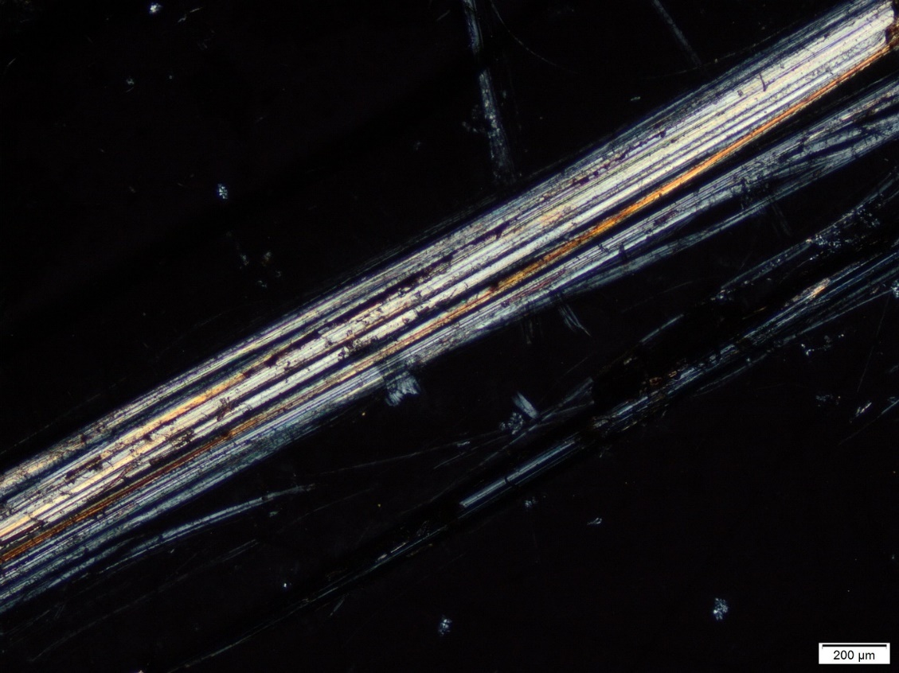
Figure S5. Sample Ch1. Chrysotile fibre bundle (XPL).
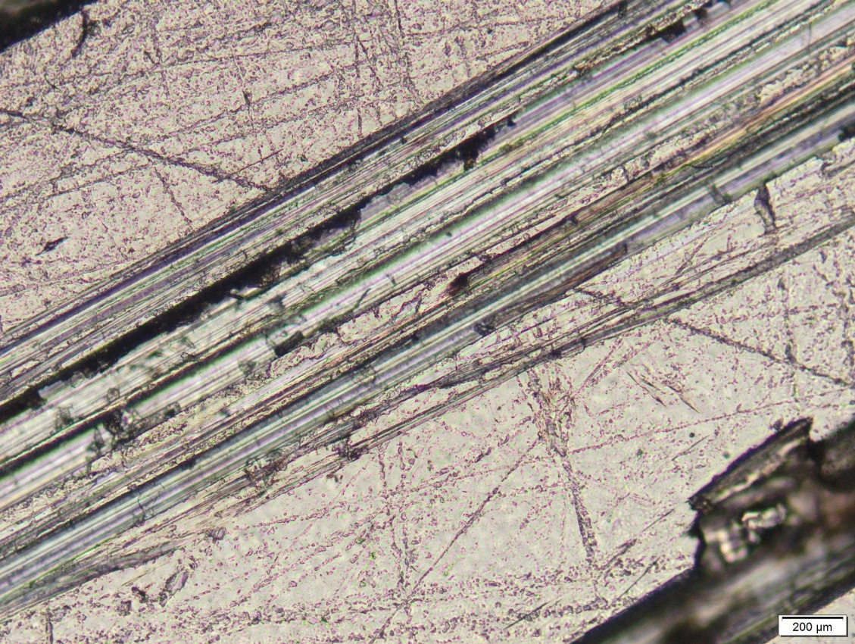
Figure S6. Sample Ch1. Partially altered chrysotile fibres shown by amorphous, irregular material and cloudiness (PPL).
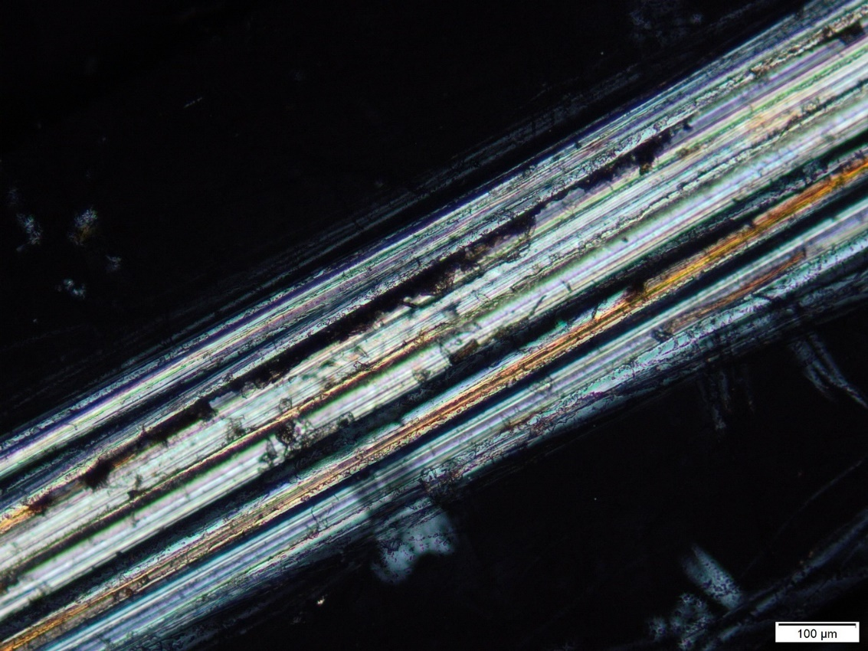
Figure S7. Sample Ch1. Partially altered chrysotile fibres shown by amorphous, irregular material and cloudiness (XPL).
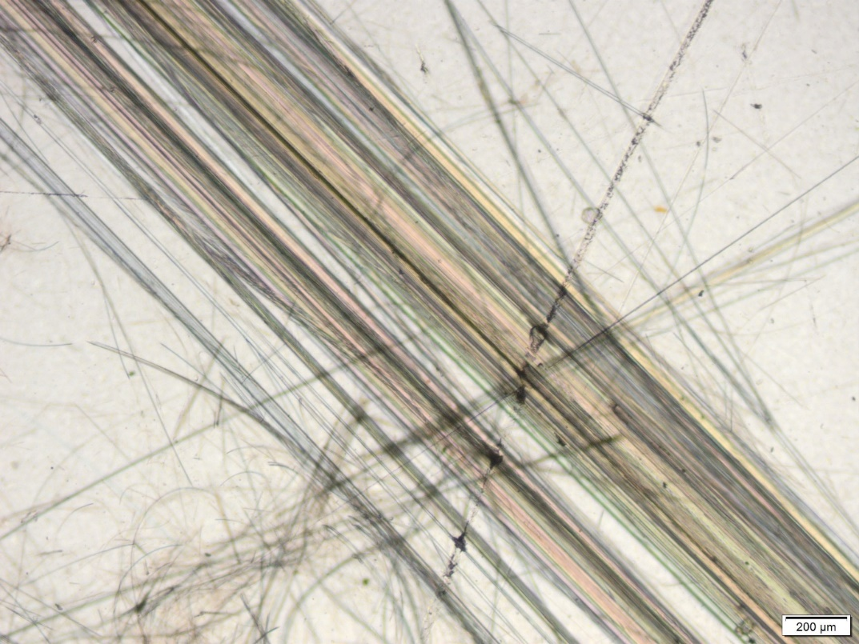
Figure S8. Sample Am2. Extremely fine amosite fibres showing parallel alignment and matting (PPL).
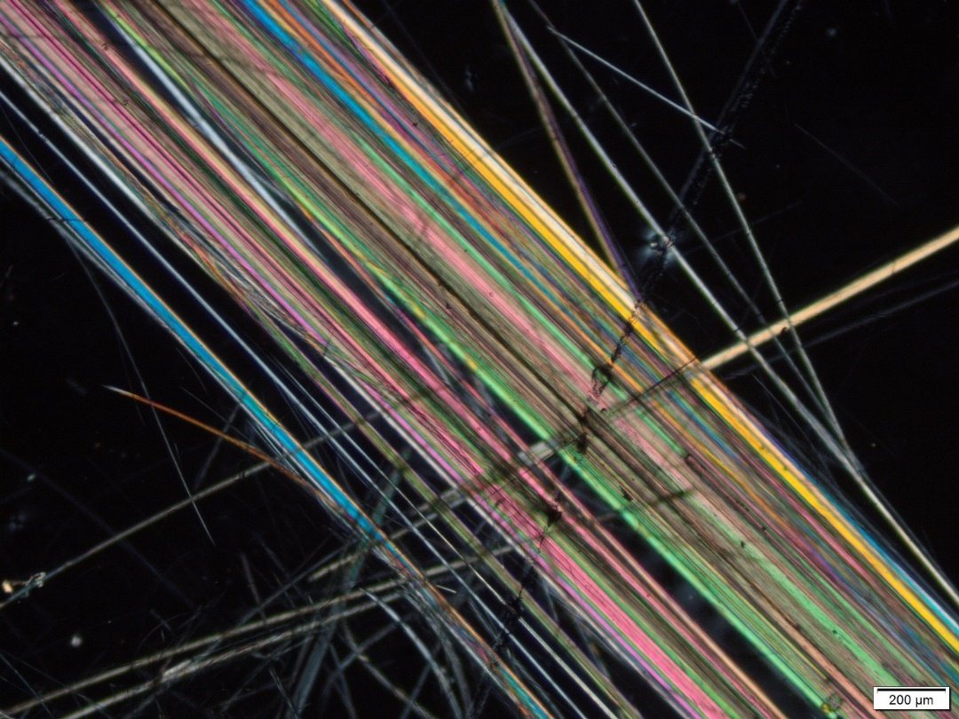
Figure S9. Sample Am2. Extremely fine amosite fibres showing parallel alignment and matting (XPL).
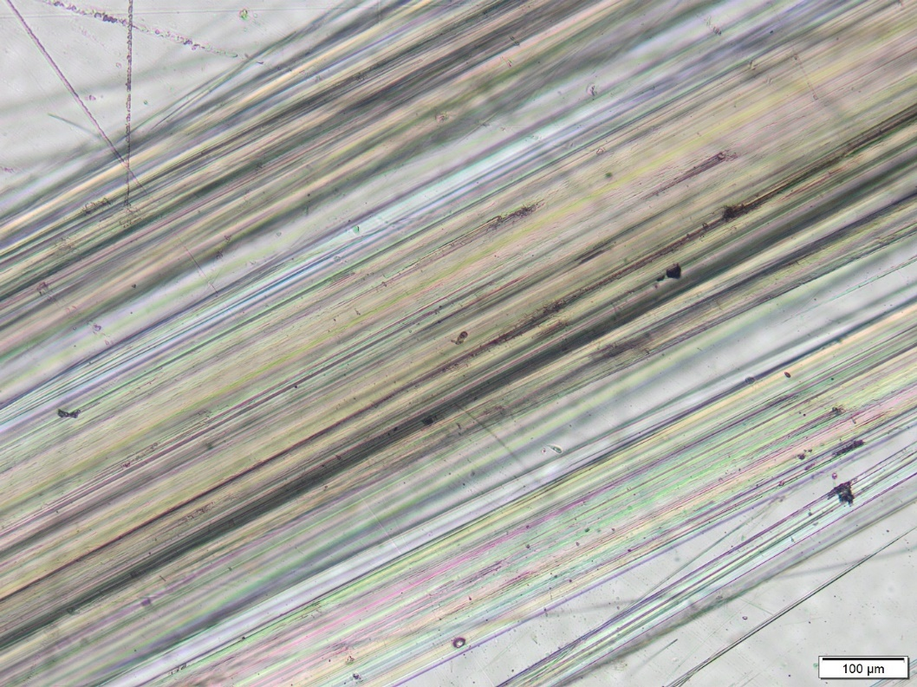
Figure S10. Sample Am2. Amosite fibres at maximum angle of pleochroism showing heterogenous colours (PPL).
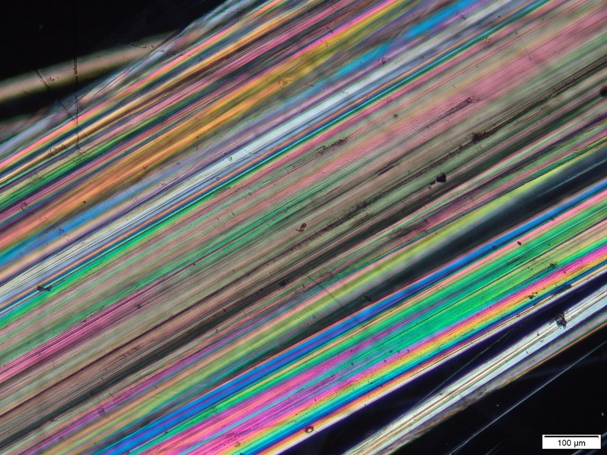
Figure S11. Sample Am2. Amosite fibres at maximum angle of birefringence showing heterogenous interference colours (XPL).
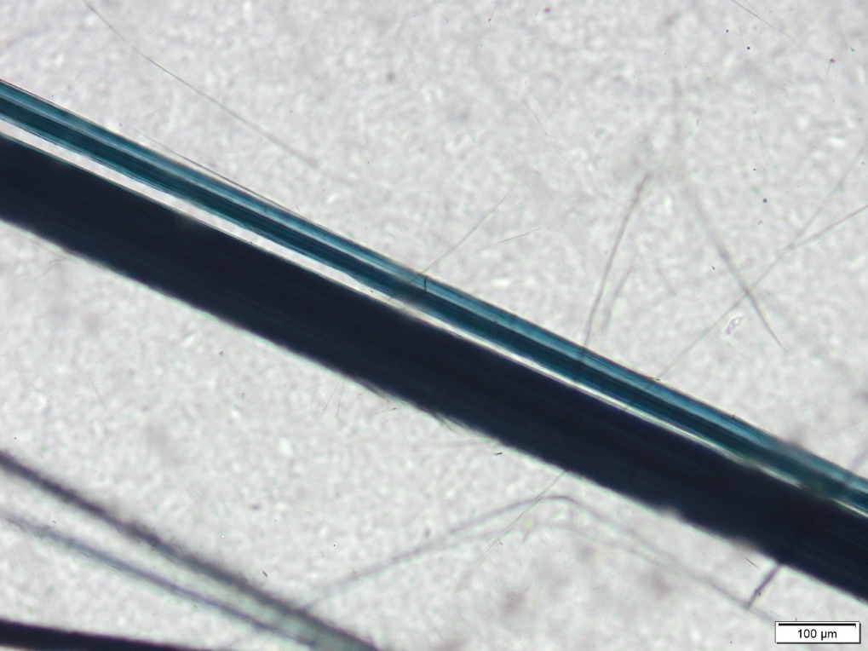
Figure S12. Sample Cr3. Poly-filamentous crocidolite (PPL).
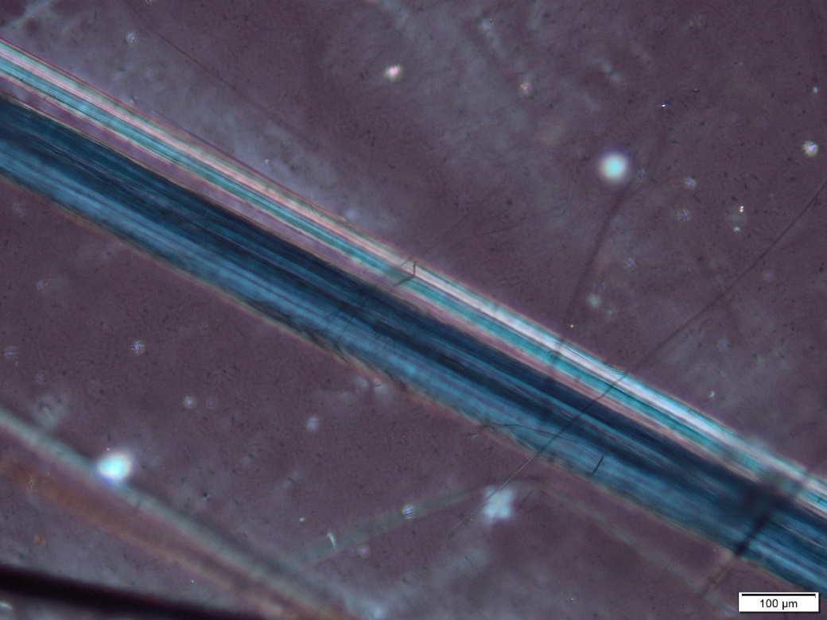
Figure S13. Sample Cr3. Poly-filamentous crocidolite (XPL).
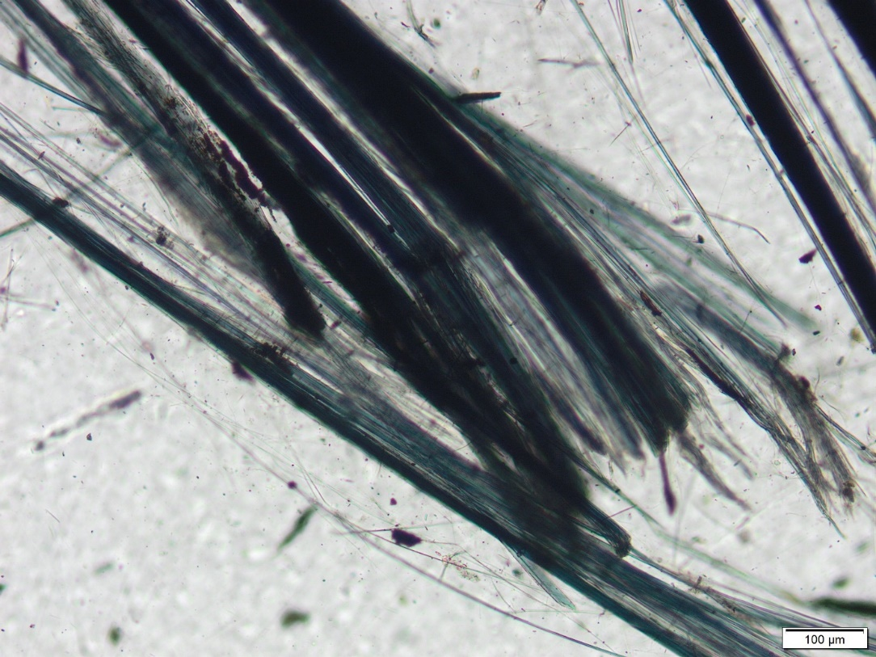
Figure S14. Sample Cr3. Crocidolite fibres with splayed ends (PPL).
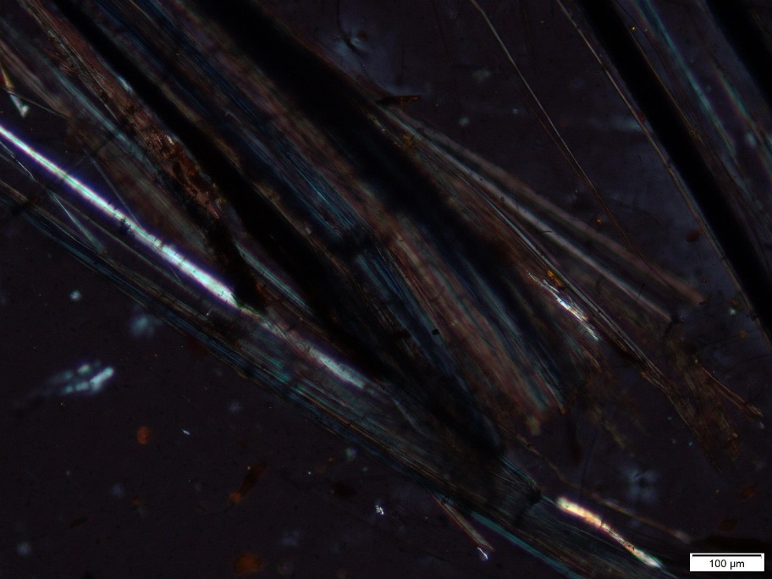
Figure S15. Sample Cr3. Crocidolite fibres with splayed ends (XPL).
Graph S1: Sample Ch1. Chrysotile asbestos XRD diffractogram and Rietveld refinement phases .
Graph S2: Sample Am2. Amosite asbestos XRD diffractogram and Rietveld refinement phases .

Graph S3: Sample Cr3. Crocidolite asbestos XRD diffractogram and Rietveld refinement phases .

Table S1. The values of 2 and intensity (I) recorded for each the peaks of each phase from the X-Ray Diffraction record (λ (CoKα) = 1.78892).
Peak # | Chrysotile rock sample |  | Amosite rock sample |  |  |  |  |  | Crocidolite rock sample
 |  |  | Amosite (grunerite) |  | Quartz low |  | Sepiolite
 | Intensity (counts) | Position [°2Ɵ] (Cobalt (Co)) | Intensity (counts) | Position [°2Ɵ] (Cobalt (Co)) | Intensity (counts) | Position [°2Ɵ] (Cobalt (Co)) | Intensity (counts) | Position [°2Ɵ] (Cobalt (Co)) | Intensity (counts) | Position [°2Ɵ] (Cobalt (Co))
1 | 15000 | 14 | 4500 | 11 | 4500 | 31 | 2000 | 4.5 | 3000 | 11.5
2 | 3000 | 22.5 | 9500 | 12 | 2200 | 59 | 3150 | 6.5 | 20000 | 12.5
3 | 6500 | 23.5 | 4000 | 30 |  |  |  |  | 1000 | 20
4 | 4000 | 26.5 | 4500 | 31.5 |  |  |  |  | 3000 | 21
5 | 8000 | 28.5 | 6100 | 33.8 |  |  |  |  | 1500 | 27
6 | 2900 | 31 | 2000 | 35 |  |  |  |  | 1800 | 28.5
7 | 2000 | 36 | 7100 | 38 |  |  |  |  | 6000 | 30.5
8 | 1200 | 39 | 5200 | 41.5 |  |  |  |  | 2500 | 32
9 | 3000 | 40 | 3100 | 45.5 |  |  |  |  | 12000 | 33.5
10 | 3100 | 42 | 4000 | 48 |  |  |  |  | 9500 | 38.5

Table S2. BET surface area report.
 | Rock Sample
BET Surface Area Report | Chrysotile | Amosite | Crocidolite
BET SSA (m²/g) | 29.6746 $±$ 0.1572 | 10.2856 $±$ 0.0535 | 18.9009 $±$ 0.1048
Slope (g/cm³ STP) | 0.145628 $±$0.000768 | 0.421158 $±$ 0.002177 | 0.229281 $±$ 0.001263
Y-intercept (g/cm³ STP) | 0.001070 $±$ 0.000116 | 0.002074 $±$ 0.000329 | 0.001035 $±$ 0.000191
C | 137.071472 | 204.057744 | 222.422981
Qm (cm³/g STP) | 6.8167 | 2.3628 | 4.3418
Correlation coefficient | 0.9998330 | 0.9998398 | 0.9998180
Molecular cross-sectional area (nm²) | 0.1620 | 0.1620 | 0.1620
STP – Standard temperature and pressure

Table S3. The dissolved mass fraction (DMF) calculated for the asbestos samples.
Time (hours) | Chrysotile | Amosite | Crocidolite
0 | 0 | 0 | 0
24 | 0.5 | 0.22 | 0.25
48 | 0.52 | 0.23 | 0.33
168 | 0.58 | 0.27 | 0.35
334 | 0.63 | 0.29 | 0.37
720 | 0.67 | 0.292 | 0.38

