Risk biomarkers for biochemical recurrence after radical prostatectomy for prostate cancer using clinical and MRI-derived semantic features

Figure S1. Flowchart of the patient selection process

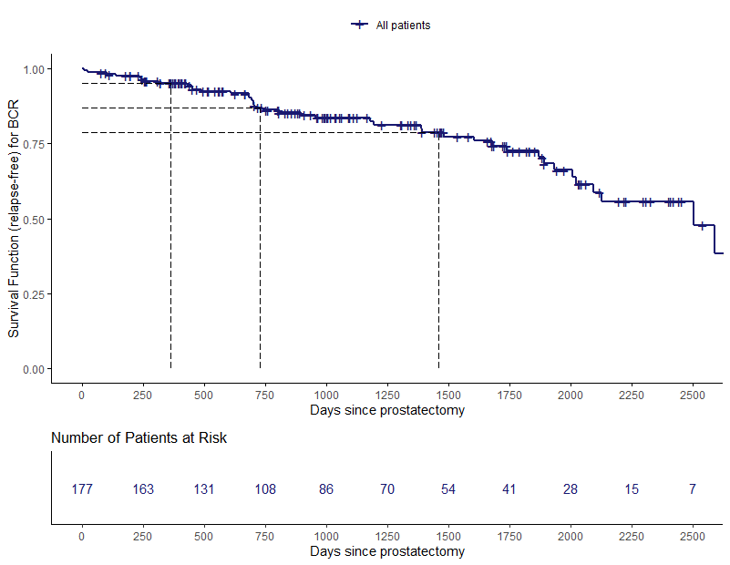

Figure S2. Estimation of the survival curve for the biochemical recurrence-free survival (BCRFS) study: Kaplan-Meier survival function (relapse-free); number of patients at risk for every 250 days; The dashed lines represent the estimates for the survival curve at 365, 730, 1460 days.

A
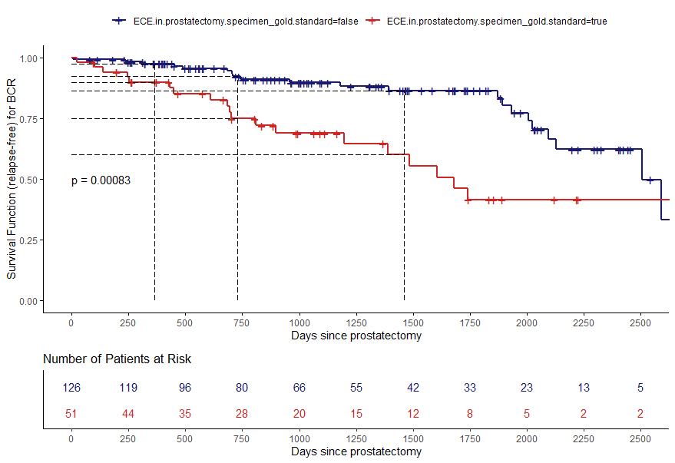
B
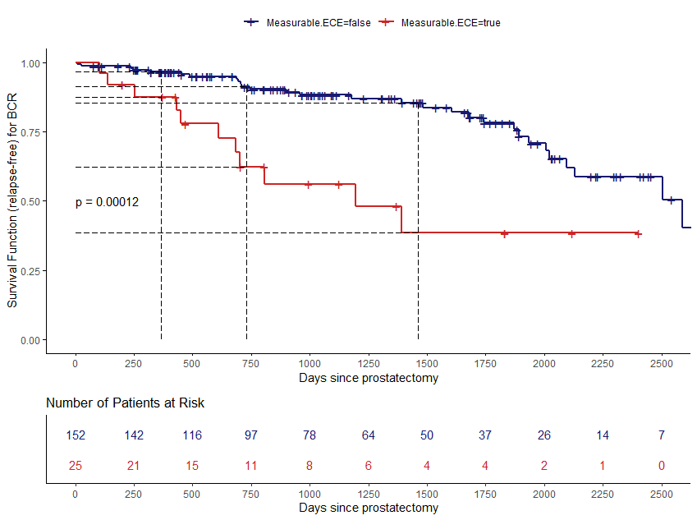
C

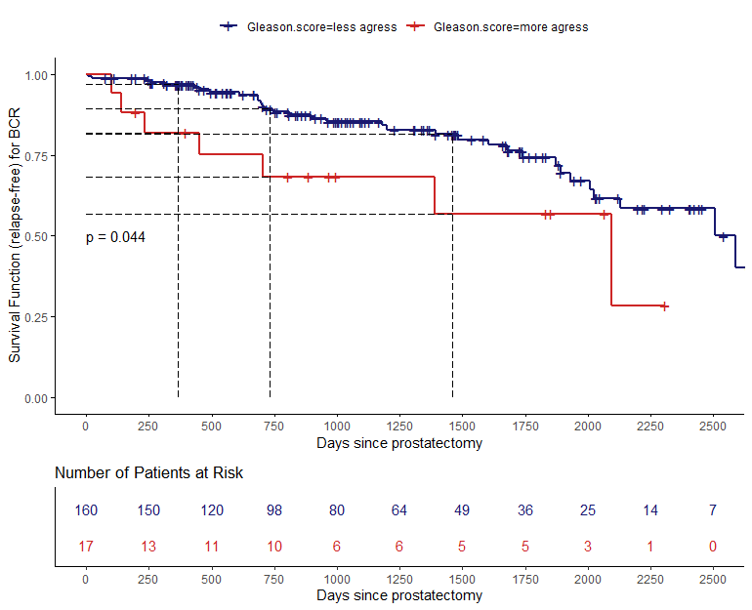D
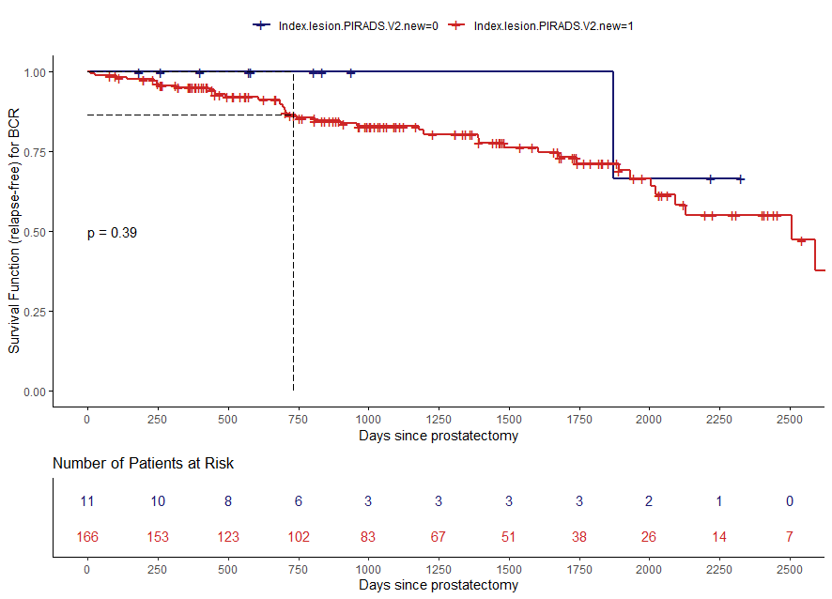E

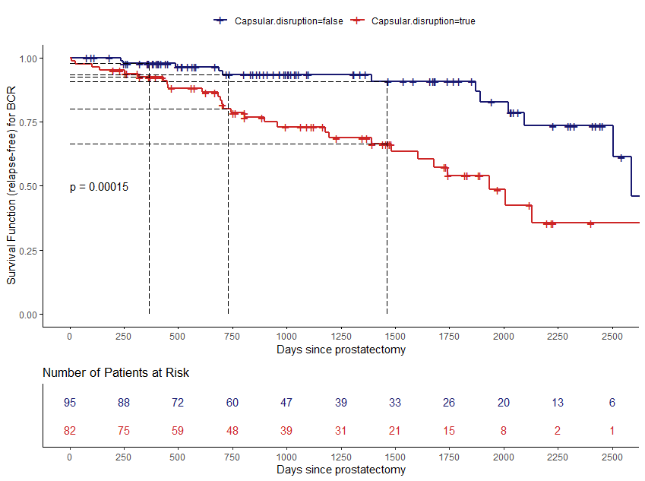
F
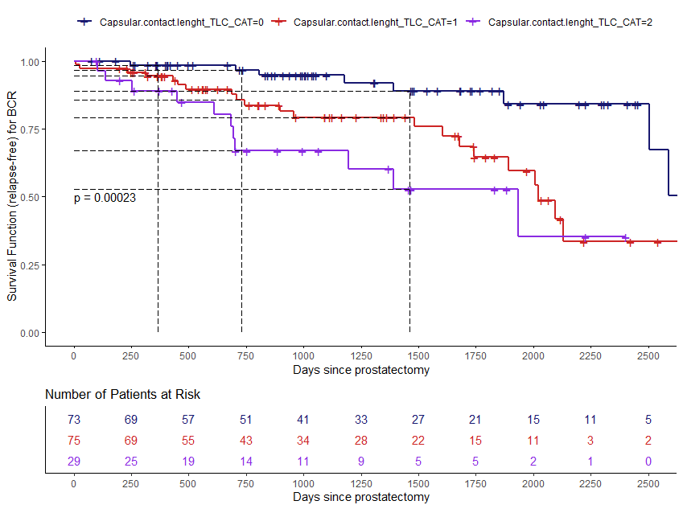G 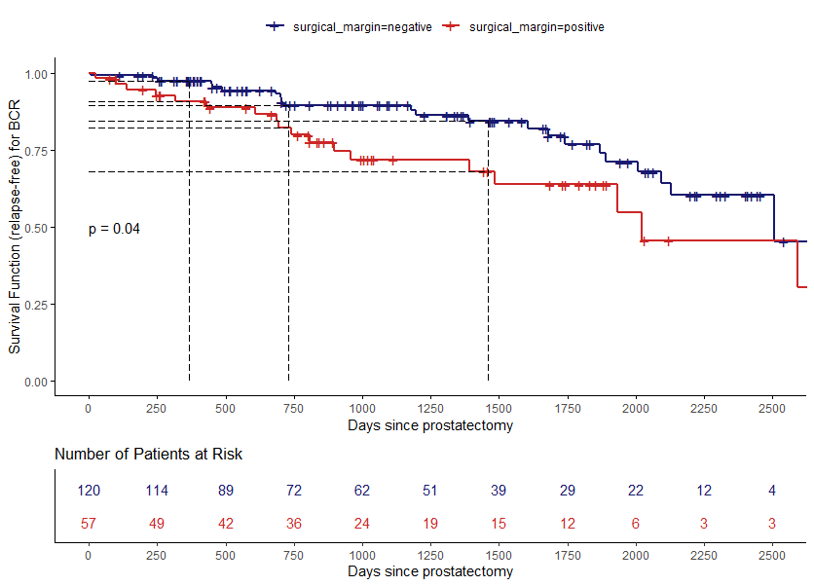 H
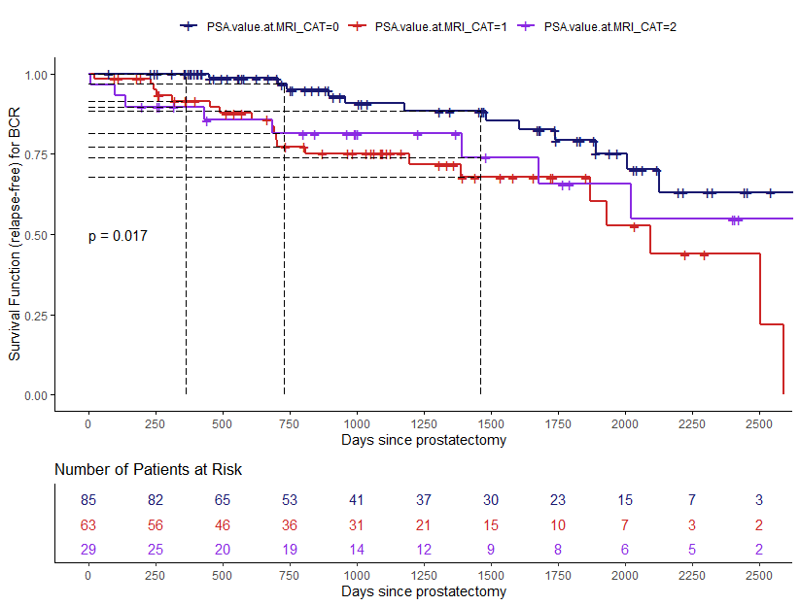
Figure S3. Estimation of the survival curves for the biochemical recurrence-free survival (BCRFS) study. Kaplan-Meier survival function (relapse-free) stratified by: pECE based on pathologic specimen staging (A), measurable ECE (B), Gleason score’s severity (C), Index Lesion PIRADS.V2 (D), capsular disruption (E), TCCL (F), surgical margins (G) and PSA (H); number of patients at risk for every 250 days; p-value from the two-tailed log-rank test to compare the two survival curves. The dashed lines represent the estimates for the survival curve at 365, 730, 1460 days.
All categorical variables are divided in two strata: present (red line) versus not present (blue line).
The remaining analysis the variables were separated into categories (CAT)
In the case of Gleason score (GS): GS CAT low/intermediate corresponds to GS 6(3+3), 7(3+4), 7(4+3) (blue line), and GS CAT high risk corresponds to 8 (4+4), 9 (4+5) (red line). For PI-RADS_v2: CAT 0, if PIRADS_v2 = 3; CAT 1, if PIRADS_v2 ≥ 4.
Categorization of the TCCL: CAT 0 if TCCL <10mm (blue line); CAT 1: 10mm ≤ TCCL<20mm (red line); 2: TCCL≥20mm (purple line). Categorization of the PSA, CAT 0 if PSA<6 ng /ml (blue line), CAT 1 if 6ng/ml ≤ PSA < 10 ng /ml (red line) and CAT 2 if PSA ≥ 10 ng /ml (purple line).

Table S1. Results from fitting a Cox proportional hazards regression model.
Variable | Coefficient | SE | Hazard Ratio  (95% CI) | p-value
Prostate Specific Antigen, PSA | 0.078 | 0.036 | 1.081  (1.007, 1.161) | 0.031
Capsular contact length | 0.063 | 0.019 | 1.065  (1.026, 1.106) | 0.001
Capsular disruption
Yes | 0.955 | 0.428 | 2.598  (1.123, 6.011) | 0.026
Measurable ECE
Yes | -0.078 | 0.445 | 0.925  (0.387, 2.212) | 0.860
Gleason score high risk
[7 (4+3), 8 (4+4), 9 (4+5), 9 (5+4)] | 0.959 | 0.438 | 2.609  (1.106, 6.152) | 0.028
CI: Confidence Interval

