Supplementary Information
Cryogenic comminution of subsea cables and flowlines: a pathway for circular recycling of end-of-life offshore infrastructure
Ibukun Oluwoye * and Arun Mathew
Curtin Corrosion Centre, Western Australian School of Mines: Minerals, Energy and Chemical Engineering, Curtin University, Perth, Australia
* Correspondence: Ibukun.Oluwoye@Curtin.edu.au

Figure S1. Variations in average temperature of the flexible flowline (i.e., average of all layers of the flowline during cryogenic cooling).
Supplementary Information
Cryogenic comminution of subsea cables and flowlines: a pathway for circular recycling of end-of-life offshore infrastructure
Ibukun Oluwoye * and Arun Mathew
Curtin Corrosion Centre, Western Australian School of Mines: Minerals, Energy and Chemical Engineering, Curtin University, Perth, Australia
* Correspondence: Ibukun.Oluwoye@Curtin.edu.au

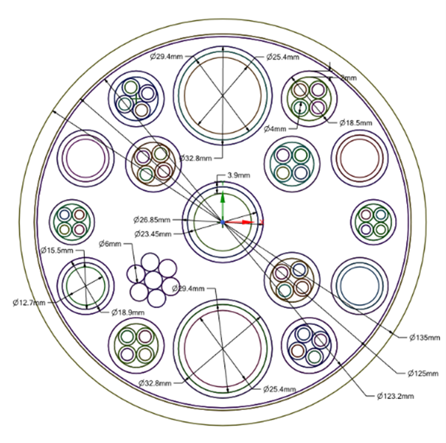
Figure S2. Schematic of umbilical cable cross-section with an outer diameter of 135 mm. Outer sheath: polyethylene; internal plastics: polyamide; filling material: epoxy thermoset; electrical insulation: PVC, etc.

